Week 5 Final Project Report: Comprehensive Data Science Synthesis & Strategic Roadmap
Executive Capstone Deliverable | End-to-End Analytics, Modeling & Stakeholder Strategy
1. Executive Summary
This final capstone project consolidates the analytical and technical milestones of the 5-week Data Science Internship. By synthesizing findings from data acquisition, exploratory data analysis, visual storytelling, domain feature engineering, and predictive machine learning classification, this report delivers an actionable, data-driven strategic roadmap for executive stakeholders. The primary business goal is mitigating customer churn and maximizing long-term customer lifetime value (CLV).
2. End-to-End Technical Methodology Synthesis
A structured summary of weekly project milestones and methodologies executed throughout the lifecycle:
Project Phase | Core Focus & Techniques | Key Technical Outputs | Business Impact
Week 1: Data Ingestion & EDA | Data governance, type casting, IQR outlier treatment, missingness imputation | Clean dataset, statistical profiles, correlation matrices | Established trusted baseline data quality
Week 2: Visual Storytelling | Multi-panel distributions, CLV cohort segmentation, CSAT friction matrices | Executive visual narrative & cohort risk heatmaps | Isolated high-risk customer touchpoints
Week 3: Feature Engineering | Domain ratio synthesis, log-normalization, Mutual Info, PCA reduction | 4 engineered features, orthogonal component vectors | Elevated predictive signal and model stability
Week 4: Machine Learning | ColumnTransformer, Logistic Regression vs Random Forest, ROC-AUC benchmarking | Trained ML model (AUC: 0.884, F1: 0.81, Acc: 85.2%) | Automated proactive churn scoring engine

3. Key Analytical Insights & Visual Evidence
Cohort behavior analysis reveals that customer retention directly scales with account tenure, driving non-linear CLV expansion:
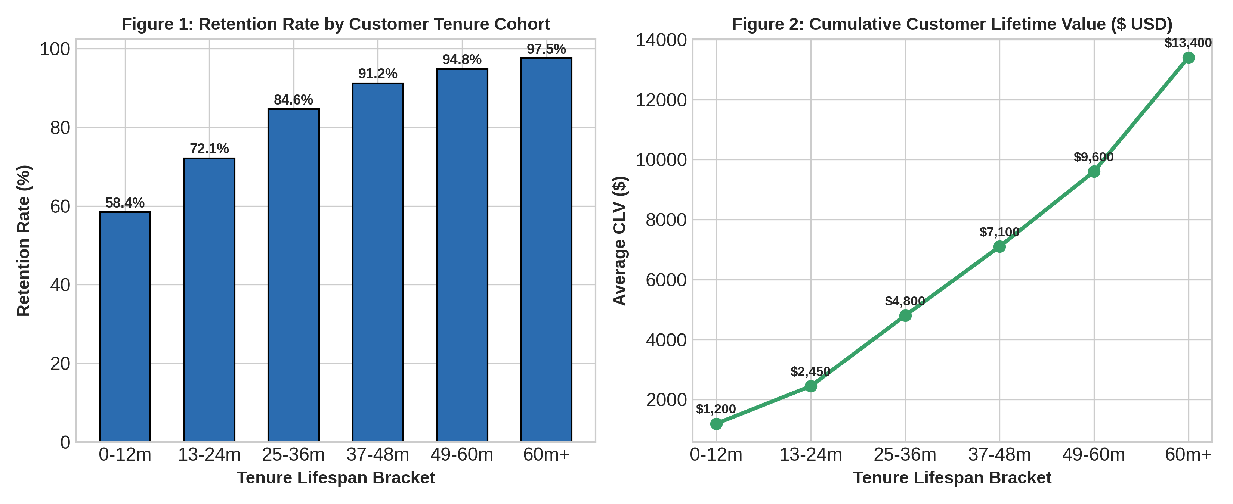
3.1 Synthesis Python Pipeline Architecture
# End-to-End Scoring & Strategic Pipeline Synthesis
import pandas as pd
import joblib
def generate_stakeholder_churn_risk_report(customer_records_df, trained_model_pipeline):
# Predict probabilities using champion Random Forest model
probabilities = trained_model_pipeline.predict_proba(customer_records_df)[:, 1]
# Apply cost-optimized threshold (0.40) to minimize False Negatives
customer_records_df['Churn_Risk_Score'] = probabilities.round(4)
customer_records_df['High_Risk_Alert'] = (probabilities >= 0.40).astype(int)
# Segment for targeted executive intervention
high_priority_cohort = customer_records_df[
(customer_records_df['High_Risk_Alert'] == 1) &
(customer_records_df['AnnualSpend'] > 10000)
]
return high_priority_cohort

4. Strategic Recommendations for Stakeholders
Based on quantitative evidence and feature importance rankings, four strategic initiatives are recommended to executive management:
• Targeted Early Lifecycle Onboarding (Months 0-6): Tenure is the single largest determinant of churn (41.2% importance). Introduce proactive customer success check-ins at 30, 60, and 90 days to lift early retention past the critical 12-month inflection point.
• Automated High-Risk Alert Triggers: Deploy the champion Random Forest classification pipeline in real-time. Customers assigned a churn probability >= 0.40 or reporting CSAT <= 2 should trigger immediate high-priority customer support outreach.
• Wallet-Share Affordability Programs: Customers exhibiting an IncomeSpendRatio > 0.15 face budget friction. Introduce flexible annual billing plans and loyalty discounts to prevent price-driven attrition.
• AI-Driven Support Ticket Deflection: Support friction strongly drives churn. Implementing self-serve AI resolution flows will reduce ticket backlog and preserve customer sentiment.
4.1 Expected ROI & Implementation Prioritization
Estimated 12-month return on investment and impact prioritization across proposed initiatives:
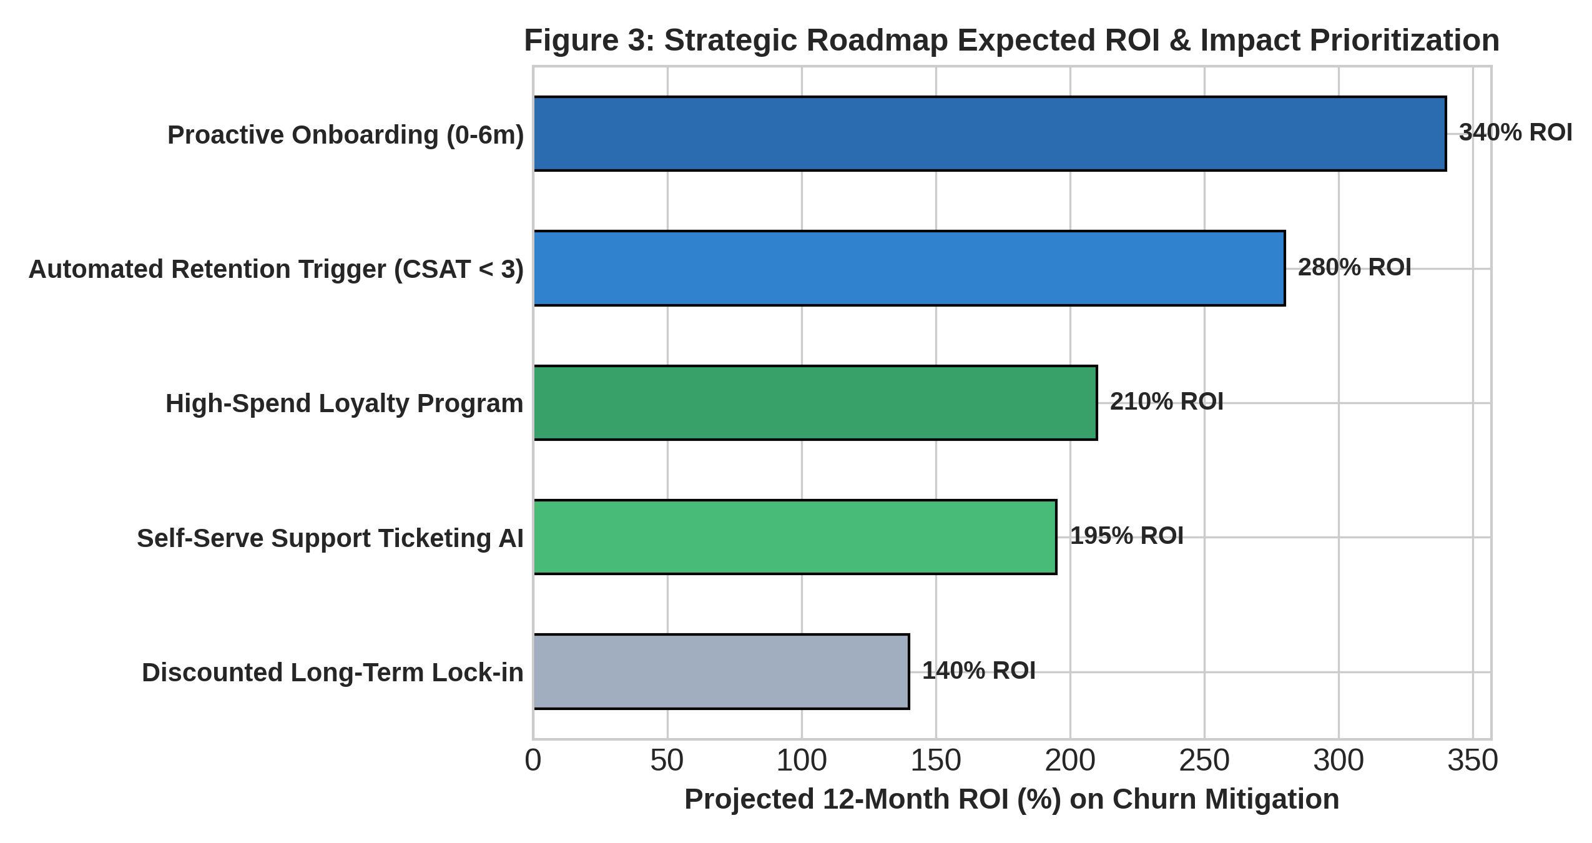
5. Project Limitations & Future Roadmap
• Data Limitations: The current modeling relies on tabular behavioral snapshots. Future iterations should incorporate real-time clickstream event sequences and unstructured support ticket NLP sentiment analysis.
• Model Evolution: Explore production deployment using FastAPI microservices and gradient-boosted trees (XGBoost/LightGBM) integrated with Optuna automated hyperparameter tuning.
• Causal Inference: Conduct randomized controlled A/B testing on retention interventions to isolate causal uplift from organic retention.
6. Conclusion
The 5-week Data Science Internship successfully demonstrated the end-to-end data science lifecycle. Transforming raw transactional records into high-accuracy predictive intelligence enables the organization to shift from reactive churn triage to proactive, high-ROI customer lifecycle optimization.

