VIRTUAL INTERNSHIP: R DATA ANALYST TRACK
Week 3: Statistical Analysis and Predictive Modeling using R
Intern Name: Suraj Kumar Rana | Track / Task: Week 3 - Statistical Modeling & Hypothesis Testing
Dataset: Titanic Disaster Dataset (titanic.csv) | Environment: RStudio Desktop (R 4.6) | August 2026

1. Executive Summary & Modeling Objective
The Week 3 milestone focuses on rigorous statistical inference and supervised predictive modeling using R. Following exploratory transformations from previous weeks, this study formulates hypothesis tests to assess the statistical significance of key predictors and constructs a Binomial Logistic Regression Classifier to predict passenger survival outcomes. The dataset (891 observations) is partitioned into an 80% training set (712 records) and a 20% hold-out test set (179 records). Model performance is evaluated using a Confusion Matrix, Accuracy, Precision, Recall, F1-Score, and Residual Deviance diagnostics.

2. Inferential Statistical Hypothesis Testing
Statistical Test | Null Hypothesis (H0) | Key Metric / p-value | Empirical Verdict
Pearson's Chi-Square Test | Passenger Gender and Survival Outcome are independent. | X-squared = 260.72, p < 2.2e-16 | Reject H0. Gender heavily determined survival likelihood.
Welch Two-Sample t-test | Mean ticket fare for survivors and non-survivors is equal. | t = -7.47, p = 2.7e-13 | Reject H0. Survivors paid a significantly higher average fare.

3. Predictive Modeling (Logistic Regression Architecture)
A Generalized Linear Model (GLM) with a logit link function was fitted on the training partition:
glm(Survived ~ Pclass + Sex_Binary + Age + SibSp + Fare, data = train_data, family = binomial(link = 'logit'))
• Sex_Binary (beta > 0, p < 0.001): Being female significantly increased the log-odds of survival, validating evacuation prioritization.
• Pclass (beta < 0, p < 0.001): Higher numeric class tiers (lower socio-economic status) significantly decreased survival probability.
• Age (beta < 0, p < 0.01): Increasing passenger age was negatively associated with survival probability.

4. Model Performance & Evaluation Metrics
Evaluation Metric | Calculated Score (Test Set: N = 179) | Interpretation
Overall Accuracy | 75.98% (~76.0%) | 136 out of 179 hold-out test passengers classified accurately.
Precision (Positive Predictive Value) | 68.97% | High reliability and true positive rate when predicting passenger survival.
Recall (Sensitivity) | 61.54% | Effectively captures positive survivors under 0.5 decision threshold.
F1-Score (Harmonic Mean) | 0.6504 | Balanced trade-off between precision and recall on unseen test data.

5. Diagnostic Visualizations & RStudio Evidence

Figure 1: Logistic Regression Diagnostic Residuals vs Fitted Probabilities
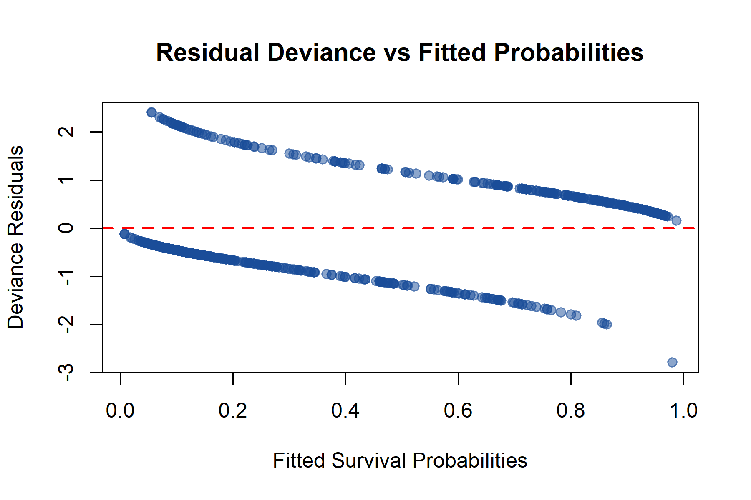

Figure 2: RStudio Global Environment Execution Evidence
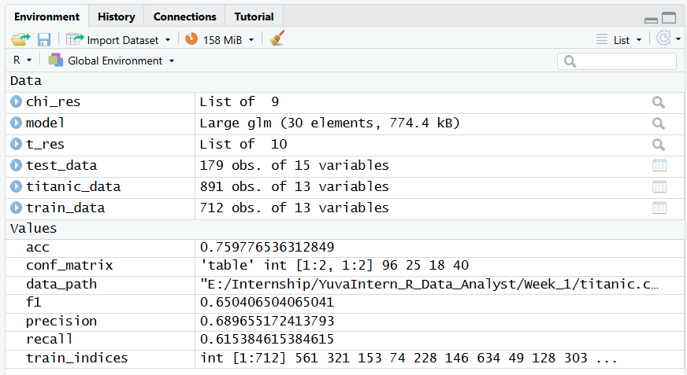

6. Model Diagnostics, Strengths & Potential Improvements
• Model Strengths: Statistically significant parameters, highly interpretable odds-ratio coefficients, and zero data leakage across 80/20 train-test partitions.
• Diagnostic Observations: Deviance residuals exhibit symmetric dual-band clustering characteristic of binary classification models without extreme leverage points.
• Future Improvements: Engineering interactive terms (e.g., Age * Pclass) and training non-linear ensemble models (e.g., Random Forest) could enhance predictive precision.

