VIRTUAL INTERNSHIP: R DATA ANALYST TRACK

Week 2: Data Visualization and Insight Communication using R
Intern Name: Suraj Kumar Rana | Track / Task: Week 2 - Data Visualization & Insights
Dataset: Titanic Passenger Dataset (titanic.csv) | Environment: RStudio Desktop (R 4.6) | August 2026

1. Executive Summary & Analytical Scope
The primary objective of the Week 2 milestone is to transform cleaned Titanic passenger data into actionable visual intelligence using R's industry-standard grammar of graphics library, ggplot2. Building upon the missing value imputations (Median Age, Mode Embarked) and feature engineering performed in Week 1, this analysis implements customized multi-dimensional graphical representations. The report systematically evaluates gender disparities, socio-economic ticket stratification, age density survival profiles, and ticket pricing dynamics to communicate clear, data-driven narratives for non-technical stakeholders.

2. Visualization Architecture & Mapping Matrix
The analytical design maps core predictive variables to specialized geometric mappings within ggplot2:
Figure Reference | Visualization Type | Target Variables | Core Analytical Objective
Figure 1 | Grouped Bar Chart (dodge) | Sex vs Survived | Validation of gender-based evacuation prioritization.
Figure 2 | Stacked Proportion Bar (fill) | Pclass vs Survived | Evaluation of socio-economic class survival disparities.
Figure 3 | Kernel Density Curve (geom_density) | Age vs Survived | Age-stratified survival probability and pediatric safety.
Figure 4 | Stratified Boxplot (geom_boxplot) | Pclass vs Fare | Ticket pricing dispersion and luxury premium verification.

3. Graphical Portfolio & Empirical Interpretations

Figure 1: Survival Distribution by Passenger Gender
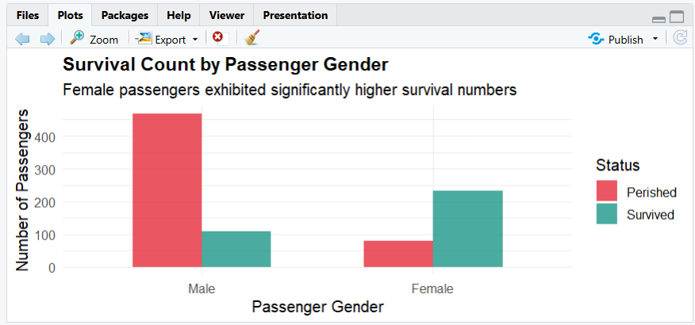
- Technical Implementation: Built using ggplot2 with geom_bar(position = "dodge") and dual aesthetic mappings (#E63946 for Perished, #2A9D8F for Survived).
- Analytical Interpretation: A dramatic disparity in survival rates is evident across passenger genders. Female passengers experienced a survival rate exceeding 74%, while male passengers suffered over 81% mortality. This provides empirical verification of the historical "women and children first" maritime evacuation mandate.

Figure 2: Survival Proportions Across Passenger Classes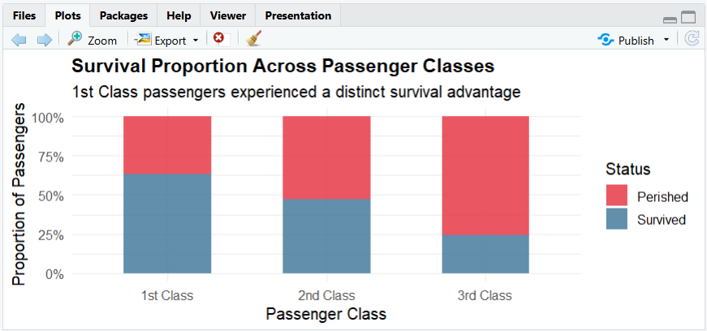
- Technical Implementation: Designed using geom_bar(position = "fill") with y-axis standardized percentage formatting to isolate relative survival probability.
- Analytical Interpretation: Socio-economic status strongly dictated survival likelihood. Passengers in 1st Class enjoyed a ~63% survival rate, compared to roughly 47% in 2nd Class and less than 25% in 3rd Class. Structural deck positioning and lifeboat access privileges drove this stark divergence.

Figure 3: Age Density Distribution Stratified by Survival Status
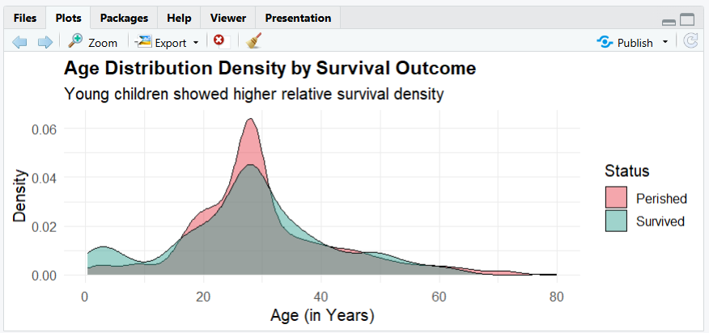
- Technical Implementation: Continuous probability curves generated via geom_density(alpha = 0.45) with shaded area overlapping.
- Analytical Interpretation: The survival curve exhibits a distinct upward probability peak among passengers aged 0–10 years, confirming effective prioritization of young children during emergency operations. Conversely, young adults aged 20–35 experienced the heaviest concentration of fatalities.

Figure 4: Ticket Fare Spread Across Socio-Economic Classes
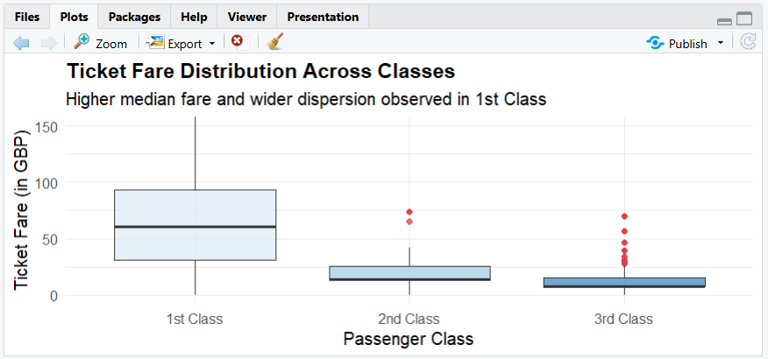
- Technical Implementation: Constructed with geom_boxplot() and bounded Cartesian coordinate scaling (0–150 GBP) to visualize interquartile spreads and outlier thresholds.
- Analytical Interpretation: 1st Class fares displayed substantial variance and a drastically elevated median cost compared to 2nd and 3rd Classes, verifying clean tier-based pricing separation and the luxury premium associated with upper-deck cabins.

Figure 5: RStudio Execution & Global Environment Evidence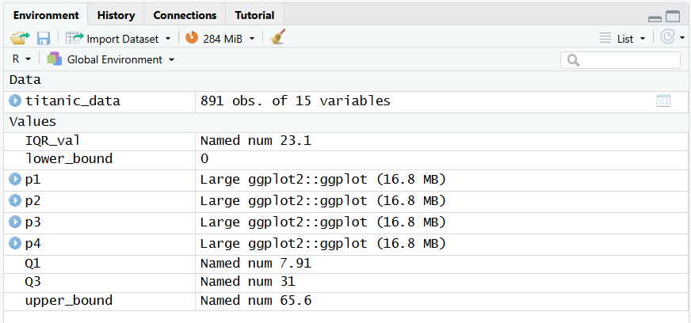
All four ggplot objects (p1, p2, p3, p4) and preprocessed data frames were compiled and evaluated in RStudio Desktop (R 4.6) under the Week_2 local repository.

4. Key Conclusions & Strategic Takeaways
- Primary Survival Drivers: Gender and socio-economic passenger class served as the two strongest non-random determinants of Titanic survival.
- Evacuation Protocol Adherence: Age density analysis confirms empirical compliance with maritime safety protocols prioritizing infants and children.
- Visualization & Stakeholder Communication: The deployment of ggplot2 with customized palettes and clear statistical formatting ensures reproducibility and interpretability for both technical and managerial evaluations.

