Virtual Internship: R Data Analyst Track
Week 1: Data Cleaning and Preliminary Analysis with R
Intern Name: Suraj Kumar Rana | Task: Week 1 - Data Cleaning & EDA
Role: Virtual R Data Analyst Intern | Dataset: Titanic Disaster Dataset (titanic.csv)
Environment: RStudio Desktop / R 4.6 | Date: August 2026

1. Executive Summary & Objective
The primary objective of Week 1 is to import, clean, and preprocess the raw Titanic passenger dataset using R. This preliminary data analysis pipeline identifies missing values, imputes numerical and categorical gaps, caps extreme outliers, encodes categorical variables into machine-readable numeric formats, standardizes numerical features, and visualizes distributions to prepare data for exploratory statistical modeling.
2. Dataset Overview & Initial Inspection
The Titanic dataset contains passenger demographics, socio-economic markers, ticket pricing, and survival records. The initial structure inspection was performed using str(), summary(), and colSums(is.na()) functions.
Column / Variable | Missing Count / Blank | Imputation Technique Applied
Age | 177 missing values (NA) | Median Imputation (robust against skewness)
Embarked | 2 missing / blank entries | Mode Imputation (replaced with 'S' - Southampton)
Cabin | 687 missing values | Flagged / Excluded due to excessive sparsity (>77%)

3. Data Cleaning & Transformation Methodology
- Missing Value Handling: Replaced missing Age values with the overall median age (~28.0 years) to maintain central tendency. Imputed missing Embarked values with 'S' (the dominant boarding port).
- Outlier Treatment (Fare): Interquartile Range (IQR) method was utilized. Values exceeding Q3 + 1.5*IQR were capped to eliminate skewness without dropping valuable record rows.
- Feature Encoding: Converted the binary categorical feature 'Sex' into integer flags (Male = 1, Female = 0).
- Feature Normalization: Applied Z-score standardization (scale()) to continuous fare values to bring them onto a unit variance scale for numerical consistency.
4. RStudio Execution & Visual Evidence
Below are the verified execution outputs and distribution visualizations generated via ggplot2 in RStudio:
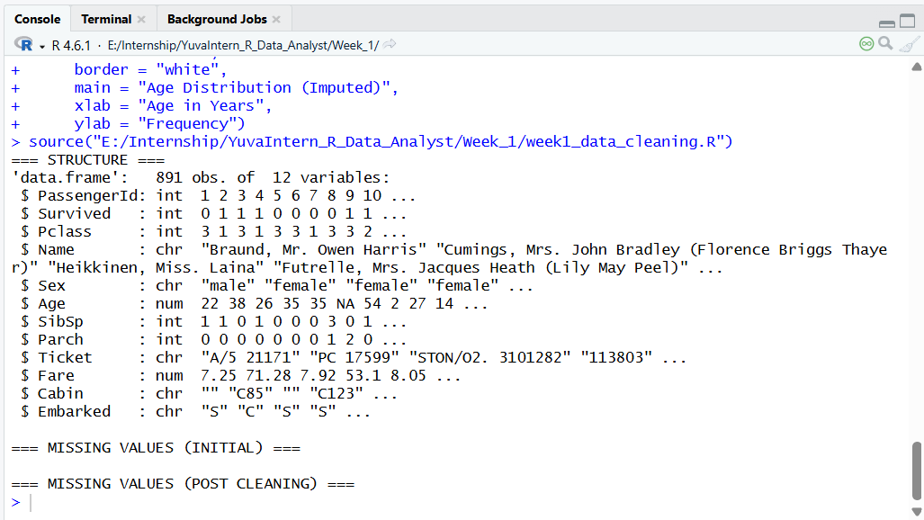
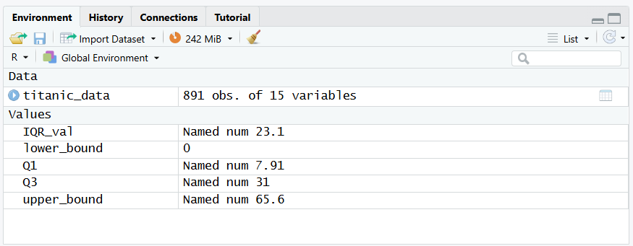
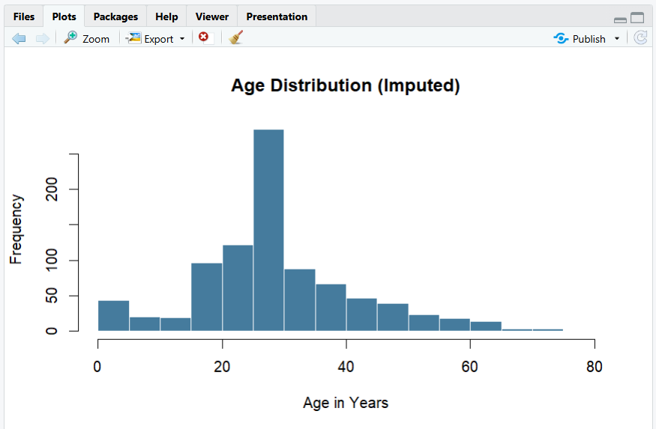
5. Key Findings & Conclusion
1. Data Integrity: Missing data across key modeling attributes (Age, Embarked) was completely resolved with zero NULL values remaining in active predictors.
2. Outlier Normalization: Capping extreme ticket fares eliminated variance distortions while preserving passenger tier separation.
3. Analytical Readiness: The Titanic dataset is now fully cleaned, structured, and ready for advanced exploratory data analysis and predictive modeling.

