SHREE DEVI INSTITUTE OF TECHNOLOGY

AIRPORT ROAD, KENJAR

MANGALURU- 574142

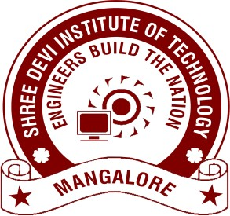
Department of Computer Science and Engineering

CERTIFICATE
This is to Certify that the project work entitled “SMART MIRROR” is a bonafide work carried out by A DINESH UDAYASANKAR (4SH13CS001), BOBIN GEORGE VARGHESE (4SH13CS027), SURAJ K (4SH13CS109), VISHNU V NAIR (4SH13CS121), in partial fulfilment for the award of Bachelor of Engineering in Computer Science and Engineering of the Visvesvaraya Technological University, Belagavi during the year 2016-2017. It is certified that all corrections/suggestions indicated for Internal Assessment have been incorporated in the report deposited in departmental library. The project report has been approved as it satisfies the academic requirements in aspect of project work prescribed for the degree of Bachelor of Engineering.

--------------------------- --------------------------- ---------------------------
Signature of the Guide Signature of the HOD Signature of the Principal
Ms. Komala B C Prof. Anand S. Uppar Dr. Dilip Kumar K
Dept. of CSE Dept. of CSE

EXTERNAL VIVA

Name of the Examiners | Signature with Date
1.

2.

