**Big Data Class Project – Part 1**

**Amazon Customer Review Data Analysis**

**Introduction:**

Big data is a term applied to data sets whose size or type is beyond the ability of traditional relational databases to capture, manage and process the data with low latency. Big data has one or more of the following characteristics: high volume, high velocity or high variety. Big data analytics is the often complex process of examining large and varied data sets, or big data, to uncover information -- such as hidden patterns, unknown correlations, market trends and customer preferences -- that can help organizations make informed business decisions.

**Problem description:**

In this project we are practicing and demonstrating out Big Data (BD) and Analytics skills. We are using Amazon customer review data which has more than 160 Million (160,796,570) observations. We will be using HDFS, Hive and AWS to handle and analyze the data and systematically extract information from.

**Data Set:**

Amazon reviews dataset: [*https://registry.opendata.aws/amazon-reviews/*](https://registry.opendata.aws/amazon-reviews/)

**Project Environment:**

AWS EMR - AWS Educate Class account.

Project tools:

1. AWS S3

2. AWS EMR - Hive and HDFS

3. AWS Athena - AWS alternative to Hive for the ﬁles stored in S3

**Dataset Requirements:**

A)Use the following product categories:

- Wireless

- Automotive

- Music

- Digital_Music_Purchase

- Sports

- Toys

- Digital_Video_Games

- Video_Games

B)Start your analysis from year 2005.

C)Exclude multiple reviews by the same users for the same product. Each user should be allowed to review the product only once. To improve performance of your queries, create external table to point to HDFS/S3 ﬁle that will include all review-ids to be excluded.

**Step 1:- AWS EMR:**

Provisioned EMR with below details:-

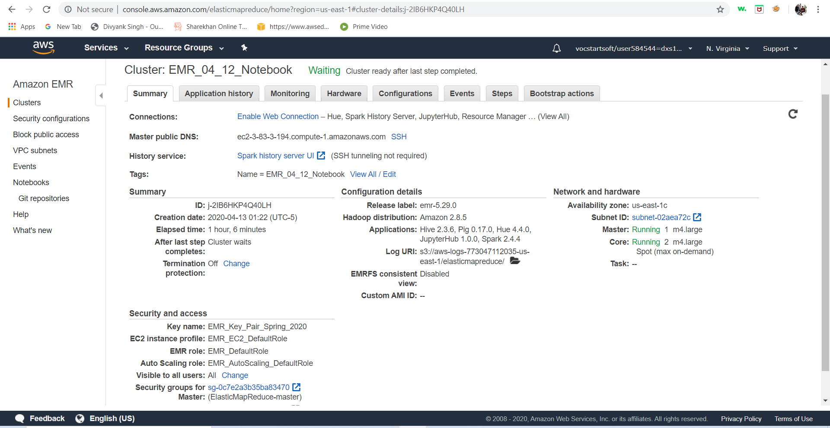

**Step 2:-**

**A) Created directory for below each product category:-**

1. **Wireless**
2. **Automotive**
3. **Music**
4. **Digital_Music_Purchase**
5. **Sports**
6. **Toys**
7. **Digital_Video_Games**
8. **Video_Games**

hdfs dfs -mkdir -p /hive/amazon-reviews-pds/parquet/product_category=Wireless/

hdfs dfs -mkdir -p /hive/amazon-reviews-pds/parquet/product_category=Automotive/

hdfs dfs -mkdir -p /hive/amazon-reviews-pds/parquet/product_category=Music/

hdfs dfs -mkdir -p /hive/amazon-reviews-pds/parquet/product_category=Sports/

hdfs dfs -mkdir -p /hive/amazon-reviews-pds/parquet/product_category=Digital_Music_Purchase/

hdfs dfs -mkdir -p /hive/amazon-reviews-pds/parquet/product_category=Toys/

hdfs dfs -mkdir -p /hive/amazon-reviews-pds/parquet/product_category=Digital_Video_Games/

hdfs dfs -mkdir -p /hive/amazon-reviews-pds/parquet/product_category=Video_Games/

**B)Copying dataset from S3 in HDFS for each of the product category mentioned:-**

s3-dist-cp --src=s3://amazon-reviews-pds/parquet/product_category=Wireless/ --dest=hdfs:///hive/amazon-reviews-pds/parquet/product_category=Wireless/

s3-dist-cp --src=s3://amazon-reviews-pds/parquet/product_category=Automotive/ --dest=hdfs:///hive/amazon-reviews-pds/parquet/product_category=Automotive/

s3-dist-cp --src=s3://amazon-reviews-pds/parquet/product_category=Music/ --dest=hdfs:///hive/amazon-reviews-pds/parquet/product_category=Music/

s3-dist-cp --src=s3://amazon-reviews-pds/parquet/product_category=Digital_Music_Purchase/ --dest=hdfs:///hive/amazon-reviews-pds/parquet/product_category=Digital_Music_Purchase/

s3-dist-cp --src=s3://amazon-reviews-pds/parquet/product_category=Sports/ --dest=hdfs:///hive/amazon-reviews-pds/parquet/product_category=Sports/

s3-dist-cp --src=s3://amazon-reviews-pds/parquet/product_category=Toys/ --dest=hdfs:///hive/amazon-reviews-pds/parquet/product_category=Toys/

s3-dist-cp --src=s3://amazon-reviews-pds/parquet/product_category=Digital_Video_Games/ --dest=hdfs:///hive/amazon-reviews-pds/parquet/product_category=Digital_Video_Games/

s3-dist-cp --src=s3://amazon-reviews-pds/parquet/product_category=Video_Games/ --dest=hdfs:///hive/amazon-reviews-pds/parquet/product_category=Video_Games/

**Step3:- Creating database and tables:**

**A)Creating Database:-**

create database amazon_review;

**B)Dropping table:-**

drop table amazon_review.amazon_reviews_parquet;

**C)Creating external table:-**

CREATE EXTERNAL TABLE amazon_review.amazon_reviews_parquet(

`marketplace` string,

`customer_id` string,

`review_id` string,

`product_id` string,

`product_parent` string,

`product_title` string,

`star_rating` int,

`helpful_votes` int,

`total_votes` int,

`vine` string,

`verified_purchase` string,

`review_headline` string,

`review_body` string,

`review_date` DATE,

`year` int)

PARTITIONED BY (

`product_category` string)

--ROW FORMAT DELIMITED

--STORED AS PARQUET

ROW FORMAT SERDE

'org.apache.hadoop.hive.ql.io.parquet.serde.ParquetHiveSerDe'

STORED AS INPUTFORMAT

'org.apache.hadoop.hive.ql.io.parquet.MapredParquetInputFormat'

OUTPUTFORMAT

'org.apache.hadoop.hive.ql.io.parquet.MapredParquetOutputFormat'

LOCATION

'hdfs:///hive/amazon-reviews-pds/parquet/'

TBLPROPERTIES (

'transient_lastDdlTime'='1583454851');

Msck repair table amazon_review.amazon_reviews_parquet;

**D)Creating table which has year>=2005 and product category ('Wireless', 'Automotive', 'Music', 'Digital_Music_Purchase', 'Sports', 'Toys', 'Digital_Video_Games', 'Video_Games')**

**Query:-**

create table amazon_review.dat

as

(select * from amazon_review.amazon_reviews_parquet where year >= 2005);

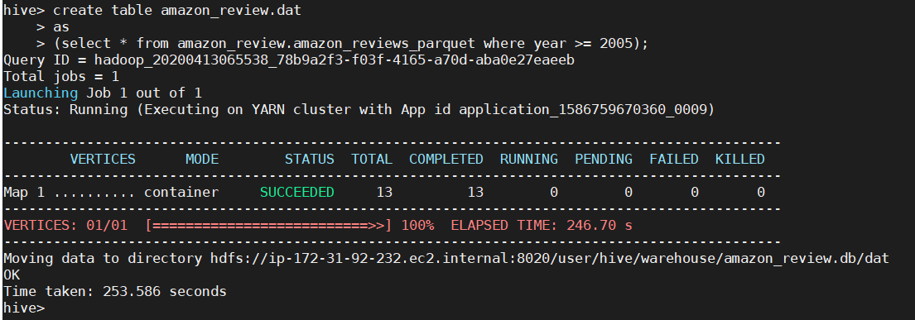

**E) Checking obs now:- 30414376**

**Query:-**

select count(review_id) from amazon_review.dat;

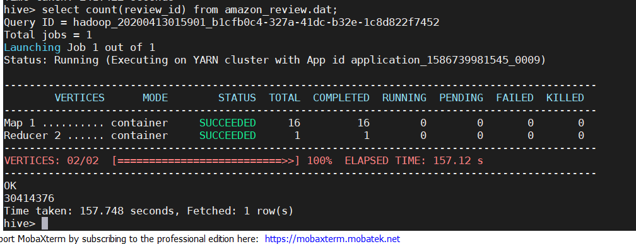

**F)Creating a table which has obs where a customer gave multiple reviews for a product:-**

**Query:-**

create table amazon_review.excludedID

as

select distinct * from amazon_review.dat where

review_id in (select review_id from

(select * from amazon_review.dat

) tab1

inner join

(select customer_id,product_id,count(*) as CNT

from amazon_review.dat

group by customer_id,product_id

having count(*)>1) tab2

on tab1.customer_id=tab2.customer_id and tab1.product_id=tab2.product_id);

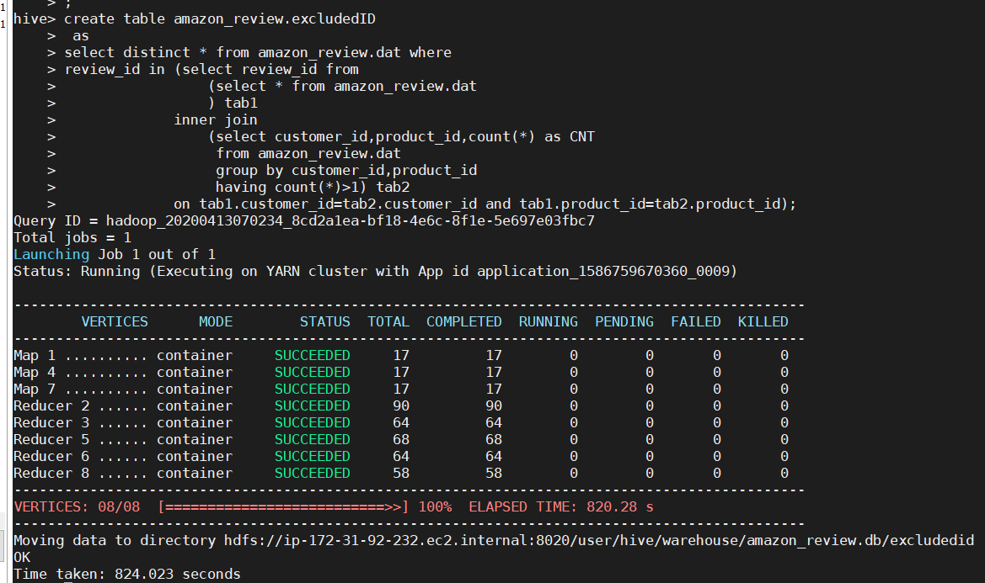

**G)Checking obs now:- 790413**

**Query:-**

select count(review_id) from amazon_review.excluded_reviewid;

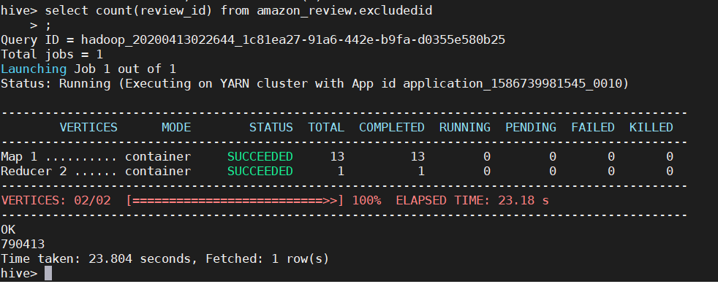

**H)Saving the obs where customer’s has only 1 review for a product:-**

**Query:-**

create table amazon_review.final

as

SELECT *

  FROM amazon_review.dat

  WHERE NOT EXISTS

   (SELECT * FROM amazon_review.excludedID

  WHERE dat.review_id = excludedid.review_id);

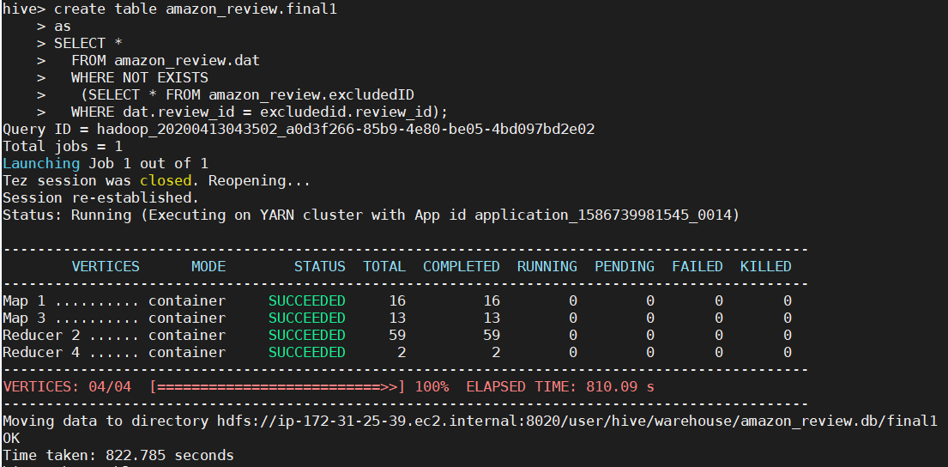

**I) Checking obs now:- 28845525**

**Query:-**

select count(review_id) from amazon_review.final;

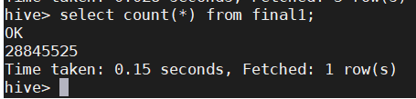

**Step4:- Performing Exploratory Data Analysis**

**1. Explore the dataset and provide basic exploratory analysis:**

1. **Number of reviews**

**Query:-**

select count(review_id) from amazon_review.final;

**Output:-**

28845525

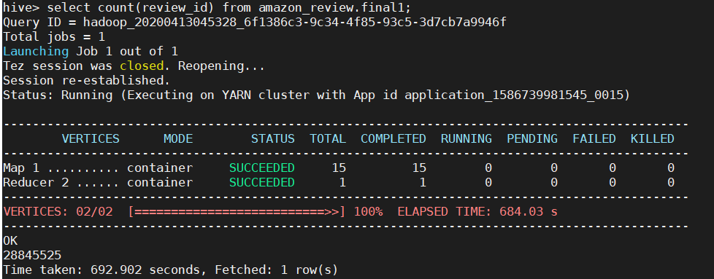

1. **Number of users**

**Query:-**

select count( customer_id) from amazon_review.final;

**Output:-**

28845525

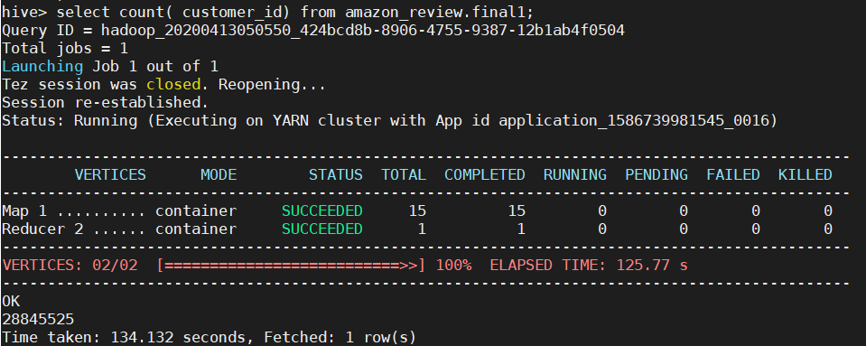

1. **Average review stars**

**Query:-**

select round(avg(star_rating),2) from amazon_review.final;

**Output:-**

4.17

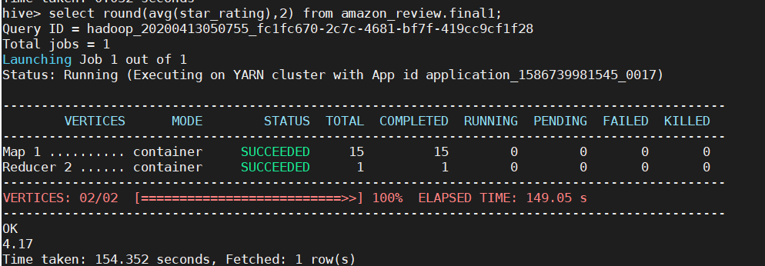

1. **Average length of the review**

**Query:-**

select round(avg(length(review_body)),2) from amazon_review.final;

**Output:-**

301.83

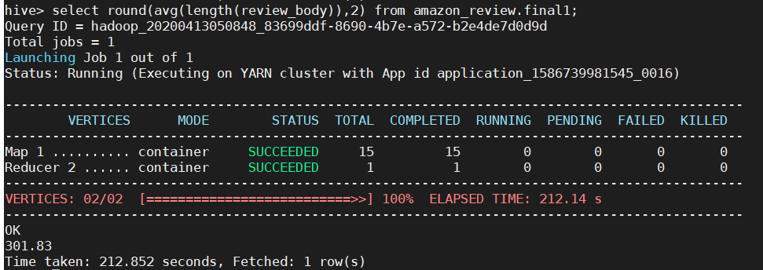

1. **Number of veriﬁed versus unveriﬁed reviews**

**Query:-**

select verified_purchase,count(*) as count_ver_pur from amazon_review.final

group by verified_purchase;

**Output:-**

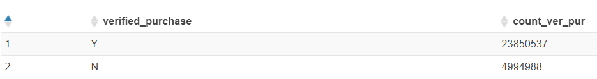

(Athena)

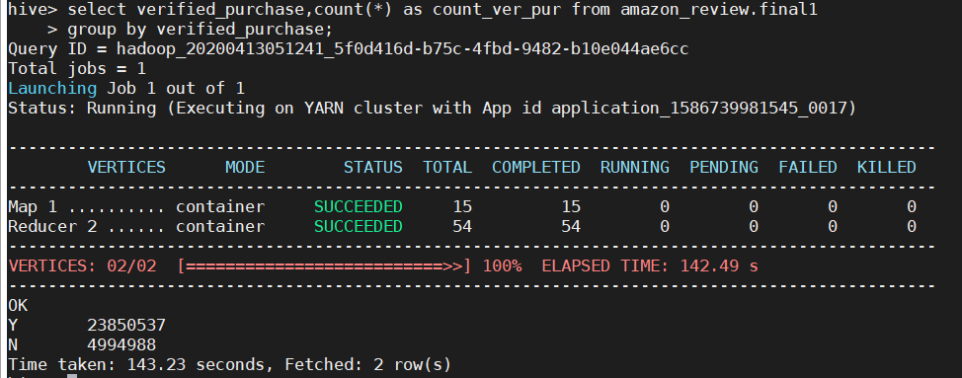

(Terminal)

1. **At least two more additional metrics:-**
2. **Count of each product_category:-**

**Query:-**

Select product_category, count_prod_cat, rank() over

(ORDER BY count_prod_cat DESC)

From

(select product_category,count(*) as count_prod_cat from amazon_review.final

group by product_category) r

;

**Output:-**

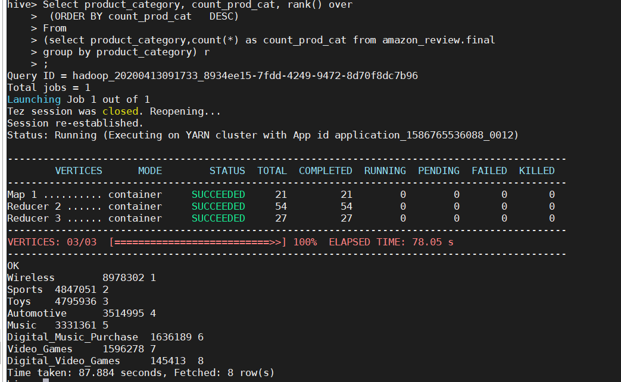

(Terminal)

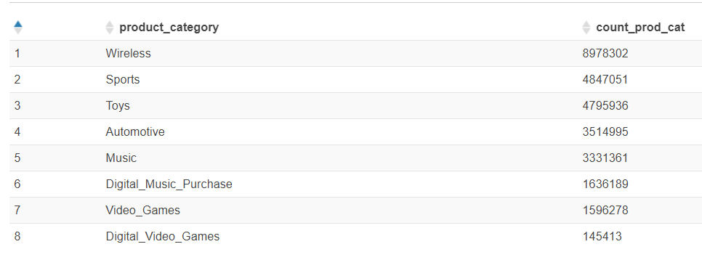

|  |  |  |  |
| --- | --- | --- | --- |
| **num** | **product_category** | **count_prod_cat** | **average** |
| 1 | Wireless | 8978302 | 31.13 |
| 2 | Sports | 4847051 | 16.8 |
| 3 | Toys | 4795936 | 16.63 |
| 4 | Automotive | 3514995 | 12.19 |
| 5 | Music | 3331361 | 11.55 |
| 6 | Digital_Music_Purchase | 1636189 | 5.67 |
| 7 | Video_Games | 1596278 | 5.53 |
| 8 | Digital_Video_Games | 145413 | 0.5 |
|  | Sum | 28845525 |  |

**Interpretation:-**

We can see that more that 31% of the reviews are of wireless products, followed by Sports(16.8%) and Toys(16.63%), whereas Video games and digital video category constitutes only 6%.

1. **Count of each marketplace:-**

**Query:-**

Select marketplace, count_mar_plc, rank() over

(ORDER BY count_mar_plc DESC)

from

(select marketplace,count(*) as count_mar_plc from amazon_review.final

group by marketplace) as r

;

**Output:-**

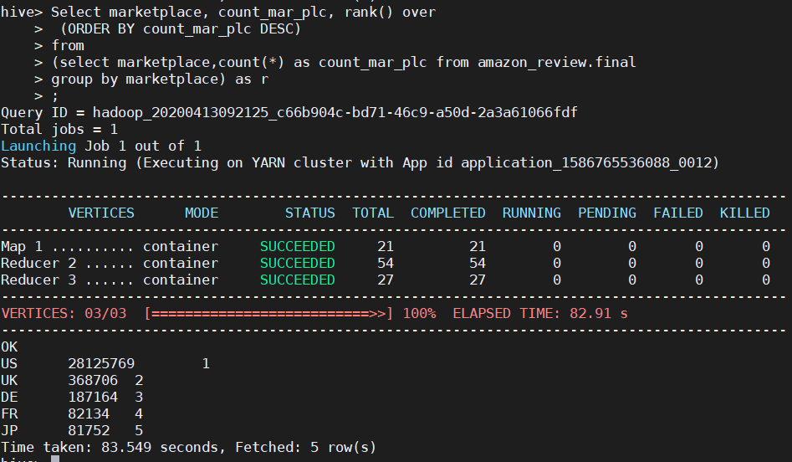

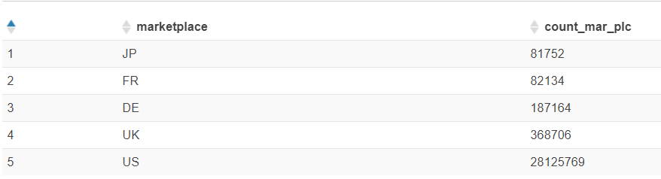

|  |  |  |  |
| --- | --- | --- | --- |
|  | **marketplace** | **count_mar_plc** | per |
| 1 | JP | 81752 | 0.28341311 |
| 2 | FR | 82134 | 0.28473741 |
| 3 | DE | 187164 | 0.64884934 |
| 4 | UK | 368706 | 1.27820866 |
| 5 | US | 28125769 | 97.5047915 |
|  | sum | 28845525 |  |

**Interpretation:-**

I have grouped dataset based on marketplace and found that more than 97% of the customers are from just US.

1. **Finding mean,min,max,standard deviation per category:-**

**Query:-**

select product_category,round(avg(star_rating),2) mean_rat ,min(star_rating) min_rat

,max(star_rating) as max_rat, round(stddev(star_rating),2) as std_dev_rat from amazon_review.final

group by product_category

order by product_category;

**Output:-**

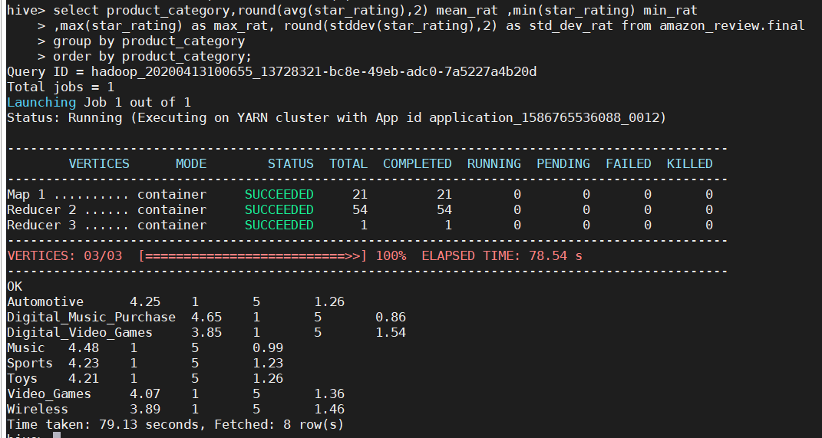

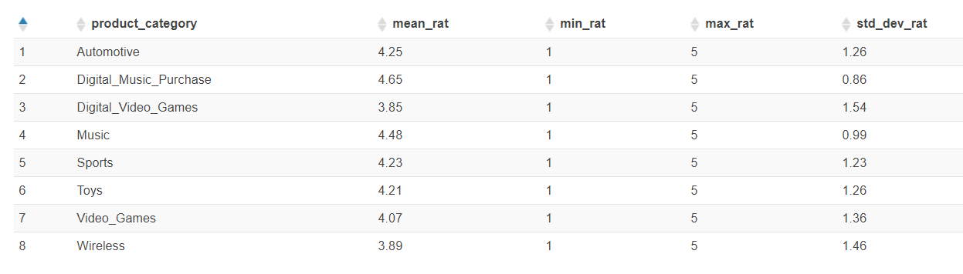

**Interpretation:-**

The output shows the minimum, maximum, mean and standard deviation for each of the product category.

1. **Provide trending (over time) analysis of each of the metrics above:-**

**Query:-**

select product_category,year,count(*) as count_prod from amazon_review.final

group by product_category,year

order by product_category,year

;

**Interpretation:-**

I have grouped dataset based on product category and year and imported the output in excel to get the above trendline, which shows that purchase count has definitely increased for all the product categories, though wireless category has noticed increase in purchase count rate highest.

**Query:-**

select marketplace,year,count(*) as count_marketplace from amazon_review.final

group by marketplace,year

order by marketplace,year

;

**Interpretation:-**

I have grouped dataset based on marketplace and year and imported the output in excel to get the above trendline, which shows that purchase count rate has significantly increased in US only.

**2. Provide detailed analysis of Music/Digital_Music_Purchase and Digital_Video_Games/Video_Games over time.**

**1. Do you see correlation (maybe negative) between the categories over time?**

**Part 1:-Checking between Music/Digital_Music_Purchase**

**Query:-**

select year,count(*) as count from amazon_review.final

where product_category in ('Music')

group by year

order by year;

**Output:-**

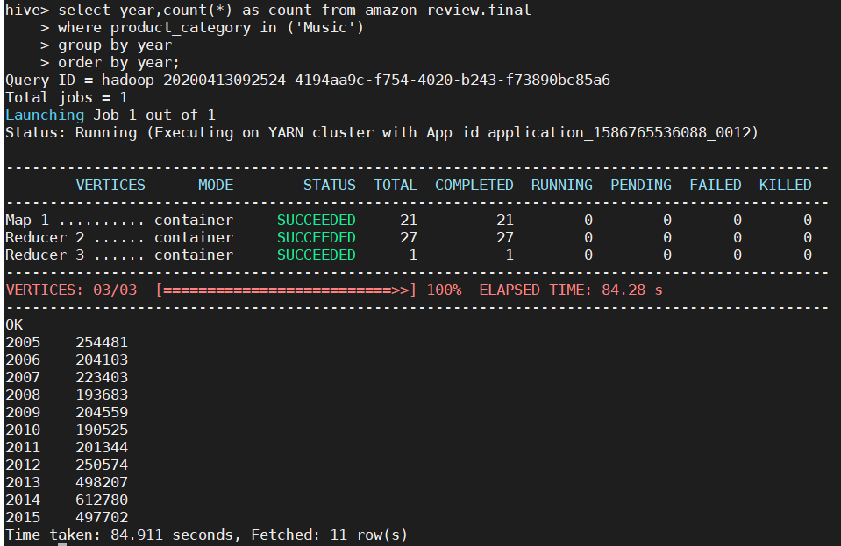

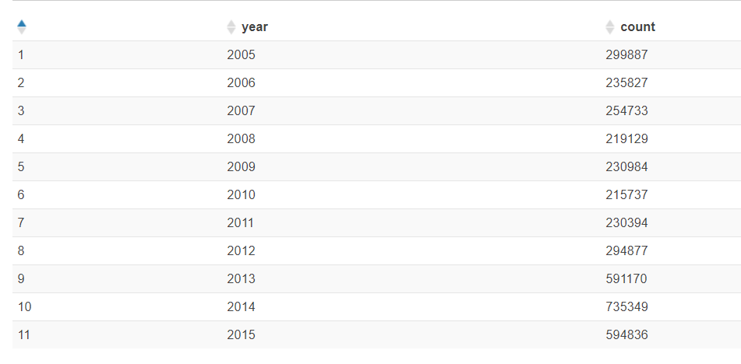

**Interpretation:-**

Here I have performed grouping dataset based on year for product category “Music”

**Query:-**

select year,count(*) as count from amazon_review.final

where product_category in ('Digital_Music_Purchase')

group by year

order by year;

**Output:-**

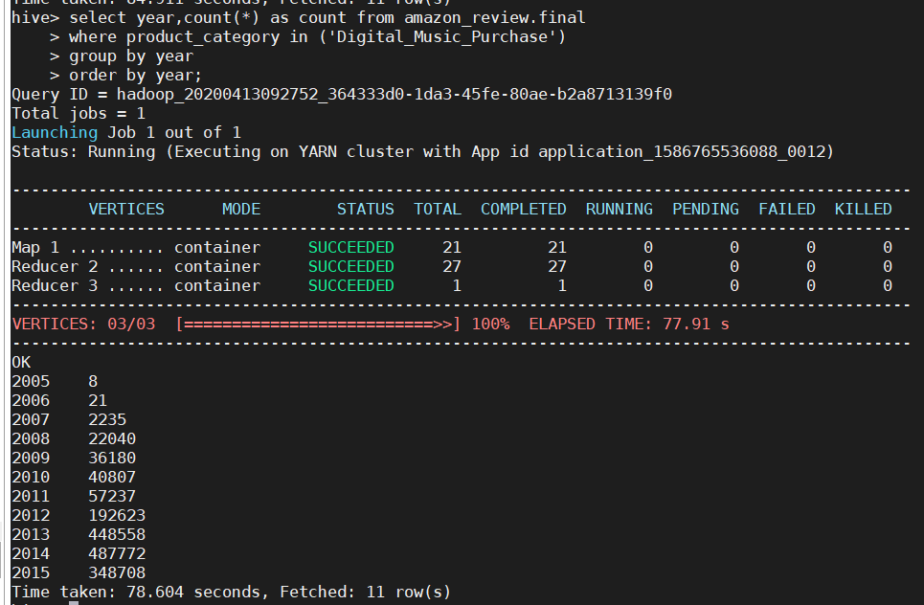

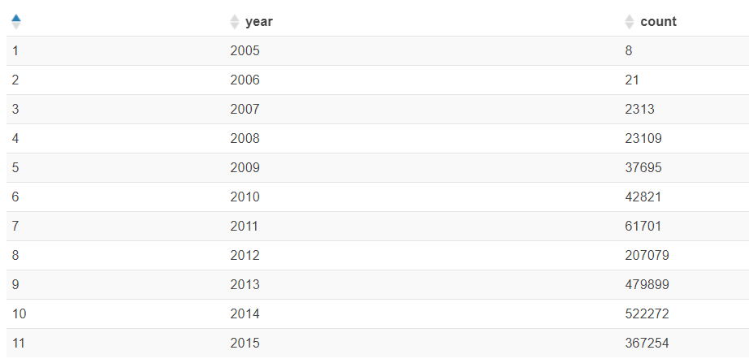

Here I have performed grouping dataset based on year for product category “Music”

**Query:- (using corr function to find the correlation between music product category and year)**

select corr(count_prod,year) as corr_music from

(select product_category,year,count(*) as count_prod from amazon_review.final

where product_category in ('Music')

group by product_category,year

order by product_category,year) as r;

**Output:-**

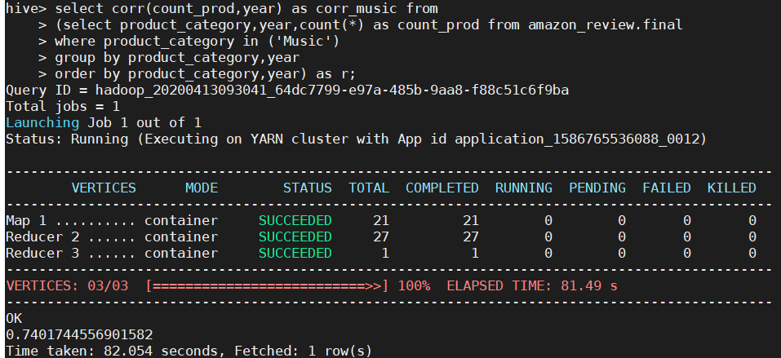

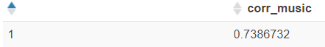

I did a correlation test between music category purchase count and years and found that there is a high positive correlation between them, which states as year increased so does the purchase count.

**Query:- (using corr function to find the correlation between digital_music_category product category and year)**

select round(corr(count_prod,year),2) as corr_music from

(select product_category,year,count(*) as count_prod from amazon_review.final

where product_category in ('Digital_Music_Purchase')

group by product_category,year

order by product_category,year) as r;

**Output:-**

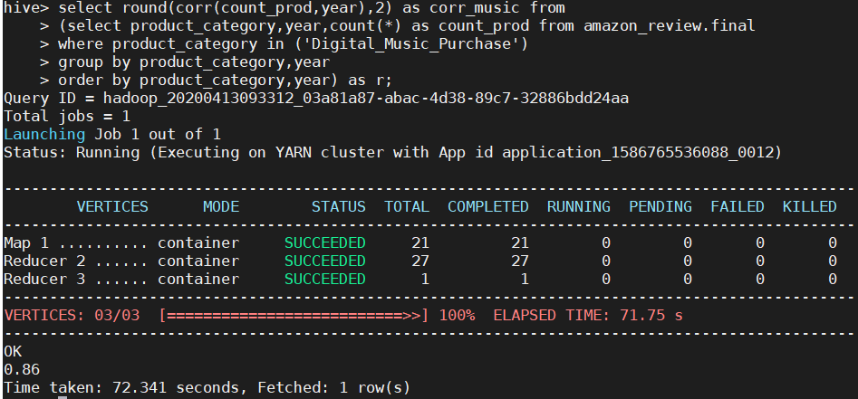

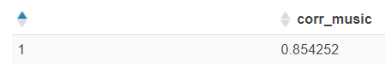

I did a correlation test between digital music category purchase count and years and found that there is a high positive correlation between them, which states as year increased so does the purchase count.

**Detailed analysis:-**

**Query:-**

select product_category,year,count(*) as count_prod from amazon_review.final

where product_category in ('Music', 'Digital_Music_Purchase')

group by product_category,year

order by product_category,year

;

The above trendline between year and music/digital_music_category even shows positive correlation

**Part2:-Checking between Digital_Video_Games/Video_Games**

**Query:-**

select year,count(*) as count from amazon_review.final

where product_category in ('Video_Games')

group by year

order by year;

**Output:-**

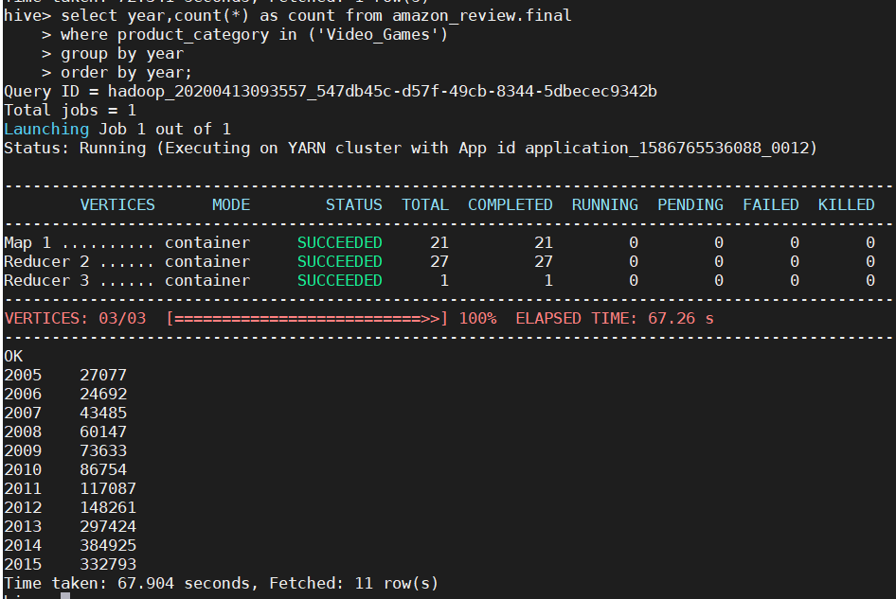

Here I have performed grouping dataset based on year for product category “Video_Games”

**Query:-**

select year,count(*) as count from amazon_review.final

where product_category in ('Digital_Video_Games')

group by year

order by year;

**Output:-**

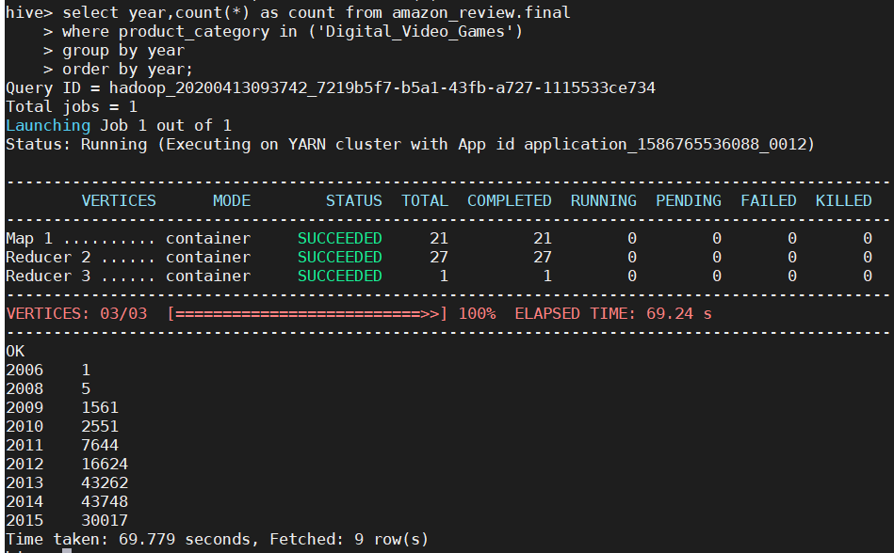

Here I have performed grouping dataset based on year for product category “Digital_Video_Games”

**Query:- (using corr function to find the correlation between Video_Games product category and year)**

select round(corr(count_prod,year),2) as corr_vid from

(select product_category,year,count(*) as count_prod from amazon_review.final

where product_category in ('Video_Games')

group by product_category,year

order by product_category,year) as r;

**Output:-**

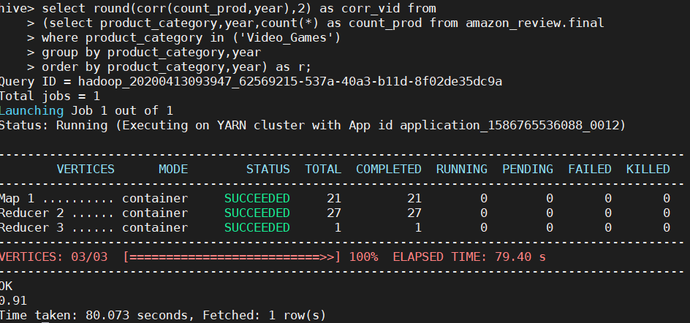

I did a correlation test between video games category purchase count and years and found that there is a high positive correlation between them, which states as year increased so does the purchase count.

**Query:- (using corr function to find the correlation between Digital_Video_Games product category and year)**

select round(corr(count_prod,year),2) as corr_vid from

(select product_category,year,count(*) as count_prod from amazon_review.final

where product_category in ('Digital_Video_Games')

group by product_category,year

order by product_category,year) as r;

**Output:-**

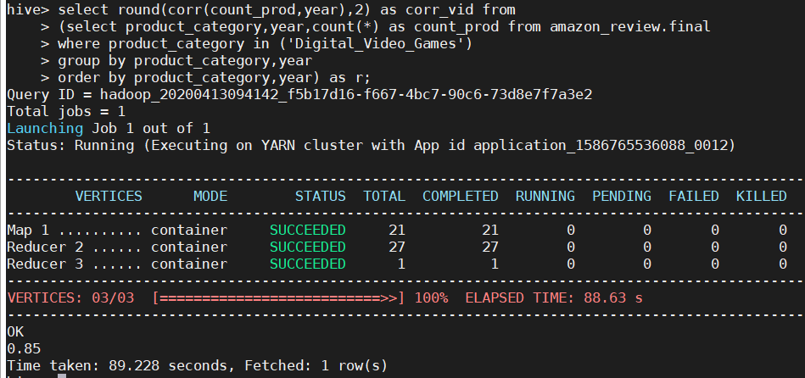

**Interpretation:-**

I did a correlation test between digital video games category purchase count and years and found that there is a high positive correlation between them, which states as year increased so does the purchase count.

**Detailed Analysis:-**

**Query:-**

select product_category,year,count(*) as count_prod from amazon_review.final

where product_category in ('Video_Games', 'Digital_Video_Games')

group by product_category,year

order by product_category,year

;

**Interpretation:-**

The above trendline between year and music/digital_music_category even shows positive correlation

**2. Are there same users reviewing in both categories?**

**Query:-**

select count(distinct dmp.customer_id) as common_cus from

(select customer_id from amazon_review.final

where product_category = 'Digital_Music_Purchase') as dmp

inner join

(select customer_id from amazon_review.final

where product_category = 'Music') as mus

on dmp.customer_id=mus.customer_id;

**Output:-**

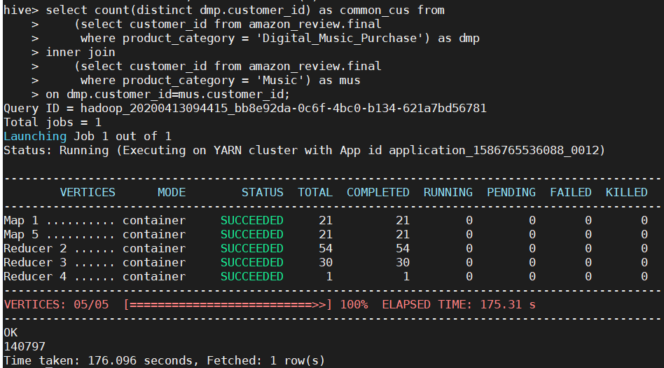

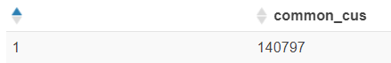

**Interpretation:-**

For Music and Digital_Music_Purchase there are 140797 common customers.

**Query:-**

select count(distinct dvs.customer_id) as common_cus from

(select customer_id from amazon_review.final

where product_category = 'Digital_Video_Games') as dvs

inner join

(select customer_id from amazon_review.final

where product_category = 'Video_Games') as vs

on dvs.customer_id=vs.customer_id;

**Output:-**

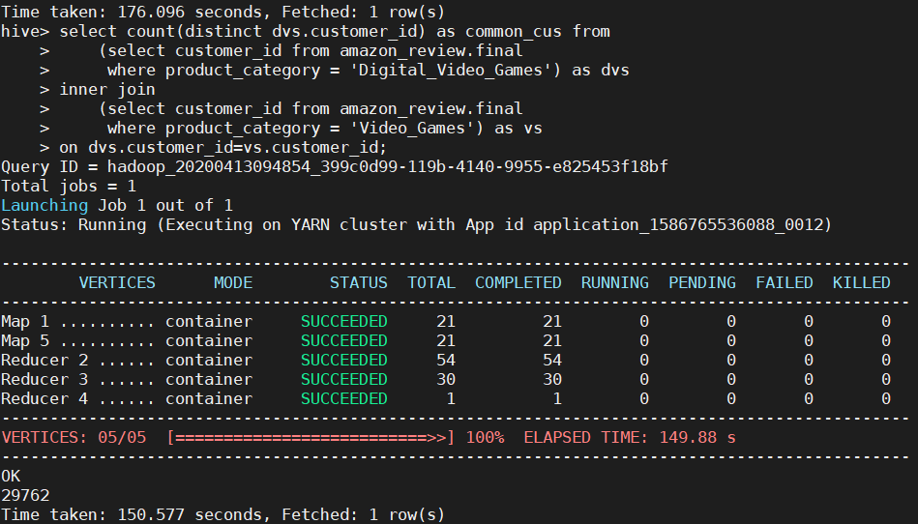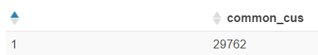

**Interpretation:-**

For Video_Games and Digital_Video_Games there are 29,762 common customers.

**3. Can you identify similar items in both categories? Do they get same rating?**

**Part1:-Video_Games and Digital_Video_Games**

1. **Finding similar items in both categories:-**

**Query:-**

select distinct vg.product_id from

(select product_id from final

where product_category='Video_Games') vg

inner join

(select product_id from final

where product_category='Digital_Video_Games') dvg

on vg.product_id=dvg.product_id

;

**Output:-**

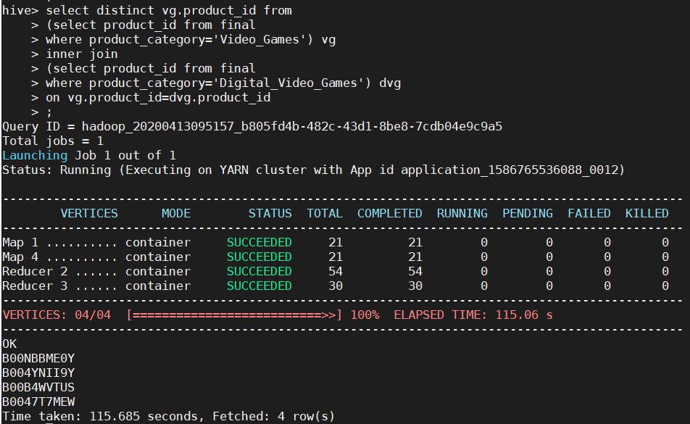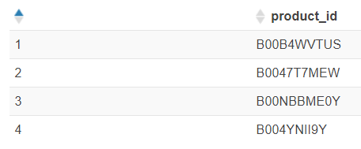

**Interpretation:-**

There is 4 similar product between Video_Games and Digital_Video_Games

1. **Do they get similar ratings:-**

select vg.product_id,vg_avg_rat,dvg_avg_rat,round((vg_avg_rat-dvg_avg_rat),2) as diff from

(select product_id, round(avg(star_rating),2) as vg_avg_rat from final

where product_category='Video_Games'

group by product_id) vg

inner join

(select product_id, round(avg(star_rating),2) as dvg_avg_rat from final

where product_category='Digital_Video_Games'

group by product_id) dvg

on vg.product_id=dvg.product_id;

**Output:-**

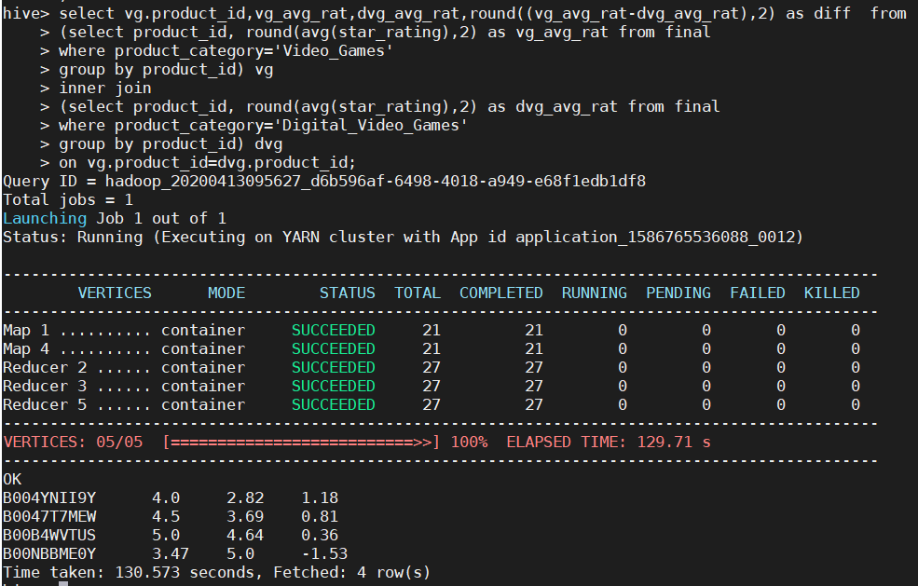

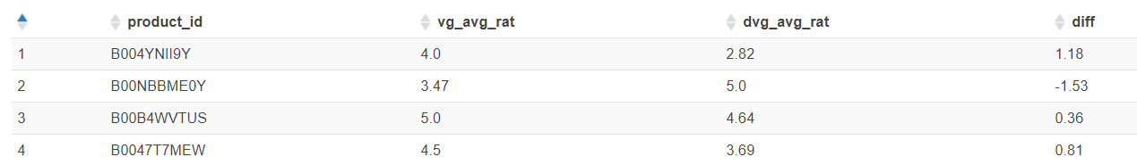

**Interpretation:-**

The above table shows that they don’t get similar ratings.

**Part2:- Music v/s Digital_Music_Purchase**

**Query:-**

select distinct m.product_id from

(select product_id from final

where product_category='Music') m

inner join

(select product_id from final

where product_category='Digital_Music_Purchase') dmp

on m.product_id=dmp.product_id;

;

**Output:-**

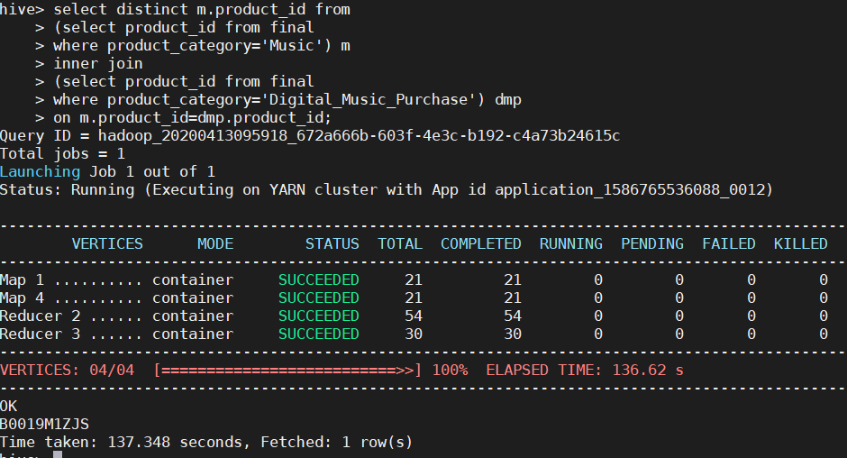

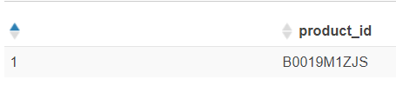

**Interpretation:-**

There is only 1 similar product between Video_Games and Digital_Video_Games

**Query:-**

select m.product_id,mus_avg_rat,dmp_avg_rat from

(select product_id, avg(star_rating) as mus_avg_rat from final

where product_category='Music'

group by product_id) m

inner join

(select product_id, avg(star_rating) as dmp_avg_rat from final

where product_category='Digital_Music_Purchase'

group by product_id) dmp

on m.product_id=dmp.product_id;

**Output:-**

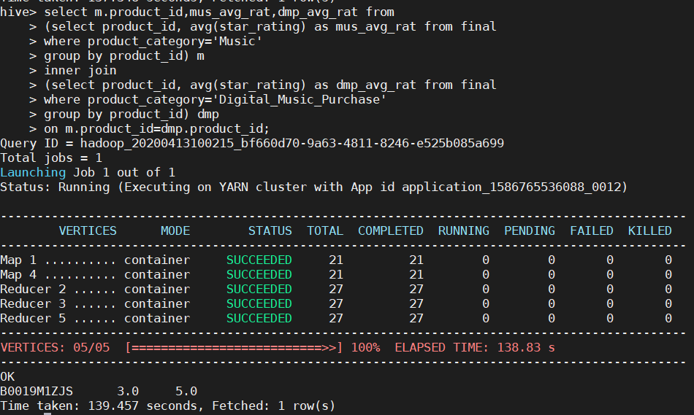



**Interpretation:-**

The above table shows that they don’t get similar ratings.

**4. You should cover additional questions and not limit yourself to the above questions**

**Query1:-**

select month(review_date) as month,count(*) from final

group by month(review_date)

order by month(review_date)

;

**Interpretation:-**

We can see that January month sees the highest purchase(3181577), then follows August July, December.

**Query2:-**

select product_category,month(review_date) as month,count(*) from final

group by product_category,month(review_date)

order by product_category,month(review_date)

;

**Interpretation:-**

Here I have grouped the dataset based on Product category and month, to find the purchase count for each category per month. We can see that in August month wireless category saw maximum purchase whereas other categories saw in January and December.

**Query3:-**

select star_rating, count(*) as cnt

from final

group by star_rating

order by star_rating;

**Output:-**

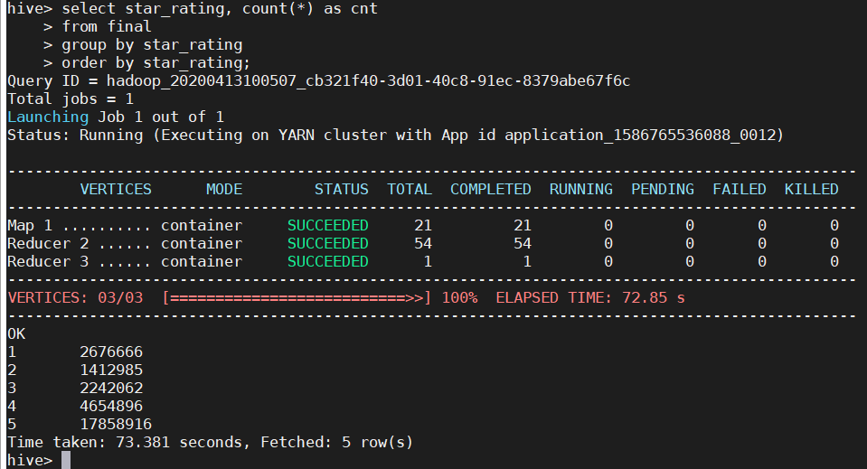

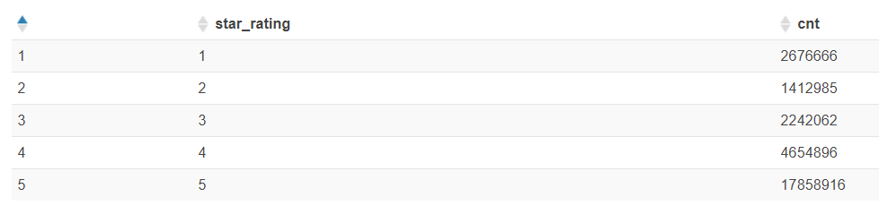

**Interpretation:-**

In the above visualization we can say that we have most data we star rating 5. That shows most of the customers are highly satisfied with the products.

**Query4:-**

select product_category,star_rating as month,count(*) from final

group by product_category,star_rating

order by product_category,star_rating

;

**Interpretation:-**

We can see that for wireless category, though purchase count is highest, customers are not highly satisfied with the products as their highest rating is 4, even after that rating 1 got maximum count.

Whereas for other product categories there is maximum purchase count for star rating 5 than other ratings, which shows that customers buying products other than wireless category are more satisfied.

**Conclusion:-**

1. We can see that more that 31% of the reviews are of wireless products, followed by Sports(16.8%) and Toys(16.63%), whereas Video games and digital video category constitutes only 6%.
2. 97% of the reviews are from just US.
3. There is a positive correlation between number of customers and years and this can be seen for all the product categories.
4. Wireless product category has noticed highest increase in reviews over the years compared to any other product category.
5. The number of customers have rapidly increased in the US than other countries.
6. There is high positive correlation between music category/ digital music category and years.
7. There is high positive correlation between video games/digital video games and years.
8. For all the product categories January and December are highest sale months whereas only wireless product sees August as the maximum sale month
9. Most of the customers are highly satisfied with the purchased products since most of the reviews are with 5 star rating.
10. We can see that for wireless category, though purchase count is highest, customers are not highly satisfied with the products.
11. Whereas for other product categories there is maximum purchase count for star rating 5 than other ratings, which shows that customers buying products other than wireless category are more satisfied.

**References:-**

<https://searchbusinessanalytics.techtarget.com/definition/big-data-analytics>

<https://www.ibm.com/analytics/hadoop/big-data-analytics>

<https://aws.amazon.com/emr/faqs/>