Step 1: Go to Administrator > Runtime Environments and click on Download Secure Agent as shown in the screenshot below.
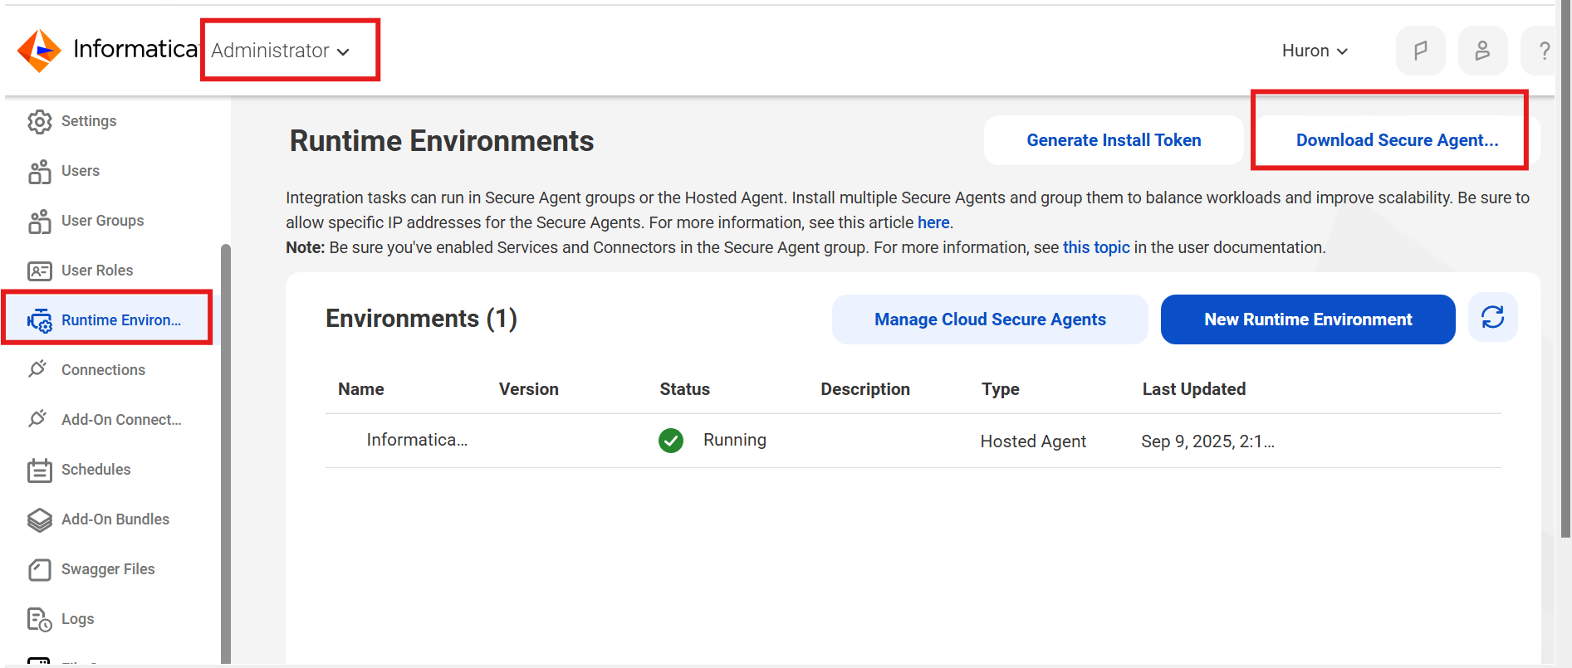

Step 2: A new pop-up will appear. Choose the platform based on your system (Windows 64-bit or Linux 64-bit).
- Copy the Installation Token and save it in a Notepad file for future use.
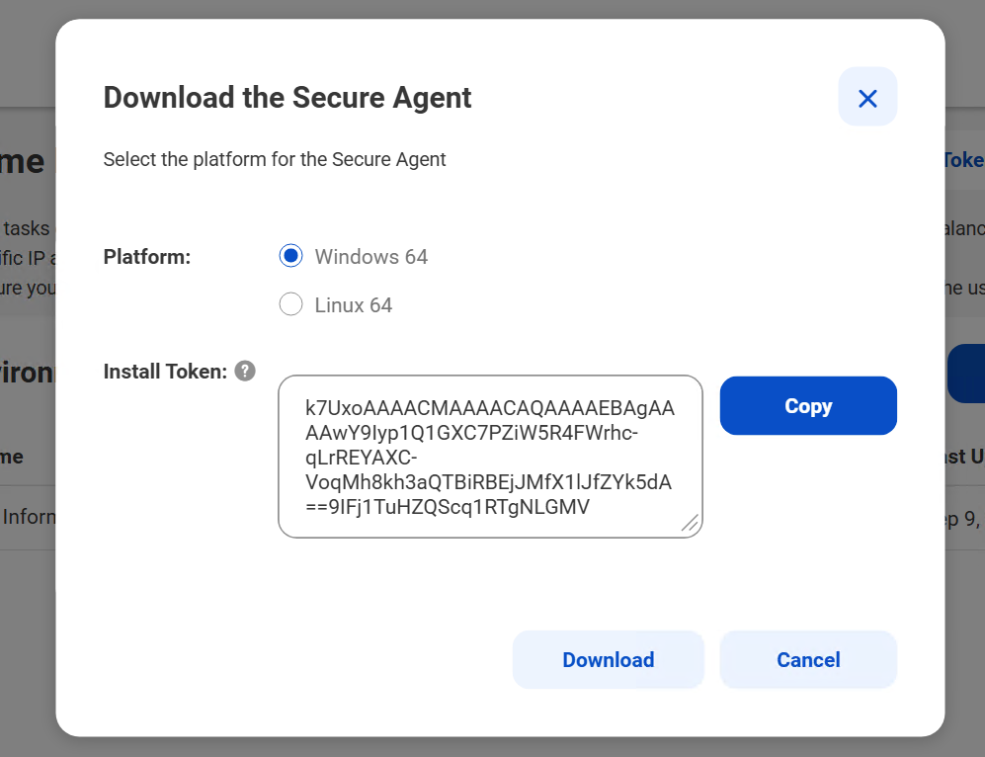
Step 3: Once the installer is downloaded, run the setup file as Administrator (right-click → Run as administrator).
- On Windows: Double-click the .exe file with administrator privileges.
- On Linux: Run the .bin file from terminal with execution permission.
⚠️ Without administrator privileges, the installation will fail and you may not be able to register the Secure Agent

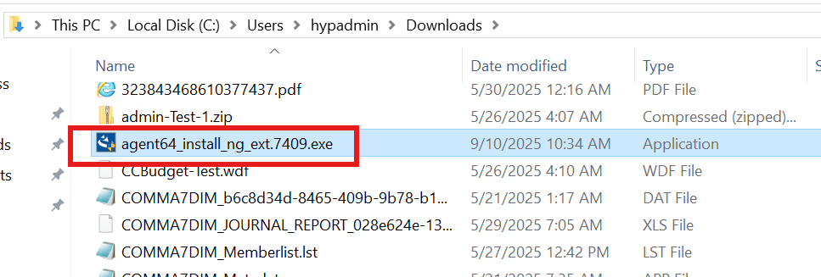

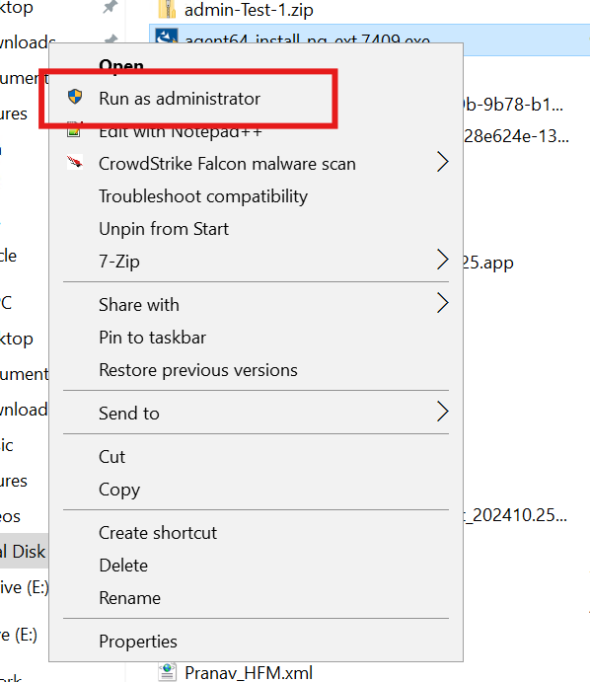

After executing the setup file, the installer will prepare for installation before launching the installation wizard.
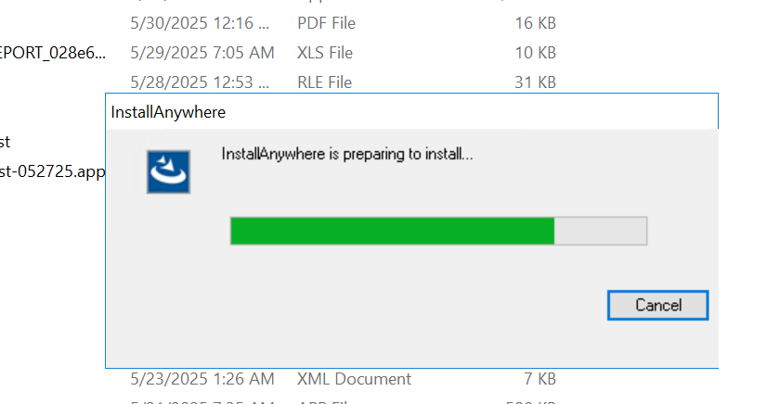

Step 4: The Secure Agent Installation Wizard will open. Choose the installation directory (default directory is recommended) and then click on Next.

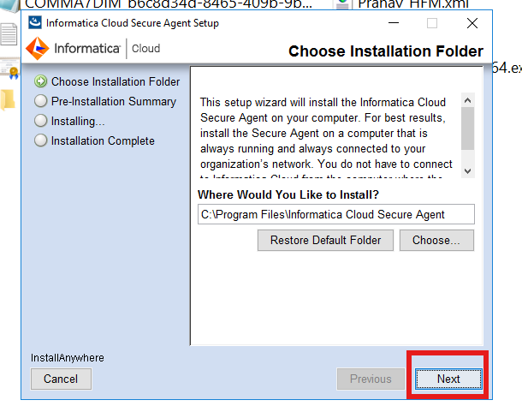

Step 5: Review the installation options shown on the screen. After verifying, click on Install to proceed.

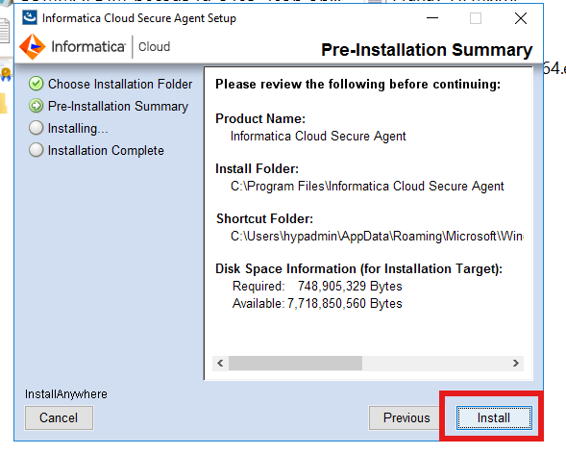
➡️ After clicking Install, the setup will display an Installing… progress screen.
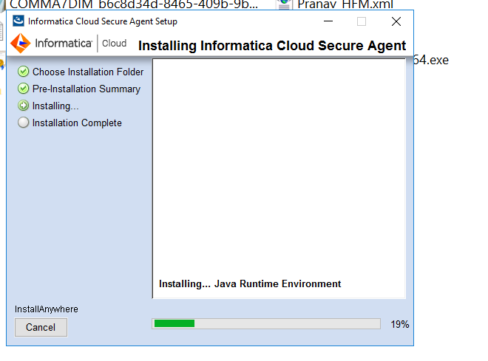

Step 6: Register the Secure Agent by providing your Username and the Install Token copied from Step 2, then click Register.
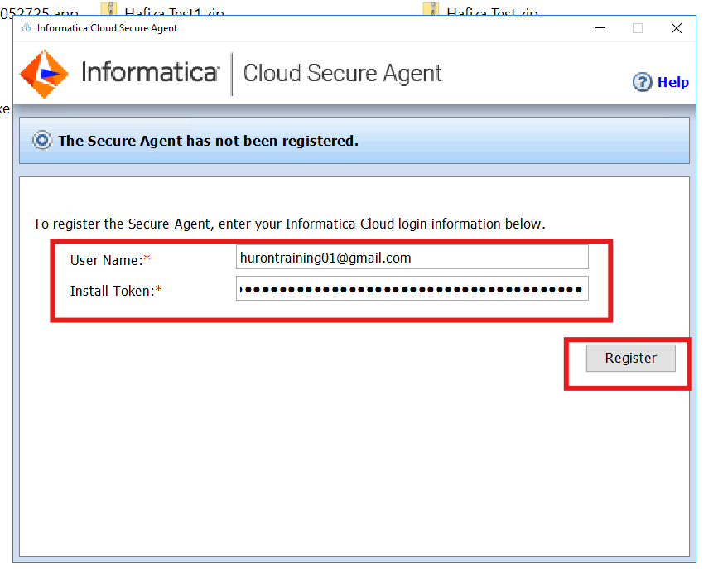

Step 7:
- After registering the Secure Agent, the Cloud Secure Agent application will open automatically.
- The agent will run automatically.
- If it does not start automatically, click the Start button to run it manually.
- Wait until all services show Up and Running before proceeding.
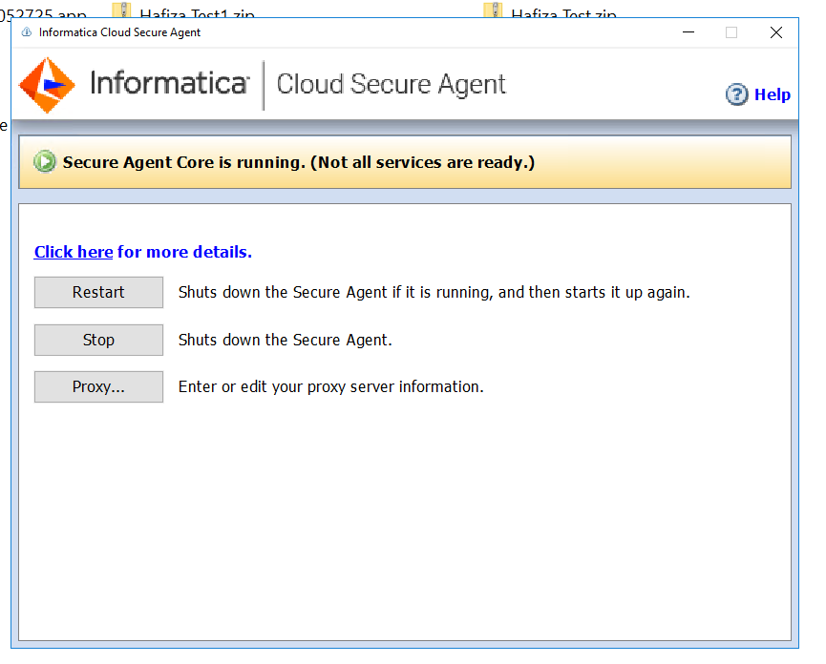

Before all services running in Informatica UI
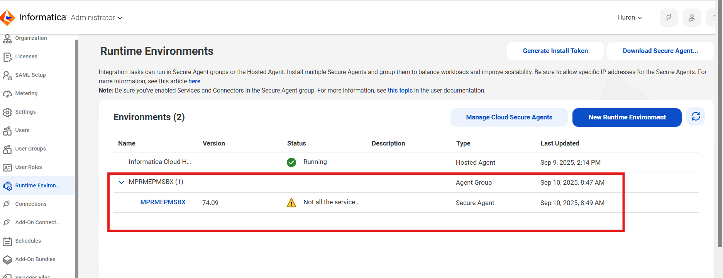

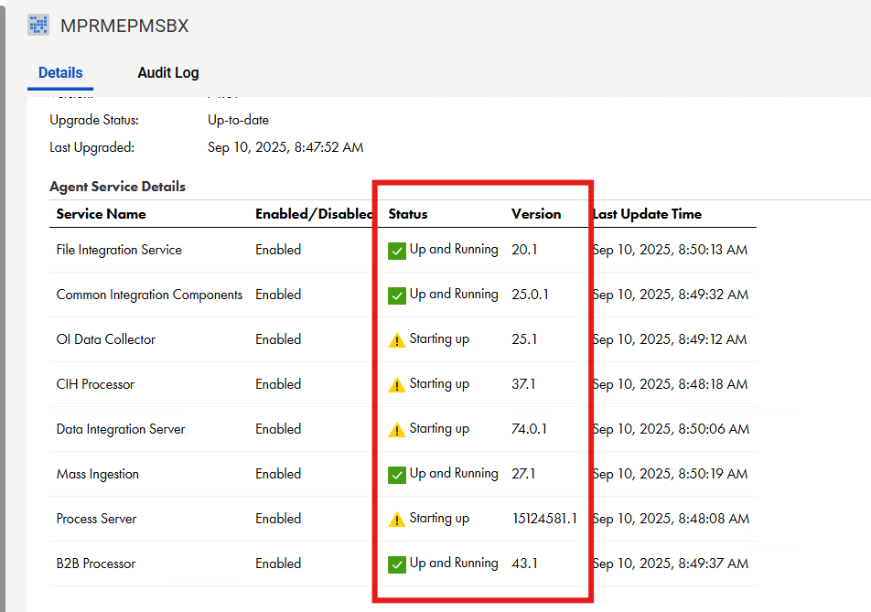

After All Services running in UI

