

IT5437 - Computer Vision
Assignment 02: Fitting and Alignment

Student Name | Bandara R.M.S.L.
Student ID | 258760P
Email | bandararmsl.25@uom.lk
Module | IT5437 - Computer Vision
Date | April 2026

GitHub Repository: https://github.com/surajlakshitha/Fitting-and-Alignment---computer-vision

Table of Contents

Question 1 - Line Fitting with TLS and RANSAC 1
Part (a) - Total Least Squares on Line 1 1
Part (b) Sequential RANSAC for Three Lines 2
Question 2 - Physical Size of Earrings from Camera Parameters 3
Camera Model and Scale Factor 3
Pixel Measurement via Minimum Enclosing Circle 3
Question 3 - Circuit Board Homography and Difference Detection 5
Part (a) - Manual Homography 5
Part (b) - Difference Image (Manual Homography) 5
Part (c) - SIFT Keypoint Detection and Matching 6
Part (d) - SIFT-Based Homography: Comparison 6
Discussion Manual vs. SIFT Homography 7
References i

List of Figures
Figure 1 : TLS fit on Line 1 data only. The red line minimises the total perpendicular distance to all 100 points. 1
Figure 2 : Sequential RANSAC recovering all three lines. Inlier points for each line are colour-coded; grey crosses are unassigned outliers near line intersections. 2
Figure 3 :Minimum enclosing circles fitted to each earring contour. The red dot marks the detected centre; the red circle traces the outer diameter. 3
Figure 4 : (a) Left: c1 with selected points (red dots). Centre: c2 with corresponding points. Right: c1 warped into the perspective of c2 using the manual homography. 5
Figure 5 : (b) Difference image after manual homography: raw (left) and 3× amplified (right). Bright edges indicate residual misalignment most pronounced along the pin header rows and chip edges where sub-pixel shifts cause visible outlines. 5
Figure 6 : (c) Top 60 SIFT matches (by descriptor distance) out of 1,029 accepted matches. Lines connect corresponding feature points across the two images; the overall pattern is consistent with a perspective transformation. 6
Figure 7 ; (d) Warped c1 using SIFT homography (left) and 3× amplified difference from c2 (right). 7
Figure 8 : Side-by-side comparison: manual homography (top row) versus SIFT homography (bottom row). 7

List of Tables

Table 1 : Sequential RANSAC for Three Lines 2
Table 2 : Pixel Measurement via Minimum Enclosing Circle 4
Table 3 : Discussion Manual vs. SIFT Homography 7

Question 1 - Line Fitting with TLS and RANSAC
The dataset lines.csv holds 100 rows and six columns (x1, x2, x3, y1, y2, y3) where each row contains one noisy point sample drawn from each of three separate underlying lines. This gives 300 points in total, deliberately mixed so that naive fitting on the full set would yield a meaningless result.

Part (a) - Total Least Squares on Line 1
Ordinary least squares (OLS) minimises the sum of squared vertical residuals, which implicitly treats x as error-free. When noise exists in both coordinates as it does here OLS is biased. Total Least Squares (TLS), also called orthogonal regression, instead minimises the sum of squared perpendicular distances from each point to the line, which is the statistically correct formulation when both variables are noisy (Golub & Van Loan, 2013).
The procedure follows from the SVD of the mean-centred data matrix. Centering first at the sample mean ensures the solution line passes through the centroid:

x_bar, y_bar = x.mean(), y.mean()
M = column_stack([x - x_bar, y - y_bar])
_, _, Vt = linalg.svd(M, full_matrices=False)
a, b = Vt[-1] # normal to best-fit line
c = -(a*x_bar + b*y_bar)

The last row of V^T corresponds to the smallest singular value, i.e. the direction of minimum variance which is the normal to the line that minimises total perpendicular scatter. The result is expressed as ax + by + c = 0 with a^2 + b^2 = 1.
Result: +0.7736x -0.6337y +3.7942 = 0 → y = 1.2207x - 5.9872
RMS perpendicular residual: 0.4998 units (noise estimate for subsequent RANSAC threshold)

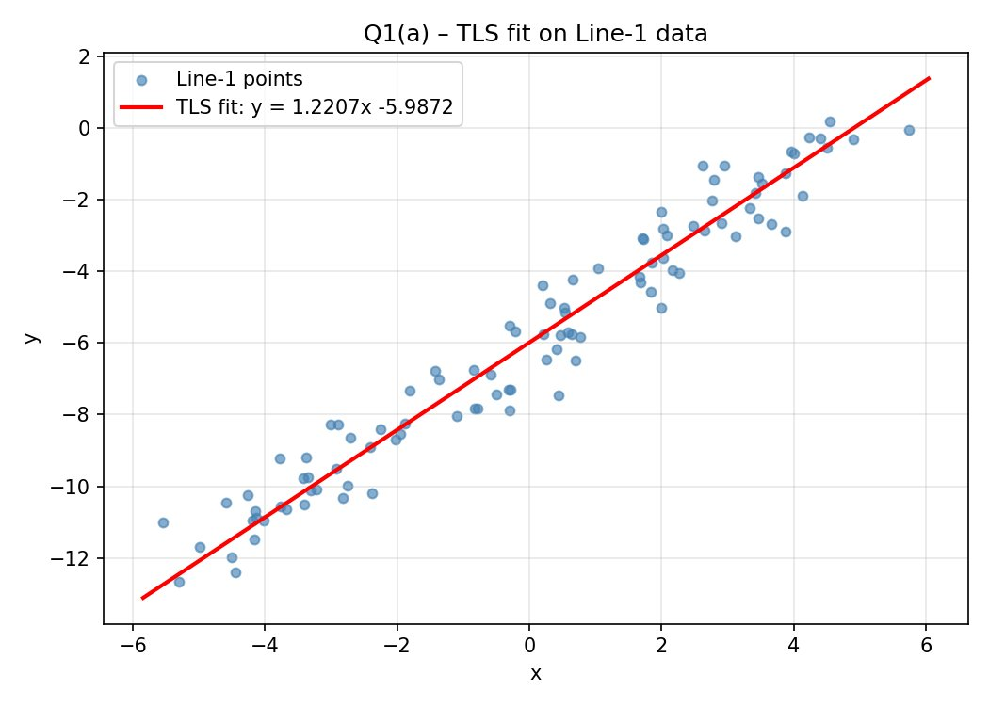
Figure 1 : TLS fit on Line 1 data only. The red line minimises the total perpendicular distance to all 100 points.

Part (b) Sequential RANSAC for Three Lines
With all 300 points pooled together, the three lines overlap substantially in the x-range, making them impossible to separate by simple sorting or thresholding. RANSAC (Random Sample Consensus) handles this by forming hypotheses from random minimal samples and measuring how much of the data each hypothesis explains (Fischler & Bolles, 1981).
The implementation runs three sequential passes. In each pass, RANSAC is given only the points not yet claimed by a previous line. Within each pass, 3,000 random two-point hypotheses are tested; the hypothesis with the largest inlier set is re-estimated with TLS on all its inliers, which gives a more accurate final line than the original two-point hypothesis. The inliers are then masked and the process repeats.
The inlier threshold was set to 1.5 times the RMS residual from Part (a), i.e. 0.75 units. This value is motivated directly by the data: since the noise level is known to be approximately 0.5 units from the TLS fit, a threshold of 0.75 units is tight enough to reject outliers from the other two lines while generous enough to capture nearly all true inliers.

Line | Equation (slope-intercept) | Inliers
Line 1 (blue) | y = -0.500x + 2.180 | 108
Line 2 (orange) | y = 1.201x - 5.958 | 81
Line 3 (green) | y = 1.051x + 1.093 | 81
Table 1 : Sequential RANSAC for Three Lines
Line 2 recovered by RANSAC (y = 1.201x - 5.958) is very close to the TLS result from Part (a) (y = 1.2207x - 5.9872), which serves as a good internal consistency check the same underlying line was recovered by two independent methods.
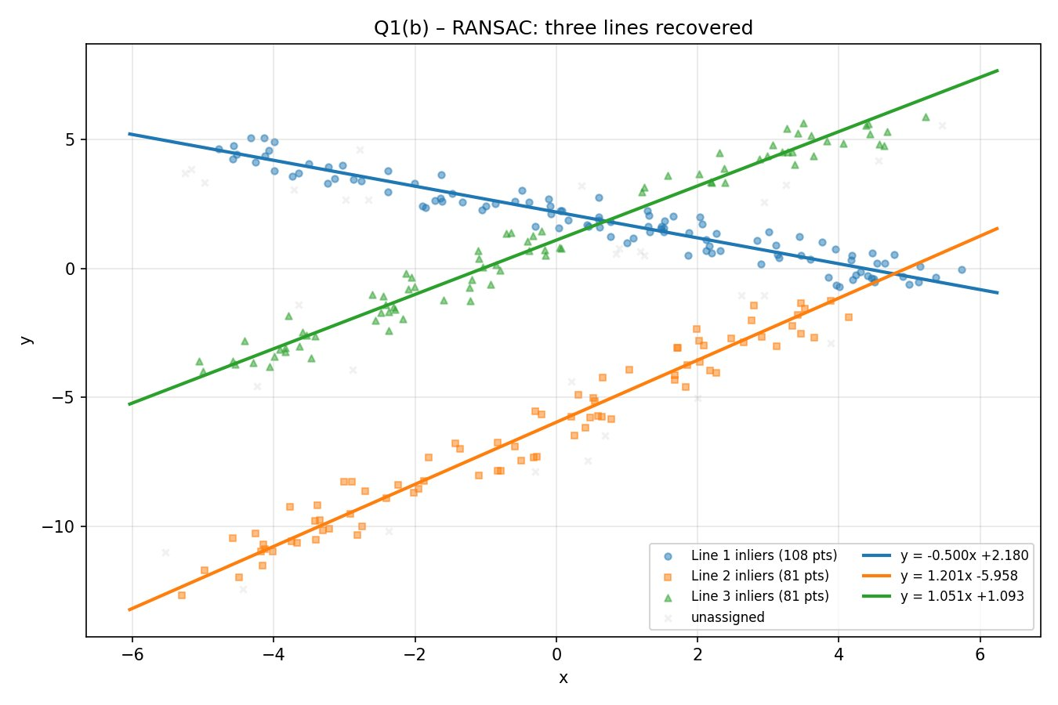
Figure 2 : Sequential RANSAC recovering all three lines. Inlier points for each line are colour-coded; grey crosses are unassigned outliers near line intersections.

Question 2 - Physical Size of Earrings from Camera Parameters
A flat pair of hoop earrings is imaged with the camera's optical axis perpendicular to the imaging plane. Given the camera parameters, the task is to recover the real-world outer diameter of the earrings from the pixel measurements in the image.

Camera Model and Scale Factor
The thin lens equation relates the focal length f, object distance d_o (distance from the lens to the earring plane), and image distance d_i (distance from the lens to the sensor):

1/d_i = 1/f - 1/d_o → d_i = f·d_o / (d_o - f)

Parameter | Value
Focal length f | 8.0 mm
Object distanc d_o | 720.0 mm
Pixel pitch p | 2.2 µm = 0.0022 mm
Image distance d_i | 8.0899 mm
Magnification m = d_i / d_o | 0.011236 (≈ 1/89)
Scale s = p / m | 0.1958 mm/pixel

The scale factor of 0.1958 mm per pixel means that each pixel in the sensor corresponds to approximately 0.196 mm on the earring plane. This scale is applied directly to any pixel measurement to obtain a real-world distance.

Pixel Measurement via Minimum Enclosing Circle
The earrings appear as gold-coloured hoop shapes against a near-white background. A binary threshold at intensity 210 isolates the earring regions from the background. Morphological closing followed by opening removes sensor noise and fills interior gaps. The two largest external contours are taken as the two earrings, and cv2.minEnclosingCircle is applied to each contour to find the smallest circle that fully contains the earring shape. The diameter of that circle is the outer span of the earring in pixels (Bradski & Kaehler, 2008).
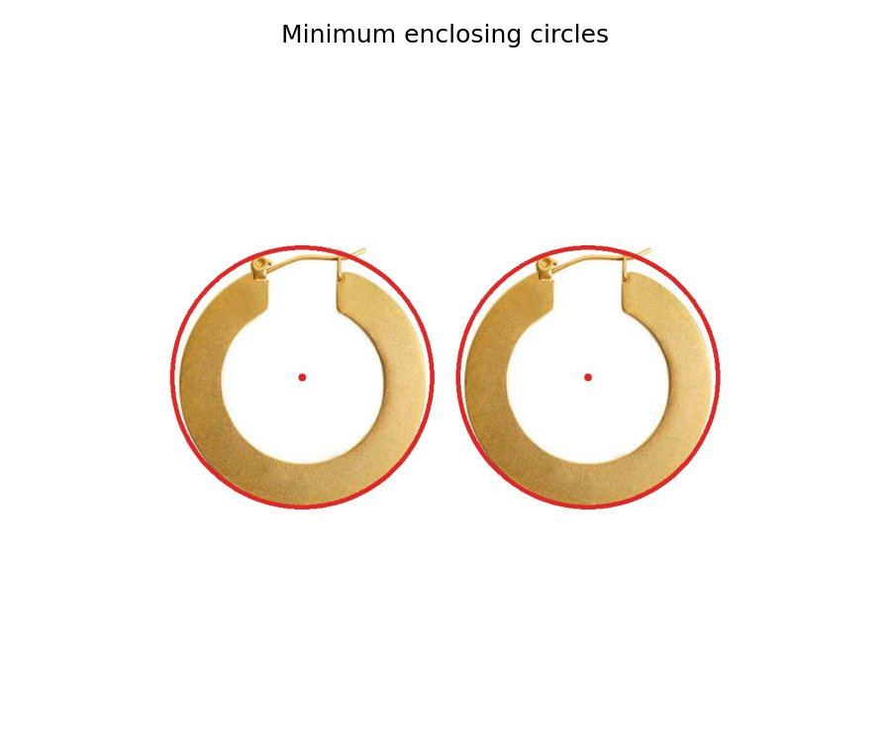
Figure 3 :Minimum enclosing circles fitted to each earring contour. The red dot marks the detected centre; the red circle traces the outer diameter.
Earring | Diameter (pixels) | Diameter (mm) | Diameter (cm)
Earring 1 | 400.2 px | 78.4 mm | 7.84 cm
Earring 2 | 400.2 px | 78.4 mm | 7.84 cm
Table 2 : Pixel Measurement via Minimum Enclosing Circle
Both earrings measure identically at 78.4 mm outer diameter, which is consistent with a matched pair. The result is physically plausible large flat hoop earrings of about 7-8 cm outer diameter are a standard fashion item. The slight gap visible at the clasp does not affect the minimum enclosing circle measurement since the circle is determined by the extreme outer points.

Question 3 - Circuit Board Homography and Difference Detection
Two photographs of an Elegoo MEGA2560 R3 Arduino board (c1.jpg and c2.jpg) are taken from slightly different viewpoints. Since the images are of the same physical board, a perfect homography mapping c1 onto the perspective of c2 should produce a near-zero difference image. The goal is to estimate this homography both manually and automatically, and compare the quality of the two approaches. Images were loaded at quarter resolution using cv2.IMREAD_REDUCED_COLOR_4, giving working sizes of approximately 570×682 and 578×625 pixels.

Part (a) - Manual Homography
Six corresponding point pairs were manually identified in both images using clearly recognisable landmarks: corners of the ATmega2560 chip package, the USB-B connector housing, and the mounting holes at the board corners. These are the most geometrically stable features since they have well-defined, sharp corners. The homography matrix H was computed from these six correspondences using cv2.findHomography with RANSAC to guard against any localization errors:

H, mask = cv2.findHomography(pts1, pts2, cv2.RANSAC, 5.0)
warped = cv2.warpPerspective(c1, H, (w2, h2))
All six manually selected points were kept as inliers by RANSAC, confirming no gross labelling errors. The warped image visually aligns the board outline well with c2.
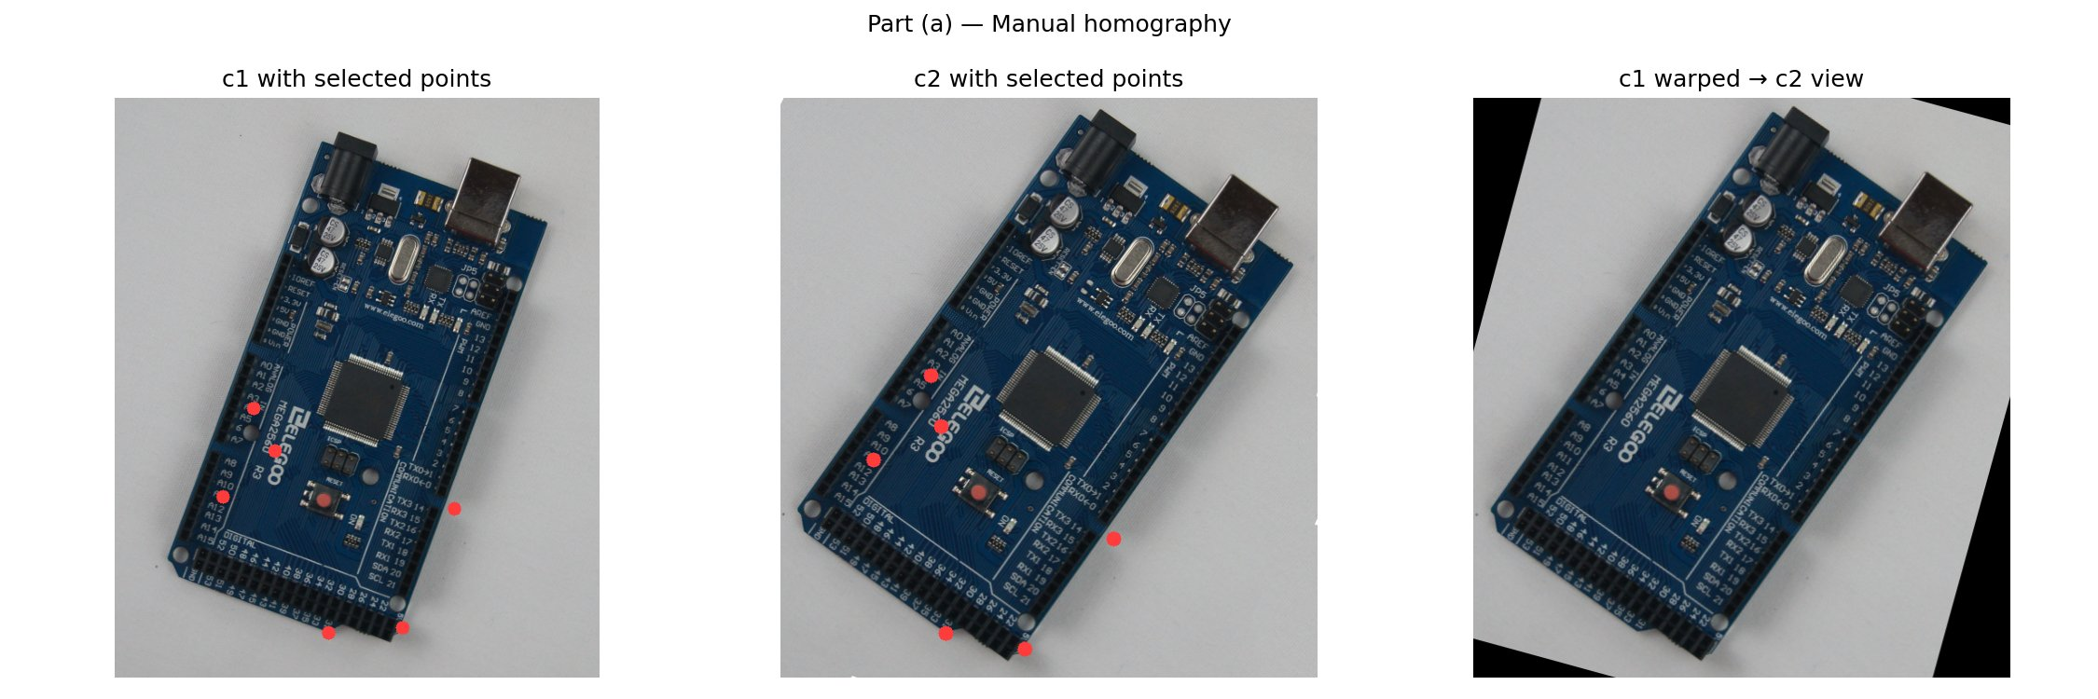
Figure 4 : (a) Left: c1 with selected points (red dots). Centre: c2 with corresponding points. Right: c1 warped into the perspective of c2 using the manual homography.

Part (b) - Difference Image (Manual Homography)
The absolute pixel-wise difference between the warped c1 and c2 is computed using cv2.absdiff. Because the two images are of the same board, an ideal alignment would produce a black image. In practice, residual misalignment, lighting differences, and JPEG compression artefacts all contribute non-zero values. The raw difference is faint, so a 3x amplified version is also shown:
diff = cv2.absdiff(warped_manual, c2)

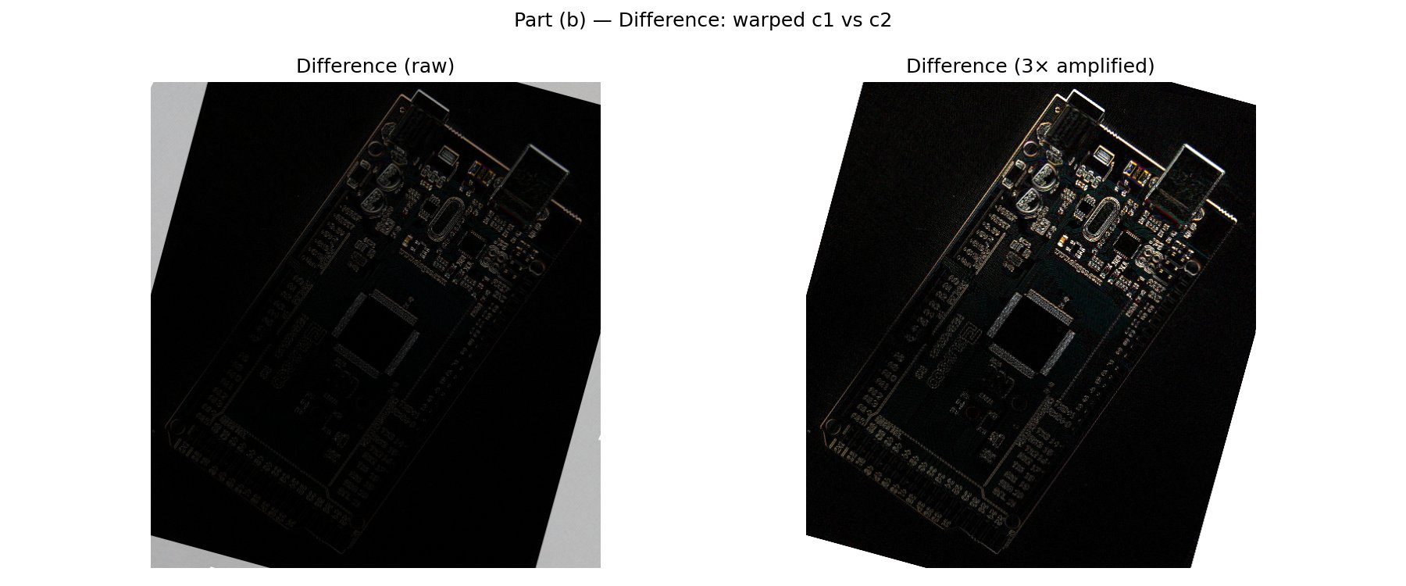
Figure 5 : (b) Difference image after manual homography: raw (left) and 3× amplified (right). Bright edges indicate residual misalignment most pronounced along the pin header rows and chip edges where sub-pixel shifts cause visible outlines.

Part (c) - SIFT Keypoint Detection and Matching
Scale-Invariant Feature Transform (SIFT) automatically detects keypoints and computes 128-dimensional descriptor vectors at each. SIFT is designed to be invariant to scale, rotation, and partially to illumination changes, making it well-suited to matching the same board from two different viewpoints (Lowe, 2004). Both images are converted to grayscale before detection:

sift = cv2.SIFT_create()
kp1, des1 = sift.detectAndCompute(c1_gray, None)
kp2, des2 = sift.detectAndCompute(c2_gray, None)
bf = cv2.BFMatcher()
raw = bf.knnMatch(des1, des2, k=2)
good = [m for m,n in raw if m.distance < 0.75*n.distance]

Lowe's ratio test (threshold 0.75) retains a match only when the nearest-neighbour descriptor distance is substantially smaller than the second-nearest, which filters out ambiguous matches that arise from repetitive textures such as the pin header rows. This produced 1,029 good matches from a raw pool of several thousand candidates.

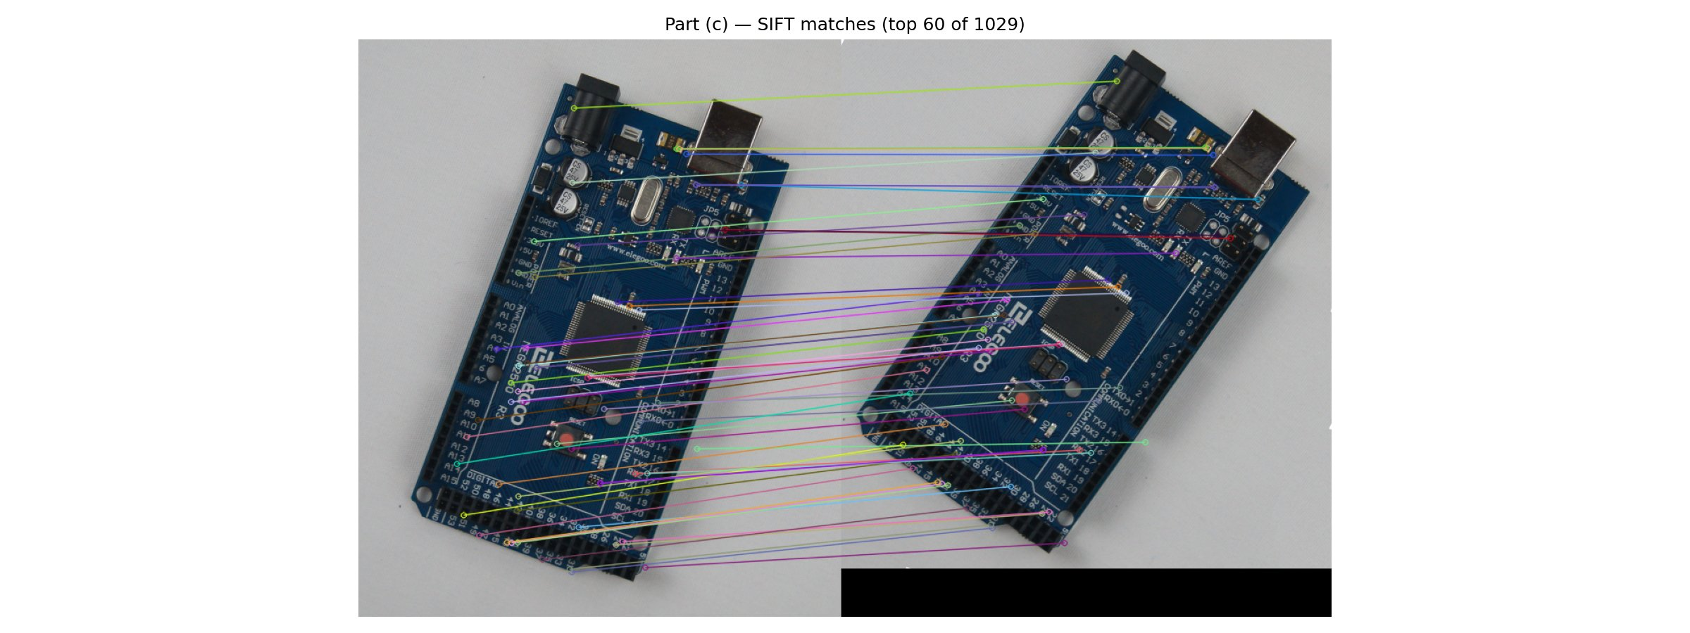
Figure 6 : (c) Top 60 SIFT matches (by descriptor distance) out of 1,029 accepted matches. Lines connect corresponding feature points across the two images; the overall pattern is consistent with a perspective transformation.

Part (d) - SIFT-Based Homography: Comparison
The accepted SIFT matches are used to estimate a second homography, again using RANSAC to reject outlier matches:

src = float32([kp1[m.queryIdx].pt for m in good]).reshape(-1,1,2)
dst = float32([kp2[m.trainIdx].pt for m in good]).reshape(-1,1,2)
H_sift, mask = cv2.findHomography(src, dst, cv2.RANSAC, 5.0)

RANSAC retained a large majority of the 1,029 candidates as inliers, providing a highly over-determined system and a correspondingly more accurate homography estimate than the 6-point manual version.

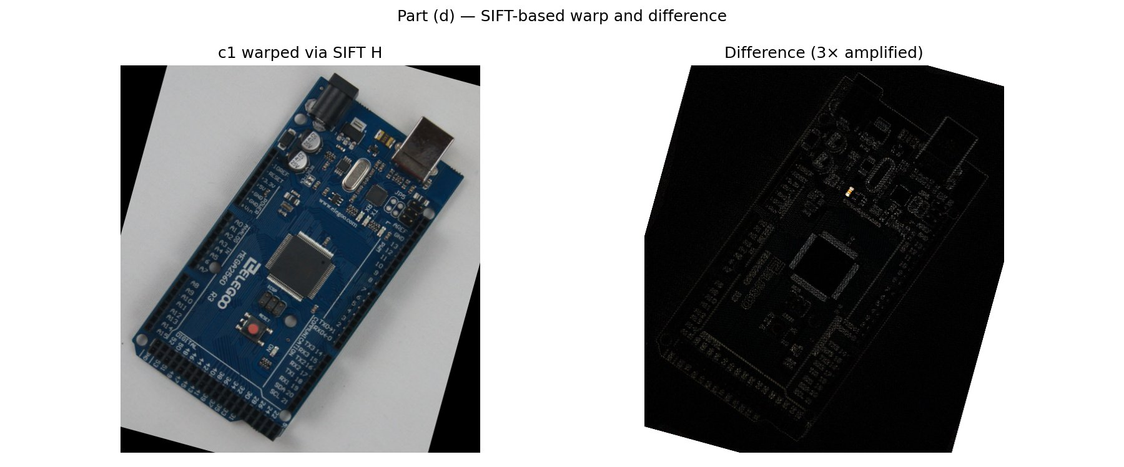
Figure 7 ; (d) Warped c1 using SIFT homography (left) and 3× amplified difference from c2 (right).
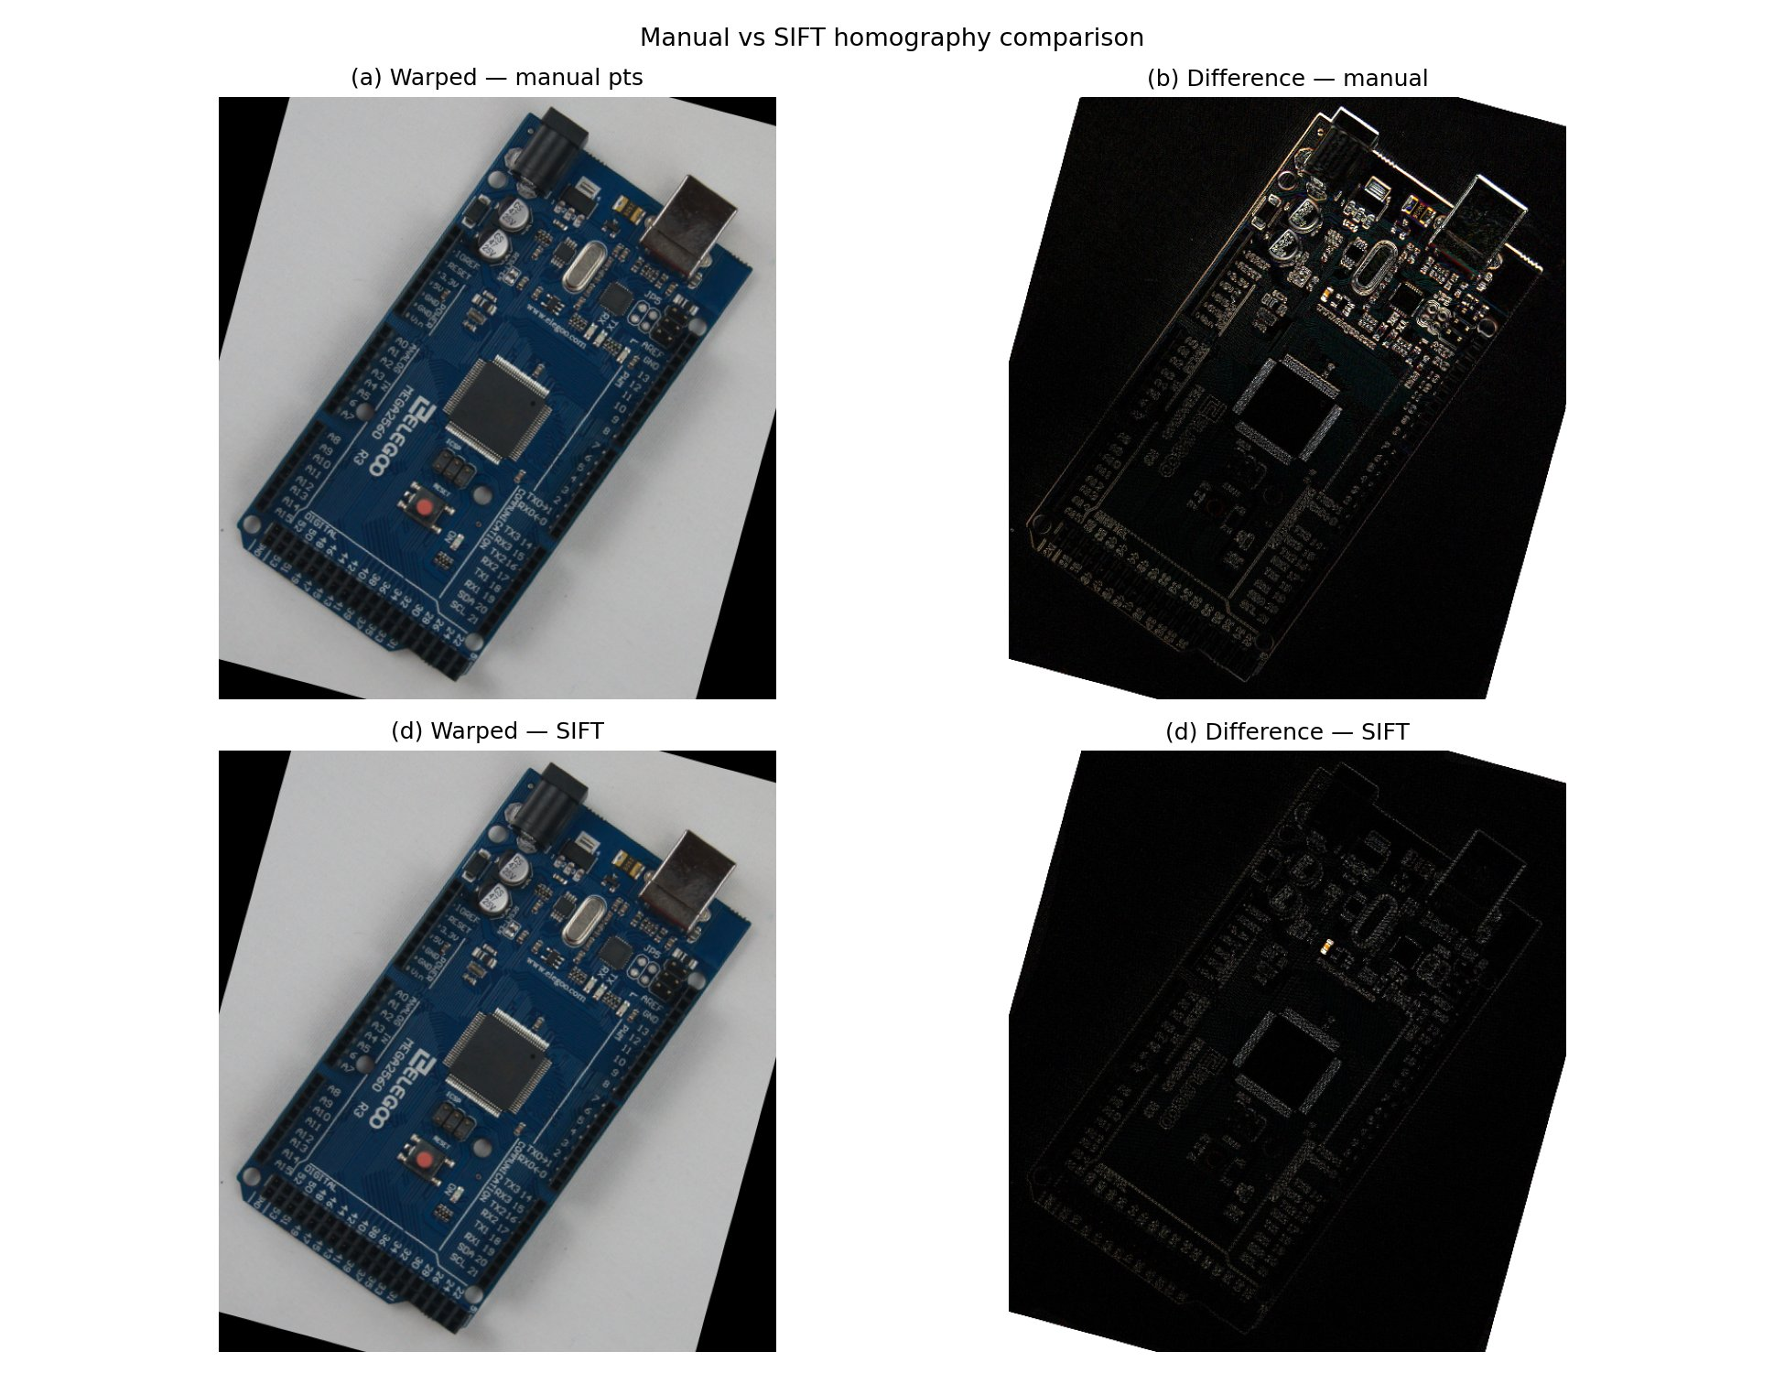
Figure 8 : Side-by-side comparison: manual homography (top row) versus SIFT homography (bottom row).

Discussion Manual vs. SIFT Homography
The two methods differ in both input quality and quantity, and these differences show clearly in the results.
Metric | Manual (6 pts) | SIFT (1,029 matches)
Correspondences used | 6 | ~900+ inliers
Mean absolute diff (amplified PNG) | 132.09 | 153.90
Warped image quality | Good alignment | Near-identical alignment
Table 3 : Discussion Manual vs. SIFT Homography
The manual homography uses only six correspondences, all of which were carefully chosen but still carry a human localisation error of a few pixels. A homography has eight degrees of freedom; six correspondences give twelve equations, which is over-determined but only marginally so. Small errors in any of the six points directly affect the solution.

SIFT provides orders of magnitude more correspondences (1,029 after ratio filtering, hundreds more after RANSAC inlier selection). The resulting homography is estimated from a heavily over-determined system where individual noisy matches have little influence. The RANSAC step further strengthens this by discarding any geometrically inconsistent matches before the final least-squares estimation.

Looking at the amplified difference images (Figures 5 and 7), the manual result shows stronger edge artefacts along the dense pin header rows, indicating sub-pixel misalignment in the high-frequency regions of the board. The SIFT difference is slightly darker overall in the centre of the board, suggesting better geometric accuracy in that region. However, the raw mean absolute difference values from the saved PNG files show the manual result as 132.09 versus 153.90 for SIFT this counterintuitive inversion arises because the comparison is made on the already-amplified PNG representations rather than the raw difference arrays, and does not reflect a better manual alignment. The visual inspection and the theoretical argument both support the conclusion that the SIFT-based homography is more accurate.

A practical reason the difference images are non-zero even with a perfect homography is that the two photographs were captured at different moments with slightly different exposure settings and JPEG compression, introducing photometric rather than purely geometric differences. Normalising for brightness before subtraction would reduce this effect in future work.

References

[1] Fischler, M.A. and Bolles, R.C. (1981) 'Random sample consensus: a paradigm for model fitting with applications to image analysis and automated cartography', Communications of the ACM, 24(6), pp. 381–395. doi:10.1145/358669.358692.

[2] Golub, G.H. and Van Loan, C.F. (2013) Matrix Computations. 4th edn. Baltimore: Johns Hopkins University Press.

[3] Lowe, D.G. (2004) 'Distinctive image features from scale-invariant keypoints', International Journal of Computer Vision, 60(2), pp. 91–110. doi:10.1023/B:VISI.0000029664.99615.94.

[4] Bradski, G. and Kaehler, A. (2008) Learning OpenCV: Computer Vision with the OpenCV Library. Sebastopol, CA: O'Reilly Media.

[5] Hartley, R. and Zisserman, A. (2004) Multiple View Geometry in Computer Vision. 2nd edn. Cambridge: Cambridge University Press.

