National Service Scheme (NSS) cell of Smt. Kashibai Navle college of engineering, Pune has organized a One Week Special Camp at DONJE Village that comes in Pune District, Maharashtra. It is imperative to mention that the DONJE has been adopted by our college. As volunteers of NSS Cell SKNCOE regularly organize different activities in and around the campus, this time the volunteers planned to organize a special camp in the village which the college has adopted. The objective of this camp was to begin the interface with community and contribution to the upliftment of people therein.

The volunteers excitingly participated in the discussion and planned the roadmap for camp along with guided supervision of Mr. Sanjay Pingat sir, Programme Officer, NSS Cell SKNCOE. Came was of total 50 volunteers. They were divided into 5 groups. Each containing 10 volunteers. Groups were formed in such a way that one group should consist of volunteers from different department, different courses and different language. Further, each group consisted both male and female volunteers. leaders were selected from each group for better coordination and delegation of responsibilities. Camp started on 15th January 2017. All the volunteers were excited. As preplanning, volunteers prepared for street play regarding ‘Women Empowerment’ and ‘Child Education’. Also posters were prepared regarding the subject. Every volunteer was self-motivated and excited for the camp.

Day 1, 15th Jan2018

Finally the day everyone was waiting for, arrived. All volunteers reported to college at 7 a.m. We departed at 7.30 a.m. .Our stay during camp was at village ‘Grampanchayat’ office. There were 2 widely spaced rooms. Students settled in there with many unknown faces.

The responsibilities were assigned to Group leader and volunteers for proper working of the group. Out of 5 groups, 4 groups were assigned for building ‘Vanrai Bandhara’ and group 1 was assigned for cooking lunch for everyone. Along with all the required tools 4 groups left. At the workplace everyone was instructed about the work they were about to do. Total of 2 Bandhara were almost built. At the time of return everyone was a bit tired as well as happy with satisfication. Then it was time for regular school activity. In evening volunteers performed ‘Street play’ in front of all villagers.

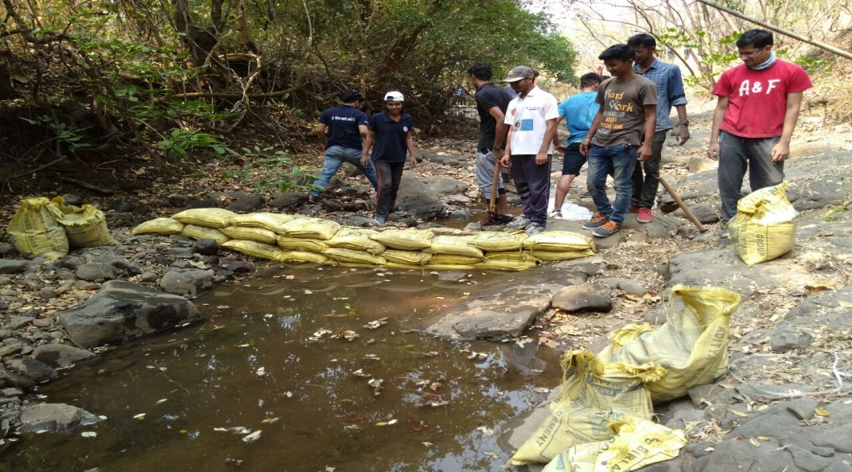

Vanrai Bandhara construction

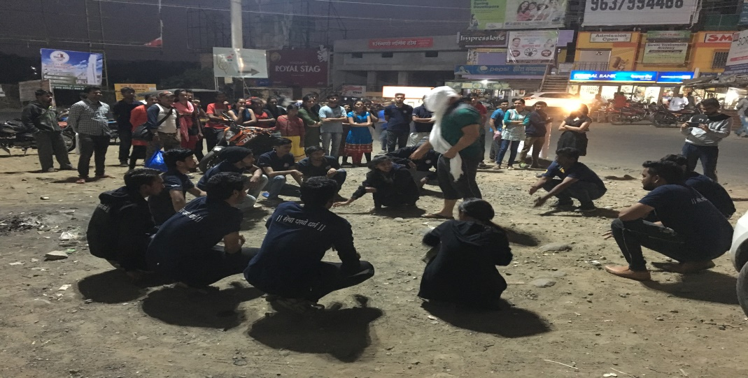

Street Play

Day 2, 16th Jan 2018.

The day started with yoga exercise early in the morning. After breakfast all volunteers gathered in groups and plan for the entire day was discussed. Out of 5 groups, 1 group was assigned for completing ‘Vanrai Bandhara’ and 3 groups were assigned for making Continuous Contour Trenches on ‘Vanrai Hill’. At the end of the work 6 tranches were constructed and both Bandhara were completed. After having lunch we carried out regular school activity successfully. In the evening students played Cricket, Football and other outdoor games. Before dinner motivating guest lecture was assigned for volunteers.

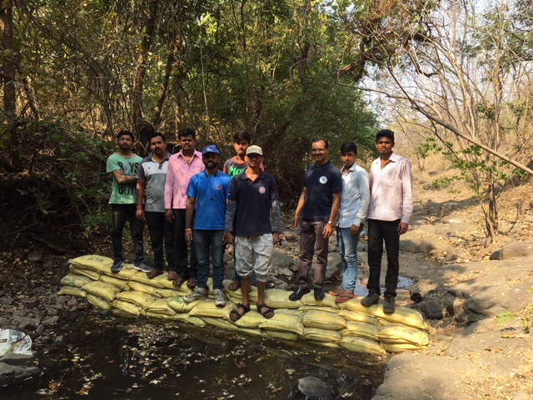

Bandhara work completed

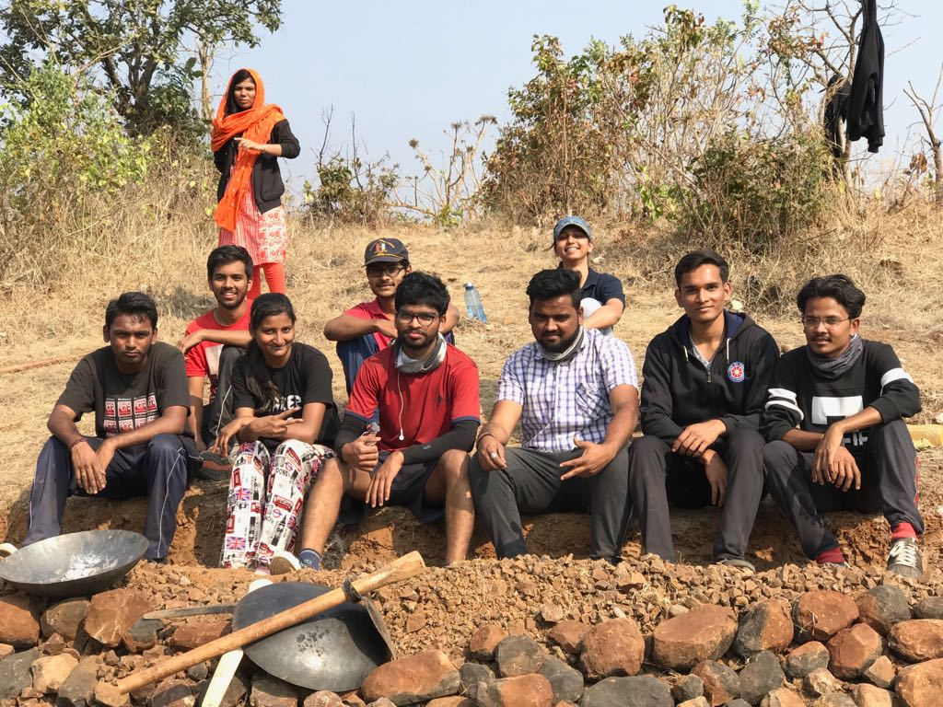

CCT

DAY 3, 17TH JAN 2018

The day started with yoga exercise early in the morning and had breakfast. After that we planned to focus on contour trenching for next 4 days and 4 groups went will all required tools. And end of work we completed 12 trenches. After having lunch we carried out regular school activity successfully. In the evening students played Cricket, Football and other outdoor games. Before dinner ‘NSS Areal Supervisor’ of SPPU Mr.Amit Gogavale inspired all volunteers .

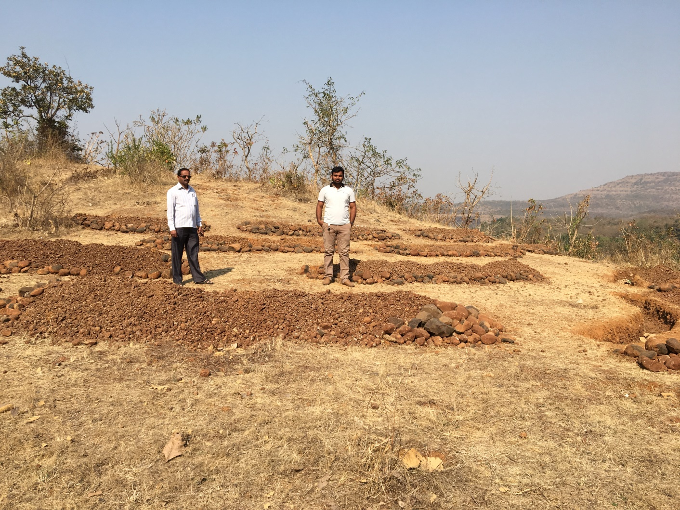

Inspection of CCT work

DAY 4, 18th JAN 2018

The day started with yoga exercise early in the morning. As planned all 4 groups prepared for CCT .Then 4 groups went to work place. Volunteers had breakfast at workplace itself and then started work without passing time. At the end of the day we completed almost 17 trenches. After having lunch we carried out regular school activity which resulted in motivation of students. In the evening students played Cricket, Football and other outdoor games. Before dinner guest lecture was arranged for volunteers. After this lecture we had an interactive talk with young female leader Mrs.Pooja Parge ,who is elected as first women Z.P. member from their village. This interaction was important regarding our social activities.

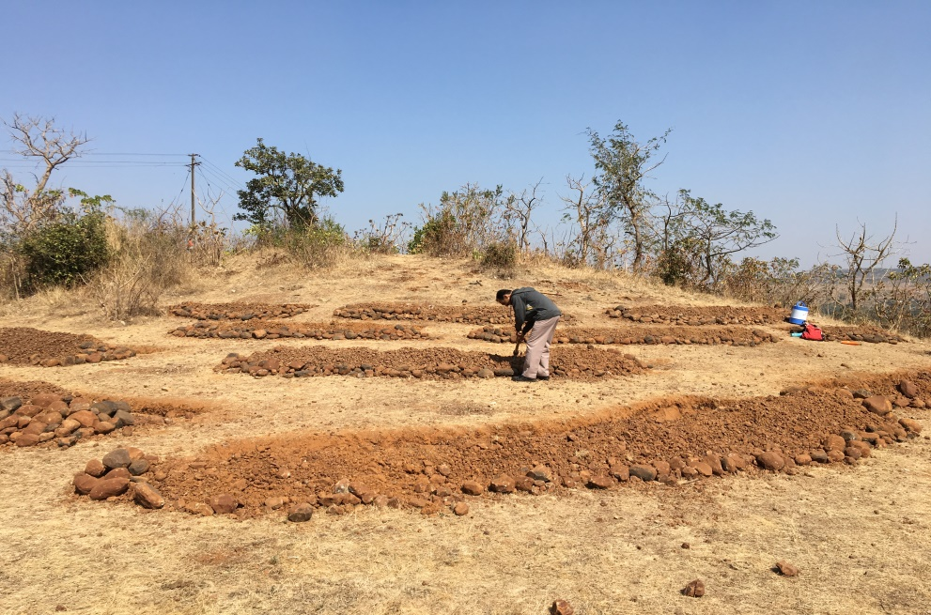

CCT

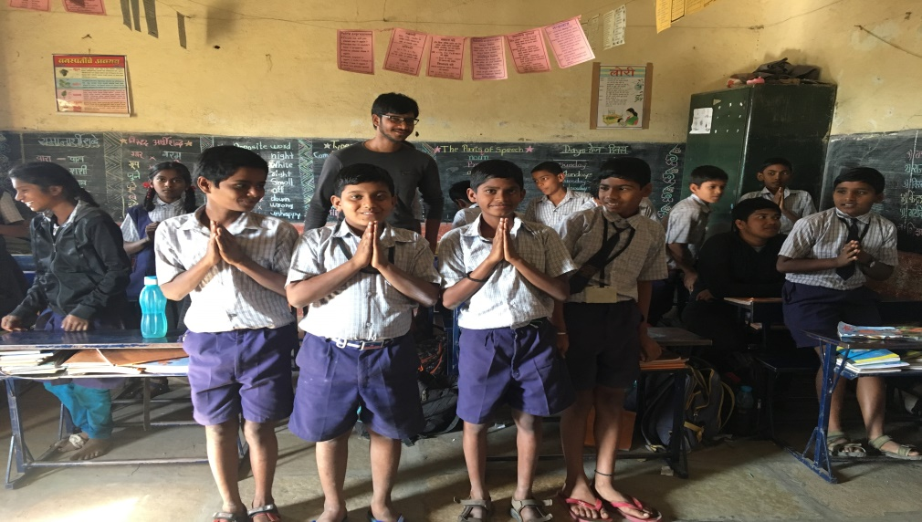

School Activity

DAY 5, 19th JAN 2018

The day started with yoga exercise early in the morning. As planned all 4 groups prepared for CCT .Then 4 groups went to work place. Volunteers had breakfast at workplace itself and then started work without passing time. At the end of the day we completed all planned 21 trenches. Our work was successfully accomplished. After having lunch we carried out regular school activity which resulted in motivation of students. In the evening students played outdoor games. In the evening our 4 senior NSS volunteers joined us and we had interactive session with them. This day was most important day in our camp as Mr.Pacharne sir,Dist. Officer of NSS SPPU visited our camp and appreciated our work. Day 5 was most successful camp day.

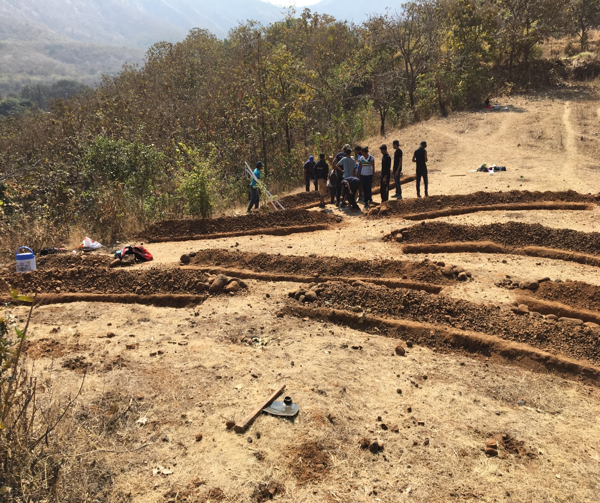

Day 6, 20th JAN 2018

As per routine we started day with exercise. That day we had planned cleanliness drive for entire village. Villagers were so cooperative and most of them participated in the cleanliness drive with all NSS volunteers. At the end of the work we cleaned almost every road and social places in village. Then volunteers had lunch. That was last day of our school activity. Some of our volunteers visited high school in the village. In the evening all volunteers gathered in seminar hall and shared their experience. Before dinner guest Mr.Nachiket delivered a personality development lecture for volunteers.

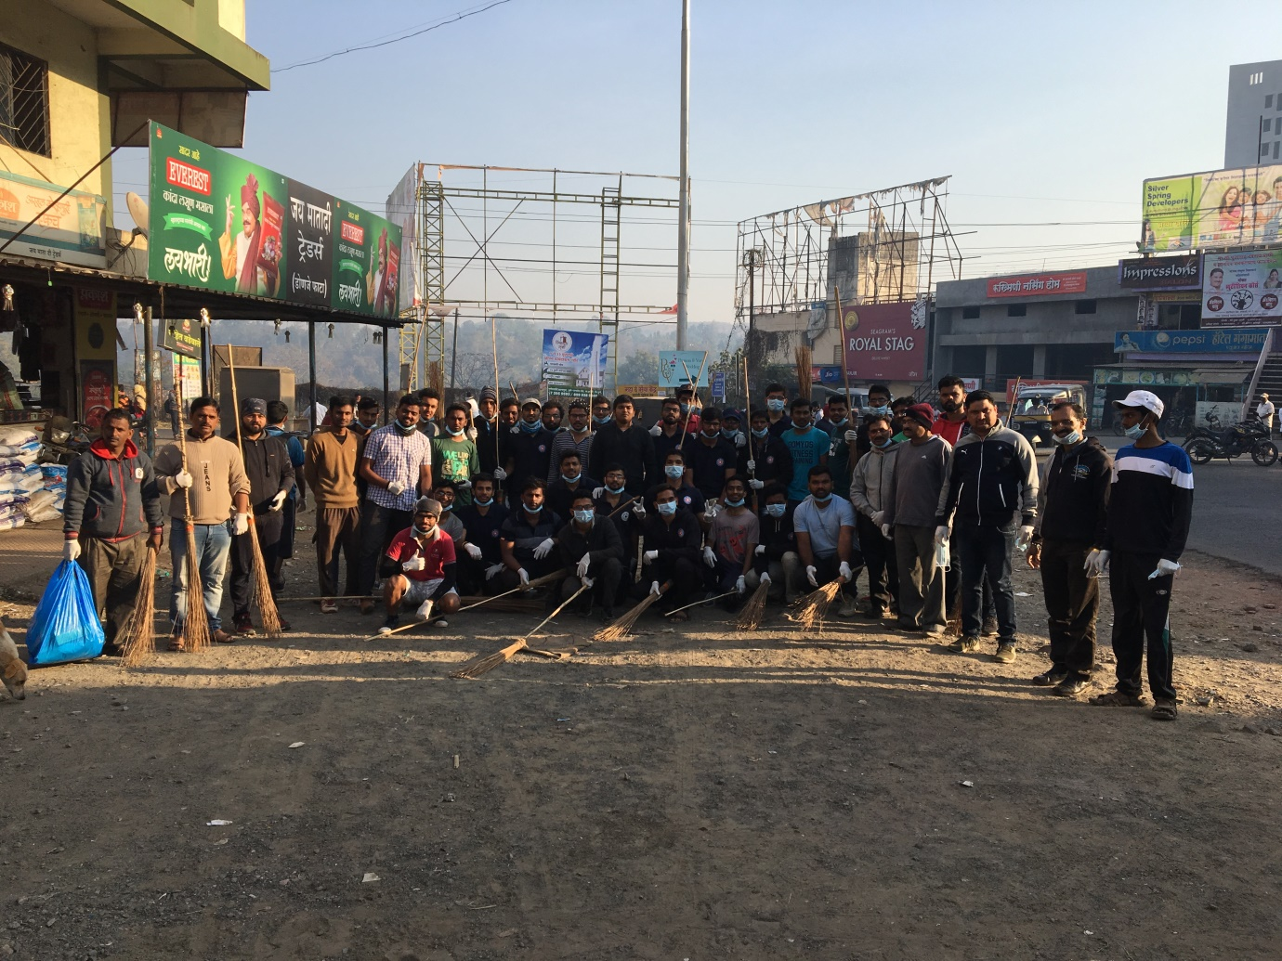

Cleanliness Drive

DAY 7, 21st JAN 2018

This was last day of our camp. In the morning the Sarpanch of Donje village and Respected members of village appreciated our work bidded farewale to volunteers. We had planned visit to old age home in the village. But due to some reasons we were not allowed to visit the place. Everyone packed their bags coordinators had revised their audit report of everything. Volunteers returned to college with successful camp and lifelong memories.

THANK YOU !