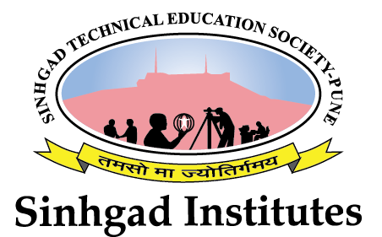

**Smt. Kashibai Navale College of Engineering**

National Service Scheme (NSS) 2016-17

**Tree Plantation Drive**

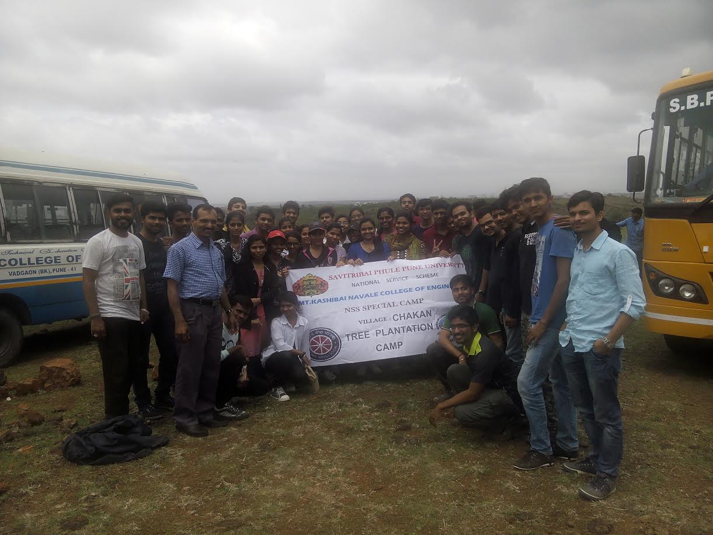

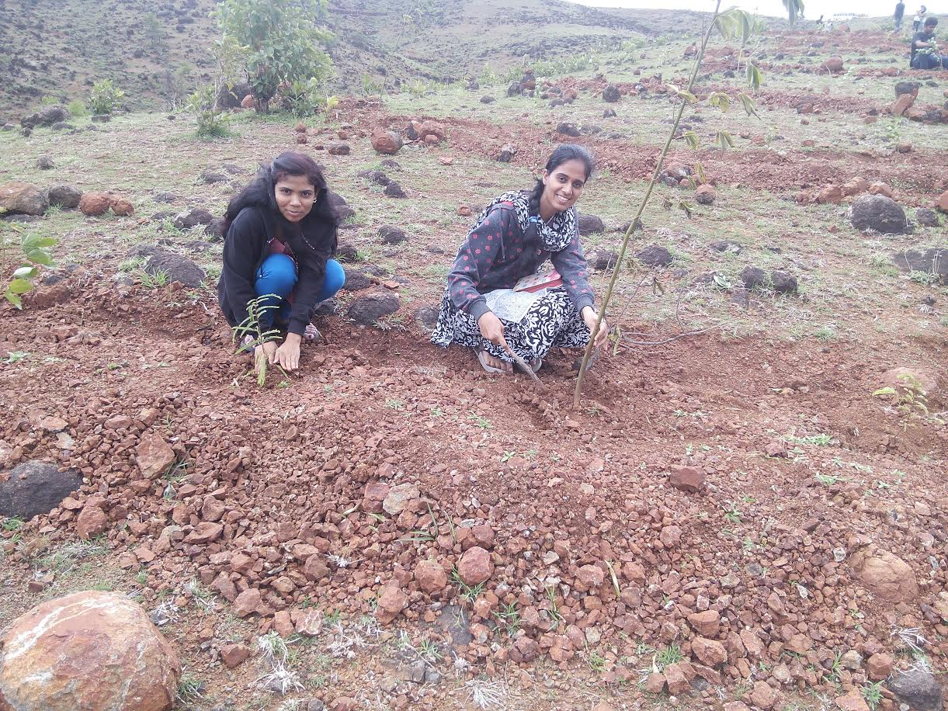

The tree plantation activity was conducted by the state government in collaboration with various organisation on the same day all over the state. We were invited to the plantation site along with many other educational institutes like schools and junior colleges.

We reached the spot early in the morning and then were served breakfast before we were allotted areas to plant the provided saplings. The transport to reach the location was provided by the college authorities in form of school buses on the institute.

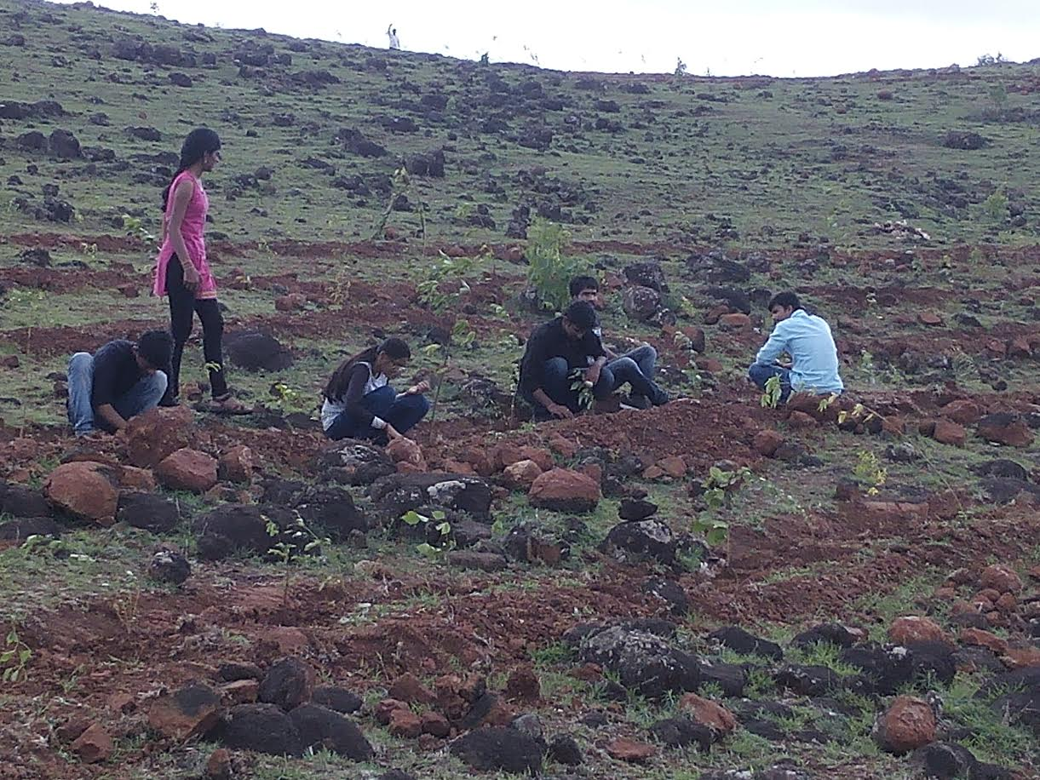

This activity was conducted on the 1st of July 2016 and was attended by the NSS unit of many colleges. We learned valuable gardening skills from the volunteers present there to guide us on the process of planting the saplings.

The activity laid the foundation for further such activities in the monsoon season to supplement the efforts to save the environment and counter climate change. The event played an important role in making students realise the power of actions, regardless of their size and grandeur.