**Introduction**

The hospitality industry is a dynamic and highly competitive sector that encompasses a wide range of services, from hotels and restaurants to event planning and leisure activities. In this rapidly evolving landscape, businesses must continually seek ways to optimize their operations, enhance guest experiences, and maximize revenue. Revenue management, a critical function within the hospitality domain, plays a pivotal role in achieving these objectives.

The term "revenue insights" has gained prominence in recent years, reflecting the industry's growing recognition of the importance of data-driven decision-making and advanced analytics. This concept goes beyond traditional revenue management practices and embraces a more holistic approach to revenue optimization, where the integration of data and technology is central. Revenue insights involve a deep dive into historical and real-time data, market trends, customer preferences, and more, to extract valuable information that can be translated into strategies to boost revenue.

This project report aims to delve into the concept of revenue insights in the hospitality domain, offering a comprehensive understanding of its significance, components, implementation, and the transformative impact it has on businesses. Through this report, we will explore how revenue insights leverage the power of data, artificial intelligence, and predictive analytics to enable hospitality enterprises to make more informed decisions and enhance their financial performance.

I. Significance of Revenue Insights in Hospitality

The significance of revenue insights in the hospitality domain cannot be overstated. Traditional revenue management practices have been effective in optimizing pricing and inventory decisions, but the landscape is evolving, and guest expectations are changing rapidly. In today's hyper-connected world, guests have access to a wealth of information, and their preferences and behaviors are subject to constant shifts. To remain competitive and profitable, hospitality businesses must adapt to these changes by harnessing the power of data and technology.

Revenue insights offer a holistic view of a business's revenue-generation potential. They consider factors such as market demand, competitor pricing, guest demographics, seasonality, and even external events, which can impact business performance. By utilizing data analytics and advanced algorithms, revenue insights provide a multidimensional understanding of the market and guests, enabling businesses to tailor their strategies accordingly.

Furthermore, revenue insights empower businesses to predict future demand and revenue trends, allowing for proactive decision-making. By identifying opportunities and threats in advance, hospitality establishments can adjust their pricing, marketing, and distribution strategies, ensuring they are always one step ahead in the highly competitive market.

II. Components of Revenue Insights

Revenue insights encompass several key components that work in synergy to provide a comprehensive understanding of the revenue landscape within the hospitality domain. These components include:

1. Data Analytics:

The foundation of revenue insights lies in the collection and analysis of data. Businesses gather data from various sources, including property management systems, online booking platforms, social media, and guest feedback. This data is then processed and analyzed to extract valuable insights into guest behavior, preferences, and market dynamics.

1. Predictive Analytics:

Predictive analytics is a crucial element of revenue insights. By utilizing historical data and sophisticated algorithms, businesses can forecast future demand and revenue trends with a high degree of accuracy. This enables them to make proactive decisions, such as adjusting room rates or developing targeted marketing campaigns.

1. Competitive Intelligence:

Staying competitive in the hospitality industry requires a keen understanding of the competitive landscape. Revenue insights involve monitoring competitor pricing and strategies to ensure that a business's offerings remain attractive and competitive.

1. Market Segmentation:

Effective market segmentation is essential for tailoring pricing and marketing strategies to different guest segments. Revenue insights help businesses identify and target the most profitable guest segments based on factors like demographics, preferences, and spending behavior.

1. Dynamic Pricing:

Dynamic pricing is a key strategy within revenue insights. It involves adjusting prices in real-time based on demand fluctuations, seasonality, and other relevant factors. Dynamic pricing ensures that businesses maximize revenue without compromising occupancy rates.

1. Distribution Strategies:

Revenue insights extend to distribution channel optimization, helping businesses make informed decisions about where and how to sell their rooms and services. This includes managing online travel agencies (OTAs), direct booking channels, and global distribution systems (GDS).

In the following sections of this report, we will explore each of these components in greater detail, emphasizing their individual contributions to the holistic concept of revenue insights in the hospitality domain.

III. Implementation of Revenue Insights

Implementing revenue insights in the hospitality domain requires a strategic approach that involves both technology and human expertise. The key steps in implementing revenue insights include:

1. Data Collection and Integration:

Gathering data from various sources within the business, such as property management systems, customer relationship management (CRM) systems, and online booking platforms. This data is then integrated and cleansed to ensure its accuracy and completeness.

1. Data Analysis and Modeling:

Leveraging data analytics tools and techniques to analyze historical data and create predictive models. These models are used to forecast demand, identify trends, and make data-driven decisions.

1. Technology Integration:

Implementing revenue management software and tools that can automate pricing adjustments and provide real-time insights. These technologies can streamline the process of dynamic pricing and distribution optimization.

1. Expertise and Training:

Employing or training revenue management professionals who understand the nuances of the hospitality industry and can interpret data effectively. These experts are essential in making informed decisions based on the insights generated.

1. Strategy Development:

Developing pricing and distribution strategies based on the insights gained. This includes setting pricing rules, identifying opportunities for upselling, and creating tailored marketing campaigns.

1. Continuous Monitoring and Adjustment:

Revenue insights are not a one-time endeavor; they require ongoing monitoring and adjustment. Businesses should regularly review data and make real-time adjustments to pricing and strategies as market conditions change.

The implementation of revenue insights is an iterative process that adapts to the evolving needs and dynamics of the hospitality industry. It requires a commitment to data-driven decision-making and a willingness to embrace technology and analytics as essential tools for success.

IV. Transformative Impact of Revenue Insights

The adoption of revenue insights in the hospitality domain has the potential to bring about transformative changes for businesses. This transformation can be observed in several key areas:

1. Revenue Growth:

Revenue insights enable businesses to maximize their revenue potential by making data-driven pricing and distribution decisions. By targeting the right guest segments with the right offers at the right time, businesses can achieve significant revenue growth.

1. Increased Profitability:

Optimized pricing and cost-effective distribution strategies contribute to higher profitability. Businesses can reduce reliance on lower-margin distribution channels and focus on direct bookings, resulting in improved margins.

1. Enhanced Guest Experiences:

Revenue insights allow businesses to better understand guest preferences and behavior. By tailoring their offerings to match guest expectations, businesses can provide more personalized and satisfying experiences.

1. Improved Market Positioning:

By monitoring and responding to competitive pricing and strategies, businesses can maintain a strong market position. They can adapt swiftly to changing market dynamics and stay ahead of the competition.

1. Data-Driven Decision-Making Culture:

The integration of revenue insights promotes a culture of data-driven decision-making within organizations. This culture values data and analytics as essential tools for success, fostering a more adaptive and innovative environment.

1. Adaptation to Market Changes:

In a rapidly changing market, businesses that leverage revenue insights are better equipped to adapt to unforeseen events, such as economic downturns, pandemics, or natural disasters. They can respond proactively to minimize the impact on their revenue and operations.

**ABOUT COMPANY**

**AI Variant** is a dedicated team of AI and Data Science Engineers to drive your business to the next level. When you approach us for any project, we diagonalize it in every possible way to give you the best possible result in the least time. Our approach is unique, and so our strategies to automate your business using the latest technologies. We add value to your service that you provide to your clients.

AI Variant specialized in Artificial Intelligence and Data Science as services, Your BI solutions, and your automation partner. We help big corporates, enterprise companies, and start-ups to automate their business, improve functionalities, and provide hassle-free services

AI Variant is an analytics firm, provides best-in-class products and solutions. We have deep analytics expertise as well as domain expertise in various industries. We are extremely passionate about taking on challenges that matter to our clients.

**Tagline –**

Ready To Make a Real Change? Let’s Build this Thing Together!

## Address –

## 49, Ground Floor, 27th Main Near IQRA International School, opposite to WIF Hospital, 1st Stage, BTM Layout, Bengaluru, Karnataka 560068

**WEBSITE –**

[WWW.AIVARIANT.COM](http://WWW.AIVARIANT.COM)

**Mission –**

Our mission is to build the best artificial intelligence platforms from smart brains and AI technologies for the clients all over the world. We promise to make things simpler using advanced analytics and add benefits to the customers delivering optimized and tailored services across all leading domains to maximize the results

**Vision –**

 We envision a technological-embedded world, where everybody can make the best choices grounded in trusted information powered with artificial intelligence and machine learning codes. Where we purely focus on new technologies to the agents, performance-driven results based on the AI era.

## Industries We Operate

* **Banking**
* **Automotive**
* **Manufacturing**
* **Aviation**
* **Energy & Resources**
* **Hospitality**
* **Retail**
* **Financial Services Insurance**
* **Life Sciences & Healthcare**
* **Technology, Media & Telecom**
* **Electrical & Electronics**

**SWOT ANALYSIS**

**1. Strengths:**

- Advanced Technology: AIVariant likely possesses cutting-edge AI technology, providing it with a competitive advantage.

- Data Processing Capabilities: If AIVariant excels in processing large datasets efficiently, it can offer superior AI solutions.

- Talented Team: A skilled and experienced team can contribute to the development and success of AIVariant.

**2. Weaknesses:**

- Dependence on Data Quality: If AIVariant heavily relies on high-quality data, any issues with data quality can hinder its performance.

- Ethical Concerns: AI systems often face ethical considerations. AIVariant may need to address concerns related to bias, privacy, and transparency.

- Limited Adoption: If AIVariant struggles with market penetration or user adoption, it could hinder overall growth.

**3. Opportunities:**

- Market Expansion: The AI industry is continually growing. AIVariant can explore new markets or expand its services to gain a larger customer base.

- Partnerships: Collaborations with other tech companies, research institutions, or businesses can open up new opportunities for innovation and growth.

- Emerging Technologies: AIVariant can capitalize on emerging technologies such as edge computing, quantum computing, or blockchain to enhance its offerings.

**4. Threats:**

- Competition: The AI sector is highly competitive. AIVariant needs to be aware of competitors and continuously innovate to stay ahead.

- Regulatory Changes: Evolving regulations in the AI space may pose challenges. AIVariant must stay compliant with changing laws and standards.

- Cybersecurity Risks: Given the sensitive nature of AI data, AIVariant must be vigilant against cybersecurity threats to protect its technology and user data.

**Literature Review**

The hospitality industry is dynamic and competitive, making it imperative for businesses to adopt innovative strategies to maximize revenue. Revenue management in the hospitality domain involves the strategic application of analytics, technology, and pricing strategies to optimize financial performance. This literature review explores the various dimensions of revenue insights in the hospitality sector, examining key themes such as technology adoption, pricing strategies, data analytics, and the impact of external factors.

**1. Technology Adoption in Revenue Management:**

a. Property Management Systems (PMS):

- Hospitality businesses leverage advanced PMS to streamline operations, enhance guest experiences, and gather valuable data.

- Integration of PMS with revenue management systems enables real-time data analysis for pricing decisions.

b. Customer Relationship Management (CRM):

- CRM systems facilitate personalized guest interactions, aiding in customer retention and loyalty.

- Data from CRM systems can be utilized for targeted marketing campaigns and pricing customization.

c. Channel Management Systems:

- Effective distribution across various online channels is crucial for revenue optimization.

- Channel management systems assist in managing inventory, pricing, and availability across diverse platforms.

**2. Pricing Strategies in Revenue Management:**

a. Dynamic Pricing:

- Real-time adjustments of room rates based on demand, seasonality, and market conditions.

- Dynamic pricing algorithms consider factors like competitor pricing, events, and booking patterns.

b. Bundling and Packages:

- Offering packages with additional services can enhance perceived value and stimulate higher spending.

- Bundling strategies require a nuanced understanding of customer preferences and market trends.

c. Discount and Promotions:

- Strategic use of discounts during low-demand periods or for specific customer segments.

- Careful consideration of the long-term impact on brand perception and profitability.

**3. Data Analytics in Revenue Management:**

a. Predictive Analytics:

- Utilizing historical data to forecast future demand patterns.

- Predictive models aid in setting optimal pricing and inventory strategies.

b. Big Data Analytics:

- Analyzing vast datasets for insights into customer behavior, preferences, and market trends.

- Big data facilitates a more granular understanding of customer segments and competitive landscapes.

c. Machine Learning and Artificial Intelligence:

- Advanced algorithms enable automated decision-making in real-time.

- AI-driven systems continuously learn from data, improving accuracy in predicting demand fluctuations.

**4. External Factors Influencing Revenue Insights:**

a. Economic Conditions:

- Economic downturns or upswings significantly impact travel patterns and spending behaviors.

- Hospitality businesses need to adapt pricing strategies accordingly.

b. Regulatory Environment:

- Changes in regulations, such as visa policies or taxation, can affect tourism flows and revenue.

- Continuous monitoring and adaptation to regulatory changes are crucial.

c. Global Events and Trends:

- Major events, cultural trends, and geopolitical shifts can influence travel behavior.

- Flexibility in pricing and marketing strategies is essential in response to external dynamics.

**5.** **Service Quality and Customer Satisfaction:**

- Numerous studies focus on the importance of service quality in the hospitality industry and its direct impact on customer satisfaction and loyalty.

- The SERVQUAL model, developed by Parasuraman et al., is often cited in these discussions as a framework for assessing service quality.

**6. Customer Experience Management:**

- The concept of customer experience is central in hospitality literature, exploring how businesses can create memorable and positive experiences for their guests.

- Personalization and customization of services to meet individual preferences are often discussed.

**7. Hospitality Marketing:**

- Marketing strategies for the hospitality industry are a frequent subject of research. This includes digital marketing, social media, and branding.

- Reputation management and the impact of online reviews on consumer decision-making are also explored.

**8. Sustainability in Hospitality:**

- As sustainability becomes a global concern, studies in the hospitality domain increasingly examine sustainable practices, eco-friendly initiatives, and their impact on consumer choices.

**9. Human Resource Management in Hospitality:**

- Employee training, satisfaction, and their role in delivering quality service are explored in the context of human resource management.

- Turnover rates, leadership styles, and employee engagement are common topics.

**10. Globalization and Cross-Cultural Issues:**

- Given the international nature of the hospitality industry, research often delves into cross-cultural challenges, understanding diverse customer expectations, and effective communication across cultures.

**11. Legal and Ethical Issues:**

- Ethical considerations and legal aspects, such as compliance with regulations and safety standards, are essential topics, especially in the context of guest safety and well-being.

**12. Innovation and Trends:**

- Researchers often explore emerging trends and innovations in the hospitality industry, such as the impact of COVID-19 on the sector, the rise of experiential tourism, and the integration of smart technologies.

**13. Risk Management:**

- Given the unpredictable nature of the hospitality industry, studies focus on risk assessment, crisis management, and strategies to handle unexpected events that may impact the business.

**RESEARCH METHODOLOGY**

Every project is started with the objective of getting results either positive ornegative. And each and every project reaches to the stage of completion through the wayof some research either with the help of primary data or secondary data. And getting ofany project and getting genuine results from that depends on the research method used by researcher.

**DEFINITION OF RESEARCH:**

Research methodology is a process to systematically solve the rescarch problem. It may be under to data science of studying how research is done scientifically. Why are search study has been undertaken, how the research problem has been defined. In what way and why the hypothesis has been formulated, what data have been collected and particular method has been adopted. Why particular technique of analyzing data has been used and a host of similar other questions are usually answered when we talk of research methodology concerning are search problem or study. A research design serves as a bridge between what has been established (the research objectives) and what is to be done, in the conduct of the study. In this project research done is of conclusive nature. Conclusive research provides information that help In making a rational decision. Descriptive design was choose to measure the satisfaction level of customers on the basis of different parameters such as quantity, price, analysis, technology, after investment ete. This designer soured complete clarity and accuracy. It also ensured minimum bias in collection of data and reduced the errors in data interpretation. Statistical method was followed in this research because the data was of descriptive nature and it also enabled accurate generalizations.

Type of research used in project is

1)Descriptive,

2)Quantitative

3)Observation type

**DESCRIPTIVE RESEARCH TYPE:**

Descriptive research includes survey sand fact-finding enquiries of different kinds, The major purpose of descriptive research is description of the state of affairs as it exists at present. Descriptive research gathers quantifiable information that can be used for statistical inference on your target audience through data analysis as a consequence this type of research takes the form of closed ended questions, which limits its ability to provide unique insights. However, used properly it can help an organization better define and measure the significance of something about a group of respondents and the population they represent.

**QUANTITATIVE RESEARCH TYPE:**

A formal, objective, systematic process for obtaining quantifiable information about the world defines Quantitative Research Type. Presented in numerical form, and analyzed through the use of statistics, used to describe and to test relationships used to examine the cause and effect to relationships in effect, to put it simply. Quantitative research is concerned with numbers, statistics, and the relationships between events numbers.

**OBSERVATION RESEARCH TYPE:**

"An extensive array of research methods used with the intention of observing interactions in surroundings. The main advantage to conducting observational research in business is that they are often unaware they are being monitored allowing the researcher to make an objective analysis."

**DATA COLLECTION**

Data collection is a means for gathering facts, statistics and details from different sources. There are two sources of Data Collection, which are as follows:

**SOURCES OF DATA COLLECTION**

**1)Primary source**

a) Through conversation with the Head and the staff of The Choice Hotels.

**2) Secondary source**

a) Annual Reports of The Choice hotel

b) Booking Data

c) Internet

**Steps for Analysis**

a) Selection - It involves selection of information relevant to the purpose of analysis.

b) Classification-It involves methodological classification of the data.

c) Interpretation-It includes drawing of inferences and conclusion.

**ANALYTICAL RESEARCH FOR THE POWER BI REPORT**

Analytical research design: Analytical Research Design means company's past data is collected to analyze the liquidity and profitability position of the company. Data analysis and interpretation is done with the help of secondary data collected through company's financial statements which includes the following

1. Statement of Profit & Loss Sheet, Balanced Sheet, Cash-Flowchart.

2. Booking data of hotel

**Analytical Tools Used:**

Microsoft Excel

Microsoft Power BI

**SAMPLE SIZE**

For analysis i have taken sample size of 13591 booking entry of 3 month from 25 properties

**DATA ANALYSIS AND INTERPRETATION, IN POWER BI**

Revenue generation is the way or manner in which a company sells itself and its products to the public to make money. It is a strategic operation that touches every part of an organization; it is not just sales or marketing. In the hospitality domain, revenue is generated through hotel room rentals, meeting space occupancy, and sales of food or beverages. Businesses face a period of growth and decline, and the hospitality industry is no exception. One thing is certain and phenomenal, the hospitality industry lives and dies by its customers. Good customer service can be a revenue generator for a hotel. Focusing on small details can mean the difference between remaining stagnant or increasing profitability. Small things add up.

This document presents the analysis of hotel data for Choice Hotel, from May 2023 — June 2023. This will enable us to gain insights into various aspects of hotel management, including, customer ratings, occupancy rates, revenue, and bookings. This analysis was performed using Power BI, a powerful data visualization and analytics tool.

**PROBLEM STATEMENT**

Choice Hotel owns multiple five-star hotels across India. They have been in the hospitality industry for the past 20 years. Due to strategic moves from other competitors and ineffective decision-making in management, Choice Hotel are losing its market share revenue in the luxury/business hotels category.

**Objective:** To provide Choice Hotel with insights from their historical data to regain their market share and revenue.

**SKILLS DEMONSTRATED**

This project exposed me to learning a lot using Microsoft Power BI.

· Multiple complex DAX formulas and Functions.

· Calculated columns

· Data Extraction, Cleaning, and Transformation (ETL)

· Data Modelling

· Data Visualization

**DATA TRANSFORMATION**

The dataset comprises five CSV files, three dimension tables, and two fact tables. The data was cleaned and transformed using Power Query in Power BI to ensure accuracy and consistency.

Data cleaning steps involved;

· Correct data type for columns.

· Replaced incorrect dates with the correct date.

**DATA MODELING**

Data model refers to the **abstract model** that demonstrates the **logical structure** of data and the **relationships** that exist in the data. In Microsoft Power BI, data model refers to everything that is loaded from query. A data model consists of **Two or more tables related**to each other.Let’s look at some basics before digging into the data modeling concept.

The **logical structure** of the tables that exist in a data model is known as the schema.  A good schema follows the following rules:

**No looping** exists between three or more tables of a data model.

Two tables are connected via **one active** relationship only.

The data model in this project of Power BI consists of five tables:

**dim_date:** Contains full date information about dates including day type (weekend or weekday), month, and week number (W19 — W32).

**dim_hotels:**Stores identity number of the hotel, property name, category it belongs to (luxury/business), and the city it’s located.

**dim_rooms:**Includes room id and room class.

**fact_bookings:**Stores information about bookings including booking dates, booking platforms, number of guests, revenue, check-in, and checkout dates.

**fact_aggregrated_bookings:**Includes successful bookings, hotel id, and capacity. The dimension tables (with the prefix “dim”) have a matching id in the fact tables (with the prefix “fact”). This modeling produces a one-to-many relationship.

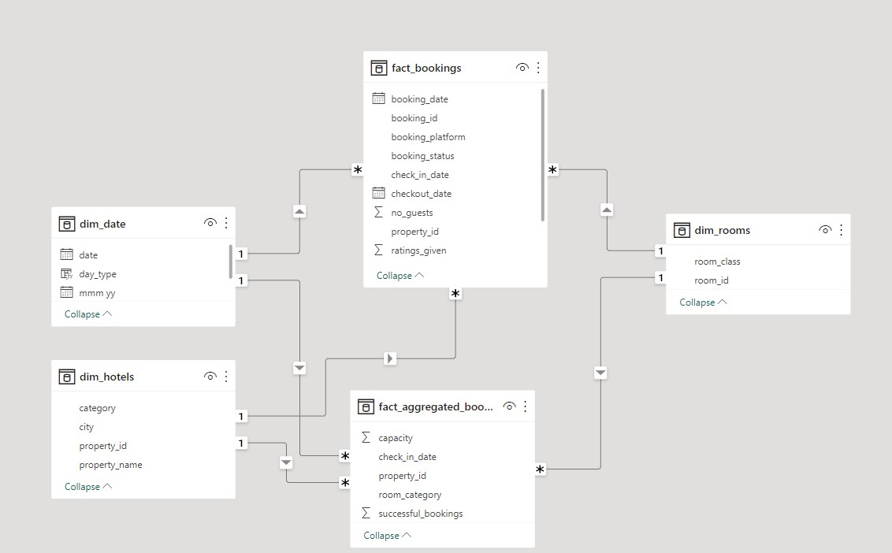

**Data Model**

In this data modelling we have used star schema method for data modelling,

Star schema

In a star schema, a **fact table is surrounded by multiple dimension tables.**

Power BI engine works best with star schema.

For example, the fact_aggregated_bookings table exists on the many side of the relationship and all the dimension tables exist on the 1 side of the relationship as shown above

The star schema does not necessarily have to be in the shape of a star.

The star schema does not necessarily need 5-dimension tables to complete the star.

**USING DAX IN POWER QUERRY**

**CALSULATED COLUMNS CREATED**

|  |  |  |  |
| --- | --- | --- | --- |
| ***1*** | ***wn*** | ***To get the week number from the corresponding date.*** | ***wn = WEEKNUM(dim_date[date])*** |
| ***2*** | ***day type*** | ***Based on the feedback from stakeholder, we considered  Friday and Saturday as weekend and weekdays from Sunday to Thurdsay. In PowerBI, Sunday weekday number is 1, Monday is 2 and so on. So, if weekday number is greater than 5, then weekend or else weekday.  https://learn.microsoft.com/en-us/dax/weekday-function-dax*** | ***day type =     Var wkd = WEEKDAY(dim_date[date],1)   return  IF(  wkd>5,"Weekend","Weekday")*** |

**MEASURES CREATED**

|  |  |  |  |
| --- | --- | --- | --- |
| ***1*** | ***Revenue*** | ***To get the total revenue_realized*** | ***Revenue = SUM(fact_bookings[revenue_realized])*** |
| ***2*** | ***Total Bookings*** | ***To get the total number of bookings happened*** | ***Total Bookings = COUNT(fact_bookings[booking_id])*** |
| ***3*** | ***Total Capacity*** | ***To get the total capacity of rooms present in hotels*** | ***Total Capacity = SUM(fact_aggregated_bookings[capacity])*** |
| ***4*** | ***Total Succesful Bookings*** | ***To get the total succesful bookings happened for all hotels*** | ***Total Succesful Bookings = SUM(fact_aggregated_bookings[successful_bookings])*** |
| ***5*** | ***Occupancy %*** | ***Occupancy means total successful bookings happened to the  total rooms available(capacity)*** | ***Occupancy % = DIVIDE([Total Succesful Bookings],[Total Capacity],0)*** |
| ***6*** | ***Average Rating*** | ***Get the average ratings given by the customers*** | ***Average Rating = AVERAGE(fact_bookings[ratings_given])*** |
| ***7*** | ***No of days*** | ***To get the total number of days present in the data. In our case, we have data from May to July. So 92 days.*** | ***No of days = DATEDIFF(MIN(dim_date[date]),MAX(dim_date[date]),DAY) +1*** |
| ***8*** | ***Total cancelled bookings*** | ***To get the"Cancelled" bookings out of all Total bookings happened*** | ***Total cancelled bookings = CALCULATE([Total Bookings],fact_bookings[booking_status]="Cancelled")*** |
| ***9*** | ***Cancellation %*** | ***calculating the cancellaton percentage.*** | ***Cancellation % = DIVIDE([Total cancelled bookings],[Total Bookings])*** |
| ***10*** | ***Total Checked Out*** | ***To get the successful 'Checked out' bookings out of all Total bookings happened*** | ***Total Checked Out = CALCULATE([Total Bookings],fact_bookings[booking_status]="Checked Out")*** |
| ***11*** | ***Total no show bookings*** | ***To get the"No Show" bookings out of all Total bookings happened   ("No show" means those customers who neither cancelled nor attend to their booked rooms)*** | ***Total no show bookings = CALCULATE([Total Bookings],fact_bookings[booking_status]="No Show")*** |
| ***12*** | ***No Show rate %*** | ***calculating the no show percentage.*** | ***No Show rate % = DIVIDE([Total no show bookings],[Total Bookings])*** |
| ***13*** | ***Booking % by Platform*** | ***To show the percentage contribution of each booking platform for bookings in hotels.  We have booking platforms like makeyourtrip, logtrip, tripster etc)*** | ***Booking % by Platform = DIVIDE([Total Bookings],  CALCULATE([Total Bookings],   ALL(fact_bookings[booking_platform])  ))*100*** |
| ***14*** | ***Booking % by Room class*** | ***To show the percentage contribution of each room class over total rooms booked.  We have room classes like Standard, Elite, Premium, Presidential.*** | ***Booking % by Room class = DIVIDE([Total Bookings],  CALCULATE([Total Bookings],   ALL(dim_rooms[room_class])  ))*100*** |
| ***15*** | ***ADR*** | ***Calculate the ADR(Average Daily rate)  It is the ratio of revenue to the total rooms booked/sold.  It is the measure of the average paid for rooms sold in a given time period*** | ***ADR = DIVIDE( [Revenue], [Total Bookings],0)*** |
| ***16*** | ***Realisation %*** | ***calculate the realisation percentage.  It is nothing but the succesful "checked out" percentage over all bookings happened.*** | ***Realisation % = 1- ([Cancellation %]+[No Show rate %])*** |
| ***17*** | ***RevPAR*** | ***Calculate the RevPAR(Revenue Per Available Room)  RevPAR represents the revenue generated per available room, whether or not they are occupied. RevPAR helps hotels measure their revenue generating performance to accurately price rooms. RevPAR can help hotels measure themselves against other properties or brands.*** | ***RevPAR = DIVIDE([Revenue],[Total Capacity])*** |
| ***18*** | ***DBRN*** | ***calculate DBRN(Daily Booked Room Nights)  This metrics tells on average how many rooms are booked for a day considering a time period*** | ***DBRN = DIVIDE([Total Bookings], [No of days])*** |
| ***19*** | ***DSRN*** | ***calculate DSRN(Daily Sellable Room Nights)  This metrics tells on average how many rooms are ready to sell for a day considering a time period*** | ***DSRN = DIVIDE([Total Capacity], [No of days])*** |
| ***20*** | ***DURN*** | ***calculate DURN(Daily Utilized Room Nights)  This metric tells on average how many rooms are succesfully utilized by customers for a day considering a time period*** | ***DURN = DIVIDE([Total Checked Out],[No of days])*** |
| ***21*** | ***Revenue WoW change %*** | ***To get the revenue change percentage week over week.  Here,  revcw for current week revpw for previous week*** | ***Revenue WoW change % =  Var selv = IF(HASONEFILTER(dim_date[wn]),SELECTEDVALUE(dim_date[wn]),MAX(dim_date[wn])) var revcw = CALCULATE([Revenue],dim_date[wn]= selv) var revpw = CALCULATE([Revenue],FILTER(ALL(dim_date),dim_date[wn]= selv-1))  return   DIVIDE(revcw,revpw,0)-1*** |
| ***22*** | ***Occupancy WoW change %*** | ***To get the occupancy change percentage week over week.  Here,  revcw for current week revpw for previous week*** | ***Occupancy WoW change % =  Var selv = IF(HASONEFILTER(dim_date[wn]),SELECTEDVALUE(dim_date[wn]),MAX(dim_date[wn])) var revcw = CALCULATE([Occupancy %],dim_date[wn]= selv) var revpw = CALCULATE([Occupancy %],FILTER(ALL(dim_date),dim_date[wn]= selv-1))  return   DIVIDE(revcw,revpw,0)-1*** |
| ***23*** | ***ADR WoW change %*** | ***To get the ADR(Average Daily rate) change percentage week over week.  Here,  revcw for current week revpw for previous week*** | ***ADR WoW change % =  Var selv = IF(HASONEFILTER(dim_date[wn]),SELECTEDVALUE(dim_date[wn]),MAX(dim_date[wn])) var revcw = CALCULATE([ADR],dim_date[wn]= selv) var revpw = CALCULATE([ADR],FILTER(ALL(dim_date),dim_date[wn]= selv-1))  return   DIVIDE(revcw,revpw,0)-1*** |
| ***24*** | ***Revpar WoW change %*** | ***To get the RevPar(Revenue Per Available Room) change percentage week over week.  Here,  revcw for current week revpw for previous week*** | ***Revpar WoW change % =  Var selv = IF(HASONEFILTER(dim_date[wn]),SELECTEDVALUE(dim_date[wn]),MAX(dim_date[wn])) var revcw = CALCULATE([RevPAR],dim_date[wn]= selv) var revpw = CALCULATE([RevPAR],FILTER(ALL(dim_date),dim_date[wn]= selv-1))  return   DIVIDE(revcw,revpw,0)-1*** |
| ***25*** | ***Realisation WoW change %*** | ***To get the Realisation change percentage week over week.  Here,  revcw for current week revpw for previous week*** | ***Realisation WoW change % =  Var selv = IF(HASONEFILTER(dim_date[wn]),SELECTEDVALUE(dim_date[wn]),MAX(dim_date[wn])) var revcw = CALCULATE([Realisation %],dim_date[wn]= selv) var revpw = CALCULATE([Realisation %],FILTER(ALL(dim_date),dim_date[wn]= selv-1))  return   DIVIDE(revcw,revpw,0)-1*** |
| ***26*** | ***DSRN WoW change %*** | ***To get the DSRN(Daily Sellable Room Nights) change percentage week over week.  Here,  revcw for current week revpw for previous week*** | ***DSRN WoW change % =  Var selv = IF(HASONEFILTER(dim_date[wn]),SELECTEDVALUE(dim_date[wn]),MAX(dim_date[wn])) var revcw = CALCULATE([DSRN],dim_date[wn]= selv) var revpw = CALCULATE([DSRN],FILTER(ALL(dim_date),dim_date[wn]= selv-1))  return   DIVIDE(revcw,revpw,0)-1*** |

**ANALYSIS/VISUALIZATION**

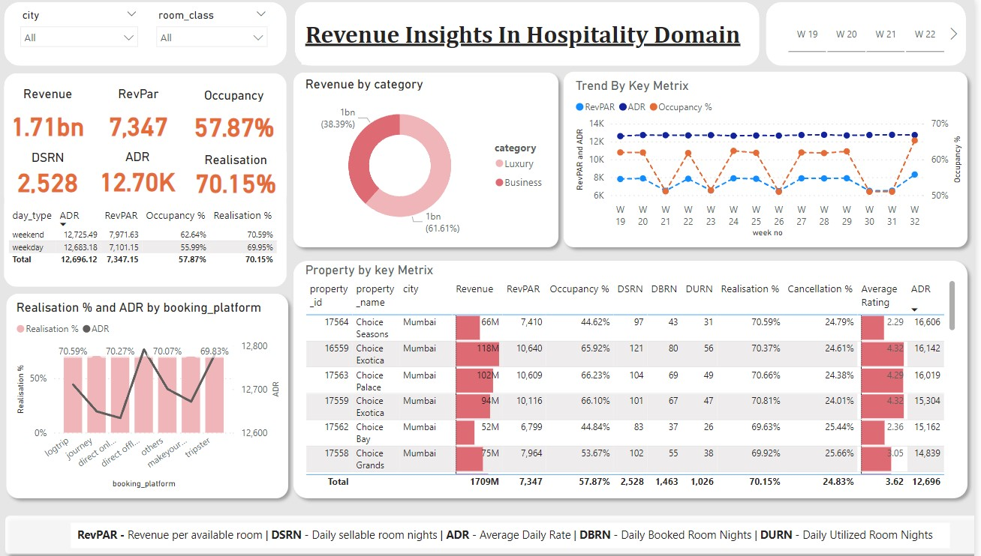

**Dashboard**

From the dashboard, the key metrics are at the left top.

Note:

* **RevPar -**Revenue Per Available Room,
* **DSRN -** Daily Sellable Room Nights/per night,
* **ADR -**Average Daily Rate/Amount per room,
* **DBRN -**Daily Booked Room Nights/per night, and
* **DURN -**Daily Booked Room Nights/per night,
* **Realization% -**The ratio of utilized rooms and booked rooms per night,
* **Occupancy% -**Total number of occupied rooms out of the available.

Also other mentioned charts, graphs are as followes

* Two filters at the left top, 1) filter by city 2) filter by room_class
* Third filter at right top, which is filter by week no.
* Realisation % and ADR by booking_platform
* Revenue by category, which contains – Luxury and Business
* Trend by key metrics, which contains – RevPar, ADR, occupancy %
* Property by key metrics, which contains – propert_id, property_name, city, Revenue, RevPar, occupancy %, DSRN, DURN, DBRN, Realisation, cancellation %, Average rating, ADR

**How much did we generate in the last three months?**

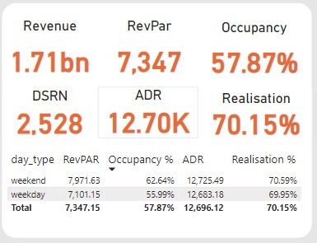

**Key Performance Indicators**

* Within the period of three months, the business was able to generate a revenue of ***1.71 billion*.**
* The occupancy rate across all locations is slightly above 50%,(***57.87%***). This means that on average, at least 50% of the rooms are utilized daily.
* The average selling price of a room for weekday  ***12,683K***and for weekend it is **12,725k** while RevPar equals ***7,347***.

***Is there any significant difference in occupancy for weekends and weekdays? Does this have any impact on the pricing?***

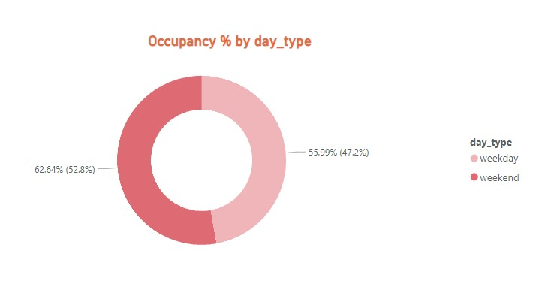

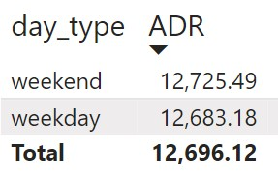

* The chart above shows that there are more guests/customers during weekends (**52.8%** occupancy) than on weekdays (**47.2%**).
* Meanwhile, there’s no significant difference in ADR and Realization on weekdays or weekends.
* This means they are using flat pricing strategy over dynamic strategy this is one of the reason for less realisation and low revenue
* This could be fixed by implementing weekday/weekend pricing strategy or Dynamic pricing strategy

**In terms of revenue generation, how has our revenue performed across the two room categories during this period?**

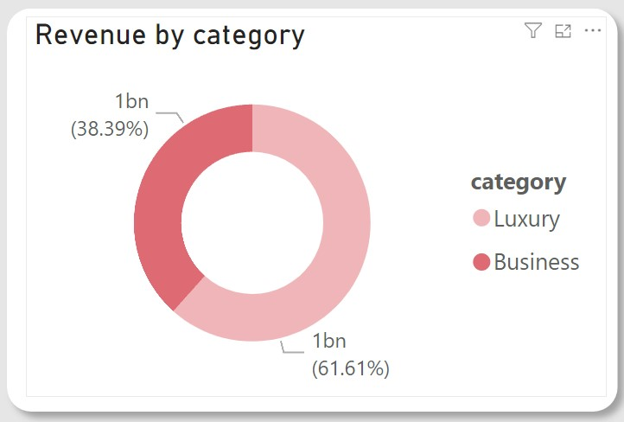

* The above chart shows that rooms in the Luxury category are contributing the majority of the revenue (**61.61%**).
* Rooms in the Business category contribute less than forty percent of the total revenue (**38.39%**).

**Could you pull weekly trends for occupancy? We’ll like to see that concerning Revenue.**

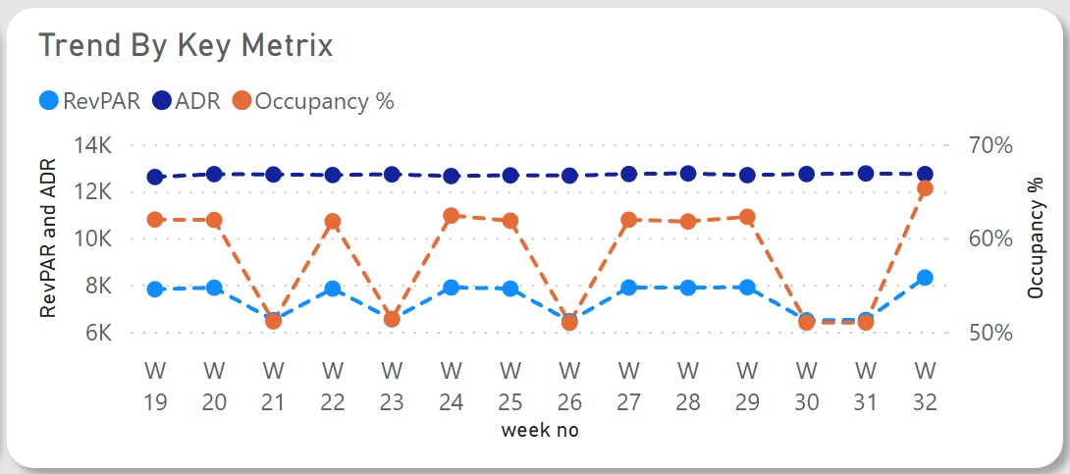

* This chart shows that RevPar and Occupancy are fluctuating while ADR is constant. RevPar is a by-product of Occupancy, hence the reason for the fluctuation.
* A constant ADR shows the pricing is relatively fixed.
* This means they are using flat pricing strategy over dynamic strategy this is one of the reason for less realisation and low revenue
* This could be fixed by implementing weekday/weekend pricing strategy or Dynamic pricing strategy

**What are our best and least performing properties in terms of revenue?**

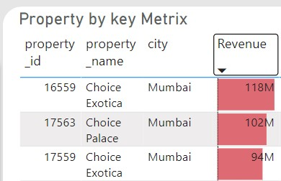

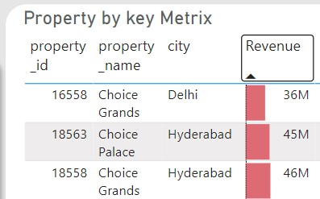

* Although there is very big difference in the revenue for best-performing and least-performing properties (hotels), Choice grands (**36M**) is performing very poorly in revenue generation.
* Where as Choice Exotic from Mumbai is on the top with **118M** revenue
* Hotels in Mumbai are generating more revenue than the hotels in Delhi and Hyderabad

**We have several booking platforms, can we see how they are all performing?**

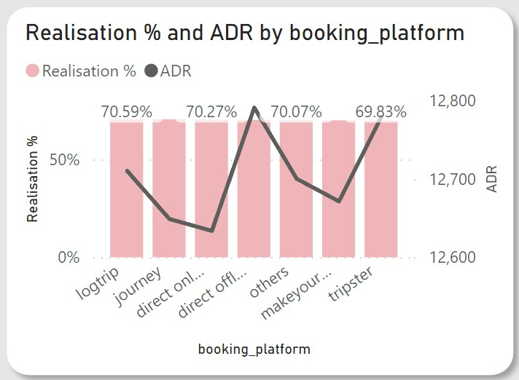

The line chart shows how ADR differs across all platforms.

* For ADR there is huge differance between direct online selling prise and direct offline prise
* Means the are selling at low price on online platform and high price at offline platform
* Where as lowest prices can put on their own sites as for that they don’t need to pay commission to every one.
* One more important thing to be considered is that pricing should be same on all platforms the should not be variable from site to site.
* If still you want to make it low on your own site then you should give discount in the form of coupons.

**KEY FINDINGS/INSIGHTS**

After analyzing the data, I was able to derive these insights:

* Over the period of three months (May, June, and July), Choice Hotel were able to generate a revenue of approximately 1.71 billion During this period, Revenue, ADR, occupancy, and RevPar increased from the latest previous week.
* The overall average rating is **3.62.**Customer satisfaction has improved over the past three months, with an average rating increase of **1.27%.**Although some hotels have ratings lower than the average.
* Weekends consistently exhibit higher occupancy rates than weekdays. There is no significant difference in ADR for weekdays and weekends. This shows that the hotel is using a flat pricing strategy.
* Other travel platforms/channels are the primary booking source, generating **40%** of total bookings and revenue. Direct offline booking contributes the least to bookings and revenue generation, with **5%.**
* The Average Daily(ADR) Rate is higher on direct offline (hotel premises) compared to other booking platforms.
* The Luxury room category contributes the majority of revenue and bookings. Mumbai city contributes most of the revenue, followed by Hyderabad, Bangalore, and Delhi.
* There is a correlation between revenue and average ratings, in that ratings with high ratings tend to generate more revenue.

**RECOMMENDATIONS**

* The rule of demand and supply and price elasticity is different for the travel, tourism, and hospitality industry. Therefore, the hotel should leverage dynamic pricing to increase revenue generation and increase prices for peak days and weekends.
* Consider differential pricing strategies for their offline booking platforms by implementing targeted marketing campaigns/promotions to boost bookings and in turn increase revenue.
* Choice Hotel should pay more attention to customer reviews and ratings and focus on improving customer satisfaction further by addressing critical areas identified in customer reviews.
* Explore opportunities to increase direct bookings through the hotel’s website to reduce dependence on other online platforms.

**CONCLUSION**

The data analysis performed using Power BI has provided valuable insights into various aspects of hotel management for The Choice Hotel. The findings and recommendations can help optimize operations, enhance customer satisfaction, and drive revenue growth. Regular monitoring and analysis of key metrics will ensure continued success in the hotel.