**DATA ANALYSIS AND INTERPRETATION, IN POWER BI**

Revenue generation is the way or manner in which a company sells itself and its products to the public to make money. It is a strategic operation that touches every part of an organization; it is not just sales or marketing. In the hospitality domain, revenue is generated through hotel room rentals, meeting space occupancy, and sales of food or beverages. Businesses face a period of growth and decline, and the hospitality industry is no exception. One thing is certain and phenomenal, the hospitality industry lives and dies by its customers. Good customer service can be a revenue generator for a hotel. Focusing on small details can mean the difference between remaining stagnant or increasing profitability. Small things add up.

This document presents the analysis of hotel data for Choice Hotel, from May 2023 — June 2023. This will enable us to gain insights into various aspects of hotel management, including, customer ratings, occupancy rates, revenue, and bookings. This analysis was performed using Power BI, a powerful data visualization and analytics tool.

**PROBLEM STATEMENT**

Choice Hotel owns multiple five-star hotels across India. They have been in the hospitality industry for the past 20 years. Due to strategic moves from other competitors and ineffective decision-making in management, Choice Hotel are losing its market share revenue in the luxury/business hotels category.

**Objective:** To provide Choice Hotel with insights from their historical data to regain their market share and revenue.

**SKILLS DEMONSTRATED**

This project exposed me to learning a lot using Microsoft Power BI.

· Multiple complex DAX formulas and Functions.

· Calculated columns

· Data Extraction, Cleaning, and Transformation (ETL)

· Data Modelling

· Data Visualization

**DATA TRANSFORMATION**

The dataset comprises five CSV files, three dimension tables, and two fact tables. The data was cleaned and transformed using Power Query in Power BI to ensure accuracy and consistency.

Data cleaning steps involved;

· Correct data type for columns.

· Replaced incorrect dates with the correct date.

**DATA MODELING**

Data model refers to the **abstract model** that demonstrates the **logical structure** of data and the **relationships** that exist in the data. In Microsoft Power BI, data model refers to everything that is loaded from query. A data model consists of **Two or more tables related**to each other.Let’s look at some basics before digging into the data modeling concept.

The **logical structure** of the tables that exist in a data model is known as the schema.  A good schema follows the following rules:

**No looping** exists between three or more tables of a data model.

Two tables are connected via **one active** relationship only.

The data model in this project of Power BI consists of five tables:

**dim_date:** Contains full date information about dates including day type (weekend or weekday), month, and week number (W19 — W32).

**dim_hotels:**Stores identity number of the hotel, property name, category it belongs to (luxury/business), and the city it’s located.

**dim_rooms:**Includes room id and room class.

**fact_bookings:**Stores information about bookings including booking dates, booking platforms, number of guests, revenue, check-in, and checkout dates.

**fact_aggregrated_bookings:**Includes successful bookings, hotel id, and capacity. The dimension tables (with the prefix “dim”) have a matching id in the fact tables (with the prefix “fact”). This modeling produces a one-to-many relationship.

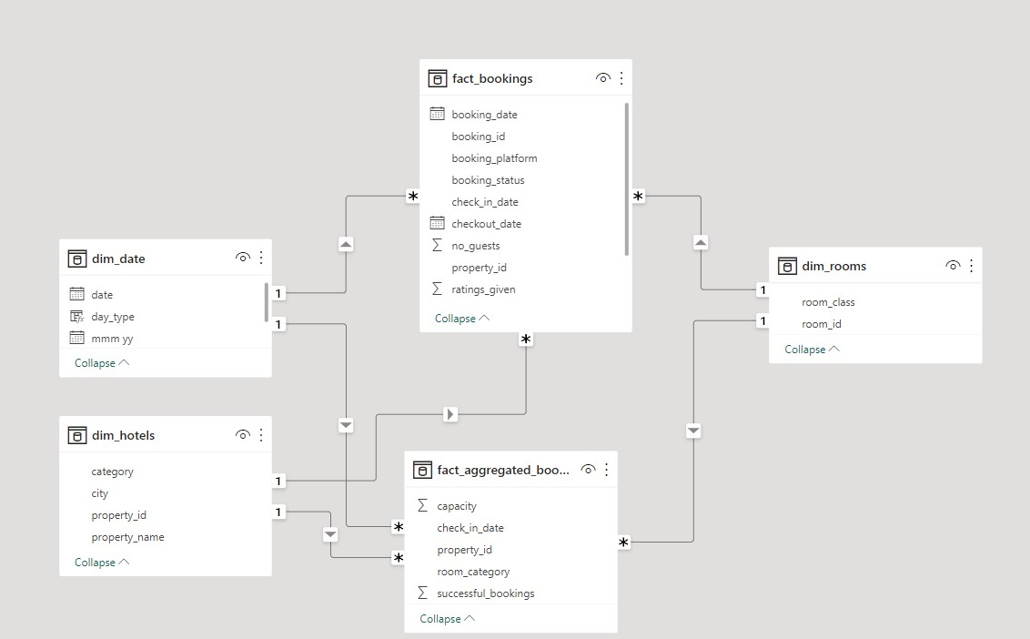

**Data Model**

In this data modelling we have used star schema method for data modelling,

Star schema

In a star schema, a **fact table is surrounded by multiple dimension tables.**

Power BI engine works best with star schema.

For example, the fact_aggregated_bookings table exists on the many side of the relationship and all the dimension tables exist on the 1 side of the relationship as shown above

The star schema does not necessarily have to be in the shape of a star.

The star schema does not necessarily need 5-dimension tables to complete the star.

**USING DAX IN POWER QUERRY**

**CALSULATED COLUMNS CREATED**

|  |  |  |  |
| --- | --- | --- | --- |
| ***1*** | ***wn*** | ***To get the week number from the corresponding date.*** | ***wn = WEEKNUM(dim_date[date])*** |
| ***2*** | ***day type*** | ***Based on the feedback from stakeholder, we considered  Friday and Saturday as weekend and weekdays from Sunday to Thurdsay. In PowerBI, Sunday weekday number is 1, Monday is 2 and so on. So, if weekday number is greater than 5, then weekend or else weekday.  https://learn.microsoft.com/en-us/dax/weekday-function-dax*** | ***day type =     Var wkd = WEEKDAY(dim_date[date],1)   return  IF(  wkd>5,"Weekend","Weekday")*** |

**MEASURES CREATED**

|  |  |  |  |
| --- | --- | --- | --- |
| ***1*** | ***Revenue*** | ***To get the total revenue_realized*** | ***Revenue = SUM(fact_bookings[revenue_realized])*** |
| ***2*** | ***Total Bookings*** | ***To get the total number of bookings happened*** | ***Total Bookings = COUNT(fact_bookings[booking_id])*** |
| ***3*** | ***Total Capacity*** | ***To get the total capacity of rooms present in hotels*** | ***Total Capacity = SUM(fact_aggregated_bookings[capacity])*** |
| ***4*** | ***Total Succesful Bookings*** | ***To get the total succesful bookings happened for all hotels*** | ***Total Succesful Bookings = SUM(fact_aggregated_bookings[successful_bookings])*** |
| ***5*** | ***Occupancy %*** | ***Occupancy means total successful bookings happened to the  total rooms available(capacity)*** | ***Occupancy % = DIVIDE([Total Succesful Bookings],[Total Capacity],0)*** |
| ***6*** | ***Average Rating*** | ***Get the average ratings given by the customers*** | ***Average Rating = AVERAGE(fact_bookings[ratings_given])*** |
| ***7*** | ***No of days*** | ***To get the total number of days present in the data. In our case, we have data from May to July. So 92 days.*** | ***No of days = DATEDIFF(MIN(dim_date[date]),MAX(dim_date[date]),DAY) +1*** |
| ***8*** | ***Total cancelled bookings*** | ***To get the"Cancelled" bookings out of all Total bookings happened*** | ***Total cancelled bookings = CALCULATE([Total Bookings],fact_bookings[booking_status]="Cancelled")*** |
| ***9*** | ***Cancellation %*** | ***calculating the cancellaton percentage.*** | ***Cancellation % = DIVIDE([Total cancelled bookings],[Total Bookings])*** |
| ***10*** | ***Total Checked Out*** | ***To get the successful 'Checked out' bookings out of all Total bookings happened*** | ***Total Checked Out = CALCULATE([Total Bookings],fact_bookings[booking_status]="Checked Out")*** |
| ***11*** | ***Total no show bookings*** | ***To get the"No Show" bookings out of all Total bookings happened   ("No show" means those customers who neither cancelled nor attend to their booked rooms)*** | ***Total no show bookings = CALCULATE([Total Bookings],fact_bookings[booking_status]="No Show")*** |
| ***12*** | ***No Show rate %*** | ***calculating the no show percentage.*** | ***No Show rate % = DIVIDE([Total no show bookings],[Total Bookings])*** |
| ***13*** | ***Booking % by Platform*** | ***To show the percentage contribution of each booking platform for bookings in hotels.  We have booking platforms like makeyourtrip, logtrip, tripster etc)*** | ***Booking % by Platform = DIVIDE([Total Bookings],  CALCULATE([Total Bookings],   ALL(fact_bookings[booking_platform])  ))*100*** |
| ***14*** | ***Booking % by Room class*** | ***To show the percentage contribution of each room class over total rooms booked.  We have room classes like Standard, Elite, Premium, Presidential.*** | ***Booking % by Room class = DIVIDE([Total Bookings],  CALCULATE([Total Bookings],   ALL(dim_rooms[room_class])  ))*100*** |
| ***15*** | ***ADR*** | ***Calculate the ADR(Average Daily rate)  It is the ratio of revenue to the total rooms booked/sold.  It is the measure of the average paid for rooms sold in a given time period*** | ***ADR = DIVIDE( [Revenue], [Total Bookings],0)*** |
| ***16*** | ***Realisation %*** | ***calculate the realisation percentage.  It is nothing but the succesful "checked out" percentage over all bookings happened.*** | ***Realisation % = 1- ([Cancellation %]+[No Show rate %])*** |
| ***17*** | ***RevPAR*** | ***Calculate the RevPAR(Revenue Per Available Room)  RevPAR represents the revenue generated per available room, whether or not they are occupied. RevPAR helps hotels measure their revenue generating performance to accurately price rooms. RevPAR can help hotels measure themselves against other properties or brands.*** | ***RevPAR = DIVIDE([Revenue],[Total Capacity])*** |
| ***18*** | ***DBRN*** | ***calculate DBRN(Daily Booked Room Nights)  This metrics tells on average how many rooms are booked for a day considering a time period*** | ***DBRN = DIVIDE([Total Bookings], [No of days])*** |
| ***19*** | ***DSRN*** | ***calculate DSRN(Daily Sellable Room Nights)  This metrics tells on average how many rooms are ready to sell for a day considering a time period*** | ***DSRN = DIVIDE([Total Capacity], [No of days])*** |
| ***20*** | ***DURN*** | ***calculate DURN(Daily Utilized Room Nights)  This metric tells on average how many rooms are succesfully utilized by customers for a day considering a time period*** | ***DURN = DIVIDE([Total Checked Out],[No of days])*** |
| ***21*** | ***Revenue WoW change %*** | ***To get the revenue change percentage week over week.  Here,  revcw for current week revpw for previous week*** | ***Revenue WoW change % =  Var selv = IF(HASONEFILTER(dim_date[wn]),SELECTEDVALUE(dim_date[wn]),MAX(dim_date[wn])) var revcw = CALCULATE([Revenue],dim_date[wn]= selv) var revpw = CALCULATE([Revenue],FILTER(ALL(dim_date),dim_date[wn]= selv-1))  return   DIVIDE(revcw,revpw,0)-1*** |
| ***22*** | ***Occupancy WoW change %*** | ***To get the occupancy change percentage week over week.  Here,  revcw for current week revpw for previous week*** | ***Occupancy WoW change % =  Var selv = IF(HASONEFILTER(dim_date[wn]),SELECTEDVALUE(dim_date[wn]),MAX(dim_date[wn])) var revcw = CALCULATE([Occupancy %],dim_date[wn]= selv) var revpw = CALCULATE([Occupancy %],FILTER(ALL(dim_date),dim_date[wn]= selv-1))  return   DIVIDE(revcw,revpw,0)-1*** |
| ***23*** | ***ADR WoW change %*** | ***To get the ADR(Average Daily rate) change percentage week over week.  Here,  revcw for current week revpw for previous week*** | ***ADR WoW change % =  Var selv = IF(HASONEFILTER(dim_date[wn]),SELECTEDVALUE(dim_date[wn]),MAX(dim_date[wn])) var revcw = CALCULATE([ADR],dim_date[wn]= selv) var revpw = CALCULATE([ADR],FILTER(ALL(dim_date),dim_date[wn]= selv-1))  return   DIVIDE(revcw,revpw,0)-1*** |
| ***24*** | ***Revpar WoW change %*** | ***To get the RevPar(Revenue Per Available Room) change percentage week over week.  Here,  revcw for current week revpw for previous week*** | ***Revpar WoW change % =  Var selv = IF(HASONEFILTER(dim_date[wn]),SELECTEDVALUE(dim_date[wn]),MAX(dim_date[wn])) var revcw = CALCULATE([RevPAR],dim_date[wn]= selv) var revpw = CALCULATE([RevPAR],FILTER(ALL(dim_date),dim_date[wn]= selv-1))  return   DIVIDE(revcw,revpw,0)-1*** |
| ***25*** | ***Realisation WoW change %*** | ***To get the Realisation change percentage week over week.  Here,  revcw for current week revpw for previous week*** | ***Realisation WoW change % =  Var selv = IF(HASONEFILTER(dim_date[wn]),SELECTEDVALUE(dim_date[wn]),MAX(dim_date[wn])) var revcw = CALCULATE([Realisation %],dim_date[wn]= selv) var revpw = CALCULATE([Realisation %],FILTER(ALL(dim_date),dim_date[wn]= selv-1))  return   DIVIDE(revcw,revpw,0)-1*** |
| ***26*** | ***DSRN WoW change %*** | ***To get the DSRN(Daily Sellable Room Nights) change percentage week over week.  Here,  revcw for current week revpw for previous week*** | ***DSRN WoW change % =  Var selv = IF(HASONEFILTER(dim_date[wn]),SELECTEDVALUE(dim_date[wn]),MAX(dim_date[wn])) var revcw = CALCULATE([DSRN],dim_date[wn]= selv) var revpw = CALCULATE([DSRN],FILTER(ALL(dim_date),dim_date[wn]= selv-1))  return   DIVIDE(revcw,revpw,0)-1*** |

**ANALYSIS/VISUALIZATION**

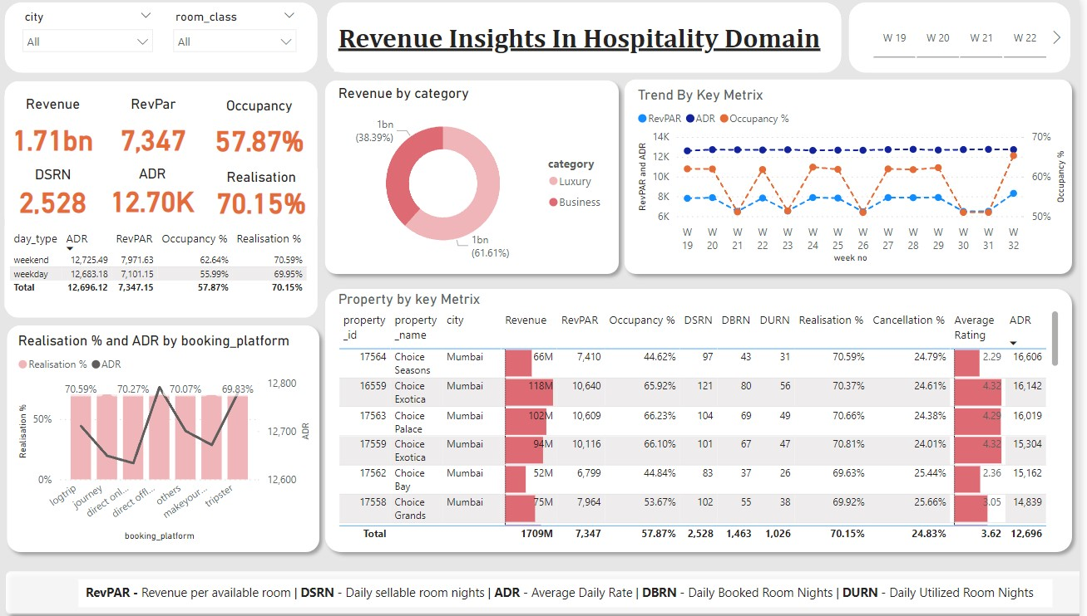

**Dashboard**

From the dashboard, the key metrics are at the left top.

Note:

* **RevPar -**Revenue Per Available Room,
* **DSRN -** Daily Sellable Room Nights/per night,
* **ADR -**Average Daily Rate/Amount per room,
* **DBRN -**Daily Booked Room Nights/per night, and
* **DURN -**Daily Booked Room Nights/per night,
* **Realization% -**The ratio of utilized rooms and booked rooms per night,
* **Occupancy% -**Total number of occupied rooms out of the available.

Also other mentioned charts, graphs are as followes

* Two filters at the left top, 1) filter by city 2) filter by room_class
* Third filter at right top, which is filter by week no.
* Realisation % and ADR by booking_platform
* Revenue by category, which contains – Luxury and Business
* Trend by key metrics, which contains – RevPar, ADR, occupancy %
* Property by key metrics, which contains – propert_id, property_name, city, Revenue, RevPar, occupancy %, DSRN, DURN, DBRN, Realisation, cancellation %, Average rating, ADR

**How much did we generate in the last three months?**

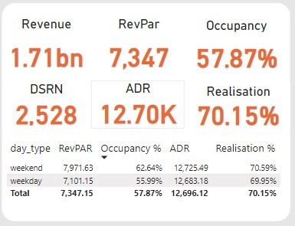

**Key Performance Indicators**

* Within the period of three months, the business was able to generate a revenue of ***1.71 billion*.**
* The occupancy rate across all locations is slightly above 50%,(***57.87%***). This means that on average, at least 50% of the rooms are utilized daily.
* The average selling price of a room for weekday  ***12,683K***and for weekend it is **12,725k** while RevPar equals ***7,347***.

***Is there any significant difference in occupancy for weekends and weekdays? Does this have any impact on the pricing?***

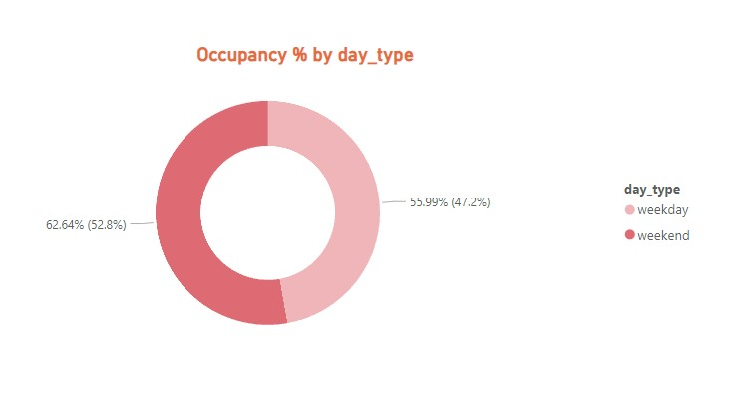

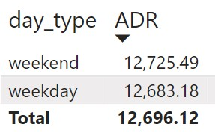

* The chart above shows that there are more guests/customers during weekends (**52.8%** occupancy) than on weekdays (**47.2%**).
* Meanwhile, there’s no significant difference in ADR and Realization on weekdays or weekends.
* This means they are using flat pricing strategy over dynamic strategy this is one of the reason for less realisation and low revenue
* This could be fixed by implementing weekday/weekend pricing strategy or Dynamic pricing strategy

**In terms of revenue generation, how has our revenue performed across the two room categories during this period?**

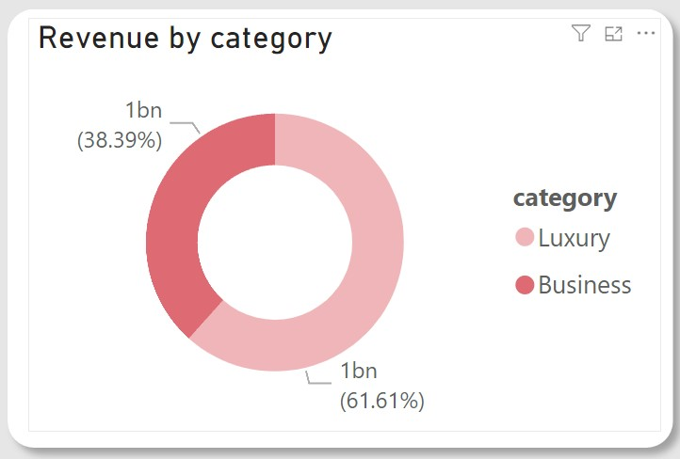

* The above chart shows that rooms in the Luxury category are contributing the majority of the revenue (**61.61%**).
* Rooms in the Business category contribute less than forty percent of the total revenue (**38.39%**).

**Could you pull weekly trends for occupancy? We’ll like to see that concerning Revenue.**

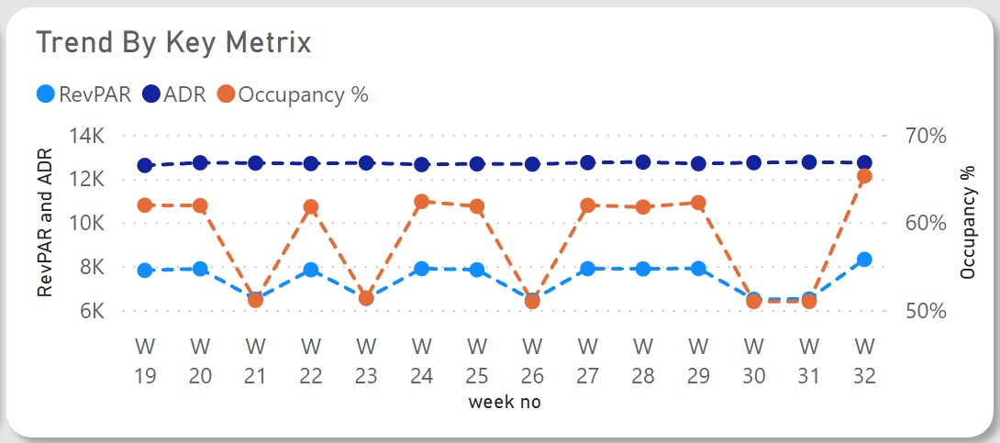

* This chart shows that RevPar and Occupancy are fluctuating while ADR is constant. RevPar is a by-product of Occupancy, hence the reason for the fluctuation.
* A constant ADR shows the pricing is relatively fixed.
* This means they are using flat pricing strategy over dynamic strategy this is one of the reason for less realisation and low revenue
* This could be fixed by implementing weekday/weekend pricing strategy or Dynamic pricing strategy

**What are our best and least performing properties in terms of revenue?**

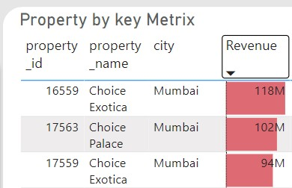

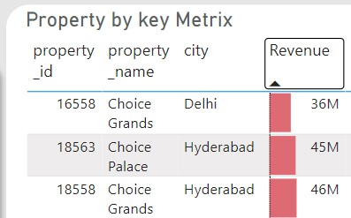

* Although there is very big difference in the revenue for best-performing and least-performing properties (hotels), Choice grands (**36M**) is performing very poorly in revenue generation.
* Where as Choice Exotic from Mumbai is on the top with **118M** revenue
* Hotels in Mumbai are generating more revenue than the hotels in Delhi and Hyderabad

**We have several booking platforms, can we see how they are all performing?**

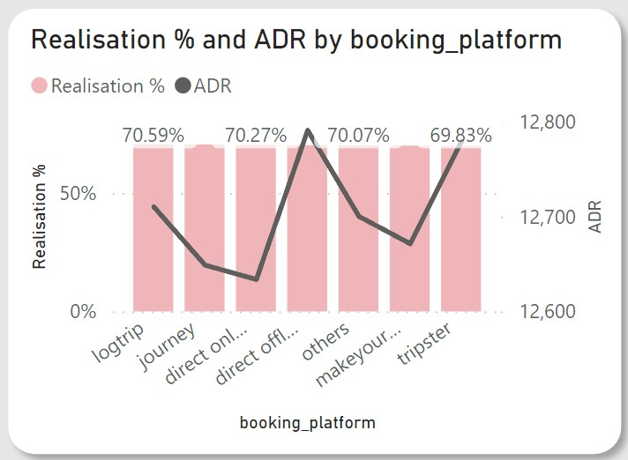

The line chart shows how ADR differs across all platforms.

* For ADR there is huge differance between direct online selling prise and direct offline prise
* Means the are selling at low price on online platform and high price at offline platform
* Where as lowest prices can put on their own sites as for that they don’t need to pay commission to every one.
* One more important thing to be considered is that pricing should be same on all platforms the should not be variable from site to site.
* If still you want to make it low on your own site then you should give discount in the form of coupons.

**KEY FINDINGS/INSIGHTS**

After analyzing the data, I was able to derive these insights:

* Over the period of three months (May, June, and July), Choice Hotel were able to generate a revenue of approximately 1.71 billion During this period, Revenue, ADR, occupancy, and RevPar increased from the latest previous week.
* The overall average rating is **3.62.**Customer satisfaction has improved over the past three months, with an average rating increase of **1.27%.**Although some hotels have ratings lower than the average.
* Weekends consistently exhibit higher occupancy rates than weekdays. There is no significant difference in ADR for weekdays and weekends. This shows that the hotel is using a flat pricing strategy.
* Other travel platforms/channels are the primary booking source, generating **40%** of total bookings and revenue. Direct offline booking contributes the least to bookings and revenue generation, with **5%.**
* The Average Daily(ADR) Rate is higher on direct offline (hotel premises) compared to other booking platforms.
* The Luxury room category contributes the majority of revenue and bookings. Mumbai city contributes most of the revenue, followed by Hyderabad, Bangalore, and Delhi.
* There is a correlation between revenue and average ratings, in that ratings with high ratings tend to generate more revenue.

**RECOMMENDATIONS**

* The rule of demand and supply and price elasticity is different for the travel, tourism, and hospitality industry. Therefore, the hotel should leverage dynamic pricing to increase revenue generation and increase prices for peak days and weekends.
* Consider differential pricing strategies for their offline booking platforms by implementing targeted marketing campaigns/promotions to boost bookings and in turn increase revenue.
* Choice Hotel should pay more attention to customer reviews and ratings and focus on improving customer satisfaction further by addressing critical areas identified in customer reviews.
* Explore opportunities to increase direct bookings through the hotel’s website to reduce dependence on other online platforms.

**CONCLUSION**

The data analysis performed using Power BI has provided valuable insights into various aspects of hotel management for The Choice Hotel. The findings and recommendations can help optimize operations, enhance customer satisfaction, and drive revenue growth. Regular monitoring and analysis of key metrics will ensure continued success in the hotel.