**HOW SELENIUM WEB DRIVER IS INSTALLED AND INTEGRATED IN ECLIPSE**

Step 1: Download Selenium Standalone Server jar

Step 2: Launch eclipse and create a java project

* Launch the Eclipse and create a Workspace.
* Create Project : Click on File -> New -> Java project

Step 3: Configure a WebDriver with Eclipse

* Add selenium standalone server jars.
* Right-click on project -> Select properties -> Select Java Build Path
* Navigate to the libraries tab and click on the Add external Jars button
* Add selenium standalone server jar files
* Click on Apply and Close button

Download Eclipse using Eclipse Installer 🡪 Follow below steps:

As shown in screenshot below, click on Install button

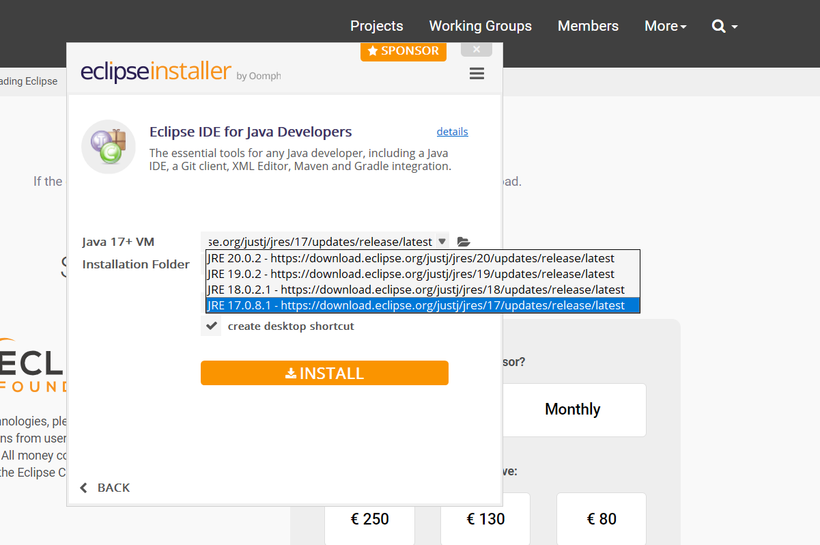

Select the Unassigned checkbox. Click on trusted Selected.

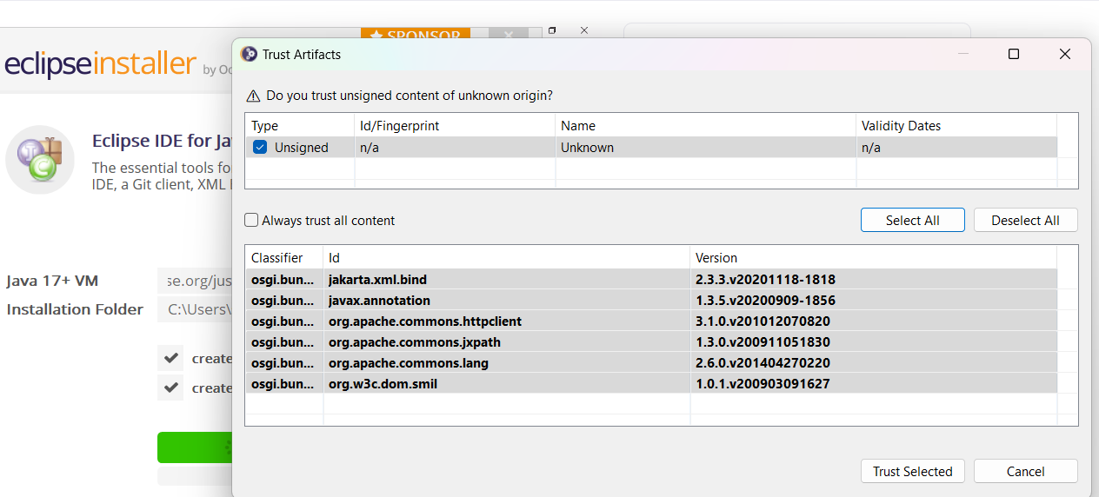

New Eclipse Editor will launch

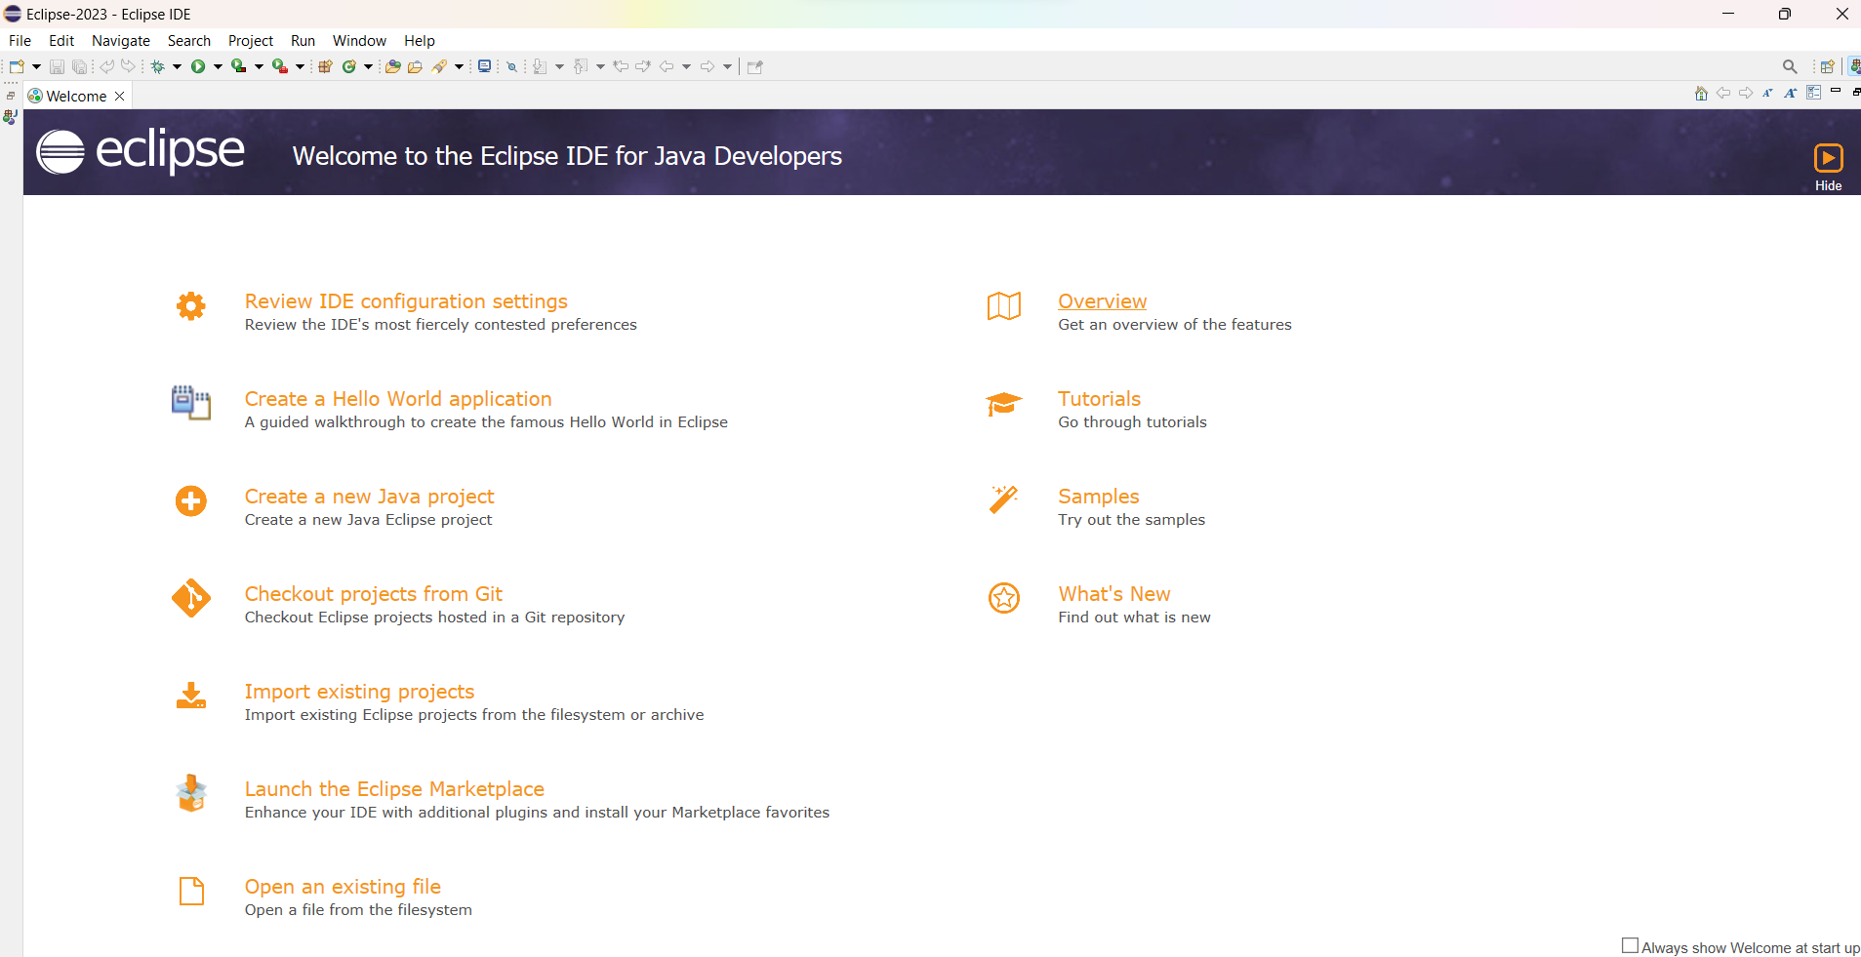

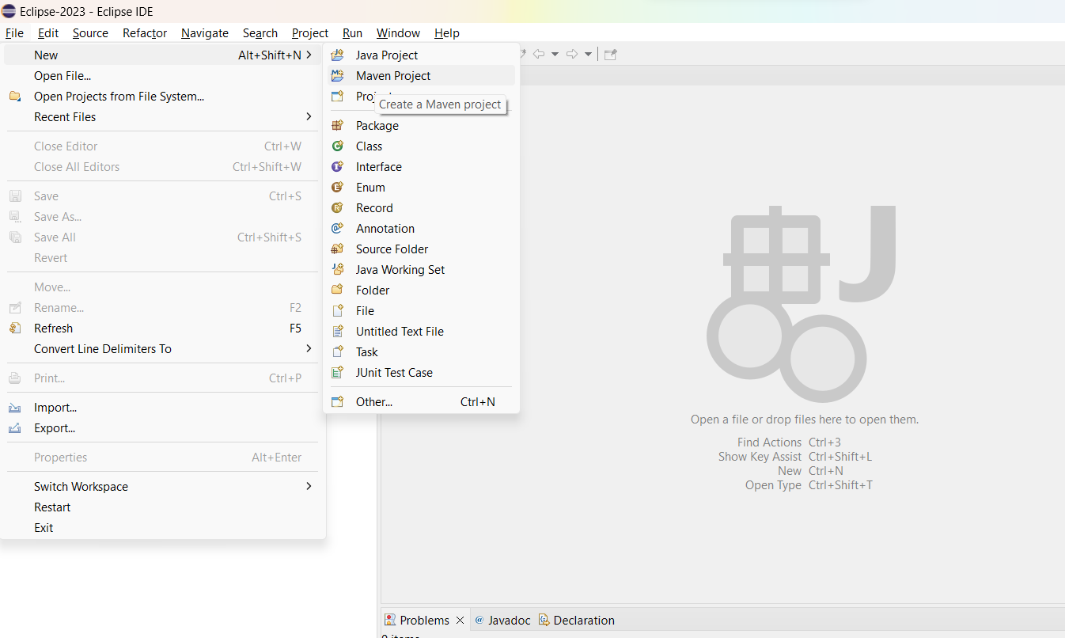

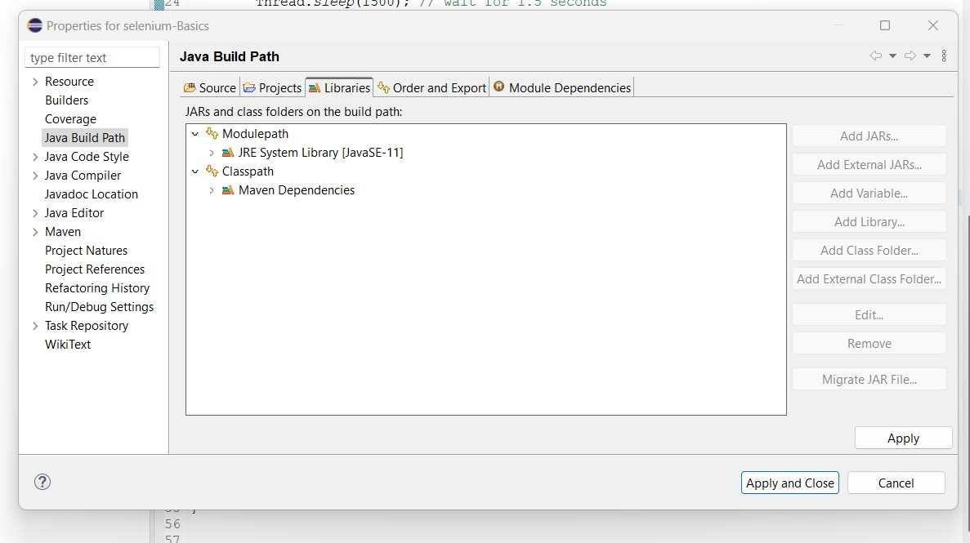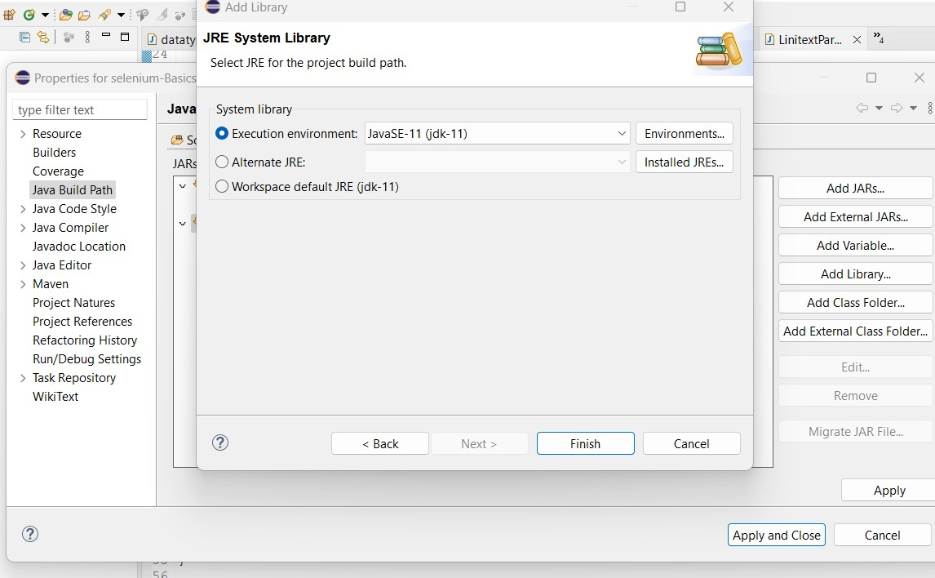

Finished