# Project Report

On

**STUDENT MANAGEMENT SYSTEM**

A Desktop Application

Submitted in partial fulfillment of the requirement

for the award of the three year diploma in

COMPUTER ENGINEERING

Under the guidance of

Mr. H S Bhatia



**AMBEDKAR INSTITUTE OF TECHNOLOGY**

Shakarpur Near Nirman Vihar Metro Station Delhi-110092

(SESSION: 2017-2020)

**Submitted by: - Guided by: -**

Suraj Mamgai Mr. H S Bhatia

BTE Roll No: 1702051062 ( Project In-Charge)

(SSPL-DRDO, Intern)

**Acknowledgement**

To get practical knowledge and to make a report on a certain topic without anybody’s help is really a task of great difficulty, fortunately, in preparation of this project report I got the help of many known as well as unknowns for providing the valuable information about each and every stage of this project.

First of all, I am extremely thankful to the **DIPLOMA (Computer Engineering) department of AMBEDKAR INSTITUTE OF TECHNOLOGY, Rohini** for giving me enough time and support to complete my project.

I consider myself privileged having found an opportunity to express our heartfelt thanks to our head of the Computer Science Engineering Department.

I am grateful to my project guide **Mr. H S Bhatia** for the guidance, inspiration and constructive suggestions that were helpful to me in the preparation of this project.

I am also thankful to my colleagues who have helped in successful completion of this project.

**AMBEDKAR INSTITUTE OF TECHNOLOGY**

SHAKARPUR, NEAR METRO STATION, DELHI-110092

## (DIRECTORATE OF TRAINING & TECHNICAL EDUCATION)

GOVT. OF NCT OF DELHI

**CERTIFICATE**

This is certified by the project report entitled “STUDENT MANAGEMENT SYSTEM” which is submitted by **MR. SURAJ MAMGAI** to **AMBEDKAR INSTITUTE OF TECHNOLOGY,** a record of bonafide project work carried out by him under our supervision and guidance and submitted for partial fulfillment to award of diploma in Computer Engineering

**Mr. H S BHATIA**

(SUPERVISOR)

**Abstract**

“STUDENT MANAGEMENT SYSTEM” is a desktop-based application to manage the database of all the students in a college within a single system. This project will handle the whole system of the college which is related to the students.

The Student Management System has most of the facilities to keep the records of students, teaching, feeds, notice, library and non- teaching stuff with all their required details along with all required daily activities. It has most of the facilities that a modern college requires to computerize its day-to -day jobs.

It comprises Administrator as well as User panel with different access levels to perform various functions.

**INTRODUCTION**

This project on “Student Management System” is useful for easy user interface. The system utilizes powerful database management, data retrieval and data manipulation. This project provides more ease for managing the data than manually maintaining it in the documents. The project is useful for saving valuable time and reduces the huge paperwork.

It will help educational Institutions like schools and colleges will keep track of their student records like personal details, contact details, marks details, etc. The Internet is rapidly becoming a part of the everyday lives of a majority of people in the world. People perform various activities on the Internet and one of them is storing their data in a data-base where they are interested in. In these databases they can post the queries and they can retrieve the required data. Obviously, there is a need for Student Information System software for management of student’s data.

There are many departments of administration for the maintenance of college information and student databases in any institution. All these departments provide various records regarding students. Most of these track records need to maintain information about the students. This information could be the general details like student name, address, performance, attendance etc. or specific information related to departments like collection of data. All the modules in college administration are interdependent. They are maintained manually. So, they need to be automated and centralized as, Information from one module will be needed by other modules.

**REQUIREMENT ANALYSIS**

1. Introduction

The following subsections are an overview of the entire Software Requirements Specification (SRS).

* 1. Purpose

This document provides the technical description of all software requirements of STUDENT MANAGEMENT SYSTEM.

The document will not only define the product functions, user characteristics, constraints, and specific requirements of the system, but also serve as a basis for the Software Design Document that is prepared according to IEEE Std.

The objective of the software is to maintain information pertaining to the students with the purpose of: -

* Planned approach towards working
* Accuracy
* Reliability
* No Redundancy
* Immediate retrieval of information
* Immediate storage of information
* Easy to Operate
  1. Scope

“STUDENT MANAGEMENT SYSTEM” is a project with a mission of viewing and manipulating student information of Ambedkar Institute of Technology in a Web-based environment. Thus, the overall system will consist of a Student Database System and Web Interface.

The Student Database System will supply the fundamental database structure of the entire system whereas Web Interface will provide a secure Web interface between the users and the database.

The Software aims to create a “paperless institute” rather than using a traditional record keeping system.

Although this project is presently being designed specifically for Ambedkar Institute of Technology but there exists the possibility in future to upgrade it to general level.

The software will not only help the following levels of users in viewing the information but also each user can alongside update changes within their respective access limits.

* Administrative Level
* User Level
* Management of Institute
* Faculty
* Students
* Department Staff

1.3 Definition

Paperless Office: refers to an integrated working environment where all the data and documentation is represented in electronic format.

Student Personal Information: refers to personal records of individual student’s biodata along with his performance throughout the course. Traditional Record Keeping System: refers to a manual system where all records are kept on papers by manual in-charge.

* 1. References

Pressman, Roger S., Software Engineering “A Practitioner’ s Approach”, Fifth Edition, McGraw-Hill, 2000.

Software Engineering by K.K Aggarwal and Yogesh Singh

1.5 Overview

This document is prepared in accordance with the IEEE Std, IEEE Recommended Practice for Software Requirements Specifications.

It also provides product perspectives, product functions, user characteristics, general constraints, and assumptions and dependencies of the system.

It will contain functional and performance requirements, design constraints, attributes and external interface requirements for the Software.

**PLATFORM (TECHNOLOGIES/TOOLS)**

**The JAVA and the Swing framework**

Java is one of the most popular and widely used programming languages and platforms. A platform is an environment that helps to develop and run programs written in any programming language.

Java is fast, reliable and secure. From desktop to web applications, scientific supercomputers to gaming consoles, cell phones to the Internet, Java is used in every nook and corner.

Overview of the JAVA LANGUAGE

Java is a popular programming language, created in 1995.

It is owned by Oracle, and more than **3 billion** devices run Java.

It is used for:

* Mobile applications (especially Android apps)
* Desktop applications
* Web applications
* Web servers and application servers
* Games
* Database connection
* And much, much more!

**Why Use Java?**

* Java works on different platforms (Windows, Mac, Linux, Raspberry Pi, etc.)
* It is one of the most popular programming languages in the world
* It is easy to learn and simple to use
* It is open-source and free
* It is secure, fast and powerful
* It has a huge community support (tens of millions of developers)

**Java** is a [general-purpose](https://en.wikipedia.org/wiki/General-purpose_language) [programming language](https://en.wikipedia.org/wiki/Programming_language) that is [class-based](https://en.wikipedia.org/wiki/Class-based_programming), [object-oriented](https://en.wikipedia.org/wiki/Object-oriented_programming), and specifically designed to have as few implementation [dependencies](https://en.wikipedia.org/wiki/Dependency_(computer_science)) as possible. It is intended to let [application developers](https://en.wikipedia.org/wiki/Application_developer) "[write once, run anywhere](https://en.wikipedia.org/wiki/Write_once,_run_anywhere)" (WORA), meaning that [compiled](https://en.wikipedia.org/wiki/Compiler) Java code can run on all platforms that support Java without the need for recompilation.

 Java applications are typically compiled to ["bytecode"](https://en.wikipedia.org/wiki/Java_bytecode) that can run on any [Java virtual machine](https://en.wikipedia.org/wiki/Java_virtual_machine) (JVM) regardless of the underlying [computer architecture](https://en.wikipedia.org/wiki/Computer_architecture). The [syntax](https://en.wikipedia.org/wiki/Syntax_(programming_languages)) of Java is similar to [C](https://en.wikipedia.org/wiki/C_(programming_language)) and [C++](https://en.wikipedia.org/wiki/C%2B%2B), but it has fewer [low-level](https://en.wikipedia.org/wiki/Low-level_programming_language) facilities than either of them.

As of 2018, Java was according to [GitHub](https://en.wikipedia.org/wiki/GitHub) one of the most [popular programming languages in use](https://en.wikipedia.org/wiki/Measuring_programming_language_popularity), particularly for [client-server](https://en.wikipedia.org/wiki/Client%E2%80%93server) [web applications](https://en.wikipedia.org/wiki/Web_applications), with a reported 9 million developers.

## 

## Structure of Java Program

Structure of a java program is the standard format released by a Language developer to the Industry programmer.

Sun Micro System has prescribed the following structure for the java programmers for developing java application.

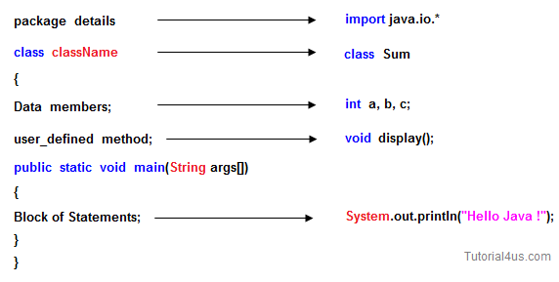

* A **package** is a collection of classes, interfaces and sub-packages. A sub package contains a collection of classes, interfaces and sub-sub packages etc. java.lang.*; package is imported by default and this package is known as default package.
* **Class** is a keyword used for developing user defined data types and every java program must start with a concept of class.
* **"ClassName"** represents a valid variable name treated as a name of the class each and every class name in java is treated as user-defined data type.
* **Data members** representing either instance or static will be selected based on the name of the class.
* **User-defined** methods represent either instance or static; they are meant for performing the operations either once or each and every time.
* Each and every java program starts execution from the main () method. And hence main () method is known as program driver.
* Since the main () method of java is not returning any value and hence its return type must be void.
* Since the main () method of java executes only once throughout the java program execution and hence its nature must be static.
* Since main () method must be accessed by every java programmer and hence whose access specifier must be public.
* Each and every main () method of java must take an array of objects of String.
* **Block of statements** represents a set of executable statements which are in term calling user-defined methods are containing business-logic.
* The file naming conversion in the java programming is that which-ever class is containing the main () method, that class name must be given as a file name with an extension .java.

## Compile and Run Java Program: It's Two Step Process

Compilation and execution of a Java program is a two-step process. During the compilation phase Java compiler compiles the source code and generates *bytecode*. This intermediate *bytecode* is saved in the form of a .class file. In second phase, Java virtual machine (JVM) also called Java interpreter takes the .class as input and generates output by executing the *bytecode*. Java is an object-oriented programming language; therefore, a program in Java is made of one or more classes. No matter how trivial a Java program is, it must be written in the form of a class.

## Compile Java Program from Command Prompt

Once the Java program is written and saved, first, it has to be compiled. To compile a Java program from the command line we need to invoke the Java compiler by supplying the javac command. Java compiler comes with JDK (Java Development Kit). JDK is a bundle of software needed for developing Java applications. It includes the JRE (Java Runtime Environment), set of API classes, Java compiler, Webstart and additional files needed to write Java applets and applications.

## Run Java Program from Command Prompt

After successful compilation of HelloWorld.java to HelloWorld.class to actually run the program, we use the Java interpreter, called java. To do so, pass the class name HelloWorld as a command-line argument, as shown follows:

[root host ~] # java HelloWorld

The message Hello World! will be printed on the screen as a result of the above command.

It is important to note that in above command we have omitted the .class suffix of the byte-code file name (that is HelloWorld.class in our case). The java command invokes the *Java Virtual Machine* (will be written JVM hereafter). JVM then loads the specified class mentioned at the command line and invokes the method main of this class and starts executing it, passing it a single argument that is an array of strings. The array of strings passed to main is to receive command line arguments. The JVM generally takes the following steps in order to run a Java program.

# **Features of Java**

The primary objective of [Java programming](https://www.javatpoint.com/java-tutorial) language creation was to make it a portable, simple and secure programming language. Apart from this, there are also some excellent features which play an important role in the popularity of this language. The features of Java are also known as java *buzzwords*.

A list of most important features of Java language is given below.

1. Simple
2. Object-Oriented
3. Portable
4. Platform independent
5. Secured
6. Robust
7. Architecture neutral
8. Interpreted
9. High Performance
10. Multithreaded
11. Distributed
12. Dynamic

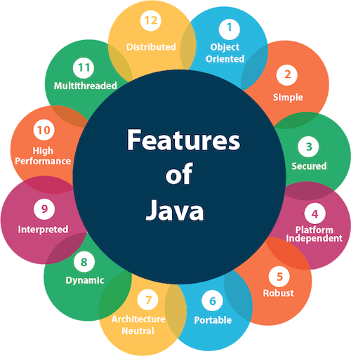

**TECHNOLOGY USED**

**Front-end**

**Swing Framework: -**

Swing Framework contains a set of classes that provides more powerful and flexible GUI components than those of **AWT**. **Swing** provides the look and feel of modern Java GUI. Swing library is an official Java GUI tool kit released by Sun Microsystems. It is used to create graphical user interfaces with Java.

Swing classes are defined in javax.swing package and its sub-packages.

#### **Main Features of Swing Toolkit: -**

1. Platform Independent
2. Customizable
3. Extensible
4. Configurable
5. Lightweight
6. Rich Controls
7. Pluggable Look and Feel

#### **AWT and Swing Hierarchy**

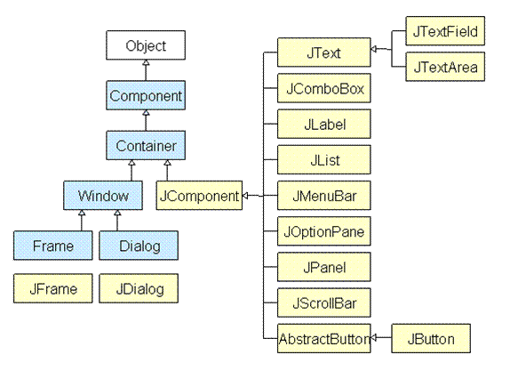

**BACK END: MySQL- XAMPP SERVER**

MySQL is [free and open-source software](https://en.wikipedia.org/wiki/Free_and_open-source_software) under the terms of the [GNU General Public License](https://en.wikipedia.org/wiki/GNU_General_Public_License), and is also available under a variety of [proprietary](https://en.wikipedia.org/wiki/Proprietary_software) licenses. MySQL was owned and sponsored by the [Swedish](https://en.wikipedia.org/wiki/Sweden) company [MySQL AB](https://en.wikipedia.org/wiki/MySQL_AB), which was bought by Sun Microsystems (now [Oracle Corporation](https://en.wikipedia.org/wiki/Oracle_Corporation)).[[8]](https://en.wikipedia.org/wiki/MySQL#cite_note-sunacquire-8) In 2010, when Oracle acquired Sun, Widenius [forked](https://en.wikipedia.org/wiki/Fork_(software_development)) the [open-source](https://en.wikipedia.org/wiki/Open-source) MySQL project to create [MariaDB](https://en.wikipedia.org/wiki/MariaDB).

The MySQL server software itself and the client libraries use a dual licensing distribution. They are offered under GPL version 2or a proprietary license

Xampp Server: -

XAMPP is a [free and open-source](https://en.wikipedia.org/wiki/Free_and_open-source) [cross-platform](https://en.wikipedia.org/wiki/Cross-platform) [web server](https://en.wikipedia.org/wiki/Web_server) [solution stack](https://en.wikipedia.org/wiki/Solution_stack) package developed by Apache Friends,[[2]](https://en.wikipedia.org/wiki/XAMPP#cite_note-kaiseidlerinterview-2) consisting mainly of the [Apache HTTP Server](https://en.wikipedia.org/wiki/Apache_HTTP_Server), [MariaDB](https://en.wikipedia.org/wiki/MariaDB) [database](https://en.wikipedia.org/wiki/Database), and [interpreters](https://en.wikipedia.org/wiki/Interpreter_(computing)) for scripts written in the [PHP](https://en.wikipedia.org/wiki/PHP) and [Perl](https://en.wikipedia.org/wiki/Perl) [programming languages](https://en.wikipedia.org/wiki/Programming_language).[[3]](https://en.wikipedia.org/wiki/XAMPP#cite_note-x_mariadb-3)[[4]](https://en.wikipedia.org/wiki/XAMPP#cite_note-4) Since most actual web server deployments use the same components as XAMPP, it makes transitioning from a local test server to a live server possible.

XAMPP's ease of deployment means a [WAMP](https://en.wikipedia.org/wiki/WAMP) or [LAMP](https://en.wikipedia.org/wiki/LAMP_(software_bundle)) stack can be installed quickly and simply on an operating system by a developer. With the advantage a number of common add-in applications such as [WordPress](https://en.wikipedia.org/wiki/Wordpress) and [Joomla!](https://en.wikipedia.org/wiki/Joomla!) can also be installed with similar ease using [Bitnami](https://en.wikipedia.org/wiki/Bitnami).

**ER diagram**

An Entity-relationship model is an abstract conceptual representation of structured data. Entity relationship modeling is a relational schema database modeling method, used in Software Project Management to produce a type of conceptual data model (or semantic data model) of a system, often a relational database, and its requirements in top-down fashion.













**Admin ER Diagram**

























**DATA FLOW DIAGRAMS**

A **data-flow diagram** (DFD) is a way of representing the flow of a data of a [process](https://en.wikipedia.org/wiki/Process) or a system (usually an [information system](https://en.wikipedia.org/wiki/Information_system)) The DFD also provides information about the outputs and inputs of each entity and the process itself. A data-flow diagram has no control flow, there are no decision rules and no loops. Specific operations based on the data can be represented by a [flowchart](https://en.wikipedia.org/wiki/Flowchart).

**Data flow diagram for login page**



username & verified /

password unverified

**Data flow diagram for registration page**



Enter details Registration

Successful



saving details to database Checking users existence



**Data flow diagram User Application**













**DESIGN**

Program pages and code

* 1. User panel
* Welcome page



Program code

/*

* To change this license header, choose License Headers in Project Properties.

* To change this template file, choose Tools | Templates

* and open the template in the editor.

*/

package user;

/**

*

* @author aahha

*/

public class Welcome extends javax.swing.JFrame {

/**

* Creates new form Demo

*/

public Welcome() {

initComponents();

}

/**

* This method is called from within the constructor to initialize the form.

* WARNING: Do NOT modify this code. The content of this method is always

* regenerated by the Form Editor.

*/

@SuppressWarnings("unchecked")

// <editor-fold defaultstate="collapsed" desc="Generated Code">

private void initComponents() {

jPanel1 = new javax.swing.JPanel();

jButton1 = new javax.swing.JButton();

jButton2 = new javax.swing.JButton();

jLabel5 = new javax.swing.JLabel();

setDefaultCloseOperation(javax.swing.WindowConstants.EXIT_ON_CLOSE);

jPanel1.setBackground(new java.awt.Color(255, 255, 255));

jPanel1.setLayout(null);

jButton1.setBackground(new java.awt.Color(0, 102, 255));

jButton1.setFont(new java.awt.Font("Mongolian Baiti", 0, 14)); // NOI18N

jButton1.setIcon(new javax.swing.ImageIcon(getClass().getResource("/project images/faculty button.png"))); // NOI18N

jButton1.addActionListener(new java.awt.event.ActionListener() {

public void actionPerformed(java.awt.event.ActionEvent evt) {

jButton1ActionPerformed(evt);

}

});

jPanel1.add(jButton1);

jButton1.setBounds(30, 370, 140, 35);

jButton2.setBackground(new java.awt.Color(0, 153, 204));

jButton2.setFont(new java.awt.Font("Mongolian Baiti", 0, 14)); // NOI18N

jButton2.setIcon(new javax.swing.ImageIcon(getClass().getResource("/project images/student button.png"))); // NOI18N

jButton2.addActionListener(new java.awt.event.ActionListener() {

public void actionPerformed(java.awt.event.ActionEvent evt) {

jButton2ActionPerformed(evt);

}

});

jPanel1.add(jButton2);

jButton2.setBounds(210, 370, 140, 35);

jLabel5.setIcon(new javax.swing.ImageIcon(getClass().getResource("/project images/WELCOME.png"))); // NOI18N

jPanel1.add(jLabel5);

jLabel5.setBounds(0, 0, 760, 500);

javax.swing.GroupLayout layout = new javax.swing.GroupLayout(getContentPane());

getContentPane().setLayout(layout);

layout.setHorizontalGroup(

layout.createParallelGroup(javax.swing.GroupLayout.Alignment.LEADING)

.addGroup(layout.createSequentialGroup()

.addGap(0, 0, 0)

.addComponent(jPanel1, javax.swing.GroupLayout.PREFERRED_SIZE, 761, javax.swing.GroupLayout.PREFERRED_SIZE)

.addGap(0, 0, Short.MAX_VALUE))

);

layout.setVerticalGroup(

layout.createParallelGroup(javax.swing.GroupLayout.Alignment.LEADING)

.addGroup(layout.createSequentialGroup()

.addGap(0, 0, 0)

.addComponent(jPanel1, javax.swing.GroupLayout.PREFERRED_SIZE, 502, javax.swing.GroupLayout.PREFERRED_SIZE)

.addGap(0, 0, Short.MAX_VALUE))

);

pack();

}// </editor-fold>

private void jButton1ActionPerformed(java.awt.event.ActionEvent evt) {

Flogin fl= new Flogin();

fl.show();

this.dispose();

}

private void jButton2ActionPerformed(java.awt.event.ActionEvent evt) {

Login lg = new Login();

lg.show();

this.dispose();

}

/**

* @param args the command line arguments

*/

public static void main(String args[]) {

/* Set the Nimbus look and feel */

//<editor-fold defaultstate="collapsed" desc=" Look and feel setting code (optional) ">

/* If Nimbus (introduced in Java SE 6) is not available, stay with the default look and feel.

* For details see http://download.oracle.com/javase/tutorial/uiswing/lookandfeel/plaf.html

*/

try {

for (javax.swing.UIManager.LookAndFeelInfo info : javax.swing.UIManager.getInstalledLookAndFeels()) {

if ("Nimbus".equals(info.getName())) {

javax.swing.UIManager.setLookAndFeel(info.getClassName());

break;

}

}

} catch (ClassNotFoundException ex) {

java.util.logging.Logger.getLogger(Welcome.class.getName()).log(java.util.logging.Level.SEVERE, null, ex);

} catch (InstantiationException ex) {

java.util.logging.Logger.getLogger(Welcome.class.getName()).log(java.util.logging.Level.SEVERE, null, ex);

} catch (IllegalAccessException ex) {

java.util.logging.Logger.getLogger(Welcome.class.getName()).log(java.util.logging.Level.SEVERE, null, ex);

} catch (javax.swing.UnsupportedLookAndFeelException ex) {

java.util.logging.Logger.getLogger(Welcome.class.getName()).log(java.util.logging.Level.SEVERE, null, ex);

}

//</editor-fold>

//</editor-fold>

/* Create and display the form */

java.awt.EventQueue.invokeLater(new Runnable() {

public void run() {

new Welcome().setVisible(true);

}

});

}

// Variables declaration - do not modify

private javax.swing.JButton jButton1;

private javax.swing.JButton jButton2;

private javax.swing.JLabel jLabel5;

private javax.swing.JPanel jPanel1;

// End of variables declaration

}

* Faculty panel
  + Faculty login page

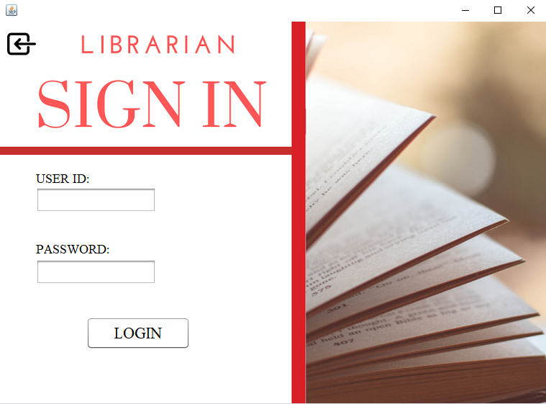

Program code

package user;

import Connection.Connect;

import java.sql.*;

import javax.swing.*;

public class Flogin extends javax.swing.JFrame {

String temp;

Connection conn;

Statement st;

ResultSet rs;

public Flogin() {

initComponents();

}

@SuppressWarnings("unchecked")

// <editor-fold defaultstate="collapsed" desc="Generated Code">

private void initComponents() {

jPanel1 = new javax.swing.JPanel();

jLabel2 = new javax.swing.JLabel();

jid = new javax.swing.JTextField();

jButton1 = new javax.swing.JButton();

jpass = new javax.swing.JPasswordField();

jButton2 = new javax.swing.JButton();

jLabel1 = new javax.swing.JLabel();

jLabel3 = new javax.swing.JLabel();

setDefaultCloseOperation(javax.swing.WindowConstants.EXIT_ON_CLOSE);

jPanel1.setLayout(null);

jLabel2.setFont(new java.awt.Font("Serif", 0, 18)); // NOI18N

jLabel2.setText("PASSWORD:");

jPanel1.add(jLabel2);

jLabel2.setBounds(50, 300, 110, 30);

jid.addActionListener(new java.awt.event.ActionListener() {

public void actionPerformed(java.awt.event.ActionEvent evt) {

jidActionPerformed(evt);

}

});

jPanel1.add(jid);

jid.setBounds(50, 230, 167, 35);

jButton1.setBackground(new java.awt.Color(255, 255, 255));

jButton1.setFont(new java.awt.Font("Times New Roman", 0, 22)); // NOI18N

jButton1.setText("LOGIN");

jButton1.addActionListener(new java.awt.event.ActionListener() {

public void actionPerformed(java.awt.event.ActionEvent evt) {

jButton1ActionPerformed(evt);

}

});

jPanel1.add(jButton1);

jButton1.setBounds(120, 410, 144, 45);

jPanel1.add(jpass);

jpass.setBounds(50, 330, 167, 35);

jButton2.setBackground(new java.awt.Color(255, 255, 255));

jButton2.setIcon(new javax.swing.ImageIcon(getClass().getResource("/project images/NEW BACK .png"))); // NOI18N

jButton2.addActionListener(new java.awt.event.ActionListener() {

public void actionPerformed(java.awt.event.ActionEvent evt) {

jButton2ActionPerformed(evt);

}

});

jPanel1.add(jButton2);

jButton2.setBounds(10, 11, 40, 40);

jLabel1.setFont(new java.awt.Font("Serif", 0, 18)); // NOI18N

jLabel1.setText("USER ID:");

jPanel1.add(jLabel1);

jLabel1.setBounds(50, 200, 103, 35);

jLabel3.setIcon(new javax.swing.ImageIcon(getClass().getResource("/project images/SIGN IN TEACHER.png"))); // NOI18N

jPanel1.add(jLabel3);

jLabel3.setBounds(0, 0, 760, 530);

javax.swing.GroupLayout layout = new javax.swing.GroupLayout(getContentPane());

getContentPane().setLayout(layout);

layout.setHorizontalGroup(

layout.createParallelGroup(javax.swing.GroupLayout.Alignment.LEADING)

.addGroup(layout.createSequentialGroup()

.addGap(0, 0, Short.MAX_VALUE)

.addComponent(jPanel1, javax.swing.GroupLayout.PREFERRED_SIZE, 761, javax.swing.GroupLayout.PREFERRED_SIZE))

);

layout.setVerticalGroup(

layout.createParallelGroup(javax.swing.GroupLayout.Alignment.LEADING)

.addGroup(layout.createSequentialGroup()

.addGap(0, 0, 0)

.addComponent(jPanel1, javax.swing.GroupLayout.PREFERRED_SIZE, 533, javax.swing.GroupLayout.PREFERRED_SIZE)

.addGap(0, 0, Short.MAX_VALUE))

);

pack();

}// </editor-fold>

private void jidActionPerformed(java.awt.event.ActionEvent evt) {

// TODO add your handling code here:

}

private void jButton1ActionPerformed(java.awt.event.ActionEvent evt) {

try

{

Connect con = new Connect();

conn= con.Connect();

String query= "select * from librarian where id='"+jid.getText()+"' and pass='"+jpass.getText()+"'";

st= conn.createStatement();

rs= st.executeQuery(query);

if(rs.isBeforeFirst())

{

JOptionPane.showMessageDialog(rootPane,"succesfully logged in ");

Libpanel ch= new Libpanel();

ch.show();

this.dispose();

}

else

{

JOptionPane.showMessageDialog(rootPane,"invalid credentials");

}

}

catch (Exception e)

{

System.out.println(e.getMessage());

}

}

private void jButton2ActionPerformed(java.awt.event.ActionEvent evt) {

Welcome wl= new Welcome();

wl.show();

this.dispose();

}

/**

* @param args the command line arguments

*/

public static void main(String args[]) {

/* Set the Nimbus look and feel */

//<editor-fold defaultstate="collapsed" desc=" Look and feel setting code (optional) ">

/* If Nimbus (introduced in Java SE 6) is not available, stay with the default look and feel.

* For details see http://download.oracle.com/javase/tutorial/uiswing/lookandfeel/plaf.html

*/

try {

for (javax.swing.UIManager.LookAndFeelInfo info : javax.swing.UIManager.getInstalledLookAndFeels()) {

if ("Nimbus".equals(info.getName())) {

javax.swing.UIManager.setLookAndFeel(info.getClassName());

break;

}

}

} catch (ClassNotFoundException ex) {

java.util.logging.Logger.getLogger(Flogin.class.getName()).log(java.util.logging.Level.SEVERE, null, ex);

} catch (InstantiationException ex) {

java.util.logging.Logger.getLogger(Flogin.class.getName()).log(java.util.logging.Level.SEVERE, null, ex);

} catch (IllegalAccessException ex) {

java.util.logging.Logger.getLogger(Flogin.class.getName()).log(java.util.logging.Level.SEVERE, null, ex);

} catch (javax.swing.UnsupportedLookAndFeelException ex) {

java.util.logging.Logger.getLogger(Flogin.class.getName()).log(java.util.logging.Level.SEVERE, null, ex);

}

//</editor-fold>

//</editor-fold>

/* Create and display the form */

java.awt.EventQueue.invokeLater(new Runnable() {

public void run() {

new Flogin().setVisible(true);

}

});

}

// Variables declaration - do not modify

private javax.swing.JButton jButton1;

private javax.swing.JButton jButton2;

private javax.swing.JLabel jLabel1;

private javax.swing.JLabel jLabel2;

private javax.swing.JLabel jLabel3;

private javax.swing.JPanel jPanel1;

private javax.swing.JTextField jid;

private javax.swing.JPasswordField jpass;

// End of variables declaration

}

* Faculty library panel



Program code

package user;

public class Libpanel extends javax.swing.JFrame {

public Libpanel() {

initComponents();

}

@SuppressWarnings("unchecked")

// <editor-fold defaultstate="collapsed" desc="Generated Code">

private void initComponents() {

jPanel1 = new javax.swing.JPanel();

jButton1 = new javax.swing.JButton();

jButton2 = new javax.swing.JButton();

jButton3 = new javax.swing.JButton();

jLabel1 = new javax.swing.JLabel();

setDefaultCloseOperation(javax.swing.WindowConstants.EXIT_ON_CLOSE);

jPanel1.setLayout(null);

jButton1.setBackground(new java.awt.Color(255, 255, 255));

jButton1.setIcon(new javax.swing.ImageIcon(getClass().getResource("/project images/ISSUE BOOK BUTTON.png"))); // NOI18N

jButton1.addActionListener(new java.awt.event.ActionListener() {

public void actionPerformed(java.awt.event.ActionEvent evt) {

jButton1ActionPerformed(evt);

}

});

jPanel1.add(jButton1);

jButton1.setBounds(390, 210, 320, 80);

jButton2.setIcon(new javax.swing.ImageIcon(getClass().getResource("/project images/return book button.png"))); // NOI18N

jButton2.addActionListener(new java.awt.event.ActionListener() {

public void actionPerformed(java.awt.event.ActionEvent evt) {

jButton2ActionPerformed(evt);

}

});

jPanel1.add(jButton2);

jButton2.setBounds(380, 380, 340, 60);

jButton3.setBackground(new java.awt.Color(255, 255, 255));

jButton3.setIcon(new javax.swing.ImageIcon(getClass().getResource("/project images/NEW BACK .png"))); // NOI18N

jButton3.addActionListener(new java.awt.event.ActionListener() {

public void actionPerformed(java.awt.event.ActionEvent evt) {

jButton3ActionPerformed(evt);

}

});

jPanel1.add(jButton3);

jButton3.setBounds(0, 0, 40, 40);

jLabel1.setIcon(new javax.swing.ImageIcon(getClass().getResource("/project images/library panel (1).png"))); // NOI18N

jPanel1.add(jLabel1);

jLabel1.setBounds(0, -20, 750, 570);

javax.swing.GroupLayout layout = new javax.swing.GroupLayout(getContentPane());

getContentPane().setLayout(layout);

layout.setHorizontalGroup(

layout.createParallelGroup(javax.swing.GroupLayout.Alignment.LEADING)

.addGroup(layout.createSequentialGroup()

.addGap(0, 0, 0)

.addComponent(jPanel1, javax.swing.GroupLayout.DEFAULT_SIZE, 751, Short.MAX_VALUE)

.addGap(0, 0, 0))

);

layout.setVerticalGroup(

layout.createParallelGroup(javax.swing.GroupLayout.Alignment.LEADING)

.addGroup(layout.createSequentialGroup()

.addGap(0, 0, 0)

.addComponent(jPanel1, javax.swing.GroupLayout.DEFAULT_SIZE, 551, Short.MAX_VALUE)

.addGap(0, 0, 0))

);

pack();

}// </editor-fold>

private void jButton3ActionPerformed(java.awt.event.ActionEvent evt) {

Flogin fl= new Flogin();

fl.show();

this.dispose();

}

private void jButton1ActionPerformed(java.awt.event.ActionEvent evt) {

Bookissue bi= new Bookissue();

bi.show();

this.dispose();

}

private void jButton2ActionPerformed(java.awt.event.ActionEvent evt) {

Book_Return br= new Book_Return();

br.show();

this.dispose();

}

/**

* @param args the command line arguments

*/

public static void main(String args[]) {

/* Set the Nimbus look and feel */

//<editor-fold defaultstate="collapsed" desc=" Look and feel setting code (optional) ">

/* If Nimbus (introduced in Java SE 6) is not available, stay with the default look and feel.

* For details see http://download.oracle.com/javase/tutorial/uiswing/lookandfeel/plaf.html

*/

try {

for (javax.swing.UIManager.LookAndFeelInfo info : javax.swing.UIManager.getInstalledLookAndFeels()) {

if ("Nimbus".equals(info.getName())) {

javax.swing.UIManager.setLookAndFeel(info.getClassName());

break;

}

}

} catch (ClassNotFoundException ex) {

java.util.logging.Logger.getLogger(Libpanel.class.getName()).log(java.util.logging.Level.SEVERE, null, ex);

} catch (InstantiationException ex) {

java.util.logging.Logger.getLogger(Libpanel.class.getName()).log(java.util.logging.Level.SEVERE, null, ex);

} catch (IllegalAccessException ex) {

java.util.logging.Logger.getLogger(Libpanel.class.getName()).log(java.util.logging.Level.SEVERE, null, ex);

} catch (javax.swing.UnsupportedLookAndFeelException ex) {

java.util.logging.Logger.getLogger(Libpanel.class.getName()).log(java.util.logging.Level.SEVERE, null, ex);

}

//</editor-fold>

//</editor-fold>

/* Create and display the form */

java.awt.EventQueue.invokeLater(new Runnable() {

public void run() {

new Libpanel().setVisible(true);

}

});

}

// Variables declaration - do not modify

private javax.swing.JButton jButton1;

private javax.swing.JButton jButton2;

private javax.swing.JButton jButton3;

private javax.swing.JLabel jLabel1;

private javax.swing.JPanel jPanel1;

// End of variables declaration

}

* Return book

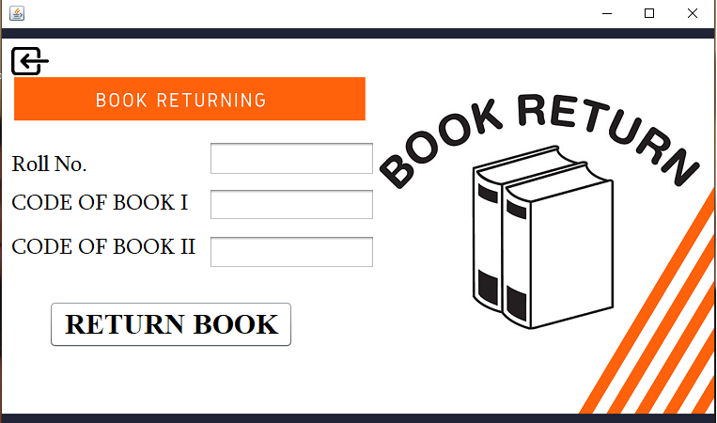

Program code

package user;

import Connection.Connect;

import java.sql.Connection;

import java.sql.ResultSet;

import java.sql.Statement;

import javax.swing.JOptionPane;

import java.sql.DriverManager;

public class Book_Return extends javax.swing.JFrame {

Connection conn;

ResultSet rs;

Statement st;

String book1,book2;

public Book_Return() {

initComponents();

}

@SuppressWarnings("unchecked")

// <editor-fold defaultstate="collapsed" desc="Generated Code">

private void initComponents() {

jPanel1 = new javax.swing.JPanel();

jcode2 = new javax.swing.JTextField();

jButton1 = new javax.swing.JButton();

jButton2 = new javax.swing.JButton();

jLabel1 = new javax.swing.JLabel();

jLabel2 = new javax.swing.JLabel();

jLabel3 = new javax.swing.JLabel();

jroll = new javax.swing.JTextField();

jcode1 = new javax.swing.JTextField();

jLabel5 = new javax.swing.JLabel();

setDefaultCloseOperation(javax.swing.WindowConstants.EXIT_ON_CLOSE);

jPanel1.setLayout(null);

jPanel1.add(jcode2);

jcode2.setBounds(220, 220, 177, 36);

jButton1.setBackground(new java.awt.Color(255, 255, 255));

jButton1.setFont(new java.awt.Font("Times New Roman", 1, 30)); // NOI18N

jButton1.setText("RETURN BOOK");

jButton1.addActionListener(new java.awt.event.ActionListener() {

public void actionPerformed(java.awt.event.ActionEvent evt) {

jButton1ActionPerformed(evt);

}

});

jPanel1.add(jButton1);

jButton1.setBounds(50, 290, 260, 50);

jButton2.setIcon(new javax.swing.ImageIcon(getClass().getResource("/project images/NEW BACK .png"))); // NOI18N

jButton2.addActionListener(new java.awt.event.ActionListener() {

public void actionPerformed(java.awt.event.ActionEvent evt) {

jButton2ActionPerformed(evt);

}

});

jPanel1.add(jButton2);

jButton2.setBounds(10, 20, 40, 30);

jLabel1.setFont(new java.awt.Font("Sylfaen", 0, 24)); // NOI18N

jLabel1.setText("Roll No.");

jPanel1.add(jLabel1);

jLabel1.setBounds(10, 130, 196, 32);

jLabel2.setFont(new java.awt.Font("Sylfaen", 0, 24)); // NOI18N

jLabel2.setText("CODE OF BOOK I");

jPanel1.add(jLabel2);

jLabel2.setBounds(10, 170, 196, 35);

jLabel3.setFont(new java.awt.Font("Sylfaen", 0, 24)); // NOI18N

jLabel3.setText("CODE OF BOOK II");

jPanel1.add(jLabel3);

jLabel3.setBounds(10, 210, 196, 49);

jPanel1.add(jroll);

jroll.setBounds(220, 120, 177, 37);

jcode1.addActionListener(new java.awt.event.ActionListener() {

public void actionPerformed(java.awt.event.ActionEvent evt) {

jcode1ActionPerformed(evt);

}

});

jPanel1.add(jcode1);

jcode1.setBounds(220, 170, 177, 35);

jLabel5.setIcon(new javax.swing.ImageIcon(getClass().getResource("/project images/book returning.png"))); // NOI18N

jPanel1.add(jLabel5);

jLabel5.setBounds(0, 0, 760, 420);

javax.swing.GroupLayout layout = new javax.swing.GroupLayout(getContentPane());

getContentPane().setLayout(layout);

layout.setHorizontalGroup(

layout.createParallelGroup(javax.swing.GroupLayout.Alignment.LEADING)

.addGroup(layout.createSequentialGroup()

.addGap(0, 0, 0)

.addComponent(jPanel1, javax.swing.GroupLayout.PREFERRED_SIZE, 758, javax.swing.GroupLayout.PREFERRED_SIZE)

.addGap(0, 0, Short.MAX_VALUE))

);

layout.setVerticalGroup(

layout.createParallelGroup(javax.swing.GroupLayout.Alignment.LEADING)

.addGroup(layout.createSequentialGroup()

.addGap(0, 0, 0)

.addComponent(jPanel1, javax.swing.GroupLayout.PREFERRED_SIZE, 431, javax.swing.GroupLayout.PREFERRED_SIZE)

.addGap(0, 0, Short.MAX_VALUE))

);

pack();

}// </editor-fold>

private void jButton1ActionPerformed(java.awt.event.ActionEvent evt) {

try

{

Connect con = new Connect();

conn= con.Connect();

String query1="select book1,book2 from login where rollno="+jroll.getText();

st=conn.createStatement();

rs=st.executeQuery(query1);

while(rs.next())

{

book1=rs.getString(1);

book2=rs.getString(2);

}

if(book1.equals(jcode1.getText()) && book2.equals(jcode2.getText()))

{

String query= "update login set book1='',book2='' where rollno='"+jroll.getText()+"'";

st= conn.createStatement();

int n=st.executeUpdate(query);

if (n>0)

{

JOptionPane.showMessageDialog(rootPane, "RETURNED SUCCESFULLY");

}

else

{

JOptionPane.showMessageDialog(rootPane, "SERVER ERROR");

}

}

else

if (book1.equals(""))

{

JOptionPane.showMessageDialog(rootPane, "NO BOOK ISSUED");

}

else

{

JOptionPane.showMessageDialog(rootPane, "DIFFERENT BOOKS");

}

}

catch (Exception e)

{

JOptionPane.showMessageDialog(rootPane, e.getMessage());

}

finally

{

jroll.setText("");

jcode1.setText("");

jcode2.setText("");

}

}

private void jButton2ActionPerformed(java.awt.event.ActionEvent evt) {

Libpanel ch= new Libpanel();

ch.show();

this.dispose();

}

private void jcode1ActionPerformed(java.awt.event.ActionEvent evt) {

}

/**

* @param args the command line arguments

*/

public static void main(String args[]) {

/* Set the Nimbus look and feel */

//<editor-fold defaultstate="collapsed" desc=" Look and feel setting code (optional) ">

/* If Nimbus (introduced in Java SE 6) is not available, stay with the default look and feel.

* For details see http://download.oracle.com/javase/tutorial/uiswing/lookandfeel/plaf.html

*/

try {

for (javax.swing.UIManager.LookAndFeelInfo info : javax.swing.UIManager.getInstalledLookAndFeels()) {

if ("Nimbus".equals(info.getName())) {

javax.swing.UIManager.setLookAndFeel(info.getClassName());

break;

}

}

} catch (ClassNotFoundException ex) {

java.util.logging.Logger.getLogger(Book_Return.class.getName()).log(java.util.logging.Level.SEVERE, null, ex);

} catch (InstantiationException ex) {

java.util.logging.Logger.getLogger(Book_Return.class.getName()).log(java.util.logging.Level.SEVERE, null, ex);

} catch (IllegalAccessException ex) {

java.util.logging.Logger.getLogger(Book_Return.class.getName()).log(java.util.logging.Level.SEVERE, null, ex);

} catch (javax.swing.UnsupportedLookAndFeelException ex) {

java.util.logging.Logger.getLogger(Book_Return.class.getName()).log(java.util.logging.Level.SEVERE, null, ex);

}

//</editor-fold>

//</editor-fold>

/* Create and display the form */

java.awt.EventQueue.invokeLater(new Runnable() {

public void run() {

new Book_Return().setVisible(true);

}

});

}

// Variables declaration - do not modify

private javax.swing.JButton jButton1;

private javax.swing.JButton jButton2;

private javax.swing.JLabel jLabel1;

private javax.swing.JLabel jLabel2;

private javax.swing.JLabel jLabel3;

private javax.swing.JLabel jLabel5;

private javax.swing.JPanel jPanel1;

private javax.swing.JTextField jcode1;

private javax.swing.JTextField jcode2;

private javax.swing.JTextField jroll;

// End of variables declaration

}

* Issue book

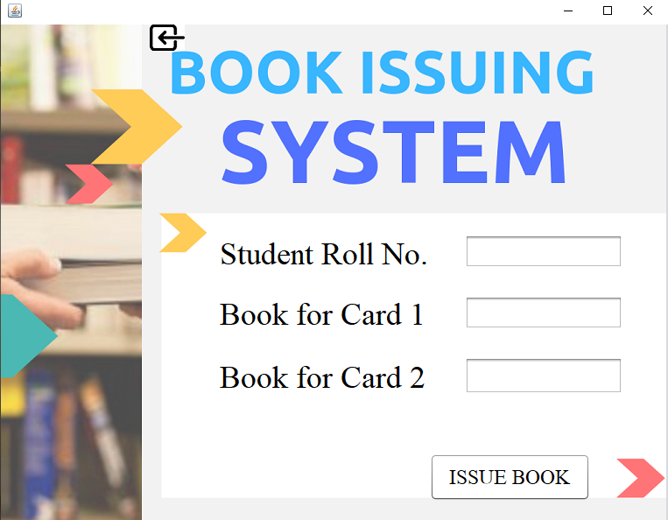

Program code

package user;

import Connection.Connect;

import java.sql.*;

import javax.swing.*;

public class Bookissue extends javax.swing.JFrame {

String temp;

Connection conn;

Statement st;

ResultSet rs;

public Bookissue() {

initComponents();

}

@SuppressWarnings("unchecked")

// <editor-fold defaultstate="collapsed" desc="Generated Code">

private void initComponents() {

jPanel1 = new javax.swing.JPanel();

jLabel2 = new javax.swing.JLabel();

jLabel3 = new javax.swing.JLabel();

jLabel4 = new javax.swing.JLabel();

jroll = new javax.swing.JTextField();

jcard1 = new javax.swing.JTextField();

jcard2 = new javax.swing.JTextField();

jButton1 = new javax.swing.JButton();

jButton2 = new javax.swing.JButton();

jLabel1 = new javax.swing.JLabel();

setDefaultCloseOperation(javax.swing.WindowConstants.EXIT_ON_CLOSE);

jPanel1.setLayout(null);

jLabel2.setFont(new java.awt.Font("Serif", 0, 36)); // NOI18N

jLabel2.setText("Student Roll No.");

jPanel1.add(jLabel2);

jLabel2.setBounds(250, 240, 250, 40);

jLabel3.setFont(new java.awt.Font("Serif", 0, 36)); // NOI18N

jLabel3.setText("Book for Card 1");

jPanel1.add(jLabel3);

jLabel3.setBounds(250, 310, 250, 38);

jLabel4.setFont(new java.awt.Font("Serif", 0, 36)); // NOI18N

jLabel4.setText("Book for Card 2");

jPanel1.add(jLabel4);

jLabel4.setBounds(250, 380, 240, 42);

jroll.setFont(new java.awt.Font("Serif", 0, 24)); // NOI18N

jPanel1.add(jroll);

jroll.setBounds(530, 240, 180, 38);

jcard1.setFont(new java.awt.Font("Serif", 0, 24)); // NOI18N

jPanel1.add(jcard1);

jcard1.setBounds(530, 310, 180, 38);

jcard2.setFont(new java.awt.Font("Serif", 0, 24)); // NOI18N

jcard2.addActionListener(new java.awt.event.ActionListener() {

public void actionPerformed(java.awt.event.ActionEvent evt) {

jcard2ActionPerformed(evt);

}

});

jPanel1.add(jcard2);

jcard2.setBounds(530, 380, 180, 42);

jButton1.setBackground(new java.awt.Color(255, 255, 255));

jButton1.setFont(new java.awt.Font("Mongolian Baiti", 0, 24)); // NOI18N

jButton1.setText("ISSUE BOOK");

jButton1.addActionListener(new java.awt.event.ActionListener() {

public void actionPerformed(java.awt.event.ActionEvent evt) {

jButton1ActionPerformed(evt);

}

});

jPanel1.add(jButton1);

jButton1.setBounds(490, 490, 183, 54);

jButton2.setIcon(new javax.swing.ImageIcon(getClass().getResource("/project images/NEW BACK .png"))); // NOI18N

jButton2.addActionListener(new java.awt.event.ActionListener() {

public void actionPerformed(java.awt.event.ActionEvent evt) {

jButton2ActionPerformed(evt);

}

});

jPanel1.add(jButton2);

jButton2.setBounds(170, 0, 40, 30);

jLabel1.setIcon(new javax.swing.ImageIcon(getClass().getResource("/project images/BOOK ISSUE.png"))); // NOI18N

jPanel1.add(jLabel1);

jLabel1.setBounds(0, 0, 760, 570);

javax.swing.GroupLayout layout = new javax.swing.GroupLayout(getContentPane());

getContentPane().setLayout(layout);

layout.setHorizontalGroup(

layout.createParallelGroup(javax.swing.GroupLayout.Alignment.LEADING)

.addGroup(layout.createSequentialGroup()

.addGap(0, 0, 0)

.addComponent(jPanel1, javax.swing.GroupLayout.PREFERRED_SIZE, 762, javax.swing.GroupLayout.PREFERRED_SIZE)

.addGap(0, 0, Short.MAX_VALUE))

);

layout.setVerticalGroup(

layout.createParallelGroup(javax.swing.GroupLayout.Alignment.LEADING)

.addGroup(layout.createSequentialGroup()

.addGap(0, 0, 0)

.addComponent(jPanel1, javax.swing.GroupLayout.DEFAULT_SIZE, 569, Short.MAX_VALUE)

.addGap(0, 0, 0))

);

pack();

}// </editor-fold>

private void jButton1ActionPerformed(java.awt.event.ActionEvent evt) {

try

{

String book1 = null;

Connect con = new Connect();

conn= con.Connect();

String query= "select lcard1 from login where rollno="+jroll.getText();

st= conn.createStatement();

rs= st.executeQuery(query);

while (rs.next())

{

temp= rs.getString(1);

}

if (temp.equals(""))

{

JOptionPane.showMessageDialog(rootPane, "cards are not activated");

jroll.setText("");

jcard1.setText("");

jcard2.setText("");

}

else

{

String query2="select book1 from login where rollno='"+jroll.getText()+"'";

st=conn.createStatement();

rs= st.executeQuery(query2);

while(rs.next())

{

book1= (rs.getString("book1"));

}

if (book1.equals(""))

{

String query1= "update login set book1='"+jcard1.getText()+"',book2='"+jcard2.getText()+"' where rollno='"+jroll.getText()+"'";

st= conn.createStatement();

int n= st.executeUpdate(query1);

if (n>0)

{

JOptionPane.showMessageDialog(rootPane, "book issued");

}

else

{

JOptionPane.showMessageDialog(rootPane, "invalid activity");

}

}

else

{

JOptionPane.showMessageDialog(rootPane, "please return your previous books first");

}

}

}

catch(Exception e)

{

JOptionPane.showMessageDialog(rootPane, e.getMessage());

}

finally

{

jroll.setText("");

jcard1.setText("");

jcard2.setText("");

}

}

private void jButton2ActionPerformed(java.awt.event.ActionEvent evt) {

Libpanel ch= new Libpanel();

ch.show();

this.dispose();

}

private void jcard2ActionPerformed(java.awt.event.ActionEvent evt) {

// TODO add your handling code here:

}

/**

* @param args the command line arguments

*/

public static void main(String args[]) {

/* Set the Nimbus look and feel */

//<editor-fold defaultstate="collapsed" desc=" Look and feel setting code (optional) ">

/* If Nimbus (introduced in Java SE 6) is not available, stay with the default look and feel.

* For details see http://download.oracle.com/javase/tutorial/uiswing/lookandfeel/plaf.html

*/

try {

for (javax.swing.UIManager.LookAndFeelInfo info : javax.swing.UIManager.getInstalledLookAndFeels()) {

if ("Nimbus".equals(info.getName())) {

javax.swing.UIManager.setLookAndFeel(info.getClassName());

break;

}

}

} catch (ClassNotFoundExcexption ex) {

java.util.logging.Logger.getLogger(Bookissue.class.getName()).log(java.util.logging.Level.SEVERE, null, ex);

} catch (InstantiationException ex) {

java.util.logging.Logger.getLogger(Bookissue.class.getName()).log(java.util.logging.Level.SEVERE, null, ex);

} catch (IllegalAccessException ex) {

java.util.logging.Logger.getLogger(Bookissue.class.getName()).log(java.util.logging.Level.SEVERE, null, ex);

} catch (javax.swing.UnsupportedLookAndFeelException ex) {

java.util.logging.Logger.getLogger(Bookissue.class.getName()).log(java.util.logging.Level.SEVERE, null, ex);

}

//</editor-fold>

//</editor-fold>

/* Create and display the form */

java.awt.EventQueue.invokeLater(new Runnable() {

public void run() {

new Bookissue().setVisible(true);

}

});

}

// Variables declaration - do not modify

private javax.swing.JButton jButton1;

private javax.swing.JButton jButton2;

private javax.swing.JLabel jLabel1;

private javax.swing.JLabel jLabel2;

private javax.swing.JLabel jLabel3;

private javax.swing.JLabel jLabel4;

private javax.swing.JPanel jPanel1;

private javax.swing.JTextField jcard1;

private javax.swing.JTextField jcard2;

private javax.swing.JTextField jroll;

// End of variables declaration

}

* Student panel
  + Login page

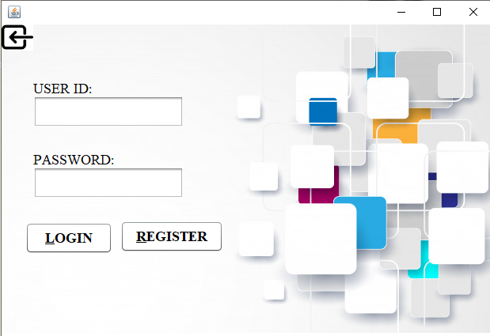

Program code

package user;

import Connection.Connect;

import java.sql.DriverManager;

import java.sql.Connection;

import java.sql.ResultSet;

import java.sql.Statement;

import javax.swing.JOptionPane;

public class Login extends javax.swing.JFrame {

String uname;

Connection conn;

Statement st;

ResultSet rs;

public Login() {

initComponents();

}

@SuppressWarnings("unchecked")

// <editor-fold defaultstate="collapsed" desc="Generated Code">

private void initComponents() {

jPanel1 = new javax.swing.JPanel();

jButton1 = new javax.swing.JButton();

jButton2 = new javax.swing.JButton();

jpass = new javax.swing.JPasswordField();

jButton3 = new javax.swing.JButton();

juname = new javax.swing.JTextField();

jSeparator1 = new javax.swing.JSeparator();

jLabel1 = new javax.swing.JLabel();

jLabel2 = new javax.swing.JLabel();

jLabel3 = new javax.swing.JLabel();

setDefaultCloseOperation(javax.swing.WindowConstants.EXIT_ON_CLOSE);

jPanel1.setBackground(new java.awt.Color(255, 255, 255));

jPanel1.setLayout(null);

jButton1.setBackground(new java.awt.Color(255, 255, 255));

jButton1.setFont(new java.awt.Font("Times New Roman", 1, 18)); // NOI18N

jButton1.setMnemonic('L');

jButton1.setText("LOGIN");

jButton1.addActionListener(new java.awt.event.ActionListener() {

public void actionPerformed(java.awt.event.ActionEvent evt) {

jButton1ActionPerformed(evt);

}

});

jPanel1.add(jButton1);

jButton1.setBounds(30, 250, 110, 40);

jButton2.setBackground(new java.awt.Color(255, 255, 255));

jButton2.setFont(new java.awt.Font("Times New Roman", 1, 18)); // NOI18N

jButton2.setMnemonic('R');

jButton2.setText("REGISTER");

jButton2.addActionListener(new java.awt.event.ActionListener() {

public void actionPerformed(java.awt.event.ActionEvent evt) {

jButton2ActionPerformed(evt);

}

});

jPanel1.add(jButton2);

jButton2.setBounds(150, 248, 130, 40);

jpass.addActionListener(new java.awt.event.ActionListener() {

public void actionPerformed(java.awt.event.ActionEvent evt) {

jpassActionPerformed(evt);

}

});

jPanel1.add(jpass);

jpass.setBounds(40, 180, 190, 40);

jButton3.setIcon(new javax.swing.ImageIcon(getClass().getResource("/project images/NEW BACK .png"))); // NOI18N

jButton3.addActionListener(new java.awt.event.ActionListener() {

public void actionPerformed(java.awt.event.ActionEvent evt) {

jButton3ActionPerformed(evt);

}

});

jPanel1.add(jButton3);

jButton3.setBounds(0, 0, 40, 33);

juname.setFont(new java.awt.Font("Times New Roman", 0, 14)); // NOI18N

juname.addActionListener(new java.awt.event.ActionListener() {

public void actionPerformed(java.awt.event.ActionEvent evt) {

junameActionPerformed(evt);

}

});

jPanel1.add(juname);

juname.setBounds(40, 90, 190, 40);

jPanel1.add(jSeparator1);

jSeparator1.setBounds(210, 240, 0, 2);

jLabel1.setFont(new java.awt.Font("Times New Roman", 0, 18)); // NOI18N

jLabel1.setText("USER ID:");

jPanel1.add(jLabel1);

jLabel1.setBounds(40, 70, 80, 22);

jLabel2.setFont(new java.awt.Font("Times New Roman", 0, 18)); // NOI18N

jLabel2.setText("PASSWORD:");

jPanel1.add(jLabel2);

jLabel2.setBounds(40, 160, 110, 22);

jLabel3.setIcon(new javax.swing.ImageIcon(getClass().getResource("/project images/login.jpg"))); // NOI18N

jPanel1.add(jLabel3);

jLabel3.setBounds(0, 0, 620, 390);

javax.swing.GroupLayout layout = new javax.swing.GroupLayout(getContentPane());

getContentPane().setLayout(layout);

layout.setHorizontalGroup(

layout.createParallelGroup(javax.swing.GroupLayout.Alignment.LEADING)

.addGroup(layout.createSequentialGroup()

.addGap(0, 0, 0)

.addComponent(jPanel1, javax.swing.GroupLayout.PREFERRED_SIZE, 619, javax.swing.GroupLayout.PREFERRED_SIZE)

.addGap(0, 0, Short.MAX_VALUE))

);

layout.setVerticalGroup(

layout.createParallelGroup(javax.swing.GroupLayout.Alignment.LEADING)

.addGroup(layout.createSequentialGroup()

.addGap(0, 0, 0)

.addComponent(jPanel1, javax.swing.GroupLayout.PREFERRED_SIZE, 394, javax.swing.GroupLayout.PREFERRED_SIZE)

.addGap(0, 0, Short.MAX_VALUE))

);

pack();

}// </editor-fold>

private void jButton1ActionPerformed(java.awt.event.ActionEvent evt) {

try

{

Connect con = new Connect();

conn= con.Connect();

uname=juname.getText();

String query= "select * from login where uname='"+juname.getText()+"' and pass='"+jpass.getText()+"'";

st= conn.createStatement();

rs= st.executeQuery(query);

if(rs.isBeforeFirst())

{

Profile pr= new Profile(uname);

pr.show();

this.dispose();

}

else

{

JOptionPane.showMessageDialog(rootPane,"invalid credentials");

}

}

catch (Exception e)

{

System.out.println(e.getMessage());

}

}

private void jButton2ActionPerformed(java.awt.event.ActionEvent evt) {

Register rs= new Register();

rs.show();

this.dispose();

}

private void jpassActionPerformed(java.awt.event.ActionEvent evt) {

}

private void jButton3ActionPerformed(java.awt.event.ActionEvent evt) {

Welcome wl= new Welcome();

wl.show();

this.dispose();

}

private void junameActionPerformed(java.awt.event.ActionEvent evt) {

// TODO add your handling code here:

}

/**

* @param args the command line arguments

*/

public static void main(String args[]) {

/* Set the Nimbus look and feel */

//<editor-fold defaultstate="collapsed" desc=" Look and feel setting code (optional) ">

/* If Nimbus (introduced in Java SE 6) is not available, stay with the default look and feel.

* For details see http://download.oracle.com/javase/tutorial/uiswing/lookandfeel/plaf.html

*/

try {

for (javax.swing.UIManager.LookAndFeelInfo info : javax.swing.UIManager.getInstalledLookAndFeels()) {

if ("Nimbus".equals(info.getName())) {

javax.swing.UIManager.setLookAndFeel(info.getClassName());

break;

}

}

} catch (ClassNotFoundException ex) {

java.util.logging.Logger.getLogger(Login.class.getName()).log(java.util.logging.Level.SEVERE, null, ex);

} catch (InstantiationException ex) {

java.util.logging.Logger.getLogger(Login.class.getName()).log(java.util.logging.Level.SEVERE, null, ex);

} catch (IllegalAccessException ex) {

java.util.logging.Logger.getLogger(Login.class.getName()).log(java.util.logging.Level.SEVERE, null, ex);

} catch (javax.swing.UnsupportedLookAndFeelException ex) {

java.util.logging.Logger.getLogger(Login.class.getName()).log(java.util.logging.Level.SEVERE, null, ex);

}

//</editor-fold>

//</editor-fold>

/* Create and display the form */

java.awt.EventQueue.invokeLater(new Runnable() {

public void run() {

new Login().setVisible(true);

}

});

}

// Variables declaration - do not modify

private javax.swing.JButton jButton1;

private javax.swing.JButton jButton2;

private javax.swing.JButton jButton3;

private javax.swing.JLabel jLabel1;

private javax.swing.JLabel jLabel2;

private javax.swing.JLabel jLabel3;

private javax.swing.JPanel jPanel1;

private javax.swing.JSeparator jSeparator1;

private javax.swing.JPasswordField jpass;

private javax.swing.JTextField juname;

// End of variables declaration

}

* Profile Page

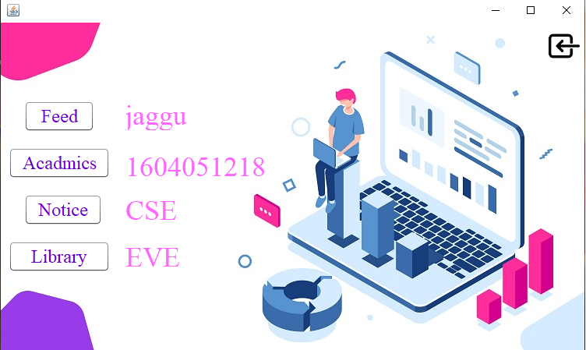

Program code

package user;

import Connection.Connect;

import java.sql.*;

import javax.swing.JOptionPane;

public class Profile extends javax.swing.JFrame {

public Profile() {

initComponents();

}

String temp,lcard1,lcard2;

String uname;

int roll;

Connection conn;

Statement st;

ResultSet rs;

void get()

{

try{

Connect con = new Connect();

conn= con.Connect();

String query= "select * from login where uname='"+uname+"'";

st= conn.createStatement();

rs= st.executeQuery(query);

try{

while (rs.next())

{

jrollno.setText(rs.getString(5));

jbranch.setText(rs.getString(6));

jshift.setText(rs.getString(7));

jname2.setText(rs.getString(1));

}

}

catch(Exception e)

{

JOptionPane.showMessageDialog(rootPane, e.getMessage());

}

}

catch(Exception e)

{

JOptionPane.showMessageDialog(rootPane, e.getMessage());

}

}

public Profile(String temp)

{

initComponents();

uname=temp;

get();

}

@SuppressWarnings("unchecked")

// <editor-fold defaultstate="collapsed" desc="Generated Code">

private void initComponents() {

jPanel1 = new javax.swing.JPanel();

jButton8 = new javax.swing.JButton();

jname2 = new javax.swing.JLabel();

jrollno = new javax.swing.JLabel();

jbranch = new javax.swing.JLabel();

jshift = new javax.swing.JLabel();

jfeed = new javax.swing.JButton();

jlibrary = new javax.swing.JButton();

jacadmics = new javax.swing.JButton();

jnotice = new javax.swing.JButton();

jLabel1 = new javax.swing.JLabel();

setDefaultCloseOperation(javax.swing.WindowConstants.EXIT_ON_CLOSE);

jPanel1.setLayout(null);

jButton8.setForeground(new java.awt.Color(255, 255, 255));

jButton8.setIcon(new javax.swing.ImageIcon(getClass().getResource("/project images/NEW BACK .png"))); // NOI18N

jButton8.setBorder(null);

jButton8.addActionListener(new java.awt.event.ActionListener() {

public void actionPerformed(java.awt.event.ActionEvent evt) {

jButton8ActionPerformed(evt);

}

});

jPanel1.add(jButton8);

jButton8.setBounds(703, 10, 40, 40);

jname2.setFont(new java.awt.Font("Times New Roman", 0, 36)); // NOI18N

jname2.setForeground(new java.awt.Color(255, 102, 255));

jname2.setText("name");

jPanel1.add(jname2);

jname2.setBounds(160, 100, 200, 38);

jrollno.setFont(new java.awt.Font("Times New Roman", 0, 36)); // NOI18N

jrollno.setForeground(new java.awt.Color(255, 102, 255));

jrollno.setText("rollno");

jPanel1.add(jrollno);

jrollno.setBounds(160, 170, 210, 30);

jbranch.setFont(new java.awt.Font("Times New Roman", 0, 36)); // NOI18N

jbranch.setForeground(new java.awt.Color(255, 102, 255));

jbranch.setText("branch");

jPanel1.add(jbranch);

jbranch.setBounds(160, 220, 140, 42);

jshift.setFont(new java.awt.Font("Times New Roman", 0, 36)); // NOI18N

jshift.setForeground(new java.awt.Color(255, 102, 255));

jshift.setText("shift");

jPanel1.add(jshift);

jshift.setBounds(160, 280, 110, 42);

jfeed.setBackground(new java.awt.Color(255, 255, 255));

jfeed.setFont(new java.awt.Font("Times New Roman", 0, 24)); // NOI18N

jfeed.setForeground(new java.awt.Color(102, 0, 204));

jfeed.setText("Feed");

jfeed.addActionListener(new java.awt.event.ActionListener() {

public void actionPerformed(java.awt.event.ActionEvent evt) {

jfeedActionPerformed(evt);

}

});

jPanel1.add(jfeed);

jfeed.setBounds(30, 100, 90, 40);

jlibrary.setBackground(new java.awt.Color(255, 255, 255));

jlibrary.setFont(new java.awt.Font("Times New Roman", 0, 24)); // NOI18N

jlibrary.setForeground(new java.awt.Color(102, 0, 204));

jlibrary.setText("Notice");

jlibrary.addActionListener(new java.awt.event.ActionListener() {

public void actionPerformed(java.awt.event.ActionEvent evt) {

jlibraryActionPerformed(evt);

}

});

jPanel1.add(jlibrary);

jlibrary.setBounds(30, 220, 100, 40);

jacadmics.setBackground(new java.awt.Color(255, 255, 255));

jacadmics.setFont(new java.awt.Font("Times New Roman", 0, 24)); // NOI18N

jacadmics.setForeground(new java.awt.Color(102, 0, 204));

jacadmics.setText("Acadmics");

jacadmics.addActionListener(new java.awt.event.ActionListener() {

public void actionPerformed(java.awt.event.ActionEvent evt) {

jacadmicsActionPerformed(evt);

}

});

jPanel1.add(jacadmics);

jacadmics.setBounds(10, 160, 130, 40);

jnotice.setBackground(new java.awt.Color(255, 255, 255));

jnotice.setFont(new java.awt.Font("Times New Roman", 0, 24)); // NOI18N

jnotice.setForeground(new java.awt.Color(102, 0, 204));

jnotice.setText("Library");

jnotice.addActionListener(new java.awt.event.ActionListener() {

public void actionPerformed(java.awt.event.ActionEvent evt) {

jnoticeActionPerformed(evt);

}

});

jPanel1.add(jnotice);

jnotice.setBounds(10, 280, 130, 40);

jLabel1.setIcon(new javax.swing.ImageIcon("C:\\Users\\aahha\\Documents\\NetBeansProjects\\login\\src\\project images\\profile.jpg")); // NOI18N

jPanel1.add(jLabel1);

jLabel1.setBounds(0, 0, 750, 420);

javax.swing.GroupLayout layout = new javax.swing.GroupLayout(getContentPane());

getContentPane().setLayout(layout);

layout.setHorizontalGroup(

layout.createParallelGroup(javax.swing.GroupLayout.Alignment.LEADING)

.addGroup(layout.createSequentialGroup()

.addGap(0, 0, 0)

.addComponent(jPanel1, javax.swing.GroupLayout.PREFERRED_SIZE, 749, javax.swing.GroupLayout.PREFERRED_SIZE)

.addGap(0, 0, Short.MAX_VALUE))

);

layout.setVerticalGroup(

layout.createParallelGroup(javax.swing.GroupLayout.Alignment.LEADING)

.addGroup(layout.createSequentialGroup()

.addGap(0, 0, 0)

.addComponent(jPanel1, javax.swing.GroupLayout.DEFAULT_SIZE, 420, Short.MAX_VALUE)

.addGap(0, 0, 0))

);

pack();

}// </editor-fold>

private void jButton8ActionPerformed(java.awt.event.ActionEvent evt) {

// JOptionPane.showConfirmDialog(rootPane, "ARE YOU SHURE");

Login lg= new Login();

lg.show();

this.dispose();

}

private void jfeedActionPerformed(java.awt.event.ActionEvent evt) {

FEED fd= new FEED(uname);

fd.show();

this.dispose();

}

private void jlibraryActionPerformed(java.awt.event.ActionEvent evt) {

StudentNotice stdn= new StudentNotice(uname);

stdn.show();

this.dispose();

}

private void jacadmicsActionPerformed(java.awt.event.ActionEvent evt) {

Acadmics acd= new Acadmics(uname);

acd.show();

this.dispose();

}

private void jnoticeActionPerformed(java.awt.event.ActionEvent evt) {

try{

Connect con = new Connect();

conn= con.Connect();

String query= "select lcard1,lcard2 from login where uname='"+uname+"'";

st= conn.createStatement();

rs= st.executeQuery(query);

while (rs.next())

{

lcard1=rs.getString("lcard1");

lcard2=rs.getString("lcard2");

}

if (lcard1.equals("") || lcard2.equals(""))

{

libreg lbg= new libreg(uname);

lbg.show();

this.dispose();

}

else

{

Library lb= new Library(uname);

lb.show();

this.dispose();

}

}

catch(Exception e)

{

JOptionPane.showMessageDialog(rootPane, "server error");

}

}

public static void main(String args[]) {

java.awt.EventQueue.invokeLater(new Runnable() {

public void run() {

new Profile().setVisible(true);

}

});

}

// Variables declaration - do not modify

private javax.swing.JButton jButton8;

private javax.swing.JLabel jLabel1;

private javax.swing.JPanel jPanel1;

private javax.swing.JButton jacadmics;

private javax.swing.JLabel jbranch;

private javax.swing.JButton jfeed;

private javax.swing.JButton jlibrary;

private javax.swing.JLabel jname2;

private javax.swing.JButton jnotice;

private javax.swing.JLabel jrollno;

private javax.swing.JLabel jshift;

// End of variables declaration

}

* + Library

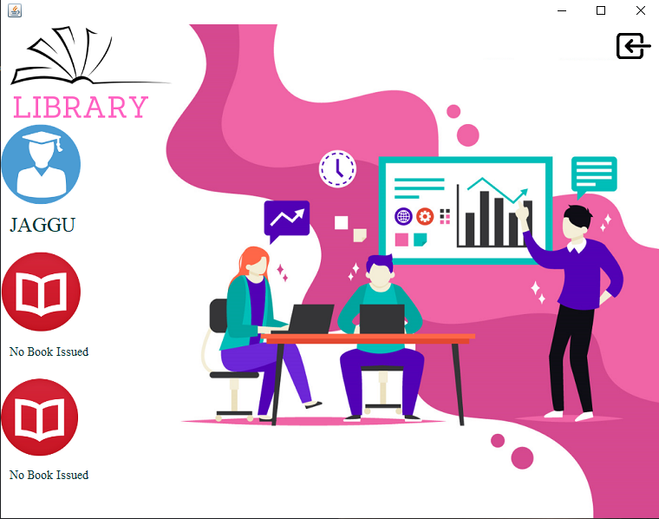

Program code

package user;

import Connection.Connect;

import java.sql.*;

import javax.swing.JOptionPane;

public class Library extends javax.swing.JFrame {

String uname;

Connection conn;

Statement st;

ResultSet rs;

String book1;

String book2;

public Library() {

initComponents();

}

public Library(String temp)

{

initComponents();

uname=temp;

try{

Connect con = new Connect();

conn= con.Connect();

String query= "select * from login where uname='"+uname+"'";

st= conn.createStatement();

rs= st.executeQuery(query);

try{

while (rs.next())

{

String s=(rs.getString(1)).toUpperCase();

jname.setText(s);

book1=(rs.getString(13));

book2=(rs.getString(14));

}

if (book1.equals("") || book2.equals(""))

{

jbook1.setText("No Book Issued");

jbook2.setText("No Book Issued");

}

else

{

String query1="select name from books where code='"+book1+"'";

st=conn.createStatement();

rs=st.executeQuery(query1);

if (rs.isBeforeFirst())

{

while (rs.next())

{

jbook1.setText(rs.getString("name"));

}

}

else

{

jbook1.setText("no book");

}

String query2="select name from books where code='"+book2+"'";

st=conn.createStatement();

rs=st.executeQuery(query2);

if (rs.isBeforeFirst())

{

while (rs.next())

{

jbook2.setText(rs.getString("name"));

}

}

else

{

jbook2.setText("no book");

}

}

}

catch(Exception e)

{

JOptionPane.showMessageDialog(rootPane, e.getMessage());

}

}

catch(Exception e)

{

JOptionPane.showMessageDialog(rootPane, e.getMessage());

}

}

@SuppressWarnings("unchecked")

// <editor-fold defaultstate="collapsed" desc="Generated Code">

private void initComponents() {

jPanel1 = new javax.swing.JPanel();

jButton1 = new javax.swing.JButton();

jname = new javax.swing.JLabel();

jbook2 = new javax.swing.JLabel();

jbook1 = new javax.swing.JLabel();

jLabel1 = new javax.swing.JLabel();

setDefaultCloseOperation(javax.swing.WindowConstants.EXIT_ON_CLOSE);

jPanel1.setLayout(null);

jButton1.setBackground(new java.awt.Color(255, 255, 255));

jButton1.setIcon(new javax.swing.ImageIcon(getClass().getResource("/project images/NEW BACK .png"))); // NOI18N

jButton1.addActionListener(new java.awt.event.ActionListener() {

public void actionPerformed(java.awt.event.ActionEvent evt) {

jButton1ActionPerformed(evt);

}

});

jPanel1.add(jButton1);

jButton1.setBounds(710, 10, 40, 30);

jname.setFont(new java.awt.Font("Times New Roman", 0, 24)); // NOI18N

jname.setForeground(new java.awt.Color(0, 51, 51));

jname.setText("NAME");

jPanel1.add(jname);

jname.setBounds(10, 210, 192, 42);

jbook2.setFont(new java.awt.Font("Times New Roman", 0, 14)); // NOI18N

jbook2.setForeground(new java.awt.Color(0, 51, 51));

jbook2.setText("book2");

jPanel1.add(jbook2);

jbook2.setBounds(10, 500, 190, 38);

jbook1.setFont(new java.awt.Font("Times New Roman", 0, 14)); // NOI18N

jbook1.setForeground(new java.awt.Color(0, 51, 51));

jbook1.setText("book1");

jPanel1.add(jbook1);

jbook1.setBounds(10, 360, 190, 34);

jLabel1.setIcon(new javax.swing.ImageIcon(getClass().getResource("/project images/LIBRARY STUDENT.png"))); // NOI18N

jPanel1.add(jLabel1);

jLabel1.setBounds(0, 0, 760, 570);

javax.swing.GroupLayout layout = new javax.swing.GroupLayout(getContentPane());

getContentPane().setLayout(layout);

layout.setHorizontalGroup(

layout.createParallelGroup(javax.swing.GroupLayout.Alignment.LEADING)

.addGroup(layout.createSequentialGroup()

.addGap(0, 0, 0)

.addComponent(jPanel1, javax.swing.GroupLayout.PREFERRED_SIZE, 761, javax.swing.GroupLayout.PREFERRED_SIZE)

.addGap(0, 0, Short.MAX_VALUE))

);

layout.setVerticalGroup(

layout.createParallelGroup(javax.swing.GroupLayout.Alignment.LEADING)

.addGroup(layout.createSequentialGroup()

.addGap(0, 0, 0)

.addComponent(jPanel1, javax.swing.GroupLayout.DEFAULT_SIZE, 569, Short.MAX_VALUE)

.addGap(0, 0, 0))

);

pack();

}// </editor-fold>

private void jButton1ActionPerformed(java.awt.event.ActionEvent evt) {

Profile pr1= new Profile(uname);

pr1.show();

this.dispose();

}

/**

* @param args the command line arguments

*/

public static void main(String args[]) {

/* Set the Nimbus look and feel */

//<editor-fold defaultstate="collapsed" desc=" Look and feel setting code (optional) ">

/* If Nimbus (introduced in Java SE 6) is not available, stay with the default look and feel.

* For details see http://download.oracle.com/javase/tutorial/uiswing/lookandfeel/plaf.html

*/

try {

for (javax.swing.UIManager.LookAndFeelInfo info : javax.swing.UIManager.getInstalledLookAndFeels()) {

if ("Nimbus".equals(info.getName())) {

javax.swing.UIManager.setLookAndFeel(info.getClassName());

break;

}

}

} catch (ClassNotFoundException ex) {

java.util.logging.Logger.getLogger(Library.class.getName()).log(java.util.logging.Level.SEVERE, null, ex);

} catch (InstantiationException ex) {

java.util.logging.Logger.getLogger(Library.class.getName()).log(java.util.logging.Level.SEVERE, null, ex);

} catch (IllegalAccessException ex) {

java.util.logging.Logger.getLogger(Library.class.getName()).log(java.util.logging.Level.SEVERE, null, ex);

} catch (javax.swing.UnsupportedLookAndFeelException ex) {

java.util.logging.Logger.getLogger(Library.class.getName()).log(java.util.logging.Level.SEVERE, null, ex);

}

//</editor-fold>

//</editor-fold>

/* Create and display the form */

java.awt.EventQueue.invokeLater(new Runnable() {

public void run() {

new Library().setVisible(true);

}

});

}

// Variables declaration - do not modify

private javax.swing.JButton jButton1;

private javax.swing.JLabel jLabel1;

private javax.swing.JPanel jPanel1;

private javax.swing.JLabel jbook1;

private javax.swing.JLabel jbook2;

private javax.swing.JLabel jname;

// End of variables declaration

}

* + - Feed

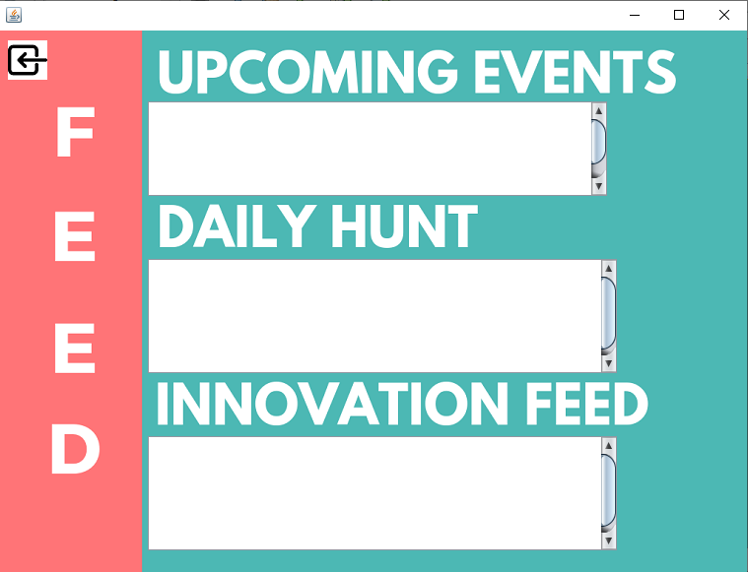

Program code

package user;

import Connection.Connect;

import java.sql.Connection;

import java.sql.DriverManager;

import java.sql.ResultSet;

import java.sql.Statement;

import javax.swing.JOptionPane;

public class FEED extends javax.swing.JFrame {

Connection conn;

Statement st;

ResultSet rs;

String uname;

public FEED() {

initComponents();

}

public FEED(String temp)

{

initComponents();

uname=temp;

try{

Connect con = new Connect();

conn= con.Connect();

String query="select * from feed ";

st= conn.createStatement();

rs= st.executeQuery(query);

while (rs.next())

{

jupcoming.setText(rs.getString("upcomingevent"));

jdaily.setText(rs.getString("dailyhunt"));

jinnovation.setText(rs.getString("innovationfeed"));

}

}

catch(Exception e)

{

JOptionPane.showMessageDialog(rootPane,e.getMessage() );

}

}

@SuppressWarnings("unchecked")

// <editor-fold defaultstate="collapsed" desc="Generated Code">

private void initComponents() {

jPanel1 = new javax.swing.JPanel();

jButton1 = new javax.swing.JButton();

jScrollPane1 = new javax.swing.JScrollPane();

jupcoming = new javax.swing.JTextArea();

jScrollPane2 = new javax.swing.JScrollPane();

jdaily = new javax.swing.JTextArea();

jScrollPane3 = new javax.swing.JScrollPane();

jinnovation = new javax.swing.JTextArea();

jLabel1 = new javax.swing.JLabel();

setDefaultCloseOperation(javax.swing.WindowConstants.EXIT_ON_CLOSE);

jPanel1.setLayout(null);

jButton1.setIcon(new javax.swing.ImageIcon(getClass().getResource("/project images/NEW BACK .png"))); // NOI18N

jButton1.addActionListener(new java.awt.event.ActionListener() {

public void actionPerformed(java.awt.event.ActionEvent evt) {

jButton1ActionPerformed(evt);

}

});

jPanel1.add(jButton1);

jButton1.setBounds(10, 10, 40, 40);

jupcoming.setEditable(false);

jupcoming.setColumns(20);

jupcoming.setFont(new java.awt.Font("Times New Roman", 0, 18)); // NOI18N

jupcoming.setRows(5);

jScrollPane1.setViewportView(jupcoming);

jPanel1.add(jScrollPane1);

jScrollPane1.setBounds(150, 70, 470, 100);

jdaily.setColumns(20);

jdaily.setFont(new java.awt.Font("Times New Roman", 0, 18)); // NOI18N

jdaily.setRows(5);

jScrollPane2.setViewportView(jdaily);

jPanel1.add(jScrollPane2);

jScrollPane2.setBounds(150, 230, 480, 120);

jinnovation.setColumns(20);

jinnovation.setFont(new java.awt.Font("Times New Roman", 0, 18)); // NOI18N

jinnovation.setRows(5);

jScrollPane3.setViewportView(jinnovation);

jPanel1.add(jScrollPane3);

jScrollPane3.setBounds(150, 410, 480, 120);

jLabel1.setIcon(new javax.swing.ImageIcon(getClass().getResource("/project images/feed.png"))); // NOI18N

jPanel1.add(jLabel1);

jLabel1.setBounds(0, 0, 760, 550);

javax.swing.GroupLayout layout = new javax.swing.GroupLayout(getContentPane());

getContentPane().setLayout(layout);

layout.setHorizontalGroup(

layout.createParallelGroup(javax.swing.GroupLayout.Alignment.LEADING)

.addGroup(layout.createSequentialGroup()

.addGap(0, 0, Short.MAX_VALUE)

.addComponent(jPanel1, javax.swing.GroupLayout.PREFERRED_SIZE, 760, javax.swing.GroupLayout.PREFERRED_SIZE))

);

layout.setVerticalGroup(

layout.createParallelGroup(javax.swing.GroupLayout.Alignment.LEADING)

.addGroup(javax.swing.GroupLayout.Alignment.TRAILING, layout.createSequentialGroup()

.addGap(0, 0, Short.MAX_VALUE)

.addComponent(jPanel1, javax.swing.GroupLayout.PREFERRED_SIZE, 550, javax.swing.GroupLayout.PREFERRED_SIZE)

.addGap(0, 0, 0))

);

pack();

}// </editor-fold>

private void jButton1ActionPerformed(java.awt.event.ActionEvent evt) {

Profile pr1= new Profile(uname);

pr1.show();

this.dispose();

}

/**

* @param args the command line arguments

*/

public static void main(String args[]) {

/* Set the Nimbus look and feel */

//<editor-fold defaultstate="collapsed" desc=" Look and feel setting code (optional) ">

/* If Nimbus (introduced in Java SE 6) is not available, stay with the default look and feel.

* For details see http://download.oracle.com/javase/tutorial/uiswing/lookandfeel/plaf.html

*/

try {

for (javax.swing.UIManager.LookAndFeelInfo info : javax.swing.UIManager.getInstalledLookAndFeels()) {

if ("Nimbus".equals(info.getName())) {

javax.swing.UIManager.setLookAndFeel(info.getClassName());

break;

}

}

} catch (ClassNotFoundException ex) {

java.util.logging.Logger.getLogger(FEED.class.getName()).log(java.util.logging.Level.SEVERE, null, ex);

} catch (InstantiationException ex) {

java.util.logging.Logger.getLogger(FEED.class.getName()).log(java.util.logging.Level.SEVERE, null, ex);

} catch (IllegalAccessException ex) {

java.util.logging.Logger.getLogger(FEED.class.getName()).log(java.util.logging.Level.SEVERE, null, ex);

} catch (javax.swing.UnsupportedLookAndFeelException ex) {

java.util.logging.Logger.getLogger(FEED.class.getName()).log(java.util.logging.Level.SEVERE, null, ex);

}

//</editor-fold>

/* Create and display the form */

java.awt.EventQueue.invokeLater(new Runnable() {

public void run() {

new FEED().setVisible(true);

}

});

}

// Variables declaration - do not modify

private javax.swing.JButton jButton1;

private javax.swing.JLabel jLabel1;

private javax.swing.JPanel jPanel1;

private javax.swing.JScrollPane jScrollPane1;

private javax.swing.JScrollPane jScrollPane2;

private javax.swing.JScrollPane jScrollPane3;

private javax.swing.JTextArea jdaily;

private javax.swing.JTextArea jinnovation;

private javax.swing.JTextArea jupcoming;

// End of variables declaration

}

* + - Academics

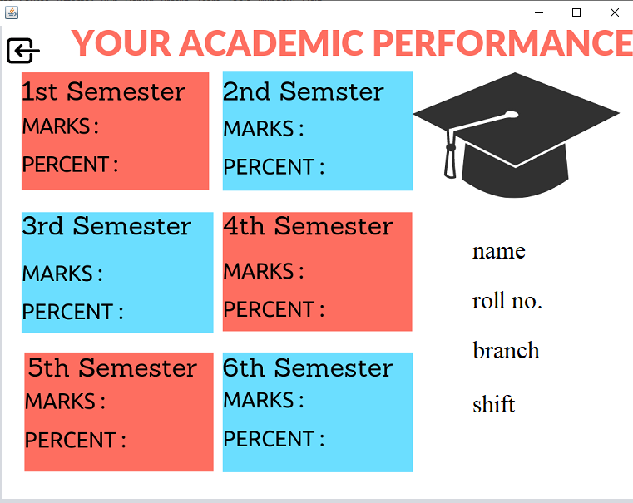

Program code

package user;

import Connection.Connect;

import java.sql.Connection;

import java.sql.DriverManager;

import java.sql.ResultSet;

import java.sql.Statement;

import javax.swing.JOptionPane;

public class Acadmics extends javax.swing.JFrame {

String uname;

Connection conn;

Statement st;

ResultSet rs;

public Acadmics() {

initComponents();

}

public Acadmics(String temp)

{

initComponents();

uname=temp;

try{

Connect con = new Connect();

conn= con.Connect();

String query= "select * from acadmics where uname='"+uname+"'";

st= conn.createStatement();

rs= st.executeQuery(query);

try{

while (rs.next())

{

jname.setText(rs.getString("name"));

jbranch.setText(rs.getString("branch"));

jshift.setText(rs.getString("shift"));

jroll.setText(rs.getString("rollno"));

jtm1.setText(rs.getString("tm1"));

jper1.setText(rs.getString("per1"));

jtm2.setText(rs.getString("tm2"));

jper2.setText(rs.getString("per2"));

jtm3.setText(rs.getString("tm3"));

jper3.setText(rs.getString("per3"));

jtm4.setText(rs.getString("tm4"));

jper4.setText(rs.getString("per4"));

jtm5.setText(rs.getString("tm5"));

jper5.setText(rs.getString("per5"));

jtm6.setText(rs.getString("tm6"));

jper6.setText(rs.getString("per6"));

}

}

catch(Exception e)

{

JOptionPane.showMessageDialog(rootPane, e.getMessage());

}

}

catch(Exception e)

{

JOptionPane.showMessageDialog(rootPane, e.getMessage());

}

}

@SuppressWarnings("unchecked")

// <editor-fold defaultstate="collapsed" desc="Generated Code">

private void initComponents() {

jPanel1 = new javax.swing.JPanel();

jButton1 = new javax.swing.JButton();

jtm1 = new javax.swing.JLabel();

jper1 = new javax.swing.JLabel();

jname = new javax.swing.JLabel();

jtm3 = new javax.swing.JLabel();

jper3 = new javax.swing.JLabel();

jtm5 = new javax.swing.JLabel();

jshift = new javax.swing.JLabel();

jroll = new javax.swing.JLabel();

jtm2 = new javax.swing.JLabel();

jper2 = new javax.swing.JLabel();

jtm4 = new javax.swing.JLabel();

jbranch = new javax.swing.JLabel();

jper6 = new javax.swing.JLabel();

jper5 = new javax.swing.JLabel();

jtm6 = new javax.swing.JLabel();

jper4 = new javax.swing.JLabel();

jLabel17 = new javax.swing.JLabel();

jLabel1 = new javax.swing.JLabel();

setDefaultCloseOperation(javax.swing.WindowConstants.EXIT_ON_CLOSE);

jPanel1.setLayout(null);

jButton1.setIcon(new javax.swing.ImageIcon(getClass().getResource("/project images/NEW BACK .png"))); // NOI18N

jButton1.addActionListener(new java.awt.event.ActionListener() {

public void actionPerformed(java.awt.event.ActionEvent evt) {

jButton1ActionPerformed(evt);

}

});

jPanel1.add(jButton1);

jButton1.setBounds(10, 10, 40, 40);

jtm1.setFont(new java.awt.Font("Times New Roman", 0, 24)); // NOI18N

jPanel1.add(jtm1);

jtm1.setBounds(160, 110, 70, 30);

jper1.setFont(new java.awt.Font("Times New Roman", 0, 24)); // NOI18N

jPanel1.add(jper1);

jper1.setBounds(160, 150, 50, 30);

jname.setFont(new java.awt.Font("Times New Roman", 0, 30)); // NOI18N

jname.setText("name ");

jPanel1.add(jname);

jname.setBounds(570, 250, 120, 40);

jtm3.setFont(new java.awt.Font("Times New Roman", 0, 24)); // NOI18N

jPanel1.add(jtm3);

jtm3.setBounds(170, 290, 70, 30);

jper3.setFont(new java.awt.Font("Times New Roman", 0, 24)); // NOI18N

jPanel1.add(jper3);

jper3.setBounds(170, 330, 60, 30);

jtm5.setFont(new java.awt.Font("Times New Roman", 0, 24)); // NOI18N

jPanel1.add(jtm5);

jtm5.setBounds(170, 440, 50, 30);

jshift.setFont(new java.awt.Font("Times New Roman", 0, 30)); // NOI18N

jshift.setText("shift");

jPanel1.add(jshift);

jshift.setBounds(570, 430, 120, 50);

jroll.setFont(new java.awt.Font("Times New Roman", 0, 30)); // NOI18N

jroll.setText("roll no.");

jPanel1.add(jroll);

jroll.setBounds(570, 310, 190, 40);

jtm2.setFont(new java.awt.Font("Times New Roman", 0, 24)); // NOI18N

jPanel1.add(jtm2);

jtm2.setBounds(410, 110, 70, 30);

jper2.setFont(new java.awt.Font("Times New Roman", 0, 24)); // NOI18N

jPanel1.add(jper2);

jper2.setBounds(410, 160, 60, 30);

jtm4.setFont(new java.awt.Font("Times New Roman", 0, 24)); // NOI18N

jPanel1.add(jtm4);

jtm4.setBounds(410, 280, 50, 30);

jbranch.setFont(new java.awt.Font("Times New Roman", 0, 30)); // NOI18N

jbranch.setText("branch ");

jPanel1.add(jbranch);

jbranch.setBounds(570, 370, 130, 40);

jper6.setFont(new java.awt.Font("Times New Roman", 0, 24)); // NOI18N

jPanel1.add(jper6);

jper6.setBounds(410, 480, 70, 0);

jper5.setFont(new java.awt.Font("Times New Roman", 0, 24)); // NOI18N

jPanel1.add(jper5);

jper5.setBounds(160, 490, 60, 30);

jtm6.setFont(new java.awt.Font("Times New Roman", 0, 24)); // NOI18N

jPanel1.add(jtm6);

jtm6.setBounds(410, 440, 60, 30);

jper4.setFont(new java.awt.Font("Times New Roman", 0, 24)); // NOI18N

jPanel1.add(jper4);

jper4.setBounds(410, 330, 60, 30);

jPanel1.add(jLabel17);

jLabel17.setBounds(0, 4, 0, 570);

jLabel1.setIcon(new javax.swing.ImageIcon(getClass().getResource("/project images/acadmics.png"))); // NOI18N

jPanel1.add(jLabel1);

jLabel1.setBounds(4, -6, 760, 580);

javax.swing.GroupLayout layout = new javax.swing.GroupLayout(getContentPane());

getContentPane().setLayout(layout);

layout.setHorizontalGroup(

layout.createParallelGroup(javax.swing.GroupLayout.Alignment.LEADING)

.addGroup(javax.swing.GroupLayout.Alignment.TRAILING, layout.createSequentialGroup()

.addGap(0, 0, Short.MAX_VALUE)

.addComponent(jPanel1, javax.swing.GroupLayout.PREFERRED_SIZE, 764, javax.swing.GroupLayout.PREFERRED_SIZE)

.addGap(0, 0, 0))

);

layout.setVerticalGroup(

layout.createParallelGroup(javax.swing.GroupLayout.Alignment.LEADING)

.addGroup(layout.createSequentialGroup()

.addGap(0, 0, 0)

.addComponent(jPanel1, javax.swing.GroupLayout.PREFERRED_SIZE, 575, javax.swing.GroupLayout.PREFERRED_SIZE)

.addGap(0, 0, Short.MAX_VALUE))

);

pack();

}// </editor-fold>

private void jButton1ActionPerformed(java.awt.event.ActionEvent evt) {

Profile pfl= new Profile(uname);

pfl.show();

this.dispose();

}

/**

* @param args the command line arguments

*/

public static void main(String args[]) {

/* Set the Nimbus look and feel */

//<editor-fold defaultstate="collapsed" desc=" Look and feel setting code (optional) ">

/* If Nimbus (introduced in Java SE 6) is not available, stay with the default look and feel.

* For details see http://download.oracle.com/javase/tutorial/uiswing/lookandfeel/plaf.html

*/

try {

for (javax.swing.UIManager.LookAndFeelInfo info : javax.swing.UIManager.getInstalledLookAndFeels()) {

if ("Nimbus".equals(info.getName())) {

javax.swing.UIManager.setLookAndFeel(info.getClassName());

break;

}

}

} catch (ClassNotFoundException ex) {

java.util.logging.Logger.getLogger(Acadmics.class.getName()).log(java.util.logging.Level.SEVERE, null, ex);

} catch (InstantiationException ex) {

java.util.logging.Logger.getLogger(Acadmics.class.getName()).log(java.util.logging.Level.SEVERE, null, ex);

} catch (IllegalAccessException ex) {

java.util.logging.Logger.getLogger(Acadmics.class.getName()).log(java.util.logging.Level.SEVERE, null, ex);

} catch (javax.swing.UnsupportedLookAndFeelException ex) {

java.util.logging.Logger.getLogger(Acadmics.class.getName()).log(java.util.logging.Level.SEVERE, null, ex);

}

//</editor-fold>

/* Create and display the form */

java.awt.EventQueue.invokeLater(new Runnable() {

public void run() {

new Acadmics().setVisible(true);

}

});

}

// Variables declaration - do not modify

private javax.swing.JButton jButton1;

private javax.swing.JLabel jLabel1;

private javax.swing.JLabel jLabel17;

private javax.swing.JPanel jPanel1;

private javax.swing.JLabel jbranch;

private javax.swing.JLabel jname;

private javax.swing.JLabel jper1;

private javax.swing.JLabel jper2;

private javax.swing.JLabel jper3;

private javax.swing.JLabel jper4;

private javax.swing.JLabel jper5;

private javax.swing.JLabel jper6;

private javax.swing.JLabel jroll;

private javax.swing.JLabel jshift;

private javax.swing.JLabel jtm1;

private javax.swing.JLabel jtm2;

private javax.swing.JLabel jtm3;

private javax.swing.JLabel jtm4;

private javax.swing.JLabel jtm5;

private javax.swing.JLabel jtm6;

// End of variables declaration

}

* + - Notice

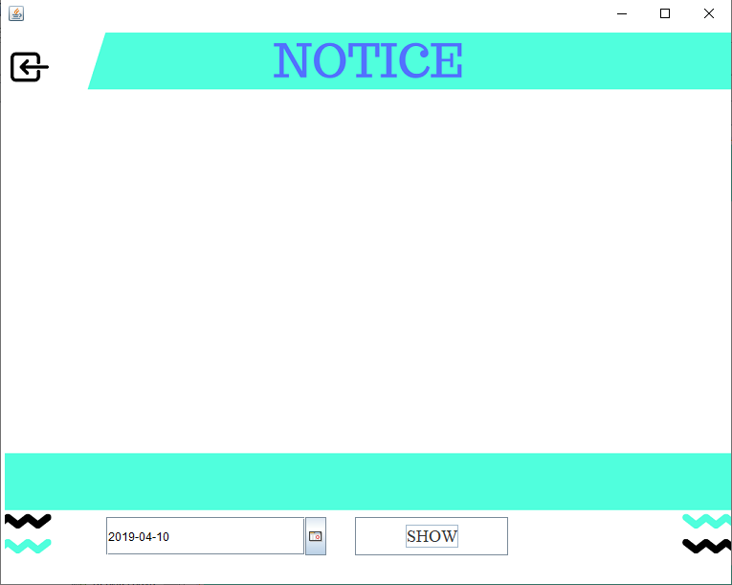

Program code

package user;

import Connection.Connect;

import java.awt.Image;

import java.sql.Connection;

import java.sql.ResultSet;

import java.sql.Statement;

import javax.swing.ImageIcon;

import javax.swing.JOptionPane;

import javax.swing.JTextField;

public class StudentNotice extends javax.swing.JFrame {

String uname;

Connection conn;

public StudentNotice() {

initComponents();

}

public StudentNotice(String temp)

{

initComponents();

uname=temp;

}

@SuppressWarnings("unchecked")

// <editor-fold defaultstate="collapsed" desc="Generated Code">

private void initComponents() {

jPanel2 = new javax.swing.JPanel();

jnotice = new javax.swing.JLabel();

jDateChooser1 = new com.toedter.calendar.JDateChooser();

jButton1 = new javax.swing.JButton();

jButton3 = new javax.swing.JButton();

jLabel2 = new javax.swing.JLabel();

setDefaultCloseOperation(javax.swing.WindowConstants.EXIT_ON_CLOSE);

jPanel2.setBackground(new java.awt.Color(255, 255, 255));

jPanel2.setLayout(null);

jPanel2.add(jnotice);

jnotice.setBounds(0, 60, 760, 370);

jDateChooser1.setDateFormatString("yyyy-MM-dd");

jPanel2.add(jDateChooser1);

jDateChooser1.setBounds(110, 510, 230, 40);

jButton1.setBackground(new java.awt.Color(255, 255, 255));

jButton1.setFont(new java.awt.Font("Times New Roman", 0, 18)); // NOI18N

jButton1.setText("SHOW");

jButton1.addActionListener(new java.awt.event.ActionListener() {

public void actionPerformed(java.awt.event.ActionEvent evt) {

jButton1ActionPerformed(evt);

}

});

jPanel2.add(jButton1);

jButton1.setBounds(370, 510, 160, 40);

jButton3.setBackground(new java.awt.Color(255, 255, 255));

jButton3.setIcon(new javax.swing.ImageIcon(getClass().getResource("/project images/NEW BACK .png"))); // NOI18N

jButton3.setBorder(null);

jButton3.addActionListener(new java.awt.event.ActionListener() {

public void actionPerformed(java.awt.event.ActionEvent evt) {

jButton3ActionPerformed(evt);

}

});

jPanel2.add(jButton3);

jButton3.setBounds(10, 20, 40, 40);

jLabel2.setIcon(new javax.swing.ImageIcon(getClass().getResource("/project images/updating notice.png"))); // NOI18N

jPanel2.add(jLabel2);

jLabel2.setBounds(4, 4, 760, 570);

javax.swing.GroupLayout layout = new javax.swing.GroupLayout(getContentPane());

getContentPane().setLayout(layout);

layout.setHorizontalGroup(

layout.createParallelGroup(javax.swing.GroupLayout.Alignment.LEADING)

.addGroup(layout.createSequentialGroup()

.addGap(0, 0, 0)

.addComponent(jPanel2, javax.swing.GroupLayout.PREFERRED_SIZE, 763, javax.swing.GroupLayout.PREFERRED_SIZE)

.addGap(0, 0, Short.MAX_VALUE))

);

layout.setVerticalGroup(

layout.createParallelGroup(javax.swing.GroupLayout.Alignment.LEADING)

.addGroup(layout.createSequentialGroup()

.addGap(0, 0, 0)

.addComponent(jPanel2, javax.swing.GroupLayout.DEFAULT_SIZE, 580, Short.MAX_VALUE)

.addGap(0, 0, 0))

);

pack();

}// </editor-fold>

private void jButton1ActionPerformed(java.awt.event.ActionEvent evt) {

try{

Connect con = new Connect();

conn= con.Connect();

String date=((JTextField)jDateChooser1.getDateEditor().getUiComponent()).getText();

Statement st = conn.createStatement();

ResultSet rs = st.executeQuery("select * from notice where date='"+date+"'");

if(rs.next()){

byte[] img = rs.getBytes("photo");

ImageIcon image = new ImageIcon(img);

Image im = image.getImage();

Image myImg = im.getScaledInstance(jnotice.getWidth(), jnotice.getHeight(),Image.SCALE_SMOOTH);

ImageIcon newImage = new ImageIcon(myImg);

jnotice.setIcon(newImage);

}

else{

JOptionPane.showMessageDialog(null, "No Data");

}

}catch(Exception e){

JOptionPane.showMessageDialog(rootPane, e.getMessage());

}

}

private void jButton3ActionPerformed(java.awt.event.ActionEvent evt) {

Profile pr= new Profile(uname);

pr.show();

this.dispose();

}

public static void main(String args[]) {

java.awt.EventQueue.invokeLater(new Runnable() {

public void run() {

new StudentNotice().setVisible(true);

}

});

}

// Variables declaration - do not modify

private javax.swing.JButton jButton1;

private javax.swing.JButton jButton3;

private com.toedter.calendar.JDateChooser jDateChooser1;

private javax.swing.JLabel jLabel2;

private javax.swing.JPanel jPanel2;

private javax.swing.JLabel jnotice;

// End of variables declaration

}

* + - Library Register

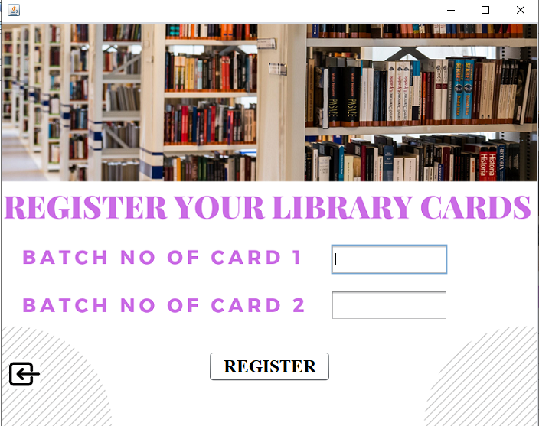

Program code

package user;

import Connection.Connect;

import java.sql.DriverManager;

import javax.swing.JOptionPane;

import java.sql.Connection;

import java.sql.DriverManager;

import java.sql.ResultSet;

import java.sql.Statement;

public class libreg extends javax.swing.JFrame {

Connection conn;

ResultSet rs;

Statement st;

String uname;

public libreg() {

initComponents();

}

public libreg(String temp) {

initComponents();

uname=temp;

}

@SuppressWarnings("unchecked")

// <editor-fold defaultstate="collapsed" desc="Generated Code">

private void initComponents() {

jPanel1 = new javax.swing.JPanel();

jButton1 = new javax.swing.JButton();

jbatch1 = new javax.swing.JTextField();

jbatch2 = new javax.swing.JTextField();

jButton2 = new javax.swing.JButton();

jLabel4 = new javax.swing.JLabel();

setDefaultCloseOperation(javax.swing.WindowConstants.EXIT_ON_CLOSE);

jPanel1.setLayout(null);

jButton1.setBackground(new java.awt.Color(255, 255, 255));

jButton1.setFont(new java.awt.Font("Times New Roman", 1, 24)); // NOI18N

jButton1.setText("REGISTER");

jButton1.addActionListener(new java.awt.event.ActionListener() {

public void actionPerformed(java.awt.event.ActionEvent evt) {

jButton1ActionPerformed(evt);

}

});

jPanel1.add(jButton1);

jButton1.setBounds(270, 430, 160, 40);

jbatch1.addActionListener(new java.awt.event.ActionListener() {

public void actionPerformed(java.awt.event.ActionEvent evt) {

jbatch1ActionPerformed(evt);

}

});

jPanel1.add(jbatch1);

jbatch1.setBounds(430, 290, 153, 40);

jbatch2.addActionListener(new java.awt.event.ActionListener() {

public void actionPerformed(java.awt.event.ActionEvent evt) {

jbatch2ActionPerformed(evt);

}

});

jPanel1.add(jbatch2);

jbatch2.setBounds(430, 350, 153, 40);

jButton2.setIcon(new javax.swing.ImageIcon(getClass().getResource("/project images/NEW BACK .png"))); // NOI18N

jButton2.addActionListener(new java.awt.event.ActionListener() {

public void actionPerformed(java.awt.event.ActionEvent evt) {

jButton2ActionPerformed(evt);

}

});

jPanel1.add(jButton2);

jButton2.setBounds(10, 440, 40, 40);

jLabel4.setIcon(new javax.swing.ImageIcon(getClass().getResource("/project images/card acvtivation.png"))); // NOI18N

jPanel1.add(jLabel4);

jLabel4.setBounds(0, 0, 700, 530);

javax.swing.GroupLayout layout = new javax.swing.GroupLayout(getContentPane());

getContentPane().setLayout(layout);

layout.setHorizontalGroup(

layout.createParallelGroup(javax.swing.GroupLayout.Alignment.LEADING)

.addGroup(layout.createSequentialGroup()

.addGap(0, 0, 0)

.addComponent(jPanel1, javax.swing.GroupLayout.PREFERRED_SIZE, 701, javax.swing.GroupLayout.PREFERRED_SIZE)

.addGap(0, 0, Short.MAX_VALUE))

);

layout.setVerticalGroup(

layout.createParallelGroup(javax.swing.GroupLayout.Alignment.LEADING)

.addGroup(layout.createSequentialGroup()

.addGap(0, 0, 0)

.addComponent(jPanel1, javax.swing.GroupLayout.PREFERRED_SIZE, 529, javax.swing.GroupLayout.PREFERRED_SIZE)

.addGap(0, 0, Short.MAX_VALUE))

);

pack();

}// </editor-fold>

private void jbatch2ActionPerformed(java.awt.event.ActionEvent evt) {

// TODO add your handling code here:

}

private void jButton1ActionPerformed(java.awt.event.ActionEvent evt) {

String b1=jbatch1.getText();

String b2= jbatch2.getText();

try{

Connect con = new Connect();

conn= con.Connect();

String query= "update login set lcard1='"+b1+"',lcard2='"+b2+"'where uname='"+uname+"'";

st= conn.createStatement();

int temp= st.executeUpdate(query);

if (temp>0)

{

JOptionPane.showMessageDialog(rootPane, "YOUR CARDS ARE NOW ACTIVATED");

Library lb= new Library(uname);

lb.show();

this.dispose();

}

else

{

JOptionPane.showMessageDialog(rootPane, "invalid cridentials");

}

}

catch(Exception e)

{

JOptionPane.showMessageDialog(rootPane, e.getMessage());

}

finally{

jbatch1.setText("");

jbatch2.setText("");

}

}

private void jbatch1ActionPerformed(java.awt.event.ActionEvent evt) {

// TODO add your handling code here:

}

private void jButton2ActionPerformed(java.awt.event.ActionEvent evt) {

Profile prf= new Profile(uname);

prf.show();

this.dispose();

}

/**

* @param args the command line arguments

*/

public static void main(String args[]) {

/* Set the Nimbus look and feel */

//<editor-fold defaultstate="collapsed" desc=" Look and feel setting code (optional) ">

/* If Nimbus (introduced in Java SE 6) is not available, stay with the default look and feel.

* For details see http://download.oracle.com/javase/tutorial/uiswing/lookandfeel/plaf.html

*/

try {

for (javax.swing.UIManager.LookAndFeelInfo info : javax.swing.UIManager.getInstalledLookAndFeels()) {

if ("Nimbus".equals(info.getName())) {

javax.swing.UIManager.setLookAndFeel(info.getClassName());

break;

}

}

} catch (ClassNotFoundException ex) {

java.util.logging.Logger.getLogger(libreg.class.getName()).log(java.util.logging.Level.SEVERE, null, ex);

} catch (InstantiationException ex) {

java.util.logging.Logger.getLogger(libreg.class.getName()).log(java.util.logging.Level.SEVERE, null, ex);

} catch (IllegalAccessException ex) {

java.util.logging.Logger.getLogger(libreg.class.getName()).log(java.util.logging.Level.SEVERE, null, ex);

} catch (javax.swing.UnsupportedLookAndFeelException ex) {

java.util.logging.Logger.getLogger(libreg.class.getName()).log(java.util.logging.Level.SEVERE, null, ex);

}

//</editor-fold>

/* Create and display the form */

java.awt.EventQueue.invokeLater(new Runnable() {

public void run() {

new libreg().setVisible(true);

}

});

}

// Variables declaration - do not modify

private javax.swing.JButton jButton1;

private javax.swing.JButton jButton2;

private javax.swing.JLabel jLabel4;

private javax.swing.JPanel jPanel1;

private javax.swing.JTextField jbatch1;

private javax.swing.JTextField jbatch2;

// End of variables declaration

}

**Future Scope**

Such a Desktop based platform has immense potential for future growth not only for students but also for faculty as well as departments concerned in improving upon their efficiency of work with no or less burden. Some of the areas where future scope lies and if implemented would help a great deal to the students at large.

* In the Future, Students can also download and upload notes.
* Also, it would be possible for students to watch lectures in the form of video content which would facilitate easy access to study material.
* Further enhancement would help in Statistics tracking and analytics of student’s performance according to his/her result.

**CONCLUSION**

* The system provides excellent support to the colleges because they can directly manage their student databases.
* Computerized surveying systems provide easy, fast access and support for the user.
* The usage of software increases efficiency, decreases effort.
* It has been thoroughly tested and implemented.