Name:Meruva Kodanda Suraj Roll no: 241020446

Code:

import math

HUMAN = "X"

SAIRAM = "O"

EMPTY = " "

# ---------- Board Helpers ----------

def print_board(board):

print()

for r in range(3):

row = [board[r*3+c] if board[r*3+c] != EMPTY else str(r*3+c+1) for c in range(3)]

print(" | ".join(row))

if r < 2: print("-"*5)

print()

def is_moves_left(board):

return EMPTY in board

def evaluate(board):

for r in range(3):

if board[r*3] == board[r*3+1] == board[r*3+2] != EMPTY:

return +10 if board[r*3] == SAIRAM else -10

for c in range(3):

if board[c] == board[c+3] == board[c+6] != EMPTY:

return +10 if board[c] == SAIRAM else -10

if board[0] == board[4] == board[8] != EMPTY:

return +10 if board[0] == SAIRAM else -10

if board[2] == board[4] == board[6] != EMPTY:

return +10 if board[2] == SAIRAM else -10

return 0

# ---------- Minimax with Alpha-Beta + Node Counter ----------

ab_nodes = 0

def minimax_ab(board, depth, is_maximizing, alpha, beta):

global ab_nodes

ab_nodes += 1

score = evaluate(board)

if score == 10: return score - depth

if score == -10: return score + depth

if not is_moves_left(board): return 0

if is_maximizing: # SAIRAM

best = -math.inf

for i in range(9):

if board[i] == EMPTY:

board[i] = SAIRAM

best = max(best, minimax_ab(board, depth+1, False, alpha, beta))

board[i] = EMPTY

alpha = max(alpha, best)

if beta <= alpha: break

return best

else: # Human

best = math.inf

for i in range(9):

if board[i] == EMPTY:

board[i] = HUMAN

best = min(best, minimax_ab(board, depth+1, True, alpha, beta))

board[i] = EMPTY

beta = min(beta, best)

if beta <= alpha: break

return best

# ---------- Best Move ----------

def best_move(board):

global ab_nodes

best_val = -math.inf

best_index = -1

ab_nodes = 0 # reset counter

for i in range(9):

if board[i] == EMPTY:

board[i] = SAIRAM

move_val = minimax_ab(board, 0, False, -math.inf, math.inf)

board[i] = EMPTY

if move_val > best_val:

best_val = move_val

best_index = i

print(f"SAIRAM evaluated {ab_nodes} nodes for this move.")

return best_index

# ---------- Play Game ----------

def play():

board = [EMPTY]*9

human_turn = True

print("Welcome to Tic Tac Toe (3x3)")

print("You are X, SAIRAM is O\n")

while True:

print_board(board)

score = evaluate(board)

if score == 10:

print("SAIRAM wins!")

break

elif score == -10:

print("You win!")

break

elif not is_moves_left(board):

print("Draw!")

break

if human_turn:

move = int(input("Your move (1-9): ")) - 1

if 0 <= move < 9 and board[move] == EMPTY:

board[move] = HUMAN

human_turn = False

else:

print("Invalid move, try again.")

else:

print("SAIRAM is thinking...")

move = best_move(board)

board[move] = SAIRAM

human_turn = True

if __name__ == "__main__":

play()

Output:

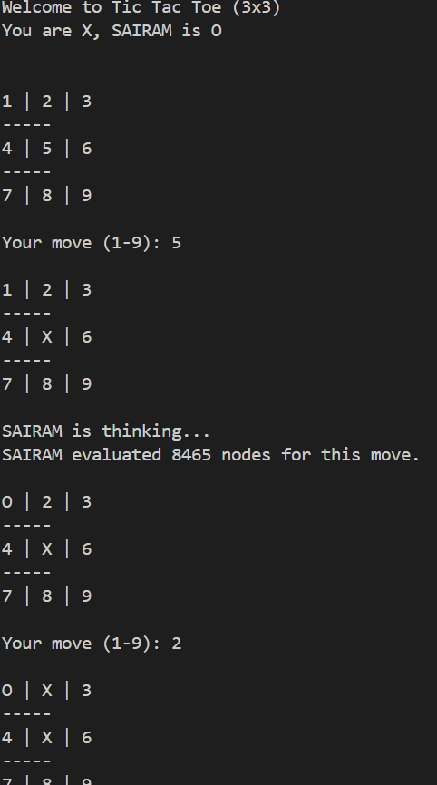

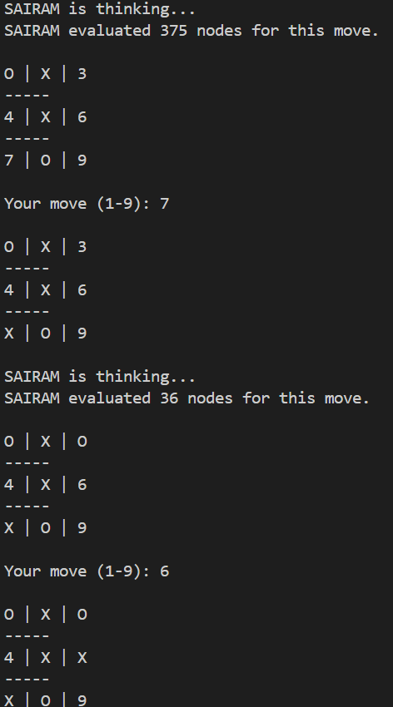

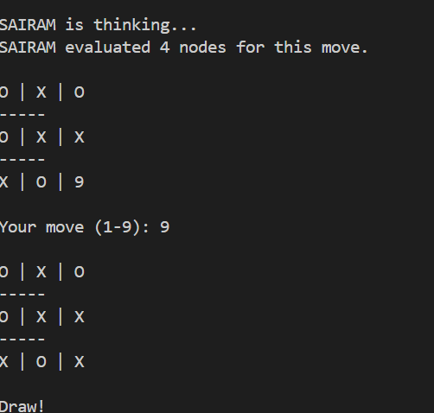

Assumptions:   
As 4x4 Tic Tac Toe has very large runtime   
I have proceeded with 3x3 tic tac toe version.