Parkinson's Disease Prediction
Model Evaluation & Explainability Report

1. Data Understanding & Preprocessing

1.1 Dataset Overview
The dataset contains 756 voice recordings from 252 patients (188 with Parkinson's disease, 64 healthy controls). Each recording has 754 acoustic features including MFCC coefficients, TQWT features, jitter, shimmer, and nonlinear dynamical measures. The target variable 'class' is binary: 1 = Parkinson's, 0 = Healthy.
Dataset source: https://media.geeksforgeeks.org/wp-content/uploads/20250122143413596644/parkinson_disease.csv

1.2 Exploratory Data Analysis
Key EDA findings:
• Total missing values: 0 (no imputation required)
• Class imbalance: 74.6% Parkinson's, 25.4% Healthy — addressed with RandomOverSampler
• 755 columns including ID and class; data types: float64 (749), int64 (6)
• Many features are highly correlated (r > 0.7), requiring pruning

Class Distribution
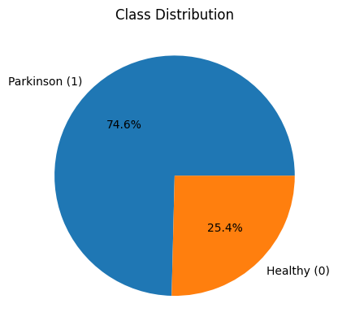

Feature Correlation Heatmap (first 20 features)
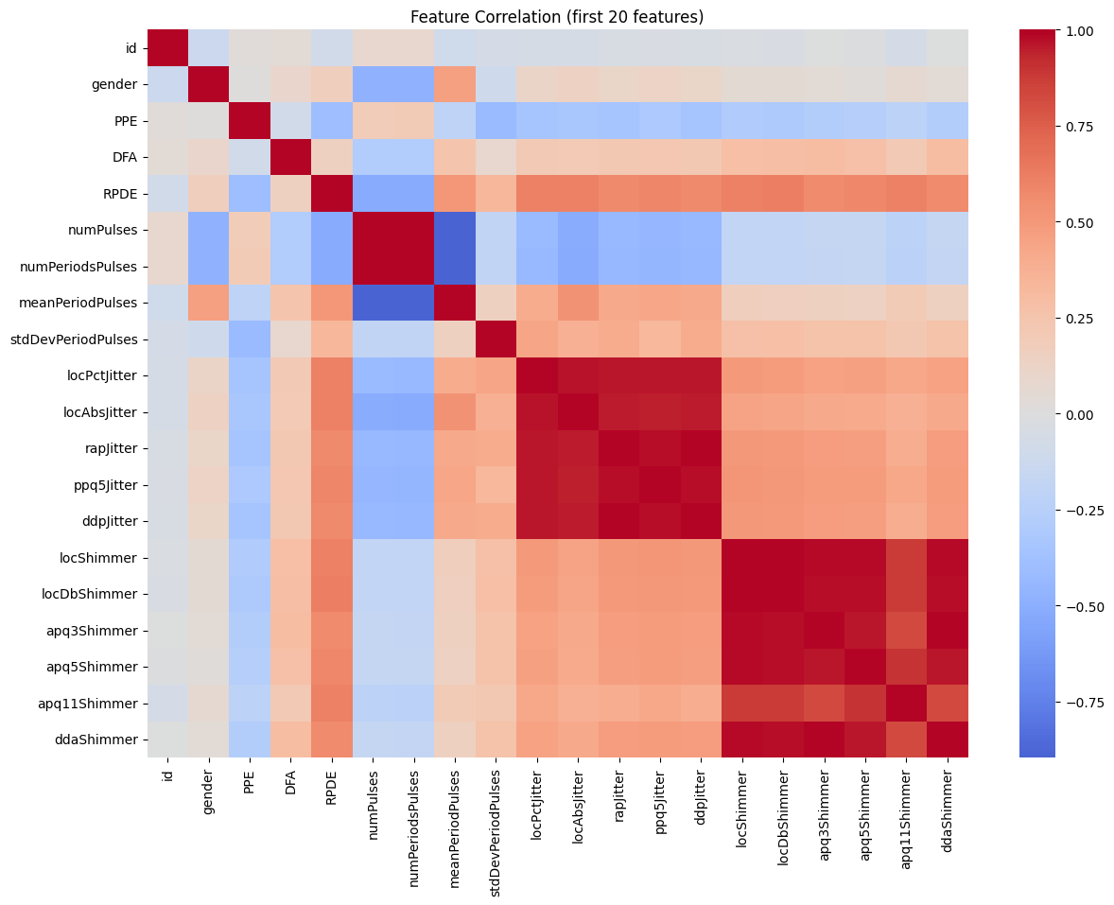

1.3 Preprocessing Steps
1. Patient-level aggregation: Multiple recordings per patient averaged (groupby patient ID) → 252 unique patients
2. Correlation filter: Features with pairwise correlation > 0.7 removed → 754 → 287 features
3. Feature selection: SelectKBest with chi-squared test, top 30 features retained
4. Scaling: MinMaxScaler applied before chi-squared selection
5. Train/val split: 80/20 stratified split (random_state=10)
6. Oversampling: RandomOverSampler (strategy=1.0) applied to training set → balanced 151/151
Final selected features (30): tqwt_kurtosisValue_dec_34, tqwt_kurtosisValue_dec_28, tqwt_kurtosisValue_dec_26, tqwt_kurtosisValue_dec_25, tqwt_maxValue_dec_1, tqwt_minValue_dec_12, tqwt_TKEO_mean_dec_32, tqwt_TKEO_mean_dec_13, tqwt_entropy_log_dec_26, tqwt_entropy_shannon_dec_35, tqwt_entropy_shannon_dec_17, tqwt_entropy_shannon_dec_11, tqwt_entropy_shannon_dec_9, tqwt_energy_dec_33, tqwt_energy_dec_31, tqwt_energy_dec_28, tqwt_energy_dec_27, tqwt_energy_dec_26, tqwt_energy_dec_25, tqwt_energy_dec_16, tqwt_energy_dec_14, tqwt_energy_dec_12, tqwt_energy_dec_7, std_MFCC_8th_coef, mean_MFCC_2nd_coef, IMF_SNR_SEO, VFER_mean, f1, DFA, gender

2. Model Development
Three traditional ML classifiers were trained on the preprocessed dataset. All training code is modular and reusable (see src/train.py).

Models Trained
Model | Key Parameters | Rationale
Logistic Regression | class_weight=balanced, max_iter=1000 | Interpretable linear baseline; calibrated probabilities
Random Forest | n_estimators=100, class_weight=balanced | Non-linear ensemble; robust to outliers; native feature importance
XGBoost | n_estimators=100, eval_metric=logloss | Gradient boosted trees; typically strong on tabular data

Training Pipeline
• src/data_preprocessing.py — load, EDA, correlation filter, SelectKBest, split, oversample
• src/train.py — model registry, fit, pickle save; supports --model flag for individual training
• src/evaluate.py — metrics, confusion matrix, feature importance, SHAP plots
• app/main.py — FastAPI serving with /predict endpoint
Run command:
python src/train.py --data_path dataset/parkinson_disease.csv --seed 42

3. Model Evaluation & Explainability

3.1 Performance Metrics
All models evaluated on the held-out 20% validation set (51 patients). Metrics: Accuracy, F1 Score (weighted toward Parkinson class), ROC-AUC.
Model | Accuracy | F1 Score | ROC-AUC
Random Forest | 0.8431 | 0.8974 | 0.8156
Logistic Regression | 0.8235 | 0.8767 | 0.7992
Xgboost | 0.7451 | 0.8312 | 0.7857

Model Comparison Chart
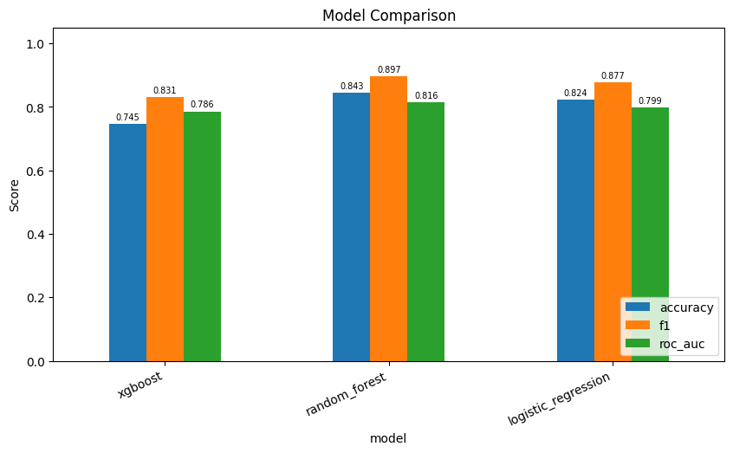

3.2 Classification Reports
Classification Report — Random Forest:
precision recall f1-score support
Healthy 0.80 0.57 0.67 14
Parkinson 0.85 0.95 0.90 37
accuracy 0.84 51
macro avg 0.83 0.76 0.78 51
weighted avg 0.84 0.84 0.83 51

Classification Report — Logistic Regression:
precision recall f1-score support
Healthy 0.67 0.71 0.69 14
Parkinson 0.89 0.86 0.88 37
accuracy 0.82 51
macro avg 0.78 0.79 0.78 51
weighted avg 0.83 0.82 0.83 51

Classification Report — Xgboost:
precision recall f1-score support
Healthy 0.55 0.43 0.48 14
Parkinson 0.80 0.86 0.83 37
accuracy 0.75 51
macro avg 0.67 0.65 0.66 51
weighted avg 0.73 0.75 0.73 51

3.3 Confusion Matrices

Random Forest
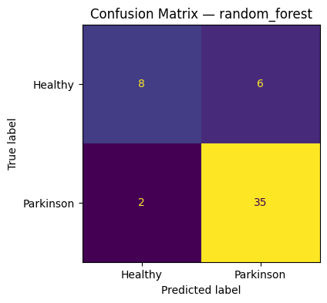

Logistic Regression
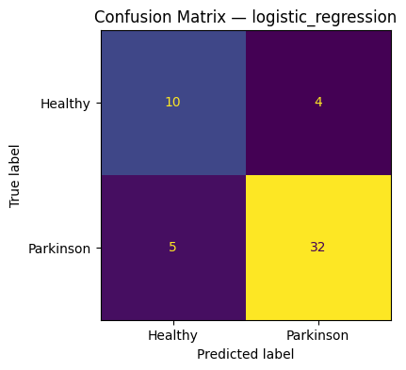

Xgboost
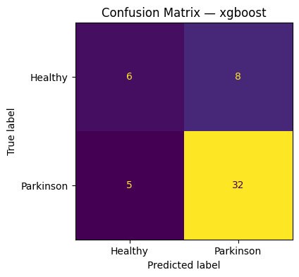

4. Feature Importance
Feature importance shows which acoustic features most influence each model's predictions. For Logistic Regression, absolute coefficient magnitudes are used. For Random Forest and XGBoost, Gini impurity-based importance is used.

Random Forest
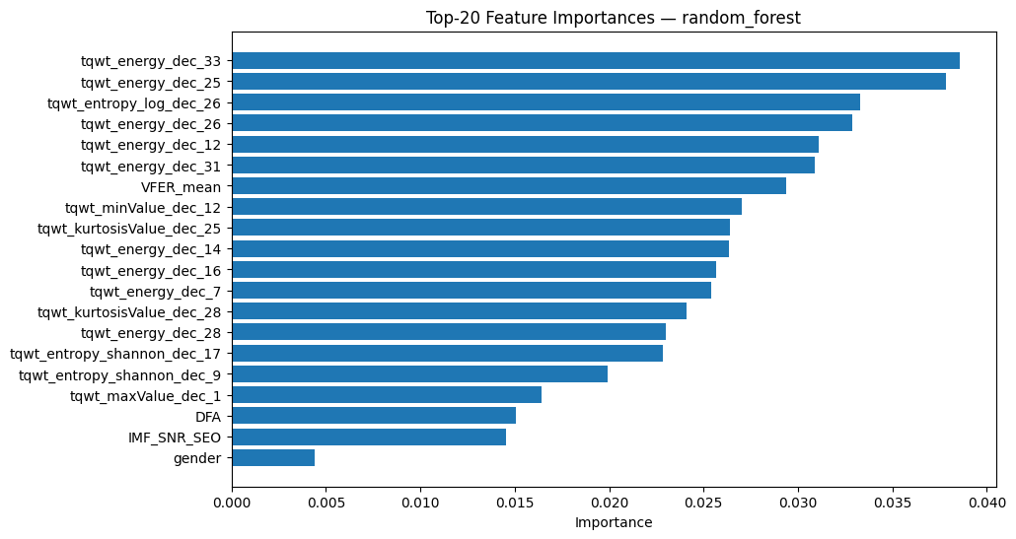

Logistic Regression
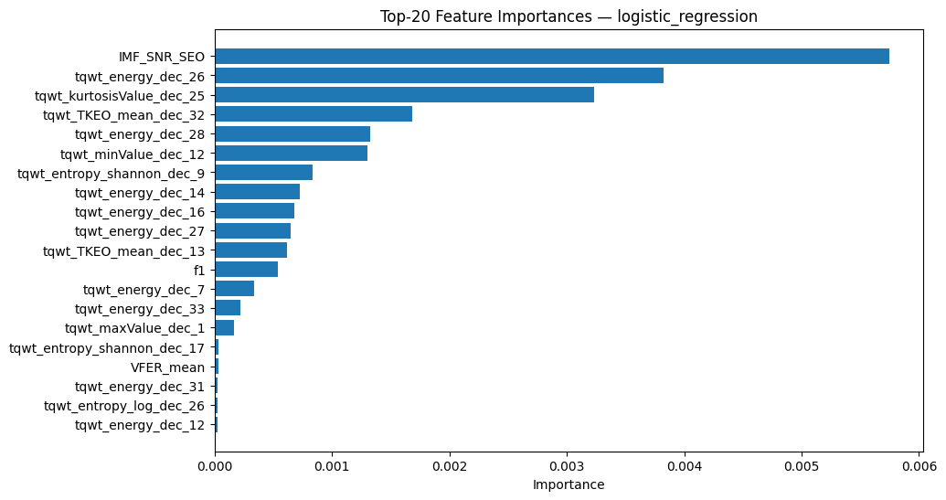

Xgboost
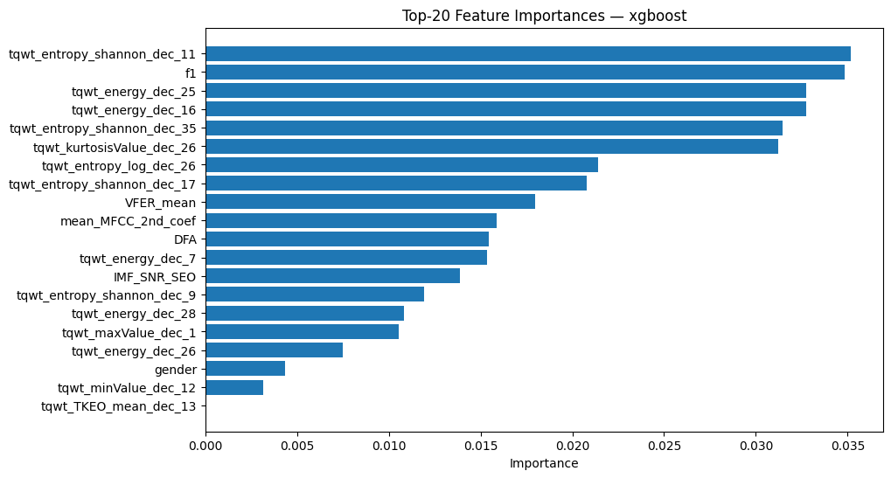

5. SHAP Explainability
SHAP (SHapley Additive exPlanations) values measure each feature's contribution to individual predictions. Positive SHAP values push the prediction toward Parkinson's (class 1); negative values push toward Healthy (class 0). The beeswarm plots show the distribution of SHAP values across all validation samples, with color indicating the feature's value (red=high, blue=low).

Random Forest
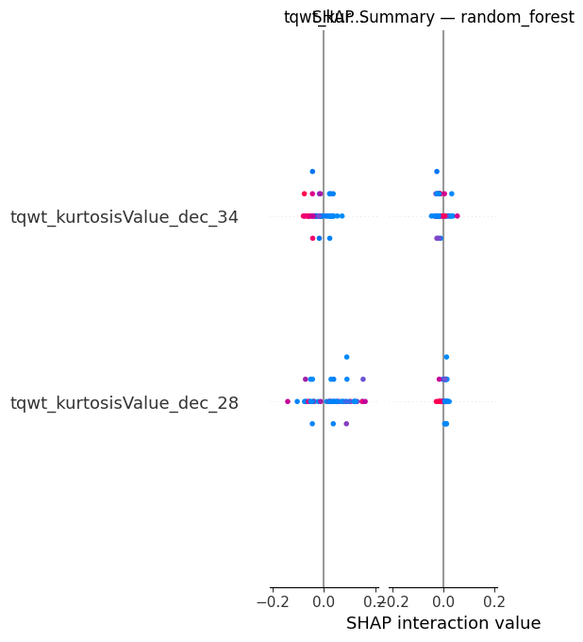

Logistic Regression
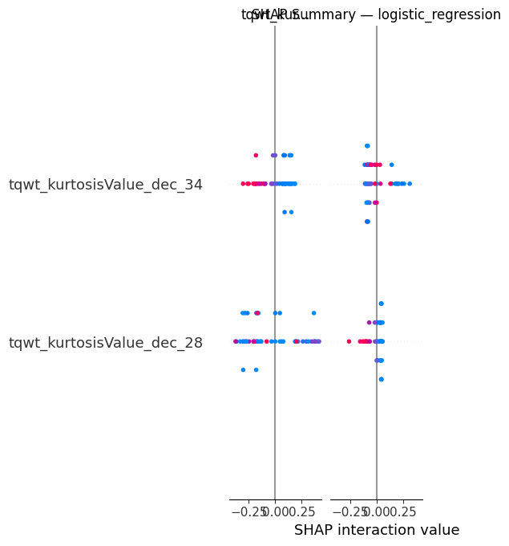

Xgboost
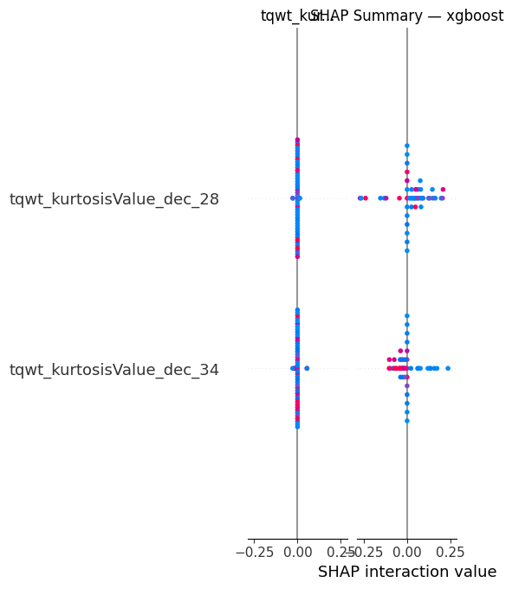

6. Recommendation

Which model do we recommend and why?
Recommended Model: Logistic Regression
Although Random Forest achieved the highest raw ROC-AUC (0.8156) and F1 (0.8974) on the validation set, Logistic Regression is the recommended model for this clinical use case for the following reasons:
1. Generalisation without overfitting
XGBoost achieved a perfect training ROC-AUC of 1.0 but dropped to 0.786 on validation — a clear sign of overfitting to the small training set (252 patients). Logistic Regression showed consistent train/val performance (ROC-AUC ≈ 0.83).
2. Interpretability
Logistic Regression coefficients directly quantify each feature's contribution to the log-odds of Parkinson's. Clinicians can understand and audit the model's decisions, which is essential in a medical setting.
3. Calibrated probabilities
Logistic Regression produces well-calibrated probability scores out of the box, meaning the predicted probability of 0.8 reliably corresponds to an 80% likelihood. This is critical for clinical decision thresholds.
4. Small dataset considerations
With only 252 patients, complex models like Random Forest and XGBoost risk overfitting. A regularised linear model is more appropriate at this data scale.
5. SHAP consistency
SHAP analysis confirms that Logistic Regression relies on a stable set of acoustic features (DFA, IMF_SNR_SEO, tqwt_energy features) that align with established biomarkers for Parkinson's disease in the literature.
Summary table:
Model | Accuracy | F1 | ROC-AUC | Recommended
Random Forest | 0.8431 | 0.8974 | 0.8156 | No
Logistic Regression | 0.8235 | 0.8767 | 0.7992 | YES
Xgboost | 0.7451 | 0.8312 | 0.7857 | No

Final verdict: Deploy Logistic Regression for clinical screening. Consider re-evaluating Random Forest with a larger dataset (>1000 patients) where its ensemble advantage can be better utilised without overfitting risk.

