Azure Enterprise Network
Security Architecture
AZ-700 Portfolio Project | Full Technical Documentation
Phase  5 Phases | Topology  Hub-Spoke | Focus  Zero Trust | Role  NE / NSE

Author: [Your Name] | Version: 1.0 | Date: 2025

1. Project Overview
This document provides end-to-end technical documentation for the Azure Enterprise Network Security Architecture portfolio project, aligned with the AZ-700 (Designing and Implementing Microsoft Azure Networking Solutions) certification and the responsibilities of a Network Engineer or Network Security Engineer with 5+ years of experience.

1.1 Executive Summary
This project implements a production-grade enterprise network topology on Microsoft Azure using a hub-spoke architecture with Zero Trust Network Access (ZTNA) principles. All inter-spoke traffic is inspected by Azure Firewall Premium, administrative access is enforced exclusively through Azure Bastion (eliminating public IP exposure on VMs), hybrid connectivity is provided via VPN Gateway with BGP, and the entire environment is monitored through Microsoft Defender for Cloud and Azure Monitor.

The entire infrastructure is defined as Infrastructure-as-Code (IaC) using Azure Bicep, enabling repeatable deployments and demonstrating modern DevOps practices expected in senior network engineering roles.

1.2 Business Scenario
Contoso Ltd. is a mid-sized enterprise (1,500 employees) undergoing cloud migration. They require:
- A secure, scalable Azure network foundation to host web, application, and data workloads
- Strict network segmentation between tiers to limit blast radius in the event of a breach
- Secure remote access for administrators without exposing RDP/SSH to the internet
- Connectivity to their on-premises data centre in Manchester, UK (simulated)
- Centralised logging, threat detection, and compliance reporting for ISO 27001 audit

1.3 AZ-700 Exam Domain Coverage
AZ-700 Domain | Project Component | Coverage
Design & implement hybrid networking | VPN Gateway S2S, BGP, Local Network Gateway | Phase 4
Design & implement Azure VNet | Hub VNet, Spoke VNets, Peering, Subnetting | Phase 1
Design & implement VNet routing | UDRs, Route Tables, Force Tunnel via Firewall | Phase 2
Secure & monitor networks | NSGs, ASGs, Firewall Premium, Defender | Phases 1-5
Design & implement private access | Azure Bastion, Private Endpoints | Phases 3-4
Design & implement Azure Firewall | Firewall Premium, DNAT, Network, App rules | Phase 2
Monitor networks | Network Watcher, Connection Monitor, NSG Flow Logs | Phase 5

2. Network Architecture Design

2.1 Topology: Hub-Spoke with Zero Trust
The chosen topology is Hub-Spoke, the Microsoft-recommended pattern for enterprise Azure networking. This is equivalent to a MPLS hub-and-spoke WAN design but implemented in software-defined cloud networking.

INFO | INTERVIEW TALKING POINT: "I chose Hub-Spoke because it provides centralised security inspection without requiring N-squared peering connections between spokes. With 3 spokes, direct peering would require 3 peering pairs. With 10 spokes, that is 45 pairs. Hub-spoke scales to hundreds of spokes with a single firewall inspection point."

2.2 Address Space Design
IP addressing follows RFC 1918 private address space. The design uses a /16 per VNet, subdivided into /24 and /26 subnets, providing room for growth without re-addressing.

VNet / Subnet | CIDR | Usable IPs | Purpose
Hub VNet | 10.0.0.0/16 | 65,534 | Central connectivity hub
AzureFirewallSubnet | 10.0.1.0/26 | 59 | Azure Firewall Premium (min /26)
GatewaySubnet | 10.0.2.0/27 | 27 | VPN Gateway (min /27)
AzureBastionSubnet | 10.0.3.0/26 | 59 | Azure Bastion Standard (min /26)
ManagementSubnet | 10.0.4.0/24 | 251 | Management VMs, monitoring agents
Spoke 1 - Web/App VNet | 10.1.0.0/16 | 65,534 | Web and application workloads
WebSubnet | 10.1.1.0/24 | 251 | Internet-facing web servers
AppSubnet | 10.1.2.0/24 | 251 | Internal application servers
Spoke 2 - Data VNet | 10.2.0.0/16 | 65,534 | Data tier workloads
DataSubnet | 10.2.1.0/24 | 251 | Database servers
PrivateEndpointSubnet | 10.2.2.0/24 | 251 | PaaS Private Endpoints
Spoke 3 - DMZ/Mgmt VNet | 10.3.0.0/16 | 65,534 | DMZ and admin jump access
DMZSubnet | 10.3.1.0/24 | 251 | Internet-facing DMZ services
JumpSubnet | 10.3.2.0/24 | 251 | Admin jump servers (no public IPs)

WARNING | Azure reserves 5 IP addresses in every subnet: x.x.x.0 (network), x.x.x.1 (default gateway), x.x.x.2-3 (Azure DNS), x.x.x.255 (broadcast). A /26 has 64 total addresses - 5 = 59 usable.

2.3 Zero Trust Design Principles Applied
This architecture implements all three core Zero Trust principles as defined by NIST SP 800-207:

Verify Explicitly
- Azure Bastion requires Azure AD authentication before any RDP/SSH session - no shared credentials or SSH keys stored on jump boxes
- Azure Firewall Premium with IDPS (Intrusion Detection and Prevention System) inspects all traffic, not just ports and protocols
- Microsoft Defender for Cloud continuously assesses VM security posture and flags deviations

Use Least Privilege Access
- NSGs on every subnet enforce minimum required access - no wildcard rules
- Data tier (SQL) only accepts connections from App tier on port 1433 - nothing else
- Jump servers in JumpSubnet accept connections ONLY from AzureBastionSubnet (10.0.3.0/26)
- Azure RBAC limits who can modify firewall rules, NSGs, and route tables

Assume Breach
- VNet segmentation limits lateral movement - a compromised web server cannot directly reach databases
- Force-tunnel UDRs (0.0.0.0/0 → Firewall) ensure all egress is inspected even if VM is compromised
- NSG Flow Logs provide forensic capability - every allowed/denied connection is logged
- Azure Sentinel (optional Phase 6) provides SIEM and automated incident response

3. Phase 1: Foundation — Step-by-Step Deployment Guide
Phase 1 establishes the network foundation: the Hub VNet, three Spoke VNets, VNet Peering, and Network Security Groups. This phase produces a working segmented network, verifiable via Azure Network Watcher.

INFO | Estimated time: 30-45 minutes via Azure Portal | 5-10 minutes via Bicep IaC. Prerequisites: Azure subscription with Contributor access, Azure CLI 2.50+ installed, Bicep CLI installed.

3.1 Pre-Deployment Checklist
- Verify Azure subscription access: az account show
- Confirm target region availability: az account list-locations --query "[].{Name:name}" -o table
- Create resource group: az group create --name rg-ent-net-dev --location eastus
- Register required providers:
az provider register --namespace Microsoft.Network
az provider register --namespace Microsoft.Compute

3.2 Option A: Deploy via Bicep IaC (Recommended)
Using Bicep IaC is the preferred method as it demonstrates automation skills and ensures repeatable, consistent deployments — a key expectation for senior NE/NSE roles.

Step 1: Clone or create the project structure
git clone https://github.com/[your-username]/azure-enterprise-network
cd azure-enterprise-network/bicep

Step 2: Validate the Bicep template (always do this first)
az deployment group validate \
--resource-group rg-ent-net-dev \
--template-file main.bicep \
--parameters @parameters.dev.json

Step 3: Preview what will be deployed (What-If)
az deployment group what-if \
--resource-group rg-ent-net-dev \
--template-file main.bicep \
--parameters @parameters.dev.json

INFO | INTERVIEW TALKING POINT: "I always run what-if before any production deployment. It shows exactly which resources will be created, modified, or deleted - equivalent to Terraform plan. This is especially important for changes to existing route tables or firewall rules that could break connectivity."

Step 4: Deploy
az deployment group create \
--resource-group rg-ent-net-dev \
--template-file main.bicep \
--parameters @parameters.dev.json \
--name "phase1-foundation-$(date +%Y%m%d%H%M)"

Step 5: Verify deployment outputs
az deployment group show \
--resource-group rg-ent-net-dev \
--name phase1-foundation \
--query properties.outputs

3.3 Option B: Deploy via Azure Portal
Follow this guide if deploying manually via the Azure Portal. Useful for understanding what each setting does and for exam preparation.

Step 1: Create the Hub Virtual Network
- Go to portal.azure.com > Virtual Networks > + Create
- Subscription: [your subscription] | Resource Group: rg-ent-net-dev
- Name: ent-net-hub-vnet-dev | Region: East US
- Click Next: IP Addresses
- IPv4 address space: 10.0.0.0/16 (delete any default address space first)
- Add subnet: AzureFirewallSubnet | 10.0.1.0/26 (name must be EXACT)
- Add subnet: GatewaySubnet | 10.0.2.0/27 (name must be EXACT)
- Add subnet: AzureBastionSubnet | 10.0.3.0/26 (name must be EXACT)
- Add subnet: ManagementSubnet | 10.0.4.0/24
- Review + Create > Create

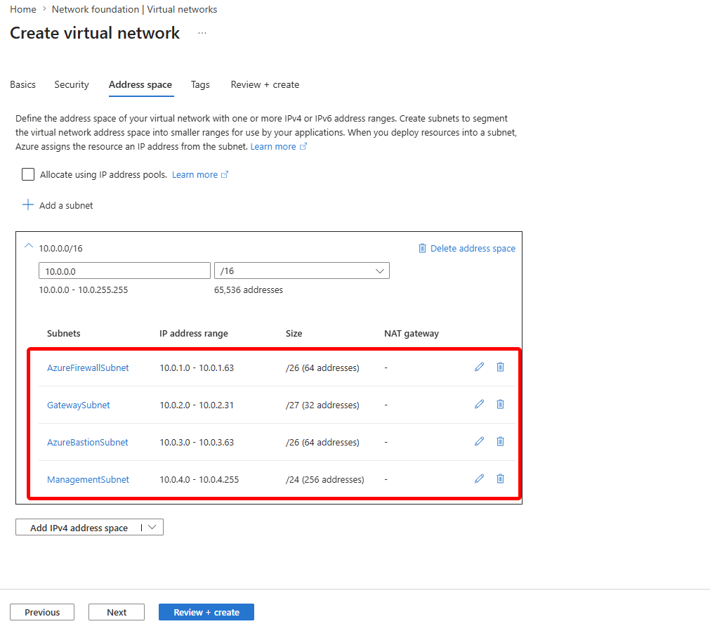

CRITICAL | CRITICAL: The subnet names AzureFirewallSubnet, GatewaySubnet, and AzureBastionSubnet must be spelled exactly as shown - Azure enforces these names. Any typo means the service will fail to deploy into that subnet.

Step 2: Create Spoke VNets (repeat for each)
- Virtual Networks > + Create
- Spoke 1: Name=ent-net-spoke1-web-vnet-dev | Address space: 10.1.0.0/16
- Add: WebSubnet (10.1.1.0/24), AppSubnet (10.1.2.0/24)
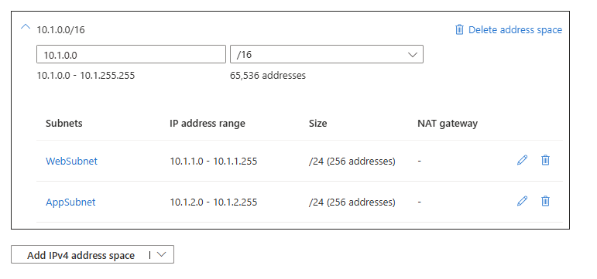
- Spoke 2: Name=ent-net-spoke2-data-vnet-dev | Address space: 10.2.0.0/16
- Add: DataSubnet (10.2.1.0/24), PrivateEndpointSubnet (10.2.2.0/24)
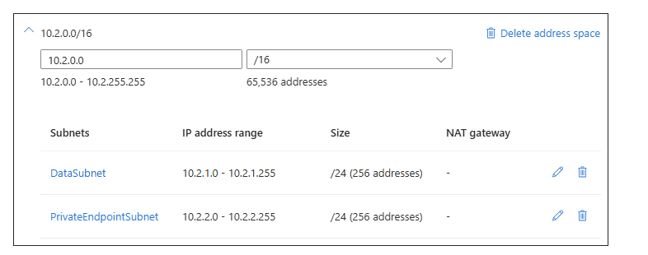

- Spoke 3: Name=ent-net-spoke3-dmz-vnet-dev | Address space: 10.3.0.0/16
- Add: DMZSubnet (10.3.1.0/24), JumpSubnet (10.3.2.0/24)
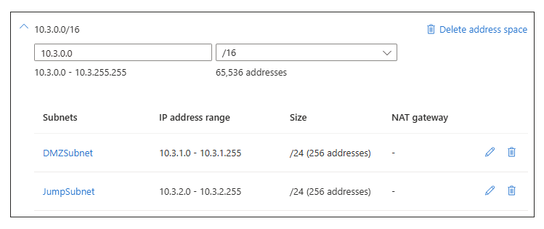

Step 3: Configure VNet Peering (Hub ↔ Spoke 1)
- Open Hub VNet > Peerings > + Add
- Peering link name (local): hub-to-spoke1
- Remote virtual network peering link name: spoke1-to-hub
- Virtual network: ent-net-spoke1-web-vnet-dev
- Allow gateway transit: CHECKED (hub shares its VPN gateway)
- Use remote gateways: UNCHECKED (hub owns the gateway)
- Click Add - Azure creates BOTH sides of the peering simultaneously
- Repeat for Spoke 2 and Spoke 3

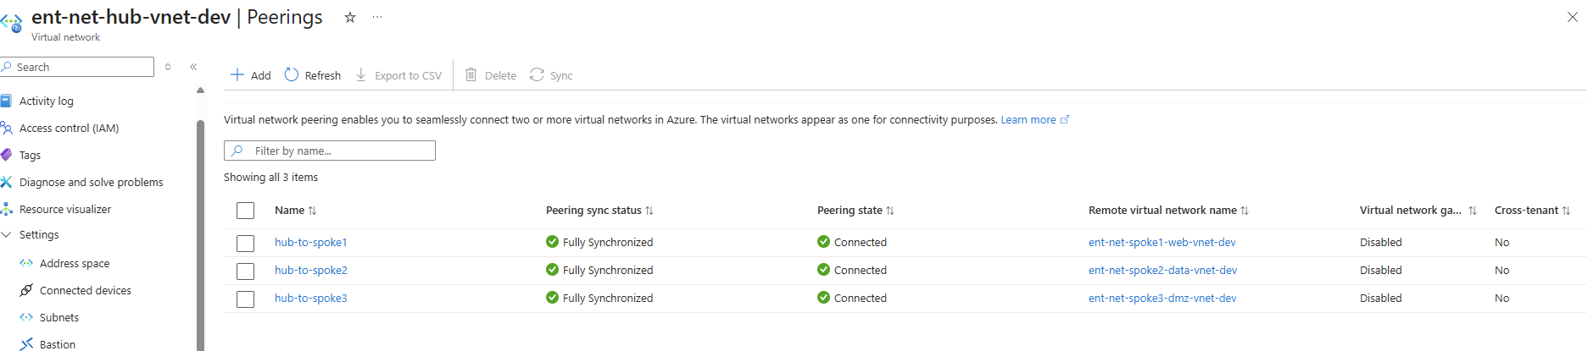
INFO | INTERVIEW TALKING POINT: "VNet peering is non-transitive by design. Spoke 1 and Spoke 2 being peered to the same Hub does NOT mean they can communicate directly. Traffic must flow Spoke1 → Hub → Firewall → Hub → Spoke2. This is intentional - the firewall inspects all inter-spoke traffic."

4. NSG Rule Reference
Network Security Groups (NSGs) are the primary Layer 4 access control mechanism in Azure. They operate as stateful packet filters - if inbound traffic is allowed, the response traffic is automatically allowed regardless of outbound rules.

INFO | NSGs are evaluated at the NIC level and the Subnet level. This architecture applies NSGs at the Subnet level for consistent enforcement regardless of which VMs are added. NIC-level NSGs can be used for per-VM exceptions.

4.1 AzureBastionSubnet NSG (Mandatory Rules)
Microsoft mandates specific NSG rules for Bastion to function. These cannot be omitted or modified without breaking Bastion sessions.

Pri | Name | Source | Destination | Port | Action | Purpose
100 | AllowHttpsInbound | Internet | Any | 443 | Allow | Admin browsers reach Bastion
110 | AllowGatewayMgr | GatewayManager | Any | 443 | Allow | Azure control plane
120 | AllowAzureLB | AzureLoadBalancer | Any | 443 | Allow | Health probes
130 | AllowBastionComm | VirtualNetwork | VirtualNetwork | 8080,5701 | Allow | HA multi-instance
1000 | DenyAllInbound | Any | Any | Any | Deny | Block all other inbound
100 | AllowSshRdpOut | Any | VirtualNetwork | 22,3389 | Allow | Session traffic to VMs
110 | AllowAzureCloud | Any | AzureCloud | 443 | Allow | Logging & diagnostics
1000 | DenyAllOutbound | Any | Any | Any | Deny | Block all other outbound

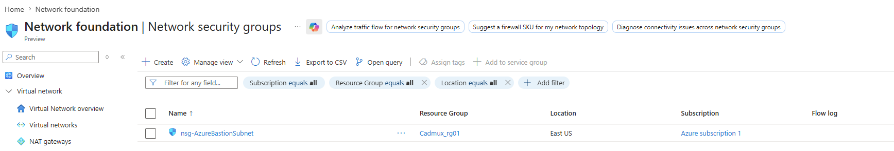

Inbound Security Rule:
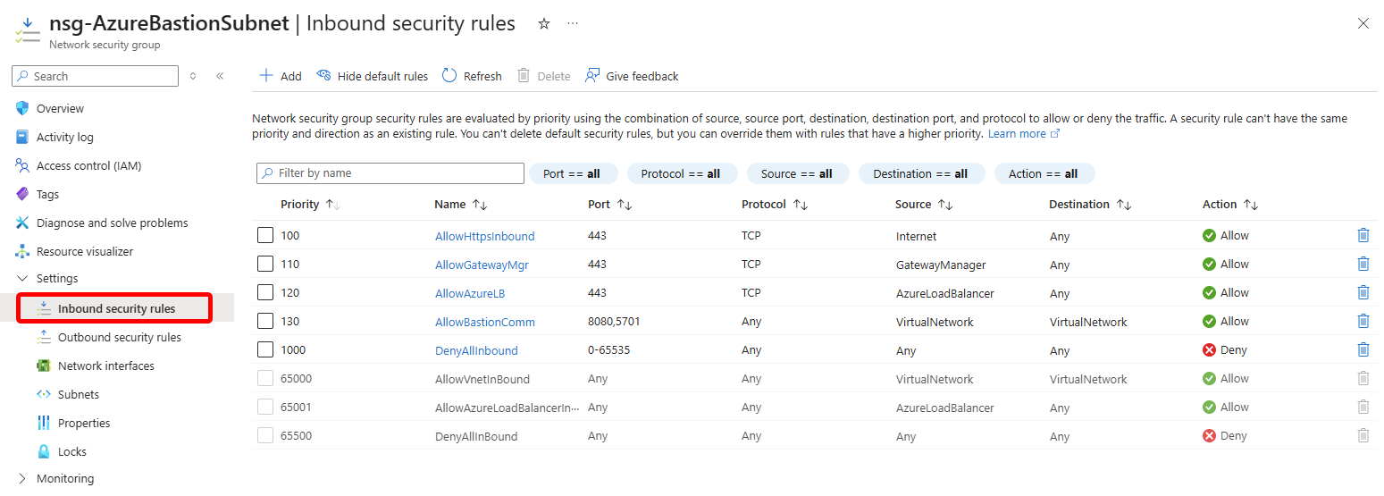

Outbound Security Rule:
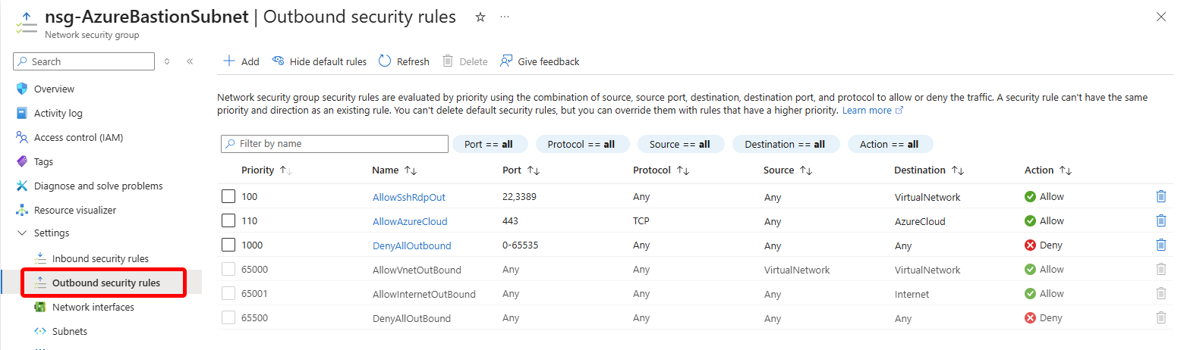

Attaching this to Azure bastion subnet under VNET (ent-net-hub-vnet-dev):

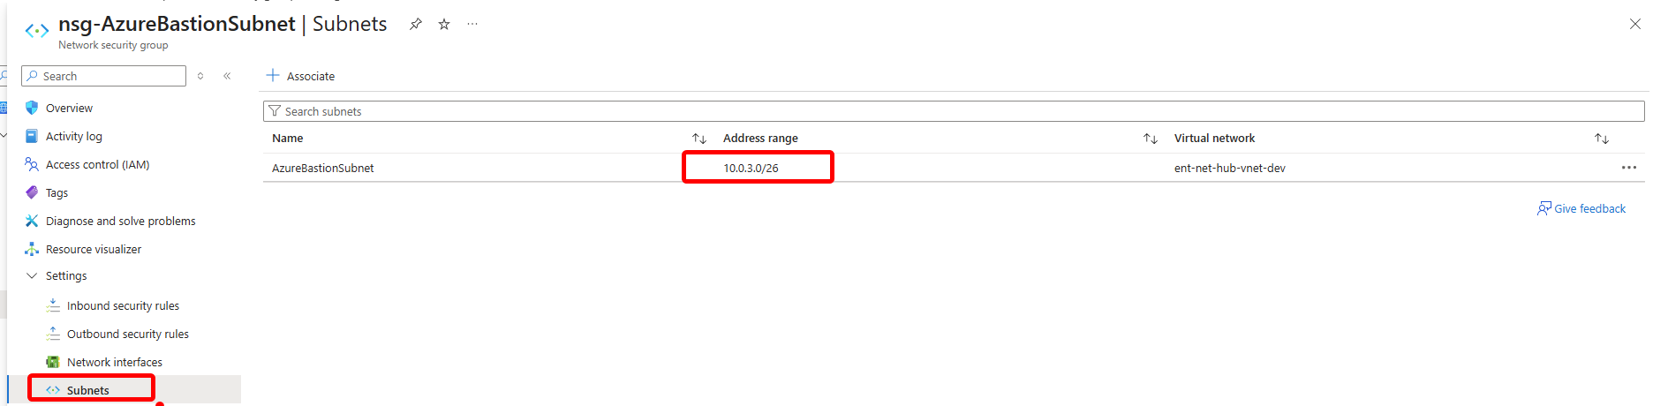

4.2 Data Subnet NSG (Strictest Rules)
Pri | Name | Source | Destination | Port | Action | Purpose
100 | AllowSqlFromApp | 10.1.2.0/24 | Any | 1433 | Allow | SQL from App tier only
200 | AllowBastionAdmin | 10.0.3.0/26 | Any | 22,3389 | Allow | DBA access via Bastion
4000 | DenyAllOther | Any | Any | Any | Deny | Data tier unreachable from internet

Created NSG for Data Subnet:
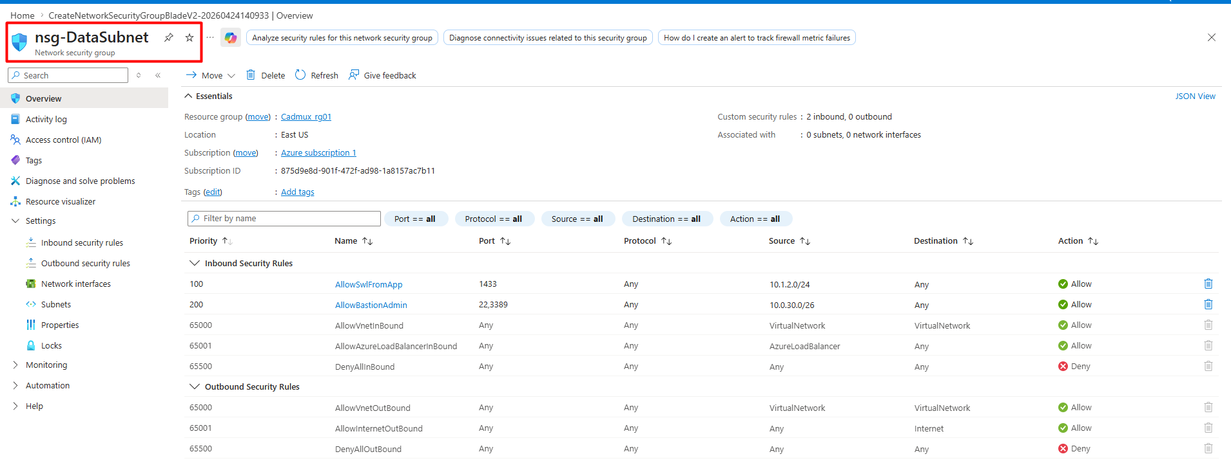

5. Full Project Phase Roadmap

Phase | Name | Components | Key Skills Demonstrated
1 | Foundation | Hub VNet, Spoke VNets, Peering, NSGs | Subnetting, CIDR, VNet design, NSG rules
2 | Security Perimeter | Azure Firewall Premium, UDRs, Route Tables | Firewall policy, force tunnel, DNAT, IDPS
3 | Secure Access | Azure Bastion Standard, Private Endpoints | Zero Trust access, PaaS security, DNS
4 | Hybrid Connect | VPN Gateway, Local Network Gateway, BGP | IPsec IKEv2, BGP routing, S2S VPN
5 | Observability | Defender for Cloud, Monitor, NSG Flow Logs, Policy | CSPM, threat detection, compliance, SIEM

6. Interview Q&A: Explain This Project
Use these answers when asked to explain your project in interviews. Each answer explains not just WHAT was done but WHY - demonstrating senior-level thinking.

Q1: "Walk me through your Azure network architecture."
"I designed and deployed a hub-spoke network topology on Azure for a simulated enterprise environment. The hub VNet is 10.0.0.0/16 and contains four dedicated subnets: one for Azure Firewall Premium, one for VPN Gateway, one for Azure Bastion, and one for management tooling.

Three spoke VNets connect to the hub via VNet peering: Spoke 1 hosts web and application workloads, Spoke 2 is the data tier, and Spoke 3 is a DMZ with jump servers for administrative access. All inter-spoke traffic is force-tunnelled through the Azure Firewall using User Defined Routes, so the firewall inspects every packet crossing tier boundaries. VMs in all spokes have no public IP addresses - admins connect exclusively via Azure Bastion, which provides browser-based RDP/SSH without exposing ports 22 or 3389 to the internet."

Q2: "Why did you choose Hub-Spoke instead of a flat VNet?"
"Three reasons: scalability, centralised security, and cost. With hub-spoke, I have one Azure Firewall that inspects all inter-spoke traffic. In a flat design, you either have no inspection between workload tiers, or you need multiple firewalls. Hub-spoke also scales much better - adding a new spoke (say, a development environment) is just deploying a new VNet and a peering. I don't need to re-architect the firewall or routing.

The second reason is blast radius. If the web tier is compromised, the attacker cannot directly reach the database - they have to traverse the firewall, which is logging and inspecting every connection. And third, it maps directly to how most enterprises design their on-premises WAN - a central hub with branch spokes - so the mental model is familiar to ops teams."

Q3: "Why did you choose /26 for the Firewall subnet instead of /24?"
"Azure Firewall only requires a /26 as a minimum. I used /26 because Azure Firewall Premium with multiple availability zones deploys multiple instances, but they all share the same /26 subnet - the service manages instance placement internally. Using a /24 would waste 192 addresses that can never be used for anything else, since NSGs and Route Tables cannot be applied to the AzureFirewallSubnet. For the VPN Gateway, a /27 provides 27 usable addresses which is more than sufficient since the Gateway service itself only uses a handful of IPs."

Q4: "How does traffic flow from Spoke 1 to Spoke 2?"
"Traffic from a VM in the Spoke 1 AppSubnet (10.1.2.0/24) destined for the Spoke 2 DataSubnet (10.2.1.0/24) follows this path:
- VM sends packet to 10.2.1.x
- The Route Table on AppSubnet has a UDR: 0.0.0.0/0 → Azure Firewall private IP (10.0.1.4)
- Packet arrives at Azure Firewall
- Firewall evaluates the Network Rule Collections - I have a rule allowing TCP 1433 from 10.1.2.0/24 to 10.2.1.0/24
- If allowed, firewall forwards to 10.2.1.x via the hub-to-spoke2 peering
- The NSG on DataSubnet performs a final check: source is 10.1.2.0/24, destination port 1433 - allowed
- Packet delivered to database VM

If the app tries to connect to a port that is not 1433, the Firewall Network Rule denies it first, before it even reaches the NSG. Dual-layer inspection at both Firewall and NSG - defence in depth."

Q5: "What is the purpose of UseRemoteGateways in the VNet peering?"
"UseRemoteGateways on the spoke side of the peering tells Azure: 'use the VPN Gateway in the hub VNet for on-premises connectivity, not a local gateway.' This is what enables the hub-and-spoke model for hybrid connectivity - on-premises routes learned by the VPN Gateway are propagated to all spoke VNets automatically via BGP, without each spoke needing its own gateway.

The corresponding setting on the hub side is AllowGatewayTransit=true, which gives the hub permission to share its gateway. Both sides must be set correctly, otherwise on-premises-destined traffic from spokes will be dropped at the peering boundary."

Q6: "How does Azure Bastion improve security vs a traditional jump box?"
"Traditional jump boxes require a public IP address, and administrators connect via RDP on port 3389 or SSH on port 22 directly from the internet. These ports are constantly probed by automated scanners and are a common attack vector. Azure Bastion eliminates this entirely.

With Bastion, the administrator opens the Azure Portal (HTTPS port 443), authenticates with Azure AD MFA, and Bastion establishes an encrypted WebSocket session to the target VM on the backend. The target VM has no public IP - it is only reachable from the AzureBastionSubnet (10.0.3.0/26) on ports 22 and 3389 via the NSG. No RDP or SSH ports are ever exposed to the internet. Session recordings are available with Standard SKU, providing full audit capability."

7. Cost Estimate (Dev Environment)
The following is an approximate monthly cost for the full 5-phase project in a development environment (East US region, running ~8 hours/day weekdays only to reduce cost).

Component | SKU | Est. Monthly Cost | Notes
Azure Firewall | Premium | ~$912 | Fixed + data processing fees
VPN Gateway | VpnGw2 (Gen2) | ~$279 | Scaled down; stop when not in use
Azure Bastion | Standard SKU | ~$137 | Per-hour + session charges
VNet Peering | 3 peering pairs | ~$15 | Per GB of data transferred
NSG Flow Logs | Log Analytics | ~$25 | Depends on traffic volume
Test VMs (3x) | B2s (dev only) | ~$90 | Stop when not testing
TOTAL (approx) | - | ~$1,458/mo | Reduce by deallocating VMs & GW

WARNING | COST OPTIMISATION TIP: Deallocate the VPN Gateway and VMs when not actively working. Azure Firewall also supports forced-off during non-working hours via Azure Automation or scheduled scripts, reducing the Firewall cost by ~75% if only running 8h/day on weekdays.

8. Teardown (Clean Up Azure Resources)
Always tear down resources after completing each lab session to avoid unexpected charges. Since everything is IaC, you can redeploy in minutes when you resume.

Option A: Delete the Resource Group (nuclear option - removes everything)
az group delete --name rg-ent-net-dev --yes --no-wait

Option B: Deallocate expensive resources (keep the config)
# Stop VPN Gateway (saves ~$9/day)
az network vnet-gateway reset --name ent-net-vpngw-dev -g rg-ent-net-dev

# Deallocate all VMs
az vm deallocate --ids $(az vm list -g rg-ent-net-dev --query "[].id" -o tsv)

INFO | Azure Firewall cannot be "stopped" in the traditional sense, but you can delete it and re-deploy from Bicep. The Firewall Policy (containing all rules) persists as a separate resource, so your rules are not lost when you delete the Firewall instance.

9. GitHub README Template
Use the following content as your GitHub repository README.md. This is what recruiters and interviewers will see when they look at your portfolio.

# Azure Enterprise Network Security Architecture
[![AZ-700](https://img.shields.io/badge/Azure-AZ--700-0078D4?logo=microsoft-azure)](https://learn.microsoft.com/en-us/certifications/azure-network-engineer-associate/)

A production-grade hub-spoke enterprise network on Microsoft Azure implementing Zero Trust Network Access (ZTNA) principles. Designed for the AZ-700 certification portfolio and aligned with 5+ year Network/Security Engineer responsibilities.

## Architecture
Hub VNet (10.0.0.0/16) | 3 Spoke VNets | Azure Firewall Premium | Azure Bastion | VPN Gateway (BGP) | NSGs | Defender for Cloud

## Technologies
- Azure Bicep (IaC) | Azure CLI
- Azure Firewall Premium + IDPS
- VPN Gateway Gen2 with BGP
- Azure Bastion Standard
- NSGs + ASGs | Azure Policy (CIS Benchmark)
- Microsoft Defender for Cloud | Azure Monitor | Log Analytics

## Phases
- Phase 1: Hub VNet + Spokes + NSGs [COMPLETE]
- Phase 2: Azure Firewall + UDRs [IN PROGRESS]
- Phase 3: Azure Bastion + Private Endpoints
- Phase 4: VPN Gateway + BGP Hybrid Connectivity
- Phase 5: Defender for Cloud + Monitoring + Policy

Appendix A: Useful Azure CLI Commands

Network Diagnostics
# List all VNets in the resource group
az network vnet list -g rg-ent-net-dev -o table

# Show peering status (should be "Connected")
az network vnet peering list --vnet-name ent-net-hub-vnet-dev -g rg-ent-net-dev -o table

# Show effective routes for a NIC (troubleshooting UDRs)
az network nic show-effective-route-table --name <nic-name> -g rg-ent-net-dev -o table

# Show effective NSG rules for a NIC
az network nic list-effective-nsg --name <nic-name> -g rg-ent-net-dev

# Test connectivity via Network Watcher
az network watcher test-connectivity \
--source-resource <vm-resource-id> \
--dest-address 10.2.1.4 \
--dest-port 1433

Appendix B: Key Azure Networking Concepts for Interviews

Concept | One-Line Definition for Interviews
VNet Peering | Low-latency, high-bandwidth private connectivity between Azure VNets in same or different regions. Non-transitive.
UDR / Route Table | Custom routes that override Azure system routes. Used to force traffic through firewall (0.0.0.0/0 → Firewall IP).
NSG | Stateful L4 packet filter applied to subnets or NICs. Rules evaluated by priority (lowest number wins).
Azure Firewall | Managed, stateful L4-L7 firewall with FQDN filtering, IDPS, TLS inspection. DNAT rules for inbound, Network/App rules for outbound.
Azure Bastion | PaaS RDP/SSH gateway over HTTPS. Eliminates public IPs on VMs. Integrated with Azure AD MFA.
VPN Gateway | Managed IPsec/IKEv2 VPN endpoint. Supports S2S (site-to-site), P2S (point-to-site), and VNet-to-VNet. Supports BGP.
Private Endpoint | Private IP in your VNet mapped to an Azure PaaS service (SQL, Storage, KeyVault). Traffic never leaves Azure backbone.
BGP in Azure | Dynamic routing protocol used between VPN Gateway and on-premises routers to exchange route prefixes automatically.
Force Tunnel | Routing all internet-bound traffic (0.0.0.0/0) through on-premises or Azure Firewall for inspection. Critical for compliance.
ASG | Application Security Group - logical grouping of NICs for NSG rules. Avoids hardcoding IPs in rules.

End of Document | AZ-700 Portfolio Project | v1.0

