Azure Enterprise Network
Phase 2: Security Perimeter
Azure Firewall Premium | Firewall Policy | UDRs | Force-Tunnel
Firewall SKU  Premium | IDPS  58,000+ Sigs | Rule Types  3 Layers | Logging  Full Telemetry

Author: [Your Name] | AZ-700 Portfolio Project | Phase 2 of 5

1. Phase 2 Overview
Phase 2 deploys the security perimeter layer of the enterprise network. This is where Zero Trust enforcement becomes real: all traffic entering, leaving, or crossing between spokes is inspected by Azure Firewall Premium before being allowed to proceed. No traffic bypasses the firewall.

1.1 What Phase 2 Deploys
Resource | SKU / Tier | Purpose
Log Analytics Workspace | PerGB2018 | Central log sink for all Firewall telemetry
Firewall Policy | Premium | Rule container: DNAT, Network, Application rules
Azure Firewall | Premium, Zone-Redundant | L4-L7 stateful inspection + IDPS
Route Tables (x7) | N/A | UDRs forcing all subnet traffic through Firewall
Diagnostic Settings | N/A | Ship 7 Firewall log categories to Log Analytics

WARNING | PREREQUISITE: Phase 1 must be fully deployed before starting Phase 2. You will need the subnet resource IDs from Phase 1 outputs to populate the parameters.phase2.dev.json file.

2. Azure Firewall Deep Dive

2.1 Standard vs Premium SKU — Why Premium?
This project uses Azure Firewall Premium. Here is exactly why that matters for the portfolio and interview:

Feature | Standard SKU | Premium SKU
Network Rules (L4) | Yes | Yes
FQDN Application Rules | Yes (HTTP/S only) | Yes (any protocol)
DNAT Rules | Yes | Yes
Threat Intelligence | Alert or Deny | Alert or Deny
IDPS (58,000+ signatures) | NOT available | Yes — Alert or Deny
TLS Inspection (HTTPS decrypt) | NOT available | Yes — requires CA cert
URL Filtering (full path) | NOT available | Yes — /path/file.exe
Web Categories | NOT available | Yes — block by content type
Approx monthly cost | ~$930/month | ~$1,160/month

TIP | INTERVIEW ANSWER: "I chose Premium because in a real enterprise, attackers increasingly use HTTPS to exfiltrate data and deliver malware. Without TLS inspection, an Azure Firewall Standard cannot see inside encrypted traffic — it can only block the domain, not inspect the payload. Premium with IDPS gives us signature-based detection against 58,000+ known threats updated daily by Microsoft's threat intelligence team."

2.2 Firewall Policy vs Classic Rules
Firewall Policy is the modern, ARM-native approach to managing Azure Firewall rules. This project uses Policy exclusively.

Aspect | Classic Rules (legacy) | Firewall Policy (this project)
Storage | Inline on Firewall resource | Separate ARM resource
Reusability | One Firewall only | Share across multiple Firewalls
Hierarchy | None | Parent → Child policy inheritance
Premium features | Limited | Full IDPS, TLS, URL, Categories
Update without restart | No — Firewall restarts | Yes — policy updates are non-disruptive
Recommended for new deployments | No | Yes — Microsoft official guidance

2.3 Rule Evaluation Order — Critical for Troubleshooting
Understanding rule evaluation order is the single most important skill for Firewall troubleshooting. Get this wrong and you will either block legitimate traffic or allow malicious traffic.

Order | Rule Type | Applies To | How It Works
1st | DNAT Rules | Inbound traffic to Firewall public IP | Translates destination IP/port. Matching DNAT rule implicitly adds SNAT for return traffic.
2nd | Network Rules | All traffic (L4) | Evaluated by priority. First match wins. Checks source IP, dest IP, port, protocol.
3rd | Application Rules | HTTP, HTTPS, MSSQL | Evaluated only if no Network rule matched. Checks FQDN, URL path, Web Category.
Final | Implicit Deny | All traffic | If no rule matched, traffic is DENIED. This deny is NOT logged by default.

CRITICAL | CRITICAL GOTCHA: If you create a Network rule that ALLOWS TCP port 443 to *.microsoft.com, the Application rules for that traffic are SKIPPED. Network rules match at L4 (IP+Port), Application rules match at L7 (FQDN+URL). They are NOT additive — the first matching rule in the highest-priority group wins and evaluation stops.

3. User Defined Routes (UDRs) — Force Tunnel Deep Dive

3.1 How Azure Routing Works (System Routes)
Before adding UDRs, Azure uses System Routes automatically created by the platform. Understanding them is essential to understand what UDRs override:

Route Name | Destination Prefix | Next Hop | Purpose
Local VNet | VNet address space | VnetLocal | Route within the VNet automatically
Peered VNets | Peered VNet address space | VNetPeering | Route to peered VNets automatically
Default Internet | 0.0.0.0/0 | Internet | All internet traffic exits directly
Azure Reserved | 10.0.0.0/8 etc. | None | RFC 1918 ranges NOT in VNet = drop

WARNING | KEY INSIGHT: Without UDRs, a VM in Spoke 1 (10.1.1.4) can reach the internet DIRECTLY via Azure's default internet route. It BYPASSES the Firewall entirely. UDRs replace the 0.0.0.0/0 system route with "send to Firewall" instead. This is the entire point of Phase 2.

3.2 The Force-Tunnel Pattern — Packet Walk
With Phase 2 deployed, here is exactly what happens when a web server (10.1.1.4) tries to connect to github.com:

- VM (10.1.1.4) sends TCP SYN to github.com (resolved to 140.82.121.4) on port 443
- Azure checks the effective route table for the NIC. It finds: 0.0.0.0/0 → VirtualAppliance → 10.0.1.4 (Firewall)
- Packet is redirected to Azure Firewall at 10.0.1.4 in the Hub VNet
- Firewall receives the packet. Source: 10.1.1.4. Destination: 140.82.121.4:443
- Firewall evaluates DNAT rules — no match (destination is not Firewall's own public IP)
- Firewall evaluates Network rules — no explicit match for github.com's IP (CDN, changes constantly)
- Firewall evaluates Application rules — checks FQDN: github.com matches rule "allow-github" → ALLOW
- Firewall SNATs the source IP (10.1.1.4 → Firewall public IP) and forwards to internet
- Response arrives at Firewall public IP. Firewall SNATs back: destination = 10.1.1.4
- Response delivered to web server. Connection established.

TIP | INTERVIEW TALKING POINT: "The Firewall performs SNAT on egress traffic. This means all internet-bound connections appear to come from the Firewall's public IP, not the VM's private IP. This is intentional — it hides internal IP addressing from the internet and ensures all return traffic comes back through the Firewall for logging."

3.3 Longest Prefix Match — Why We Need /16 UDRs for Inter-Spoke
This is a common interview trap. A single 0.0.0.0/0 UDR does NOT force inter-spoke traffic through the firewall. Here is why:

Destination | Matching Routes | Winner (Longest Prefix) | Result
10.2.1.5 (Data Spoke) | 10.2.0.0/16 via Peering AND 0.0.0.0/0 via Firewall UDR | 10.2.0.0/16 (more specific) | BYPASSES Firewall — goes direct via peering!
10.2.1.5 (with /16 UDR added) | 10.2.0.0/16 via Firewall UDR (overrides peering route) | 10.2.0.0/16 via Firewall | Goes through Firewall — CORRECT
140.82.121.4 (GitHub) | 0.0.0.0/0 via Firewall UDR only | 0.0.0.0/0 via Firewall | Goes through Firewall — correct

This is why our route tables contain BOTH 0.0.0.0/0 AND specific /16 routes for each spoke. The /16 routes override Azure's automatic peering routes, ensuring inter-spoke traffic goes to the Firewall first.

4. Firewall Rule Reference

4.1 DNAT Rules — Inbound NAT
Rule Name | Source | Destination | Port | Protocol | Translated To
dnat-https-to-web | Any (Internet) | Firewall PIP | 443 | TCP | 10.1.1.4:443
dnat-http-to-web | Any (Internet) | Firewall PIP | 80 | TCP | 10.1.1.4:80

4.2 Network Rules — East-West + Egress (L4)
Rule Name | Source | Destination | Port | Purpose | Action
allow-web-to-app | 10.1.1.0/24 | 10.1.2.0/24 | 8080,8443 | Web → App tier | Allow
allow-app-to-sql | 10.1.2.0/24 | 10.2.1.0/24 | 1433 | App → SQL | Allow
allow-jump-to-all | 10.3.2.0/24 | All internal | 22,3389 | Admin RDP/SSH | Allow
allow-mgmt-to-all | 10.0.4.0/24 | 10.0.0.0/8 | Any | Ops tooling | Allow
allow-ntp | All internal | Any | 123/UDP | Time sync | Allow
allow-azure-monitor | All internal | AzureMonitor | 443 | Telemetry | Allow
deny-web-to-data | 10.1.1.0/24 | 10.2.1.0/24 | Any | Block web→DB direct | Deny
deny-spoke-default | All spokes | All spokes | Any | Default east-west deny | Deny

4.3 Application Rules — FQDN-Based Egress (L7)
Rule Name | Source | Protocols | FQDNs / Categories
allow-azure-management | All internal | HTTPS:443 | *.azure.com, *.microsoft.com, *.windows.net
allow-windows-update | All internal | HTTP+HTTPS | *.windowsupdate.microsoft.com, *.update.microsoft.com
allow-github | All internal | HTTPS:443 | github.com, *.github.com, ghcr.io
allow-linux-repos | All internal | HTTP+HTTPS | archive.ubuntu.com, *.ubuntu.com, *.centos.org
deny-malicious-categories | All internal | HTTP+HTTPS | Web Categories: Malware, Phishing, Spyware, BotNets

5. Step-by-Step Portal Deployment Guide
INFO | Estimated time: 60-90 minutes via Azure Portal. The Firewall resource alone takes 5-10 minutes to provision. Do not cancel or close the browser during deployment.

5.1 Deploy Log Analytics Workspace
- Portal > Log Analytics Workspaces > + Create
- Resource Group: rg-ent-net-dev | Name: ent-net-law-dev | Region: East US
- Pricing Tier: Pay-as-you-go (PerGB2018)
- Review + Create > Create
- After creation: Open workspace > Agents > Note the Workspace ID (38bcc4e6-c426-4e11-ab1a-2d075fe35140) and Primary Key ()
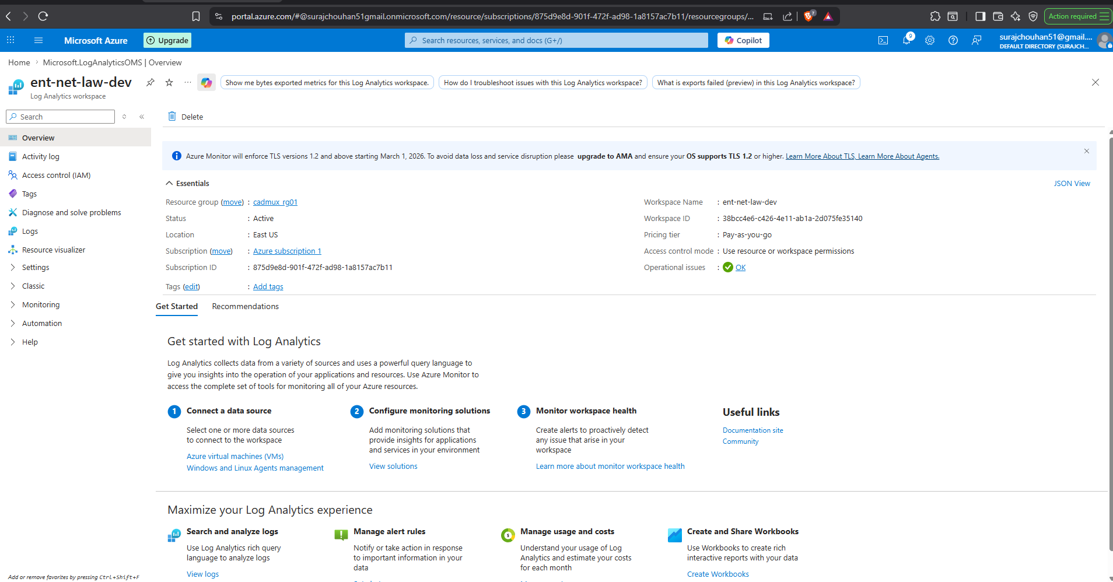

5.2 Create Firewall Policy
- Portal > Firewall Policies > + Create
- Name: ent-net-fw-policy-dev | Region: East US | Policy Tier: Premium
- DNS Settings tab: Enable DNS Proxy = ON (required for FQDN Network rules)
- IDPS tab: IDPS mode = Alert
- Review + Create > Create
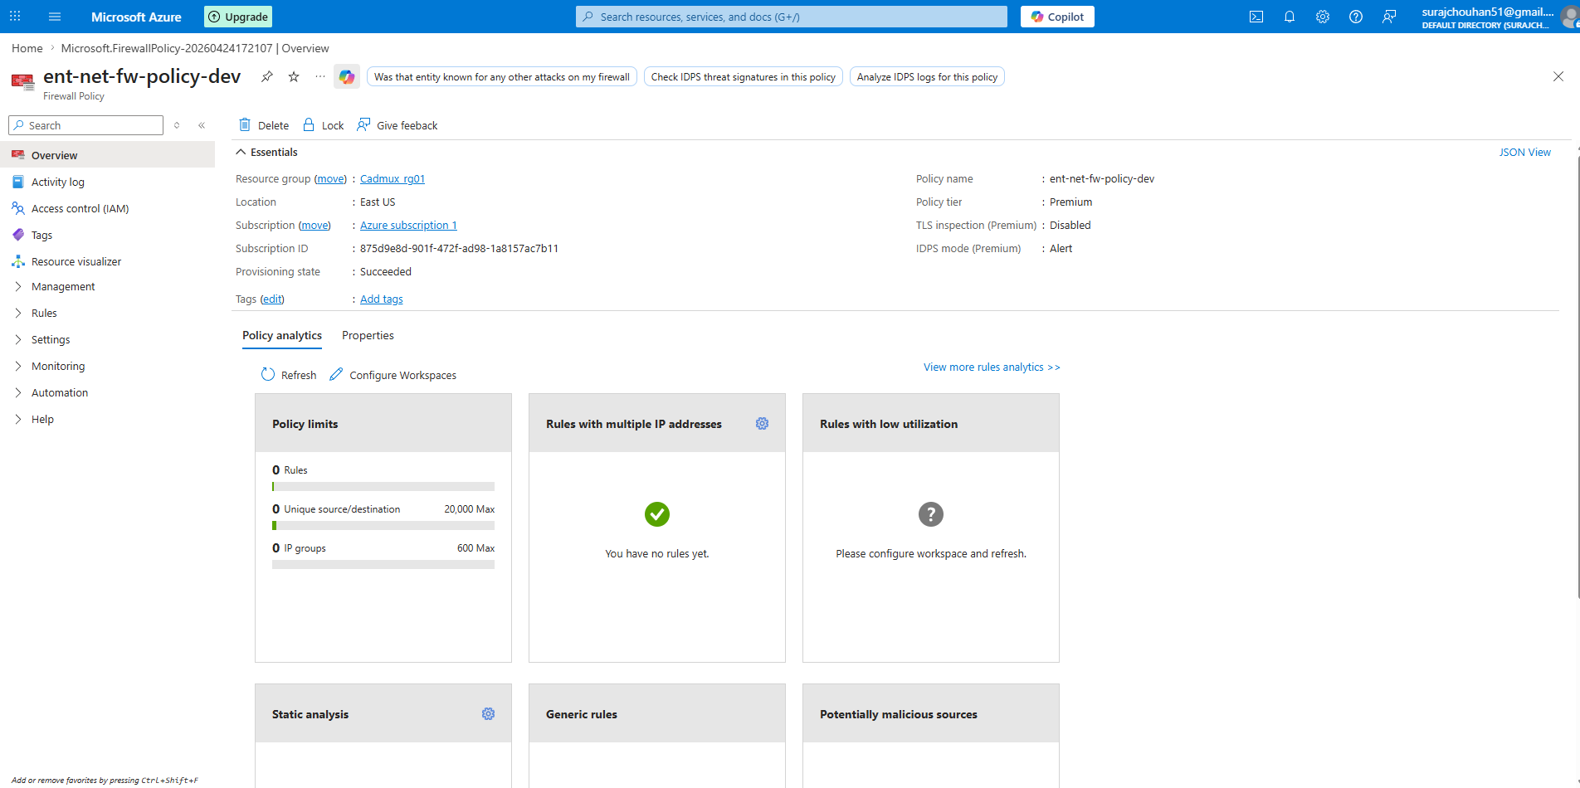

5.3 Add Rule Collections to the Policy
- Open ent-net-fw-policy-dev > Rule Collections > + Add rule collection
- DNAT Collection: Name=rc-dnat-inbound-web | Type=DNAT | Priority=100
- Add rule: dnat-https-to-web | Source=* | Dest=Firewall PIP | Port=443 | Translated=10.1.1.4:443
- Network Collection: Name=rc-net-east-west | Type=Network | Priority=200 | Action=Allow
- Add rules: allow-web-to-app, allow-app-to-sql, allow-jump-to-all-rdp-ssh (as per table in Section 4.2)
- Network Collection (Deny): Name=rc-net-explicit-deny | Priority=900 | Action=Deny
- Add rules: deny-web-direct-to-data, deny-spoke-to-spoke-default
- Application Collection: Name=rc-app-allow-internet | Type=Application | Priority=300 | Action=Allow
- Add rules: allow-azure-management, allow-github, allow-linux-repos (as per table in Section 4.3)

WARNING | PORTAL TIP: Add rules one at a time and Save after each rule collection. The portal does not auto-save — if you add 10 rules and navigate away without saving, you lose all of them.

5.4 Deploy Azure Firewall
- Portal > Firewalls > + Create
- Resource Group: rg-ent-net-dev | Name: ent-net-firewall-dev | Region: East US
- Firewall tier: Premium
- Firewall management: Use a Firewall Policy to manage this firewall
- Choose a Firewall Policy: ent-net-fw-policy-dev
- Virtual network: ent-net-hub-vnet-dev
- Public IP address: + Add new > Name: ent-net-fw-pip-dev > Standard SKU > Static
- Availability Zones: 1, 2, 3 (select all three for zone redundancy)
- Review + Create > Create (takes 5-10 minutes)
- After creation: Open Firewall > Copy the Private IP address (typically 10.0.1.4) — you need this for UDRs
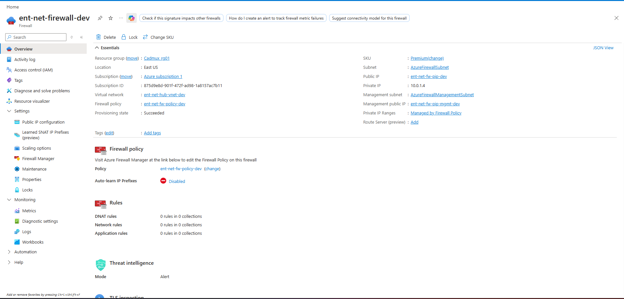

5.5 Create and Associate Route Tables
- Portal > Route Tables > + Create
- Name: ent-net-rt-spoke1-web-dev | Region: East US | Propagate gateway routes: Yes
- Open the route table > Routes > + Add:
- Route 1: udr-to-spoke1 | Dest: 10.1.0.0/16 | Next hop: Virtual appliance | IP: 10.0.1.4
- Route 2: udr-to-spoke2 | Dest: 10.2.0.0/16 | Next hop: Virtual appliance | IP: 10.0.1.4
- Route 3: udr-to-spoke3 | Dest: 10.3.0.0/16 | Next hop: Virtual appliance | IP: 10.0.1.4
- Route 4: udr-to-hub | Dest: 10.0.0.0/16 | Next hop: Virtual appliance | IP: 10.0.1.4
- Route 5: udr-default-fw | Dest: 0.0.0.0/0 | Next hop: Virtual appliance | IP: 10.0.1.4
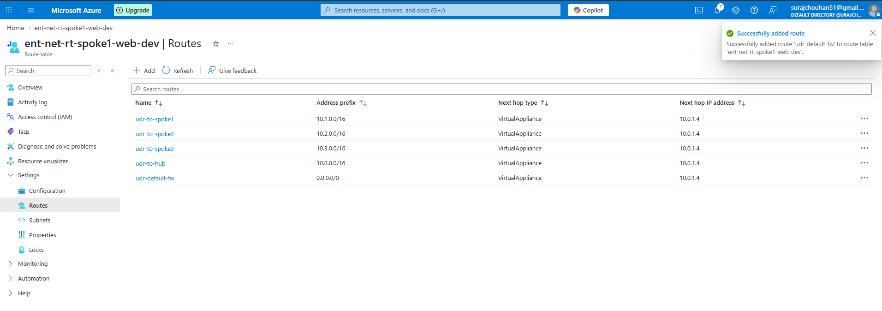
- Subnets > + Associate > VNet: ent-net-spoke1-web-vnet-dev > Subnet: WebSubnet
- Repeat steps 1-10 for all remaining subnets (AppSubnet, DataSubnet, etc.)
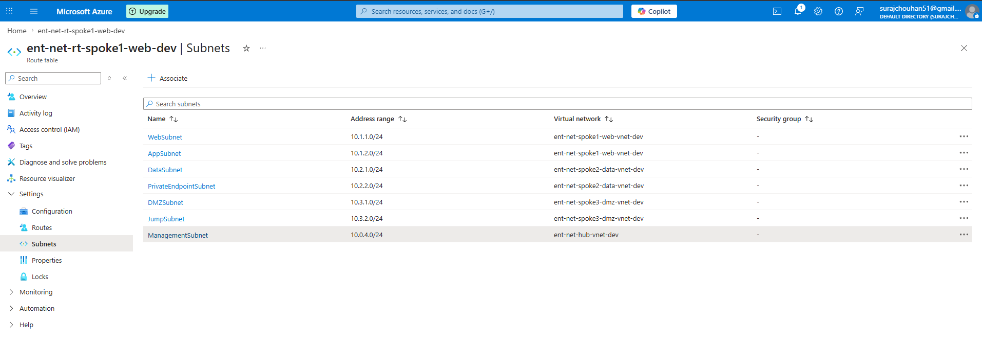

CRITICAL | DO NOT add a route table to AzureFirewallSubnet or GatewaySubnet. Adding UDRs to the Firewall subnet creates a routing loop (Firewall would try to send traffic to itself). Azure will warn you but still allows it — a common misconfiguration mistake.

6. IaC Deployment Guide (Bicep)

6.1 Get Phase 1 Subnet IDs
Before deploying Phase 2, retrieve subnet IDs from your Phase 1 deployment:

# Get all Phase 1 outputs
az deployment group show \
--name deploy-hub-vnet \
--resource-group rg-ent-net-dev \
--query "properties.outputs" -o json

# Or get a specific subnet ID directly
az network vnet subnet show \
--vnet-name ent-net-hub-vnet-dev \
--name AzureFirewallSubnet \
--resource-group rg-ent-net-dev \
--query id -o tsv

6.2 Populate the Parameters File
Edit parameters.phase2.dev.json and replace all <SUB_ID> placeholders with your actual Azure Subscription ID and confirm all subnet resource IDs are correct.

# Get your subscription ID
az account show --query id -o tsv

6.3 Validate, Preview, Deploy
# Step 1: Validate Bicep syntax and ARM schema
az deployment group validate \
--resource-group rg-ent-net-dev \
--template-file bicep/main-phase2.bicep \
--parameters @bicep/parameters.phase2.dev.json

# Step 2: What-If preview (see all changes before applying)
az deployment group what-if \
--resource-group rg-ent-net-dev \
--template-file bicep/main-phase2.bicep \
--parameters @bicep/parameters.phase2.dev.json

# Step 3: Deploy (expect 10-15 minutes due to Firewall provisioning)
az deployment group create \
--resource-group rg-ent-net-dev \
--template-file bicep/main-phase2.bicep \
--parameters @bicep/parameters.phase2.dev.json \
--name "phase2-security-$(date +%Y%m%d%H%M)"

6.4 Verify Deployment
# Confirm Firewall is running and get private IP
az network firewall show \
--name ent-net-firewall-dev \
--resource-group rg-ent-net-dev \
--query "{name:name, privateIp:ipConfigurations[0].properties.privateIPAddress, provisioningState:provisioningState}"

# Confirm route tables are associated with subnets
az network vnet subnet show \
--vnet-name ent-net-spoke1-web-vnet-dev -g rg-ent-net-dev \
--name WebSubnet --query "routeTable.id" -o tsv

# Check effective routes on a test VM NIC
az network nic show-effective-route-table \
--name <your-vm-nic-name> -g rg-ent-net-dev -o table

7. Post-Deployment Validation Tests
These tests prove the deployment is working correctly. Run each test after Phase 2 deployment and screenshot the results for your portfolio.

Test 1: Verify Effective Routes on a Spoke VM
- Deploy a test VM in WebSubnet (Windows Server 2022, B2s, no public IP)
- Portal > Network Interfaces > [VM NIC] > Effective Routes
- Expected: You should see 0.0.0.0/0 pointing to VirtualAppliance (10.0.1.4)
- Expected: You should see 10.1.0.0/16, 10.2.0.0/16, 10.3.0.0/16 all → VirtualAppliance
TIP | Screenshot this page. The effective routes table is a powerful interview visual — it proves the UDRs are applied and overriding system routes.

Test 2: Verify Internet Egress Goes Through Firewall
- Connect to the test VM via Azure Bastion (Phase 3) — or via serial console for now
- On Windows: Run in PowerShell: Invoke-WebRequest https://github.com -UseBasicParsing
- Expected: Request succeeds (GitHub is in our allow list)
- Portal > Firewall > Logs > Application Rule Log
- Expected: You see an ALLOW log entry with Source=10.1.1.x, Dest=github.com, Action=Allow

Test 3: Verify Blocked Traffic is Denied and Logged
- On the test VM: Try to reach a non-approved site: Invoke-WebRequest https://example-blocked.com
- Expected: Request times out or is refused
- Portal > Firewall > Logs > Application Rule Log
- Expected: You see a DENY log entry — this proves the implicit deny is working

Test 4: Verify Network Watcher Connection Monitor
# Run connectivity test from Spoke 1 to Spoke 2 via Azure Network Watcher
az network watcher test-connectivity \
--source-resource /subscriptions/<SUB>/resourceGroups/rg-ent-net-dev/providers/Microsoft.Compute/virtualMachines/web-vm-01 \
--dest-address 10.2.1.4 \
--dest-port 1433 \
--resource-group rg-ent-net-dev
Expected result: "Reachable" — this confirms Spoke 1 → Firewall → Spoke 2 on port 1433 is allowed by the Network rule.

8. Interview Q&A — Phase 2 Questions

Q1: "How does traffic get from Spoke 1 to Spoke 2 through the Firewall?"
"The key is User Defined Routes. I have a route table attached to every spoke subnet that contains two types of routes: a 0.0.0.0/0 default route pointing to the Firewall's private IP (10.0.1.4), and explicit /16 routes for each spoke address space also pointing to the Firewall.

The /16 routes are critical and a common mistake to miss. Without them, Azure's peering routes are more specific (/16) than my default UDR (/0), so peering wins and traffic bypasses the Firewall. By adding explicit /16 UDRs in the route table, I override the peering routes, ensuring all inter-spoke traffic goes to the Firewall first, gets inspected, and then gets forwarded if the policy allows it."

Q2: "What is IDPS and how did you configure it?"
"IDPS stands for Intrusion Detection and Prevention System. Azure Firewall Premium includes a signature-based IDPS engine with over 58,000 signatures covering attack categories like exploit kits, botnet C2 traffic, SQL injection, and lateral movement patterns. Microsoft updates the signatures daily through their threat intelligence feed.

I configured it in Alert mode initially, not Deny mode. This is intentional — in a new environment you don't know what your baseline traffic looks like. Running Deny from day one often causes false positives that break legitimate applications. My approach was: deploy in Alert mode for the first two weeks, review the IDPS logs in Log Analytics to identify any false positives, add signature overrides for confirmed false positives, then switch to Deny mode once the environment is baselined."

Q3: "Why do you need DNS Proxy on the Firewall?"
"Without DNS Proxy, FQDN-based network rules don't work reliably. Here's why: when I write a network rule saying allow TCP 443 to *.microsoft.com, the Firewall needs to know which IPs correspond to *.microsoft.com to enforce the rule. Without DNS Proxy, the Firewall resolves the FQDN once at rule-creation time and uses those static IPs. But *.microsoft.com uses hundreds of IPs across CDNs that change constantly, so the rule breaks.

With DNS Proxy enabled, all VMs in the VNets point their DNS to the Firewall's private IP. Every DNS query flows through the Firewall. When a VM resolves microsoft.com and gets back 52.x.x.x, the Firewall sees that resolution, caches the mapping, and uses it to match against FQDN network rules in real time. This is also why the Firewall's private IP must be set as the DNS server on VMs or via DHCP options on the VNet."

Q4: "How would you troubleshoot a connectivity issue after Phase 2?"
"My troubleshooting flow is layered:
- Start with effective routes: az network nic show-effective-route-table. If 0.0.0.0/0 is not pointing to the Firewall, the UDR is missing or wrong.
- Check Firewall logs in Log Analytics. Query AZFWNetworkRule and AZFWApplicationRule for the source IP and time window. If there's a Deny entry, I know which rule collection is blocking it.
- If the Firewall shows Allow but connectivity still fails, move to NSGs. Use az network nic list-effective-nsg to see the effective NSG rules on the destination VM's NIC. The Firewall logs the allowed traffic, but the NSG on the destination might still block it.
- Use Network Watcher Connection Monitor to run an end-to-end TCP test between source and destination — it shows which hop is failing.
- If all of the above show Allow but it still doesn't work, check whether the application itself is listening on the expected port and whether it's firewall (Windows Firewall / iptables) is blocking."

9. Log Analytics KQL Queries for Your Portfolio
These KQL queries demonstrate operational capability. Run them in your Log Analytics workspace, screenshot the results, and include them in your portfolio. They show you can not only deploy but also operate and investigate the environment.

Query 1: Top Denied Connections (last 24 hours)
AZFWNetworkRule
| where TimeGenerated > ago(24h)
| where Action == "Deny"
| summarize DenyCount = count() by SourceIp, DestinationIp, DestinationPort
| top 20 by DenyCount desc
| project SourceIp, DestinationIp, DestinationPort, DenyCount

Query 2: IDPS Signature Hits
AZFWIdpsSignature
| where TimeGenerated > ago(7d)
| summarize HitCount = count() by SignatureId, Description, Severity, Action
| order by HitCount desc

Query 3: Internet Destinations by Volume (Top Talkers)
AZFWApplicationRule
| where TimeGenerated > ago(24h)
| where Action == "Allow"
| summarize RequestCount = count() by Fqdn, SourceIp
| top 20 by RequestCount desc

Query 4: Threat Intelligence Hits
AZFWThreatIntel
| where TimeGenerated > ago(7d)
| project TimeGenerated, SourceIp, DestinationIp, Protocol, Action, ThreatIntelCategory, Description
| order by TimeGenerated desc

10. Cost Control and Teardown

10.1 Phase 2 Additional Monthly Cost
Resource | Approx Monthly Cost | Cost Driver
Azure Firewall Premium | ~$912/month | $1.25/hr fixed + $0.016/GB data processed
Firewall Public IP | ~$3.65/month | Static Standard IP
Log Analytics Workspace | ~$0-25/month | First 5GB/day free, then $2.76/GB
Route Tables | Free | No charge for route tables
Phase 2 Total Addition | ~$915-940/month | Firewall dominates the cost

10.2 Cost Reduction for Portfolio Dev
- Delete the Firewall when not working, redeploy from Bicep in 10 minutes: az network firewall delete -n ent-net-firewall-dev -g rg-ent-net-dev
- The Firewall Policy (rules) is a separate resource and persists for free when Firewall is deleted
- Log Analytics workspace retains existing logs even when Firewall is deleted
- Estimated saving: ~$30/day by deleting Firewall on weekends and evenings

# Quick delete Firewall only (preserves Policy and logs)
az network firewall delete \
--name ent-net-firewall-dev \
--resource-group rg-ent-net-dev

# Redeploy when needed
az deployment group create \
--resource-group rg-ent-net-dev \
--template-file bicep/main-phase2.bicep \
--parameters @bicep/parameters.phase2.dev.json

End of Phase 2 Documentation | Azure Enterprise Network Security Architecture | v1.0

