|  |
| --- |
|  |

**Academic Year: 2022-23 Name of Student: Himanshu Shinde**

**Semester: III Student ID: 21102082**

**Class / Branch: SE C-1**

**Subject: CG**

**Name of Instructor: Prof. Babita Gawate**

**Experiment 2**

**PROBLEM STATEMENT**: Write a program to implement Bresenham’s line drawing algorithm in C. Using the Bresenham’s line drawing algorithm as a function, draw a square, cube, and a cylinder. Divide the output screen into 3 parts, and display the geometric figures in such a way that all edges appear dotted or dashed ( ---------- or ..............).

**Program :**

**#include<stdio.h>**

**#include<graphics.h>**

**#include<dos.h>**

**#include<conio.h>**

**#include<math.h>**

**void drawline(int x1,int y1,int x2,int y2)**

**{**

**int x,y,dx,dy,twody,twodydx,p,end,c=0;**

**if(x1<x2)**

**{**

**x=x1;**

**y=y1;**

**end=x2;**

**}**

**else**

**{**

**x=x2;**

**y=y2;**

**end=x1;**

**}**

**putpixel(x,y,WHITE);**

**dx=abs(x1-x2);**

**dy=abs(y1-y2);**

**twody=2*dy;**

**twodydx=2*(dy-dx);**

**p=2*dy-dx;**

**while(x<end)**

**{**

**if(p<0)**

**{**

**x++;**

**p+=twody;**

**}**

**else**

**{**

**x++;**

**y++;**

**p+=twodydx;**

**}**

**if(c%5!=0)**

**{**

**putpixel(x,y,WHITE);**

**}**

**c++;**

**}**

**}**

**void draw_straight_line(int x1,int y1,int x2,int y2)**

**{int c=0;**

**if(x1==x2)**

**{**

**while(y1!=y2)**

**{**

**if(y2>y1)**

**{**

**y1++;**

**}**

**else**

**{**

**if(y1>y2)**

**{**

**y1--;**

**}**

**}**

**if(c%5!=0)**

**{**

**putpixel(x1,y1,WHITE);**

**}**

**c++;**

**}**

**}**

**else**

**{**

**if(y1==y2)**

**{**

**while(x1!=x2)**

**{**

**if(x2>x1)**

**{**

**x1++;**

**}**

**else**

**{**

**if(x1>x2)**

**{**

**x1--;**

**}**

**}**

**if(c%5!=0)**

**{**

**putpixel(x1,y1,WHITE);**

**}**

**c++;**

**}**

**}**

**}**

**}**

**int main()**

**{ int x1,y1,x2,y2;**

**int gd=DETECT,gm;**

**initgraph(&gd,&gm,"C:\\TurboC3\\BGI");**

**//Screen Splitter**

**draw_straight_line(318,0,318,239);**

**drawline(0,239,636,239);**

**//Square**

**drawline(30,30,220,30);**

**draw_straight_line(30,30,30,220);**

**draw_straight_line(220,30,220,220);**

**drawline(30,220,220,220);**

**//Cube**

**drawline(400,75,545,75);**

**draw_straight_line(400,75,400,220);**

**draw_straight_line(545,75,545,220);**

**drawline(400,220,545,220);**

**drawline(360,45,505,45);**

**draw_straight_line(360,45,360,190);**

**draw_straight_line(505,45,505,190);**

**drawline(360,190,505,190);**

**drawline(360,45,400,75);**

**drawline(505,190,545,220);**

**drawline(360,190,400,220);**

**drawline(505,45,545,75);**

**//Cylinder**

**drawline(90,260,500,260);**

**drawline(90,440,500,440);**

**circle(90,350,90);**

**ellipse(500,350,270,90,90,90);**

**getch();**

**closegraph();**

**return 0;**

**}**

**Output 2:**

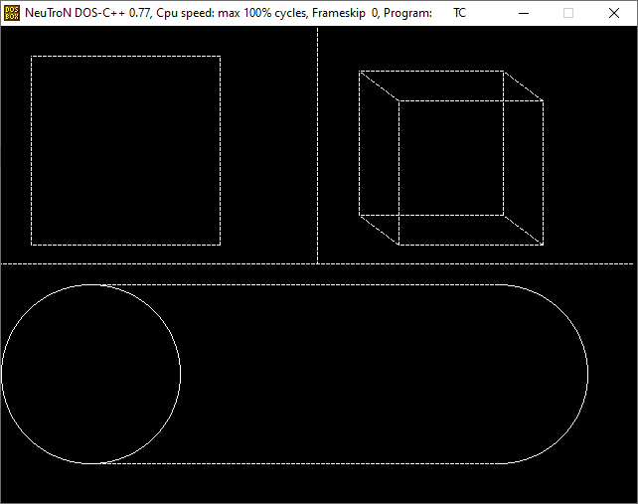

**Conclusion:** Bresenham’s line drawing algorithm avoids the use of fractions and rounding off operations thus reducing the processing and complexity. Hence it is preferred over DDA algorithm