INDUSTRY PROJECT REPORT
Retail Sales Performance Analysis
Using Python, Machine Learning & Power BI
Submitted by:
Suraj Mondal

GitHub Repository:
https://github.com/surajmondal2005/industry_project_tcs

Academic Year: 2024–2025
[Institution Name] | [Department Name] | [Course Name]

Abstract
This report presents a comprehensive analysis of retail sales performance conducted as part of an industry-level academic project. The study leverages a transactional retail dataset to uncover patterns in sales trends, customer behaviour, and product category performance. Using Python-based data analysis libraries — namely Pandas, NumPy, and Scikit-learn — the project performs end-to-end data processing, exploratory analysis, and machine learning-based customer segmentation. The insights derived are visualised through an interactive Power BI dashboard, enabling stakeholders to make informed, data-driven decisions. Key findings indicate that the Electronics category drives the highest revenue, female customers account for a marginally larger share of total sales, and K-Means clustering successfully segments customers into low-, medium-, and high-value groups.

1. Introduction
The retail industry generates enormous volumes of transactional data on a daily basis. Analysing this data effectively provides actionable insights that can drive revenue growth, improve inventory management, and enhance customer satisfaction. In an increasingly competitive marketplace, organisations that leverage data analytics for decision-making gain a significant strategic advantage.
This project, titled Retail Sales Performance Analysis, was undertaken as part of an industry-oriented academic programme in collaboration with Tata Consultancy Services (TCS). The objective was to simulate a real-world data analytics workflow — from raw data ingestion to the delivery of a business intelligence dashboard — using industry-standard tools and methodologies.
The project involved processing a structured retail transaction dataset, performing feature engineering and exploratory data analysis (EDA), applying unsupervised machine learning for customer segmentation, and building an interactive Power BI dashboard to communicate findings to a non-technical audience. The entire analytical pipeline was developed in Python, ensuring reproducibility and scalability.

2. Objectives
The primary objectives of this project are as follows:
- To collect, clean, and preprocess a retail transaction dataset for analytical use.
- To perform exploratory data analysis to identify sales trends, seasonal patterns, and category-level performance.
- To engineer meaningful features from raw data to enrich the analytical model.
- To apply K-Means clustering to segment customers based on purchasing behaviour into low-, medium-, and high-value groups.
- To develop an interactive Power BI dashboard incorporating KPI cards, trend charts, demographic breakdowns, and customer segmentation visuals.
- To derive actionable business insights from the analysis that can inform retail strategy and decision-making.

3. Tools and Technologies Used
The following tools and libraries were employed throughout the project lifecycle:
- Python 3.x: Primary programming language used for data processing, analysis, and machine learning.
- Pandas: Utilised for data ingestion, cleaning, transformation, and aggregation operations.
- NumPy: Applied for numerical computations and array-based operations to support feature engineering.
- Scikit-learn: Employed for implementing K-Means clustering to perform customer segmentation.
- Power BI: Used to build the interactive business intelligence dashboard for visualisation and reporting.
- Jupyter Notebook: Development environment for iterative code execution and documentation.
- GitHub: Version control platform used to manage and share the project codebase.

4. Methodology
The project followed a structured, end-to-end data analytics pipeline comprising five distinct phases: data collection, data preprocessing, feature engineering, exploratory data analysis, and machine learning. Each phase is described in detail below.

4.1 Data Collection
A structured retail transaction dataset was sourced for this project. Each record in the dataset corresponds to an individual transaction and includes the following fields:
- transaction_id: Unique identifier for each sales transaction.
- date: Date on which the transaction was recorded.
- customer_id: Unique identifier assigned to each customer.
- gender: Gender of the customer (Male/Female).
- age: Age of the customer in years.
- product_category: Category of the product purchased (e.g., Electronics, Clothing, Beauty).
- quantity: Number of units purchased in the transaction.
- price_per_unit: Unit selling price of the product.
- total_amount: Computed total value of the transaction (quantity × price per unit).
[Insert Code Screenshot Here — Data Loading / Dataset Preview]

4.2 Data Preprocessing
Prior to analysis, the dataset was subjected to a thorough preprocessing pipeline to ensure data quality and consistency. The following steps were performed:
- Handling Missing Values: All columns were inspected for null or missing entries. Rows with missing critical fields (such as customer_id or total_amount) were removed, while minor gaps in non-critical fields were handled using median or mode imputation as appropriate.
- Removing Duplicates: Duplicate transaction records, identified based on transaction_id, were detected and removed to prevent skewed analysis results.
- Data Type Formatting: The date column was converted from string format to a datetime object to facilitate time-series analysis. Numerical columns (age, quantity, price_per_unit, total_amount) were verified and cast to appropriate data types.
- Categorical Standardisation: Textual fields such as gender and product_category were standardised to ensure uniformity (e.g., consistent capitalisation and removal of trailing whitespace).
[Insert Code Screenshot Here — Data Preprocessing Steps]

4.3 Feature Engineering
To enrich the dataset and enable more granular analysis, several derived features were created:
- Month: Extracted from the date field to enable monthly trend analysis and identification of seasonal patterns.
- Quarter: Derived from the date field to support quarterly performance comparisons.
- Age Group: Customer age was binned into labelled demographic categories (e.g., 18–25, 26–35, 36–50, 51+) to facilitate demographic segmentation.
- Total Amount (Validation): The total_amount field was cross-verified against the product of quantity and price_per_unit to ensure data integrity.
[Insert Code Screenshot Here — Feature Engineering]

4.4 Data Analysis
Exploratory data analysis was conducted across three primary dimensions:

Sales Trends
Monthly and quarterly aggregations of total_amount were computed to identify temporal trends. This analysis revealed periods of elevated and suppressed sales activity throughout the year, providing insights into demand seasonality and potential promotional opportunities.

Category Performance
Revenue and transaction volume were aggregated by product_category to assess the relative contribution of each category to overall sales. This enabled identification of high-performing and underperforming product segments.

Customer Demographics
Purchase behaviour was cross-referenced with gender and age group to understand the demographic profile of the customer base. This analysis informed targeted marketing recommendations and informed the design of the segmentation model.
[Insert Code Screenshot Here — EDA Visualisations / Output]

4.5 Machine Learning — Customer Segmentation
K-Means clustering was applied to segment customers based on their total purchasing expenditure. The following steps were undertaken:
- Customer-level aggregates of total_amount were computed to represent each customer's overall spending.
- The data was standardised using Scikit-learn's StandardScaler to normalise the feature space prior to clustering.
- The Elbow Method was applied to determine the optimal number of clusters (k), which was identified as k = 3.
- K-Means clustering was executed with k = 3, resulting in three distinct customer segments.
- Each cluster was labelled based on average spend: Low-Value Customers (Cluster 0), Medium-Value Customers (Cluster 1), and High-Value Customers (Cluster 2).
- Cluster assignments were merged back into the original dataset to enable downstream visualisation and analysis.
[Insert Code Screenshot Here — K-Means Clustering / Elbow Method Plot]

5. Dashboard Development
An interactive Power BI dashboard was developed to present the analytical findings in a visually compelling and intuitive format. The dashboard is designed to serve both technical analysts and non-technical business stakeholders. It comprises the following components:
- KPI Cards: Three summary cards display headline metrics at a glance: Total Sales (cumulative revenue across all transactions), Average Sales (mean transaction value), and Total Quantity (aggregate units sold). These cards provide an immediate performance snapshot.
- Sales Trend Line Chart: A time-series line chart plots monthly total sales, allowing stakeholders to track performance over time, identify growth trajectories, and pinpoint anomalies or seasonal dips.
- Sales by Category Bar Chart: A horizontal bar chart ranks product categories by total revenue, enabling direct comparison of category-level performance. This visual highlights the dominance of the Electronics category.
- Sales by Gender Pie Chart: A pie chart illustrates the proportional revenue contribution of male and female customers, supporting demographic-driven marketing and product strategy decisions.
- Customer Segmentation Scatter/Cluster Chart: A scatter plot visualises customer clusters derived from the K-Means model, with each data point colour-coded according to its segment (Low, Medium, or High Value). This chart communicates the output of the machine learning pipeline in an accessible visual format.
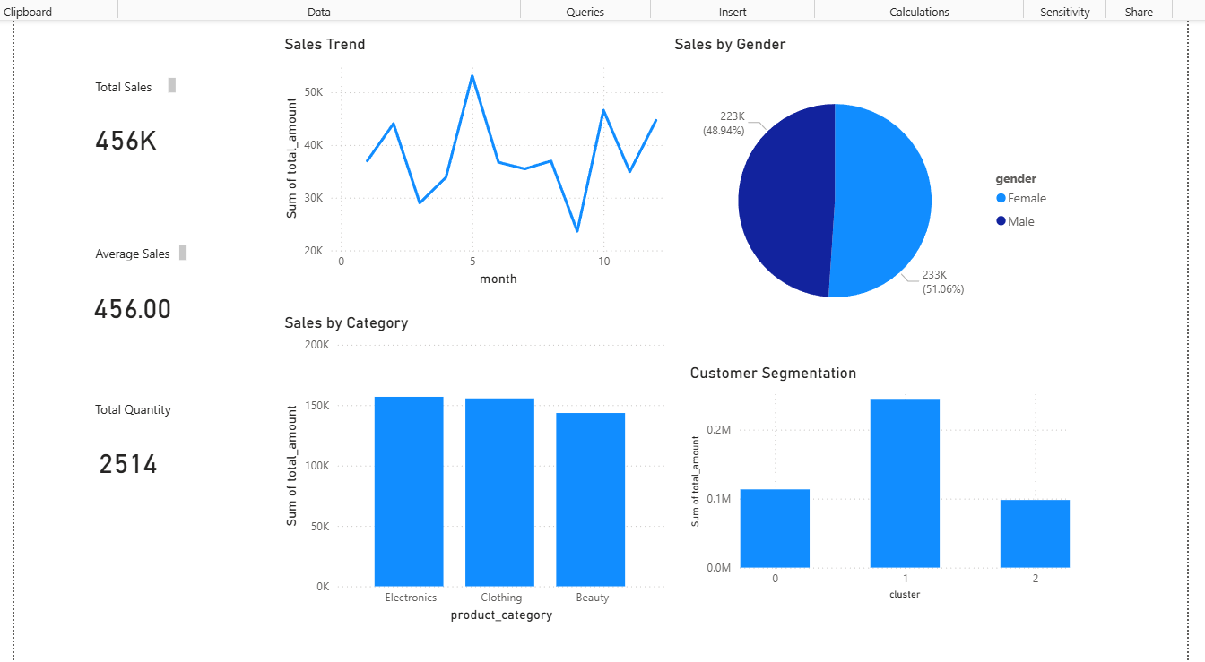
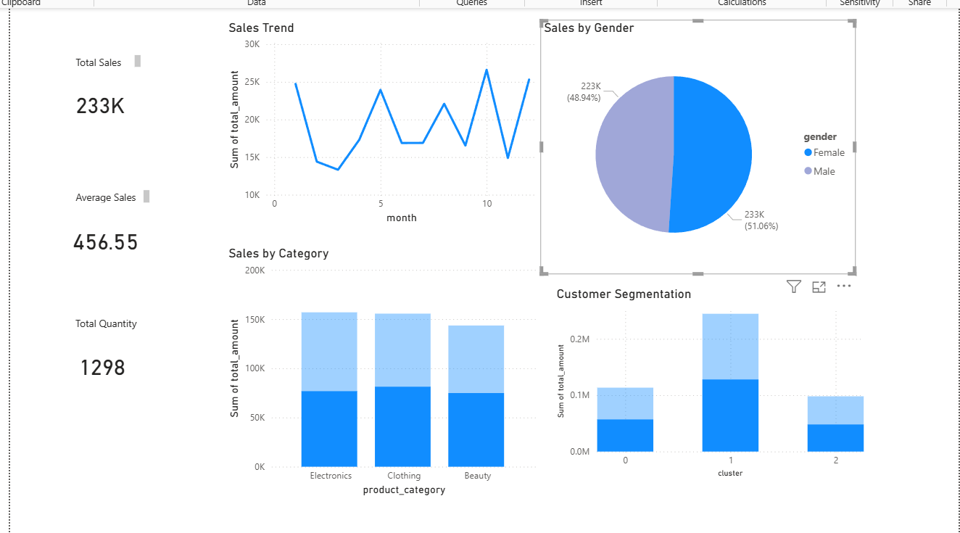
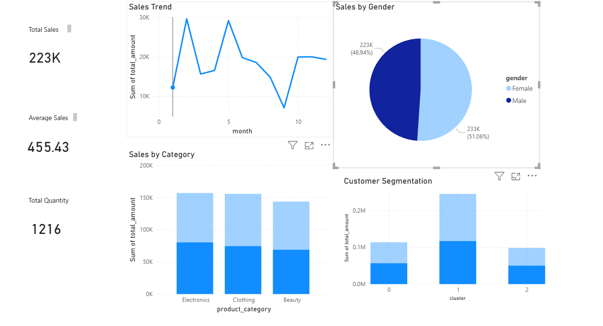

6. Results and Key Insights
The analysis yielded several significant findings with direct implications for retail strategy and operations:
- Electronics Category Generates Highest Revenue: Across all product categories, Electronics consistently recorded the highest total sales revenue. This indicates strong consumer demand and higher average transaction values in this segment, suggesting that inventory investment and promotional campaigns should prioritise this category.
- Sales Vary Significantly Across Months: The monthly sales trend analysis revealed notable variation throughout the year. Certain months exhibited sales peaks — potentially aligned with festive seasons or promotional events — while others showed subdued activity. This pattern underscores the importance of aligning marketing campaigns and stock planning with seasonal demand cycles.
- Female Customers Contribute Marginally More to Revenue: Gender-disaggregated analysis indicates that female customers account for a slightly higher proportion of total sales compared to male customers. This finding can inform targeted product placement strategies and gender-specific promotional initiatives.
- High-Value Customers Successfully Identified via Clustering: The K-Means clustering model successfully partitioned the customer base into three distinct value segments. High-value customers, though representing a smaller proportion of the total customer base, contribute disproportionately to overall revenue. Identifying and retaining this cohort through loyalty programmes and personalised outreach represents a high-return business opportunity.

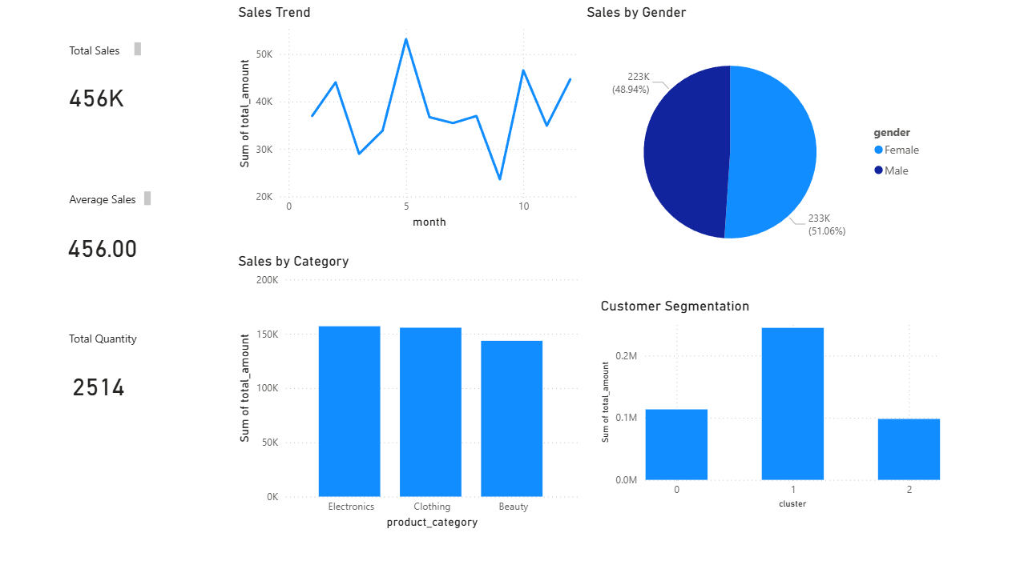

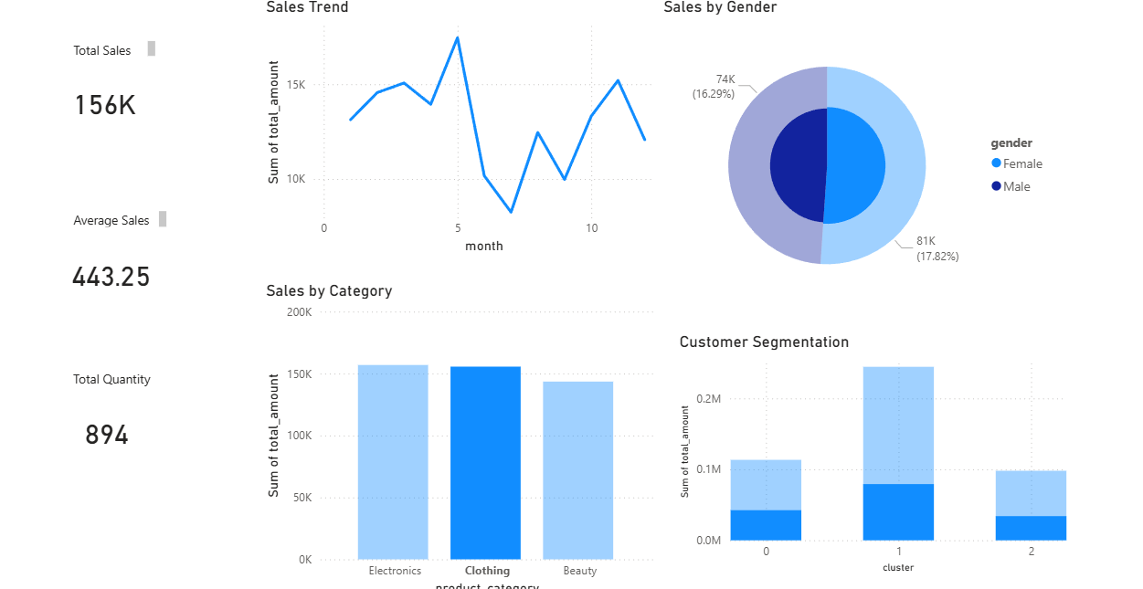

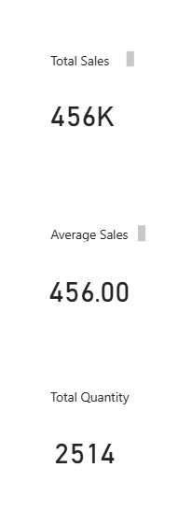

7. Conclusion
This project successfully demonstrates the application of data analytics and machine learning techniques to a real-world retail dataset. By integrating Python-based data processing with Power BI visualisation, the project delivers a comprehensive analytical solution that bridges the gap between raw transactional data and actionable business intelligence.
The analytical pipeline — encompassing data cleaning, feature engineering, exploratory analysis, and K-Means clustering — provides a robust and replicable framework applicable to a broad range of retail contexts. The resulting Power BI dashboard serves as an effective communication tool, enabling stakeholders to monitor key performance indicators, understand customer demographics, and leverage machine learning insights without requiring technical expertise.
The project reinforced several key competencies relevant to the industry, including data wrangling, statistical reasoning, machine learning model deployment, and data storytelling. It represents a practical application of academic learning within a professional analytical framework, fully aligned with the objectives of the TCS industry collaboration programme.

8. Future Scope
While the current project delivers meaningful insights, several avenues exist for extending its scope and analytical depth:
- Integration of real-time sales data feeds via APIs to enable live dashboard updates and dynamic performance monitoring.
- Development of predictive sales forecasting models using time-series techniques such as ARIMA or Facebook Prophet to anticipate future demand.
- Application of association rule mining (e.g., Apriori algorithm) to identify product cross-selling and upselling opportunities.
- Expansion of the customer segmentation model to incorporate RFM (Recency, Frequency, Monetary) analysis for richer behavioural profiling.
- Deployment of the analytical pipeline as a web-based application using frameworks such as Streamlit or Dash, enabling browser-based access to insights.
- Incorporation of sentiment analysis from customer reviews to complement quantitative sales data with qualitative consumer feedback.

9. GitHub Repository
The complete source code, dataset, and supplementary documentation for this project are publicly available at the following GitHub repository:
https://github.com/surajmondal2005/industry_project_tcs
The repository includes the Jupyter Notebooks used for data preprocessing and analysis, the processed dataset, the Power BI (.pbix) dashboard file, and a detailed README providing setup and usage instructions.

References
[1] McKinney, W. (2022). Python for Data Analysis (3rd ed.). O'Reilly Media.
[2] Géron, A. (2022). Hands-On Machine Learning with Scikit-Learn, Keras, and TensorFlow (3rd ed.). O'Reilly Media.
[3] Microsoft Corporation. (2024). Power BI Documentation. Retrieved from https://docs.microsoft.com/en-us/power-bi/
[4] Scikit-learn Developers. (2024). Scikit-learn: Machine Learning in Python. Retrieved from https://scikit-learn.org/
[5] Pandas Development Team. (2024). Pandas Documentation. Retrieved from https://pandas.pydata.org/docs/
[6] GitHub Repository: https://github.com/surajmondal2005/industry_project_tcs

