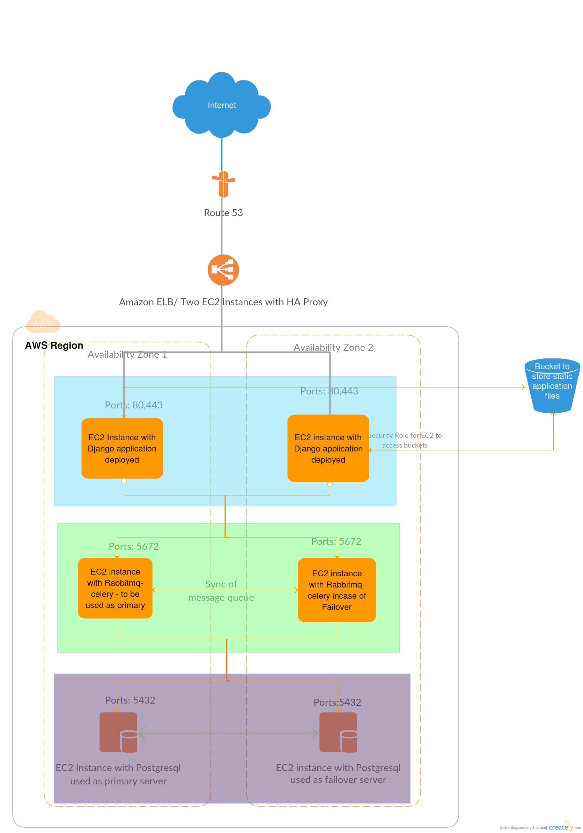

Elastic Load Balancer:

* + To distribute load between the servers, and in case of failover
  + Instead of Amazon ELD, two EC2 instances with HA Proxy for Load Balancing

Webserver

* + Django Application deployed on two EC2 instances, and webserver running on both instances
  + Static files required for the application to be fetched from S3

Rabbitmq-celery cluster

* + Rabbitmq server and celery worker process deployed on two EC2 instances
  + Synchronization of message queue between the two servers

Postgresql cluster

* Postgresql deployed on two EC2 instances with Active-Passive Cluster

S3 bucket:

* To host static files