Ajax

What is AJAX?
AJAX stands for Asynchronous JavaScript And XML. It is not a programming language. It is a technology for developing better, faster and interactive Web Applications using HTML, CSS, JavaScript and XML.
- HTML : Hypertext Markup Language (HTML) is used for defining the structure of a Web Application.
- CSS : Cascading Style Sheet (CSS) is used to provide look and style to a Web Application.
- JavaScript : JavaScript is used for making a Web Application interactive, interesting and user friendly.
- XML : Extensible Markup Language (XML) is a format to store and transport data from the Web Server.

Where it is used?
There are too many web applications running on the web that are using ajax technology like gmail, facebook,twitter, google map, youtube etc.

Understanding Synchronous vs Asynchronous

Synchronous (Classic Web-Application Model)
A synchronous request blocks the client until operation completes i.e. browser is unresponsive. In such case, javascript engine of the browser is blocked.
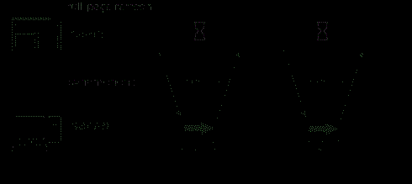
As you can see in the above image, full page is refreshed at request time and user is blocked until request completes.
Let's understand it another way.
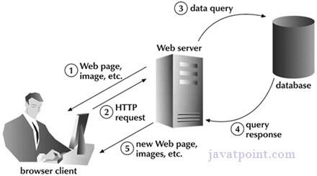

Asynchronous (AJAX Web-Application Model)

An asynchronous request doesn’t block the client i.e. browser is responsive. At that time, user can perform another operations also. In such case, javascript engine of the browser is not blocked.

As you can see in the above image, full page is not refreshed at request time and user gets response from the ajax engine.
Let's try to understand asynchronous communication by the image given below.
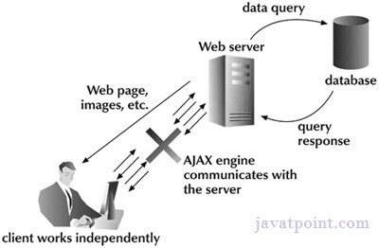

AJAX Technologies
As describe earlier, ajax is not a technology but group of inter-related technologies. AJAX technologies includes:
- HTML/XHTML and CSS
- DOM
- XML or JSON
- XMLHttpRequest
- JavaScript

HTML/XHTML and CSS
These technologies are used for displaying content and style. It is mainly used for presentation.

DOM
It is used for dynamic display and interaction with data.

XML or JSON
For carrying data to and from server. JSON (Javascript Object Notation) is like XML but short and faster than XML.

XMLHttpRequest
For asynchronous communication between client and server. For more visit next page.

JavaScript
It is used to bring above technologies together.
Independently, it is used mainly for client-side validation.

Understanding XMLHttpRequest

An object of XMLHttpRequest is used for asynchronous communication between client and server.
It performs following operations:
- Sends data from the client in the background
- Receives the data from the server
- Updates the webpage without reloading it.

Properties of XMLHttpRequest object
The common properties of XMLHttpRequest object are as follows:
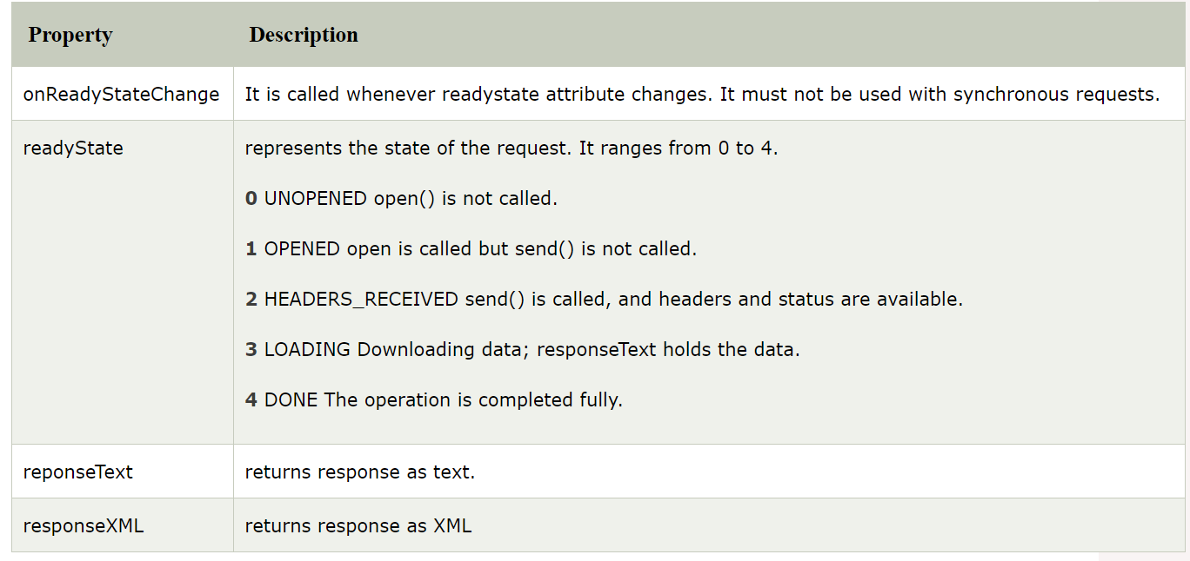

Methods of XMLHttpRequest object

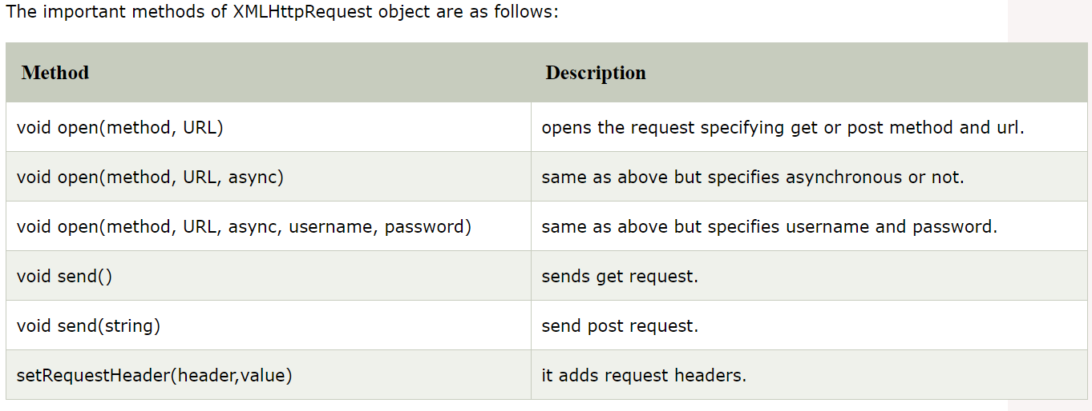

How AJAX works?
AJAX communicates with the server using XMLHttpRequest object. Let's try to understand the flow of ajax or how ajax works by the image displayed below.
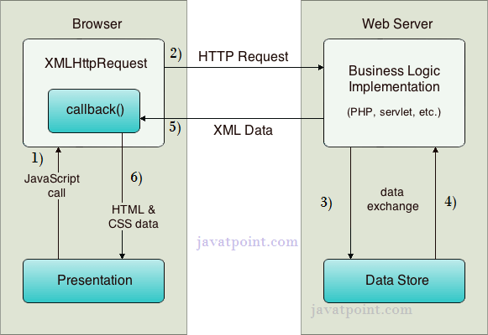
As you can see in the above example, XMLHttpRequest object plays a important role.
- User sends a request from the UI and a javascript call goes to XMLHttpRequest object.
- HTTP Request is sent to the server by XMLHttpRequest object.
- Server interacts with the database using JSP, PHP, Servlet, ASP.net etc.
- Data is retrieved.
- Server sends XML data or JSON data to the XMLHttpRequest callback function.
- HTML and CSS data is displayed on the browser.

Ajax Java Example
To create ajax example, you need to use any server-side language e.g. Servlet, JSP, PHP, ASP.Net etc. Here we are using JSP for generating the server-side code.
In this example, we are simply printing the table of the given number.

Steps to create ajax example with jsp
You need to follow following steps:
- load the org.json.jar file
- create input page to receive any text or number
- create server side page to process the request
- provide entry in web.xml file

