Laravel
Laravel is a powerful MVC PHP framework, designed for developers who need a simple and elegant toolkit to create full-featured web applications. Laravel was created by Taylor Otwell.
Laravel is an open-source PHP framework, which is robust and easy to understand. It follows a model-view-controller design pattern. Laravel reuses the existing components of different frameworks which helps in creating a web application. The web application thus designed is more structured and pragmatic.
Laravel offers a rich set of functionalities which incorporates the basic features of PHP frameworks like CodeIgniter, Yii and other programming languages like Ruby on Rails. Laravel has a very rich set of features which will boost the speed of web development.
If you are familiar with Core PHP and Advanced PHP, Laravel will make your task easier. It saves a lot time if you are planning to develop a website from scratch. Moreover, a website built in Laravel is secure and prevents several web attacks.

Advantages of Laravel
Laravel offers you the following advantages, when you are designing a web application based on it −
- The web application becomes more scalable, owing to the Laravel framework.
- Considerable time is saved in designing the web application, since Laravel reuses the components from other framework in developing web application.
- It includes namespaces and interfaces, thus helps to organize and manage resources.

Composer
Composer is a tool which includes all the dependencies and libraries. It allows a user to create a project with respect to the mentioned framework (for example, those used in Laravel installation). Third party libraries can be installed easily with help of composer.
All the dependencies are noted in composer.json file which is placed in the source folder.

Artisan
Command line interface used in Laravel is called Artisan. It includes a set of commands which assists in building a web application. These commands are incorporated from Symphony framework, resulting in add-on features in Laravel 5.1 (latest version of Laravel).

Features of Laravel
Laravel offers the following key features which makes it an ideal choice for designing web applications −

Modularity
Laravel provides 20 built in libraries and modules which helps in enhancement of the application. Every module is integrated with Composer dependency manager which eases updates.

Testability
Laravel includes features and helpers which helps in testing through various test cases. This feature helps in maintaining the code as per the requirements.

Routing
Laravel provides a flexible approach to the user to define routes in the web application. Routing helps to scale the application in a better way and increases its performance.

Configuration Management
A web application designed in Laravel will be running on different environments, which means that there will be a constant change in its configuration. Laravel provides a consistent approach to handle the configuration in an efficient way.

Query Builder and ORM
Laravel incorporates a query builder which helps in querying databases using various simple chain methods. It provides ORM (Object Relational Mapper) and ActiveRecord implementation called Eloquent.

Schema Builder
Schema Builder maintains the database definitions and schema in PHP code. It also maintains a track of changes with respect to database migrations.

Template Engine
Laravel uses the Blade Template engine, a lightweight template language used to design hierarchical blocks and layouts with predefined blocks that include dynamic content.

E-mail
Laravel includes a mail class which helps in sending mail with rich content and attachments from the web application.

Authentication
User authentication is a common feature in web applications. Laravel eases designing authentication as it includes features such as register, forgot password and send password reminders.

Redis
Laravel uses Redis to connect to an existing session and general-purpose cache. Redis interacts with session directly.

Queues
Laravel includes queue services like emailing large number of users or a specified Cron job. These queues help in completing tasks in an easier manner without waiting for the previous task to be completed.

Event and Command Bus
Laravel 5.1 includes Command Bus which helps in executing commands and dispatch events in a simple way. The commands in Laravel act as per the application’s lifecycle.

Laravel - Installation
For managing dependencies, Laravel uses composer. Make sure you have a Composer installed on your system before you install Laravel. In this chapter, you will see the installation process of Laravel.
You will have to follow the steps given below for installing Laravel onto your system −
Step 1 − Visit the following URL and download composer to install it on your system.
https://getcomposer.org/download/
Step 2 − After the Composer is installed, check the installation by typing the Composer command in the command prompt as shown in the following screenshot.
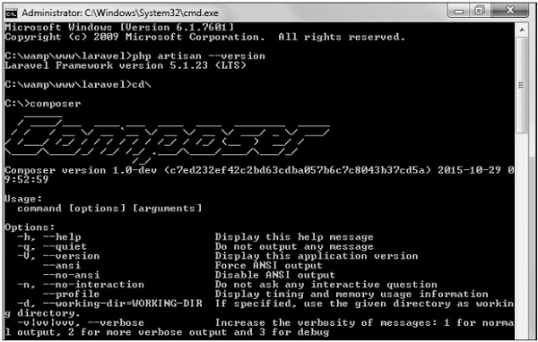
Step 3 − Create a new directory anywhere in your system for your new Laravel project. After that, move to path where you have created the new directory and type the following command there to install Laravel.
composer create-project laravel/laravel –-prefer-dist
Now, we will focus on installation of version 5.7. In Laravel version 5.7, you can install the complete framework by typing the following command −
composer create-project laravel/laravel test dev-develop
The output of the command is as shown below −
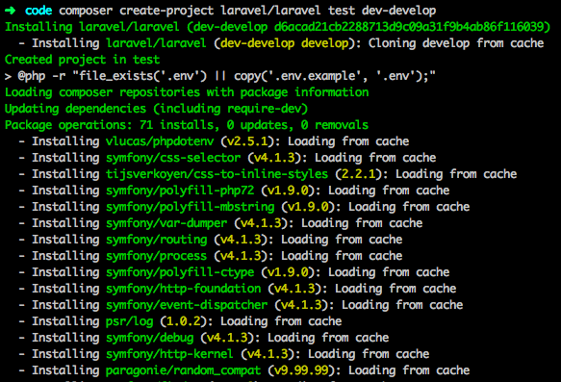
The Laravel framework can be directly installed with develop branch which includes the latest framework.
Step 4 − The above command will install Laravel in the current directory. Start the Laravel service by executing the following command.
php artisan serve
Step 5 − After executing the above command, you will see a screen as shown below −
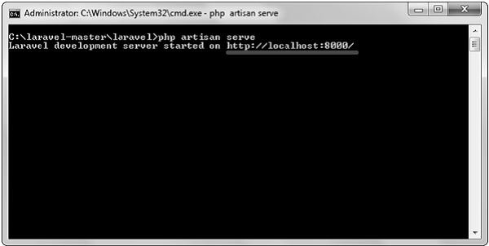
Step 6 − Copy the URL underlined in gray in the above screenshot and open that URL in the browser. If you see the following screen, it implies Laravel has been installed successfully.
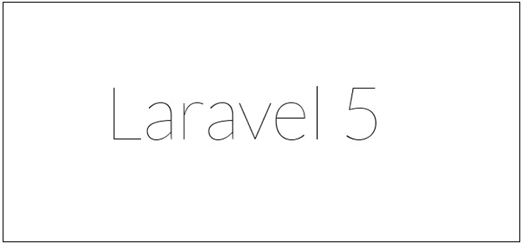

Laravel - Configuration
In the previous chapter, we have seen that the basic configuration files of Laravel are included in the config directory. In this chapter, let us discuss the categories included in the configuration.

Environment Configuration
Environment variables are those which provide a list of web services to your web application. All the environment variables are declared in the .env file which includes the parameters required for initializing the configuration.
By default, the .env file includes following parameters −
APP_ENV = local
APP_DEBUG = true
APP_KEY = base64:ZPt2wmKE/X4eEhrzJU6XX4R93rCwYG8E2f8QUA7kGK8 =
APP_URL = http://localhost
DB_CONNECTION = mysql
DB_HOST = 127.0.0.1
DB_PORT = 3306
DB_DATABASE = homestead
DB_USERNAME = homestead
DB_PASSWORD = secret
CACHE_DRIVER = file
SESSION_DRIVER = file
QUEUE_DRIVER = sync
REDIS_HOST = 127.0.0.1
REDIS_PASSWORD = null
REDIS_PORT = 6379
MAIL_DRIVER = smtp
MAIL_HOST = mailtrap.ioMAIL_PORT = 2525
MAIL_USERNAME = null
MAIL_PASSWORD = null
MAIL_ENCRYPTION = null

Important Points
While working with basic configuration files of Laravel, the following points are to be noted −
- The .env file should not be committed to the application source control, since each developer or user has some predefined environment configuration for the web application.
- For backup options, the development team should include the .env.example file, which should contain the default configuration.

Retrieval of Environment Variables
All the environment variables declared in the .env file can be accessed by env-helper functions which will call the respective parameter. These variables are also listed into $_ENV global variable whenever application receives a request from the user end. You can access the environment variable as shown below −
'env' => env('APP_ENV', 'production'),
env-helper functions are called in the app.php file included in the config folder. The above given example is calling for the basic local parameter.

Accessing Configuration Values
You can easily access the configuration values anywhere in the application using the global config helper function. In case if the configuration values are not initialized, default values are returned.
For example, to set the default time zone, the following code is used −
config(['app.timezone' => 'Asia/Kolkata']);

Caching of Configuration
To increase the performance and to boost the web application, it is important to cache all the configuration values. The command for caching the configuration values is −
config:cache
The following screenshot shows caching in a systematic approach −
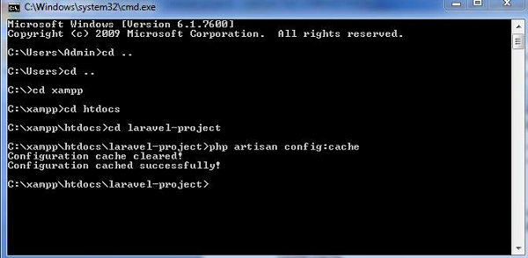

Maintenance

Maintenance Mode
Sometimes you may need to update some configuration values or perform maintenance on your website. In such cases, keeping it in maintenance mode, makes it easier for you. Such web applications which are kept in maintenance mode, throw an exception namely MaintenanceModeException with a status code of 503.
You can enable the maintenance mode on your Laravel web application using the following command −
php artisan down
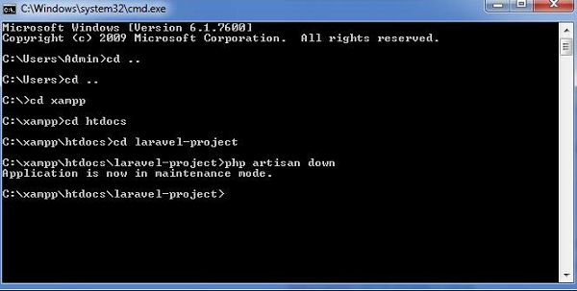
The following screenshot shows how the web application looks when it is down −

Once you finish working on updates and other maintenance, you can disable the maintenance mode on your web application using following command −
php artisan up
p
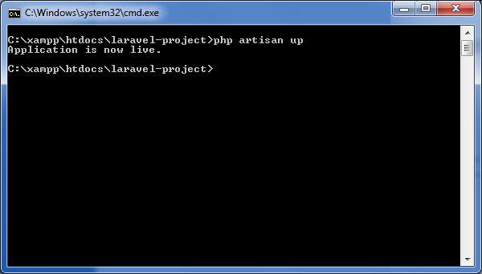
Now, you can find that the website shows the output with proper functioning and depicting that the maintenance mode is now removed as shown below −
−

Laravel - Routing
In Laravel, all requests are mapped with the help of routes. Basic routing routes the request to the associated controllers. This chapter discusses routing in Laravel.
Routing in Laravel includes the following categories −
- Basic Routing
- Route parameters
- Named Routes

Basic Routing
All the application routes are registered within the app/routes.php file. This file tells Laravel for the URIs it should respond to and the associated controller will give it a particular call. The sample route for the welcome page can be seen as shown in the screenshot given below −
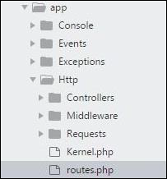
Route::get ('/', function () {
return view('welcome');});

Example
Observe the following example to understand more about Routing −
app/Http/routes.php
<?php
Route::get('/', function () {
return view('welcome');
});
resources/view/welcome.blade.php
<!DOCTYPE html>
<html>
<head>
<title>Laravel</title>
<link href = "https://fonts.googleapis.com/css?family=Lato:100" rel = "stylesheet"
type = "text/css">

<style>
html, body {
height: 100%;
}
body {
margin: 0;
padding: 0;
width: 100%;
display: table;
font-weight: 100;
font-family: 'Lato';
}
.container {
text-align: center;
display: table-cell;
vertical-align: middle;
}
.content {
text-align: center;
display: inline-block;
}
.title {
font-size: 96px;
}
</style>
</head>

<body>
<div class = "container">

<div class = "content">
<div class = "title">Laravel 5.1</div>
</div>

</div>
</body>
</html>

The routing mechanism is shown in the image given below −
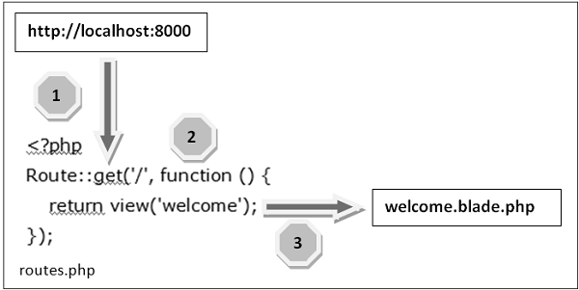
Let us now understand the steps involved in routing mechanism in detail −
Step 1 − Initially, we should execute the root URL of the application.
Step 2 − Now, the executed URL should match with the appropriate method in the route.php file. In the present case, it should match the method and the root (‘/’) URL. This will execute the related function.
Step 3 − The function calls the template file resources/views/welcome.blade.php. Next, the function calls the view() function with argument ‘welcome’ without using the blade.php.
This will produce the HTML output as shown in the image below −


Route Parameters
Sometimes in the web application, you may need to capture the parameters passed with the URL. For this, you should modify the code in routes.php file.
You can capture the parameters in routes.php file in two ways as discussed here −

Required Parameters
These parameters are those which should be mandatorily captured for routing the web application. For example, it is important to capture the user’s identification number from the URL. This can be possible by defining route parameters as shown below −
Route::get('ID/{id}',function($id) {
echo 'ID: '.$id;
});

Optional Parameters
Sometimes developers can produce parameters as optional and it is possible with the inclusion of ? after the parameter name in URL. It is important to keep the default value mentioned as a parameter name. Look at the following example that shows how to define an optional parameter −
Route::get('user/{name?}', function ($name = 'TutorialsPoint') { return $name;}
The example above checks if the value matches to TutorialsPoint and accordingly routes to the defined URL.

Named Routes
Named routes allow a convenient way of creating routes. The chaining of routes can be specified using name method onto the route definition. The following code shows an example for creating named routes with controller −
Route::get('user/profile', 'UserController@showProfile')->name('profile');
The user controller will call for the function showProfile with parameter as profile. The parameters use name method onto the route definition.

Laravel - Controllers
In the MVC framework, the letter ‘C’ stands for Controller. It acts as a directing traffic between Views and Models. In this chapter, you will learn about Controllers in Laravel.

Creating a Controller
Open the command prompt or terminal based on the operating system you are using and type the following command to create controller using the Artisan CLI (Command Line Interface).
php artisan make:controller <controller-name> --plain
Replace the <controller-name> with the name of your controller. This will create a plain constructor as we are passing the argument — plain. If you don’t want to create a plain constructor, you can simply ignore the argument. The created constructor can be seen at app/Http/Controllers.
You will see that some basic coding has already been done for you and you can add your custom coding. The created controller can be called from routes.php by the following syntax.

Syntax
Route::get(‘base URI’,’controller@method’);

Example
Step 1 − Execute the following command to create UserController.
php artisan make:controller UserController --plain
Step 2 − After successful execution, you will receive the following output.
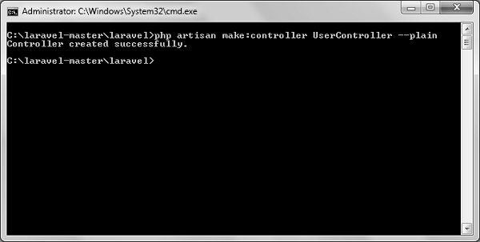
Step 3 − You can see the created controller at app/Http/Controller/UserController.php with some basic coding already written for you and you can add your own coding based on your need.
<?php

namespace App\Http\Controllers;

use Illuminate\Http\Request;
use App\Http\Requests;
use App\Http\Controllers\Controller;

class UserController extends Controller {
//
}

Controller Middleware
We have seen middleware before and it can be used with controller also. Middleware can also be assigned to controller’s route or within your controller’s constructor. You can use the middleware method to assign middleware to the controller. The registered middleware can also be restricted to certain method of the controller.

Assigning Middleware to Route
Route::get('profile', [
'middleware' => 'auth',
'uses' => 'UserController@showProfile'
]);
Here we are assigning auth middleware to UserController in profile route.

Assigning Middleware within Controller’s constructor
<?php

namespace App\Http\Controllers;

use Illuminate\Http\Request;
use App\Http\Requests;
use App\Http\Controllers\Controller;

class UserController extends Controller {
public function __construct() {
$this->middleware('auth');
}
}
Here we are assigning auth middleware using the middleware method in the UserController constructor.

Example
Step 1 − Add the following lines of code to the app/Http/routes.php file and save it.
routes.php
<?php
Route::get('/usercontroller/path',[
'middleware' => 'First',
'uses' => 'UserController@showPath'
]);
Step 2 − Create a middleware called FirstMiddleware by executing the following line of code.
php artisan make:middleware FirstMiddleware
Step 3 − Add the following code into the handle method of the newly created FirstMiddleware at app/Http/Middleware.
FirstMiddleware.php
<?php

namespace App\Http\Middleware;
use Closure;

class FirstMiddleware {
public function handle($request, Closure $next) {
echo '<br>First Middleware';
return $next($request);
}
}
Step 4 − Create a middleware called SecondMiddleware by executing the following command.
php artisan make:middleware SecondMiddleware
Step 5 − Add the following code in the handle method of the newly created SecondMiddleware at app/Http/Middleware.
SecondMiddleware.php
<?php

namespace App\Http\Middleware;
use Closure;

class SecondMiddleware {
public function handle($request, Closure $next) {
echo '<br>Second Middleware';
return $next($request);
}
}
Step 6 − Create a controller called UserController by executing the following line.
php artisan make:controller UserController --plain
Step 7 − After successful execution of the URL, you will receive the following output −
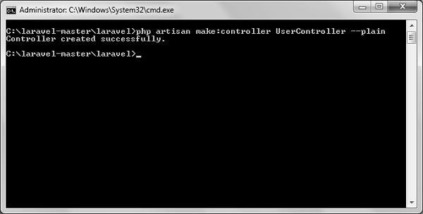
Step 8 − Copy the following code to app/Http/UserController.php file.
app/Http/UserController.php
<?php

namespace App\Http\Controllers;

use Illuminate\Http\Request;
use App\Http\Requests;
use App\Http\Controllers\Controller;

class UserController extends Controller {
public function __construct() {
$this->middleware('Second');
}
public function showPath(Request $request) {
$uri = $request->path();
echo '<br>URI: '.$uri;

$url = $request->url();
echo '<br>';

echo 'URL: '.$url;
$method = $request->method();
echo '<br>';
echo 'Method: '.$method;
}
}
Step 9 − Now launch the php’s internal web server by executing the following command, if you haven’t executed it yet.
php artisan serve
Step 10 − Visit the following URL.
http://localhost:8000/usercontroller/path
Step 11 − The output will appear as shown in the following image.
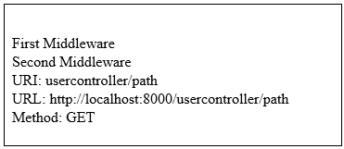

Restful Resource Controllers
Often while making an application we need to perform CRUD (Create, Read, Update, Delete) operations. Laravel makes this job easy for us. Just create a controller and Laravel will automatically provide all the methods for the CRUD operations. You can also register a single route for all the methods in routes.php file.

Example
Step 1 − Create a controller called MyController by executing the following command.
php artisan make:controller MyController
Step 2 − Add the following code in
app/Http/Controllers/MyController.php file.
app/Http/Controllers/MyController.php
<?php

namespace App\Http\Controllers;

use Illuminate\Http\Request;
use App\Http\Requests;
use App\Http\Controllers\Controller;

class MyController extends Controller {
public function index() {
echo 'index';
}
public function create() {
echo 'create';
}
public function store(Request $request) {
echo 'store';
}
public function show($id) {
echo 'show';
}
public function edit($id) {
echo 'edit';
}
public function update(Request $request, $id) {
echo 'update';
}
public function destroy($id) {
echo 'destroy';
}
}
Step 3 − Add the following line of code in app/Http/routes.php file.
app/Http/routes.php
Route::resource('my','MyController');
Step 4 − We are now registering all the methods of MyController by registering a controller with resource. Below is the table of actions handled by resource controller.
Verb | Path | Action | Route Name
GET | /my | index | my.index
GET | /my/create | create | my.create
POST | /my | store | my.store
GET | /my/{my} | show | my.show
GET | /my/{my}/edit | edit | my.edit
PUT/PATCH | /my/{my} | update | my.update
DELETE | /my/{my} | destroy | my.destroy
Step 5 − Try executing the URLs shown in the following table.
URL | Description | Output Image
http://localhost:8000/my | Executes index method of MyController.php | index
http://localhost:8000/my/create | Executes create method of MyController.php | create
http://localhost:8000/my/1 | Executes show method of MyController.php | show
http://localhost:8000/my/1/edit | Executes edit method of MyController.php | edit

Implicit Controllers
Implicit Controllers allow you to define a single route to handle every action in the controller. You can define it in route.php file with Route:controller method as shown below.
Route::controller(‘base URI’,’<class-name-of-the-controller>’);
Replace the <class-name-of-the-controller> with the class name that you have given to your controller.
The method name of the controller should start with HTTP verb like get or post. If you start it with get, it will handle only get request and if it starts with post then it will handle the post request. After the HTTP verb you can, you can give any name to the method but it should follow the title case version of the URI.

Example
Step 1 − Execute the below command to create a controller. We have kept the class name ImplicitController. You can give any name of your choice to the class.
php artisan make:controller ImplicitController --plain
Step 2 − After successful execution of step 1, you will receive the following output −
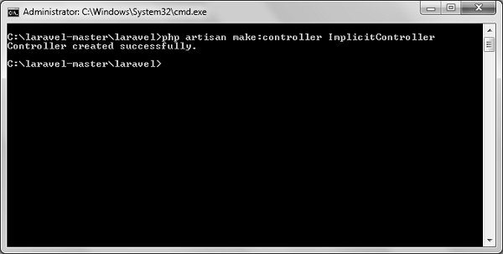
Step 3 − Copy the following code to
app/Http/Controllers/ImplicitController.php file.
app/Http/Controllers/ImplicitController.php
<?php

namespace App\Http\Controllers;

use Illuminate\Http\Request;
use App\Http\Requests;
use App\Http\Controllers\Controller;

class ImplicitController extends Controller {
/**
* Responds to requests to GET /test
*/
public function getIndex() {
echo 'index method';
}

/**
* Responds to requests to GET /test/show/1
*/
public function getShow($id) {
echo 'show method';
}

/**
* Responds to requests to GET /test/admin-profile
*/
public function getAdminProfile() {
echo 'admin profile method';
}

/**
* Responds to requests to POST /test/profile
*/
public function postProfile() {
echo 'profile method';
}
}
Step 4 − Add the following line to app/Http/routes.php file to route the requests to specified controller.
app/Http/routes.php
Route::controller('test','ImplicitController');

Constructor Injection
The Laravel service container is used to resolve all Laravel controllers. As a result, you are able to type-hint any dependencies your controller may need in its constructor. The dependencies will automatically be resolved and injected into the controller instance.

Example
Step 1 − Add the following code to app/Http/routes.php file.
app/Http/routes.php
class MyClass{
public $foo = 'bar';
}
Route::get('/myclass','ImplicitController@index');
Step 2 − Add the following code to
app/Http/Controllers/ImplicitController.php file.
app/Http/Controllers/ImplicitController.php
<?php

namespace App\Http\Controllers;

use Illuminate\Http\Request;
use App\Http\Requests;
use App\Http\Controllers\Controller;

class ImplicitController extends Controller {
private $myclass;

public function __construct(\MyClass $myclass) {
$this->myclass = $myclass;
}
public function index() {
dd($this->myclass);
}
}
Step 3 − Visit the following URL to test the constructor injection.
http://localhost:8000/myclass
Step 4 − The output will appear as shown in the following image.
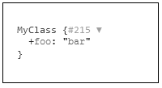

Method Injection
In addition to constructor injection, you may also type — hint dependencies on your controller's action methods.

Example
Step 1 − Add the following code to app/Http/routes.php file.
app/Http/routes.php
class MyClass{
public $foo = 'bar';
}
Route::get('/myclass','ImplicitController@index');
Step 2 − Add the following code to
app/Http/Controllers/ImplicitController.php file.
app/Http/Controllers/ImplicitController.php
<?php

namespace App\Http\Controllers;

use Illuminate\Http\Request;
use App\Http\Requests;
use App\Http\Controllers\Controller;

class ImplicitController extends Controller {
public function index(\MyClass $myclass) {
dd($myclass);
}
}
Step 3 − Visit the following URL to test the constructor injection.
http://localhost:8000/myclass
It will produce the following output −

Laravel - Request

Retrieving the Request URI
The “path” method is used to retrieve the requested URI. The is method is used to retrieve the requested URI which matches the particular pattern specified in the argument of the method. To get the full URL, we can use the url method.

Example
Step 1 − Execute the below command to create a new controller called UriController.
php artisan make:controller UriController –plain
Step 2 − After successful execution of the URL, you will receive the following output −
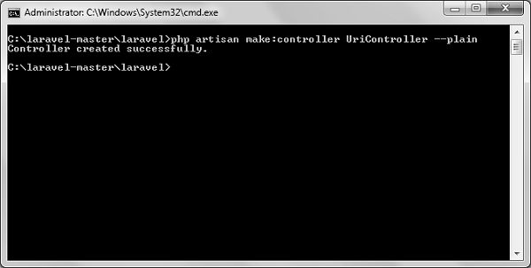
Step 3 − After creating a controller, add the following code in that file.
app/Http/Controllers/UriController.php
<?php

namespace App\Http\Controllers;

use Illuminate\Http\Request;
use App\Http\Requests;
use App\Http\Controllers\Controller;

class UriController extends Controller {

public function index(Request $request) {
// Usage of path method
$path = $request->path();
echo 'Path Method: '.$path;
echo '<br>';

// Usage of is method
$pattern = $request->is('foo/*');
echo 'is Method: '.$pattern;
echo '<br>';

// Usage of url method
$url = $request->url();
echo 'URL method: '.$url;
}
}
Step 4 − Add the following line in the app/Http/route.php file.
app/Http/route.php
Route::get('/foo/bar','UriController@index');
Step 5 − Visit the following URL.
http://localhost:8000/foo/bar
Step 6 − The output will appear as shown in the following image.
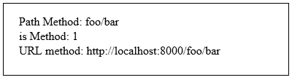

Retrieving Input
The input values can be easily retrieved in Laravel. No matter what method was used “get” or “post”, the Laravel method will retrieve input values for both the methods the same way. There are two ways we can retrieve the input values.
- Using the input() method
- Using the properties of Request instance

Using the input() method
The input() method takes one argument, the name of the field in form. For example, if the form contains username field then we can access it by the following way.
$name = $request->input('username');

Using the properties of Request instance
Like the input() method, we can get the username property directly from the request instance.
$request->username

Example
Observe the following example to understand more about Requests −
Step 1 − Create a Registration form, where user can register himself and store the form at resources/views/register.php
<html>

<head>
<title>Form Example</title>
</head>

<body>
<form action = "/user/register" method = "post">
<input type = "hidden" name = "_token" value = "<?php echo csrf_token() ?>">

<table>
<tr>
<td>Name</td>
<td><input type = "text" name = "name" /></td>
</tr>
<tr>
<td>Username</td>
<td><input type = "text" name = "username" /></td>
</tr>
<tr>
<td>Password</td>
<td><input type = "text" name = "password" /></td>
</tr>
<tr>
<td colspan = "2" align = "center">
<input type = "submit" value = "Register" />
</td>
</tr>
</table>

</form>
</body>
</html>
Step 2 − Execute the below command to create a UserRegistration controller.
php artisan make:controller UserRegistration --plain
Step 3 − After successful execution of the above step, you will receive the following output −
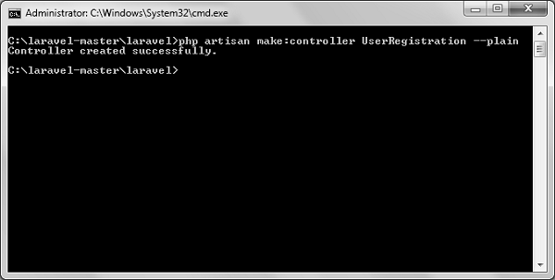
Step 4 − Copy the following code in
app/Http/Controllers/UserRegistration.php controller.
app/Http/Controllers/UserRegistration.php
<?php

namespace App\Http\Controllers;

use Illuminate\Http\Request;
use App\Http\Requests;
use App\Http\Controllers\Controller;

class UserRegistration extends Controller {
public function postRegister(Request $request) {
//Retrieve the name input field
$name = $request->input('name');
echo 'Name: '.$name;
echo '<br>';

//Retrieve the username input field
$username = $request->username;
echo 'Username: '.$username;
echo '<br>';

//Retrieve the password input field
$password = $request->password;
echo 'Password: '.$password;
}
}
Step 5 − Add the following line in app/Http/routes.php file.
app/Http/routes.php
Route::get('/register',function() {
return view('register');
});
Route::post('/user/register',array('uses'=>'UserRegistration@postRegister'));
Step 6 − Visit the following URL and you will see the registration form as shown in the below figure. Type the registration details and click Register and you will see on the second page that we have retrieved and displayed the user registration details.
http://localhost:8000/register
Step 7 − The output will look something like as shown in below the following images.
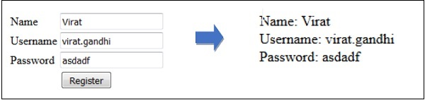

Laravel - Response
A web application responds to a user’s request in many ways depending on many parameters. This chapter explains you in detail about responses in Laravel web applications.

Basic Response
Laravel provides several different ways to return response. Response can be sent either from route or from controller. The basic response that can be sent is simple string as shown in the below sample code. This string will be automatically converted to appropriate HTTP response.

Example
Step 1 − Add the following code to app/Http/routes.php file.
app/Http/routes.php
Route::get('/basic_response', function () {
return 'Hello World';
});
Step 2 − Visit the following URL to test the basic response.
http://localhost:8000/basic_response
Step 3 − The output will appear as shown in the following image.
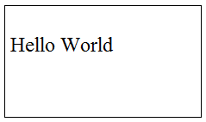

Attaching Headers
The response can be attached to headers using the header() method. We can also attach the series of headers as shown in the below sample code.
return response($content,$status)
->header('Content-Type', $type)
->header('X-Header-One', 'Header Value')
->header('X-Header-Two', 'Header Value');

Example
Observe the following example to understand more about Response −
Step 1 − Add the following code to app/Http/routes.php file.
app/Http/routes.php
Route::get('/header',function() {
return response("Hello", 200)->header('Content-Type', 'text/html');
});
Step 2 − Visit the following URL to test the basic response.
http://localhost:8000/header
Step 3 − The output will appear as shown in the following image.
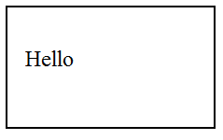

Attaching Cookies
The withcookie() helper method is used to attach cookies. The cookie generated with this method can be attached by calling withcookie() method with response instance. By default, all cookies generated by Laravel are encrypted and signed so that they can't be modified or read by the client.

Example
Observe the following example to understand more about attaching cookies −
Step 1 − Add the following code to app/Http/routes.php file.
app/Http/routes.php
Route::get('/cookie',function() {
return response("Hello", 200)->header('Content-Type', 'text/html')
->withcookie('name','Virat Gandhi');
});
Step 2 − Visit the following URL to test the basic response.
http://localhost:8000/cookie
Step 3 − The output will appear as shown in the following image.

JSON Response
JSON response can be sent using the json method. This method will automatically set the Content-Type header to application/json. The json method will automatically convert the array into appropriate json response.

Example
Observe the following example to understand more about JSON Response −
Step 1 − Add the following line in app/Http/routes.php file.
app/Http/routes.php
Route::get('json',function() {
return response()->json(['name' => 'Virat Gandhi', 'state' => 'Gujarat']);
});
Step 2 − Visit the following URL to test the json response.
http://localhost:8000/json
Step 3 − The output will appear as shown in the following image.
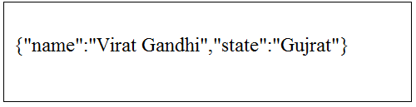

Laravel - Blade Templates
Laravel 5.1 introduces the concept of using Blade, a templating engine to design a unique layout. The layout thus designed can be used by other views, and includes a consistent design and structure.
When compared to other templating engines, Blade is unique in the following ways −
- It does not restrict the developer from using plain PHP code in views.
- The blade views thus designed, are compiled and cached until they are modified.
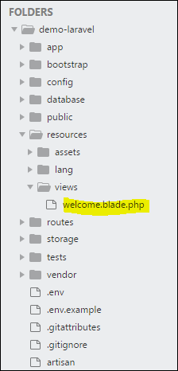
The complete directory structure of Laravel is shown in the screenshot given here.
You can observe that all views are stored in the resources/views directory and the default view for Laravel framework is welcome.blade.php.
Please note that other blade templates are also created similarly.

Steps for Creating a Blade Template Layout
You will have to use the following steps to create a blade template layout −

Step 1
- Create a layout folder inside the resources/views folder. We are going to use this folder to store all layouts together.
- Create a file name master.blade.php which will have the following code associated with it −
<html>
<head>
<title>DemoLaravel - @yield('title')</title>
</head>
<body>
@yield('content')
</body>
</html>

Step 2
In this step, you should extend the layout. Extending a layout involves defining the child elements. Laravel uses the Blade @extends directive for defining the child elements.
When you are extending a layout, please note the following points −
- Views defined in the Blade Layout injects the container in a unique way.
- Various sections of view are created as child elements.
- Child elements are stored in layouts folder as child.blade.php
An example that shows extending the layout created above is shown here −
@extends('layouts.app')
@section('title', 'Page Title')
@section('sidebar')
@parent
<p>This refers to the master sidebar.</p>
@endsection
@section('content')
<p>This is my body content.</p>
@endsection

Step 3
To implement the child elements in views, you should define the layout in the way it is needed.
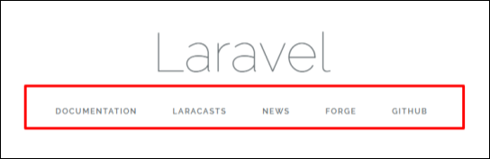
Observe the screenshot shown here. You can find that each of links mentioned in the landing page are hyperlinks. Please note that you can also create them as child elements with the help of blade templates by using the procedure given above.

