VB.NET NOTES

Introduction from Beginning

Install Visual Studio.net
How to install visual studio.net?

Explanation

Install Visual Studio.net 2008
Visual Studio can be installed from a CD or by downloading from Microsoft Website at http://www.microsoft.com/express/downloads/. The latest version is the Microsoft Visual Studio 2010 edition, the website has a trial version that can be downloaded from the same location by choosing the version as required.
The downloaded file would be a .exe file, when double clicked on it will open up an wizard. By choosing the location , the type of installation like custom or standard user can install only the required applications like Visual Basic.net 2008 from the available choices.
Following is the System Requirement to install Visual Studio.net 2008:
System Components | Recommended Configuration
Processor | 600 MHz - 1 GHz
RAM | 192 MB - 256 MB
Hardisk Space | 1 GB - 3.8 GB
Operating System | Windows 2000 Service Pack 4, Windows XP Service Pack 2,  Windows Server 2003 Service Pack 1 or Windows Vista or Higher
CD ROM or DVD Drive | Required
VGA | 800 X 600, 256 colors - 1024 X 768, High Color 16-bit

Create a Project in VB.NET
How to Create a Project in VB.NET?

Explanation

Create a Project in VB.NET
A Visual Basic Project is container for the forms, methods, classes, controls that are used for an Visual Basic Application.

Steps to Create a VB.net Project:
Click on the Programs->Microsoft Visual Studio.net 2008, to get the following window.
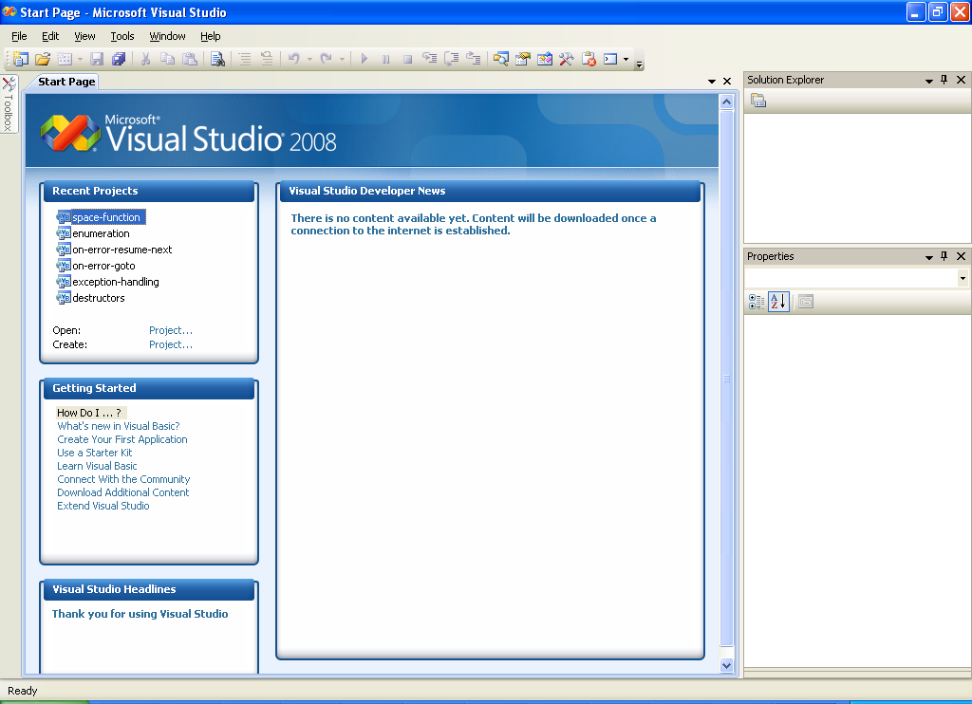
Choose File->New Project from the Menu Bar to get the New Project window.
Select the type of Project as per the requirement from following choices Windows Application,Class Library, Console Application,Windows Control Library, Web Control Library,Windows Service, Empty Project,Crystal Reports.
To develop a Windows Based Application Choose Windows Application fill in a Name for the application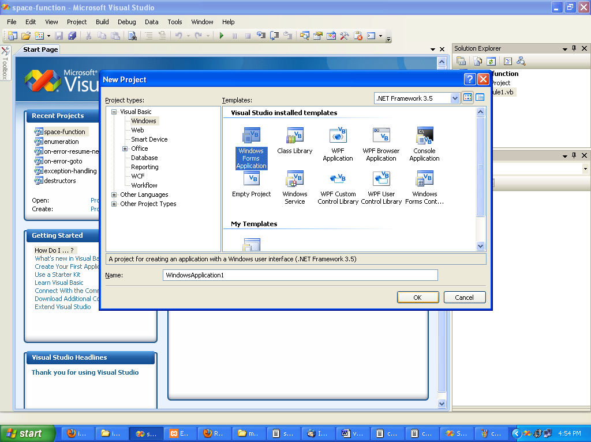
By default, a project named My Project and a form Form1 will be created. Project name and form name can be renamed later.
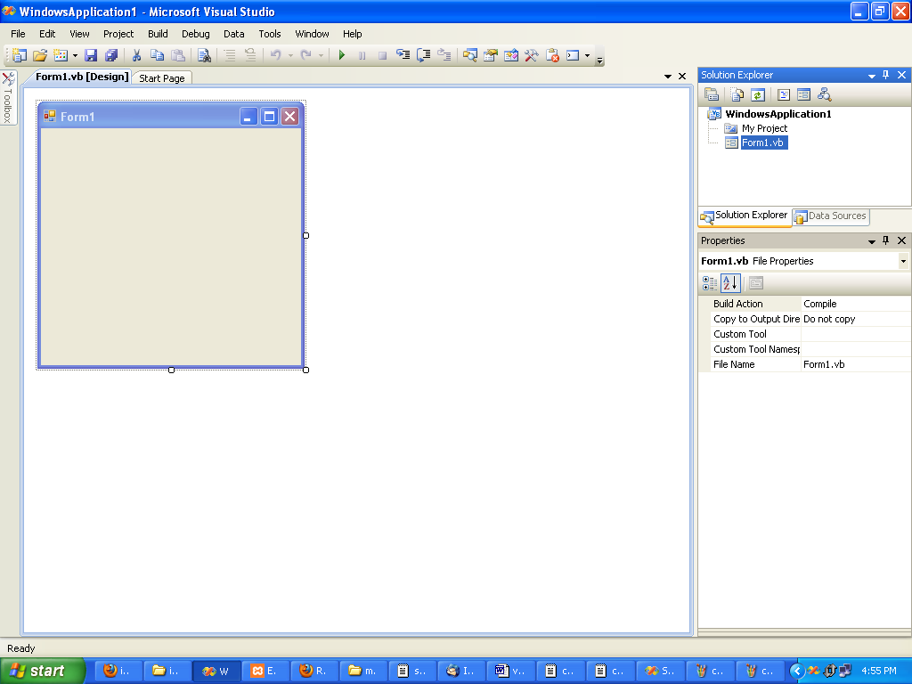

Saving Project in VB.Net
How to save a project in VB.Net 2008?

Explanation

Saving Project in VB.Net
There are many ways for saving a project created using VB.Net 2008. But the recommended option is to browse to File->Save All. This option saves all the files associated with a project.
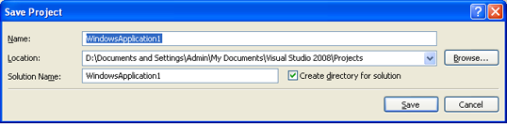
Provide a Name that will be populated as the Solution Name, also specify the location to save the project.

Run a Visual Basic .Net 2008 Project
How to Run a Visual Basic .Net 2008 Project?

Explanation

Run a Visual Basic .Net 2008 Project
Visual Studio.net 2008 unlike previous versions is a compiler based one. So all the programs are pre-compiled, only the user needs to simply debugg and run the application.
Run a Visual Basic .Net 2008 Project by pressing the F5 key or by choosing Debug -> Start Debugging from the Menu Bar.
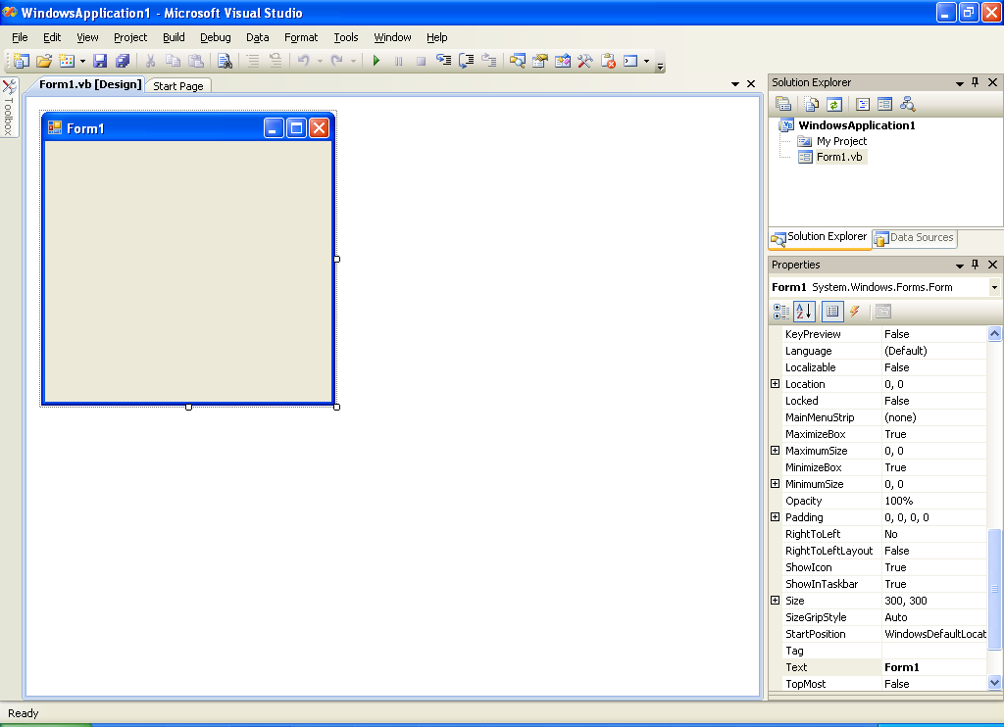

Open Existing Project in VB.NET
How to open existing project in VB.NET?

Explanation

Open Existing Project in VB.NET
In Visual Studio.net 2008 an existing project can be opened using the Recent Projects option in the Start Page.
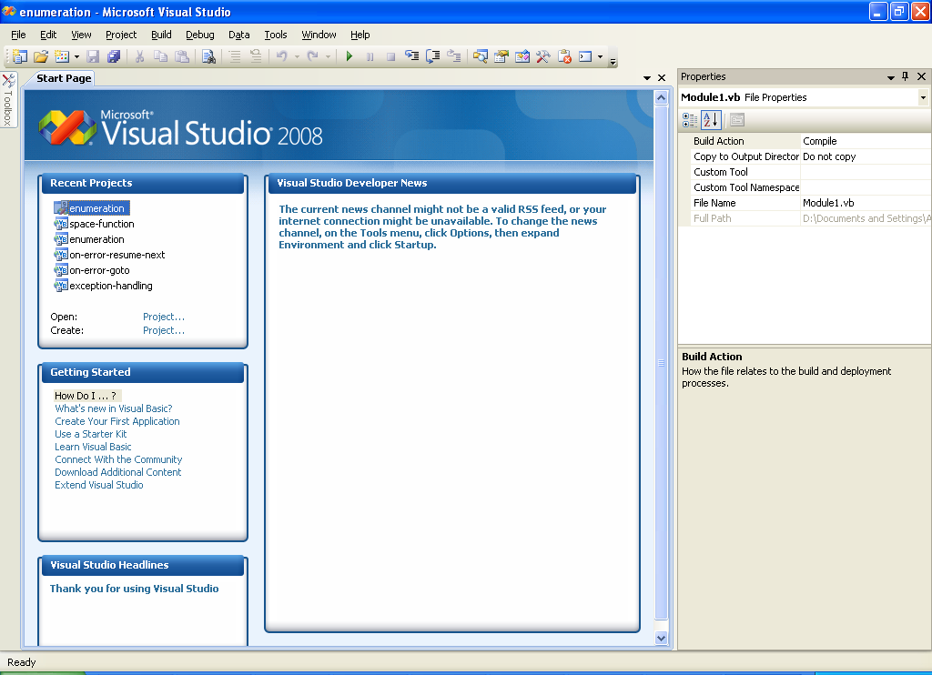
Visual Basic.net 2008 an existing project can also be opened using the File -> Open Project from the Menu Bar. Both these displays a window with project folder, once the project is selected and opened using the file with the extension .sln for windows application. The Solution Browser displays all the components of that project.
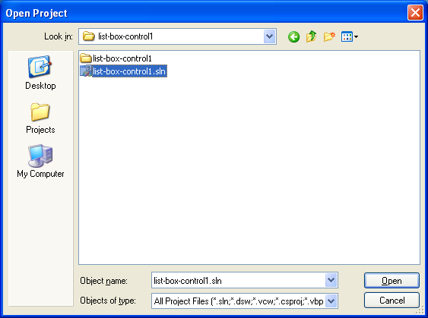
*********************************************************************************

Integrated Developement Environment (IDE) for VB.NET
How to know about IDE for VB.NET?

Explanation

Visual Basic.net 2008 IDE
Integrated Developement Environment (IDE) consist of inbuilt compiler, debugger, editors, automation tools for easy developement of code.Visual Basic.net 2008 IDE can by accessed by opening a new project.
Visual Basic.net 2008 IDE was first introduced with version 5.0 and Integrated Developement Environment of Visual Studio.net 2008 had undergone minor design changes. VB IDE consist of Solution Explorer, ToolBox, Form, Properties Window, Menu Bar. In Visual Studio windows related to a project are combined together and placed at certain locations on the screen. This type of IDE is know as Multiple Document Interface or MDI.
To make all the windows visible choose Window->Reset Window Layout to view all the windows.
Following is the screen shot of the IDE of Visual Studio.net 2008.
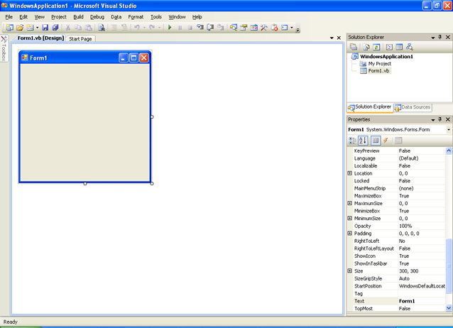

Menu Bar, Menus in VB.NET
List of menus in VB.NET?

Explanation

Menu Bar
Menu bar in Visual Basic.net 2008 consist of the commands that are used for constructing a software code. These commands are listed as menus and sub menus.
Menu bar also includes a simple Toolbar, that lists the commonly used commands as buttons. This Toolbar can be customized, so that the buttons can be added as required.
Following table lists the ToolBar Buttons and their actions.
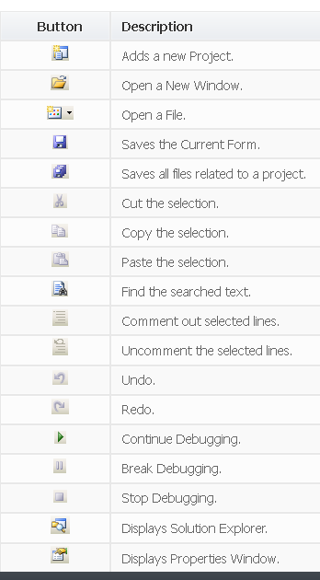

Toolbox in VB.NET
How to use the Toolbox in VB.NET?

Explanation

Tool Box
Toolbox in Visual Basic.net 2008 consist of Controls, Containers, Menu Options, Crystal Report Controls, Data Controls, Dialogs, Components, Printing controls, that are used in a form to design the interfaces of an application.
Following table lists the Common Controls listed in the ToolBox.
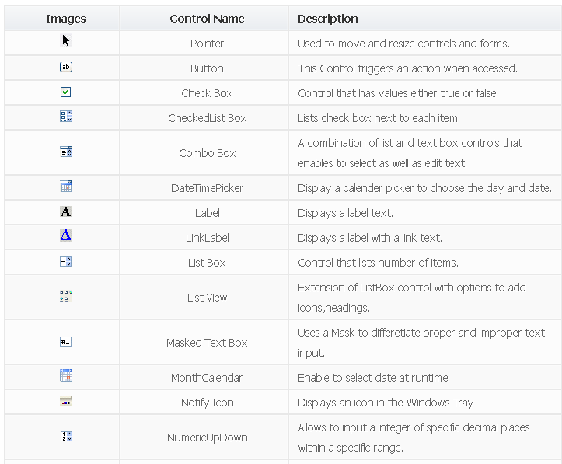
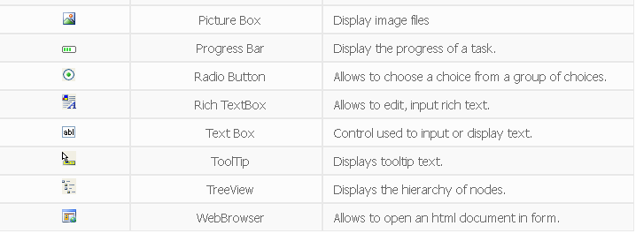

Solution Explorer in VB.NET
what is solution explorer in vb.net?

Explanation

Solution Explorer
Solution Explorer in Visual Basic.net 2008 lists of all the files associated with a project. It is docked on the right under the Toolbar in the VB IDE. In VB 6 this was known as 'Project Explorer'
Solution Explorer has options to view the code, form design, refresh listed files. Projects files are displayed in a drop down tree like structure, widely used in Windows based GUI applications.
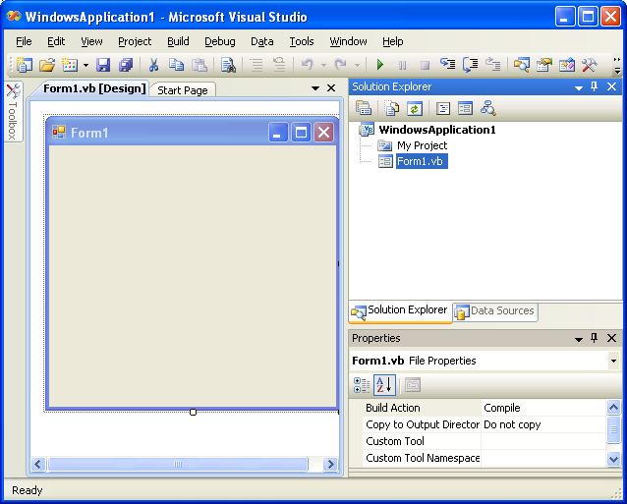

Windows Form Properties in VB.NET
What are windows form properties in VB.NET?

Explanation

Properties Window
Windows form properties in Visual Basic.net 2008 lists the properties of an selected object. Every object in VB has it own properties that can be used to change the look and even the functionality of the object.
Properties Window lists the properties of the forms and controls in an alphabetical order by default. User also has options to view the properties based on the category they belong to.
Following is the screen shot of Properties Window.
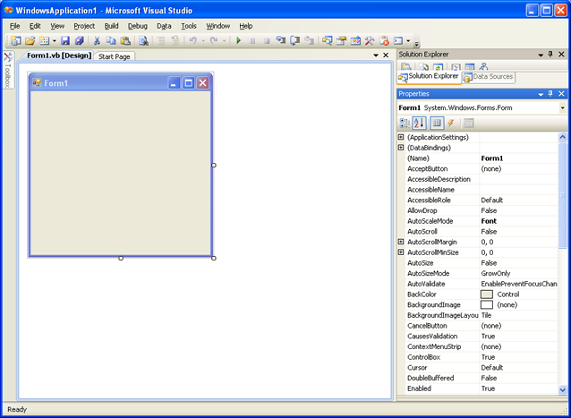

Forms In VB.NET
Forms In VB.NET ?

Explanation

Visual Basic Forms
Forms in Visual Basic.net 2008 are the basic object used to develop an application, it also contains the coding as well as the controls embedded in it.
Following is the screenshot of a Form in Visual Basic.net 2008.
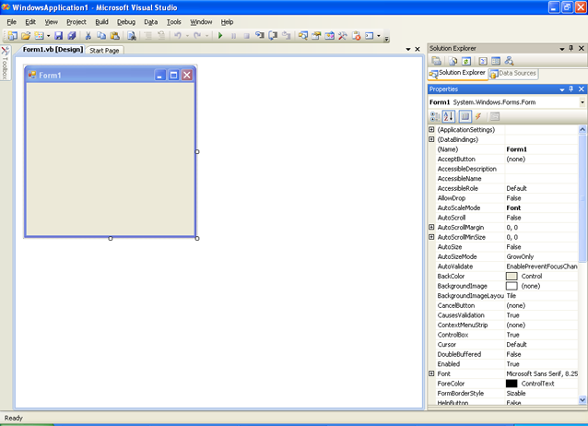
Forms is created by default when a Project is created with a default name Form1. Every form has its own Properties, Methods and Events. Usually the form properties name, caption are changed as required, since multiple forms will be used in a Project.

Form Properties In VB.NET
What are Form Properties?

Explanation

Form Properties
Forms in Visual Basic.net 2008 is so important to the user as it is the application for the user. So identifying and displaying forms is vital to the usability of an application. Even the developers need to alter the properties to manage the forms in VB.net.
Following table lists some important Properties of Forms in Visual Basic.net 2008.
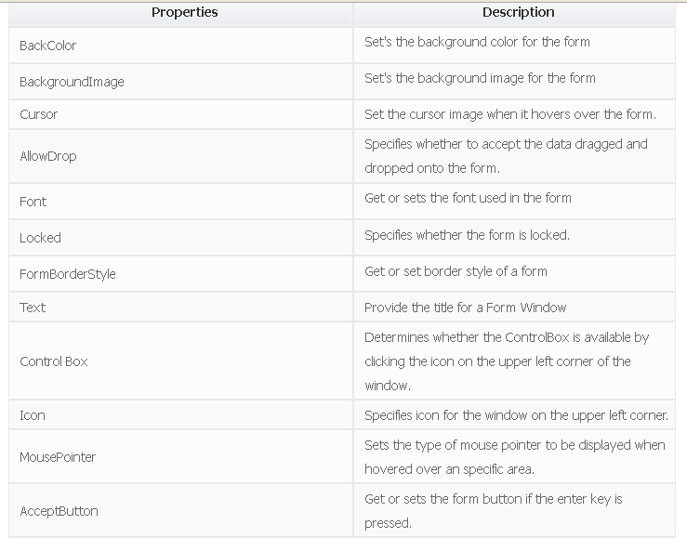
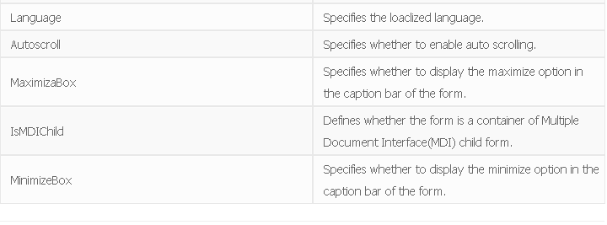

Show / Hide Form in VB.NET
How to show and hide form in VB.NET?

Explanation

Show / Hide Forms
Form in Visual Basic.net 2008 are displayed and hidden using two different methods.To display a form the Show() method is used and to hide a form Hide() method is used.

Show Method:
This method is used to display the form on top of all other windows even if it is loaded or not loaded into the memory.

Syntax:
FormName.Show
or
FormName.Show(1,)
In the above syntax, the Show method can also have argument values 0 or 1 for Modeless or Modal forms. By default this methods modeless or normal forms, but the modal forms more interactive.

Hide Method:
This method hides a form object from the screen, still with the object being loaded in the memory.

Syntax:
FormName.Hide

Example:
Public Class Form1
Private Sub Button1_Click(ByVal sender As System.Object,
ByVal e As System.EventArgs) Handles Button1.Click
DisplayForm.Show()
End Sub
Private Sub Button2_Click(ByVal sender As System.Object,
ByVal e As System.EventArgs) Handles Button2.Click
DisplayForm.Hide()
End Sub
End Class

Description:
In the above example, two forms Form1, Form2 are used. An image is added to Form2 using the the click event of Button1 and Button2 the form is shown or hidden. Thus you can show or hide the forms.

Load and Unload Forms in VB.NET
How to load and unload forms in VB.NET?

Explanation

Show Hide Forms
Forms in VB.net 2008 are loaded and unloaded using two different statements.To load a form the Load statement is used and to unload a form Unload statement is used.

Load Method:
This method is used to load a form into the memory, but will not display the form.

Syntax:
Load FormName

UnLoad Method:
This statement is used to unload a form from the memory.

Syntax:
UnLoad FormName

Data Types in VB.NET
How to use Data Types?

Explanation

Visual Basic.net 2008 Datatypes
Data Type in Visual Basic.net 2008 defines the type of data a programming element should be assigned, how it should be stored and the number of bytes occupied by it.
In VB.net 2008 all the variables by default are of Variant datatype was used for numeric, date, time and string data, but in VB.net 2008 Variant and Currency datatypes are no longer available. Following are the common data types used in Visual Basic.Net 2008.
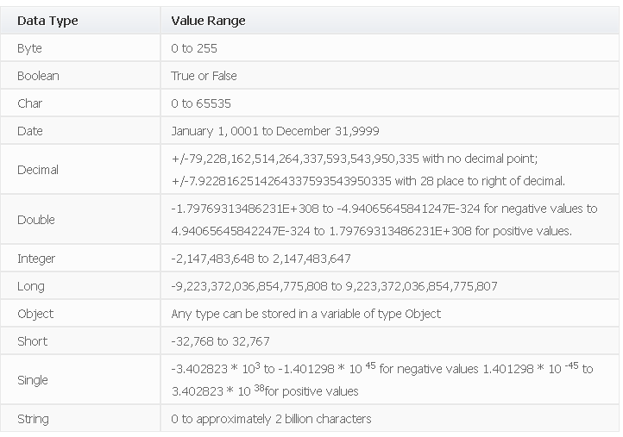

Constants in VB.NET
How to use Constants in VB.NET?

Explanation

Constants in VB.NET
Constants in VB.NET 2008 are declared using the keyword Const. Once declared, the value of these constants cannot be altered at run time.

Syntax:
[Private | Public | Friend | Protected Friend ]
Const constName As datatype = value
In the above syntax, the Public or Private can be used according to the scope of usage. The Value specifies the unchangable value for the constant specifed using the name constName.

Example:
Public Class Form1
Public Const PI As Double = 3.14159
Private Sub Button1_Click(ByVal sender As System.Object,
ByVal e As System.EventArgs) Handles Button1.Click
Dim r, a As Single
r = Val(TextBox1.Text)
a = PI * r * r
TextBox2.Text = a
End Sub
End Class

Description:
In the above example, a constant PI is declared as Public so that it can be used anywhere in the class.

Variables in VB.NET
How to declare variables in VB.NET?

Explanation

Visual Basic.net 2008 Variables
Variables in VB.net 2008 are used to store values and also they have a datatype and a unique name.

Naming Convention:
Variables in Visual Basic should start with an alphabet or a letter and should not contain any special characters like %,&,!,#,@ or $. The variable should not exceed 255 characters.

Scope of Variables:
A variable declared in the general declaration of a form can be used in all the procedures. Variables declared inside a procedure will have a scope only inside the procedure, so they are declared using the Dim keyword.

Example
Public Class Form1
Private Sub Button1_Click(ByVal sender As System.Object,
ByVal e As System.EventArgs) Handles Button1.Click
Dim c As Integer
c = Val(TextBox1.Text) + Val(TextBox2.Text)
TextBox3.Text = c
End Sub
End Class

Description:
In the above example, Dim statement is used to declare variables, c that can be used within the sub procedure.

User Defined Data Types in VB.NET
How to know about the User Defined Data Types in VB.NET?

Explanation

User Defined Data Types
User defined data type in VB.net 2008 is a collection of variables of different primitive datatypes available in Visual Basic.net 2008 combined under a single user defined data type. This gives the flexibility to inlcude real time objects into an application.
User defined data types are defined using a Structure Statement and are declared using the Dim Statement.

Structure Statement:
The Structure statement is declared in the general declaration part of form or a Module.

Syntax:
[ Public | Protected | Friend | Protected Friend | Private]
Structure varname elementname [([subscripts])] As type
[elementname [([subscripts])] As type]
. . .
End Structure
In the above syntax varname is the name of the user defined datatype, that follows the naming convention of a variable. Public option makes these datatypes available in all projects, modules, classes. If declared Private the user defined datatypes can be used where it is declared, same applies to Friend and Protected Friend. elementname is the name of the element of an user defined datatype. type is the primitive datatype available in visual basic.

Dim Statement:
This is used to declare and allocate a storage space for an variable or an user defined variable.

Syntax:
Dim variable [As Type]

Example:
Structure EmpDetails
Dim EmpNo As Integer
Dim EmpName As String
Dim EmpSalary As Integer
Dim EmpExp As Integer
End Structure
Public Class Form1
Private Sub Button1_Click
(ByVal sender As System.Object,
ByVal e As System.EventArgs)
Handles Button1.Click
Dim TotalSal As New EmpDetails()
TotalSal.EmpNo = TextBox1.Text
TotalSal.EmpName = TextBox2.Text
TotalSal.EmpSalary = TextBox3.Text
TotalSal.EmpExp = TextBox4.Text
TextBox5.Text = Val(TotalSal.EmpSalary) *
Val(TotalSal.EmpExp)
End Sub End Class

Description:
In the above example, Structure statement is used to define user defined datatypes, EmpDetails which is assigned to TotalSal.

If Then Statement in VB.NET
How to use If Then statement?

Explanation

If Then Statement
If Then statement is a control structure which executes a set of code only when the given condition is true.

Syntax:

If [Condition] Then
[Statements]
In the above syntax when the Condition is true then the Statements after Then are executed.

Example:
Private Sub Button1_Click_1(ByVal sender As System.Object,
ByVal e As System.EventArgs) Handles Button1.Click
If Val(TextBox1.Text) > 25 Then
TextBox2.Text = "Eligible"
End If

Description:
In the above If Then example the button click event is used to check if the age got using TextBox1 is greater than 25, if true a message is displayed in TextBox2

If Then Else Statement In VB.NET
How to use If Then Else Statement?

Explanation

If Then Else Statement
If Then Else statement is a control structure which executes different set of code statements when the given condition is true or false.

Syntax:

If [Condition] Then
[Statements] Else
[Statements]
In the above syntax when the Condition is true, the Statements after Then are executed.If the condition is false then the statements after the Else part is executed.

Example:
Private Sub Button1_Click(ByVal sender As System.Object,
ByVal e As System.EventArgs) Handles Button1.Click
If Val(TextBox1.Text) >= 40 Then
MsgBox("GRADUATED")
Else
MsgBox("NOT GRADUATED")
End If
End Sub

Description:
In the above If Then Else example the marks are entered in TextBox1.When a button is clicked a message GRADUATED is displayed if the condition (>40) is true and NOT GRADUATED if it is false.

Nested If Then Else Statement in VB.NET
How to use nested if then else statement in VB.NET?

Explanation

Nested If Then Else Statement
Nested If..Then..Else statement is used to check multiple conditions using if then else statements nested inside one another.

Syntax:
If [Condition] Then
If [Condition] Then
[Statements]
Else
[Statements] Else
[Statements]
In the above syntax when the Condition of the first if then else is true, the second if then else is executed to check another two conditions. If false the statements under the Else part of the first statement is executed.

Example:
Private Sub Button1_Click(ByVal sender As System.Object,
ByVal e As System.EventArgs) Handles Button1.Click
If Val(TextBox1.Text) >= 40 Then
If Val(TextBox1.Text) >= 60 Then
MsgBox("You have FIRST Class")
Else
MsgBox("You have SECOND Class")
End If
Else
MsgBox("Check your Average marks entered")
End If
End Sub

Description:
In the above nested if then else statement example first the average mark is checked if it is more than 40, if true the second if then else control is used check for first or second class. If the first condition is false the statements under the else part is executed.

Select Case Statement in VB.NET
How to Write a Select Case Statement in VB.net?

Explanation

Select Case Statement
Select case statement is used when the expected results for a condition can be known previously so that different set of operations can be done based on each condition.

Syntax:
Select Case Expression
Case Expression1
Statement1
Case Expression2
Statement2
Case Expressionn
Statementn
...
Case Else
Statement
End Select
In the above syntax, the value of the Expression is checked with Expression1..n to check if the condition is true. If none of the conditions are matched the statements under the Case Else is executed.

Example:
Private Sub Button1_Click(ByVal sender As System.Object,
ByVal e As System.EventArgs) Handles Button1.Click
Dim c As String
c = TextBox1.Text
Select c
Case "Red"
MsgBox("Color code of Red is::#FF0000")
Case "Green"
MsgBox("Color code of Green is::#808000")
Case "Blue"
MsgBox("Color code of Blue is:: #0000FF")
Case Else
MsgBox("Enter correct choice")
End Select
End Sub

Description:
In the above example based on the color input in TextBox1, the color code for RGB colors are displayed, if the color is different then the statement under Case Else is executed. Thus we can easily execute the select case statement.

Do While Loop In VB.NET
How to use Do While Loop?

Explanation

Do While Loop Statement
Do While Loop Statement is used to execute a set of statements only if the condition is satisfied. But the loop get executed once for a false condition once before exiting the loop. This is also know as Entry Controlled loop.

Syntax:
Do While [Condition]
[Statements]
Loop
In the above syntax the Statements are executed till the Condition remains true.

Example:
Private Sub Form1_Load(ByVal sender As System.Object,
ByVal e As System.EventArgs) Handles MyBase.Load
Dim a As Integer
a = 1
Do While a < 100
a = a * 2
MsgBox("Product is::" & a)
Loop
End Sub

Description:
In the above Do While Loop example the loop is continued after the value 64 to display 128 which is false according to the given condition and then the loop exits.

While Wend Statement in VB.NET
What is a while wend statement in VB.NET?

Explanation

While Wend Statement
While Wend Statement is a looping statement where a condition is checked first, if it is true a set of statements are executed. The condition can also become false atleast once while this statement is used.

Syntax:
While condition
[statements]
Wend
In the above syntax the Statements are executed when the Condition is true. The condition may also become false while the statements are executed.

Example:
Private Sub Form1_Load(ByVal sender As System.Object,
ByVal e As System.EventArgs) Handles MyBase.Load
Dim n As Integer
n = 1
While n <= 1
n = n + 1
MsgBox("First incremented value is:" & n)
End While
End Sub

Description:
In the above example, the value of n is 2 in the loop, which is false according to the condition but the loop is continued until the condition is checked. Thus the while wend statement can be used.

Do Loop While In VB.NET
How to use Do Loop While?

Explanation

Do Loop While Statement
Do Loop While Statement executes a set of statements and checks the condition, this is repeated until the condition is true. It is also known as an Exit Control loop

Syntax:
Do
[Statements]
Loop While [Condition]
In the above syntax the Statements are executed first then the Condition is checked to find if it is true.

Example:
Private Sub Form1_Load(ByVal sender As System.Object,
ByVal e As System.EventArgs) Handles MyBase.Load
Dim cnt As Integer
Do
cnt = 10
MsgBox("Value of cnt is::" & cnt)
Loop While cnt <= 9
End Sub

Description:
In the above Do Loop While example, a message is displayed with a value 10 only after which the condition is checked, since it is not satisfied the loop exits.

Do Until Loop In VB.NET
How to use Do Until Loop?

Explanation

Do Loop Until Statement
Do Loop Until Statement executes a set of statements until a condition becomes false, this is an infinite loop might have to terminated using Ctrl + Break .

Syntax:
Do
[Statements]
Loop Until [Condition]
In the above syntax the Statements are executed until the Condition becomes false.

Example:
Private Sub Form1_Load(ByVal sender As System.Object,
ByVal e As System.EventArgs) Handles MyBase.Load
Dim X As String
Do
X$ = InputBox$("Correct Password Please")
Loop Until X$ = "Ranger"
End Sub

Description:
In the above Do Until Loop example, a input box is displayed until the correct password is typed.

For Next Loop In VB.NET
How to use For Next Loop?

Explanation

For Next Loop Statement
For Next Loop Statement executes a set of statements repeatedly in a loop for the given initial, final value range with the specified step by step increment or decrement value.

Syntax:
For counter = start To end [Step]
[Statement]
Next [counter]
In the above syntax the Counter is range of values specified using the Start ,End parameters. The Step specifies step increment or decrement value of the counter for which the statements are executed.

Example:
Private Sub Form1_Load(ByVal sender As System.Object,
ByVal e As System.EventArgs) Handles MyBase.Load
Dim i As Integer
Dim j As Integer
j = 0
For i = 1 To 10 Step 1
j = j + 1
MsgBox("Value of j is::" & j)
Next i
End Sub

Description:
In the above For Next Loop example the counter value of i is set to be in the range of 1 to 10 and is incremented by 1. The value of j is increased by 1 for 10 times as the loop is repeated

Operator Precedence in VB.NET
What is operator precedence in VB.NET?

Explanation

Visual Basic.net 2008 Tutorial:
Operator Precedence is the order in which the operators in the expression are evaluated. The Arithmetic operators have the highest precedence followed by concatenation, comparison, logical, bitwise operator. All the comparison operators in Visual Basic.net 2008 have equal precedence so that they are evaluated from left to right.
Operators | Description
^ | Exponentiation
+,- | Unary identity and negation
*, / | Multiplication and floating-point division
 | Integer division
Mod | Modulus arithmetic
+,-, + | Addition, Subtraction, String concatenation
& | String concatenation
<<,>> | Arithmetic bit shift
=, <>, <, <=, >, >=, Is, IsNot, Like, TypeOf...Is | All Comparison, Logical, Bitwise Operators.
Not | Negation
And,AndAlso | Conjuction
Or,OrElse | Inclusive disjunction
Xor | Exclusive disjunction

Arithmetic Operators in Visual Basic VB.NET
What are all the Arithmetic Operators in Visual Basic VB.NET?

Explanation

Arithmetic Operators in Visual Basic VB.NET
Operators used for basic arithmetic operations like addition, subtraction, multiplication, division, are known as Arithmetic Operators.
Following table lists the Arithmetic Operators used in Visual Basic.
Operator | Description
^ | Exponentiation Operator
* | Multiplication Operator
/ | Division Operator
 | Integer division Operator
Mod | Modulus Operator
+ | Unary and Binary Addition Operator
- | Unary and Binary Negation Operator

Example:
Public Class Form1
Private Sub Button1_Click(ByVal sender As System.Object,
ByVal e As System.EventArgs) Handles Button1.Click
TextBox3.Text = Val(TextBox1.Text) + Val(TextBox2.Text)
End Sub
Private Sub Button2_Click(ByVal sender As System.Object,
ByVal e As System.EventArgs) Handles Button2.Click
TextBox4.Text = Val(TextBox1.Text) - Val(TextBox2.Text)
End Sub
Private Sub Button3_Click(ByVal sender As System.Object,
ByVal e As System.EventArgs) Handles Button3.Click
TextBox5.Text = Val(TextBox1.Text) * Val(TextBox2.Text)
End Sub
Private Sub Button4_Click(ByVal sender As System.Object,
ByVal e As System.EventArgs) Handles Button4.Click
TextBox6.Text = Val(TextBox1.Text) / Val(TextBox2.Text)
End Sub
Private Sub Button5_Click(ByVal sender As System.Object,
ByVal e As System.EventArgs) Handles Button5.Click
TextBox7.Text = Val(TextBox1.Text) Val(TextBox2.Text)
End Sub
Private Sub Button6_Click(ByVal sender As System.Object,
ByVal e As System.EventArgs) Handles Button6.Click
TextBox8.Text = Val(TextBox1.Text) Mod Val(TextBox2.Text)
End Sub End Class

Description:
In the above example, we use two text boxes TextBox1 and TextBox2 to get the operands for performing arithmetic operations by clicking on appropriate operator buttons.

Concatenation Operators in VB.NET
How to join or concatenate strings in VB.Net?

Explanation

Concatenation Operators in VB.NET
Concatenation Operators in VB.NET are used to join or concatenate two strings. The + and & are the basic concatenation operators.
Both these operands can be used to concatenate strings, but the + operator is preferred while concatenating numbers.
Following table lists the Concatenation Operators used in Visual Basic.
Operator | Description
+ | Exponentiation Operator
& | Multiplication Operator

Example:
Public Class Form1
Private Sub Button1_Click(ByVal sender As System.Object,
ByVal e As System.EventArgs) Handles Button1.Click
Dim a As String
Dim b As String
Dim c As String
a = TextBox1.Text
b = TextBox2.Text
c = a + b
MsgBox("String Concatenated using + is::>" & c)
End Sub
Private Sub Button2_Click(ByVal sender As System.Object,
ByVal e As System.EventArgs) Handles Button2.Click
Dim x As String
Dim y As String
Dim z As String
x = TextBox1.Text
y = TextBox2.Text
z = x & y
MsgBox("String Concatenated using + is::>" & z)
End Sub
End Class

Description:
In the above example, TextBox1 and TextBox2 are used to get input strings. Using the click event of Button1 and Button2 the strings are concatenated using both plus and ampersand concatenation operators.

Comparison Operators in VB.NET
List of Comparison Operators in VB.NET

Explanation

Comparison Operators in VB.NET
Comparison Operators are used to compare two expressions to return a result which will be a Boolean value.
Following table lists the Comparison Operators used in Visual Basic.
Operator | Description
< | Less than
<= | Less than or equal to
> | Greater than
>= | Greater than or equal to
= | Equal to
<> | Not equals

Example:
Public Class Form1
Private Sub Button1_Click(ByVal sender As System.Object,
ByVal e As System.EventArgs) Handles Button1.Click
Dim a, b As Integer
a = Val(TextBox1.Text)
b = Val(TextBox2.Text)
If a > b Then
MsgBox("A is greater than B")
ElseIf a < b Then
MsgBox("A is Less than B")
ElseIf a = b Then
MsgBox("A is equal to B")
Else
MsgBox("Enter Valid Numbers")
End If
End Sub
End Class

Description:
In the above example, the values got using the TextBox1 and TextBox2 are compared using the logical comparison operators >,<,= using a if..elseif loop.

Logical Operators in VB.NET
How to use the logical operators in VB.NET?

Explanation

Logical Operators
Logical Operators are used to compare Boolean expressions to return the result as a Boolean value.
Following table lists the Logical Operators used in Visual Basic.net 2008.
Operator | Description
And | Both Conditions must be true
or | Either one condition is true
Xor | One condition can be true, but not both
Not | None should be true

Example:
Public Class Form1
Private Sub Button1_Click(ByVal sender As System.Object,
ByVal e As System.EventArgs) Handles Button1.Click
If ((Val(TextBox1.Text) > 10) And (Val(TextBox1.Text) < 20))
Then
MsgBox("Date is in the Middle of the Month")
ElseIf ((Val(TextBox1.Text) < 1) Or (Val(TextBox1.Text) > 31))
Then
MsgBox("Enter a Valid Date")
Else
MsgBox("Date entered is either is in Start or End of Month")
End If
End Sub
End Class

Explanation:
In the above example we have used And operator to check the value entered in the TextBox1 is from middle of the month. Or operator is used to find the invalid entry.

Bit Shift Operator in VB.NET
How to bitwise shift in VB.NET?

Explanation

Bit Shift Operator in VB.NET
Bit Shift Operators are used to do arithmetic shifting of bits either to the right or to the left.
Following table lists the BitShift Operators used in Visual Basic.
Operator | Description
<< | Left shift operator
>> | Right shift operator

Example:
Public Class Form1
Private Sub Button1_Click(ByVal sender As System.Object,
ByVal e As System.EventArgs) Handles Button1.Click
Dim a As Integer
Dim b As Integer
Dim c As Integer
a = Val(TextBox1.Text)
b = Val(TextBox2.Text)
c = a >> b
MsgBox("Integer Value after RIGHT SHIFT is::>" & c,
MsgBoxStyle.OkCancel)
End Sub
Private Sub Button2_Click(ByVal sender As System.Object,
ByVal e As System.EventArgs) Handles Button2.Click
Dim x As Integer
Dim y As Integer
Dim z As Integer
x = Val(TextBox1.Text)
y = Val(TextBox2.Text)
z = x << y
MsgBox("Integer Value after LEFT SHIFT is::>" & z,
MsgBoxStyle.OkCancel)
End Sub End Class

Description:
In the above example, TextBox1 is used to get integer to shift bits and TextBox2 is used to get the number of places to shift. Using the click event of two operator buttons Button1 and Button2 the bits are shifted either to left or to right. The integer value returned after shifting bits are displayed in a Message Box.

Controls in VB.NET
How to know about the controls in VB.NET?

Explanation

Visual Basic.net 2008 Controls
Controls in Visual Basic.net 2008 are objects that can be inserted into a form, simply by dragging the objects. Each control has unique properties, events, methods to use these controls effectively using code. Visual basic controls can be classified as Standard Controls, Built-in ActiveX Controls.
Standard Controls:
- DateTimePicker
- TextBox Control
- Label Control
- CheckedListBox Control
- LinkLabel Control
- ListBox Control
- ListView Control
- MaskedTextBox Control
- CheckBox Control
- MonthCalendar Control
- NotifyIcon Control
- Button Control
- PictureBox Control
- ProgressBar Control
- RadioButton Control
- RichTextBox Control
- ToolTip Control
- TreeView Control
- ImageList Control
- Timer Control
- ScrollBars Controls

Console Applications in VB.NET 2008
- What are Console Applications in VB.NET?
- Explanation
- Console Applications in VB.NET 2008
- Console Applications in VB.NET 2008 is used to reduce the space occupied by Windows Application usually developed in Vb.net. Using the Console Application, a user is prompted to input data and display the output in a DOS prompt.
Console applications can be created by opting New Projects->Console Application
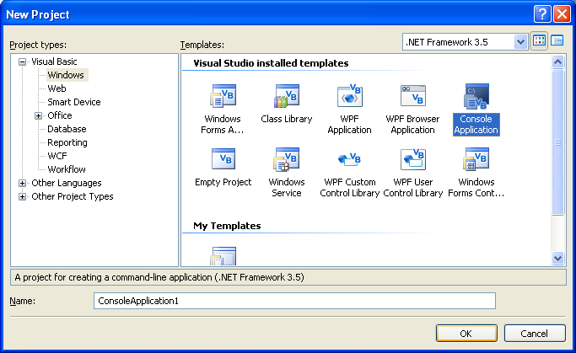
All the Console Applications by default have a module Module1 and the code is included inside Sub Main() - End Sub. Just like VB.net applications the code is executed using Debug->Start Debugging option. But the result is displayed in a Console Window or a DOS Window instead of a form.

Example:
Module Module1
Sub Main()
System.Console.WriteLine("HELLO WORLD")
System.Console.ReadLine()
End Sub
End Module

Result:
HELLO WORLD
In the above example the text "HELLO WORLD" is displayed in the Console Window.

Namespace:
In the above example, System.Console is a namespace, which is a collection of classes and datastructures that can be used for a specific purpose.

Module:
A Module contains a group of functions. Modules are used to create common functions, that can be called from anywhere if declared as 'Public'.

Create Classes in VB.NET
Learn how to create a class in VB.Net?

Explanation

Classes in VB.NET 2008
Classes in VB.net is type used to create data or objects that are instances of a class. Objects and classes are so closely associated with each other, so that classes can be used only if it contains objects.
The Scope of usage of classes and the objects are based on the access types used when they are declared as Public, Private, Friend and Protected.

Example:
Module Module1
Public Class Add
Dim i, j As Integer
Public Sub Display()
System.Console.WriteLine("Enter First Integer:")
i = Console.ReadLine()
System.Console.WriteLine("Enter Second Integer:")
j = Console.ReadLine()
Console.WriteLine("Result of Addition is:" & (i + j))
End Sub
End Class
Sub Main()
Dim add1 As New Add
add1.Display()
Console.Read()
End Sub
End Module

Result:
Enter First Integer:
2
Enter Second Integer:
3
Result of Addition is:
5

Description:
In the above example, class Add is declared as 'Public', so that the method display is derived and used by creating an instance add1 inside sub main().

Objects in VB.NET
What are Objects in VB.NET?

Explanation

Objects
Objects in VB.net are instances of a class. Advantage of objects is that it can be used flexibly by referring the class name without the need to write code.
Every object that has its own Properties, Methods and Events. Properties of the object define the characteristics, the Methods define the procedure that can operate on a Object. The events are possible actions that can occur to an object

Example:
Module Module1
Sub Main()
Dim obj As New Subtr
obj.min()
End Sub
Public Class Subtr
Dim a As Integer = 100
Dim b As Integer = 10
Sub min()
Console.WriteLine("Subtraction of 100-10::" & a - b)
Console.ReadLine()
End Sub
End Class
End Module

Result:
Subtraction of 100-10::90

Description:
In the above example,obj is an instance of the class Subtr.Using this object the function min is used without writing any code.

nheritance in VB.NET
How to use Inheritance in VB.NET?

Explanation

Inheritance in VB.net 2008
Inheritance in VB.net is method by which the properties of the base classes are added to the derived classes. In Vb.net the keyword Inherits is used in the derived class to specify its base class.
The MustInherit keyword is used to speciy that class can be used only as a base class,NotInheritable is used to specify that a class cannot be inherited.

Example:
Module Module1
Public Class s1
Public a As Integer = 5
Public Function val() As Integer
Return a
End Function
End Class
Public Class s2
Inherits s1
Public c As Integer = 20
Public Function add() As Integer
Return c + a
End Function
End Class
Sub Main()
Dim res As New s2
System.Console.WriteLine("Final Value is::")
System.Console.WriteLine(res.add())
Console.Read()
End Sub
End Module

Result:
Final Value is: 25

Description:
In the above example the value of a is inherited to from base class s1 to the derived class s2. Using the instance res of class s2 the values of 'a' as well as 'c' is added to give the result.

Overloading in VB.NET
What is overloading in VB.NET?

Explanation

Over loading VB.NET
Overloading in visual basic.net is the method by which a property or a method takes different forms at different instances. It can also be termed as "Polymorphism".

Example:
Module Module1
Public Class mul
Public a, b As Integer
Public c, d As Double
Public Function mul(ByVal a As Integer) As Integer
Return a
End Function
Public Function mul(ByVal a As Integer,
ByVal b As Integer) As Integer
Return a * b
End Function
Public Function mul(ByVal d As Double,
ByVal c As Double) As Double
Return d * c
End Function
End Class
Sub Main()
Dim res As New mul
System.Console.WriteLine
("Overloaded Values of Class Mul is::")
System.Console.WriteLine(res.mul(10))
System.Console.WriteLine(res.mul(20, 10))
System.Console.WriteLine(res.mul(12.12, 13.23))
Console.Read()
End Sub End Module

Result:
Overloaded values of Class Mul is:
10
200
160.3476

Description:
In the above overloading example the same function mul is called to perform different operations based on the arguments as well as on the datatype.

Overriding in VB.NET
What is overriding in VB.NET?

Explanation

Over riding in VB.NET
Overriding in VB.net is method by which a inherited property or a method is overidden to perform a different functionality in a derived class. The base class function is declared using a keyword Overridable and the derived class function where the functionality is changed contains an keyword Overrides.

Example:
Module Module1
Class Over
Public Overridable Function add(ByVal x As Integer,
ByVal y As Integer)
Console.WriteLine('Function Inside Base Class')
Return (x + y)
End Function
End Class
Class DerOver
Inherits Over
Public Overrides Function add(ByVal x As Integer,
ByVal y As Integer)
Console.WriteLine(MyBase.add(120, 100))
Console.WriteLine('Function Inside Derived Class')
Return (x + y)
End Function
End Class
Sub Main()
Dim obj As New DerOver
Console.WriteLine(obj.add(10, 100))
Console.Read()
End Sub
End Module

Result:
Function Inside Base Class
220
Function Inside Derived Class
110

Description:
In the above overriding example the base class function add is overridden in the derived class using the MyBase.add(120,100) statement. So first the overidden value is displayed, then the value from the derived class is displayed.

Abstract Class in VB.NET
What is an Abstract Class in VB.NET?

Explanation

Abstract Class in vb.net 2008
Abstract Classes in VB.net are classes that cannot be instantiated, but can implement any number of members. The Abstract Classes are declared using the keyword MustInherit. Overideable members should be declared inside the abstract class using the keyword MustOverride that are instantiated in the derived class by overriding them.

Example:
Module Module1
Public MustInherit Class student
Public id As Integer
Public Function Add() As Integer
Dim i, j As Integer
i = 100
j = 200
Console.WriteLine("Result:" & (i + j))
End Function
Public MustOverride Sub Disp()
End Class
Class Shed
Inherits student
Public Overrides Sub Disp()
Console.WriteLine("Instantiating the abstract member
function disp() in the derived class.")
End Sub
End Class
Sub Main()
Dim obj As New Shed
obj.Add()
obj.Disp()
Console.Read()
End Sub End Module

Result:
Result:300
Instantiating the abstract member function disp()
in the derived class

Description:
In the above example, the Absract class 'student' acts as a base class and the abstract member of the class 'Disp()' is overidden inside the derived class Shed.

Interfaces in VB.NET
How to use Interfaces in VB.NET?

Explanation

Interfaces in vb.net 2008.
Interfaces in VB.net are used to define the class members using a keyword Interface, without actually specifying how it should be implemented in a Class. Intefaces are examples for multiple Inheritance and are implemented in the classes using the keyword Implements that is used before any Dim statement in a class.

Example:
Module Module1
Public Interface Interface1
Function Add(ByVal x As Integer) As Integer
End Interface
Public Class first
Implements Interface1
Public Function Add(ByVal x As Integer)
As Integer Implements Interface1.Add
Console.WriteLine("Implementing x+x
in first class::" & (x + x))
End Function
End Class
Public Class second
Implements Interface1
Public Function Add(ByVal x As Integer)
As Integer Implements Interface1.Add
Console.WriteLine("Implementing x+x+x
in second class::" & (x + x + x))
End Function
End Class
Sub Main()
Dim obj1 As New first
Dim obj2 As New second
obj1.Add(10)
obj2.Add(50)
Console.Read()
End Sub
End Module

Result:
Implementing x+x in first class:: 20
Implementing x+x+x in second class:: 150

Description:
In the above example interface Interface1 is implemented in classes first and second but differently to add the value of 'x' twice and thrice respectively.

Delegates In VB.NET
How to use Delegates?

Explanation

Delegates in vb.net 2008.
Delegates are pointers that are used to store and tranfer information like the memory address, event handled by functions and subroutines. Delagates are type safe, since they check for the signatures of functions and subroutines only if same, they transfer information. A delegate is declared using the keyword Delegate to a function or procedure name.

Example:
Module Module1
Public Delegate Function del1(ByVal x As Integer,
ByVal y As Integer) As Integer
Public Delegate Sub Display()
Public Function check(ByVal x As Integer,
ByVal y As Integer) As Integer
Return (x + y)
End Function
Public Function multi(ByVal x As Integer,
ByVal y As Integer) As Integer
Return (x * y)
End Function
Class deleg
Public Sub Disp()
Console.WriteLine("Method inside the Class")
End Sub
End Class
Sub Main()
Dim a As New del1(AddressOf check)
Dim b As New del1(AddressOf multi)
Dim ob As New deleg
Dim c As New Display(AddressOf ob.Disp)
Console.WriteLine(a(10, 20))
Console.WriteLine(b(10, 20))
c()
Console.Read()
End Sub
End Module

Result:
30
200
Method Inside Class

Description:
In the above Delegate example del1 is a delegate that gets two integer arguments and return an integer. Using this delegate with the keyword AddressOf the values stored in the memory location of the procedures check and multi are retreived.
Using the delegate Display the sub procedure Disp() inside the class deleg is also displayed.

Constructors and Destructors in VB.NET
Introduction to Constructors and Destructors in VB.NET

Explanation

Constructors and Destructors in VB.NET
Constructors used in a class are member functions to initialize or set the objects of a class in VB.net. They dont return any value and are defined in a Sub with a keyword New.
Multiple constructors can be created in class with any access specifiers, by default constructors are of Public access type.

Example:
Module Module1
Public Class Sample
Private a As Integer
Public Sub New(ByVal setval As Integer)
a = setval
End Sub
Public Function disp()
Return a
End Function
End Class
Sub Main()
Dim d As New Sample(5)
Console.WriteLine("Value of a is initialized to:")
Console.WriteLine(d.disp())
Console.Read()
End Sub
End Module

Result:
Value of a is initialized to:
5

Description:
In the above example, using the Constructor declared within the sub procedure New the value of a is set to 5.

Destructors:
Destructors or finalizer is a method used to deallocate the resources of an object that are no longer used, its invoked automatically by the VB.net environment. The keyword Overrides is used with the Finalizer method.

Example:
Protected Overrides Sub Finalize()
Console.WriteLine("Calling Destructor")
Ens Sub

Declaring Arrays In VB.NET
How to use Declaring Arrays?

Explanation

Declaring Arrays in VB.net 2008
Arrays is a construct used to store multiple values of same data type that can be accessed using an index value. Arrays in VB.net 2008 are different since it contains exactly the same number of elements that are declared unlike in VB6 which will have one element more.
Arrays in VB.net are declared using the Dim statement, but by using the access specifiers Public, Private, Static, Protected the scope of usage of arrays can be controlled within the code.
Following are the basic types of arrays used in VB.net
- Single Dimension Array
- Multi Dimension Array
- Jagged Array
- Dynamic Arrays

One dimensional Array in VB.NET
How to use the One dimensional array in VB.NET?

Explanation

One Dimensional Array
One dimensional array stores all the elements of an array in a single row starting with index 0 until the end of the array.

Example:
Module Module1
Sub Main()
Dim ary(4) As Integer
Dim j As Integer
Dim i As Integer
ary = New Integer() {1, 2, 2, 3}
For i = 0 To ary.GetUpperBound(0)
j = ary(i) + j
Next
System.Console.Write("The Sum of Array is::")
System.Console.WriteLine(j)
Console.ReadLine()
End Sub
End Module

Result:
The Sum of Array is:8

Description:
In the above example, one dimensional array of type Integer ary is declared with four elements. Using a loop with the starting value of '0' to upperbound value of the array got using the GetBound(0), the sum of array is calculated.

Multidimensional Array in VB.NET
How to use multidimensional array in VB.NET?

Explanation

Multi Dimensional Array
Multidimensional array is an array in which each element acts as an array that are represented as row and columns.

Example:
Module Module1
Sub Main()
Dim arr(3, 2) As String
Dim i As Integer
Dim j As Integer
arr(1, 1) = "COSCO"
arr(1, 2) = "Football"
arr(2, 1) = "NIKE"
arr(2, 2) = "Boots"
arr(3, 1) = "ADDIDAS"
arr(3, 2) = "Spikes"
For i = 1 To 3
For j = 1 To 2
System.Console.WriteLine(arr(i, j))
Next
Next
Console.ReadLine()
End Sub
End Module

Result:
COSCO
Football
NIKE
Boots
ADDIDAS
Spikes

Description:
In the above example using a multi dimensional array of string datatype, all the elements are retreived using a loop and displayed in the console. This array can be also said to be a Rectangular Array since it contains the same number of rows and columns.

Jagged Array in VB.NET
How to use Jagged Array in VB.NET?

Explanation

Jagged Array
Jagged Array is also an Multi Dimensional array with different number of rows and column elements. This type of array can be used to reduce the space occupied by an array, since all rows don't have equal number of columns.

Example:
Module Module1
Sub Main()
Dim one() As Integer = {1, 2, 3}
Dim two() As Integer = {3, 4, 5, 6, 7}
Dim jag()() As Integer = {one, two}
Dim i, j As Integer
For i = 0 To jag.Length - 1
For j = 0 To jag(i).Length - 1
Console.Write((jag(i)(j)))
Next
Console.WriteLine()
Next
Console.ReadLine()
End Sub
End Module

Result:
123
34567

Description:
In the above example jag is a jagged array that has different number of rows and columns elemenst referenced using two other arrays one and two.

Dynamic Array In VB.NET
What is Dynamic Array?

Explanation

Dynamic Array
Dynamic arrays are array that are declared using a Dim statement with blank parenthesis initially and are dynamically allocated dimensions using the Redim statement.

Example:
Module Module1
Sub Main()
Dim a() As Integer = {2, 2}
Dim i, j As Integer
Console.WriteLine("Array before Redim")
For i = 0 To a.GetUpperBound(0)
Console.WriteLine(a(i))
Next
ReDim Preserve a(5)
Console.WriteLine("Array after Redim")
For j = 0 To a.GetUpperBound(0)
Console.WriteLine(a(j))
Next
Console.ReadLine()
End Sub
End Module

Result:
Array before Redim
2
2
Array after Redim
2
2
0
0
0
0

Description:
In the above Dynamic Array example, the array a initially declared with 2 elements, then using the ReDim statement a dimension of 5 is assigned. The Preserve keyword is used to preserve the existing elements intact.

Database Connection In VB.NET
How to connect Database in VB.NET?

Explanation

Connecting Databases in VB.net 2008.
In ADO.net the databases are connected first, then a copy of the database is stored in the memory immediatley the connection to the database is disconnected. Database is connected only if any changes made to the copy of the database need to be updated to the datatbase itself.
ADO.net classes are contained in the 'System.Date' namespace. Following are some of the important classes used in ADO.net.
- Connection
- Command
- DataAdapter
- DataReader
- DataSet

Connection:
This class is used to provide connection to the database. SqlConnection class is used for MS-SQL server database. OleDBConnection is used for databases like Oracle and MS-Access.

Command:
This class is used to provide the command to be executed on an database. The sql commands include select, update, insert and delete queries.Three major method used by this classes are ExecuteNonQuery execute commands that dont return values,ExecuteScalar executes commands that returns a single value,ExecuteReader executes commands that returns a result set.

DataAdapter:
This class acts as bridge between the databases and the copy of the database in the memory.Fill method is used to populate the datatset or datatable with data from the database.Update method is used to update the database after the dataset is manipulated.

DataReader
This class acts as a read only or forward only action to fetch data from a database.ExecuteReader method is used to returns the object of this class.

DataSet
This class stores the copy of the database retreived from the original.
Following example, is used to display the records from an access database and enables to Insert, Update, Delete records. Also has buttons to traverse the database between Next, Previous, First and Last record.

Example:
Imports System.Data.OleDb
Imports System.Console
Public Class Form1
Inherits System.Windows.Forms.Form
Dim cn As OleDbConnection
Dim cmd As OleDbCommand
Dim dr As OleDbDataReader
Dim icount As Integer
Dim str As String
Public head As New System.Data.DataTable
Public No As Integer = 0
Public headadaptor As New OleDbDataAdapter
Public headcommand As New OleDbCommandBuilder
Private Sub Insert1_Click(ByVal sender As System.Object,
ByVal e As System.EventArgs) Handles Insert1.Click
cn = New OleDbConnection("Provider=Microsoft.Jet.OLEDB.4.0;
Data Source=C:student.mdb;")
cn.Open()
str = "insert into student values(" & CInt(TextBox1.Text) & ",
'" & TextBox2.Text & "','" & _TextBox3.Text & "'," &
TextBox4.Text & ")"
cmd = New OleDbCommand(str, cn)
cmd.ExecuteNonQuery()
MessageBox.Show("Data Inserted!...")
cn.Close()
initial()
showRecords()
End Sub
Private Sub Update2_Click(ByVal sender As System.Object,
ByVal e As System.EventArgs) Handles Update2.Click
cn = New OleDbConnection("Provider=Microsoft.Jet.OLEDB.4.0;
Data Source=C:student.mdb;")
cn.Open()
str = "update student set name='" & TextBox2.Text & "',
sex='" & TextBox3.Text & "',age=" & _TextBox4.Text &"
where id=" & TextBox1.Text
cmd = New OleDbCommand(str, cn)
cmd.ExecuteNonQuery()
MessageBox.Show("Data Updated!...")
initial()
showRecords()
cn.Close()
End Sub
Private Sub Delete3_Click(ByVal sender As System.Object,
ByVal e As System.EventArgs) Handles Delete3.Click
cn = New OleDbConnection("Provider=Microsoft.Jet.OLEDB.4.0;
Data Source=C:student.mdb;")
cn.Open()
initial()
str = "delete from student where id=" & TextBox1.Text
cmd = New OleDbCommand(str, cn)
cmd.ExecuteNonQuery()
MessageBox.Show("Data Deleted!...")
head = New DataTable
headadaptor.Fill(head)
No = No - 1
showRecords()
initial()
cn.Close()
End Sub
Private Sub First4_Click(ByVal sender As System.Object,
ByVal e As System.EventArgs) Handles Button4.Click
No = 0
display()
End Sub
Sub display()
If (No <= head.Rows.Count - 1) Then
TextBox1.Text = head.Rows(No)("ID").ToString
TextBox2.Text = head.Rows(No)("Name").ToString
TextBox3.Text = head.Rows(No)("Sex").ToString
TextBox4.Text = head.Rows(No)("Age").ToString
End If
End Sub
Sub showRecords()
cn = New OleDbConnection("Provider=Microsoft.Jet.OLEDB.4.0;
Data Source=C:student.mdb;")
cn.Open()
cmd = New OleDbCommand("select * from student", cn)
dr = cmd.ExecuteReader
While dr.Read()
TextBox1.Text = dr(0)
TextBox2.Text = dr(1)
TextBox3.Text = dr(2)
TextBox4.Text = dr(3)
End While
dr.Close()
cn.Close()
End Sub
Private Sub Form1_Load(ByVal sender As System.Object,
ByVal e As System.EventArgs) Handles MyBase.Load
cn = New OleDbConnection("Provider=Microsoft.Jet.OLEDB.4.0;
Data Source=C:student.mdb;")
cn.Open()
initial()
End Sub
Sub initial()
headadaptor = New OleDbDataAdapter("select * from student",
cn)
headcommand = New OleDbCommandBuilder(headadaptor)
headadaptor.Fill(head)
display()
End Sub
Private Sub Next6_Click(ByVal sender As System.Object,
ByVal e As System.EventArgs) Handles Next6.Click
If (No = head.Rows.Count - 1) Then
MsgBox("this is last")
Else
No = No + 1
display()
End If
End Sub
Private Sub Last8_Click(ByVal sender As System.Object,
ByVal e As System.EventArgs) Handles Last8.Click
No = head.Rows.Count - 1
display()
End Sub
Private Sub Previous7_Click(ByVal sender As System.Object,
ByVal e As System.EventArgs) Handles Previous7.Click
If (No = 0) Then
MsgBox("this is first")
Else
No = No - 1
display()
End If
End Sub
Private Sub Clear9_Click(ByVal sender As System.Object,
ByVal e As System.EventArgs) Handles Clear9.Click
TextBox1.Text = ""
TextBox2.Text = ""
TextBox3.Text = ""
TextBox4.Text = ""
End Sub
End Class
In the above Database Connection example the access database named 'student.mdb' is used with the 'ID' as the primary key. So the 'OleDbConnection','OleDbCommand' classes are used. A function named 'initial()' is used to populate the datatset using the 'Fill' method. And a display() method is used to display records.

Enumeration In VB.NET
What is Enumeration?

Explanation

Enumeration in vb.net 2008.
Enumeration in is a collection of related set of constants that are declared using the keyword Enum Statement. All the members are of "enum" datatype and will have an numeric value that start with '0' for first element.

Syntax:
Enum enumeration name [ As data type ]
member list
End Enum
In the above syntax the enumeration name provides a unique name for the enumeration, data type can be specified if required, member list lists the members of the enumeration.

Example:
Module Module1
Enum Fruits
Orange = 1
Apple = 2
Guava = 3
End Enum
Sub Main()
Console.WriteLine("First Fruit is::"
& Fruits.Orange.ToString())
Console.WriteLine("Second Fruit is::"
& Fruits.Apple.ToString())
Console.WriteLine("Third Fruit is::"
& Fruits.Guava.ToString())
Console.ReadLine()
End Sub
End Module

Result:
First Fruit is:: Orange
Second Fruit is:: Apple
Third Fruit is:: Guava

Description:
In the above example, three enumeration members are listed under the enumeration name Fruits that have a numeric value starting from '1'.

Create a File in VB.NET
How to Create a File in VB.NET?

Explanation

Create a File in VB.NET 2008.
To Create a File in VB.NET, the FileStream Class is used. The members of this class FileAccess, FileMode, FileShare enumerations along with constructors are used to open or create or share a file. Then using the classes StreamReader, StreamWriter are used to modify the file data

Example:
Imports System.IO
Module Module1
Sub Main()
Dim w As StreamWriter
w = File.CreateText("C:sample.txt")
w.Flush()
w.Close()
End Sub
End Module

Description:
In the above example, a file sample.txt is created using the File.CreateText method and the StreamWriter class.

Open a File in vb.net 2008
How to open a file in VB.NET?

Explanation

Opening a File in Vb.net 2008.
To open a file, the File.OpenText method of the FileStream class is used along with the StreamReader class. Files are opened by default in synchronous mode, by using contructors files can also be opened asynchronously.

Example:
Imports System.IO
Module Module1
Sub Main()
Dim r As StreamReader
r = File.OpenText("c:sample1.txt")
Console.WriteLine(r.ReadToEnd)
Console.Read()
r.Close()
End Sub
End Module

Result:
Welcome to.Net Programming
This is an example to open a File
In the above example, the File.OpenText method and the StreamReader class is used to open a text file 'sample1.txt'.

Write File in VB.NET
How to write a file in VB.NET?

Explanation

Write a File in Vb.net 2008.
To write a file, the StreamWriter class and File.CreateText method is used to create a file first. Then the WriteLine method is used to write text.

Example:
Imports System.IO
Module Module1
Sub Main()
Dim w As StreamWriter
Dim r As StreamReader
w = File.CreateText("C:write.txt")
w.WriteLine("Welcome to.Net Programming")
w.WriteLine("This is an example to write to a File")
w.Flush()
w.Close()
r = File.OpenText("c:write.txt")
Console.WriteLine(r.ReadToEnd)
Console.Read()
r.Close()
End Sub
End Module

Result:
Welcome to.Net Programming
This is an example to write to a File
In the above example, the file 'write.txt' is created using the File.CreateText method. The same file is read with the File.OpenText method.

Appending Text to a File in VB.NET
How to append text to a file in VB.NET?

Explanation

Appending Text to a File in VB.NET 2008
The functions StreamWriter Class and File.AppendText method is used to append text to an existing file.

Example:
Imports System.IO
Module Module1
Sub Main()
Dim w As StreamWriter
Dim r As StreamReader
w = File.AppendText("C:write.txt")
w.WriteLine("Appended Text")
w.Flush()
w.Close()
r = File.OpenText("c:write.txt")
Console.WriteLine(r.ReadToEnd)
Console.Read()
r.Close()
End Sub
End Module

Result:
Welcome to.Net Programming
This is an example to create, write to a File
Appended text
In the above example, the file 'write.txt' is appended with the text 'Appended Text' using the File.AppendText method. Appending text to your file is quite easy.

Exception Handling In VB.NET
What is Exception Handling?

Explanation

Exception Handling in vb.net 2008.
Exceptions Handling are errors that are triggered at runtime, that are handled in VB.net using structured error handling with the Try..Catch..Finally statement. The On erro goto, On Error Resume Next statement is used for unstructured error handling.
The exceptions can be handled in the Try..Catch..finally using the Built-in exception handling methods.

Example1:
Module Module1
Sub Main()
Dim a(3) As Integer
Try
a(5) = 45
Catch ex As IndexOutOfRangeException
Console.WriteLine(ex.Message)
Catch ex As Exception
Console.WriteLine(ex.Message)
Finally
Console.WriteLine("End of Execution")
End Try
Console.Read()
End Sub
End Module

Result:
Index was outside the bounds of the array
End of Execution

Description:
In the above example, the dimension of the array declared is '3' and the array given array under the Try statement is '5'. The exception is caught by the catch statement using the specific exception option IndexOutOfRangeException and even the Exception option display messages for all exceptions.

On Error Goto Statement:

Example2:
Module Module1
Sub Main()
Dim i, j As Integer
For i = 0 To 10 Step 1
On Error GoTo ErrorHandler
j = 100 / i
Console.WriteLine("Value of j is::")
Console.WriteLine(j)
Next
ErrorHandler:
Console.WriteLine("Division by zero error")
Console.Read()
End Sub
End Module

Result:
Division by zero error

On Error Goto Statement:
In the above example the ustructured error handling statement On Error Goto is used along with the ErrorHandler to display the error message that diverts the flow of the program itself.

Example3:
Module Module1
Public Class student
Public Function Add(ByVal i As Integer,
ByVal j As Integer) As Integer
Console.WriteLine("Result:"(i / j))
End Function
End Class
Sub Main()
On Error Resume Next
Dim obj As New student
obj.Add(10, 0)
Console.WriteLine("Check the Arguments")
Console.Read()
End Sub
End Module

Result:
Check the Arguments
In the above the example when the exception occurs the flow of the program is continued from the next line.

