INTRODUCTION TO VB.NET
Visual Basic .NET (VB.NET) is an object-oriented computer programming language implemented on the .NET Framework. Although it is an evolution of classic Visual Basic language, it is not backwards-compatible with VB6, and any code written in the old version does not compile under VB.NET.
Like all other .NET languages, VB.NET has complete support for object-oriented concepts. Everything in VB.NET is an object, including all of the primitive types (Short, Integer, Long, String, Boolean, etc.) and user-defined types, events, and even assemblies. All objects inherits from the base class Object.
VB.NET is implemented by Microsoft's .NET framework. Therefore, it has full access to all the libraries in the .Net Framework. It's also possible to run VB.NET programs on Mono, the open-source alternative to .NET, not only under Windows, but even Linux or Mac OSX.
The following reasons make VB.Net a widely used professional language:
Modern, general purpose.
Object oriented.
Component oriented.
Easy to learn.
Structured language.
It produces efficient programs.
It can be compiled on a variety of computer platforms.
Part of .Net Framework.
Strong Programming Features VB.Net
VB.Net has numerous strong programming features that make it endearing to multitude of programmers worldwide. Let us mention some of these features:
Boolean Conditions
Automatic Garbage Collection
Standard Library
Assembly Versioning
Properties and Events
Delegates and Events Management
Easy-to-use Generics
Indexers
Conditional Compilation
Simple Multithreading

VB.Net - Environment
The .Net Framework
The .Net framework is a revolutionary platform that helps you to write the following types of applications:
Windows applications
Web applications
Web services
The .Net framework applications are multi-platform applications. The framework has been designed in such a way that it can be used from any of the following languages: Visual Basic, C#, C++, Jscript, and COBOL, etc.
All these languages can access the framework as well as communicate with each other.
The .Net framework consists of an enormous library of codes used by the client languages like VB.Net. These languages use object-oriented methodology.
Following are some of the components of the .Net framework:
Common Language Runtime (CLR)
The .Net Framework Class Library
Common Language Specification
Common Type System
Metadata and Assemblies
Windows Forms
ASP.Net and ASP.Net AJAX
ADO.Net
Windows Workflow Foundation (WF)
Windows Presentation Foundation
Windows Communication Foundation (WCF)
LINQ
For the jobs each of these components perform, please see ASP.Net - Introduction, and for details of each component, please consult Microsoft's documentation.
Integrated Development Environment (IDE) For VB.Net
Microsoft provides the following development tools for VB.Net programming:
Visual Studio 2010 (VS)
Visual Basic 2010 Express (VBE)
Visual Web Developer
VB.Net - Program Structure
VB.Net Hello World Example
A VB.Net program basically consists of the following parts:
Namespace declaration
A class or module
One or more procedures
Variables
The Main procedure
Statements & Expressions
Comments
Let us look at a simple code that would print the words "Hello World":
Imports System
Module Module1
'This program will display Hello World
Sub Main()
Console.WriteLine("Hello World")
Console.ReadKey()
End Sub
End Module

VB.Net - Basic Syntax
VB.Net is an object-oriented programming language. In Object-Oriented Programming methodology, a program consists of various objects that interact with each other by means of actions. The actions that an object may take are called methods. Objects of the same kind are said to have the same type or, more often, are said to be in the same class.
When we consider a VB.Net program, it can be defined as a collection of objects that communicate via invoking each other's methods. Let us now briefly look into what do class, object, methods and instant variables mean.
Object - Objects have states and behaviors. Example: A dog has states - color, name, breed as well as behaviors - wagging, barking, eating, etc. An object is an instance of a class.
Class - A class can be defined as a template/blueprint that describes the behaviors/states that object of its type support.
Methods - A method is basically a behavior. A class can contain many methods. It is in methods where the logics are written, data is manipulated and all the actions are executed.
Instant Variables - Each object has its unique set of instant variables. An object's state is created by the values assigned to these instant variables.
VB.Net - Data Types
Data types refer to an extensive system used for declaring variables or functions of different types. The type of a variable determines how much space it occupies in storage and how the bit pattern stored is interpreted
Data Types Available in VB.Net
VB.Net provides a wide range of data types. The following table shows all the data types available:
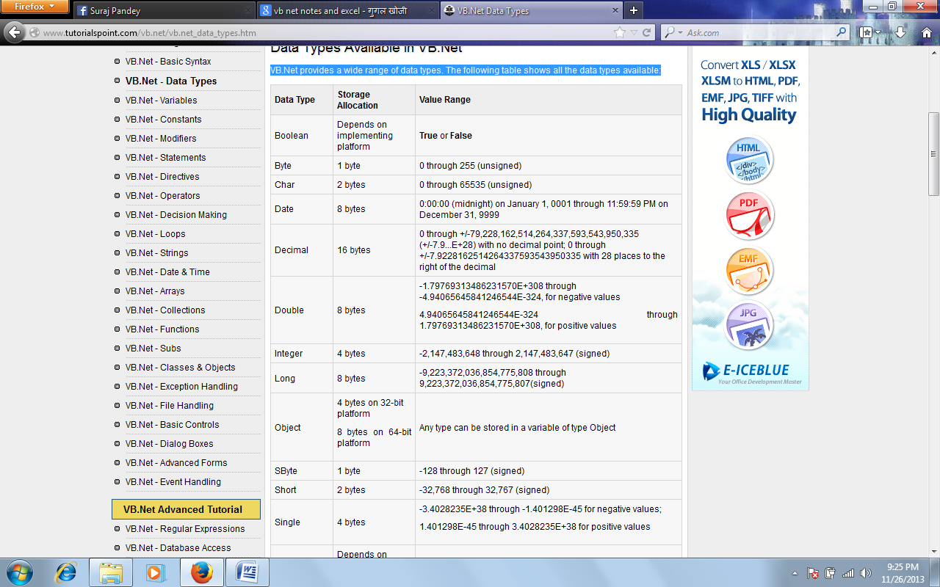
Example
The following example demonstrates use of some of the types:
Module DataTypes
Sub Main()
Dim b As Byte
Dim n As Integer
Dim si As Single
Dim d As Double
Dim da As Date
Dim c As Char
Dim s As String
Dim bl As Boolean
b = 1
n = 1234567
si = 0.12345678901234566
d = 0.12345678901234566
da = Today
c = "U"c
s = "Me"
If ScriptEngine = "VB" Then
bl = True
Else
bl = False
End If
If bl Then
'the oath taking
Console.Write(c & " and," & s & vbCrLf)
Console.WriteLine("declaring on the day of: {0}", da)
Console.WriteLine("We will learn VB.Net seriously")
Console.WriteLine("Lets see what happens to the floating point variables:")
Console.WriteLine("The Single: {0}, The Double: {1}", si, d)
End If
Console.ReadKey()
End Sub

End Module
When the above code is compiled and executed, it produces the following result:
U and, Me
declaring on the day of: 12/4/2012 12:00:00 PM
We will learn VB.Net seriously
Lets see what happens to the floating point variables:
The Single:0.1234568, The Double: 0.123456789012346
The Type Conversion Functions in VB.Net
VB.Net provides the following in-line type conversion functions:
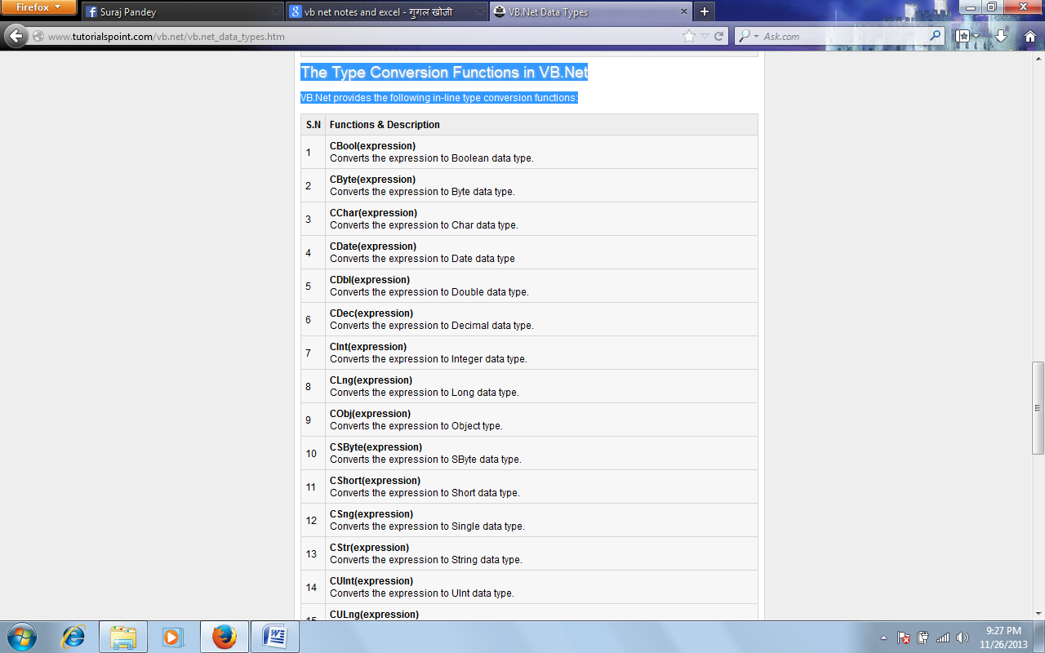
Example:
The following example demonstrates some of these functions:
Module DataTypes
Sub Main()
Dim n As Integer
Dim da As Date
Dim bl As Boolean = True
n = 1234567
da = Today
Console.WriteLine(bl)
Console.WriteLine(CSByte(bl))
Console.WriteLine(CStr(bl))
Console.WriteLine(CStr(da))
Console.WriteLine(CChar(CChar(CStr(n))))
Console.WriteLine(CChar(CStr(da)))
Console.ReadKey()
End Sub
End Module
When the above code is compiled and executed, it produces the following result:
True
-1
True
12/4/2012
1
1

VB.Net – Variables
A variable is nothing but a name given to a storage area that our programs can manipulate. Each variable in VB.Net has a specific type, which determines the size and layout of the variable's memory; the range of values that can be stored within that memory; and the set of operations that can be applied to the variable.
The basic value types provided in VB.Net can be categorized as:
Type | Example
Integral types | SByte, Byte, Short, UShort, Integer, UInteger, Long, ULong and Char
Floating point types | Single and Double
Decimal types | Decimal
Boolean types | True or False values, as assigned
Date types | Date

VB.Net also allows defining other value types of variable like Enum and reference types of variables like Class. We will discuss date types and Classes in subsequent chapters.
Variable Declaration in VB.Net
The Dim statement is used for variable declaration and storage allocation for one or more variables. The Dim statement is used at module, class, structure, procedure or block level.
Syntax for variable declaration in VB.Net is:
[ < attributelist> ] [ accessmodifier ] [[ Shared ] [ Shadows ] | [ Static ]]
[ ReadOnly ] Dim [ WithEvents ] variablelist

Example
Try the following example which makes use of various types of variables:
Module variablesNdataypes
Sub Main()
Dim a As Short
Dim b As Integer
Dim c As Double
a = 10
b = 20
c = a + b
Console.WriteLine("a = {0}, b = {1}, c = {2}", a, b, c)
Console.ReadLine()
End Sub
End Module
When the above code is compiled and executed, it produces the following result:
a = 10, b = 20, c = 30

Accepting Values from User
The Console class in the System namespace provides a function ReadLine for accepting input from the user and store it into a variable. For example,
Dim message As String
message = Console.ReadLine
The following example demonstrates it:
Module variablesNdataypes
Sub Main()
Dim message As String
Console.Write("Enter message: ")
message = Console.ReadLine
Console.WriteLine()
Console.WriteLine("Your Message: {0}", message)
Console.ReadLine()
End Sub
End Module

VB.Net - Constants and Enumerations
The constants refer to fixed values that the program may not alter during its execution. These fixed values are also called literals.
Constants can be of any of the basic data types like an integer constant, a floating constant, a character constant, or a string literal. There are also enumeration constants as well.
The constants are treated just like regular variables except that their values cannot be modified after their definition.
An enumeration is a set of named integer constants.
Declaring Constants
In VB.Net, constants are declared using the Const statement. The Const statement is used at module, class, structure, procedure, or block level for use in place of literal values.
The syntax for the Const statement is:
[ < attributelist> ] [ accessmodifier ] [ Shadows ]
Const constantlist
constantname [ As datatype ] = initializer
constantname: specifies the name of the constant
datatype: specifies the data type of the constant
initializer: specifies the value assigned to the constant
For example,
' The following statements declare constants.
Const maxval As Long = 4999
Public Const message As String = "HELLO"
Private Const piValue As Double = 3.1415
Example
The following example demonstrates declaration and use of a constant value:
Module constantsNenum
Sub Main()
Const PI = 3.14149
Dim radius, area As Single
radius = 7
area = PI * radius * radius
Console.WriteLine("Area = " & Str(area))
Console.ReadKey()
End Sub
End Module
When the above code is compiled and executed, it produces the following result:
Area = 153.933

Declaring Enumerations
An enumerated type is declared using the Enum statement. The Enum statement declares an enumeration and defines the values of its members. The Enum statement can be used at the module, class, structure, procedure, or block level.
The syntax for the Enum statement is as follows:
[ < attributelist> ] [ accessmodifier ] [ Shadows ]
Enum enumerationname [ As datatype ]
memberlist
End Enum

Each member in the memberlist has the following syntax and parts:
[< attribute list>] member name [ = initializer ]
Where,
name: specifies the name of the member. Required.
initializer: value assigned to the enumeration member. Optional.
For example,
Enum Colors
red = 1
orange = 2
yellow = 3
green = 4
azure = 5
blue = 6
violet = 7
End Enum
Example
The following example demonstrates declaration and use of the Enum variable Colors:
Module constantsNenum
Enum Colors
red = 1
orange = 2
yellow = 3
green = 4
azure = 5
blue = 6
violet = 7
End Enum
Sub Main()
Console.WriteLine("The Color Red is : " & Colors.red)
Console.WriteLine("The Color Yellow is : " & Colors.yellow)
Console.WriteLine("The Color Blue is : " & Colors.blue)
Console.WriteLine("The Color Green is : " & Colors.green)
Console.ReadKey()
End Sub
End Module
When the above code is compiled and executed, it produces the following result:
The Color Red is: 1
The Color Yellow is: 3
The Color Blue is: 6
The Color Green is: 4

VB.Net - Statements
A statement is a complete instruction in Visual Basic programs. It may contain keywords, operators, variables, literal values, constants and expressions.
Statements could be categorized as:
Declaration statements - these are the statements where you name a variable, constant, or procedure, and can also specify a data type.
Executable statements - these are the statements, which initiate actions. These statements can call a method or function, loop or branch through blocks of code or assign values or expression to a variable or constant. In the last case, it is called an Assignment statement.
Declaration Statements
The declaration statements are used to name and define procedures, variables, properties, arrays, and constants. When you declare a programming element, you can also define its data type, access level, and scope.
The programming elements you may declare include variables, constants, enumerations, classes, structures, modules, interfaces, procedures, procedure parameters, function returns, external procedure references, operators, properties, events, and delegates.
Following are the declaration statements in VB.Net:
S.N | Statements and Description | Example
1 | Dim Statement  Declares and allocates storage space for one or more variables. | Dim number As Integer  Dim quantity As Integer = 100  Dim message As String = "Hello!"
2 | Const Statement  Declares and defines one or more constants. | Const maximum As Long = 1000  Const naturalLogBase As Object  = CDec(2.7182818284)
3 | Enum Statement  Declares an enumeration and defines the values of its members. | Enum CoffeeMugSize  Jumbo  ExtraLarge  Large  Medium  Small  End Enum
4 | Class Statement  Declares the name of a class and introduces the definition of the variables, properties, events, and procedures that the class comprises. | Class Box  Public length As Double  Public breadth As Double  Public height As Double  End Class
5 | Structure Statement  Declares the name of a structure and introduces the definition of the variables, properties, events, and procedures that the structure comprises. | Structure Box  Public length As Double  Public breadth As Double  Public height As Double  End Structure
6 | Module Statement  Declares the name of a module and introduces the definition of the variables, properties, events, and procedures that the module comprises. | Public Module myModule  Sub Main()  Dim user As String =  InputBox("What is your name?")  MsgBox("User name is" & user)  End Sub  End Module
7 | Interface Statement  Declares the name of an interface and introduces the definitions of the members that the interface comprises. | Public Interface MyInterface  Sub doSomething()  End Interface
8 | Function Statement  Declares the name, parameters, and code that define a Function procedure. | Function myFunction  (ByVal n As Integer) As Double  Return 5.87 * n  End Function
9 | Sub Statement  Declares the name, parameters, and code that define a Sub procedure. | Sub mySub(ByVal s As String)  Return  End Sub
10 | Declare Statement  Declares a reference to a procedure implemented in an external file. | Declare Function getUserName  Lib "advapi32.dll"  Alias "GetUserNameA"  (  ByVal lpBuffer As String,  ByRef nSize As Integer) As Integer
11 | Operator Statement  Declares the operator symbol, operands, and code that define an operator procedure on a class or structure. | Public Shared Operator +  (ByVal x As obj, ByVal y As obj) As obj  Dim r As New obj  ' implemention code for r = x + y  Return r  End Operator
12 | Property Statement  Declares the name of a property, and the property procedures used to store and retrieve the value of the property. | ReadOnly Property quote() As String  Get  Return quoteString  End Get  End Property
13 | Event Statement  Declares a user-defined event. | Public Event Finished()
14 | Delegate Statement  Used to declare a delegate. | Delegate Function MathOperator(  ByVal x As Double,  ByVal y As Double  ) As Double
Executable Statements
An executable statement performs an action. Statements calling a procedure, branching to another place in the code, looping through several statements, or evaluating an expression are executable statements. An assignment statement is a special case of an executable statement.
Example
The following example demonstrates a decision making statement:
Module decisions
Sub Main()
'local variable definition '
Dim a As Integer = 10

' check the boolean condition using if statement '
If (a < 20) Then
' if condition is true then print the following '
Console.WriteLine("a is less than 20")
End If
Console.WriteLine("value of a is : {0}", a)
Console.ReadLine()
End Sub
End Module
When the above code is compiled and executed, it produces the following result:
a is less than 20;
value of a is : 10

VB.Net - Operators
An operator is a symbol that tells the compiler to perform specific mathematical or logical manipulations. VB.Net is rich in built-in operators and provides following types of commonly used operators:
Arithmetic Operators
Comparison Operators
Logical/Bitwise Operators
Bit Shift Operators
Assignment Operators
Miscellaneous Operators
This tutorial will explain the most commonly used operators.
Arithmetic Operators
Following table shows all the arithmetic operators supported by VB.Net. Assume variable A holds 2 and variable B holds 7, then:
Show Examples
Operator | Description | Example
^ | Raises one operand to the power of another | B^A will give 49
+ | Adds two operands | A + B will give 9
- | Subtracts second operand from the first | A - B will give -5
* | Multiplies both operands | A * B will give 14
/ | Divides one operand by another and returns a floating point result | B / A will give 3.5
\ | Divides one operand by another and returns an integer result | B \ A will give 3
MOD | Modulus Operator and remainder of after an integer division | B MOD A will give 1
Comparison Operators
Following table shows all the comparison operators supported by VB.Net. Assume variable A holds 10 and variable B holds 20, then:
Operator | Description | Example
== | Checks if the values of two operands are equal or not; if yes, then condition becomes true. | (A == B) is not true.
<> | Checks if the values of two operands are equal or not; if values are not equal, then condition becomes true. | (A <> B) is true.
> | Checks if the value of left operand is greater than the value of right operand; if yes, then condition becomes true. | (A > B) is not true.
< | Checks if the value of left operand is less than the value of right operand; if yes, then condition becomes true. | (A < B) is true.
>= | Checks if the value of left operand is greater than or equal to the value of right operand; if yes, then condition becomes true. | (A >= B) is not true.
<= | Checks if the value of left operand is less than or equal to the value of right operand; if yes, then condition becomes true. | (A <= B) is true.
Apart from the above, VB.Net provides three more comparison operators, which we will be using in forthcoming chapters; however, we give a brief description here.
Is Operator - It compares two object reference variables and determines if two object references refer to the same object without performing value comparisons. If object1 and object2 both refer to the exact same object instance, result is True; otherwise, result is False.
IsNot Operator - It also compares two object reference variables and determines if two object references refer to different objects. If object1 and object2 both refer to the exact same object instance, result is False; otherwise, result is True.
Like Operator - It compares a string against a pattern.
Logical/Bitwise Operators
Following table shows all the logical operators supported by VB.Net. Assume variable A holds Boolean value True and variable B holds Boolean value False, then:
Show Examples
Operator | Description | Example
And | It is the logical as well as bitwise AND operator. If both the operands are true, then condition becomes true. This operator does not perform short-circuiting, i.e., it evaluates both the expressions. | (A And B) is False.
Or | It is the logical as well as bitwise OR operator. If any of the two operands is true, then condition becomes true. This operator does not perform short-circuiting, i.e., it evaluates both the expressions. | (A Or B) is True.
Not | It is the logical as well as bitwise NOT operator. Use to reverses the logical state of its operand. If a condition is true, then Logical NOT operator will make false. | Not(A And B) is True.
Xor | It is the logical as well as bitwise Logical Exclusive OR operator. It returns True if both expressions are True or both expressions are False; otherwise it returns False. This operator does not perform short-circuiting, it always evaluates both expressions and there is no short-circuiting counterpart of this operator. | A Xor B is True.
AndAlso | It is the logical AND operator. It works only on Boolean data. It performs short-circuiting. | (A AndAlso B) is False.
OrElse | It is the logical OR operator. It works only on Boolean data. It performs short-circuiting. | (A OrElse B) is True.
IsFalse | It determines whether an expression is False.
IsTrue | It determines whether an expression is True.
Bit Shift Operators
We have already discussed the bitwise operators. The bit shift operators perform the shift operations on binary values. Before coming into the bit shift operators, let us understand the bit operations.
Bitwise operators work on bits and perform bit-by-bit operations. The truth tables for &, |, and ^ are as follows:
p | q | p & q | p | q | p ^ q
0 | 0 | 0 | 0 | 0
0 | 1 | 0 | 1 | 1
1 | 1 | 1 | 1 | 0
1 | 0 | 0 | 1 | 1
Assume if A = 60; and B = 13; now in binary format they will be as follows:
A = 0011 1100
B = 0000 1101
-----------------
A&B = 0000 1100
A|B = 0011 1101
A^B = 0011 0001
~A = 1100 0011
We have seen that the Bitwise operators supported by VB.Net are And, Or, Xor and Not. The Bit shift operators are >> and << for left shift and right shift, respectively.
Assume that the variable A holds 60 and variable B holds 13, then:
Operator | Description | Example
And | Bitwise AND Operator copies a bit to the result if it exists in both operands. | (A AND B) will give 12, which is 0000 1100
Or | Binary OR Operator copies a bit if it exists in either operand. | (A Or B) will give 61, which is 0011 1101
Xor | Binary XOR Operator copies the bit if it is set in one operand but not both. | (A Xor B) will give 49, which is 0011 0001
Not | Binary Ones Complement Operator is unary and has the effect of 'flipping' bits. | (Not A ) will give -61, which is 1100 0011 in 2's complement form due to a signed binary number.
<< | Binary Left Shift Operator. The left operands value is moved left by the number of bits specified by the right operand. | A << 2 will give 240, which is 1111 0000
>> | Binary Right Shift Operator. The left operands value is moved right by the number of bits specified by the right operand. | A >> 2 will give 15, which is 0000 1111
Assignment Operators
There are following assignment operators supported by VB.Net:
Operator | Description | Example
= | Simple assignment operator, Assigns values from right side operands to left side operand | C = A + B will assign value of A + B into C
+= | Add AND assignment operator, It adds right operand to the left operand and assigns the result to left operand | C += A is equivalent to C = C + A
-= | Subtract AND assignment operator, It subtracts right operand from the left operand and assigns the result to left operand | C -= A is equivalent to C = C - A
*= | Multiply AND assignment operator, It multiplies right operand with the left operand and assigns the result to left operand | C *= A is equivalent to C = C * A
/= | Divide AND assignment operator, It divides left operand with the right operand and assigns the result to left operand (floating point division) | C /= A is equivalent to C = C / A
\= | Divide AND assignment operator, It divides left operand with the right operand and assigns the result to left operand (Integer division) | C \= A is equivalent to C = C \A
^= | Exponentiation and assignment operator. It raises the left operand to the power of the right operand and assigns the result to left operand. | C^=A is equivalent to C = C ^ A
<<= | Left shift AND assignment operator | C <<= 2 is same as C = C << 2
>>= | Right shift AND assignment operator | C >>= 2 is same as C = C >> 2
&= | Concatenates a String expression to a String variable or property and assigns the result to the variable or property. | Str1 &= Str2 is same as  Str1 = Str1 & Str2
Miscellaneous Operators
There are few other important operators supported by VB.Net.
Operator | Description | Example
AddressOf | Returns the address of a procedure. | AddHandler Button1.Click,  AddressOf Button1_Click
Await | It is applied to an operand in an asynchronous method or lambda expression to suspend execution of the method until the awaited task completes. | Dim result As res  = Await AsyncMethodThatReturnsResult()  Await AsyncMethod()
GetType | It returns a Type object for the specified type. The Type object provides information about the type such as its properties, methods, and events. | MsgBox(GetType(Integer).ToString())
Function Expression | It declares the parameters and code that define a function lambda expression. | Dim add5 = Function(num As  Integer) num + 5  'prints 10  Console.WriteLine(add5(5))
If | It uses short-circuit evaluation to conditionally return one of two values. The If operator can be called with three arguments or with two arguments. | Dim num = 5  Console.WriteLine(If(num >= 0,  "Positive", "Negative"))
Operators Precedence in VB.Net
Operator precedence determines the grouping of terms in an expression. This affects how an expression is evaluated. Certain operators have higher precedence than others; for example, the multiplication operator has higher precedence than the addition operator:
For example, x = 7 + 3 * 2; here, x is assigned 13, not 20 because operator * has higher precedence than +, so it first gets multiplied with 3*2 and then adds into 7.
Here, operators with the highest precedence appear at the top of the table, those with the lowest appear at the bottom. Within an expression, higher precedence operators will be evaluated first.
Operator | Precedence
Await | Highest
Exponentiation (^)
Unary identity and negation (+, -)
Multiplication and floating-point division (*, /)
Integer division (\)
Modulus arithmetic (Mod)
Addition and subtraction (+, -)
Arithmetic bit shift (<<, >>)
All comparison operators (=, <>, <, <=, >, >=, Is, IsNot, Like, TypeOf...Is)
Negation (Not)
Conjunction (And, AndAlso)
Inclusive disjunction (Or, OrElse)
Exclusive disjunction (Xor) | Lowest

VB.Net - Decision Making
Decision making structures require that the programmer specify one or more conditions to be evaluated or tested by the program, along with a statement or statements to be executed if the condition is determined to be true, and optionally, other statements to be executed if the condition is determined to be false.
Following is the general form of a typical decision making structure found in most of the programming languages:
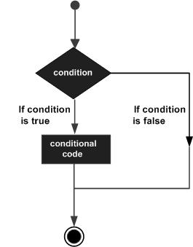
VB.Net provides the following types of decision making statements. Click the following links to check their details.
Statement | Description
If ... Then statement | An If...Then statement consists of a boolean expression followed by one or more statements.
If...Then...Else statement | An If...Then statement can be followed by an optional Else statement, which executes when the boolean expression is false.
nested If statements | You can use one If or Else if statement inside another If or Else if statement(s).
Select Case statement | A Select Case statement allows a variable to be tested for equality against a list of values.
nested Select Case statements | You can use one select case statement inside another select case statement(s).

VB.Net - Loops
There may be a situation when you need to execute a block of code several number of times. In general, statements are executed sequentially: The first statement in a function is executed first, followed by the second, and so on.
Programming languages provide various control structures that allow for more complicated execution paths.
A loop statement allows us to execute a statement or group of statements multiple times and following is the general form of a loop statement in most of the programming languages:
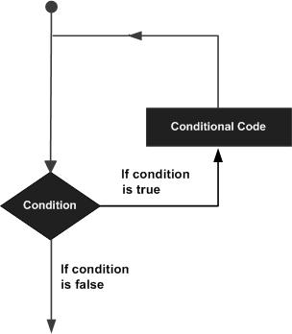
VB.Net provides following types of loops to handle looping requirements. Click the following links to check their details.
Loop Type | Description
Do Loop | It repeats the enclosed block of statements while a Boolean condition is True or until the condition becomes True. It could be terminated at any time with the Exit Do statement.
For...Next | It repeats a group of statements a specified number of times and a loop index counts the number of loop iterations as the loop executes.
For Each...Next | It repeats a group of statements for each element in a collection. This loop is used for accessing and manipulating all elements in an array or a VB.Net collection.
While... End While | It executes a series of statements as long as a given condition is True.
With... End With | It is not exactly a looping construct. It executes a series of statements that repeatedly refer to a single object or structure.
Nested loops | You can use one or more loops inside any another While, For or Do loop.
Loop Control Statements:
Loop control statements change execution from its normal sequence. When execution leaves a scope, all automatic objects that were created in that scope are destroyed.
VB.Net provides the following control statements. Click the following links to check their details.
Control Statement | Description
Exit statement | Terminates the loop or select case statement and transfers execution to the statement immediately following the loop or select case.
Continue statement | Causes the loop to skip the remainder of its body and immediately retest its condition prior to reiterating.
GoTo statement | Transfers control to the labeled statement. Though it is not advised to use GoTo statement in your program.

VB.Net - Strings
In VB.Net, you can use strings as array of characters, however, more common practice is to use the String keyword to declare a string variable. The string keyword is an alias for the System.String class.
Creating a String Object
You can create string object using one of the following methods:
By assigning a string literal to a String variable
By using a String class constructor
By using the string concatenation operator (+)
By retrieving a property or calling a method that returns a string
By calling a formatting method to convert a value or object to its string representation
The following example demonstrates this:
Module strings
Sub Main()
Dim fname, lname, fullname, greetings As String
fname = "Rowan"
lname = "Atkinson"
fullname = fname + " " + lname
Console.WriteLine("Full Name: {0}", fullname)

'by using string constructor
Dim letters As Char() = {"H", "e", "l", "l", "o"}
greetings = New String(letters)
Console.WriteLine("Greetings: {0}", greetings)

'methods returning String
Dim sarray() As String = {"Hello", "From", "Tutorials", "Point"}
Dim message As String = String.Join(" ", sarray)
Console.WriteLine("Message: {0}", message)

'formatting method to convert a value
Dim waiting As DateTime = New DateTime(2012, 12, 12, 17, 58, 1)
Dim chat As String = String.Format("Message sent at {0:t} on {0:D}", waiting)
Console.WriteLine("Message: {0}", chat)
Console.ReadLine()
End Sub
End Module
When the above code is compiled and executed, it produces the following result:
Full Name: Rowan Atkinson
Greetings: Hello
Message: Hello From Tutorials Point
Message: Message sent at 5:58 PM on Wednesday, December 12, 2012

Examples:
The following example demonstrates some of the methods mentioned above:
Comparing Strings:
#include <include.h>
Module strings
Sub Main()
Dim str1, str2 As String
str1 = "This is test"
str2 = "This is text"
If (String.Compare(str1, str2) = 0) Then
Console.WriteLine(str1 + " and " + str2 +
" are equal.")
Else
Console.WriteLine(str1 + " and " + str2 +
" are not equal.")
End If
Console.ReadLine()
End Sub
End Module
When the above code is compiled and executed, it produces the following result:
This is test and This is text are not equal.
String Contains String:
Module strings
Sub Main()
Dim str1 As String
str1 = "This is test"
If (str1.Contains("test")) Then
Console.WriteLine("The sequence 'test' was found.")
End If
Console.ReadLine()
End Sub
End Module
When the above code is compiled and executed, it produces the following result:
The sequence 'test' was found.
Getting a Substring:
Module strings
Sub Main()
Dim str As String
str = "Last night I dreamt of San Pedro"
Console.WriteLine(str)
Dim substr As String = str.Substring(23)
Console.WriteLine(substr)
Console.ReadLine()
End Sub
End Module
When the above code is compiled and executed, it produces the following result:
Last night I dreamt of San Pedro
San Pedro.
Joining Strings:
Module strings
Sub Main()
Dim strarray As String() = {"Down the way where the nights are gay",
"And the sun shines daily on the mountain top",
"I took a trip on a sailing ship",
"And when I reached Jamaica",
"I made a stop"}
Dim str As String = String.Join(vbCrLf, strarray)
Console.WriteLine(str)
Console.ReadLine()
End Sub
End Module
When the above code is compiled and executed, it produces the following result:
Down the way where the nights are gay
And the sun shines daily on the mountain top
I took a trip on a sailing ship
And when I reached Jamaica
I made a stop

VB.Net - Arrays

An array stores a fixed-size sequential collection of elements of the same type. An array is used to store a collection of data, but it is often more useful to think of an array as a collection of variables of the same type.
All arrays consist of contiguous memory locations. The lowest address corresponds to the first element and the highest address to the last element.
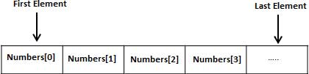
Creating Arrays in VB.Net
To declare an array in VB.Net, you use the Dim statement. For example,
Dim intData(30) ' an array of 31 elements
Dim strData(20) As String ' an array of 21 strings
Dim twoDarray(10, 20) As Integer 'a two dimensional array of integers
Dim ranges(10, 100) 'a two dimensional array
You can also initialize the array elements while declaring the array. For example,
Dim intData() As Integer = {12, 16, 20, 24, 28, 32}
Dim names() As String = {"Karthik", "Sandhya", _
"Shivangi", "Ashwitha", "Somnath"}
Dim miscData() As Object = {"Hello World", 12d, 16ui, "A"c}
The elements in an array can be stored and accessed by using the index of the array. The following program demonstrates this:
Module arrayApl
Sub Main()
Dim n(10) As Integer ' n is an array of 11 integers '
Dim i, j As Integer
' initialize elements of array n '
For i = 0 To 10
n(i) = i + 100 ' set element at location i to i + 100
Next i
' output each array element's value '
For j = 0 To 10
Console.WriteLine("Element({0}) = {1}", j, n(j))
Next j
Console.ReadKey()
End Sub
End Module
When the above code is compiled and executed, it produces the following result:
Element(0) = 100
Element(1) = 101
Element(2) = 102
Element(3) = 103
Element(4) = 104
Element(5) = 105
Element(6) = 106
Element(7) = 107
Element(8) = 108
Element(9) = 109
Element(10) = 110
Dynamic Arrays
Dynamic arrays are arrays that can be dimensioned and re-dimensioned as par the need of the program. You can declare a dynamic array using the ReDim statement.
Syntax for ReDim statement:
ReDim [Preserve] arrayname(subscripts)
Where,
The Preserve keyword helps to preserve the data in an existing array, when you resize it.
arrayname is the name of the array to re-dimension.
subscripts specifies the new dimension.
Module arrayApl
Sub Main()
Dim marks() As Integer
ReDim marks(2)
marks(0) = 85
marks(1) = 75
marks(2) = 90
ReDim Preserve marks(10)
marks(3) = 80
marks(4) = 76
marks(5) = 92
marks(6) = 99
marks(7) = 79
marks(8) = 75
For i = 0 To 10
Console.WriteLine(i & vbTab & marks(i))
Next i
Console.ReadKey()
End Sub
End Module
When the above code is compiled and executed, it produces the following result:
0 85
1 75
2 90
3 80
4 76
5 92
6 99
7 79
8 75
9 0
10 0
Multi-Dimensional Arrays
VB.Net allows multidimensional arrays. Multidimensional arrays are also called rectangular arrays.
You can declare a 2-dimensional array of strings as:
Dim twoDStringArray(10, 20) As String
or, a 3-dimensional array of Integer variables:
Dim threeDIntArray(10, 10, 10) As Integer
The following program demonstrates creating and using a 2-dimensional array:
Module arrayApl
Sub Main()
' an array with 5 rows and 2 columns
Dim a(,) As Integer = {{0, 0}, {1, 2}, {2, 4}, {3, 6}, {4, 8}}
Dim i, j As Integer
' output each array element's value '
For i = 0 To 4
For j = 0 To 1
Console.WriteLine("a[{0},{1}] = {2}", i, j, a(i, j))
Next j
Next i
Console.ReadKey()
End Sub
End Module
When the above code is compiled and executed, it produces the following result:
a[0,0]: 0
a[0,1]: 0
a[1,0]: 1
a[1,1]: 2
a[2,0]: 2
a[2,1]: 4
a[3,0]: 3
a[3,1]: 6
a[4,0]: 4
a[4,1]: 8
Jagged Array
A Jagged array is an array of arrays. The follwoing code shows declaring a jagged array named scores of Integers:
Dim scores As Integer()() = New Integer(5)(){}
The following example illustrates using a jagged array:
Module arrayApl
Sub Main()
'a jagged array of 5 array of integers
Dim a As Integer()() = New Integer(4)() {}
a(0) = New Integer() {0, 0}
a(1) = New Integer() {1, 2}
a(2) = New Integer() {2, 4}
a(3) = New Integer() {3, 6}
a(4) = New Integer() {4, 8}
Dim i, j As Integer
' output each array element's value
For i = 0 To 4
For j = 0 To 1
Console.WriteLine("a[{0},{1}] = {2}", i, j, a(i)(j))
Next j
Next i
Console.ReadKey()
End Sub
End Module
When the above code is compiled and executed, it produces the following result:
a[0][0]: 0
a[0][1]: 0
a[1][0]: 1
a[1][1]: 2
a[2][0]: 2
a[2][1]: 4
a[3][0]: 3
a[3][1]: 6
a[4][0]: 4
a[4][1]: 8

Example
The following program demonstrates use of some of the methods of the Array class:
Module arrayApl
Sub Main()
Dim list As Integer() = {34, 72, 13, 44, 25, 30, 10}
Dim temp As Integer() = list
Dim i As Integer
Console.Write("Original Array: ")
For Each i In list
Console.Write("{0} ", i)
Next i
Console.WriteLine()
' reverse the array
Array.Reverse(temp)
Console.Write("Reversed Array: ")
For Each i In temp
Console.Write("{0} ", i)
Next i
Console.WriteLine()
'sort the array
Array.Sort(list)
Console.Write("Sorted Array: ")
For Each i In list
Console.Write("{0} ", i)
Next i
Console.WriteLine()
Console.ReadKey()
End Sub
End Module
When the above code is compiled and executed, it produces the following result:
Original Array: 34 72 13 44 25 30 10
Reversed Array: 10 30 25 44 13 72 34
Sorted Array: 10 13 25 30 34 44 72

VB.Net – Functions
A procedure is a group of statements that together perform a task when called. After the procedure is executed, the control returns to the statement calling the procedure. VB.Net has two types of procedures:
Functions
Sub procedures or Subs
Functions return a value, whereas Subs do not return a value.
Defining a Function
The Function statement is used to declare the name, parameter and the body of a function. The syntax for the Function statement is:
[Modifiers] Function FunctionName [(ParameterList)] As ReturnType
[Statements]
End Function
Where,
Modifiers: specify the access level of the function; possible values are: Public, Private, Protected, Friend, Protected Friend and information regarding overloading, overriding, sharing, and shadowing.
FunctionName: indicates the name of the function
ParameterList: specifies the list of the parameters
ReturnType: specifies the data type of the variable the function returns
Example
Following code snippet shows a function FindMax that takes two integer values and returns the larger of the two.
Function FindMax(ByVal num1 As Integer, ByVal num2 As Integer) As Integer
' local variable declaration */
Dim result As Integer
If (num1 > num2) Then
result = num1
Else
result = num2
End If
FindMax = result
End Function
Function Returning a Value
In VB.Net, a function can return a value to the calling code in two ways:
By using the return statement
By assigning the value to the function name
The following example demonstrates using the FindMax function:
Module myfunctions
Function FindMax(ByVal num1 As Integer, ByVal num2 As Integer) As Integer
' local variable declaration */
Dim result As Integer
If (num1 > num2) Then
result = num1
Else
result = num2
End If
FindMax = result
End Function
Sub Main()
Dim a As Integer = 100
Dim b As Integer = 200
Dim res As Integer
res = FindMax(a, b)
Console.WriteLine("Max value is : {0}", res)
Console.ReadLine()
End Sub
End Module
When the above code is compiled and executed, it produces the following result:
Max value is : 200
Recursive Function
A function can call itself. This is known as recursion. Following is an example that calculates factorial for a given number using a recursive function:
Module myfunctions
Function factorial(ByVal num As Integer) As Integer
' local variable declaration */
Dim result As Integer
If (num = 1) Then
Return 1
Else
result = factorial(num - 1) * num
Return result
End If
End Function
Sub Main()
'calling the factorial method
Console.WriteLine("Factorial of 6 is : {0}", factorial(6))
Console.WriteLine("Factorial of 7 is : {0}", factorial(7))
Console.WriteLine("Factorial of 8 is : {0}", factorial(8))
Console.ReadLine()
End Sub
End Module
When the above code is compiled and executed, it produces the following result:
Factorial of 6 is: 720
Factorial of 7 is: 5040
Factorial of 8 is: 40320
Param Arrays
At times, while declaring a function or sub procedure, you are not sure of the number of arguments passed as a parameter. VB.Net param arrays (or parameter arrays) come into help at these times.
The following example demonstrates this:
Module myparamfunc
Function AddElements(ParamArray arr As Integer()) As Integer
Dim sum As Integer = 0
Dim i As Integer = 0
For Each i In arr
sum += i
Next i
Return sum
End Function
Sub Main()
Dim sum As Integer
sum = AddElements(512, 720, 250, 567, 889)
Console.WriteLine("The sum is: {0}", sum)
Console.ReadLine()
End Sub
End Module
When the above code is compiled and executed, it produces the following result:
The sum is: 2938
Passing Arrays as Function Arguments
You can pass an array as a function argument in VB.Net. The following example demonstrates this:
Module arrayParameter
Function getAverage(ByVal arr As Integer(), ByVal size As Integer) As Double
'local variables
Dim i As Integer
Dim avg As Double
Dim sum As Integer = 0
For i = 0 To size - 1
sum += arr(i)
Next i
avg = sum / size
Return avg
End Function
Sub Main()
' an int array with 5 elements '
Dim balance As Integer() = {1000, 2, 3, 17, 50}
Dim avg As Double
'pass pointer to the array as an argument
avg = getAverage(balance, 5)
' output the returned value '
Console.WriteLine("Average value is: {0} ", avg)
Console.ReadLine()
End Sub
End Module
When the above code is compiled and executed, it produces the following result:
Average value is: 214.4

VB.Net - Sub Procedures
Sub procedures are procedures that do not return any value. We have been using the Sub procedure Main in all our examples. We have been writing console applications so far in these tutorials. When these applications start, the control goes to the Main Sub procedure, and it in turn, runs any other statements constituting the body of the program.
Defining Sub Procedures
The Sub statement is used to declare the name, parameter and the body of a sub procedure. The syntax for the Sub statement is:
[Modifiers] Sub SubName [(ParameterList)]
[Statements]
End Sub
Where,
Modifiers: specify the access level of the procedure; possible values are: Public, Private, Protected, Friend, Protected Friend and information regarding overloading, overriding, sharing, and shadowing.
SubName: indicates the name of the Sub
ParameterList: specifies the list of the parameters
Example
The following example demonstrates a Sub procedure CalculatePay that takes two parameters hours and wages and displays the total pay of an employee:
Module mysub
Sub CalculatePay(ByVal hours As Double, ByVal wage As Decimal)
'local variable declaration
Dim pay As Double
pay = hours * wage
Console.WriteLine("Total Pay: {0:C}", pay)
End Sub
Sub Main()
'calling the CalculatePay Sub Procedure
CalculatePay(25, 10)
CalculatePay(40, 20)
CalculatePay(30, 27.5)
Console.ReadLine()
End Sub
End Module
When the above code is compiled and executed, it produces the following result:
Total Pay: $250.00
Total Pay: $800.00
Total Pay: $825.00
Passing Parameters by Value
This is the default mechanism for passing parameters to a method. In this mechanism, when a method is called, a new storage location is created for each value parameter. The values of the actual parameters are copied into them. So, the changes made to the parameter inside the method have no effect on the argument.
In VB.Net, you declare the reference parameters using the ByVal keyword. The following example demonstrates the concept:
Module paramByval
Sub swap(ByVal x As Integer, ByVal y As Integer)
Dim temp As Integer
temp = x ' save the value of x
x = y ' put y into x
y = temp 'put temp into y
End Sub
Sub Main()
' local variable definition
Dim a As Integer = 100
Dim b As Integer = 200
Console.WriteLine("Before swap, value of a : {0}", a)
Console.WriteLine("Before swap, value of b : {0}", b)
' calling a function to swap the values '
swap(a, b)
Console.WriteLine("After swap, value of a : {0}", a)
Console.WriteLine("After swap, value of b : {0}", b)
Console.ReadLine()
End Sub
End Module
When the above code is compiled and executed, it produces the following result:
Before swap, value of a :100
Before swap, value of b :200
After swap, value of a :100
After swap, value of b :200
It shows that there is no change in the values though they had been changed inside the function.
Passing Parameters by Reference
A reference parameter is a reference to a memory location of a variable. When you pass parameters by reference, unlike value parameters, a new storage location is not created for these parameters. The reference parameters represent the same memory location as the actual parameters that are supplied to the method.
In VB.Net, you declare the reference parameters using the ByRef keyword. The following example demonstrates this:
Module paramByref
Sub swap(ByRef x As Integer, ByRef y As Integer)
Dim temp As Integer
temp = x ' save the value of x
x = y ' put y into x
y = temp 'put temp into y
End Sub
Sub Main()
' local variable definition
Dim a As Integer = 100
Dim b As Integer = 200
Console.WriteLine("Before swap, value of a : {0}", a)
Console.WriteLine("Before swap, value of b : {0}", b)
' calling a function to swap the values '
swap(a, b)
Console.WriteLine("After swap, value of a : {0}", a)
Console.WriteLine("After swap, value of b : {0}", b)
Console.ReadLine()
End Sub
End Module
When the above code is compiled and executed, it produces the following result:
Before swap, value of a : 100
Before swap, value of b : 200
After swap, value of a : 200
After swap, value of b : 100

VB.Net - Classes & Objects
Class Definition
A class definition starts with the keyword Class followed by the class name; and the class body, ended by the End Class statement. Following is the general form of a class definition:
[ <attributelist> ] [ accessmodifier ] [ Shadows ] [ MustInherit | NotInheritable ] [ Partial ] _
Class name [ ( Of typelist ) ]
[ Inherits classname ]
[ Implements interfacenames ]
[ statements ]
End Class
Where,
attributelist is a list of attributes that apply to the class. Optional.
accessmodifier defines the access levels of the class, it has values as - Public, Protected, Friend, Protected Friend and Private. Optional.
Shadows indicate that the variable re-declares and hides an identically named element, or set of overloaded elements, in a base class. Optional.
MustInherit specifies that the class can be used only as a base class and that you cannot create an object directly from it, i.e., an abstract class. Optional.
NotInheritable specifies that the class cannot be used as a base class.
Partial indicates a partial definition of the class.
Inherits specifies the base class it is inheriting from.
Implements specifies the interfaces the class is inheriting from.
The following example demonstrates a Box class, with three data members, length, breadth and height:
Module mybox
Class Box
Public length As Double ' Length of a box
Public breadth As Double ' Breadth of a box
Public height As Double ' Height of a box
End Class
Sub Main()
Dim Box1 As Box = New Box() ' Declare Box1 of type Box
Dim Box2 As Box = New Box() ' Declare Box2 of type Box
Dim volume As Double = 0.0 ' Store the volume of a box here
' box 1 specification
Box1.height = 5.0
Box1.length = 6.0
Box1.breadth = 7.0
' box 2 specification
Box2.height = 10.0
Box2.length = 12.0
Box2.breadth = 13.0
'volume of box 1
volume = Box1.height * Box1.length * Box1.breadth
Console.WriteLine("Volume of Box1 : {0}", volume)
'volume of box 2
volume = Box2.height * Box2.length * Box2.breadth
Console.WriteLine("Volume of Box2 : {0}", volume)
Console.ReadKey()
End Sub
End Module
When the above code is compiled and executed, it produces the following result:
Volume of Box1 : 210
Volume of Box2 : 1560
Member Functions and Encapsulation
A member function of a class is a function that has its definition or its prototype within the class definition like any other variable. It operates on any object of the class of which it is a member and has access to all the members of a class for that object.
Member variables are attributes of an object (from design perspective) and they are kept private to implement encapsulation. These variables can only be accessed using the public member functions.
Let us put above concepts to set and get the value of different class members in a class:
Module mybox
Class Box
Public length As Double ' Length of a box
Public breadth As Double ' Breadth of a box
Public height As Double ' Height of a box
Public Sub setLength(ByVal len As Double)
length = len
End Sub
Public Sub setBreadth(ByVal bre As Double)
breadth = bre
End Sub
Public Sub setHeight(ByVal hei As Double)
height = hei
End Sub
Public Function getVolume() As Double
Return length * breadth * height
End Function
End Class
Sub Main()
Dim Box1 As Box = New Box() ' Declare Box1 of type Box
Dim Box2 As Box = New Box() ' Declare Box2 of type Box
Dim volume As Double = 0.0 ' Store the volume of a box here

' box 1 specification
Box1.setLength(6.0)
Box1.setBreadth(7.0)
Box1.setHeight(5.0)

'box 2 specification
Box2.setLength(12.0)
Box2.setBreadth(13.0)
Box2.setHeight(10.0)

' volume of box 1
volume = Box1.getVolume()
Console.WriteLine("Volume of Box1 : {0}", volume)

'volume of box 2
volume = Box2.getVolume()
Console.WriteLine("Volume of Box2 : {0}", volume)
Console.ReadKey()
End Sub
End Module
When the above code is compiled and executed, it produces the following result:
Volume of Box1 : 210
Volume of Box2 : 1560
Constructors and Destructors
A class constructor is a special member Sub of a class that is executed whenever we create new objects of that class. A constructor has the name New and it does not have any return type.
Following program explains the concept of constructor:
Class Line
Private length As Double ' Length of a line
Public Sub New() 'constructor
Console.WriteLine("Object is being created")
End Sub
Public Sub setLength(ByVal len As Double)
length = len
End Sub

Public Function getLength() As Double
Return length
End Function
Shared Sub Main()
Dim line As Line = New Line()
'set line length
line.setLength(6.0)
Console.WriteLine("Length of line : {0}", line.getLength())
Console.ReadKey()
End Sub
End Class
When the above code is compiled and executed, it produces the following result:
Object is being created
Length of line : 6
A default constructor does not have any parameter, but if you need, a constructor can have parameters. Such constructors are called parameterized constructors. This technique helps you to assign initial value to an object at the time of its creation as shown in the following example:
Class Line
Private length As Double ' Length of a line
Public Sub New(ByVal len As Double) 'parameterised constructor
Console.WriteLine("Object is being created, length = {0}", len)
length = len
End Sub
Public Sub setLength(ByVal len As Double)
length = len
End Sub

Public Function getLength() As Double
Return length
End Function
Shared Sub Main()
Dim line As Line = New Line(10.0)
Console.WriteLine("Length of line set by constructor : {0}", line.getLength())
'set line length
line.setLength(6.0)
Console.WriteLine("Length of line set by setLength : {0}", line.getLength())
Console.ReadKey()
End Sub
End Class
When the above code is compiled and executed, it produces the following result:
Object is being created, length = 10
Length of line set by constructor : 10
Length of line set by setLength : 6
A destructor is a special member Sub of a class that is executed whenever an object of its class goes out of scope.
A destructor has the name Finalize and it can neither return a value nor can it take any parameters. Destructor can be very useful for releasing resources before coming out of the program like closing files, releasing memories, etc.
Destructors cannot be inherited or overloaded.
Following example explains the concept of destructor:
Class Line
Private length As Double ' Length of a line
Public Sub New() 'parameterised constructor
Console.WriteLine("Object is being created")
End Sub
Protected Overrides Sub Finalize() ' destructor
Console.WriteLine("Object is being deleted")
End Sub
Public Sub setLength(ByVal len As Double)
length = len
End Sub
Public Function getLength() As Double
Return length
End Function
Shared Sub Main()
Dim line As Line = New Line()
'set line length
line.setLength(6.0)
Console.WriteLine("Length of line : {0}", line.getLength())
Console.ReadKey()
End Sub
End Class
When the above code is compiled and executed, it produces the following result:
Object is being created
Length of line : 6
Object is being deleted
Shared Members of a VB.Net Class
We can define class members as static using the Shared keyword. When we declare a member of a class as Shared, it means no matter how many objects of the class are created, there is only one copy of the member.
The keyword Shared implies that only one instance of the member exists for a class. Shared variables are used for defining constants because their values can be retrieved by invoking the class without creating an instance of it.
Shared variables can be initialized outside the member function or class definition. You can also initialize Shared variables inside the class definition.
You can also declare a member function as Shared. Such functions can access only Shared variables. The Shared functions exist even before the object is created.
The following example demonstrates the use of shared members:
Class StaticVar
Public Shared num As Integer
Public Sub count()
num = num + 1
End Sub
Public Shared Function getNum() As Integer
Return num
End Function
Shared Sub Main()
Dim s As StaticVar = New StaticVar()
s.count()
s.count()
s.count()
Console.WriteLine("Value of variable num: {0}", StaticVar.getNum())
Console.ReadKey()
End Sub
End Class
When the above code is compiled and executed, it produces the following result:
Value of variable num: 3
Inheritance
One of the most important concepts in object-oriented programming is that of inheritance. Inheritance allows us to define a class in terms of another class which makes it easier to create and maintain an application. This also provides an opportunity to reuse the code functionality and fast implementation time.
When creating a class, instead of writing completely new data members and member functions, the programmer can designate that the new class should inherit the members of an existing class. This existing class is called the base class, and the new class is referred to as the derived class.
Base & Derived Classes:
A class can be derived from more than one class or interface, which means that it can inherit data and functions from multiple base classes or interfaces.
The syntax used in VB.Net for creating derived classes is as follows:
<access-specifier> Class <base_class>
...
End Class
Class <derived_class>: Inherits <base_class>
...
End Class
Consider a base class Shape and its derived class Rectangle:
' Base class
Class Shape
Protected width As Integer
Protected height As Integer
Public Sub setWidth(ByVal w As Integer)
width = w
End Sub
Public Sub setHeight(ByVal h As Integer)
height = h
End Sub
End Class
' Derived class
Class Rectangle : Inherits Shape
Public Function getArea() As Integer
Return (width * height)
End Function
End Class
Class RectangleTester
Shared Sub Main()
Dim rect As Rectangle = New Rectangle()
rect.setWidth(5)
rect.setHeight(7)
' Print the area of the object.
Console.WriteLine("Total area: {0}", rect.getArea())
Console.ReadKey()
End Sub
End Class
When the above code is compiled and executed, it produces the following result:
Total area: 35
Base Class Initialization
The derived class inherits the base class member variables and member methods. Therefore, the super class object should be created before the subclass is created. The super class or the base class is implicitly known as MyBase in VB.Net
The following program demonstrates this:
' Base class
Class Rectangle
Protected width As Double
Protected length As Double
Public Sub New(ByVal l As Double, ByVal w As Double)
length = l
width = w
End Sub
Public Function GetArea() As Double
Return (width * length)
End Function
Public Overridable Sub Display()
Console.WriteLine("Length: {0}", length)
Console.WriteLine("Width: {0}", width)
Console.WriteLine("Area: {0}", GetArea())
End Sub
'end class Rectangle
End Class
'Derived class
Class Tabletop : Inherits Rectangle
Private cost As Double
Public Sub New(ByVal l As Double, ByVal w As Double)
MyBase.New(l, w)
End Sub
Public Function GetCost() As Double
Dim cost As Double
cost = GetArea() * 70
Return cost
End Function
Public Overrides Sub Display()
MyBase.Display()
Console.WriteLine("Cost: {0}", GetCost())
End Sub
'end class Tabletop
End Class
Class RectangleTester
Shared Sub Main()
Dim t As Tabletop = New Tabletop(4.5, 7.5)
t.Display()
Console.ReadKey()
End Sub
End Class
When the above code is compiled and executed, it produces the following result:
Length: 4.5
Width: 7.5
Area: 33.75
Cost: 2362.5
VB.Net supports multiple inheritance.
VB.Net - Exception Handling
An exception is a problem that arises during the execution of a program. An exception is a response to an exceptional circumstance that arises while a program is running, such as an attempt to divide by zero.
Exceptions provide a way to transfer control from one part of a program to another. VB.Net exception handling is built upon four keywords: Try, Catch, Finally and Throw.
Try: A Try block identifies a block of code for which particular exceptions will be activated. It's followed by one or more Catch blocks.
Catch: A program catches an exception with an exception handler at the place in a program where you want to handle the problem. The Catch keyword indicates the catching of an exception.
Finally: The Finally block is used to execute a given set of statements, whether an exception is thrown or not thrown. For example, if you open a file, it must be closed whether an exception is raised or not.
Throw: A program throws an exception when a problem shows up. This is done using a Throw keyword.
Syntax
Assuming a block will raise an exception, a method catches an exception using a combination of the Try and Catch keywords. A Try/Catch block is placed around the code that might generate an exception. Code within a Try/Catch block is referred to as protected code, and the syntax for using Try/Catch looks like the following:
Try
[ tryStatements ]
[ Exit Try ]
[ Catch [ exception [ As type ] ] [ When expression ]
[ catchStatements ]
[ Exit Try ] ]
[ Catch ... ]
[ Finally
[ finallyStatements ] ]
End Try
You can list down multiple catch statements to catch different type of exceptions in case your try block raises more than one exception in different situations.
Exception Classes in .Net Framework
In the .Net Framework, exceptions are represented by classes. The exception classes in .Net Framework are mainly directly or indirectly derived from the System.Exception class. Some of the exception classes derived from the System.Exception class are the System.ApplicationException and System.SystemException classes.
The System.ApplicationException class supports exceptions generated by application programs. So the exceptions defined by the programmers should derive from this class.
The System.SystemException class is the base class for all predefined system exception.
The following table provides some of the predefined exception classes derived from the Sytem.SystemException class:
Exception Class | Description
System.IO.IOException | Handles I/O errors.
System.IndexOutOfRangeException | Handles errors generated when a method refers to an array index out of range.
System.ArrayTypeMismatchException | Handles errors generated when type is mismatched with the array type.
System.NullReferenceException | Handles errors generated from deferencing a null object.
System.DivideByZeroException | Handles errors generated from dividing a dividend with zero.
System.InvalidCastException | Handles errors generated during typecasting.
System.OutOfMemoryException | Handles errors generated from insufficient free memory.
System.StackOverflowException | Handles errors generated from stack overflow.
Handling Exceptions
VB.Net provides a structured solution to the exception handling problems in the form of try and catch blocks. Using these blocks the core program statements are separated from the error-handling statements.
These error handling blocks are implemented using the Try, Catch and Finally keywords. Following is an example of throwing an exception when dividing by zero condition occurs:
Module exceptionProg
Sub division(ByVal num1 As Integer, ByVal num2 As Integer)
Dim result As Integer
Try
result = num1 \ num2
Catch e As DivideByZeroException
Console.WriteLine("Exception caught: {0}", e)
Finally
Console.WriteLine("Result: {0}", result)
End Try
End Sub
Sub Main()
division(25, 0)
Console.ReadKey()
End Sub
End Module
When the above code is compiled and executed, it produces the following result:
Exception caught: System.DivideByZeroException: Attempted to divide by zero.
at ...
Result: 0
Creating User-Defined Exceptions
You can also define your own exception. User-defined exception classes are derived from the ApplicationException class. The following example demonstrates this:
Module exceptionProg
Public Class TempIsZeroException : Inherits ApplicationException
Public Sub New(ByVal message As String)
MyBase.New(message)
End Sub
End Class
Public Class Temperature
Dim temperature As Integer = 0
Sub showTemp()
If (temperature = 0) Then
Throw (New TempIsZeroException("Zero Temperature found"))
Else
Console.WriteLine("Temperature: {0}", temperature)
End If
End Sub
End Class
Sub Main()
Dim temp As Temperature = New Temperature()
Try
temp.showTemp()
Catch e As TempIsZeroException
Console.WriteLine("TempIsZeroException: {0}", e.Message)
End Try
Console.ReadKey()
End Sub
End Module
When the above code is compiled and executed, it produces the following result:
TempIsZeroException: Zero Temperature found
Throwing Objects
You can throw an object if it is either directly or indirectly derived from the System.Exception class.
You can use a throw statement in the catch block to throw the present object as:
Throw [ expression ]
The following program demonstrates this:
Module exceptionProg
Sub Main()
Try
Throw New ApplicationException("A custom exception _
is being thrown here...")
Catch e As Exception
Console.WriteLine(e.Message)
Finally
Console.WriteLine("Now inside the Finally Block")
End Try
Console.ReadKey()
End Sub
End Module
When the above code is compiled and executed, it produces the following result:
A custom exception is being thrown here...
Now inside the Finally Block
VB.Net - Basic Controls
VB.Net provides a huge variety of controls that help you to create rich user interface. Functionalities of all these controls are defined in the respective control classes. The control classes are defined in the System.Windows.Forms namespace.
The following table lists some of the commonly used controls:
S.N. | Widget & Description
1 | Forms  The container for all the controls that make up the user interface.
2 | TextBox  It represents a Windows text box control.
3 | Label  It represents a standard Windows label.
4 | Button  It represents a Windows button control.
5 | ListBox  It represents a Windows control to display a list of items.
6 | ComboBox  It represents a Windows combo box control.
7 | RadioButton  It enables the user to select a single option from a group of choices when paired with other RadioButton controls.
8 | CheckBox  It represents a Windows CheckBox.
9 | PictureBox  It represents a Windows picture box control for displaying an image.
10 | ProgressBar  It represents a Windows progress bar control.
11 | ScrollBar  It Implements the basic functionality of a scroll bar control.
12 | DateTimePicker  It represents a Windows control that allows the user to select a date and a time and to display the date and time with a specified format.
13 | TreeView  It displays a hierarchical collection of labeled items, each represented by a TreeNode.
14 | ListView  It represents a Windows list view control, which displays a collection of items that can be displayed using one of four different views.
VB.Net - Database Access
Applications communicate with a database, firstly, to retrieve the data stored there and present it in a user-friendly way, and secondly, to update the database by inserting, modifying and deleting data.
Microsoft ActiveX Data Objects.Net (ADO.Net) is a model, a part of the .Net framework that is used by the .Net applications for retrieving, accessing and updating data.
ADO.Net Object Model
ADO.Net object model is nothing but the structured process flow through various components. The object model can be pictorially described as:
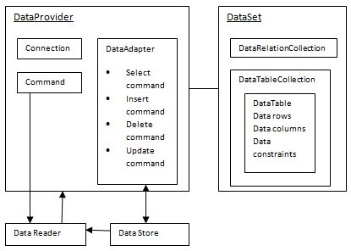
The data residing in a data store or database is retrieved through the data provider. Various components of the data provider retrieve data for the application and update data.
An application accesses data either through a dataset or a data reader.
Datasets store data in a disconnected cache and the application retrieves data from it.
Data readers provide data to the application in a read-only and forward-only mode.
Data Provider
A data provider is used for connecting to a database, executing commands and retrieving data, storing it in a dataset, reading the retrieved data and updating the database.
The data provider in ADO.Net consists of the following four objects:
S.N | Objects & Description
1 | Connection  This component is used to set up a connection with a data source.
2 | Command  A command is a SQL statement or a stored procedure used to retrieve, insert, delete or modify data in a data source.
3 | DataReader  Data reader is used to retrieve data from a data source in a read-only and forward-only mode.
4 | DataAdapter  This is integral to the working of ADO.Net since data is transferred to and from a database through a data adapter. It retrieves data from a database into a dataset and updates the database. When changes are made to the dataset, the changes in the database are actually done by the data adapter.
There are following different types of data providers included in ADO.Net
The .Net Framework data provider for SQL Server - provides access to Microsoft SQL Server.
The .Net Framework data provider for OLE DB - provides access to data sources exposed by using OLE DB.
The .Net Framework data provider for ODBC - provides access to data sources exposed by ODBC.
The .Net Framework data provider for Oracle - provides access to Oracle data source.
The EntityClient provider - enables accessing data through Entity Data Model (EDM) applications.
DataSet
DataSet is an in-memory representation of data. It is a disconnected, cached set of records that are retrieved from a database. When a connection is established with the database, the data adapter creates a dataset and stores data in it. After the data is retrieved and stored in a dataset, the connection with the database is closed. This is called the 'disconnected architecture'. The dataset works as a virtual database containing tables, rows, and columns.
The following diagram shows the dataset object model:
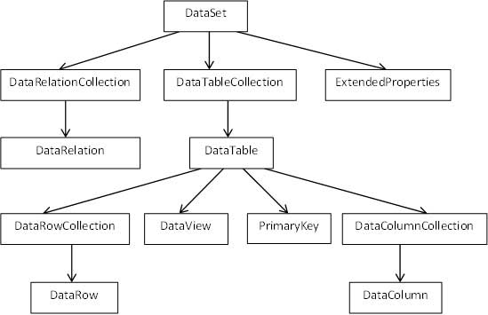
The DataSet class is present in the System.Data namespace. The following table describes all the components of DataSet:
S.N | Components & Description
1 | DataTableCollection  It contains all the tables retrieved from the data source.
2 | DataRelationCollection  It contains relationships and the links between tables in a data set.
3 | ExtendedProperties  It contains additional information, like the SQL statement for retrieving data, time of retrieval, etc.
4 | DataTable  It represents a table in the DataTableCollection of a dataset. It consists of the DataRow and DataColumn objects. The DataTable objects are case-sensitive.
5 | DataRelation  It represents a relationship in the DataRelationshipCollection of the dataset. It is used to relate two DataTable objects to each other through the DataColumn objects.
6 | DataRowCollection  It contains all the rows in a DataTable.
7 | DataView  It represents a fixed customized view of a DataTable for sorting, filtering, searching, editing and navigation.
8 | PrimaryKey  It represents the column that uniquely identifies a row in a DataTable.
9 | DataRow  It represents a row in the DataTable. The DataRow object and its properties and methods are used to retrieve, evaluate, insert, delete, and update values in the DataTable. The NewRow method is used to create a new row and the Add method adds a row to the table.
10 | DataColumnCollection  It represents all the columns in a DataTable.
11 | DataColumn  It consists of the number of columns that comprise a DataTable.
Connecting to a Database
The .Net Framework provides two types of Connection classes:
SqlConnection - designed for connecting to Microsoft SQL Server.
OleDbConnection - designed for connecting to a wide range of databases, like Microsoft Access and Oracle.
Example 1
We have a table stored in Microsoft SQL Server, named Customers, in a database named testDB. Please consult 'SQL Server' tutorial for creating databases and database tables in SQL Server.
Let us connect to this database. Take the following steps:
Select TOOLS -> Connect to Database
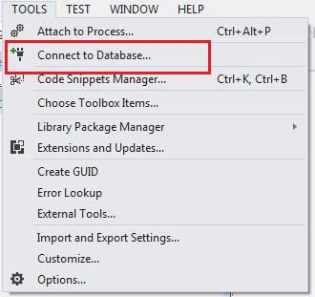
Select a server name and the database name in the Add Connection dialog box.
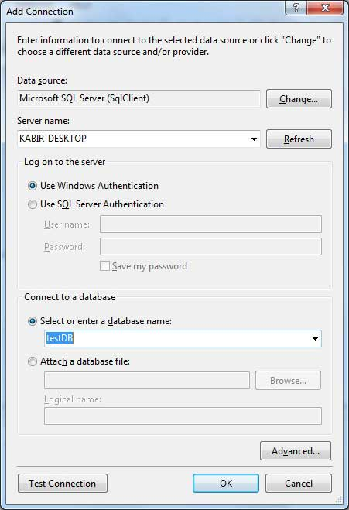
Click on the Test Connection button to check if the connection succeeded.
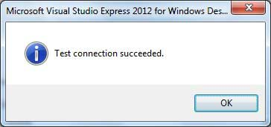
Add a DataGridView on the form.
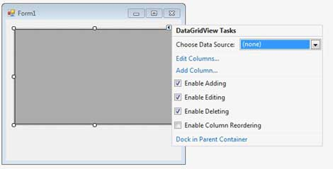
Click on the Choose Data Source combo box.
Click on the Add Project Data Source link.
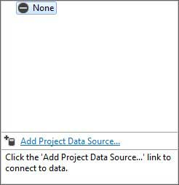
This opens the Data Source Configuration Wizard.
Select Database as the data source type
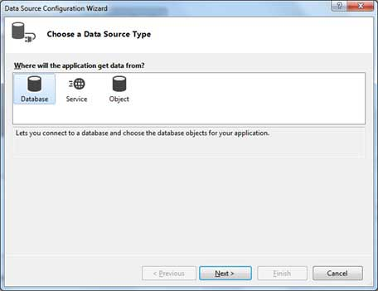
Choose DataSet as the database model.
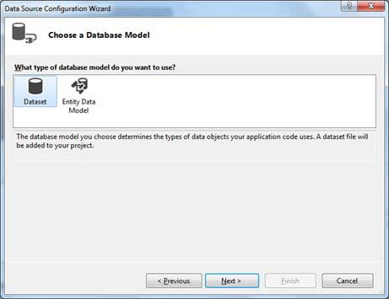
Choose the connection already set up.
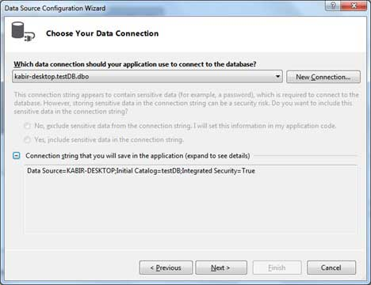
Save the connection string.
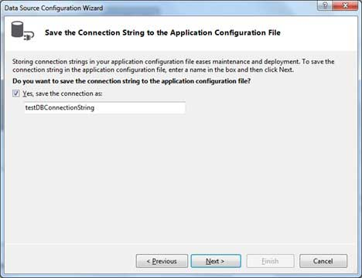
Choose the database object, Customers table in our example, and click the Finish button.
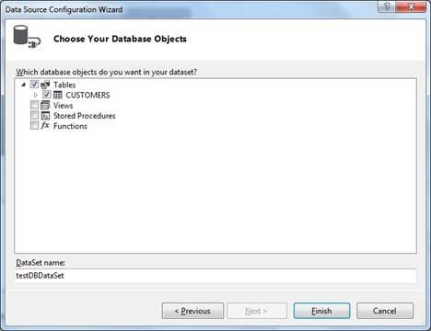
Select the Preview Data link to see the data in the Results grid:
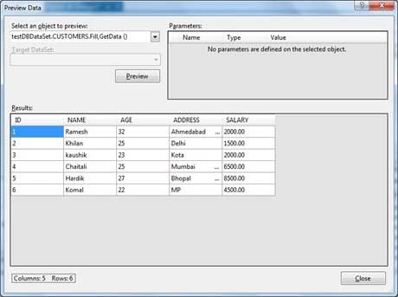
When the application is run using Start button available at the Microsoft Visual Studio tool bar, it will show the following window:
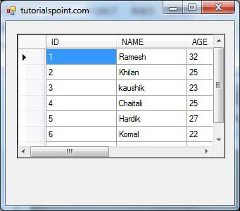
Example 2
In this example, let us access data in a DataGridView control using code. Take the following steps:
Add a DataGridView control and a button in the form.
Change the text of the button control to 'Fill'.
Double click the button control to add the required code for the Click event of the button, as shown below:
Imports System.Data.SqlClient
Public Class Form1
Private Sub Form1_Load(sender As Object, e As EventArgs) _
Handles MyBase.Load
'TODO: This line of code loads data into the 'TestDBDataSet.CUSTOMERS' table. You can move, or remove it, as needed.
Me.CUSTOMERSTableAdapter.Fill(Me.TestDBDataSet.CUSTOMERS)
' Set the caption bar text of the form.
Me.Text = "tutorialspoint.com"
End Sub
Private Sub Button1_Click(sender As Object, e As EventArgs) Handles Button1.Click
Dim connection As SqlConnection = New sqlconnection()
connection.ConnectionString = "Data Source=KABIR-DESKTOP; _
Initial Catalog=testDB;Integrated Security=True"
connection.Open()
Dim adp As SqlDataAdapter = New SqlDataAdapter _
("select * from Customers", connection)
Dim ds As DataSet = New DataSet()
adp.Fill(ds)
DataGridView1.DataSource = ds.Tables(0)
End Sub
End Class
When the above code is executed and run using Start button available at the Microsoft Visual Studio tool bar, it will show the following window:
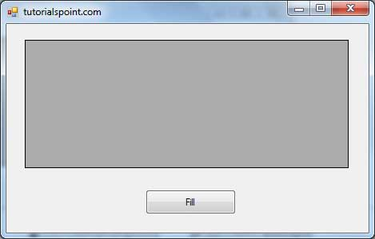
Clicking the Fill button displays the table on the data grid view control:
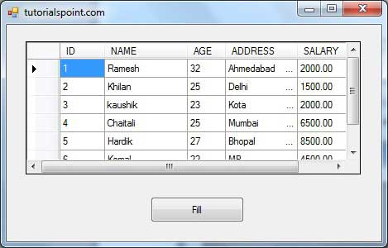
Creating Table, Columns and Rows
We have discussed that the DataSet components like DataTable, DataColumn and DataRow allow us to create tables, columns and rows, respectively.
The following example demonstrates the concept:
Example 3
So far, we have used tables and databases already existing in our computer. In this example, we will create a table, add columns, rows and data into it and display the table using a DataGridView object.
Take the following steps:
Add a DataGridView control and a button in the form.
Change the text of the button control to 'Fill'.
Add the following code in the code editor.
Public Class Form1
Private Sub Form1_Load(sender As Object, e As EventArgs) Handles MyBase.Load
' Set the caption bar text of the form.
Me.Text = "tutorialspont.com"
End Sub
Private Function CreateDataSet() As DataSet
'creating a DataSet object for tables
Dim dataset As DataSet = New DataSet()
' creating the student table
Dim Students As DataTable = CreateStudentTable()
dataset.Tables.Add(Students)
Return dataset
End Function
Private Function CreateStudentTable() As DataTable
Dim Students As DataTable
Students = New DataTable("Student")
' adding columns
AddNewColumn(Students, "System.Int32", "StudentID")
AddNewColumn(Students, "System.String", "StudentName")
AddNewColumn(Students, "System.String", "StudentCity")
' adding rows
AddNewRow(Students, 1, "Zara Ali", "Kolkata")
AddNewRow(Students, 2, "Shreya Sharma", "Delhi")
AddNewRow(Students, 3, "Rini Mukherjee", "Hyderabad")
AddNewRow(Students, 4, "Sunil Dubey", "Bikaner")
AddNewRow(Students, 5, "Rajat Mishra", "Patna")
Return Students
End Function
Private Sub AddNewColumn(ByRef table As DataTable, _
ByVal columnType As String, ByVal columnName As String)
Dim column As DataColumn = _
table.Columns.Add(columnName, Type.GetType(columnType))
End Sub

'adding data into the table
Private Sub AddNewRow(ByRef table As DataTable, ByRef id As Integer,_
ByRef name As String, ByRef city As String)
Dim newrow As DataRow = table.NewRow()
newrow("StudentID") = id
newrow("StudentName") = name
newrow("StudentCity") = city
table.Rows.Add(newrow)
End Sub
Private Sub Button1_Click(sender As Object, e As EventArgs) Handles Button1.Click
Dim ds As New DataSet
ds = CreateDataSet()
DataGridView1.DataSource = ds.Tables("Student")
End Sub
End Class
When the above code is executed and run using Start button available at the Microsoft Visual Studio tool bar, it will show the following window:
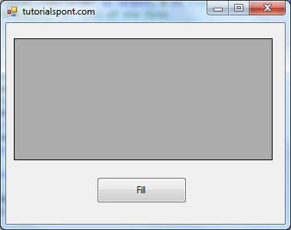
Clicking the Fill button displays the table on the data grid view control:
