Fibonacci series: It is mathematical function to add each previous subsequent number. In Fibonacci series each subsequent number is the sum of the previous two integer value. Suppose you have two integers value are 2 and 5 then you will get output 7, 12. See below figure to know how Fibonacci series works.
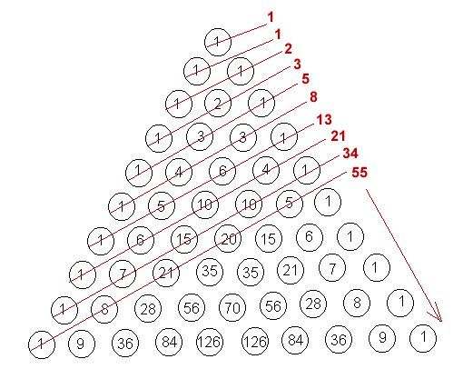
Module1.vb
Imports System.Collections.Generic
Module Module1
Sub Main()
Dim n1 As Integer
Dim n2 As Integer
n1 = 1
n2 = 1
Console.WriteLine("{0}", n1)
While n2 < 300
Console.WriteLine(n2)
n2 = n2 + n1
n1 = n2 - n1
End While
Console.ReadLine()
End Sub
End Module
Output
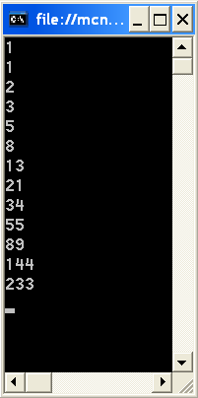
For your better understanding I used below code to represent how Fibonacci series works.
Module2.vb
Module Module1
Sub Main()
Dim n1 As Integer
Dim n2 As Integer
n1 = 1
n2 = 1
Console.WriteLine("n1 is {0}", n1)
Console.WriteLine("n2 is {0} ", n2 & vbLf)
While n2 < 500
n2 = n2 + n1
Console.WriteLine("n2 is n2+n1=" & n2)
n1 = n2 - n1
Console.WriteLine("n1 is n2-n1=" & n1 & vbLf)
End While
Console.ReadLine()
End Sub
End Module
Output
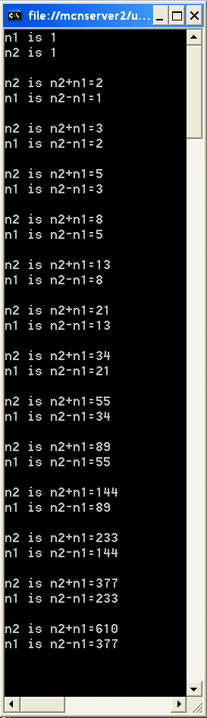
VB.NET program that generates Fibonacci sequence

Module Module1

Function Fibonacci(ByVal n As Integer) As Integer
Dim a As Integer = 0
Dim b As Integer = 1

' Add up numbers.
For i As Integer = 0 To n - 1
Dim temp As Integer = a
a = b
b = temp + b
Next

Return a
End Function

Sub Main()
' Display first 10 Fibonacci numbers.
For i As Integer = 0 To 10
Console.WriteLine(Fibonacci(i))
Next
End Sub

End Module

Output

0
1
1
2
3
5
8
13
21
34
55

How To Method Overloading In VB.NET

In method overloading, multiple method having the same name but different type of argument. sometimes our reqirement needs us to be able to create more function with same names this allows programer to provide easiness to the user by allowing user to use single name for different purposes.
For example:
Public Overloads Sub area(ByVal r)
Public Overloads Sub area(ByVal length, ByVal width)
In the above example there are two method which has the same name but use for different purpose one define the area of circle and other define the area of rectangle. Both method have the different parameter.
The following code define the Function overloading:
Imports System
Module Module1
Class overload
Dim r As Double
Public Overloads Sub area(ByVal r) // define the function name area
Console.Write("Area of the Circle :")
Console.WriteLine(1 / 3 * 3.14 * r * r * r)
End Sub
Dim length As Integer
Dim width As Integer
Public Overloads Sub area(ByVal length, ByVal width) // define the function area
Console.Write(" Area of the Rectangle :")
Console.WriteLine(length * width)
End Sub

End Class

Sub Main()

Dim r As New overload() // creating object of the class overload
r.area(3.1)
r.area(4, 5)

End Sub
End Module

OUTPUT:

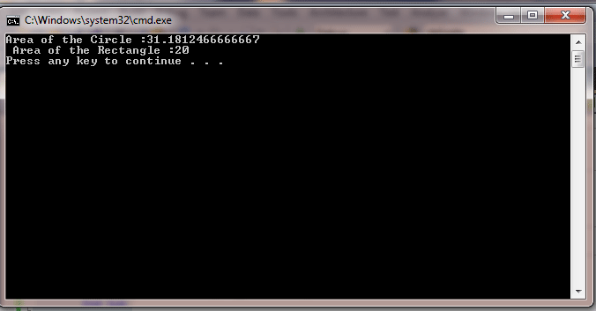

Sum by Function Overloading

Module SumByFuncOverloading

Sub Main()
Dim a, b, s1, s2 As Integer
Console.Write("Enter the value of a: ")
a = CInt(Console.ReadLine())
Console.Write("Enter the value of b: ")
b = CInt(Console.ReadLine())
Console.WriteLine()
Console.WriteLine("Display")
Console.WriteLine("a= " + a.ToString())
Console.WriteLine("b= " + b.ToString())
'function overloading
s1 = add(a)
s2 = add(a, b)
Console.WriteLine()
Console.WriteLine("Sum1= " + s1.ToString())
Console.WriteLine("Sum2= " + s2.ToString())
Console.ReadLine()
End Sub
Function add(ByVal m As Integer) As Integer
'adding 100 to m
m += 100
Return m
End Function
Function add(ByVal p As Integer, ByVal q As Integer) As Integer
Return p + q
End Function
End Module

Leap Year Checking

Module LeapYear
Sub main()
Dim y As Integer
Console.Write("Enter Year:")
y = CInt(Console.ReadLine())
If y Mod 100 = 0 Then
If y Mod 400 = 0 Then
Console.WriteLine("The year is a Leap year")
Else
Console.WriteLine("The year is NOT a Leap year")
End If
Else
If y Mod 4 = 0 Then
Console.WriteLine("The year is a Leap year")
Else
Console.WriteLine("The year is NOT a Leap year")
End If
End If
Console.ReadLine()
End Sub
End Module

Abstract Class Example

Public MustInherit Class Class1
Public n As Integer
Sub New()
Console.WriteLine("Inside Abstract CLass1 Constructor...")
Console.Write("Enter a number = ")
n = CInt(Console.ReadLine)
End Sub
MustOverride Sub display()
End Class

Public Class Class2 : Inherits Class1

Public Overrides Sub display()
Console.WriteLine("n= " + n.ToString())
End Sub
End Class

Module AbstractClassExample
Sub Main()
Dim obj As Class1
Dim obj1 As New Class2
obj = obj1
obj.display()
Console.ReadLine()
End Sub
End Module
Output:
Inside Abstract CLass1 Constructor...
Enter a number = 2

n= 2

ByVal Calling

Module Module1
Sub Main()
Dim result As Integer
Dim x, y As Integer
Console.WriteLine("ByVal")
Console.Write("Enter Original value1:")
x = CInt(Console.ReadLine)
Console.Write("Enter Original value2:")
y = CInt(Console.ReadLine)
Console.WriteLine()
result = sum2values(x, y) 'calling the function with 2 parameters
Console.WriteLine("Result=" & result)
Console.WriteLine()
Console.WriteLine("Now Values of x=" & x & " and y=" & y)
Console.WriteLine()
Console.WriteLine("x and y are Unchanged")
Console.ReadLine()
End Sub
'defining a function with 2 parameters
Function sum2values(ByVal x, ByVal y)
'modifying values of x and y
Console.Write("Enter New value1:")
x = CInt(Console.ReadLine)
Console.Write("Enter New value2:")
y = CInt(Console.ReadLine)
sum2values = x + y
End Function

End Module

ByRef Calling

Module Module2
Sub Main()
Dim result As Integer
Dim x, y As Integer
Console.WriteLine("ByRef")
Console.Write("Enter Original value1:")
x = CInt(Console.ReadLine)
Console.Write("Enter Original value2:")
y = CInt(Console.ReadLine)
Console.WriteLine()
result = sum2values(x, y) 'calling the function with 2 parameters
Console.WriteLine("Result=" & result)
Console.WriteLine()
Console.WriteLine("Now Values of x=" & x & " and y=" & y)
Console.WriteLine()
Console.WriteLine("x and y are changed")
Console.ReadLine()
End Sub
'defining a function with 2 parameters
Function sum2values(ByRef x, ByRef y)
'modifying values of x and y
Console.Write("Enter New value1:")
x = CInt(Console.ReadLine)
Console.Write("Enter New value2:")
y = CInt(Console.ReadLine)
sum2values = x + y
End Function
End Module

A short Project on All String Function

Module StringFunctions
Sub main()

Dim strng As String
Dim key, nu, ascii As String
key = 89

While key = 89 Or key = 121
Console.Clear()
Console.WriteLine("---------------------")
Console.WriteLine("---String Function---")
Console.WriteLine("---------------------")
Console.WriteLine("1.Asc()")
Console.WriteLine("2.Chr()")
Console.WriteLine("3.GetChar")
Console.WriteLine("4.Instr()")
Console.WriteLine("5.InStrRev")
Console.WriteLine("6.LCase")
Console.WriteLine("7.Left()")
Console.WriteLine("8.LTrim")
Console.WriteLine("9.Mid()")
Console.WriteLine("10.Replace()")
Console.WriteLine("11.Right()")
Console.WriteLine("12.Rtrim()")
Console.WriteLine("13.Str()")
Console.WriteLine("14.Space()")
Console.WriteLine("15.StrComp()")
Console.WriteLine("16.StrRev()")
Console.WriteLine("17.Trim()")
Console.WriteLine("18.Ucase()")

Dim x As Integer
Console.WriteLine()
Console.Write("Please enter your choice: ")
x = CInt(Console.ReadLine())
Console.WriteLine()

If x <= 18 Then

Select Case x

Case 1
Console.Write("Enter a String: ")
strng = Console.ReadLine()

Dim Ascii_val As String
Ascii_val = Asc(strng)
Console.WriteLine("Ascii value=" + Ascii_val.ToString())
Console.WriteLine()

Case 2
Dim n As Integer
Console.Write("Enter the ascii value: ")
n = CInt(Console.ReadLine())
Dim char_code As String
char_code = Chr(n)
Console.WriteLine("char code=" & char_code)
Console.WriteLine()

Case 3
Console.Write("Enter a String: ")
strng = Console.ReadLine()

Dim get_char As String
Dim n1 As Integer
Console.Write("Enter the position: ")
n1 = CInt(Console.ReadLine())
get_char = GetChar(strng, n1)
Console.WriteLine("get char=" & get_char)
Console.WriteLine()

Case 4
Console.Write("Enter a String: ")
strng = Console.ReadLine()

Dim sub_str As String
Console.Write("Enter the sub string: ")
sub_str = Console.ReadLine()
Dim pos As Integer = InStr(strng, sub_str)
Console.WriteLine("Starting positon=" & pos)
Console.WriteLine()

Case 5
Console.Write("Enter a String: ")
strng = Console.ReadLine()

Dim sub_str2 As String
Console.Write("Enter the sub string: ")
sub_str2 = Console.ReadLine()
Dim pos2 As Integer = InStrRev(strng, sub_str2)
Console.WriteLine("Starting positon=" & pos2)
Console.WriteLine()

Case 6
Console.Write("Enter a String in UPPER CASE: ")
strng = Console.ReadLine()

Dim low_case As String = LCase(strng)
Console.WriteLine("string in lower case=" & low_case)
Console.WriteLine()

Case 7
Console.Write("Enter a String: ")
strng = Console.ReadLine()

Dim n4 As Integer
Console.Write("Enter number of characters: ")
n4 = CInt(Console.ReadLine())
Dim sub_str4 As String = Left(strng, n4)
Console.WriteLine("Sub String: " + sub_str4)
Console.WriteLine()

Case 8
Console.Write("Enter a String starting with spaces: ")
strng = Console.ReadLine()

Dim left_trim As String = LTrim(strng)
Console.WriteLine("After left Trimming=" & left_trim)
Console.WriteLine()

Case 9
Console.Write("Enter a String: ")
strng = Console.ReadLine()

Dim n2, n3 As Integer
Console.Write("Enter starting position: ")
n2 = CInt(Console.ReadLine())
Console.Write("Enter number of characters: ")
n3 = CInt(Console.ReadLine())
Dim sub_str3 As String = Mid(strng, n2, n3)
Console.WriteLine("Sub String: " & sub_str3)
Console.WriteLine()

Case 10
Console.Write("Enter a String: ")
strng = Console.ReadLine()

Dim c As String
Console.Write("enter character: ")
c = Console.ReadLine()
Dim sub_str5 As String
Console.Write("enter new string: ")
sub_str5 = Console.ReadLine()
Dim new_str As String = Replace(strng, c, sub_str5)
Console.WriteLine("New String: " + new_str)
Console.WriteLine()

Case 11
Console.Write("Enter a String: ")
strng = Console.ReadLine()

Dim n4 As Integer
Console.Write("Enter starting position: ")
n4 = CInt(Console.ReadLine())
Dim sub_str4 As String = Right(strng, n4)
Console.WriteLine("Sub String: " + sub_str4)
Console.WriteLine()

Case 12
Console.Write("Enter a String with spaces at end: ")
strng = Console.ReadLine()

Dim right_trim As String = RTrim(strng)
Console.WriteLine("After right Trimming=" & right_trim)
Console.WriteLine()

Case 13

Dim n As Integer
Console.Write("Enter your number: ")
n = CInt(Console.ReadLine())
Dim sub_str As String = Str(n)
Console.WriteLine("String equivalent: " + sub_str)
Console.WriteLine()

Case 14
Console.Write("Enter a String: ")
strng = Console.ReadLine()

Dim n As Integer
Console.Write("Enter number of spaces: ")
n = CInt(Console.ReadLine())
Dim new_str As String = (strng & Space(n) & strng)
Console.WriteLine("new_str: " + new_str)
Console.WriteLine()

Case 15
Console.Write("Enter 1st String: ")
strng = Console.ReadLine()

Dim new_str As String
Console.Write("Enter 2nd String to compare: ")
new_str = Console.ReadLine()
Dim comp As String = StrComp(strng, new_str)
If comp = 0 Then
Console.WriteLine("Both strings are equal.")
ElseIf comp = 1 Then
Console.WriteLine("First string has greater value.")
Else
Console.WriteLine("Second string has greater value.")
End If
Console.WriteLine()

Case 16
Console.Write("Enter a String: ")
strng = Console.ReadLine()

Dim str_rev As String = StrReverse(strng)
Console.WriteLine("String in reverse: " + str_rev)
Console.WriteLine()

Case 17
Console.Write("Enter a String with spaces on both sides: ")
strng = Console.ReadLine()

Dim trimming As String = Trim(strng)
Console.WriteLine("After Trimming=" & trimming)
Console.WriteLine()

Case 18
Console.Write("Enter a String in lower case: ")
strng = Console.ReadLine()

Dim up_case As String = UCase(strng)
Console.WriteLine("string in UPPER case=" & up_case)
Console.WriteLine()

End Select
Else
Console.WriteLine("Invalid Number")
Console.WriteLine()

End If

Console.Write("Do you want to continue(Y/N): ")
nu = Console.ReadLine()
ascii = Asc(nu)
key = ascii

End While

End Sub
End Module

Swapping of 2 integers Using Function

Module SwapByFunction

Sub Main()
Dim a, b As Integer
swap(a, b)
Console.ReadLine()
End Sub
Sub swap(ByVal a, ByVal b)
Dim t As Integer
Console.Write("a = ")
a = CInt(Console.ReadLine())
Console.Write("b = ")
b = CInt(Console.ReadLine())
Console.WriteLine()
Console.WriteLine("Before Swapping...")
Console.WriteLine("a = " + a.ToString() + " b = " + b.ToString())
t = a
a = b
b = t
Console.WriteLine()
Console.WriteLine("After Swapping...")
Console.WriteLine("a = " + a.ToString() + " b = " + b.ToString())
End Sub

End Module

Factorial of a number using Recursion

Module FactorialRecFunc
Sub Main()
Dim n, fact As Integer
Console.Write("Enter Number : ")
n = CInt(Console.ReadLine())
If n < 0 Then
Console.WriteLine("Factorial of negative number is NOT possible.")
ElseIf n = 0 Or n = 1 Then
Console.WriteLine("Factorial of " + n.ToString() + " =1")
Else
fact = factorial(n)
Console.WriteLine("Factorial of " + n.ToString() + " =" + fact.ToString())
End If
Console.ReadLine()
End Sub
Function factorial(ByVal m As Integer) As Integer
If m = 0 Then
Return 1
Else
Return m * factorial(m - 1)
End If
End Function
End Module

Find GCD using recursion

Module GCDRecFunc
Sub Main()
Dim m, n, g As Integer
Console.Write("Enter 1st Number : ")
m = CInt(Console.ReadLine())
Console.Write("Enter 2nd Number : ")
n = CInt(Console.ReadLine())
g = gcd(m, n)
Console.WriteLine("GCD = " + g.ToString())
Console.ReadLine()
End Sub
Function gcd(ByVal x As Integer, ByVal y As Integer) As Integer
If x Mod y = 0 Then
Return y
Else
Return gcd(y, x Mod y)
End If
End Function
End Module

