Assignment: 1

**1. In the below elements which of them are values or an expression? eg:- values can be integer or string and expressions will be mathematical operators.**

*,'hello', -87.8,-,/,+,6

**Ans:**

There are a total of 4 Operators and 3 Expressions in above question,

They are:

Expressions: * ,- , / ,+

Values: 'hello', -87.8, 6

**2. What is the difference between string and variable?**

**Ans:**

A Variable is used to store data and it is nothing but a container to store some values whereas a String is a type of data or

information which is stored inside a variable.

So variable is just a container to store values and string is one a data type available.

Example: a='ineuron'

In the above example a is a variable which is storing string value i.e., 'ineuron'

A String is a group of characters or a single character usually enclosed in Double quotes " " or single quotes ' '.

Even triple quotes can be used in Python but generally used to represent multiline strings and docstrings.

**3. Describe three different data types.**

**Ans:**

Three fundamental Data types in python are int, float, complex.

**int :** We can use int data type to represent whole numbers (integral values) Example: int_num=100

**float** : We can use float data type to represent floating point values (decimal values) Example: flo_num=1.3e3

**complex** : Complex number is represented by complex class. It is specified as (real part) + (imaginary part)j. Example: com_num=10+3.5j

There are many more data types available in python which can be used to store data. Eg. Boolean, Lists, tuples, dictionaries., etc..

**4. What is an expression made up of? What do all expressions do?**

**Ans:**

Expression is made up of variable_name(container), values( In case of mathematical calculations values are called as operands), and operators .

E.g of an Expression :

A=5

10+20+A #This is an expression which will be evaluated and result will be 35.

In the above expression

‘A’ is the **variable_name** which is storing value = 5

Followed by ‘+’ which is an addition **operator**

Then we have 10 and 20 which are integer ‘**values**’ or operands.

**5. This assignment statements, like spam = 10. What is the difference between an expression and a statement?**

**Ans:**

An expression is a combination of values, variables, and operators. When we type an expression at the prompt, the interpreter evaluates it, which means that it finds the value of the expression. An expression is evaluated as per the precedence of its operators. So that if there is more than one operator in an expression, their precedence decides which operation will be performed first.

**Eg:** 5*4+50-50 is an example of a expression which is evaluated by interpreter and result will be 20.

A statement is a unit of code that has an effect, like creating a variable or displaying a value. When we type a statement, the interpreter executes it, which means that it does whatever the statement says. In general, statements don’t have values. A statement is an instruction that a Python interpreter can execute. There are mainly four types of statements in Python, Print statements, Assignment statements, Conditional statements and Looping statements.

**Eg:** name=’Suraj’

course=’FSDS’

**6. After running the following code, what does the variable bacon contain?**

bacon = 22  
bacon + 1

**Ans:**

The variable bacon will contain value as 22 only as we only incremented value of bacon for that particular instance.

If we want to increment value of bacon we have to reassign it’s value to itself.

Like, bacon=bacon+1

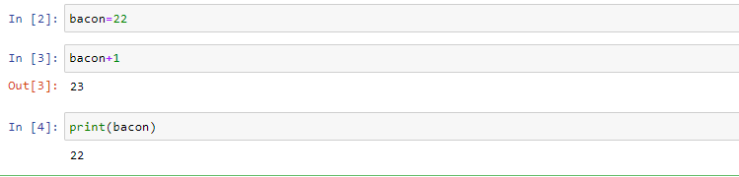

#### 7. What should the values of the following two terms be?

'spam'+'spamspam'  
'spam'*3

**Ans:** Both expressions evaluate to the string

**'spam'+'spamspam' :** 'spamspamspam'  the first expression follows String Concatenation

**'spam'*3**: spamspamspam follows String Multiplication and prints spamspamspam.

#### 8. Why is eggs a valid variable name while 100 is invalid?

**Ans:**

As per python, Variable names cannot begin with a number. The python rules for naming a variable are :-

1. Variable name must start with a letter or the underscore character.
2. Variable name cannot start with a number.
3. Variable name can only contain alpha-numeric characters and underscores (A-z, 0-9, & _ ).
4. Variable names are case-sensitive (name, GAURAV and gaurav are three different variables).
5. The reserved words (keywords) cannot be used naming the variable.

So as per the above rules we can name a variable as eggs but it cannot begin with a number so 100 is an invalid variable name.

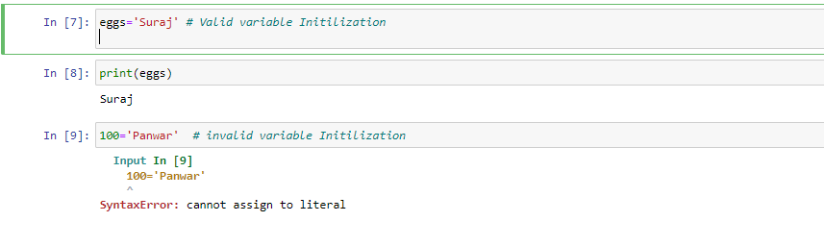

#### 9. What three functions can be used to get the integer, floating-point number, or string version of a value?

#### Ans:

#### The int(), float(),and str() functions will evaluate to the integer, floating-point number, string version of the value passed to them. So by using these type casting functions we can convert or get the desired data type of a particular value.

#### 

#### 10. Why does this expression cause an error? How can you fix it?

#### 'I have eaten ' + 99 + 'burritos.'

#### Ans:

#### The error is because of 99 as it is not a string. 99 must be type-casted to a string to fix this error. The correct way of representing is mentioned below:

**Input:** 'I have eaten ' + str(99) + 'burritos.'  
**Output:** 'I have eaten 99 burritos.'

#### 