AT ASSET CLEANUP UTILITY
Automating VFS and Event asset cleanup for faster, safer MFT deployments

Reduces a repetitive XML cleanup activity from 10-90 minutes per export to approximately 5-30 seconds, while improving consistency and reducing deployment risk.

1. Executive Summary
The AT Asset Cleanup Utility is an internally developed automation solution that prepares Managed File Transfer (MFT) asset export XML files for migration and deployment. The utility filters and cleans both Virtual Folder Structure (VFS) and Event assets, producing a focused, deployment-ready XML package without repetitive manual editing.

Business Problem
- MFT exports can contain unrelated assets, environment-specific user references, certificates and unnecessary dependencies.
- Engineers must manually locate required content, remove unwanted XML sections and validate the resulting file.
- Manual editing is difficult to standardize and becomes increasingly error prone as export size grows.

Proposed Solution
- Accept an MFT XML export and the VFS paths and Event assets required for deployment.
- Retain only the requested assets and remove unrelated content automatically.
- Remove user IDs, user templates, certificates and empty dependency blocks.
- Return a clean XML file for review, migration or deployment.

2. Scope and Core Capabilities
Capability | What the utility does | Business value
VFS cleanup | Retain selected VFS entries by parent path and VFS name. If no VFS path is supplied, all VFS assets are removed. | Prevents unrelated folder structures from entering the deployment package.
Event cleanup | Retains selected Event assets and removes unrelated Event definitions. | Create smaller and more focused migration packages.
Security cleanup | Removes user IDs, user templates, certificates, user collections and attribute-based user records. | Reduces environment-specific and sensitive configuration carryover.
Dependency cleanup | Keeps require dependencies and removes empty dependency blocks. | Reduces import issues and manual rework.
XML handling | Processes namespace-aware XML and preserves valid document structure. | Supports repeatable processing across exported packages.

3. Tool Interface Overview
The following illustrative interface views show how the utility can be presented to users. The screenshots are representative mock-ups based on the current cleanup workflow and can be replaced with captured production screens when the final interface is available.

Input and Cleanup Selection
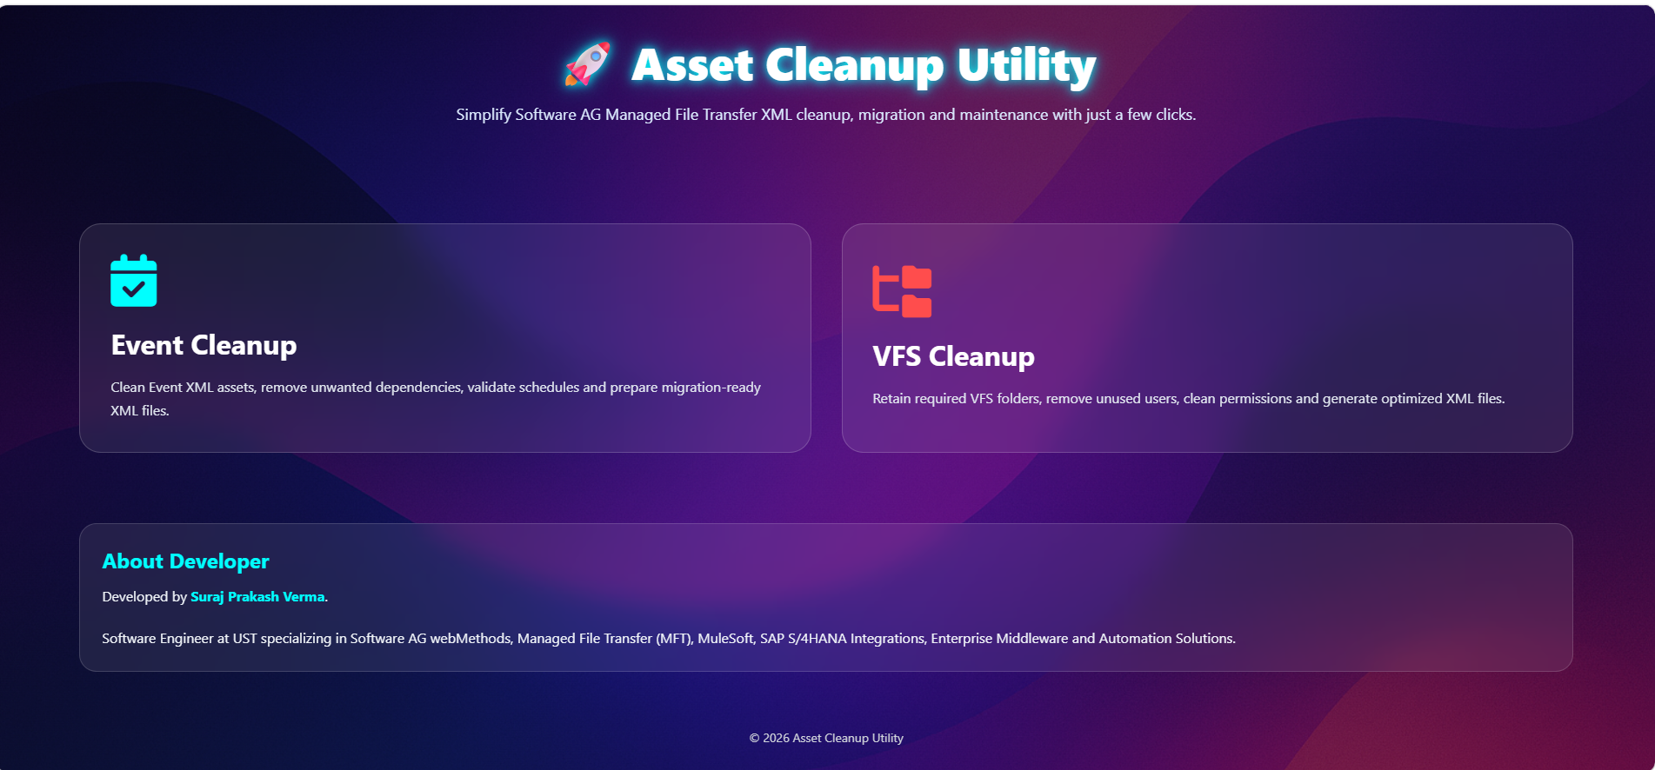
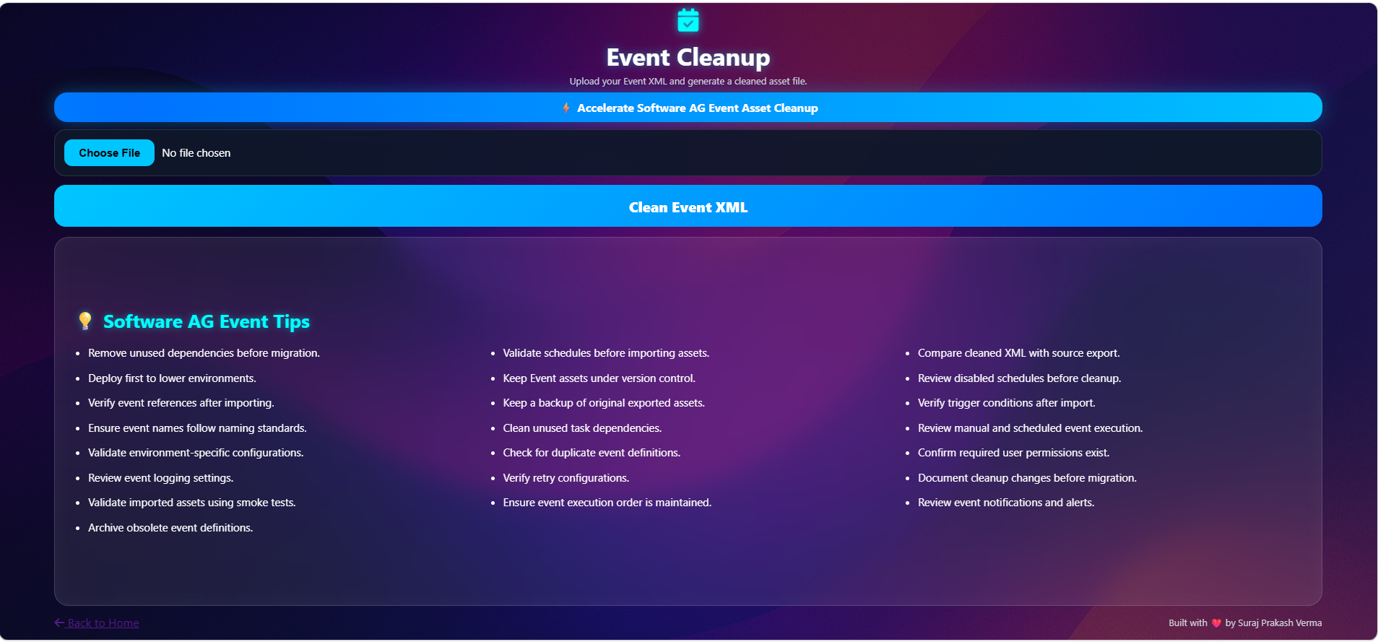
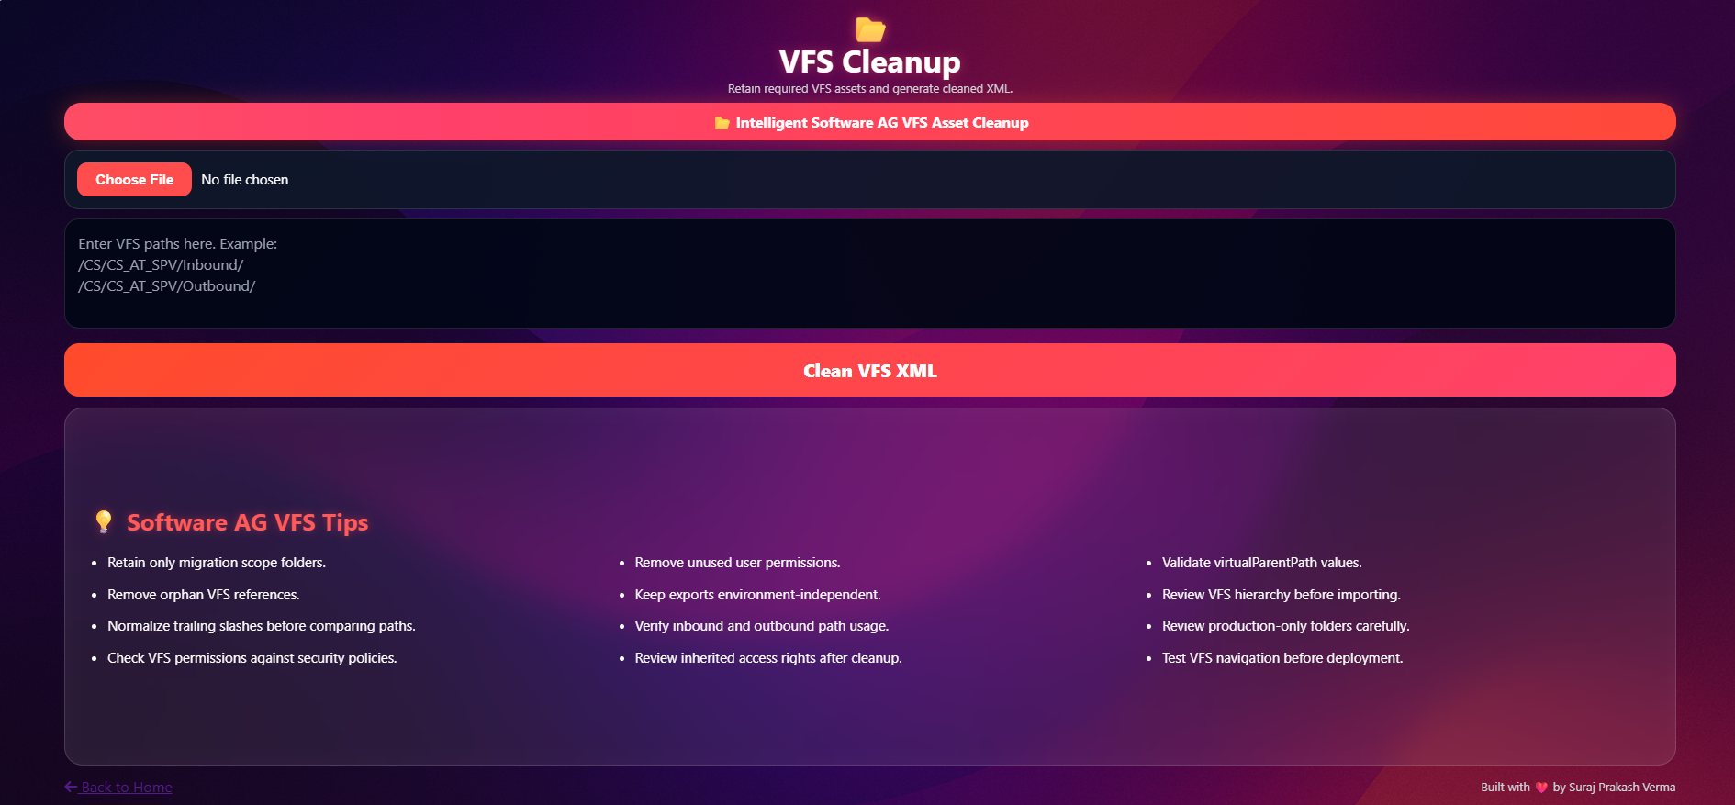
Illustrative interface for XML upload, VFS path selection, Event selection and cleanup options.
- Upload the source XML export.
- Enter one or more VFS paths and Event asset names.
- Select or apply standard cleanup controls.
- Run the cleanup using a single action.

4. Estimated Efficiency Impact
The estimates below are planning assumptions based on typical manual cleanup effort. Actual savings will vary by export complexity, review requirements and frequency of use.
Export size | Manual cleanup | Using utility
Small assets | 30-45 minutes | 5-30 seconds
Medium assets | 60-90 minutes | 5-30 seconds
Large assets | 90-150 minutes | 5-30 seconds

Illustrative Annual Savings
Assumptions
5 cleanup activities per engineer per week, 30 minutes of average manual effort per activity, and 52 working weeks for annualized comparison.
Measure | Single engineer | Team of 5
Manual effort per week | 150 minutes | 750 minutes
Estimated tool-assisted effort | 2-5 minutes | 10-25 minutes
Indicative annual time saved | 125-130 hours | 625-650 hours
Working-day equivalent, 8-hour day | About 16 days | About 78-81 days

5. Business Benefits
Productivity | Releases engineering time from repetitive XML editing.
Quality | Applies the same cleanup logic consistently across packages.
Risk reduction | Reduces accidental inclusion of users, certificates and unrelated dependencies.
Speed | Shortens deployment and migration package preparation.
Governance | Improves traceability through clear selection and result summaries.
Scalability | Can support multiple teams, projects and environments with the same process.

6. Risk, Controls and Adoption Considerations
Input validation: Validate XML format and clearly report invalid or unsupported input files.
Backup and traceability: Doesn’t Preserve the source export and generate output as a new file; optionally retain a processing summary.
Functional verification: Test VFS and Event selection against representative exports, including empty input and nested dependency scenarios.
Access and data handling: Run the utility within approved environments and avoid retaining export files longer than required.
Change management: Version cleanup rules, document updates and maintain regression test samples as XML structures evolve.

7. End-to-End Demonstration
This demonstration shows the complete operating flow, beginning with an asset export from the SAG ActiveTransfer server and ending with a cleaned XML file ready for review or deployment.

- Log in to the ActiveTransfer DEV administration interface using an approved account.
- Navigate to Asset movement > Export Assets.
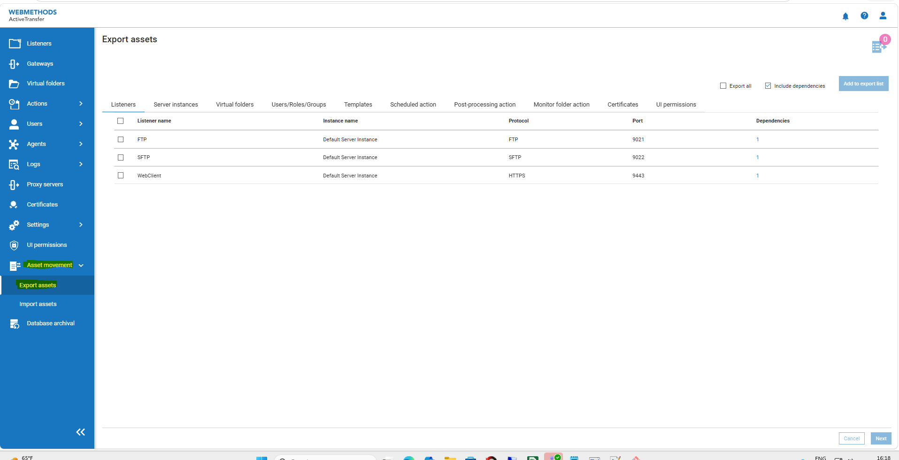

- Select the required Event assets from their respective tabs.
- Filter the required asset and uncheck the include dependencies.
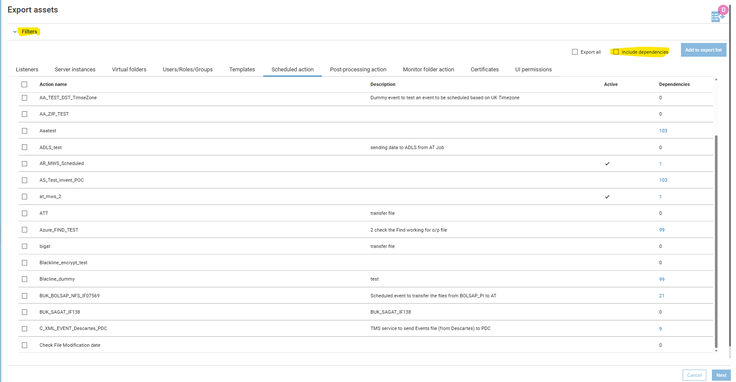
- Select the required events, click on add to export list.

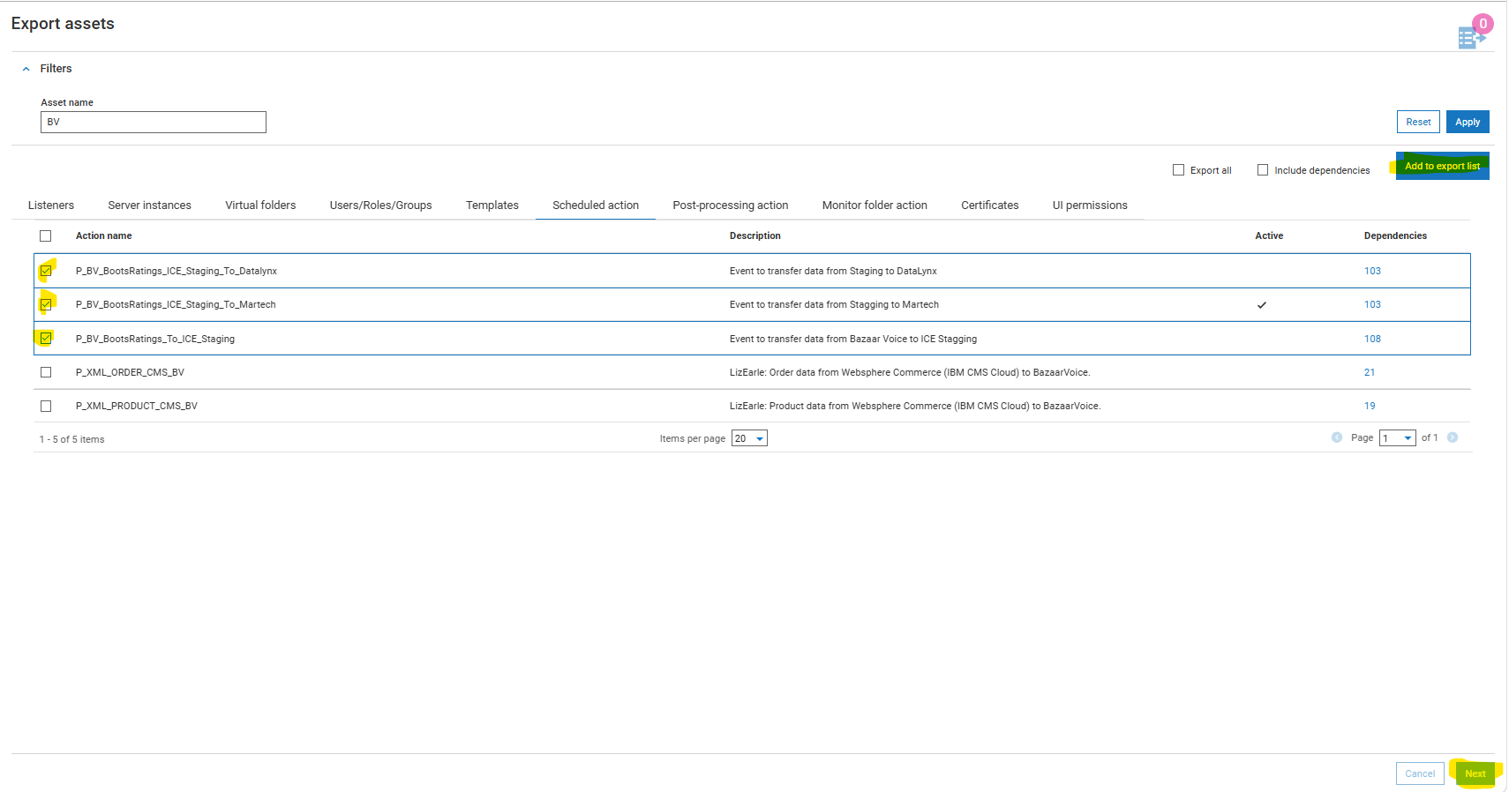
- Verify all the assets.
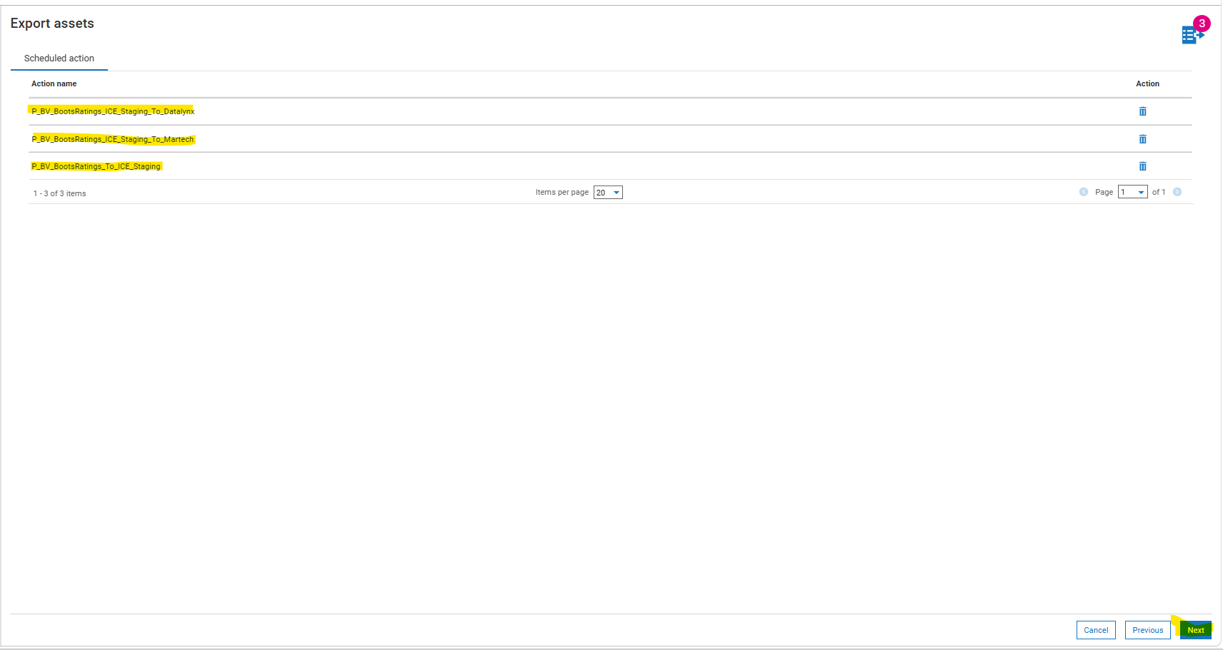
- Give a name to zip file.
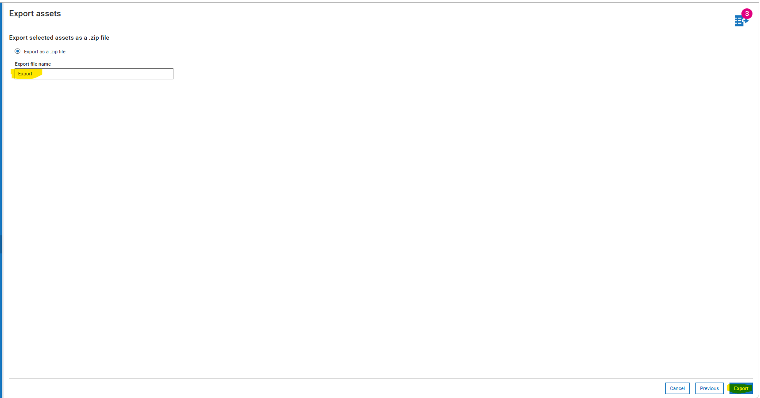
- Extract the downloaded ZIP to obtain the XML export file used as the tool input.

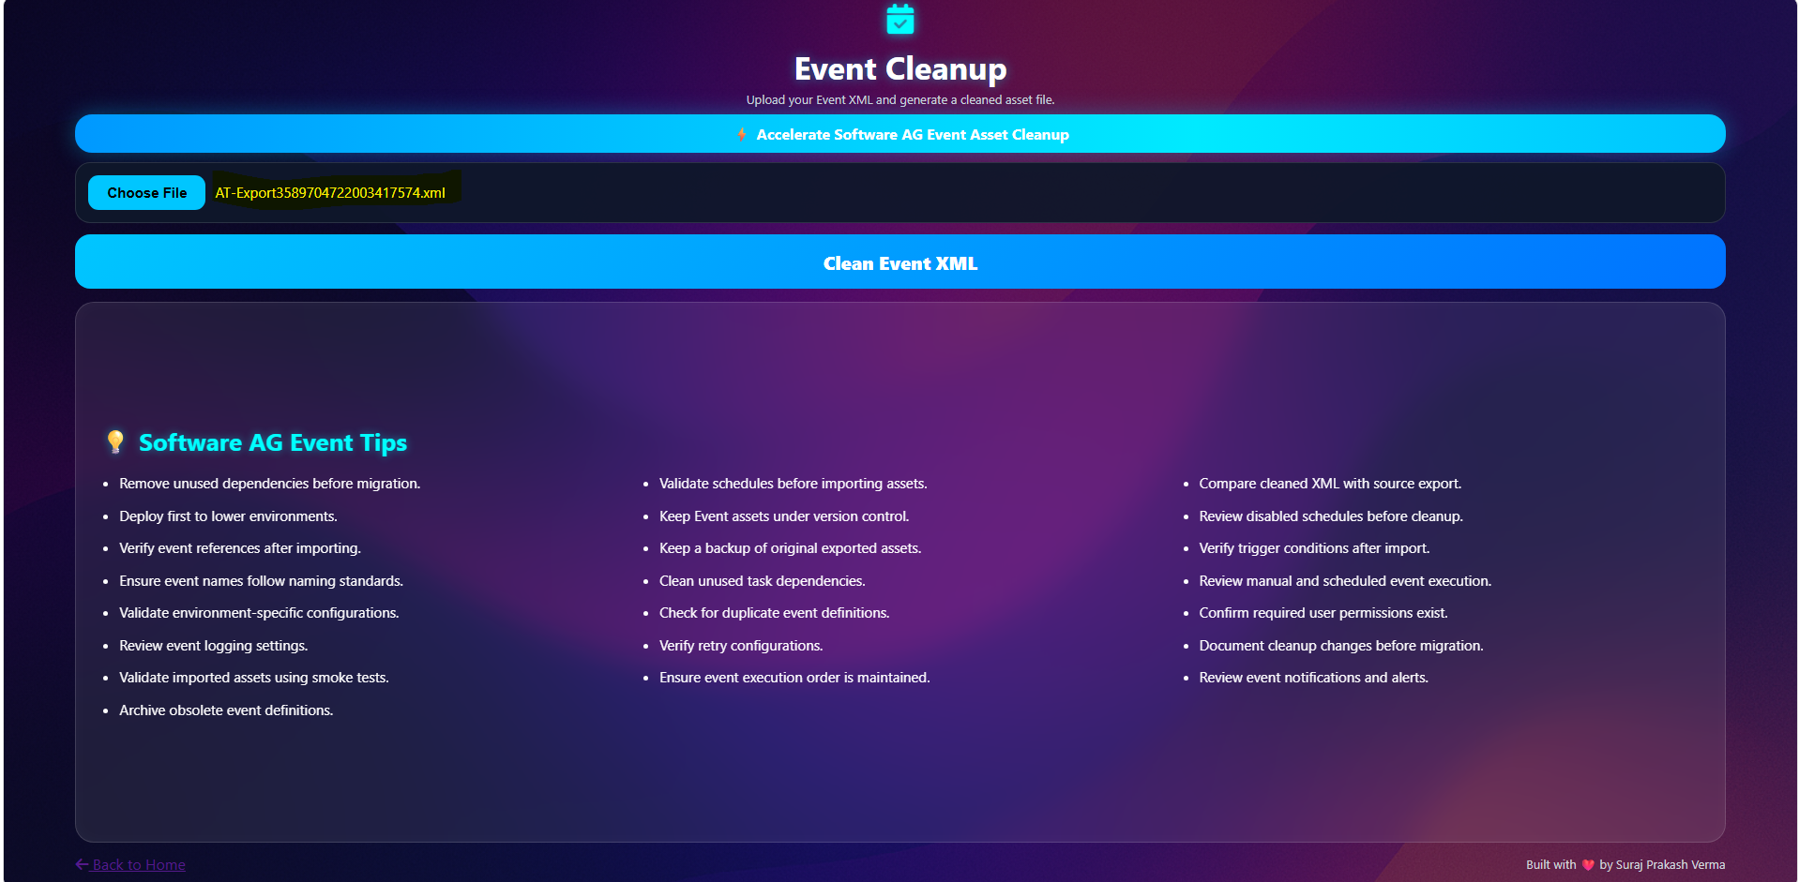
Sample Input:
Sample Output:

- Filter and select the required VFS assets, click on add to export list.

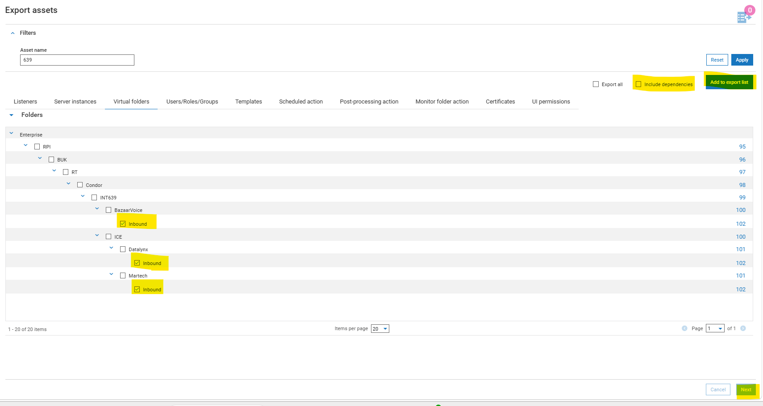
- Verify all the assets.

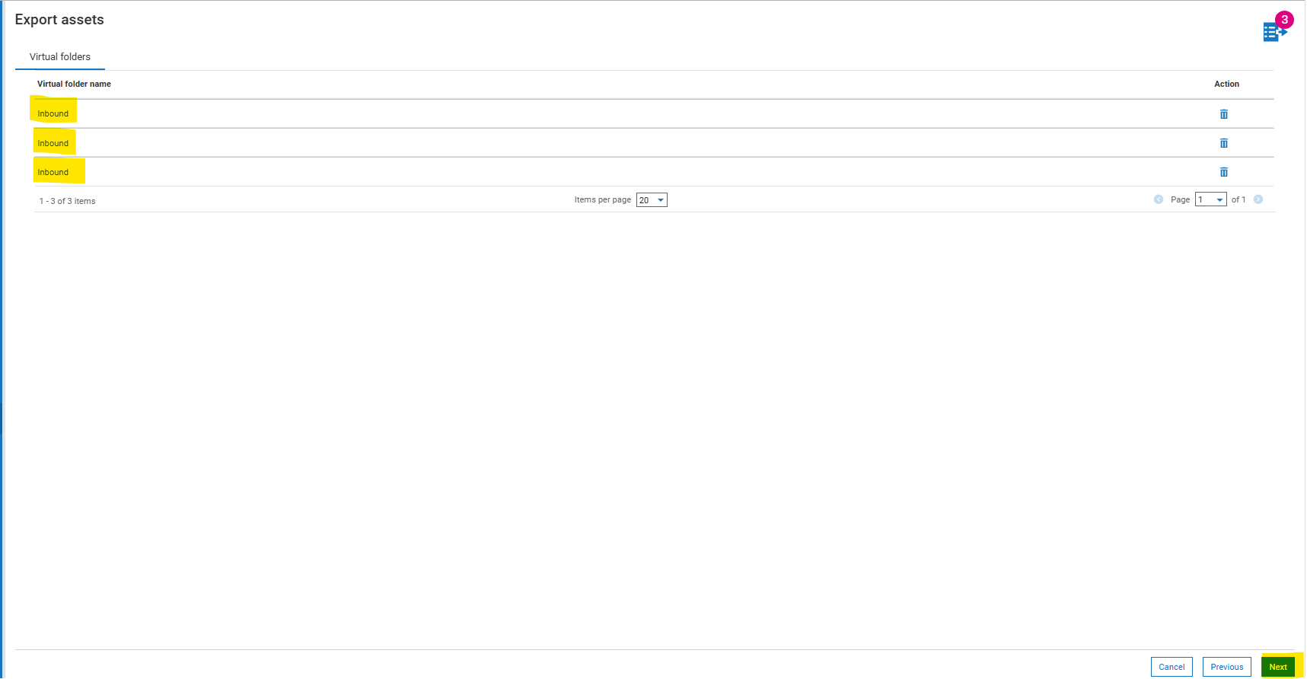
- Give a name to zip file.
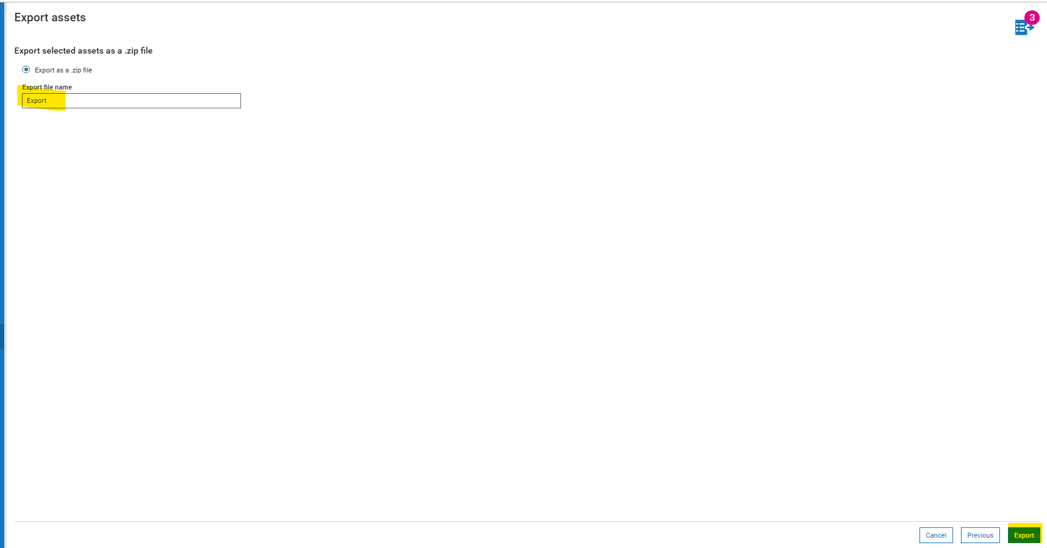
- Extract the downloaded ZIP to obtain the XML export file used as the tool input.

- Enter the VFS paths to retain, one per line or comma separated.
- Enter the Event assets to retain.
- If the VFS input is left empty, the utility removes all VFS assets.
- Run Clean Assets. The utility processes the XML and creates a separate cleaned output file without overwriting the original export.

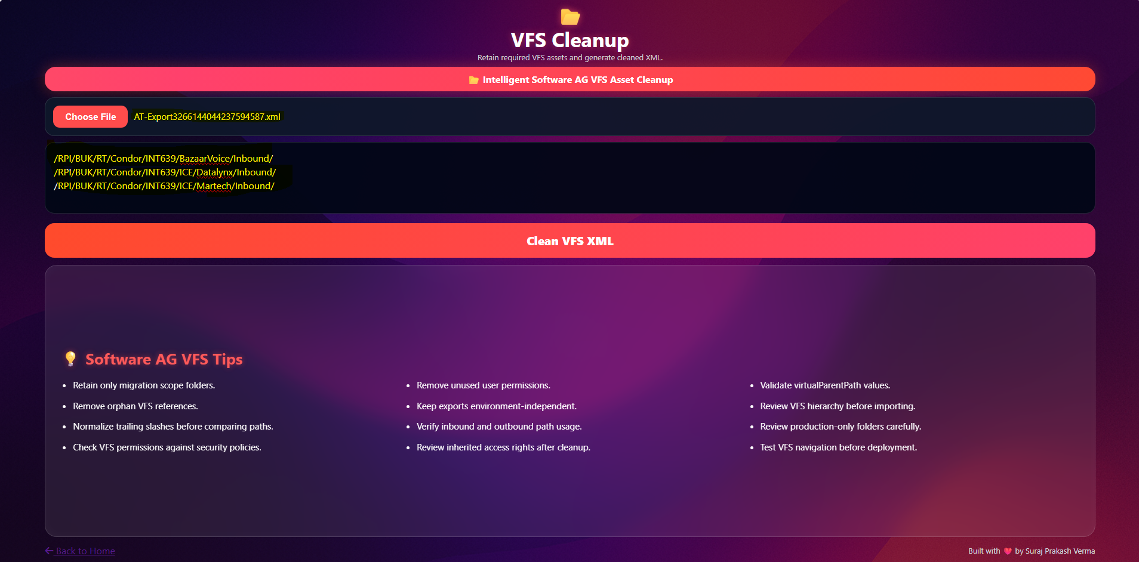
Sample Input:
Sample Output:

8. Conclusion
The AT Asset Cleanup Utility converts a repetitive and error-prone XML preparation activity into a fast and standardized process. By supporting both VFS and Event assets, the utility can improve engineering productivity, reduce deployment risk and create cleaner migration packages. Based on the stated usage assumptions, the indicative benefit is approximately 125-130 hours saved per engineer each year, with further value from quality improvements and reduced rework.
Decision summary
Proceed with controlled pilot adoption, measure actual time savings, and finalize the production interface and operating model before wider rollout.

