### Answer1- A line graph, also known as a line chart, is a type of chart used to visualize the value of something over time. For example, a manufacturer, who manufactures product X may plot the number of product sold over time to analyze the trend. The line graph consists of a horizontal x-axis and a vertical y-axis

### **Visualization with line graph**

For this we have to follow some steps :

* Open Tableau tool and connect a dataset into it.
* Drag and drop the one sheet of the connected dataset.
* Click on Sheet1 (at the bottom) to open the tableau worksheet.
* On clicking Sheet1 you will get whole dataset attributes on the left side and a worksheet for work.

**Example :**

* Select the Region and Sales fields as column and row respectively.
* Select the chart type line graph.
* Drag and drop the subcategory field in **Marks section,**choose **color**( by clicking three dots near it) to apply different color that makes it easier to distinguish between different subcategories.

Area charts in Tableau show relationships between different aspects or dimensions in a data set. This relationship is shown as the proportion of totals or percentage of certain data values.

for this, we have to open the worksheet first. Follow the steps below and open the worksheet :

1. Open Tableau tool and connect a dataset into it.
2. Drag and drop the one sheet of the connected dataset.
3. Click on sheet1 to open the tableau worksheet.
4. On clicking Sheet1 you will get whole dataset attributes on the left side and a worksheet for work.

**Example :**

* Select the **Order Date** and **profit** fields as column and row respectively.
* Select the chart type area chart.
* Apply marks by color of **Subcategory**. (Drag and drop Subcategory on color in marks section)

ANSWER2-Tableau Grouping is the process of merging or combining two or more values for further analysis. For example, When we see products by region report, we may find a few underperforming products. Sometimes, it may be annoying to see all those underperforming products. So we have to perform Tableau grouping on those records (combining those records) and display them as one product in a report

Example-In this example, we will show you how to create a Group from the Tableau dimensions pane. To do this, Drag and Drop the State-Province name from Dimension Region to Rows Shelf and the Sales Amount from Measures region to Columns Shelf.

To create tableau groups from the dimensions pane, Please select the Dimension on which you want to create the group, and then right-click on it will open the context menu. Please select Create option and then choose Group.. option from the context menu.

Once you select the option, a new window will open

* Field Name: Please specify the Unique name for the category or leave the default name. Make sure that the name should reflect the set functionality.
* Add to: This will show the existing ones. You can use this to add the items to the existing set.

We are selecting some of the random low-performed states. Please do not forget to click the Group button

Once you click on the button, a new group with a random name will create. You can use the Rename button to change the name as per your specification.

Next, click Apply and the OK button to close the window. That’s it; we successfully created our Tableau Group from the dimension pane. Let us replace the State Province Name from the Row shelf with State Province Name group.

It will show you the newly created and added Group in the report.

The following instructions use the Sample for combination

1. Drag Region to Columns.
2. Drag SUM(Sales) to Rows.
3. Drag Measure Names to Filters and select Profit, Order Quantity and Shipping Cost, then click **OK**.
4. Drag Measure Values to Rows.
5. Right-click Measure Values on the Rows shelf and select **Dual axis**.
6. Select Sales on the Marks card and format marks as desired.
7. Select Measure Names on the Marks card and format as desired.

ANSWER3If you drop one field on Color and then drop a different field on Color, the second field replaces the first field. However, depending on the chart type, for example treemaps and bullet graphs, you can put multiple fields on color. You can use one field to set the hue, and the other to show gradations within that hue.

Follow these steps, using the Sample - Superstore data source, to build a treemap with two fields on Color.

1. Drag **Category** and **Sub-Category** to **Columns**.
2. Drag **Sales** to **Size** on the **Marks** card.
3. Click **Show Me** in the toolbar, then select the Treemap chart type.

Tableau moves all fields to the **Marks** card, putting **SUM(Sales)** on both **Size** and **Color**, and **Category** and **Sub-Category** on **Label**:

click the label icon to the left of **Category** on the **Marks** card and select **Color**:

Click the label icon to the left of **Category** on the **Marks** card and select **Color**:

Tableau uses distinct, categorical colors for the first field, **Category**, and a range of sequential shades to distinguish values for the second field, **Sub-Category**:

The size of the individual rectangles is still determined by **Sales**, per **Category** and **Sub-Category**.

The two fields on **Color** (**Category** and **Sub-Category**) are related within a hierarchy, so if you swap their positions on the **Marks** card, moving **Sub-Category** to be above **Category**, the effect is the same as if you had removed **Category**from the view altogether. The treemap changes to show a uniquely colored rectangle for each **Sub-Category**:

1. When the two fields on Color are not related within a hierarchy, you can switch the order of the fields on the Marks card so that the field that was used for categorical colors was used for sequential shades, and vice versa.

If you aren’t satisfied with the colors that Tableau used, you can change them. To open the Edit Colors dialog, do one of the following:

* + In Tableau Desktop, double-click the color legend.
  + In Tableau Server or Tableau Cloud, click the drop-down arrow in the top right-hand corner of the legend.

1. Make the view more readable by adding **Category**, **Sub-Category**, and **Sales** to **Label**. Users can hover to see tooltips for any rectangle that is too small to show text by default.

ANSWER4Tableau offers 4 types of join: inner, left, right, and full outer join.

In general, there are four types of joins that you can use in Tableau: inner, left, right, and full outer. If you aren't sure what join type you want to use to combine data from multiple tables, you should use relationships.

|  |  |
| --- | --- |
| **Join Type** | **Result** |
| Inner | When you use an inner join to combine tables, the result is a table that contains values that have matches in both tables.  When a value doesn't match across both tables, it is dropped entirely. |
| Left | When you use a left join to combine tables, the result is a table that contains all values from the left table and corresponding matches from the right table.  When a value in the left table doesn't have a corresponding match in the right table, you see a null value in the data grid. |
| Right | When you use a right join to combine tables, the result is a table that contains all values from the right table and corresponding matches from the left table.  When a value in the right table doesn't have a corresponding match in the left table, you see a null value in the data grid. |
| Full outer | When you use a full outer join to combine tables, the result is a table that contains all values from both tables.  When a value from either table doesn't have a match with the other table, you see a null value in the data grid. |
| *Union* | Though union is not a type of join, union is another method for combining two or more tables by appending rows of data from one table to another. Ideally, the tables that you union have the same number of fields, and those fields have matching names and data types. For more information about union, see [Union Your Data](https://help.tableau.com/current/pro/desktop/en-us/union.htm). |

Not all databases support all join types. If an option is unavailable in the join dialog, it is likely due to a constraint from your data source.

ANSWER5

1. : Start Page.
2. Data Source Page.
3. The Tableau Workspace. Work with Data Fields in the Data Pane. Navigate Data Sources in the Data Pane. Navigate Between the Start Page and Workspace. ...
4. Reorganize your Workspace.
5. Files Types and Folders.
6. Language and Locale.
7. Helpful Visual Cues in Tableau.

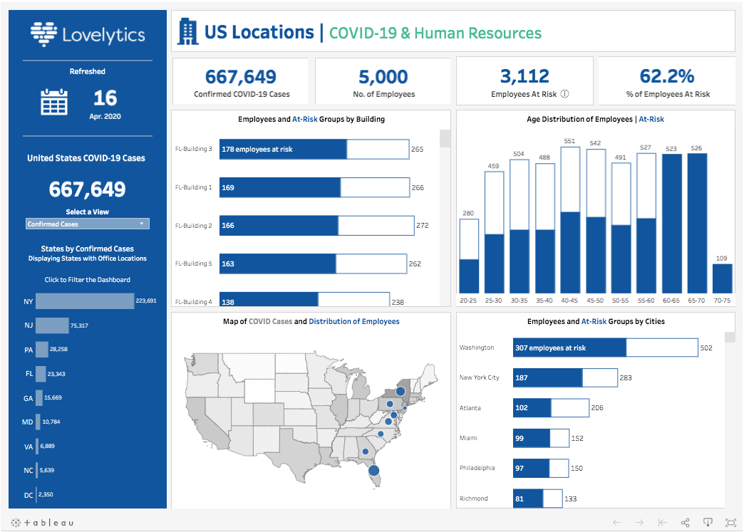

ANSWER6A scatter plot (aka scatter chart, scatter graph) uses dots to represent values for two different numeric variables. The position of each dot on the horizontal and vertical axis indicates values for an individual data point. Scatter plots are used to observe relationships between variables.

The example scatter plot above shows the diameters and heights for a sample of fictional trees. Each dot represents a single tree; each point’s horizontal position indicates that tree’s diameter (in centimeters) and the vertical position indicates that tree’s height (in meters). From the plot, we can see a generally tight positive correlation between a tree’s diameter and its height. We can also observe an outlier point, a tree that has a much larger diameter than the others. This tree appears fairly short for its girth, which might warrant further investigation.

[Heatmap](https://chartio.com/learn/charts/heatmap-complete-guide/) can be a good alternative to the scatter plot when there are a lot of data points that need to be plotted and their density causes overplotting issues. However, the heatmap can also be used in a similar fashion to show relationships between variables when one or both variables are not continuous and numeric. If we try to depict discrete values with a scatter plot, all of the points of a single level will be in a straight line. Heatmaps can overcome this overplotting through their binning of values into boxes of counts

. A retail chain is trying to decide which region of California has the most potential for high sales volume and should have new store branches added. The market researcher uses a heat map to quickly determine the areas where the revenue is highest.

To create a heat map, complete the following steps:

1. Drag a point dataset to the page and drop it on the **Map** drop zone.

Note:

You can also create a map by selecting a field and clicking the **Map** button above the data pane.

1. Expand the legend to display the **Layer options** pane.
2. Browse to the **Symbology** tab Symbology.
3. Change **Symbol type** to **Heat map**.

ANSWER7

A table calculation is a transformation you apply to the values in a visualization. Table calculations are a special type of calculated field that computes on the local data in Tableau. They are calculated based on what is currently in the visualization and do not consider any measures or dimensions that are filtered out of the visualization.

You can use table calculations for a variety of purposes, including:

* Transforming values to rankings
* Transforming values to show running totals
* Transforming values to show percent of total

Quick table calculations allow you to quickly apply a common table calculation to your visualization using the most typical settings for that calculation type. This article demonstrates how to apply a quick table calculation to a visualization using an example.

The following quick table calculations are available in Tableau for you to use:

* Running total
* Difference
* Percent difference
* Percent of total
* Rank
* Percentile
* Moving average
* YTD total
* Compound growth rate
* Year of year growth

Set up the visualization

1. Open Tableau Desktop and connect to the **Sample-Superstore** data source, which comes with Tableau.
2. Navigate to a new worksheet.
3. From the **Data** pane, under Dimensions, drag **Order Date** to the **Columns**shelf.
4. From the **Data** pane, under Dimensions, drag **State**to the **Rows**shelf.
5. From the **Data** pane, under Measures, drag **Sales**to **Text**on the Marks Card.
6. From the **Data** pane, under Measures, drag **Profit**to **Color**on the Marks Card.
7. On the Marks card, click the Mark Type drop-down and select **Square**.

Common examples of table calculations include running sum, moving average, and percent of total. Calculations are computed over local data (post-filtered data) within Tableau. The important concepts to keep in mind are: Table calculation math will be based only on dimensions (granularity) within the view.0

ANSWER8

Distribution Bands allow users either to create bands as one or more multiples of a previous aggregate (for instance, 50%, 100%, or 150% of the median) or to create lines or bands based on statistical measures (for instance, percentiles, quantiles, and standard deviation).

* **Reference distribution:** The reference distribution is a distribution that uses the reference line for the division. The visualization is distributed in some parts with the help of a reference line as it works as a distribution boundary between these parts of the visualization.
* For this we have to follow some steps :
* Open the Tableau tool and connect a dataset into it. Drag and drop the one sheet of the connected dataset. Click on sheet1 to open the tableau worksheet. On clicking Sheet1 you will get whole dataset attributes on the left side and a worksheet for work.

To draw a reference distribution band you have to first draw a graph or chart by selecting attributes (by drag and drop) then apply the concept of distribution band.

reference distributions add a gradient of shading to indicate the values’ distribution along the axis. Distribution can be defined by percentiles, percentages, quantiles (as in the below image), or standard deviation.

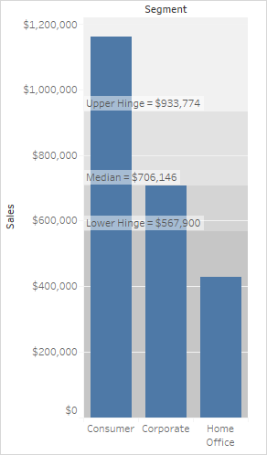

ANSWER9

1. Start Building a Viz by Dragging Fields to the View. Use Axes and Multiple Measures in a View. ...
2. Add Visual Detail. About the Marks Card. ...
3. Filter and Sort Data. Filter Data. ...
4. Showcase Insights. Show Totals. ...
5. Add Interactivity using Actions. ...
6. Build Common Chart Types. ...
7. Build Advanced Chart Types. ...
8. Build Data Views for Accessibility.

**Understanding the Steps Involved in Setting Up Tableau Pie Charts**

1. Step 1: Load the Dataset. ...
2. Step 2: Construct a Bar Chart. ...
3. Step 3: Convert a Bar Chart into a Pie Chart. ...
4. Step 4: Increase the Size of the Pie Chart. ...
5. Step 5: Drag and Place Dimensions to Label Card. ...
6. Step 6: Apply Formatting to the Pie Chart.

In this example we draw a pie chart by following simple steps :

* Drag and drop two fields one for row and another for column.
* Click on show me and select the pie chart
* Increase the size of the pie chart by using size marks and select and drag.

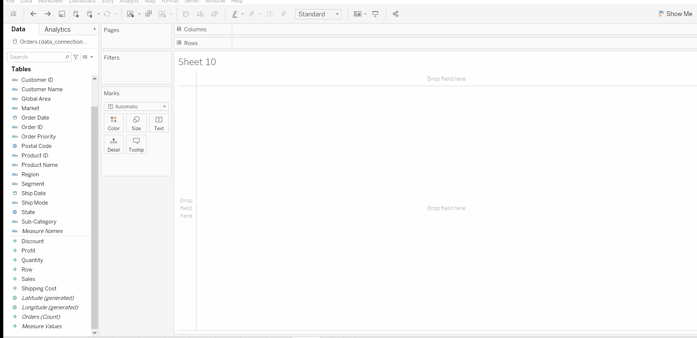

ANSWER10

Create a story point

1. Click the **New Story** tab.



Tableau opens a new story as your starting point:

In the lower-left corner of the screen, choose a size for your story. Choose from one of the predefined sizes, or set a custom size, in pixels:

1. By default, your story gets its title from the sheet name. To edit it, right-click the sheet tab, and choose **Rename Sheet**.

If you're using Tableau Desktop, you can also rename a story by double-clicking the title.

1. To start building your story, double-click a sheet on the left to add it to a story point.

IWhen you add a sheet to a story point, that sheet remains connected to the original sheet. If you modify the original sheet, your changes will automatically be reflected on the story points that use it.n Tableau Desktop, you can also drag sheets into your story point.

1. Click **Add a caption** to summarize the story point.

In Tableau Desktop, you can highlight a key takeaway for your viewers by dragging a text object to the story worksheet and typing a comment.

1. To further highlight the main idea of this story point, you can change a filter or sort on a field in the view. Then save your changes by clicking **Update** on the story toolbar above the navigator box:

Add another story point by doing one of the following:

* Click **Blank** to use a fresh sheet for the next story point.

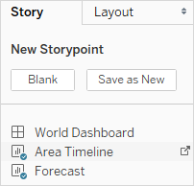

Start customizing a story point and click **Save as New** on the toolbar above the navigator box.

* + Click **Duplicate** to use the current story point as the basis for a new one.