2.1)

Using the given information, calculating the $α_{1}, α_{2}, α_{3}$

For $X_{1}=0,$

Here, $α_{i}(K)$ represents $α$ for the $K$ state $i$

$$α_{1}\left(1\right)=P\left(X_{1}=S_{1}\right)*P\left(y=0 | x=S_{1}\right)=0.6*0.7=0.42$$

$$α_{2}\left(2\right)=P\left(X_{1}=S_{2}\right)*P\left(y=0 | x=S_{2}\right)=0.4*0.8=0.32$$

For $X_{2}=1$

$$α_{2}\left(1\right)=P\left(y=1 | x=S1\right)\left(a_{11}α_{1}\left(1\right)+a_{21}α_{1}\left(2\right)\right)=0.3*\left(0.42*0.9+0.32*0.2\right)$$

$$=0.1326$$

$$α_{2}\left(2\right)=P\left(y=1 | x=s2\right)\left(a_{12}α_{1}\left(1\right)+a_{22}α_{1}\left(2\right)\right)=0.2*\left(0.42*0.1+0.32*0.8\right)$$

$$=0.0596$$

For $X_{3}=0$

$$α_{3}\left(1\right)=P\left(y=0 | x=S1\right)\left(a_{11}α_{2}\left(1\right)+a_{21}α_{2}\left(2\right)\right)=0.7*\left(0.1326*0.9+0.0596*0.2\right)=0.091882$$

$$α_{3}\left(2\right)=P\left(y=0 | x=S2\right)\left(a_{12}α_{2}\left(1\right)+a_{22}α_{2}\left(2\right)\right)=0.8*\left(0.1326*0.1+0.0596*0.8\right)=0.048752$$

Therefore,

$$P(x_{1:3}=α_{3}\left(S1\right)+α_{3}\left(S2\right)=0.1406$$

2.2)

For $X_{3}=0$

$$β_{3}\left(1\right)=1$$

$$β_{3}\left(2\right)=1$$

For $X_{2}=1$

$$β_{2}\left(1\right)={(β}_{3}\left(1\right){*a}_{11}*b_{0S1})+(β\left(2\right)*a_{12}*b_{0S2})=\left(1*0.9*0.7\right)+\left(1*0.1*0.8\right)=0.71$$

$$β_{2}\left(2\right)=(β_{3}\left(1\right){*a}_{21}*b_{0S1})+(β_{3}\left(2\right)*a_{22}*b_{0S2})=\left(1*0.2*0.7+1*0.8*0.8\right)=0.78$$

For $X_{1}=0$

$$β_{1}\left(1\right)=\left(β_{2}\left(1\right)*a_{11}*b_{1s1}\right)+\left(β_{2}\left(2\right)a_{12}*b_{1s2}\right)=\left(0.71*0.9*0.7\right)+\left(0.78*0.1*0.8\right)=0.2073$$

$$β_{1}\left(2\right)=(β_{2}\left(1\right)*a_{21}*b_{1s1})+(β_{2}\left(2\right)*a_{22}*b_{1s2}=(0.71*0.2*0.7)+(0.78*0.8*0.8)=0.1674$$

$$P\left(X_{1:3 }\right)=β_{1}\left(S1\right)π_{1}P\left(x_{1}=0 | Z_{1}=S1\right)+β_{2}\left(S2\right)π_{2}P\left(x_{1}=0 | Z_{1}=S2\right)=0.140634$$

2.3)

From the above results, we can conclude that both forward and backward algorithms agree.

2.4) Calculating $γ_{1},γ_{2}and γ_{3}$

$$γ_{1}=P\left(X_{1}=S_{1} | O;θ\right)=\frac{α_{1}\left(1\right)β_{1}(1)}{α_{1}\left(1\right)β_{1}\left(1\right)+α_{1}\left(2\right)β_{1}\left(2\right)}=\frac{0.42*0.2073}{0.42*0.2073+ 0.32*0.1674}=0.6190$$

$$P\left(X_{1}=S_{2} | O;θ\right)=1-0.5917=0.4082$$

$$γ_{2}=P\left(X_{2}=S_{1} | O;θ\right)=\frac{α_{2}\left(1\right)β_{2}(1)}{α_{2}\left(1\right)β_{2}\left(1\right)+α_{2}\left(2\right)β_{2}\left(2\right)}=\frac{0.1326*0.71}{0.1326*0.71+ 0.0596*.78}=0.6694$$

$$P\left(X_{2}=S_{2} | O;θ\right)=1-0.3968=0.3305$$

$$γ_{3}=P\left(X_{3}=S_{1} | O;θ\right)=\frac{α_{3}\left(1\right)β_{3}(1)}{α_{3}\left(1\right)β_{3}\left(1\right)+α_{3}\left(2\right)β_{3}\left(2\right)}=\frac{0.09188*1}{0.09188*1+ 0.04875*1}=0.6533$$

$$P\left(X_{3}=S_{2} | O;θ\right)=1-0.6533=0.3466$$

Hence the most likely sequence is $S_{1}S_{1}S_{1}$

2.5)

$$δ_{1}\left(S1\right)=P\left(Z_{1}=S1,x_{1}=0\right)=π_{1}P\left(x_{1}=0 | Z_{1}=S_{1}\right)=0.6*0.7=0.42$$

$$δ_{2}\left(S2\right)=P\left(Z_{1}=S_{2}, x_{1}=0\right)=π_{2}P\left(x_{1}=0 | Z_{1}=S_{2}\right)=0.4*0.8=0.32$$

$$δ_{2}\left(S1\right)=\max\left\{δ_{1}\left(S1\right)*a_{11}*P\left(x_{2}=1 | Z_{2}=S1\right), δ_{1}\left(S2\right)*a_{21}*P\left(x_{2}=1 | Z_{2}=S2\right)\right\}$$

$$=\max\left(0.1134,0.0192\right)$$

$$=0.1134$$

$$δ_{2}\left(S2\right)=\max\left\{δ_{1}\left(S2\right)*a_{12}*P\left(x_{2}=1 | Z_{2}=S2\right), δ_{1}\left(S2\right)*a_{22}*P\left(x_{2}=1 | Z_{2}=S2\right)\right\}$$

$$=\max\left(0.0084, 0.0512\right)$$

$$=0.0512$$

$$δ_{3}\left(S1\right)=\max\left\{δ_{2}\left(S1\right)*a_{11}*P\left(x_{3}=1 | Z_{3}=S1\right), δ_{2}\left(S2\right)*a_{21}*P\left(x_{3}=1 | Z_{3}=S2\right)\right\}$$

$$=\max\left(0.071442, 0.007168\right)$$

$$=0.071442$$

$$δ_{3}\left(S2\right)=\max\left\{δ_{2}\left(S1\right)*a_{11}*P\left(x_{3}=1 | Z_{3}=S1\right), δ_{2}\left(S2\right)*a_{21}*P\left(x_{3}=1 | Z_{3}=S2\right)\right\}$$

$$=\max\left(0.015876, 0.032768\right)$$

$$=0.032768$$

Hence the most likely sequence is S1, S1 and S1

Question 1.

$$J\left(\vec{v}\right)=\sum_{i=1}^{n}{{\left\|\vec{x_{i}}-\left({\vec{v}}^{T}\vec{x_{i}}\right)\vec{v_{i}} \right\|}^{2}}$$

Expanding,

$$=\sum_{i=1}^{n}{{\left(\vec{x_{i}}-(\left({\vec{v}}^{T}\vec{x_{i}}\right)\vec{v_{ }}\right)}^{T}(\vec{x_{i}}-\left({\vec{v}}^{T}\vec{x_{i}}\right)\vec{v_{ }})}$$

$$=\sum_{i=1}^{n}{{\left(\vec{x_{i}^{T}}-{\vec{v}}^{T}({\vec{v}}^{T}\vec{x_{i}}\right)}^{T}\vec{x_{i}}-\vec{x_{i}}({\vec{v}}^{T}\vec{x_{i}}})\vec{v_{ }}$$

$$=\sum_{i=1}^{n}{{\left\|\vec{x_{i}}\right\|}^{2}-2}{\left({\vec{v}}^{T}\vec{x_{i}}\right)}^{2}+{\left({\vec{v}}^{T}\vec{x_{i}}\right)}^{2}(\vec{v_{ }}{\vec{v_{ }}}^{T})$$

$$=\sum_{i=1}^{n}{{\left\|\vec{x_{i}}\right\|}^{2}-{\left({\vec{v}}^{T}\vec{x_{i}}\right)}^{2}}$$

$$=\sum_{i=1}^{n}{{\left\|\vec{x_{i}}\right\|}^{2}-R(\vec{v_{ }})}$$

In order to minimize $J(\vec{v_{ }})$ we have to maximize $R(\vec{v_{ }})$ and hence both are equivalent.

3.

D)

For k = 1

Time taken for computation = 36.1047

Training accuracy = 60.1527

Test accuracy = 54.6364

For k = 3

Time taken for computation = 18.0293

Training accuracy = 86.6961

Test accuracy = 79.5

For k = 5

Time taken for computation = 16.5943

Training accuracy = 95.3753

Test accuracy = 87.1818

For k = 15

Time taken for computation = 13.2664

Training accuracy = 97.7952

Test accuracy = 89.2273

For k = 100

Time taken for computation = 13.3101

Training accuracy = 97.5694

Test accuracy = 88.9545

Increase in K values results in increase in accuracy in both training and test data. Till it reaches a point. This is because higher the number of K, higher the information retained in the reconstruction of image.

For Runtime, we see that it reduces as the value of K increases and after reaching a plateau the runtime starts to increase again.

B)

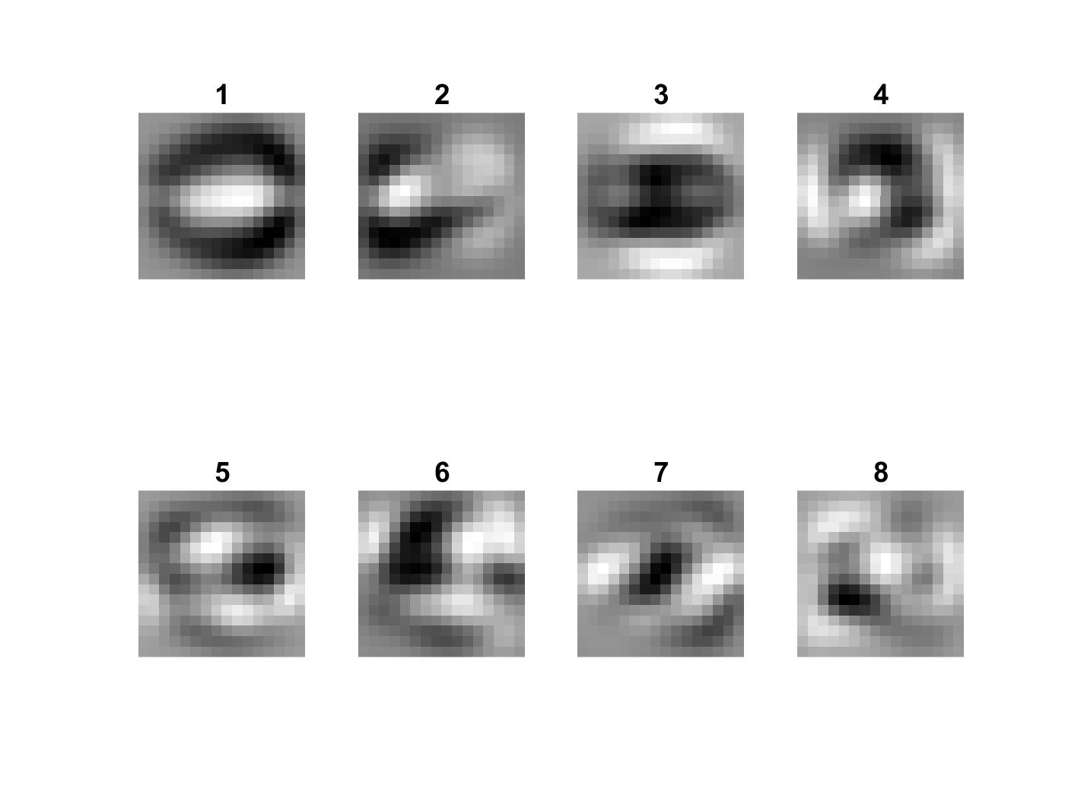

C)

