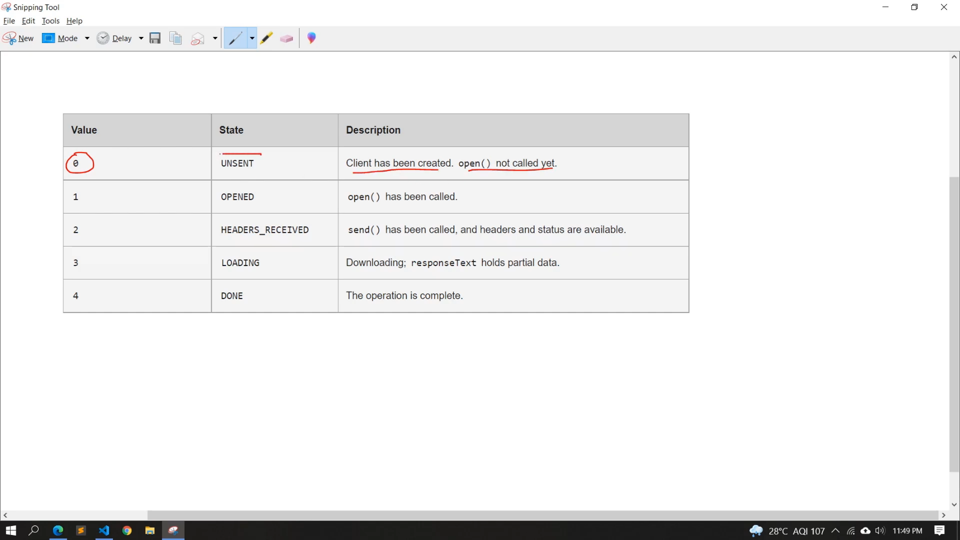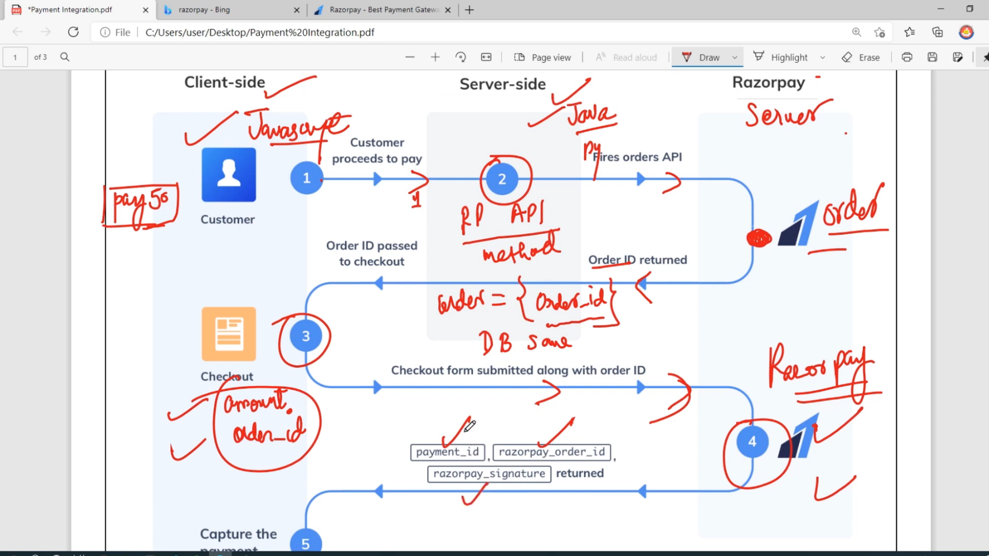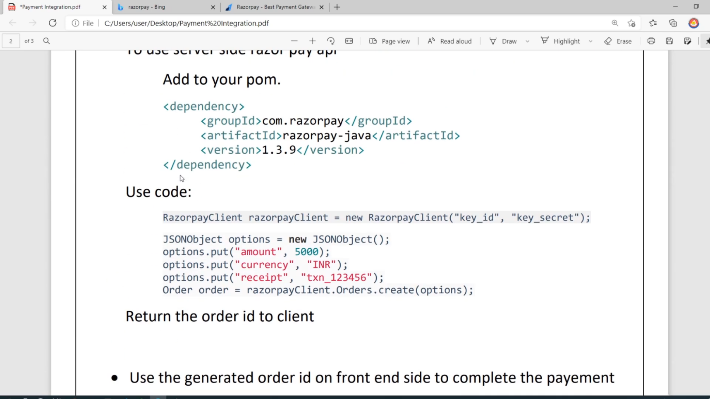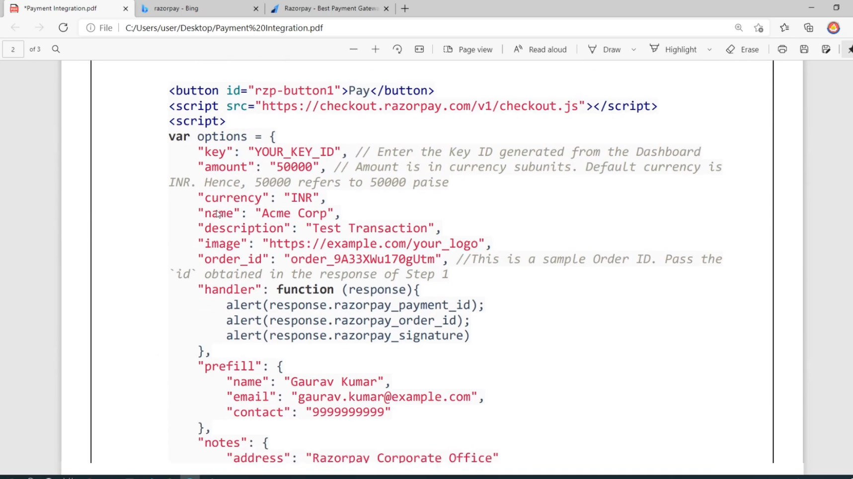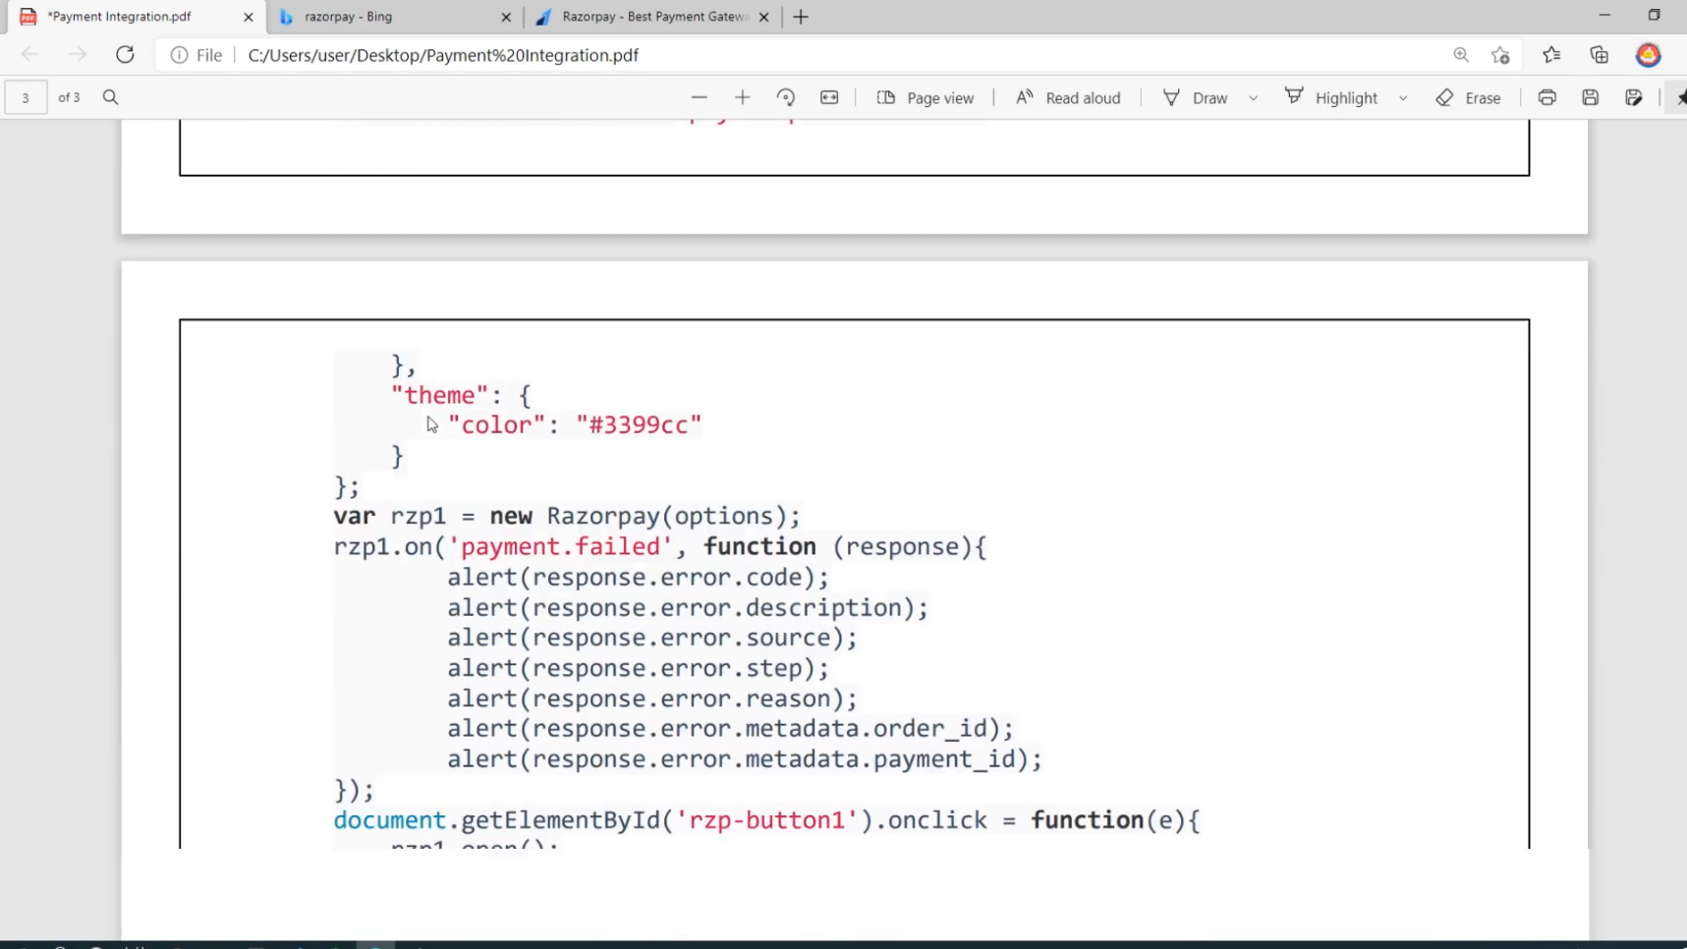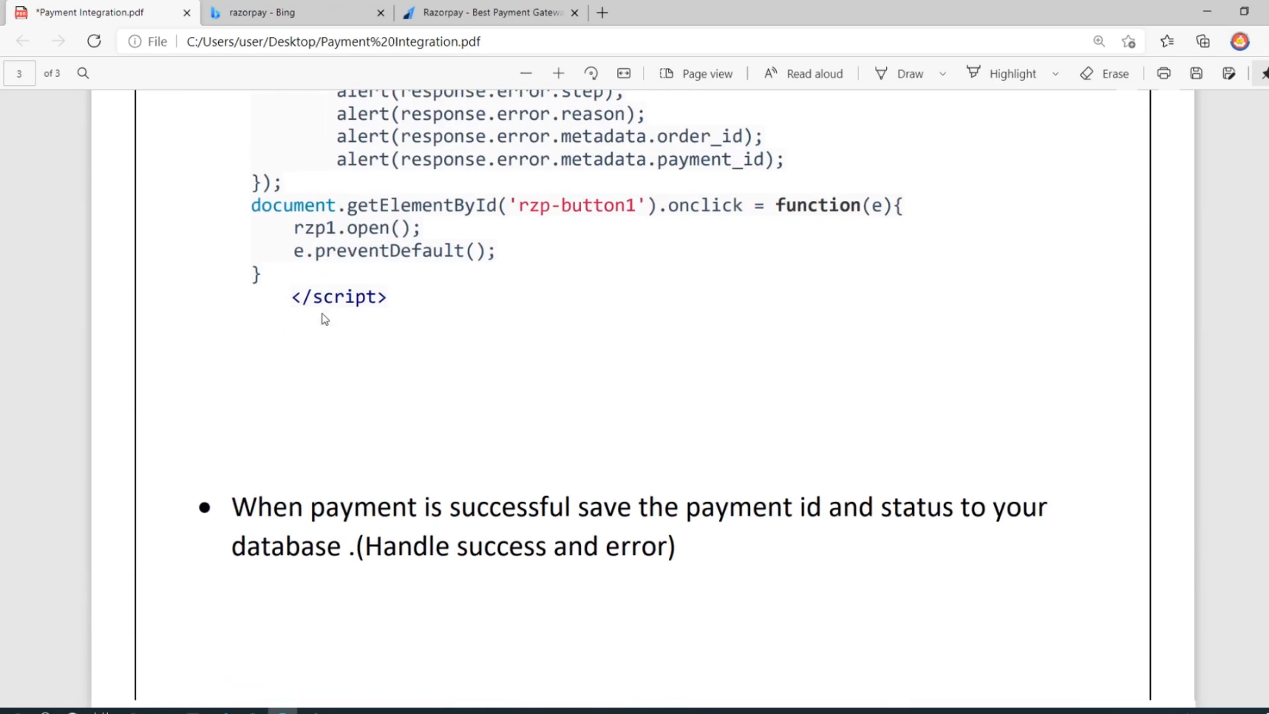

*Create a Razorpay Account

• Generate and download API Keys

• Create a payment form.

• When user click on pay button then send the request to server and create order at server side using razorpay api at backed, if you want to save the order save your database and return order_ID ( very important to complete the payment )

**To use server side razor pay api**

Add to your pom.

<dependency>

<groupId>com.razorpay</groupId>

<artifactId>razorpay-java</artifactId>

<version>1.3.9</version>

</dependency>

**Use code:**

RazorpayClient razorpayClient = new RazorpayClient ("key_id", "key_secret");

JSONObject options = new JSONObject(); options.put("amount", 5000);

options.put("currency", "INR");

options.put("receipt", "txn_123456");

below is also same

Order order = razorpayClient.Orders.create(options);

[Return the order ID to the client

Use the generator order ID on front end side to complete the payment

<button id="rzp-button1">Pay</button>

<button id="rzp-button1">Pay</button>

<script src="https://checkout.razorpay.com/v1/checkout.js"></script>

<script>

var options = {

"key": "YOUR_KEY_ID", // Enter the Key ID generated from the Dashboard

"amount": "50000", // Amount is in currency subunits. Default currency is INR. Hence, 50000 refers to 50000 paise

"currency": "INR",

"name": "Acme Corp",

"description": "Test Transaction",

"image": "https://example.com/your_logo",

"order_id": "order_9A33XWu170gUtm", //This is a sample Order ID. Pass the `id` obtained in the response of Step 1

"callback_url": "https://eneqd3r9zrjok.x.pipedream.net/",

"prefill": {

"name": "Gaurav Kumar",

"email": "gaurav.kumar@example.com",

"contact": "9999999999"

},

"notes": {

"address": "Razorpay Corporate Office"

},

"theme": {

"color": "#3399cc"

}

};

var rzp1 = new Razorpay(options);

document.getElementById('rzp-button1').onclick = function(e){

rzp1.open();

e.preventDefault();

}

</script>

<button id="rzp-button1">Pay</button>

<script src="https://checkout.razorpay.com/v1/checkout.js"></script>

<script>

var options = {

"key": "YOUR_KEY_ID", // Enter the Key ID generated from the Dashboard

"amount": "50000", // Amount is in currency subunits. Default currency is INR. Hence, 50000 refers to 50000 paise

"currency": "INR",

"name": "Acme Corp",

"description": "Test Transaction",

"image": "https://example.com/your_logo",

"order_id": "order_9A33XWu170gUtm", //This is a sample Order ID. Pass the `id` obtained in the response of Step 1

"handler": function (response){

alert(response.razorpay_payment_id);

alert(response.razorpay_order_id);

alert(response.razorpay_signature)

},

"prefill": {

"name": "Gaurav Kumar",

"email": "gaurav.kumar@example.com",

"contact": "9999999999"

},

"notes": {

"address": "Razorpay Corporate Office"

},

"theme": {

"color": "#3399cc"

}

};

var rzp1 = new Razorpay(options);

rzp1.on('payment.failed', function (response){

alert(response.error.code);

alert(response.error.description);

alert(response.error.source);

alert(response.error.step);

alert(response.error.reason);

alert(response.error.metadata.order_id);

alert(response.error.metadata.payment_id);

});

document.getElementById('rzp-button1').onclick = function(e){

rzp1.open();

e.preventDefault();

}

</script>

var rzp1

new Razorpay (options);

rzp1.on('payment. failed', function (response){

alert(response.error.code);

alert(response.error.description);

alert(response.error.source);

alert(response.error.step);

alert(response.error.reason);

alert(response.error.metadata.order_id);

alert(response.error.metadata.payment_id);

});

document.getElementById('rzp-button1').onclick= function(e){

rzp1.open();

e.preventDefault();

}

</script>