# An

# Industrial Training Report

on

“Industrial Training On OOPs Library Management System”

Submitted in partial fulfillment for the award of degree

of

**S.Y. B. Tech.**

in

**INFORMATION TECHNOLOGY**

Submitted by

1. **Diwate Suraj Ramrao 20141222**

Under the Guidance of

**Prof. N. M. Mule**

**Prof. P. D. Sheth**



**Government College of Engineering, Karad**

(An Autonomous Institute of Government of Maharashtra)

# Academic Year 2021-2022

**Government College of Engineering, Karad**

(An Autonomous Institute of Government of Maharashtra)

# Department of Information Technology

***CERTIFICATE***

This is to certify that the Industrial Training entitled “ Industrial Training On OOPs ” has been carried out by:

1. **Suraj Ramrao Diwate 20141222**

of Second Year B. Tech. I.T. class under the guidance of Prof. N.M.Mule And Prof. P.D.Sheth during the academic year 2021 -22 (Sem-III).

|  |  |
| --- | --- |
| **Prof. N. M. Mule**  **Prof. P. D. Sheth** | **Dr. S. J. Wagh** |
|  |  |
| **Guide** | **Head, IT** |

**Acknowledgement**

Apart from individual efforts, the success of an Industrial Training depends largely on the encouragement and guidelines of many others. We take this opportunity to express our gratitude to the people who have been instrumental throughout the training period.

It is our privilege to express our gratitude towards our industry mentor *Kedar Kulkarni Sir* and academic guide Prof. N.M.Mule And Prof. P.D.Sheth for their valuable guidance, encouragement, inspiration and whole-hearted cooperation throughout the project work. We thank him for being a motivation through all our highs and importantly, our lows.

We deeply express our sincere thanks to our Head of Department Dr. S. J. Wagh for encouraging and allowing us to present the skills gained and work done during training period on “ Title of training ” and providing us with the necessary facilities to enable us to fulﬁll our training requirements as best as possible. We take this opportunity to thank all faculty members and staff of Department of Information Technology, who have directly or indirectly helped our project.

We pay our respects to honorable Principal Dr. A. T. Pise for their encouragement. Our thanks and appreciations also go to our family and friends, who have been a source of encouragement and inspiration throughout the duration of the industrial training.

**Certificate Of Completion**

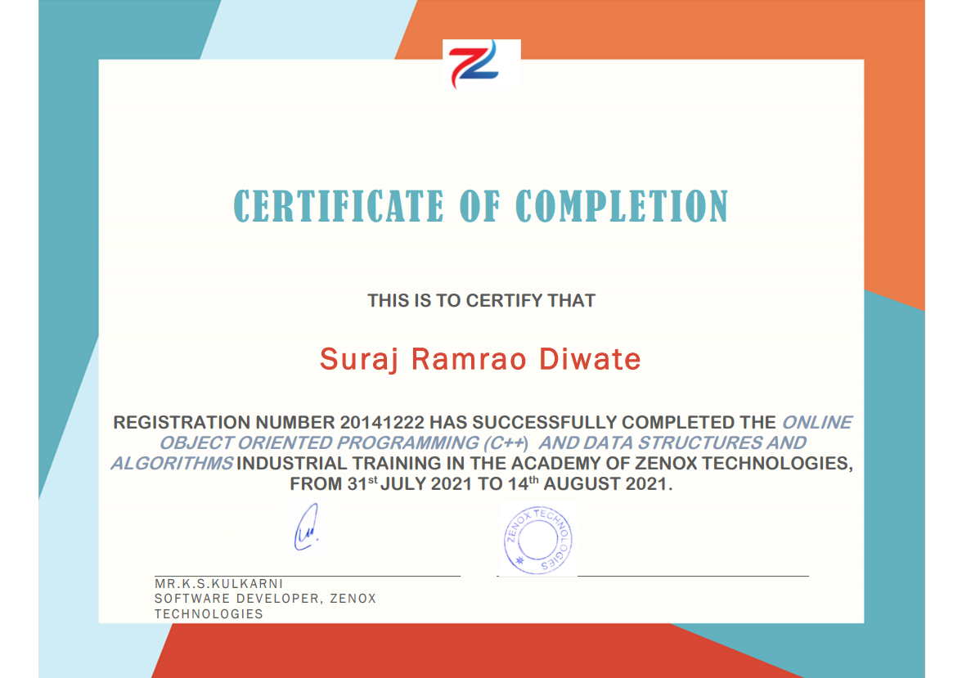

Weekly Overview of Internship Activities

|  |  |  |
| --- | --- | --- |
| Sr. No. | Date | Topic Learned |
| 1 | 31/7/2021 | Introduction to cpp and basic concepts |
| 2 | 3/8/2021 | Features of OOPs |
| 3 | 7/8/2021 | Concept of Class and Object |
| 4 | 10/8/2021 | Function overloading and its implementation |
| 5 | 12/8/2021 | Basics of DSA |
| 6 | 15/8/2021 | Concept of STL |

TABLE OF CONTENTS

|  |  |
| --- | --- |
| * Abstract | I |
| * Industry Details | II |
| * List of Figures | III |
| * List of Abbreviations | IV |

|  |  |  |
| --- | --- | --- |
| Sr. No. | Contents | Page No. |
| 1 | Introduction  // Technical Details Learned  1.1  1.2  1.3 |  |
| 2 | Project Implementation  2.1 Project Title  // Description  2.2 Design  // Architecture/Flowchart, Block diagram  2.3 Implementation  // Source code  2.4 Results  //Snapshot  2.5 Conclusion //project  References |  |
| 3 | Case Study on Recent Trends/ Advances  (//in the domain of internship) |  |
| 4 | Conclusion // about overall training |  |

**Abstract**

**1. What is OOPs ?**

**OOPs stands for the Object-Oriented Programming system. Programs are treated as a collection of objects in oops. Each object is nothing but an example of a class.**

**2. Why use OOPs?**

**OOPs has clarity in programming. It has flexibility and simplicity in solving complex problems. Reuseage of code is easy as the Inheritance concept helps to reduce redundancy of code. Data and code are bound together by encapsulation. OOPs has features for data hiding, so private data can be store and maintain confidentiality. Problems can be divided into different parts making it simple to solve. The concept of polymorphism has flexibility for that a single entity can have multiple forms.**

**3.we understand the features of oops like encapsulation, inheritance, polymorphism,abstraction.**

**4. Also we have learn some basic concepts of DSA**

**Industry Details**

* **Industry Name – Zenox Technologies**
* **Located In – Kolhapur**
* **Zenox technologies is one of the most reliable software company based in Kolhapur**
* **Primary Goal is t deliver the best user experience through the effective user software solutions**

**List of Figures**

* List of Abbreviations
* Introduction
* Project Implementation
* Case Study on Recent Trends/ Advances
* Conclusion

**List of Abbreviations**

**CPA** critical path analysis

**DFID** Department for International Development (UK)

**EU** European Union

**fEC** full economic costing

**ICT** information and communication technology

**JISC** Joint Information Systems Committee of the UK Higher Education Funding Councils

**LSP** Local Strategic Partnership

**M&E** monitoring and evaluation

**MSC** most significant change

**PCM** project cycle management

**PERT** programme evaluation and review technique

**PME** project monitoring and evaluation

**QMS** quality management system

**RFP** request for proposal

**SROI** social return on investment

**TRAC** transparent approach to costing

**UAT** user acceptance test

**UFE** utilisation-focused evaluation

**UNESCO** United Nations Educational, Scientific and Cultural Organization

**Chapter 1**

**Introduction**

**// description about internship topic//**

// Technical Details Learned

1.1 **Object-oriented programming has four basic concepts: encapsulation, abstraction, inheritance, and polymorphism**

1.2  **Even if these concepts seem incredibly complex, understanding the general framework of how they work will help you understand the basics of an OOP computer program**

1.3 I**t will Help us in developing projects and many more things**.

**Chapter 2**

**Project Implementation**

2.1 Project Title

Library Management System

2.2 Design

Login option

librarian

student

booklist

Search book

Add book

Issue book

booklist

Serach book

2.3 Implementation

[// Source code](https://drive.google.com/drive/folders/1bn3niWInCeiINWkd2VK4JhBRl4PAdQ12?usp=sharing)

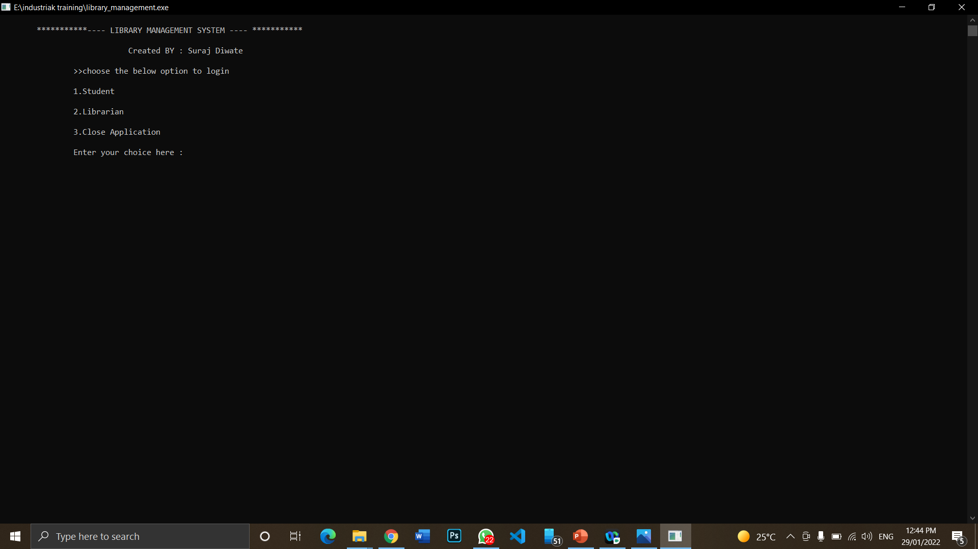 2.4 Results

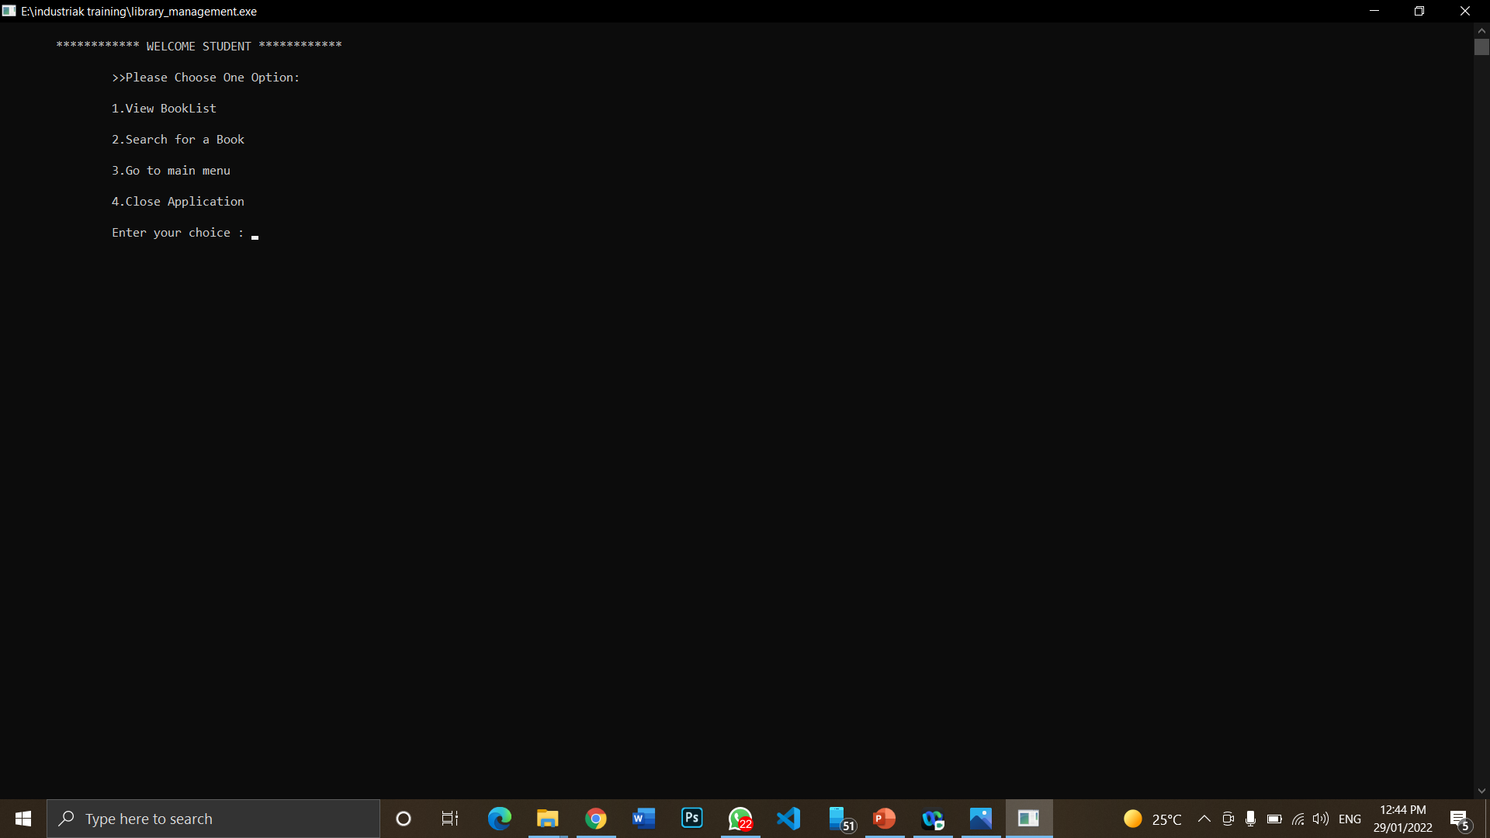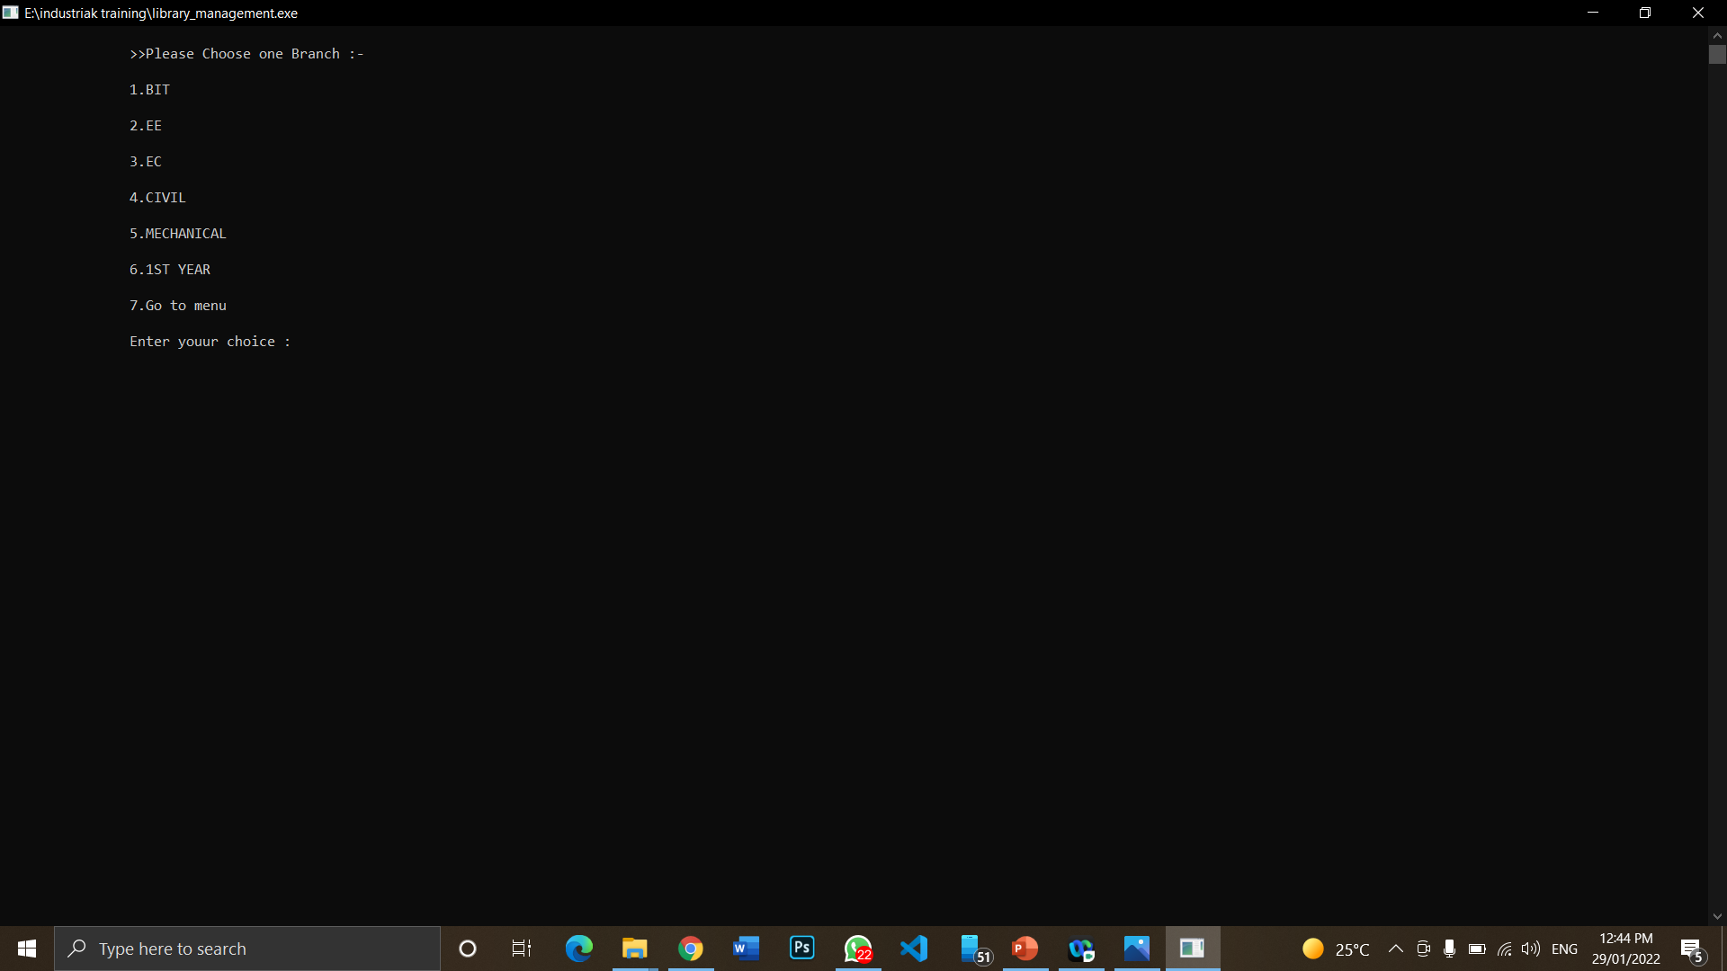

**Chapter 3**

**Case Study on Recent Trends/ Advances**

The task of teaching students to think objectively is complex. Object-oriented methodology is based on the concepts of classes and objects. Classes form the structure of data and actions and use this information for the construction of objects. One class can form more than one object at the same time; each of them will be independent of the others. The creation of projects related to the implementation of classes of mathematical abstractions shapes object thinking of students at the mathematical faculty. The development of object-oriented projects includes the environment and a design object (problems of creating software systems; features of a complex system; a project model; a life cycle of the software product), the design of software products (the meaning of design; the importance of model building; elements of software design; object-oriented analysis, design and programming), principles and tools of object-oriented analysis (classification and object-oriented programming; difficulties of classification; object-oriented analysis), principles and tools of object-oriented designing (abstraction; encapsulation; modularity; hierarchy), advantages of the object model. The presented methodological approach to the implementation of classes of mathematical abstractions and structures allows: to conduct object-oriented decomposition of the subject area (mathematical object “line in space”); to learn UML for building a project model; to define logical program objects that will be implemented in the C ++ system; to realize the class “straight line in space” and the structure of the program, using the features of the concrete environment; create visual projects.

**Conclusion**

From my internship at Zenox Technology, I was able to get a better understanding of how the OOPs and DSA works and how effective it is. I enjoyed working with the Zenox Technology team to devise and implement different oops concepts. However, I still have a long way to go in understanding the technological aspects of OOps , and I need to build up my public speaking skills as well.

Overall, I found the OOPs internship experience to be positive, and I'm sure I will be able to use the skills I learned in my career later.