# An

# Industrial Training Report

on

“Industrial Training On OOPs Library Management System”

Submitted in partial fulfillment for the award of degree

of

**S.Y. B. Tech.**

in

**INFORMATION TECHNOLOGY**

Submitted by

1. **Diwate Suraj Ramrao 20141222**

Under the Guidance of

**Prof. N. M. Mule**

**Prof. P. D. Sheth**



**Government College of Engineering, Karad**

(An Autonomous Institute of Government of Maharashtra)

# Academic Year 2021-2022

**Government College of Engineering, Karad**

(An Autonomous Institute of Government of Maharashtra)

# Department of Information Technology

***CERTIFICATE***

This is to certify that the Industrial Training entitled “ Industrial Training On OOPs ” has been carried out by:

1. **Suraj Ramrao Diwate 20141222**

of Second Year B. Tech. I.T. class under the guidance of Prof. N.M.Mule And Prof. P.D.Sheth during the academic year 2021 -22 (Sem-III).

|  |  |
| --- | --- |
| **Prof. N. M. Mule**  **Prof. P. D. Sheth** | **Dr. S. J. Wagh** |
| **Guide** | **Head, IT** |

**Acknowledgement**

Apart from individual efforts, the success of an Industrial Training depends largely on the encouragement and guidelines of many others. We take this opportunity to express our gratitude to the people who have been instrumental throughout the training period.

It is our privilege to express our gratitude towards our industry mentor *Kedar Kulkarni Sir* and academic guide Prof. N.M.Mule And Prof. P.D.Sheth for their valuable guidance, encouragement, inspiration and whole-hearted cooperation throughout the project work. We thank him for being a motivation through all our highs and importantly, our lows.

We deeply express our sincere thanks to our Head of Department Dr. S. J. Wagh for encouraging and allowing us to present the skills gained and work done during training period on “ Title of training ” and providing us with the necessary facilities to enable us to fulﬁll our training requirements as best as possible. We take this opportunity to thank all faculty members and staff of Department of Information Technology, who have directly or indirectly helped our project.

We pay our respects to honorable Principal Dr. A. T. Pise for their encouragement. Our thanks and appreciations also go to our family and friends, who have been a source of encouragement and inspiration throughout the duration of the industrial training.

**Certificate Of Completion**

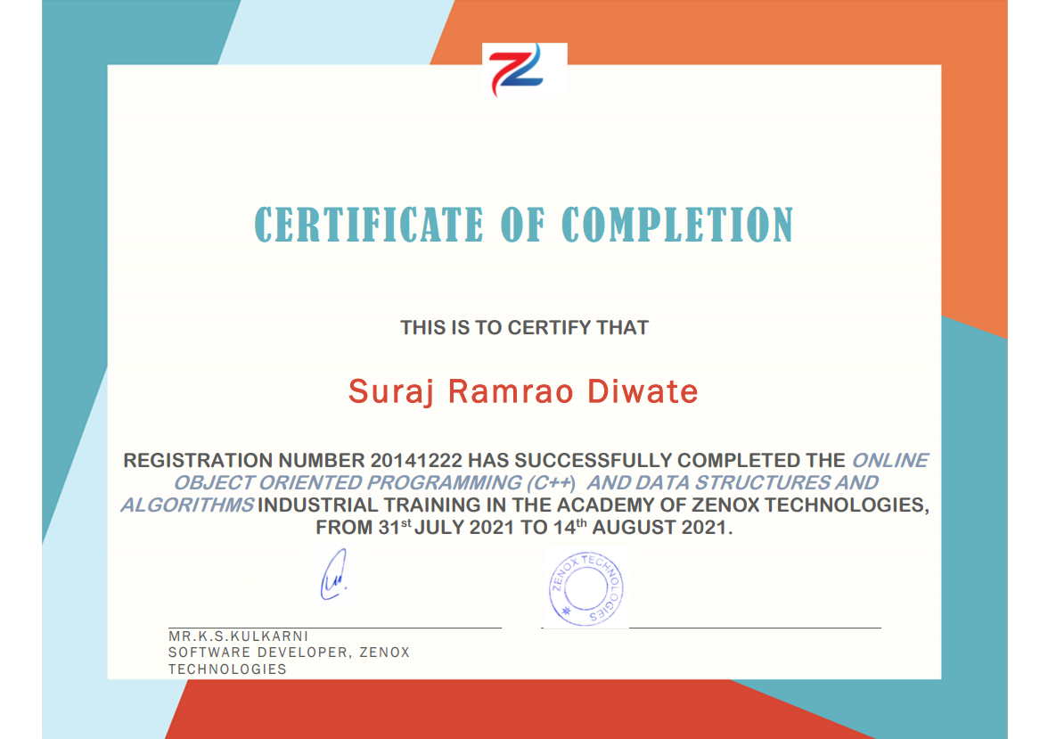

Weekly Overview of Internship Activities

|  |  |  |  |
| --- | --- | --- | --- |
| Sr. No. | Date | Day | Topic Learned |
| 1 |  |  |  |
|  |  |  |  |
|  |  |  |  |
|  |  |  |  |
|  |  |  |  |
|  |  |  |  |

TABLE OF CONTENTS

|  |  |
| --- | --- |
| * Abstract | I |
| * Industry Details | II |
| * List of Figures | III |
| * List of Abbreviations | IV |

|  |  |  |
| --- | --- | --- |
| Sr. No. | Contents | Page No. |
| 1 | Introduction  // Technical Details Learned  1.1  1.2  1.3 |  |
| 2 | Project Implementation  2.1 Project Title  // Description  2.2 Design  // Architecture/Flowchart, Block diagram  2.3 Implementation  // Source code  2.4 Results  //Snapshot  2.5 Conclusion //project  References |  |
| 3 | Case Study on Recent Trends/ Advances  (//in the domain of internship) |  |
| 4 | Conclusion // about overall training |  |

**Abstract**

**1. What is OOPs ?**

**OOPs stands for the Object-Oriented Programming system. Programs are treated as a collection of objects in oops. Each object is nothing but an example of a class.**

**2. Why use OOPs?**

**OOPs has clarity in programming. It has flexibility and simplicity in solving complex problems. Reuseage of code is easy as the Inheritance concept helps to reduce redundancy of code. Data and code are bound together by encapsulation. OOPs has features for data hiding, so private data can be store and maintain confidentiality. Problems can be divided into different parts making it simple to solve. The concept of polymorphism has flexibility for that a single entity can have multiple forms.**

**Industry Details**

**List of Figures**

**List of Abbreviations**

**Chapter 1**

**Introduction**

**// description about internship topic//**

// Technical Details Learned

1.1

1.2

1.3

**Chapter 2**

**Project Implementation**

2.1 Project Title

// Description

2.2 Design

// Architecture/Flowchart, Block diagram

2.3 Implementation

// Source code

2.4 Results

//Snapshot

2.5 Conclusion

References

**Chapter 3**

**Case Study on Recent Trends/ Advances**

**Chapter 4**

**Conclusion**

// From my internship at Areqa, I was able to get a better understanding of how the marketing industry works and how effective it is. I enjoyed working with the Areqa marketing team to devise and implement different marketing strategies. However, I still have a long way to go in understanding the psychological aspects of marketing, and I need to build up my public speaking skills as well.

Overall, I found the marketing internship experience to be positive, and I'm sure I will be able to use the skills I learned in my career later. //