Name: Suraj Rimal

**Lab Assignment: Chapter 5**

Q no 9

1. Solution:

***require('MASS')***

***data('Boston')***

***mu <- mean(Boston$medv)***

***mu***

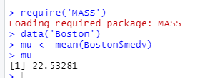

1. Solution

***se <- sqrt(var(Boston$medv)/nrow(Boston))***

***se***



The standard error is found 0.4088611. We can compute the standard error of the sample mean by dividing the sample standard deviation by the square root of the number of observations.

1. Solution

***library(boot)***

***set.seed(1)***

***boot.fn <- function(data, index) {***

***mu <- mean(data[index])***

***return (mu)***

***}***

***boot(Boston$medv, boot.fn, 1000)***

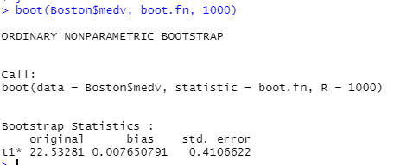

The bootstrap estimated standard error of 0.4106622 which is very near to the estimate observed in 9(b) of 0.40886.

1. Solution:

***med <- median(Boston$medv)***

***med***



The median is  21.2

1. Solution:

***boot.fn <- function(data, index) {***

***mu <- median(data[index])***

***return (mu)***

***}***

***boot(Boston$medv, boot.fn, 1000)***

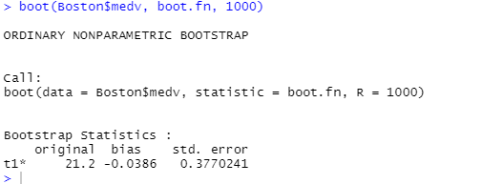

We obtained an estimated median value of 21.2 which is equivalent to the value observed in (e), with a standard error of 0.37702 which is relatively small compared to median value.