package com.example.suraj.myapplication;

import android.content.Intent;

import android.os.Bundle;

import android.support.design.widget.FloatingActionButton;

import android.support.design.widget.Snackbar;

import android.text.Editable;

import android.view.View;

import android.support.design.widget.NavigationView;

import android.support.v4.view.GravityCompat;

import android.support.v4.widget.DrawerLayout;

import android.support.v7.app.ActionBarDrawerToggle;

import android.support.v7.app.AppCompatActivity;

import android.support.v7.widget.Toolbar;

import android.view.Menu;

import android.view.MenuItem;

import android.widget.Button;

import android.widget.EditText;

import android.widget.TextView;

public class first extends AppCompatActivity

{

private EditText Name;

private EditText Password;

private TextView Info;

private Button Login;

private int count=5;

@Override

protected void onCreate(Bundle savedInstanceState) {

super.onCreate(savedInstanceState);

setContentView(R.layout.activity_first);

Name=(EditText)findViewById(R.id.etname);

Password=(EditText)findViewById(R.id.etpassword);

Info=(TextView)findViewById(R.id.tvinfo);

Login=(Button)findViewById(R.id.btnlogin);

Info.setText("no of attempts remaing : 5");

Login.setOnClickListener(new View.OnClickListener() {

@Override

public void onClick(View view) {

validate(Name.getText().toString(),Password.getText().toString());

}

});

}

private void validate(String username, String userpassword)

{

if((username.equals("admin"))&& (userpassword.equals("123456")))

{

Intent intent=new Intent(first.this,Second.class);

startActivity(intent);

}

else

{

count--;

Info.setText("No of Attempts remaing: " +String.valueOf(count));

if(count == 0){

Login.setEnabled(false);

}

}

}}

**To Create second page, follow the steps:**

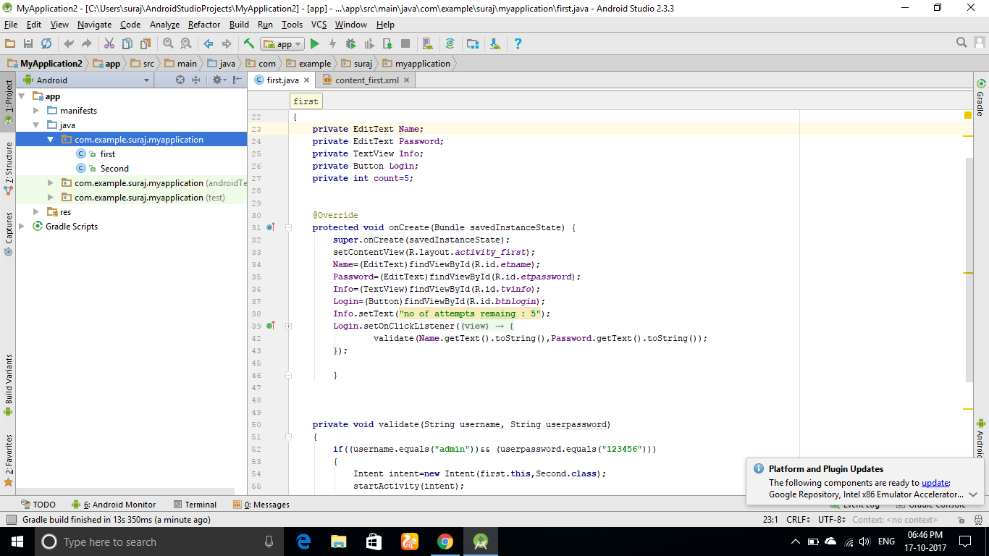

1. Click on app -> java -> (in one of your com.example, where your first page is available ) right click on [com.example…..]
2. 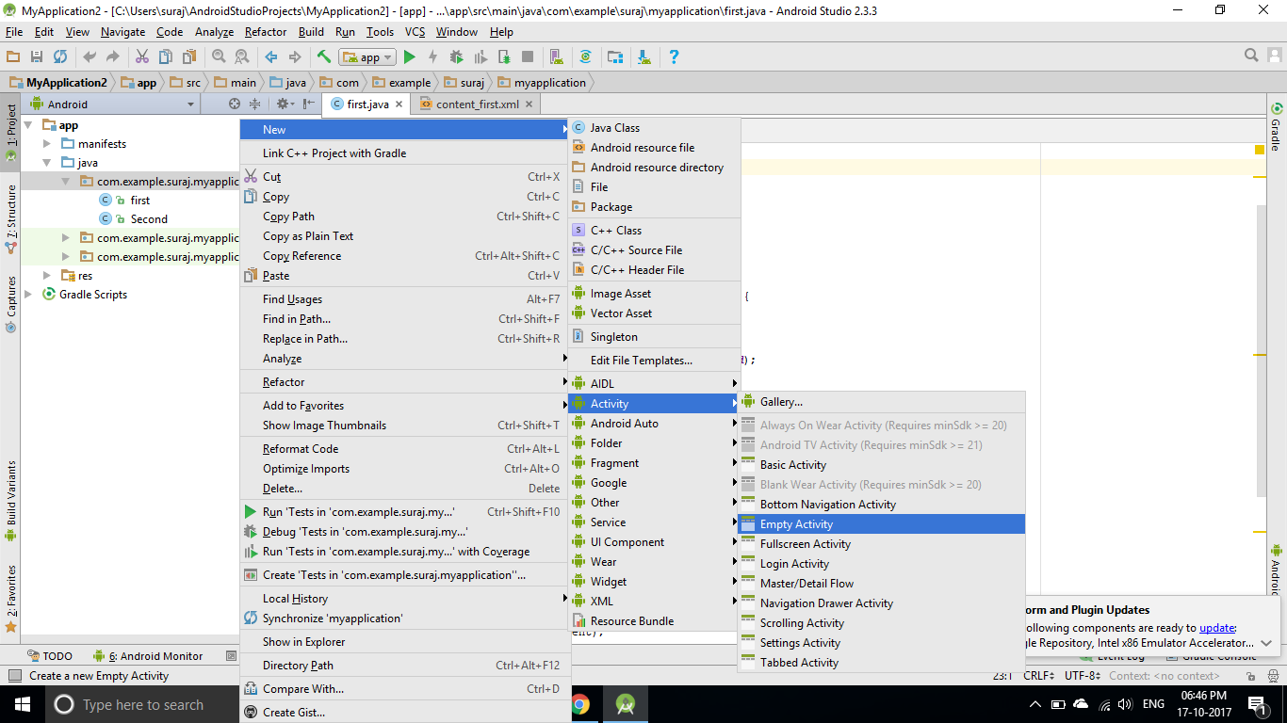

**Click on New -> Activity -> Empty Activity -> (name it “second”) -> write on new page something.**

**Now you are ready to complie.**