Process Management in Linux

What is a Process ?

A process is a series of steps and decisions involved in the way work is completed. We may not realize it, but processes are everywhere and in every aspect of our leisure and work.

Now speaking more techincally a process refers to a program in execution.It can be anything from a small background task, such as a spell-checker or system events handler to a full-blown application.

Why its important to manage process ?

As we have multiple processes running simultaneously on our system which may or may not be using system resources.So it becomes crucial to manage them and limit their control over system resources ensuring their effective usage.

It is responsibility of operating system to manage all the running processes of the system. Operating system manages processes by performing tasks such as resource allocation and process scheduling.

Hence process management describes the starting, pausing, resuming, and terminating of processes.

What is Multitasking

Lets take an example, you might have a web browser and a spreadsheet open on your machine at the same time.However, things are not as they appear, the processes behind these applications typically do not run at exactly the
same time.

Consider a system with a one-core CPU which is running multiple processes , but only one process may actually use the CPU at any given time.
In practice, each process uses the CPU for a small fraction of a second, then pauses and lets another process uses the CPU for another small fraction of a second and so on.

The act of one process giving up control of the CPU to another process is called a
context switching , which gives a process enough time for
significant computation in a given time slice.

Indeed, a process often finishes its current task during a single slice .However, because the slices are so small, humans can’t perceive them, and the system appears to be running multiple processes at the same time (a capability known as the time slice).

Linux Kernal in Context Switching

The kernel is responsible for context switching in Linux.However the CPU (the actual hardware) interrupts the current process based on an internal timer, switches into kernel mode, and hands control back to the kernel.

The kernel records the current state of the CPU and memory, which will be essential to resuming the process that was just interrupted.The kernel is now ready to let another process run.

Its also one of the role of kernell to analyzes the list of processes that are ready to run and chooses one followed by the memory allocation for this new process, and then prepares the CPU.

The kernel tells the CPU how long the time slice for the new process will last , switching the CPU into user mode and hands control of the CPU to the process.

Process Life Cycle (GENERIC)

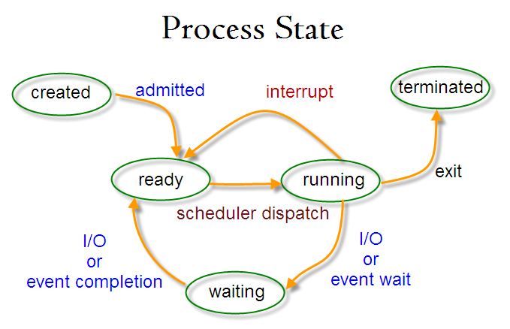

How process comes into existance in Linux

In a Linux system, the first process to start is the ‘init’ and it has a PID of 1. All subsequent processes are init’s children, grandchildren and so on. The Linux kernel uses a scheduler and it controls the execution sequence of all the processes. Linux processes can have one of four states at any given time: running, waiting or sleeping, stopped and zombie

A process achieves a running state when it is actually executing (running) or waiting for execution in the queue of the scheduler, which means it is ready to run or execute.

Further it can be in a waiting or sleeping state if it must wait for an event to occur or some resource-specific operation needs to complete before the process can continue to run.

When a process has completed its execution, but is waiting to retrieve its exit state, the process is said to be in a zombie state. Once it crosses the zombie state or retrieves its exit status, the process dies or ceases to exist.

Foreground Process

A foreground process is any command or task you run directly and wait for it to complete. Some foreground processes show some type of user interface that supports ongoing user interaction, whereas others execute a task and "freeze" the computer while it completes that task.
For example, to see a simple listing of the files in the active directory, type:
$ls -al

Background Process

Unlike with a foreground process, the shell does not have to wait for a background process to end before it can run more processes. Within the limit of the amount of memory available, you can enter many background commands one after another. To run a command as a background process, type the command and add a space and an ampersand (&) to the end of the command. For example:

$ls -al &

Zombie Process

A process which has finished the execution but still has entry in the process table to report to its parent process is known as a zombie process. A child process always first becomes a zombie before being removed from the process table. The parent process reads the exit status of the child process which reaps off the child process entry from the process table.

Orphan Process

A process whose parent process no more exists i.e. either finished or terminated without waiting for its child process to terminate is called an orphan process.
In the following code, parent finishes execution and exits while the child process is still executing and is called an orphan process now.
However, the orphan process is soon adopted by init process, once its parent process dies.

Deamon Process
A daemon process is a background process that is not under the direct control of the user. This process is usually started when the system is bootstrapped and it terminated with the system shut down.
Usually the parent process of the daemon process is the init process. This is because the init process usually adopts the daemon process after the parent process forks the daemon process and terminates.

