ENTERPRISE SMART LIBRARY
MANAGEMENT PLATFORM
DevOps Practical Implementation Report

AWS EC2 • MobaXterm SSH • Jenkins CI • Docker • Kubernetes / Minikube

Implementation evidence and command explanations

Prepared from the supplied screenshots and terminal evidence

Name: Suraj Ganesh Sase
PRN: 2125UDSM1104
Subject: DevOps

1. Project Overview
This practical deploys a Library Management Platform on an AWS EC2 Ubuntu instance. The work is performed on the remote Linux server through MobaXterm/SSH, rather than running the deployment locally in VS Code. Docker packages the application into a container image, Jenkins automates code-quality checks and tests, and Kubernetes (using Minikube) maintains three application replicas.

Objectives
- Launch and connect to an AWS EC2 Ubuntu instance using SSH.
- Install and verify the server tools required for the practical.
- Set up Jenkins and connect a pipeline to the GitHub repository.
- Run automated code-quality checks and unit tests in Jenkins.
- Build and run the application as a Docker container.
- Deploy three replicas with Kubernetes and verify automatic pod replacement.

High-level workflow
AWS EC2 Ubuntu instance
└── MobaXterm SSH terminal
├── Git / Python application and tests
├── Jenkins CI pipeline
├── Docker image + running container
└── Minikube / Kubernetes deployment (3 replicas)
Repository branch used for the verified Jenkins build: staged/foundation. The project directory in the repository is unit-3/library-management-platform.

2. Launch the AWS EC2 Instance
The first screenshot below shows the AWS EC2 Launch an instance page, placed first as requested. The screenshot is included as supplied; it shows the instance name field and AMI selection. Review the final selected AMI and instance type in the AWS console before repeating this setup, because the screenshot appears to show a SQL Server-related Ubuntu image and a small instance type.
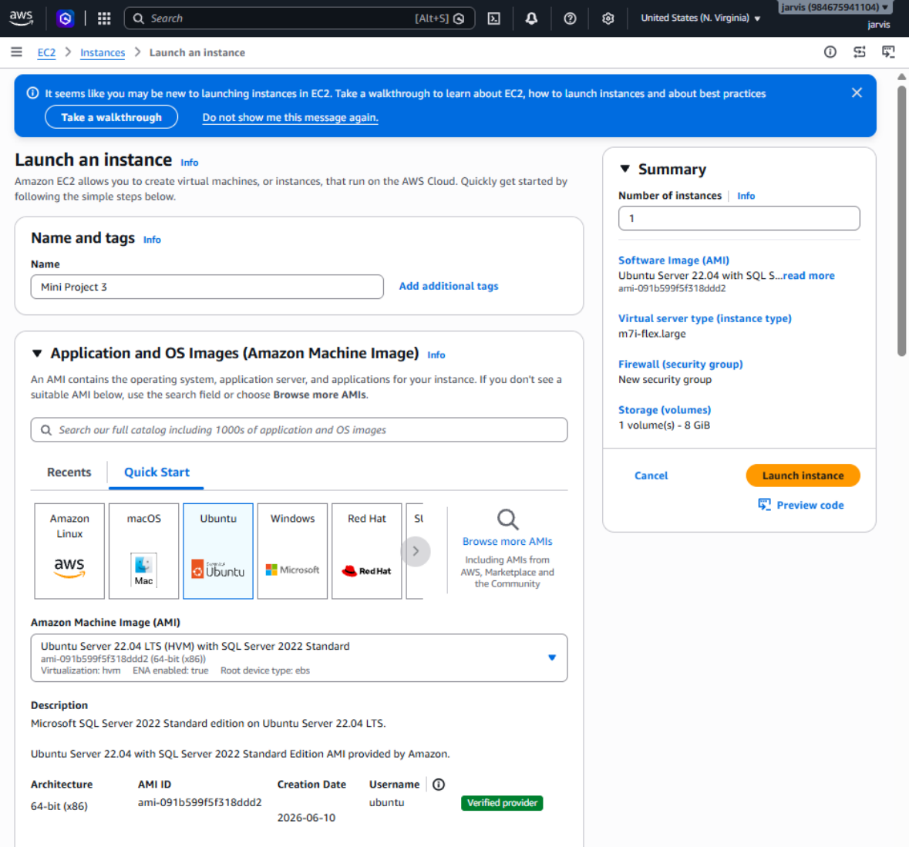
Evidence screenshot 28 from the supplied evidence PDF.

Connecting from MobaXterm
MobaXterm provides an SSH terminal to administer the Ubuntu instance remotely. Connect using the instance's public IPv4 address and the matching private key, with the username ubuntu. Do not include private keys, passwords, or Jenkins initial-admin secrets in screenshots or a submitted report.
ssh -i <your-key.pem> ubuntu@<EC2-Public-IPv4>
Purpose: This command opens an encrypted SSH session to the EC2 server. Replace the placeholders with the actual key file and public IPv4 address; when using MobaXterm's saved SSH session, the same connection details are entered in its session settings.

3. Inspect and Prepare the Ubuntu Server
The commands below were used to inspect system resources and confirm that the required runtime tools were available.

Update package metadata
sudo apt update
This refreshes the list of packages available from the configured Ubuntu repositories. It does not by itself upgrade all installed software; it prepares the server to install packages by their current repository versions.

Check memory and disk capacity
free -h
df -h /
`free -h` displays RAM and swap usage in readable units, while `df -h /` reports the space available on the root filesystem. These checks help confirm that the instance has enough resources for Jenkins, Docker, and Minikube.

Check Java and Docker
java -version
docker --version
Jenkins requires Java to run, so `java -version` confirms the installed Java runtime. `docker --version` confirms that the Docker CLI is installed; later commands check whether the daemon and containers are working.

Install Java 21 runtime
sudo apt install -y openjdk-21-jre-headless
java -version
The first command installs the headless Java 21 runtime without desktop components, which is suitable for a server. The second verifies the installation and prints the installed version.

Install Python package and virtual-environment tools
sudo apt install -y python3-pip python3-venv
These packages provide pip for installing Python dependencies and venv for creating isolated Python environments. Jenkins uses an isolated environment so the project's Python packages do not need to be installed globally.
Evidence note: the supplied terminal log includes an early `java -version` result showing Java was missing, followed by successful installation and a version check. This is a normal setup progression; the final successful check is the relevant result.

4. Install and Start Jenkins
Jenkins was installed from its official Debian package repository. The repository signing key is important because apt uses it to verify package authenticity before installation.

Add the Jenkins signing key and repository
sudo wget -O /usr/share/keyrings/jenkins-keyring.asc \
https://pkg.jenkins.io/debian-stable/jenkins.io-2026.key
echo "deb [signed-by=/usr/share/keyrings/jenkins-keyring.asc] https://pkg.jenkins.io/debian-stable binary/" | sudo tee /etc/apt/sources.list.d/jenkins.list > /dev/null
sudo apt update
The `wget` command downloads the repository signing key into the system keyring directory. The `echo ... | sudo tee` command adds the Jenkins package repository, and `sudo apt update` refreshes package metadata so Jenkins can be installed.

Install Jenkins and verify its service
sudo apt install -y jenkins
sudo systemctl status jenkins --no-pager
The first command installs Jenkins and its service definition. The second displays the service status; the evidence showed `active (running)`, confirming Jenkins started successfully.
Security note: the supplied text file contains the Jenkins initial administrator password. That secret is intentionally not reproduced in this report. If it was exposed beyond a private setup session, rotate/re-secure the Jenkins account and avoid sharing the secret.

5. Jenkins Pipeline Configuration and Verification
The Jenkins job is named Library-Management-CI. Its pipeline checks out the GitHub repository, prepares Python dependencies, runs Flake8 code-quality checks, executes pytest tests and publishes a JUnit test report, then builds the Docker image.

Pipeline stages
- Setup Python: checks Python, creates a virtual environment, and installs requirements.
- Code Quality: runs Flake8 over the application, database, tests, and run.py.
- Run Tests: executes pytest and writes a JUnit XML report for Jenkins.
- Build Docker Image: builds library-management-platform:1.0 from the Dockerfile.

Git branch
The Jenkins job was updated from `*/foundation` to `*/staged/foundation`. A new build completed successfully, and the test report showed all tests passing.

Jenkins dashboard evidence
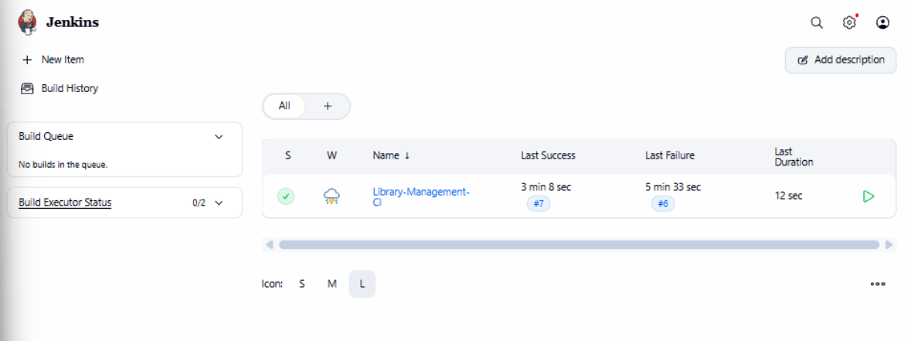
Evidence screenshot 3 from the supplied evidence PDF.
The dashboard screenshot shows Library-Management-CI with a green status indicator and a recorded last successful build. The later verified build from `staged/foundation` also ended with `Finished: SUCCESS` according to the console output shared during the practical.

Example commands used inside the CI job
python3 -m venv .venv-ci
.venv-ci/bin/python -m pip install -r requirements.txt
.venv-ci/bin/python -m flake8 app database tests run.py
.venv-ci/bin/python -m pytest tests/ --junitxml=pytest-results.xml
docker build -t library-management-platform:1.0 .
The virtual environment isolates project dependencies; Flake8 checks style and common errors; pytest runs automated tests; and the Docker build creates a reusable image. Jenkins executes these steps automatically on the configured agent, so a successful pipeline provides repeatable verification.

6. Docker Image and Container
Docker packages the application and its runtime dependencies into an image. A container is a running instance of that image, allowing the application to run consistently on the EC2 host.

List available images
sudo docker images
This lists Docker images stored locally. The supplied terminal evidence shows `library-management-platform:1.0`, along with the Python base image and Minikube's node image.
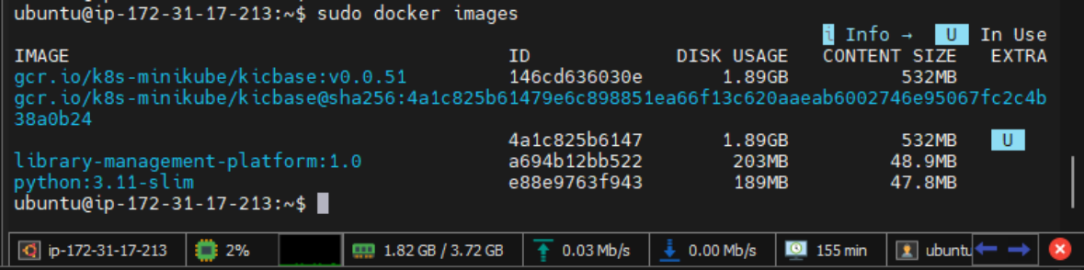
Evidence screenshot 1 from the supplied evidence PDF.

List running containers
sudo docker ps
This displays running containers, their image, status, port mappings, and names. The supplied output shows the `library-app` container running with host port 5000 mapped to container port 5000, as well as the Minikube container.

Check application health
curl http://localhost:5000/health
The curl command sends an HTTP request to the application's health endpoint on the EC2 host. The response `{"status":"healthy"}` confirms that the endpoint responded successfully at the time of the test.

Check the home endpoint
curl http://127.0.0.1:8081/
curl http://127.0.0.1:8081/health
These requests use port 8081, which was used for Kubernetes service port-forwarding in the supplied terminal log. The home endpoint returned the Library Management Platform welcome response and the health endpoint returned a healthy status.

7. Kubernetes Deployment with Minikube
Kubernetes manages the desired number of application replicas. The deployment is configured for three pods, and the NodePort service exposes port 5000 through node port 30080 within the Minikube setup.

Check pods
kubectl get pods
This lists the Kubernetes pods and shows readiness, current status, restart count, and age. The successful output showed three `library-app` pods, each `1/1 Running`.

Check deployment
kubectl get deployment
This shows the deployment's desired, updated, and available replica counts. The output showed `library-app` with 3/3 ready, 3 updated, and 3 available replicas.

Check services
kubectl get services
This lists cluster services and their service types and ports. The `library-app-service` entry showed type `NodePort` and mapping `5000:30080/TCP`, while the default `kubernetes` service exposes the cluster API.

Port-forward and test the application
kubectl port-forward svc/library-app-service 8081:5000
# In a second terminal session:
curl http://127.0.0.1:8081/health
Port-forward temporarily forwards local port 8081 to port 5000 on the Kubernetes service. The curl request confirms the application is reachable through the Kubernetes service path; keep the port-forward command running in its terminal while testing.

Self-healing test
kubectl get pods
kubectl delete pod <actual-pod-name>
kubectl get pods -w
The delete command removes one selected pod; it does not delete the deployment. Because the deployment declares three replicas, the Kubernetes controller creates a replacement pod. The supplied output showed a new pod appearing first as `0/1 Running` and then becoming `1/1 Running`, while the other two remained healthy.
Important: replace `<actual-pod-name>` with a real pod name from `kubectl get pods`; typing the placeholder literally results in a NotFound error. Press Ctrl+C to stop `kubectl get pods -w` after the replacement is ready.

8. Step-by-Step Screenshot Evidence (Chronological Order)
This section places all 84 supplied screenshots in the order the work was actually done: local development and testing, AWS launch, SSH setup, Docker, Kubernetes, Jenkins and final verification. Each step shows the command or action used, the screenshot, and a two-sentence explanation. The Jenkins initial admin password in step 74 has been blacked out.

8.1 Application Development and Local Testing (VS Code / PowerShell)

Step 1: Create the project folder structure
Get-Location
git status --short
Get-ChildItem unit-3
$folders | ForEach-Object { New-Item -ItemType Directory -Path $_ -Force }
tree unit-3\library-management-platform /F
code unit-3\library-management-platform
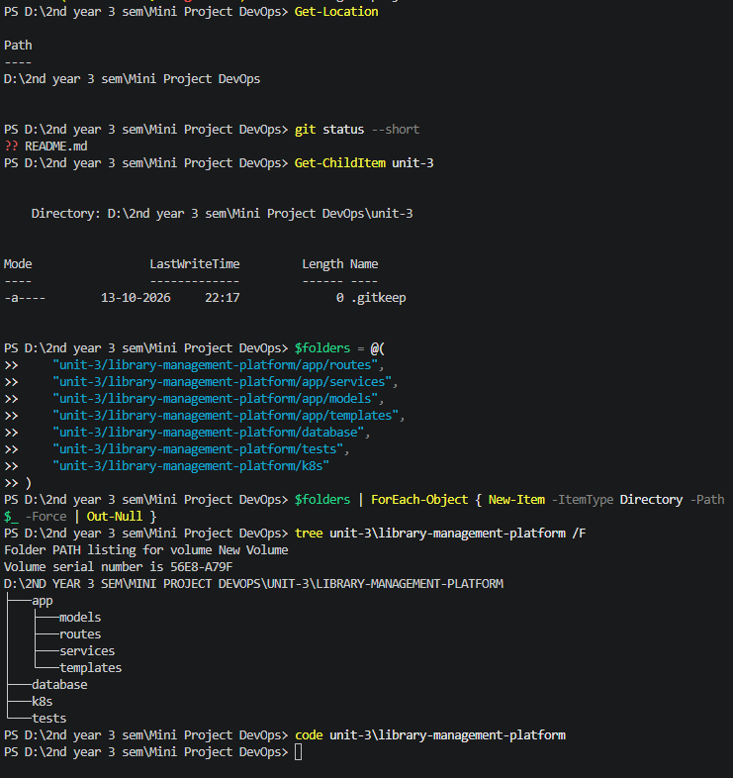
These PowerShell commands confirm the working folder and Git state, then create the app, database, tests and k8s folders for the project. The tree command shows the resulting layout, and code opens the project in VS Code.

Step 2: Create the package __init__.py files
New-Item -ItemType File -Force -Path "app\__init__.py", "app\routes\__init__.py", "app\services\__init__.py", ...
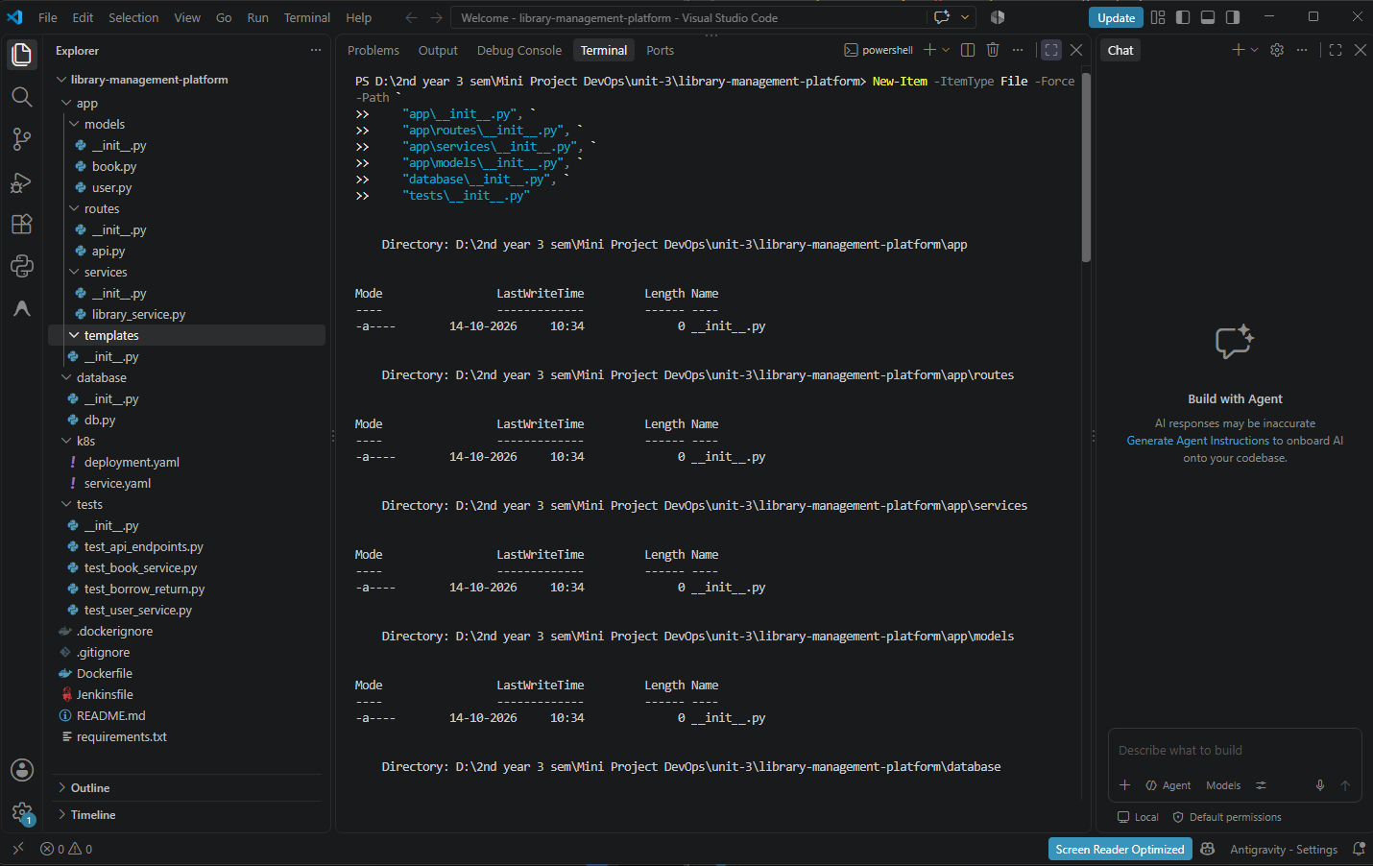
This command creates empty __init__.py files so the app, routes, services, models, database and tests folders work as Python packages. The -Force switch lets it run again without errors.

Step 3: Create the remaining project files
New-Item -ItemType File -Force -Path "app\routes\api.py", "app\services\library_service.py", "k8s\deployment.yaml", "Dockerfile", "Jenkinsfile", ...
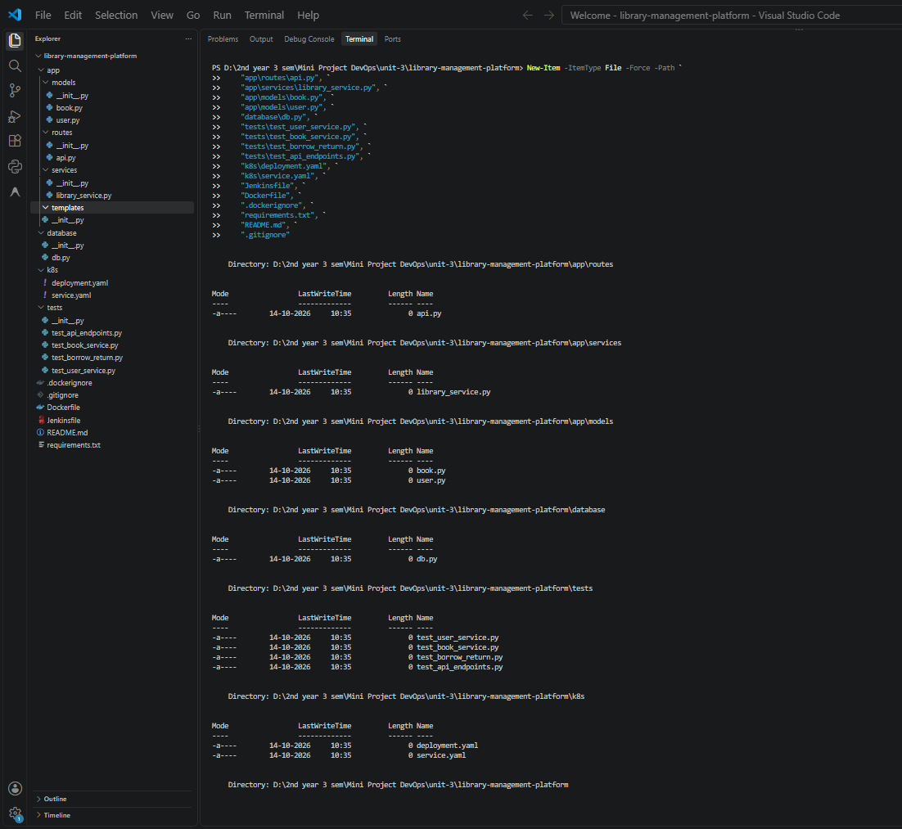
This creates the empty source, test, Kubernetes, Docker and Jenkins files that the project needs. The output lists each file with Length 0, showing they are placeholders to be filled in next.

Step 4: database/db.py (first version)
File: database/db.py
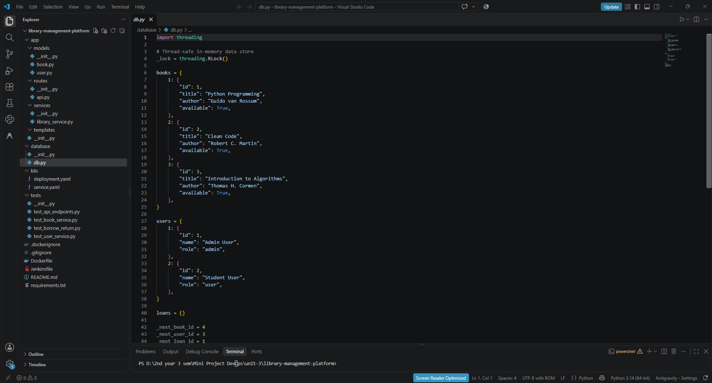
This file is the thread-safe in-memory data store, using an RLock with seeded books and users and an empty loans dictionary. It stands in for a real database so the mini project stays simple.

Step 5: app/models/book.py
File: app/models/book.py
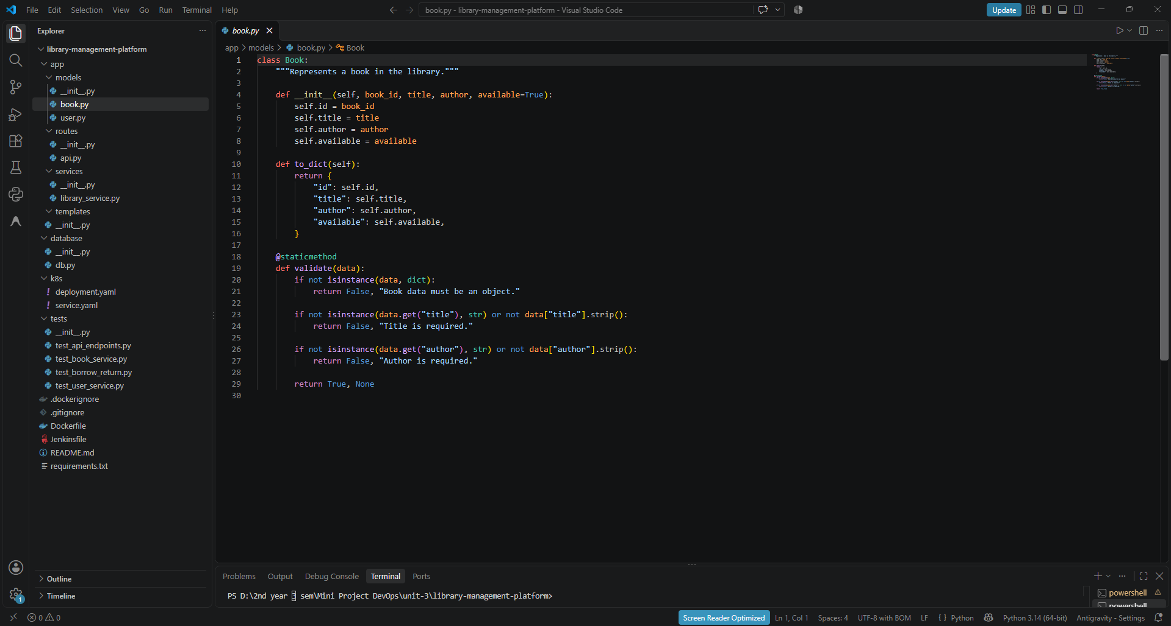
The Book class stores the id, title, author and availability, and to_dict() converts it to JSON-friendly data. Its validate() method rejects a missing or empty title or author.

Step 6: app/models/user.py
File: app/models/user.py
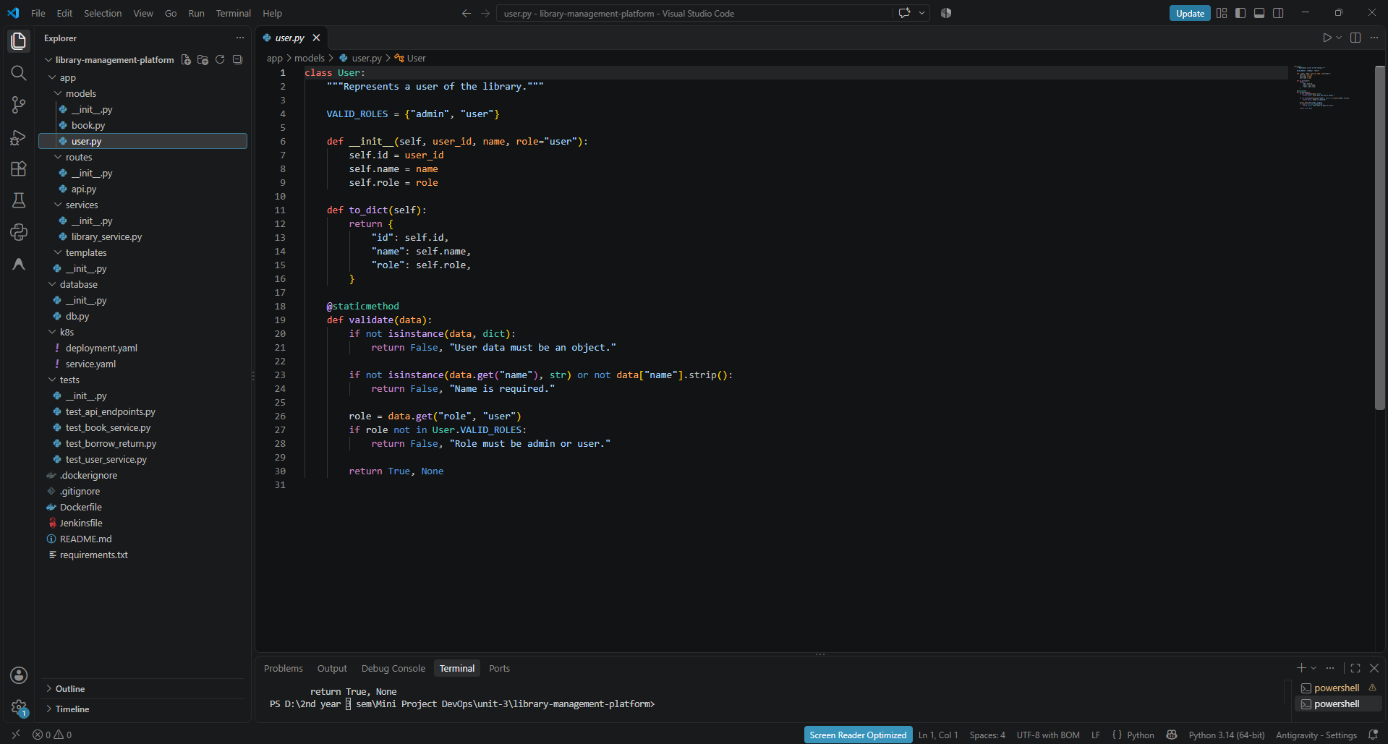
The User class stores the id, name and role, and to_dict() returns them as a dictionary. Its validate() method requires a name and allows only the roles admin or user.

Step 7: database/db.py (updated version)
File: database/db.py
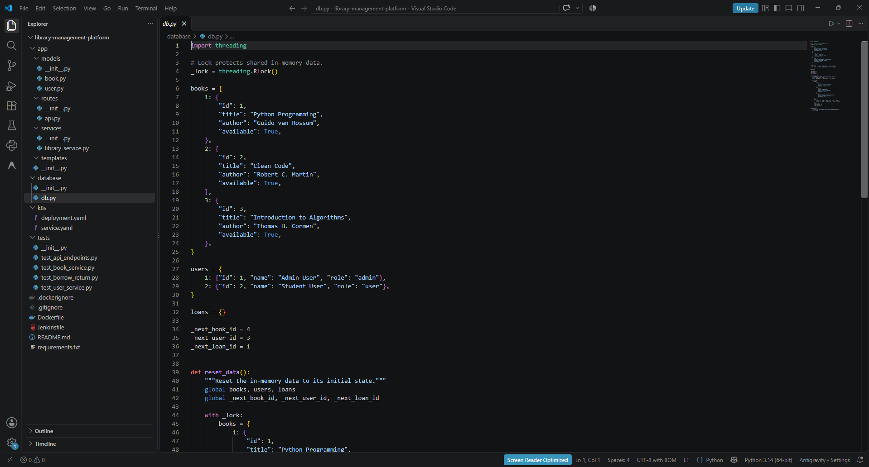
The updated db.py adds a reset_data() function that restores the in-memory data to its initial state. This lets every test start from clean seed data.

Step 8: app/services/library_service.py
File: app/services/library_service.py
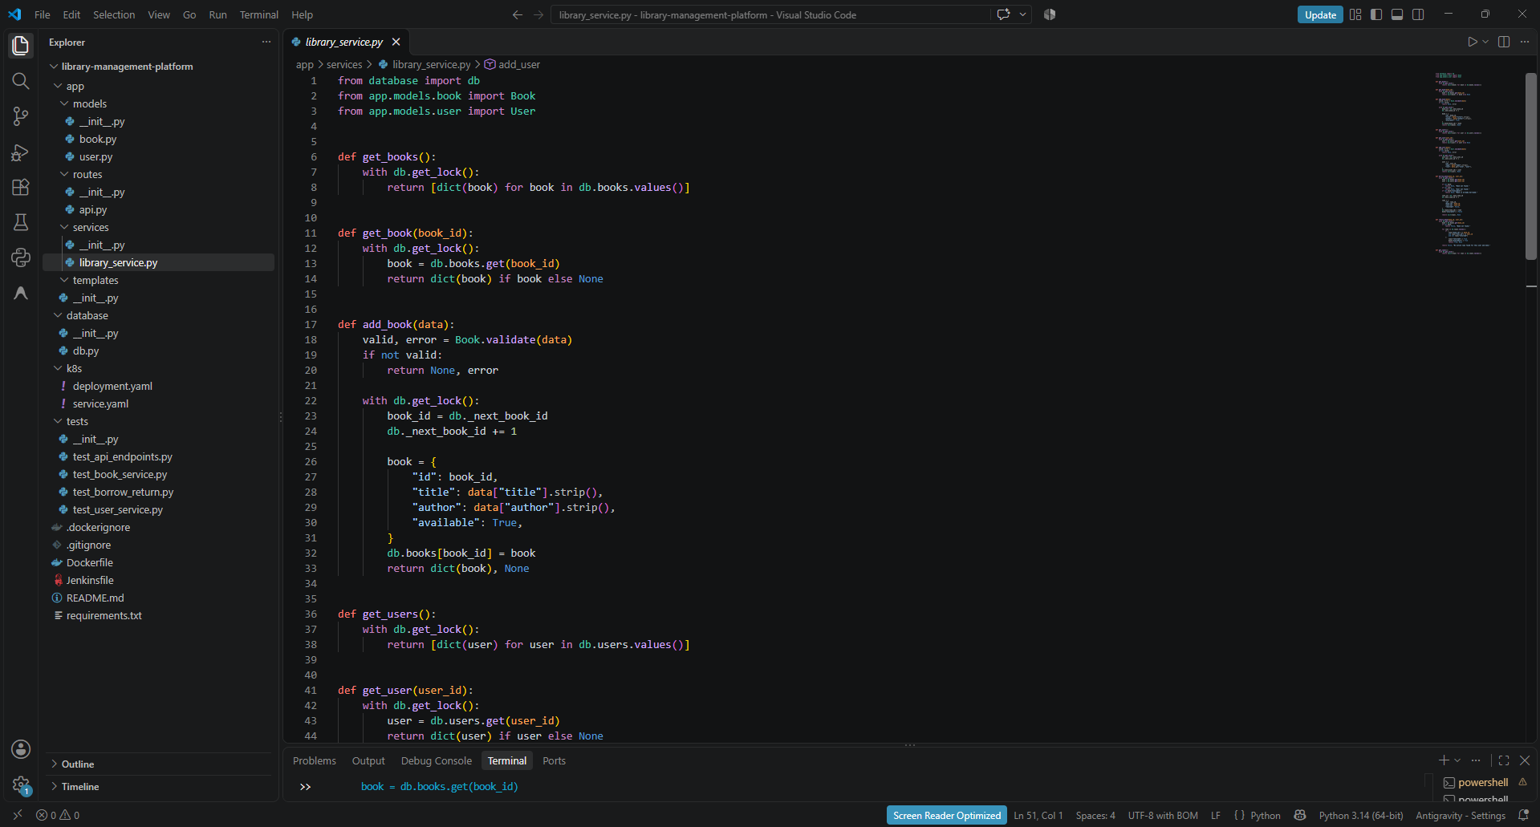
This service layer holds the business logic, such as get_books, get_book, add_book and the user functions, and wraps data access in the database lock. add_book first validates the input with Book.validate and then creates a new id.

Step 9: app/routes/api.py
File: app/routes/api.py
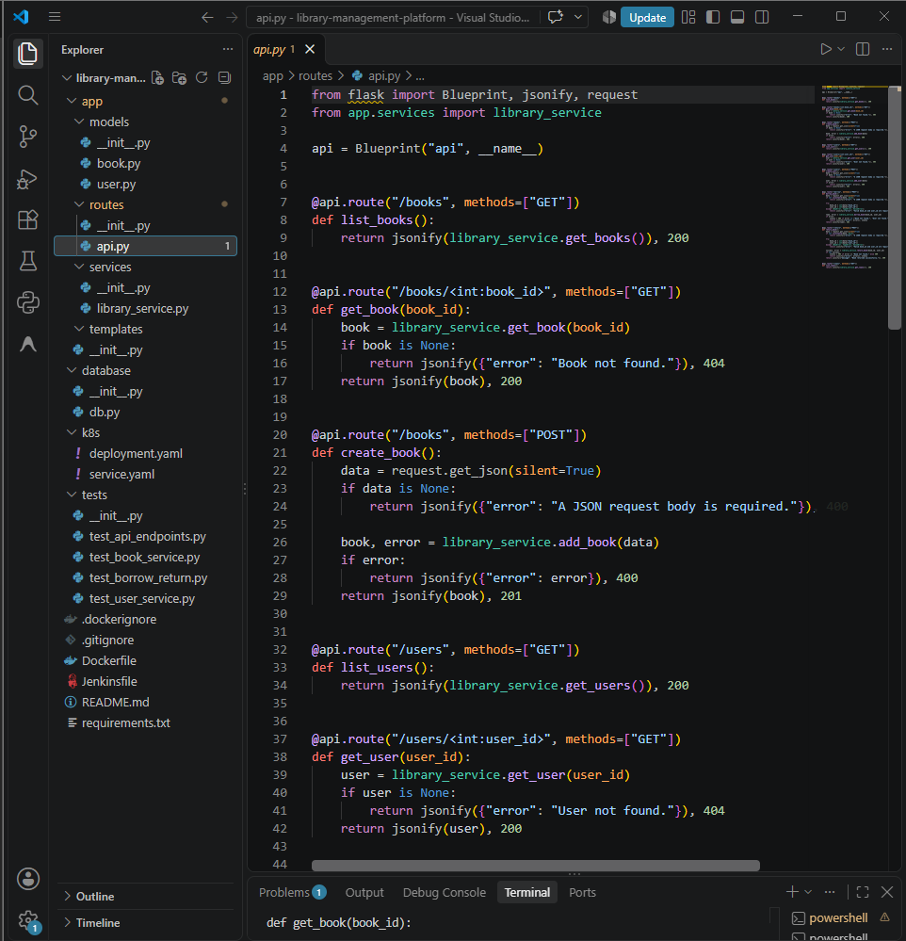
This Flask Blueprint defines the REST routes such as GET /books, GET /books/<id>, POST /books and the matching user routes. It returns JSON with suitable status codes such as 200, 201, 400 and 404.

Step 10: run.py
File: run.py
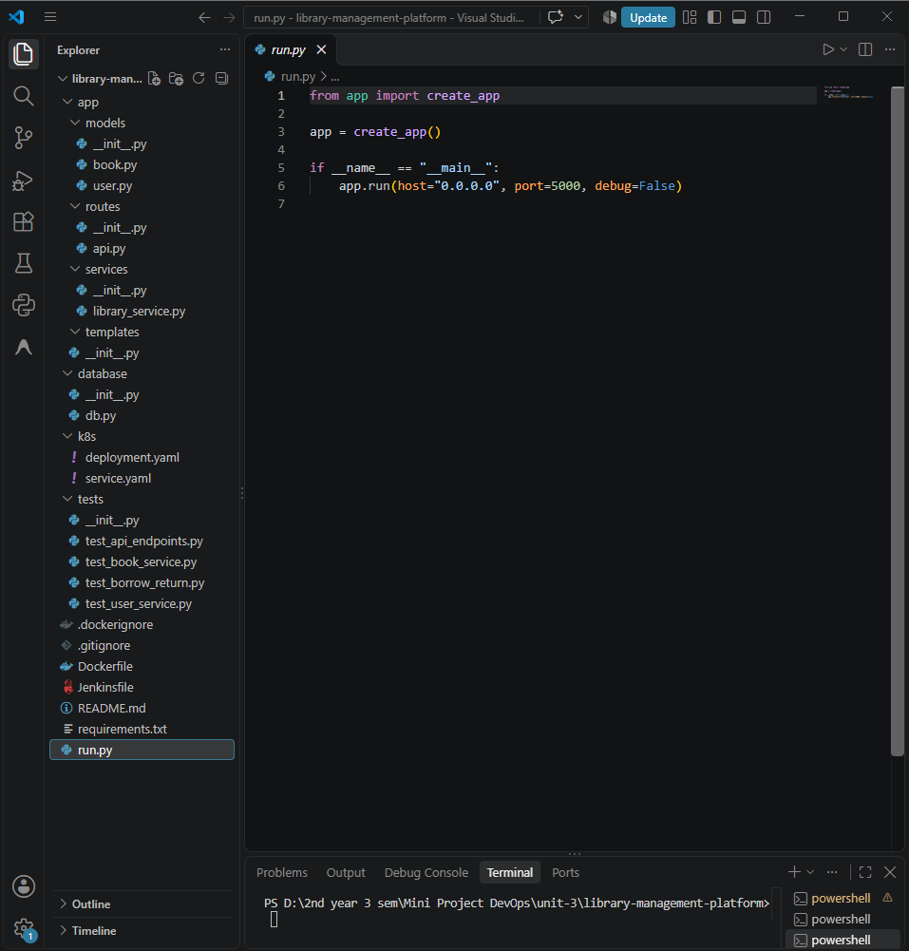
run.py builds the Flask app with create_app() and starts it on host 0.0.0.0, port 5000. The same app object (run:app) is later used by gunicorn inside Docker.

Step 11: Create a Python virtual environment
py -m venv .venv
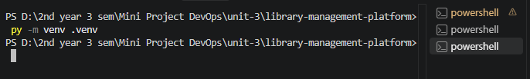
This creates an isolated Python environment named .venv inside the project folder. It keeps the project's packages separate from the system Python.

Step 12: Activate the environment and install requirements
Set-ExecutionPolicy -Scope Process -ExecutionPolicy Bypass
.\.venv\Scripts\Activate.ps1
python -m pip install -r requirements.txt
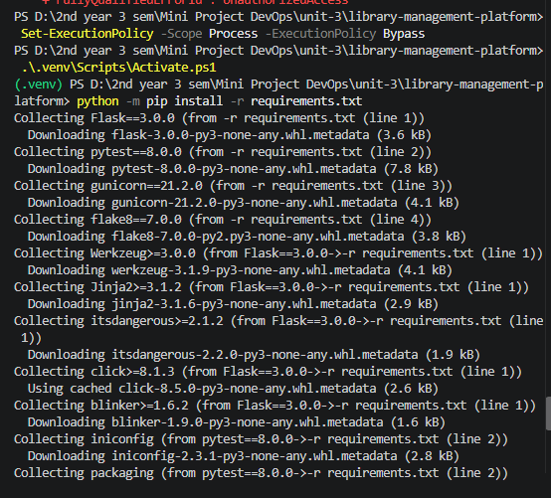
The execution policy is relaxed for this PowerShell session only so the activation script can run, and then the environment is activated. pip then installs Flask, pytest, gunicorn and flake8 from requirements.txt.

Step 13: Verify installed packages
python -m pip list
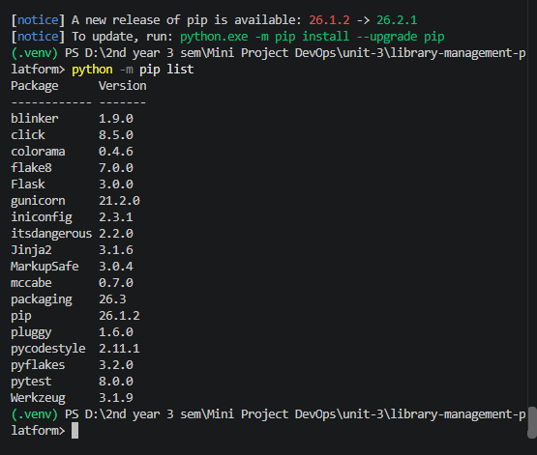
This lists every package installed in the virtual environment. It confirms Flask 3.0.0, pytest 8.0.0, gunicorn 21.2.0 and flake8 7.0.0 are present along with their dependencies.

Step 14: Run the Flask app locally
python run.py
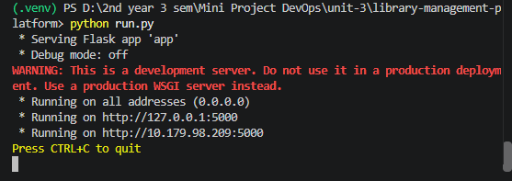
This starts the Flask development server on port 5000, listening on all addresses. The red warning is normal and only says the development server is not meant for production, which is why gunicorn is used in Docker.

Step 15: Test the book service
python -m pytest tests/test_book_service.py -v
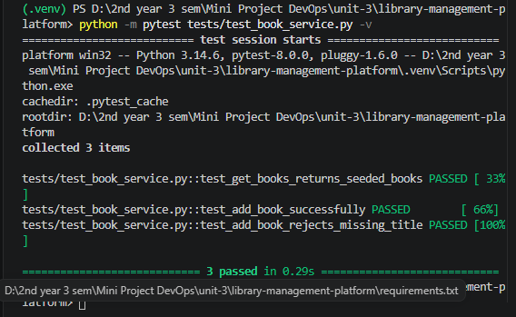
This runs only the book service tests in verbose mode. All 3 tests passed, covering the seeded books, adding a book and rejecting a missing title.

Step 16: Test the user service
python -m pytest tests/test_user_service.py -v
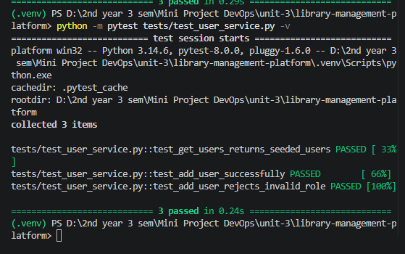
This runs only the user service tests in verbose mode. All 3 tests passed, covering the seeded users, adding a user and rejecting an invalid role.

Step 17: Test the API endpoints
python -m pytest tests/test_api_endpoints.py -v
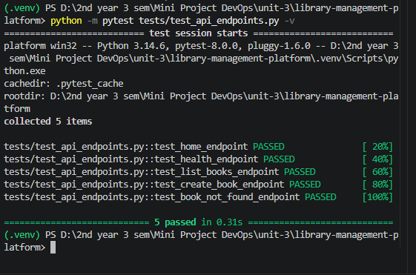
This runs the API tests in verbose mode. All 5 tests passed, covering the home, health, list-books, create-book and book-not-found endpoints.

Step 18: Run the complete test suite
python -m pytest tests/ -v
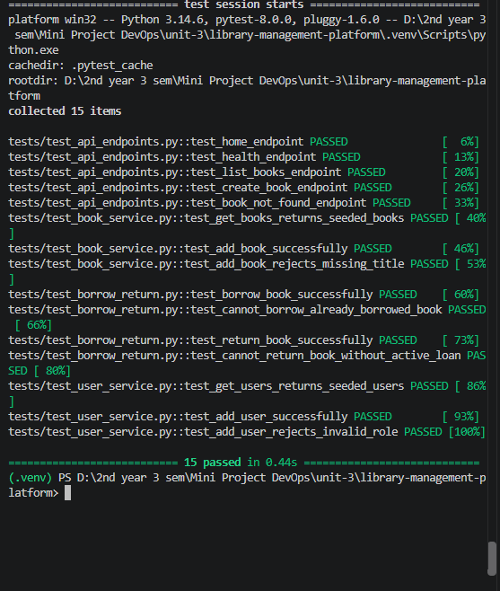
This runs every test file together, including the borrow and return tests. All 15 tests passed in 0.44 seconds, so the application logic is verified before it is deployed.

Step 19: Check code quality with Flake8
python -m flake8 app database tests run.py
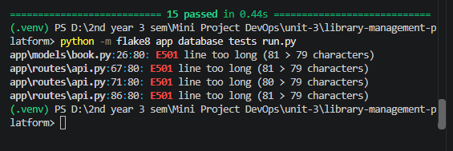
Flake8 checks the code style of the app, database, tests and run.py. It reported four E501 warnings for lines of 80 to 81 characters, which only need shortening to meet the 79-character limit.

Step 20: Stage the files in Git
git add .
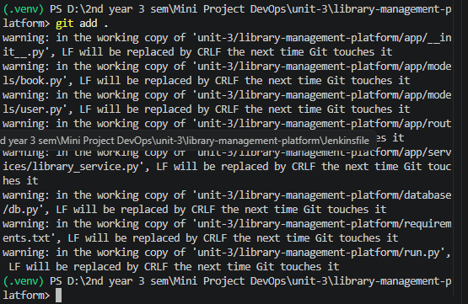
This stages all the new project files so they can be committed. The LF-to-CRLF messages are only Windows line-ending notices and do not stop the command.

Step 21: Commit the foundation code
git commit -m "Add library platform foundation"
git log -1 --oneline
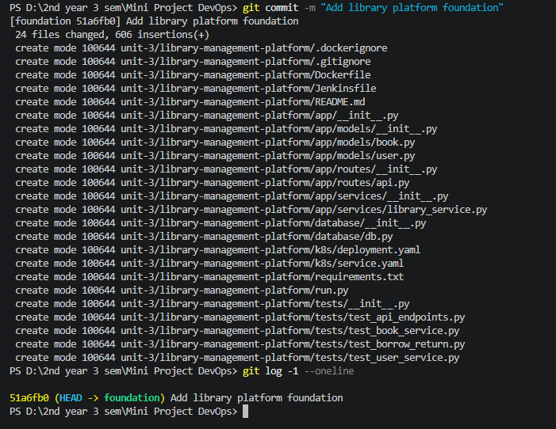
This saves 24 new files (606 lines) as a commit on the foundation branch. The git log command confirms the latest commit is 51a6fb0 on that branch.

8.2 Launching the AWS EC2 Instance

Step 22: Launch an instance: name and AMI
AWS Console > EC2 > Launch an instance
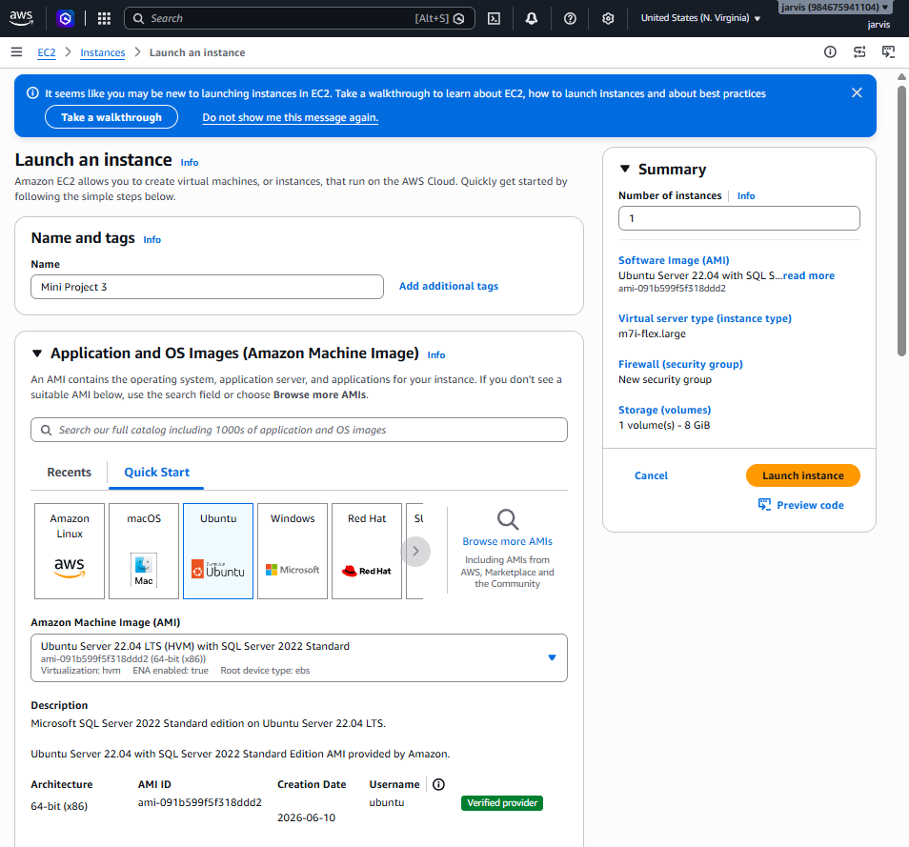
The instance is named Mini Project 3 in the US East (N. Virginia) region, and the Quick Start Ubuntu option is selected. The summary at this point still shows a SQL Server Ubuntu AMI, an m7i-flex.large type and an 8 GiB volume, which were changed in the next steps.

Step 23: Instance type: m7i-flex.large (first choice)
Instance type > m7i-flex.large
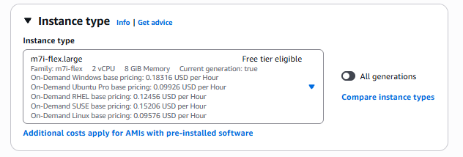
This panel shows the first type offered, m7i-flex.large with 2 vCPU and 8 GiB memory, marked free tier eligible. It was replaced by c7i-flex.large in the final setup.

Step 24: Choose the Ubuntu Server 24.04 LTS AMI
Application and OS Images > Ubuntu Server 24.04 LTS (HVM), SSD Volume Type
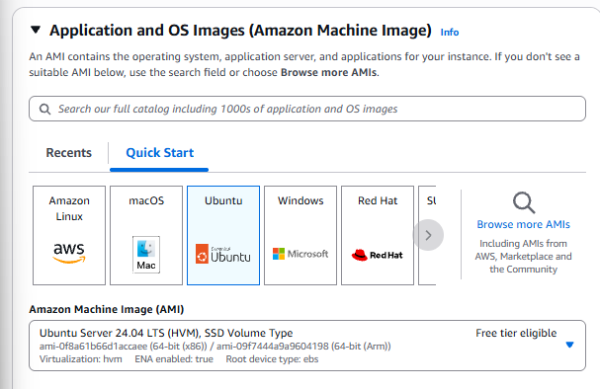
The AMI is switched to plain Ubuntu Server 24.04 LTS, which is free tier eligible and has no SQL Server software pre-installed. This matches the Ubuntu 24.04 system shown after the SSH login.

Step 25: Choose the c7i-flex.large instance type
Instance type > c7i-flex.large
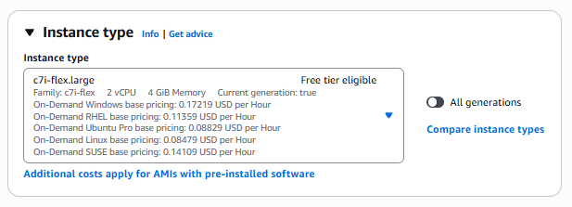
The instance type is set to c7i-flex.large with 2 vCPU and 4 GiB memory, also free tier eligible. This is enough for Docker, Minikube and Jenkins, as the later checks show 2 CPUs and 3.7 GiB of RAM.

Step 26: Configure storage
Configure storage > 1 x 30 GiB gp2
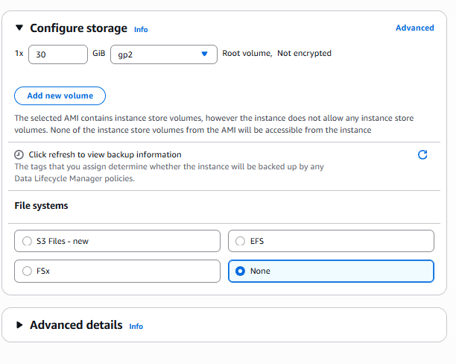
The root volume is increased from the default 8 GiB to 30 GiB of gp2 storage. The extra space is needed for Docker images, the Minikube base image and Jenkins.

Step 27: Instance is running
EC2 > Instances
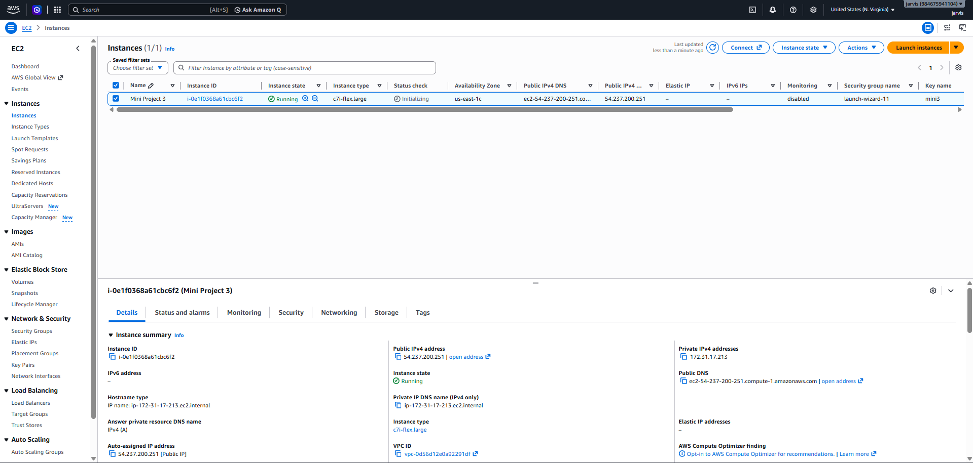
The Instances page shows Mini Project 3 in the Running state with type c7i-flex.large in us-east-1c, while status checks are still initialising. Its public IPv4 address, 54.237.200.251, is used to connect over SSH.

8.3 SSH Access and Server Preparation (MobaXterm)

Step 28: Connect to the server with MobaXterm SSH
ssh ubuntu@54.237.200.251 (MobaXterm SSH session)
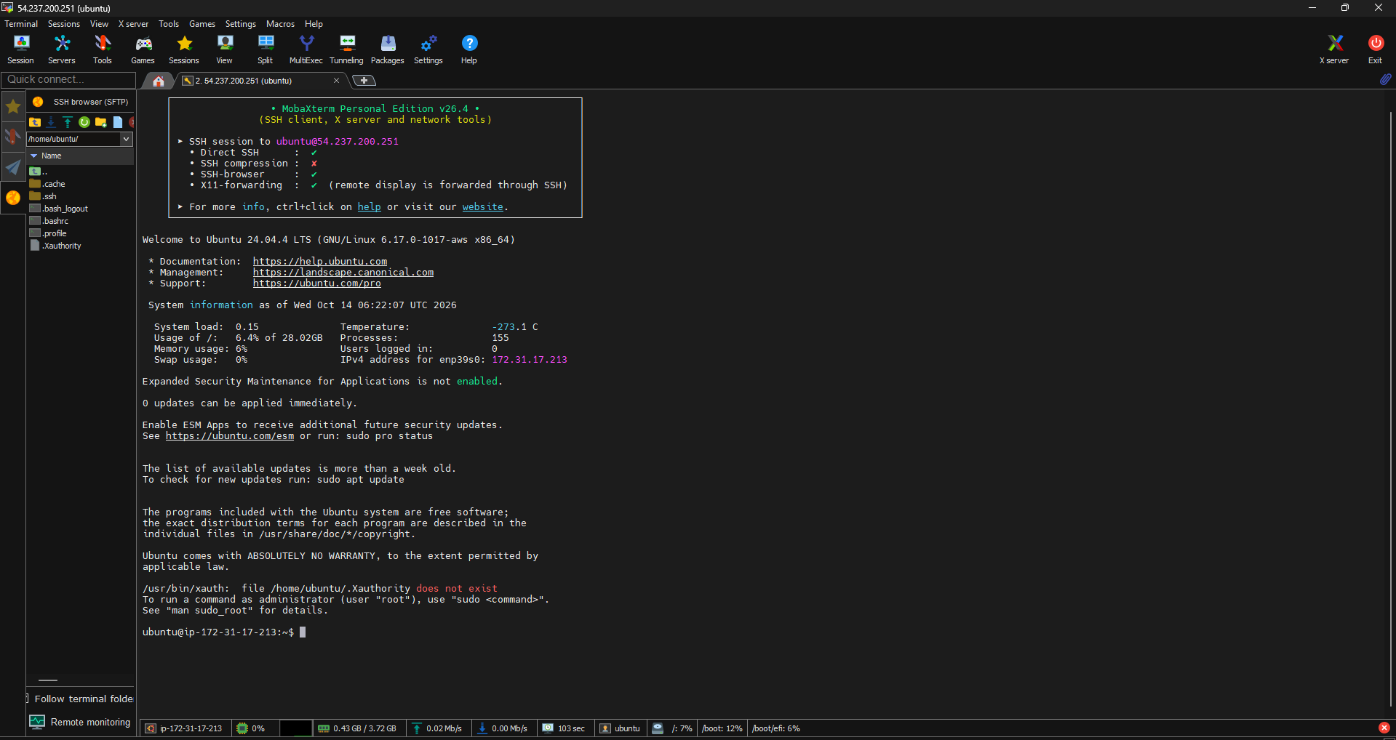
MobaXterm opens an SSH session to the EC2 public IP as the ubuntu user, and the welcome banner confirms Ubuntu 24.04.4 LTS. This terminal is used for all the server work that follows.

Step 29: Switch to root and refresh package lists
sudo su
sudo apt update
sudo su switches to the root user, and apt update refreshes the list of available packages. This is done before installing any new software.

Step 30: Check OS, CPU, memory and disk
lsb_release -a
nproc
free -h
df -h /
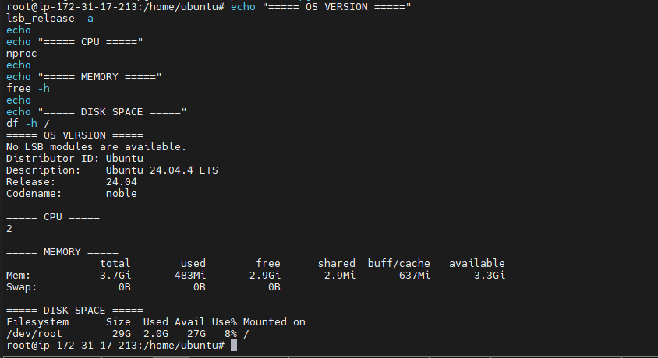
These commands show Ubuntu 24.04, 2 CPUs, 3.7 GiB of memory and a 29 GB root disk that is only 8% used. They confirm the server has enough resources before tools are installed.

Step 31: Check the Git version
git --version
This checks that Git is installed on the server. It reports version 2.43.0.

Step 32: Clone the GitHub repository
cd /home/ubuntu
git clone https://github.com/surajsase08/DevOps-mini-projects.git
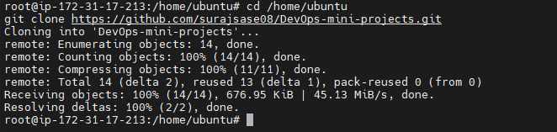
This downloads the project repository from GitHub into /home/ubuntu. The output shows all 14 objects were received successfully.

Step 33: Look for the project folder
ls -la
ls -la unit-3/library-management-platform
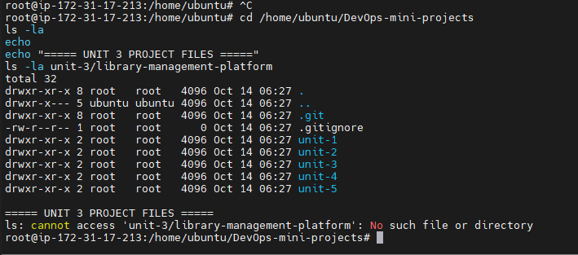
The first listing shows the folders unit-1 to unit-5, but the second command reports that the library project folder does not exist. This happened because the clone was on the main branch, which did not yet contain the library project.

Step 34: Check the current Git branch
git status
git branch
git log -1 --oneline
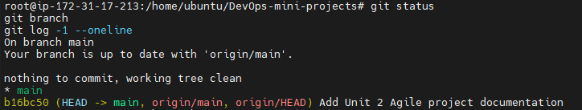
These commands show the clone is on the main branch, up to date with origin/main, with the Unit 2 documentation as its latest commit. This confirms the library code is not on main.

Step 35: Fetch the remote branches
git fetch origin
git branch -a
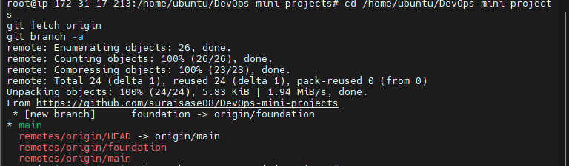
git fetch downloads branch information from GitHub without changing any local files. It found a new remote branch called foundation, which holds the library project.

Step 36: Switch to the foundation branch
git switch -c foundation --track origin/foundation
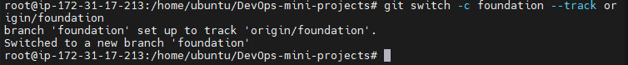
This creates a local branch named foundation that tracks the remote one and switches to it. The project files are now available in the working folder.

Step 37: Confirm the project files exist
ls -la unit-3/library-management-platform
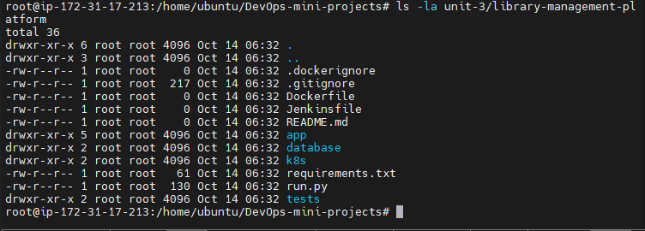
The listing now shows app, database, k8s, tests, requirements.txt and run.py. The Dockerfile, Jenkinsfile and README.md are still 0 bytes at this stage.

Step 38: Switch back to the ubuntu user
su - ubuntu
This leaves the root shell and logs in as the normal ubuntu user with its own environment. Docker, Minikube and kubectl are run as this user later.

Step 39: Check the user and folder ownership
whoami
pwd
ls -ld /home/ubuntu/DevOps-mini-projects
ls -ld /home/ubuntu/DevOps-mini-projects/unit-3/library-management-platform
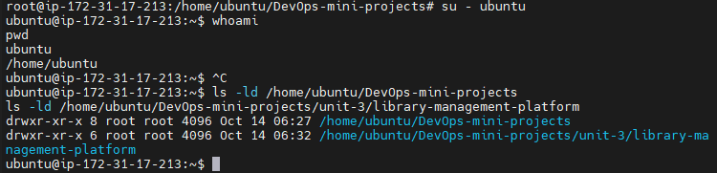
These commands confirm the current user is ubuntu in /home/ubuntu. They also show the cloned folders are owned by root, because the clone was done as root.

Step 40: Enter the project folder
cd /home/ubuntu/DevOps-mini-projects/unit-3/library-management-platform
pwd
ls -l
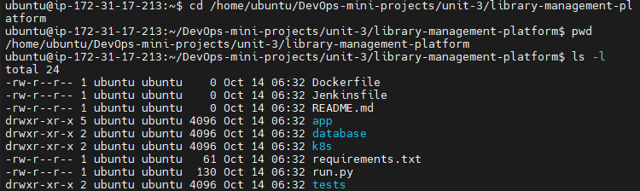
This moves into the project folder and lists its files, which are now owned by ubuntu. The folder contains app, database, k8s and tests along with the Dockerfile, Jenkinsfile and requirements.txt.

Step 41: View run.py
cat run.py
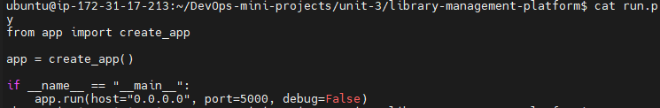
This prints run.py, which creates the Flask app and runs it on 0.0.0.0, port 5000. It confirms the file reached the server correctly.

Step 42: View requirements.txt
cat requirements.txt
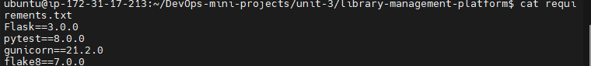
This displays the Python dependencies: Flask 3.0.0, pytest 8.0.0, gunicorn 21.2.0 and flake8 7.0.0. Both Docker and Jenkins install packages from this file.

Step 43: List the project files
find app database tests k8s -maxdepth 2 -type f
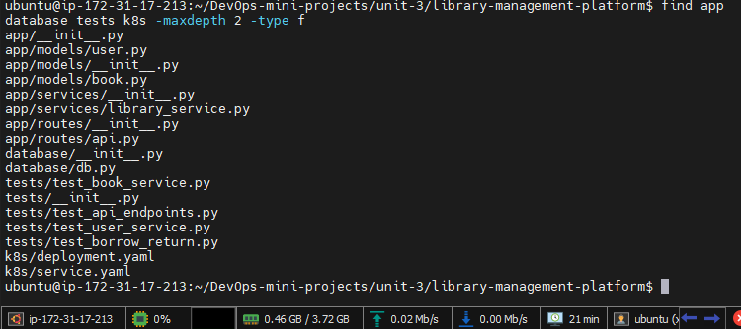
This lists every file inside the four project folders so the structure can be checked at a glance. All the model, route, service, database, test and Kubernetes YAML files are present.

Step 44: View the application factory
cat app/__init__.py
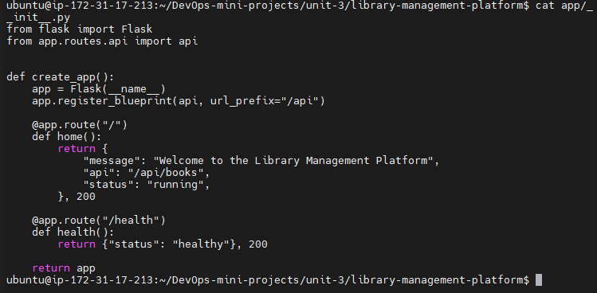
This prints create_app(), which registers the API blueprint under /api. It also defines the / home route and the /health route used by Docker checks and Kubernetes probes.

8.4 Docker Image and Container

Step 45: View the Dockerfile
cat Dockerfile
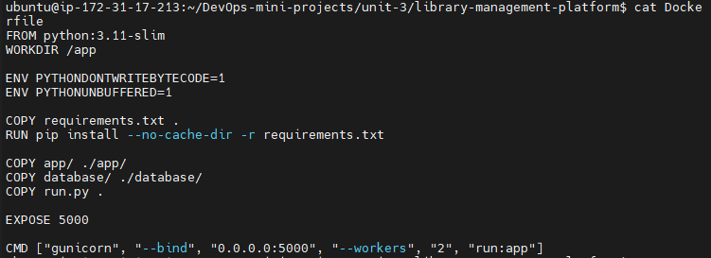
The Dockerfile starts from python:3.11-slim, installs the requirements, copies the app, database and run.py, and exposes port 5000. The container starts the app with gunicorn using 2 workers on port 5000.

Step 46: Check the Docker version
docker --version
This checks that Docker is installed on the server. It reports version 29.1.3.

Step 47: Check that the Docker service is running
sudo systemctl is-active docker
This asks systemd whether the Docker service is running. The answer active confirms the Docker daemon is up.

Step 48: Docker permission check
docker ps
sudo docker ps
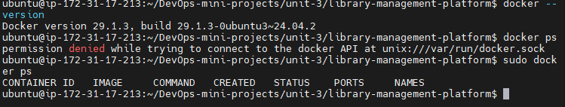
Running docker ps as the ubuntu user fails with permission denied because that user cannot access the Docker socket. Using sudo works and shows an empty list, so no containers are running yet.

Step 49: List Docker images
sudo docker images
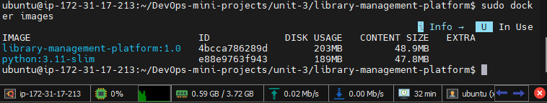
This lists the local Docker images. It shows library-management-platform:1.0 (203 MB) together with its base image python:3.11-slim.

Step 50: Run the application container
sudo docker run -d --name library-app -p 5000:5000 library-management-platform:1.0
This starts the application in the background as a container named library-app and maps host port 5000 to container port 5000. The long ID printed is the new container's ID.

Step 51: Check the container and its health endpoint
sudo docker ps
curl http://localhost:5000/health
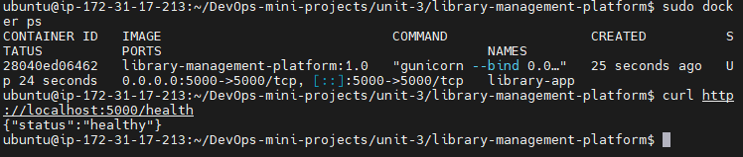
docker ps shows library-app running with port 5000 published. The curl request returns {"status":"healthy"}, proving the app responds from inside the container.

Step 52: Test the books API
curl http://localhost:5000/api/books
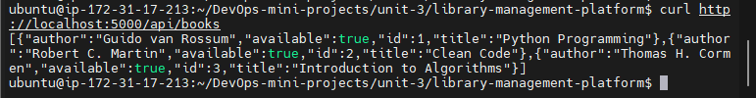
This calls the books API and returns the three seeded books as JSON: Python Programming, Clean Code and Introduction to Algorithms. It confirms the API and its in-memory data work inside the container.

Step 53: Check server resources with the container running
free -h
df -h /
nproc
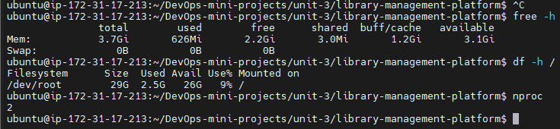
These checks show about 626 MiB of memory used, 9% of the disk used and 2 CPUs. The server still has enough headroom to run Minikube next.

8.5 Kubernetes Deployment with Minikube

Step 54: Check for kubectl and Minikube
kubectl version --client
minikube version
sudo docker --version
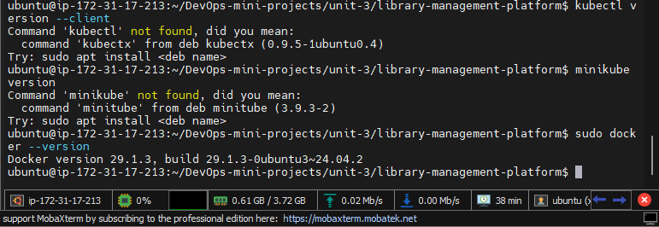
The first two commands fail with command not found, which shows kubectl and Minikube are not installed yet, while Docker is available. This tells us what must be installed next.

Step 55: Install kubectl
sudo snap install kubectl --classic
kubectl version --client
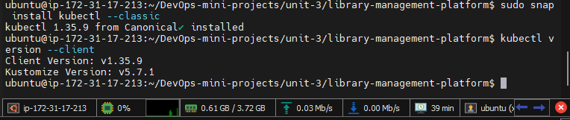
This installs the kubectl command-line tool using snap. The version check confirms kubectl v1.35.9 is ready to use.

Step 56: Install Minikube
curl -LO https://storage.googleapis.com/minikube/releases/latest/minikube-linux-amd64
sudo install minikube-linux-amd64 /usr/local/bin/minikube
rm minikube-linux-amd64
minikube version
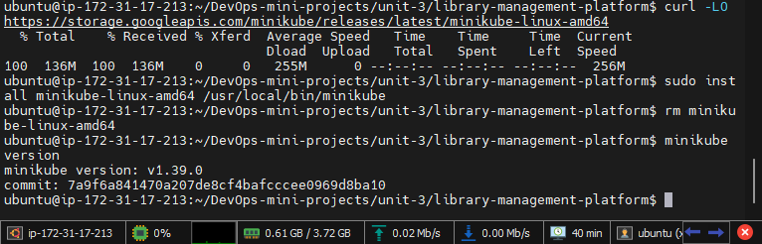
These commands download the Minikube binary, install it into /usr/local/bin and delete the downloaded file. The version check shows Minikube v1.39.0 is ready.

Step 57: Start the Minikube cluster
minikube start --driver=docker --cpus=2 --memory=2500
kubectl get nodes
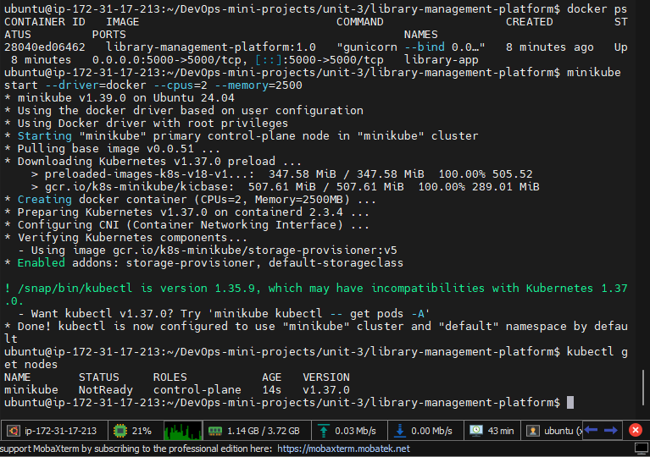
This starts a single-node Kubernetes cluster inside a Docker container using 2 CPUs and 2500 MB of memory. The node shows NotReady at first because it was checked only seconds after starting.

Step 58: Confirm the cluster is ready
minikube status
kubectl get nodes
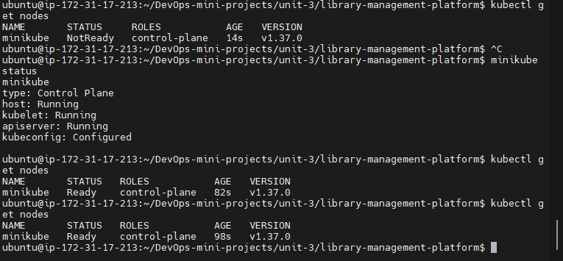
minikube status shows the host, kubelet and API server all Running and kubeconfig Configured. A little later kubectl get nodes shows the minikube node as Ready.

Step 59: View the Deployment manifest
cat k8s/deployment.yaml
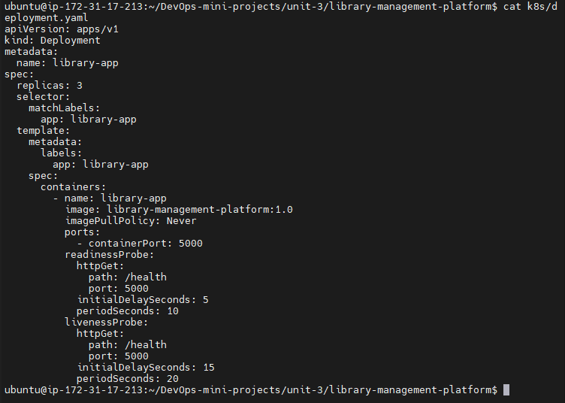
The Deployment runs 3 replicas of library-management-platform:1.0 and uses imagePullPolicy Never so the local image is used. Readiness and liveness probes check the /health endpoint on port 5000.

Step 60: View the Service manifest
cat k8s/service.yaml
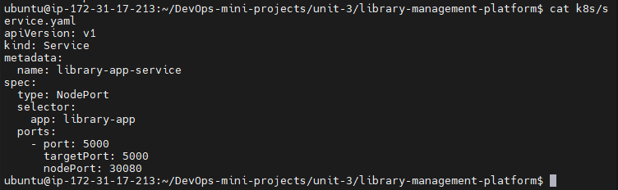
This NodePort Service selects the pods labelled app: library-app and maps service port 5000 to container port 5000. It exposes the application on node port 30080.

Step 61: Check pods and deployment
kubectl get pods
kubectl get deployments
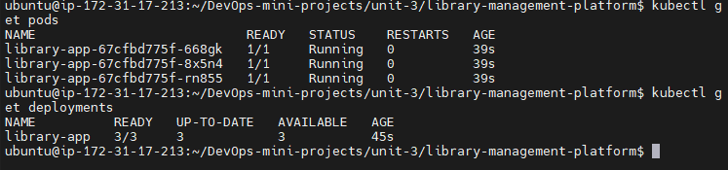
All three library-app pods are 1/1 Running with 0 restarts. The deployment shows 3/3 ready, up to date and available, matching the desired replica count.

Step 62: Check services and endpoints
kubectl get services
kubectl get endpoints library-app-service
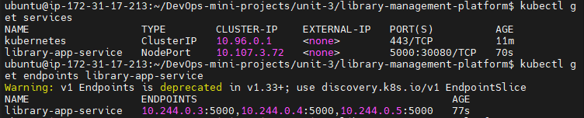
library-app-service is a NodePort service with 5000:30080/TCP, shown beside the default kubernetes service. The endpoints command lists three pod IPs on port 5000, so the service sends traffic to all three pods.

Step 63: Port-forward the service
kubectl port-forward svc/library-app-service 8081:5000
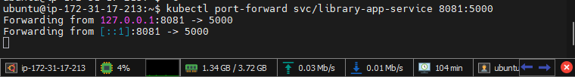
This temporarily forwards local port 8081 to port 5000 of the Kubernetes service. The terminal must stay open while the application is being tested.

Step 64: Test through the port-forward and delete a pod
curl http://127.0.0.1:8081/health
curl http://127.0.0.1:8081/
kubectl delete pod library-app-67cfbd775f-668gk
kubectl get pods
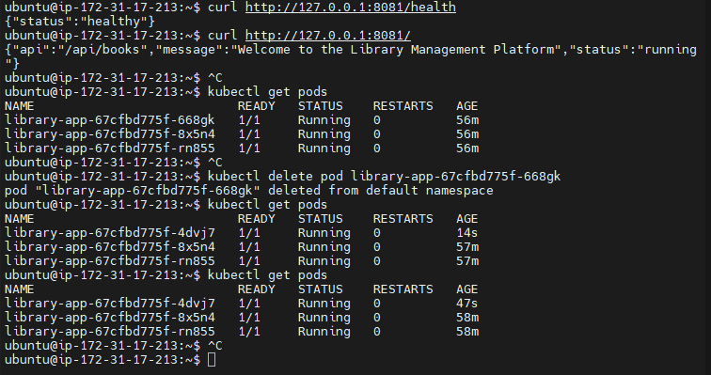
The curl calls return a healthy status and the welcome message through the Kubernetes service. After one pod is deleted, Kubernetes creates a replacement (4dvj7) and three pods are running again, demonstrating self-healing.

8.6 Jenkins Installation and CI Pipeline

Step 65: Check the Java version
java -version
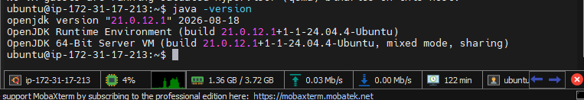
Jenkins needs Java, so this command checks the installed runtime. It reports OpenJDK 21.0.12.1.

Step 66: Check the Jenkins service
sudo systemctl status jenkins --no-pager
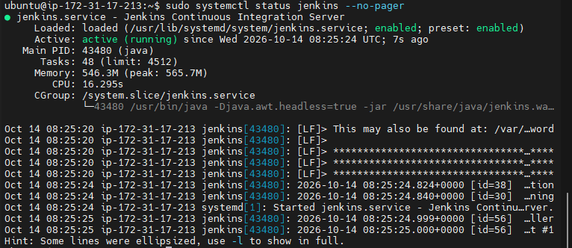
This shows the Jenkins service is active (running) and enabled to start at boot. The log lines show it started on 14 Oct 2026.

Step 67: Open port 8080 in the security group
AWS Console > EC2 > Security Groups > Edit inbound rules
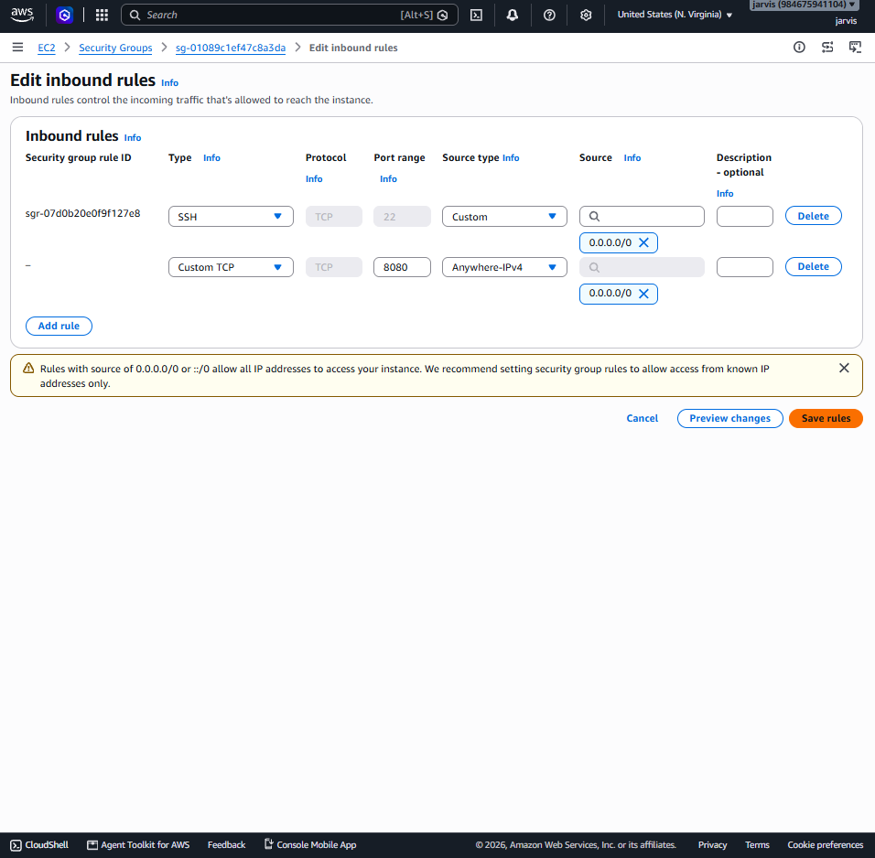
A Custom TCP inbound rule for port 8080 is added next to SSH on port 22 so the Jenkins web page can be opened from a browser. Both rules use source 0.0.0.0/0, which AWS warns is open to everyone, so a real setup should restrict it to your own IP.

Step 68: Read the Jenkins initial admin password
sudo cat /var/lib/jenkins/secrets/initialAdminPassword
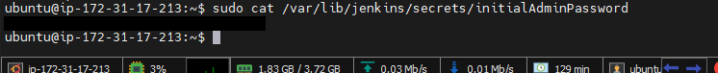
This prints the one-time administrator password that Jenkins asks for during first-time setup. The password in this screenshot has been blacked out for security.

Step 69: Unlock Jenkins in the browser
Browser: http://54.237.200.251:8080
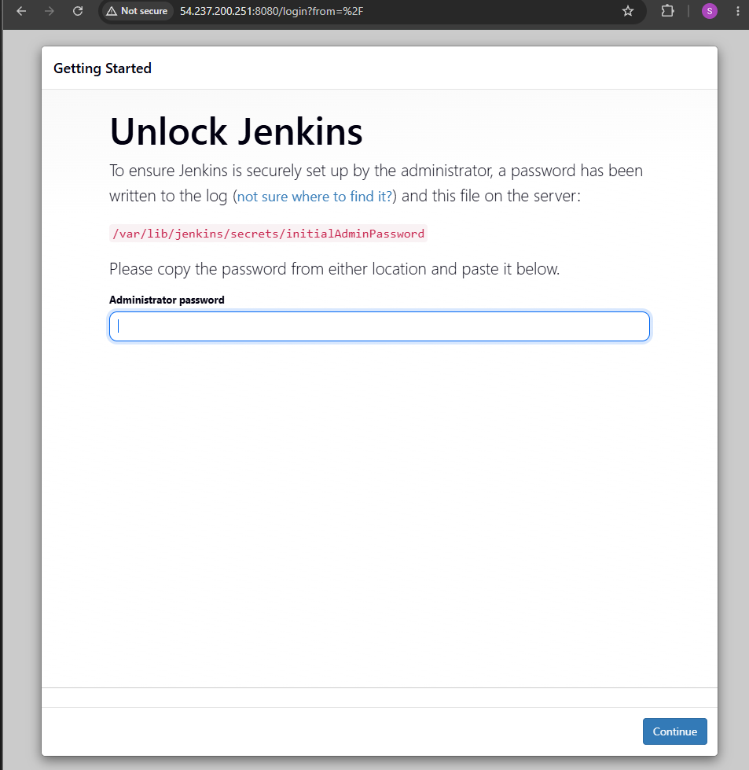
Opening the server's public IP on port 8080 shows the Unlock Jenkins page. The password from the previous step is pasted here to continue.

Step 70: Install the suggested plugins
Install suggested plugins
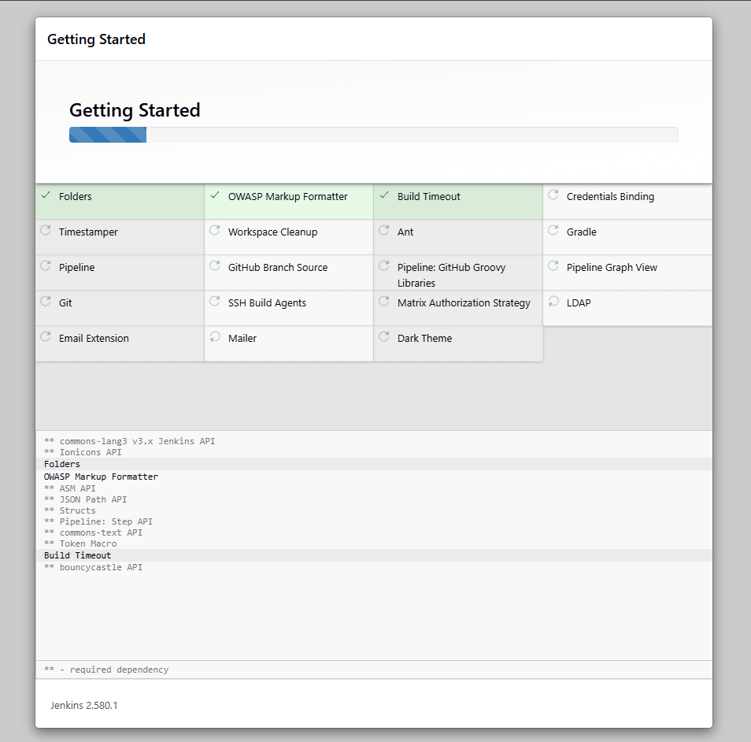
Jenkins installs the suggested plugins, such as Git, Pipeline, Folders and Timestamper. Setup continues automatically when the progress bar finishes.

Step 71: Jenkins is ready
Start using Jenkins
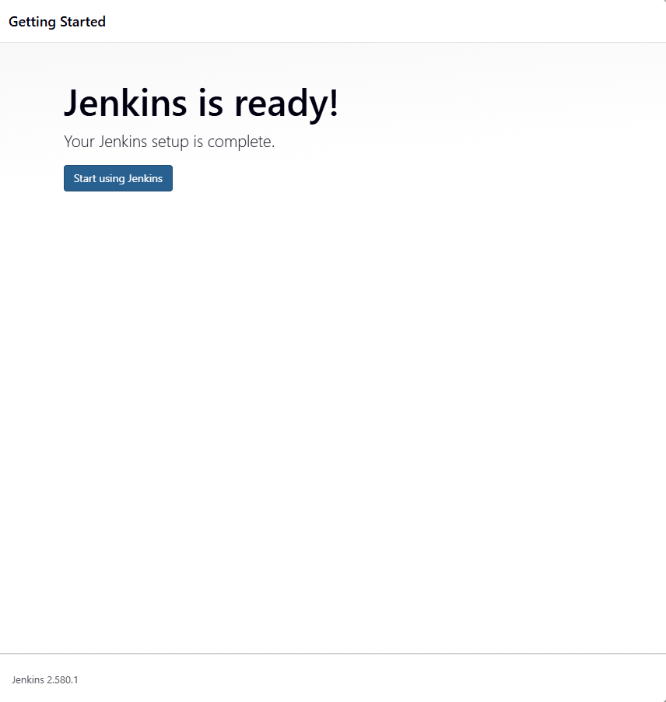
This page confirms the initial Jenkins setup is complete (version 2.580.1). Clicking Start using Jenkins opens the dashboard.

Step 72: Create the pipeline job
New Item > Library-Management-CI > Pipeline
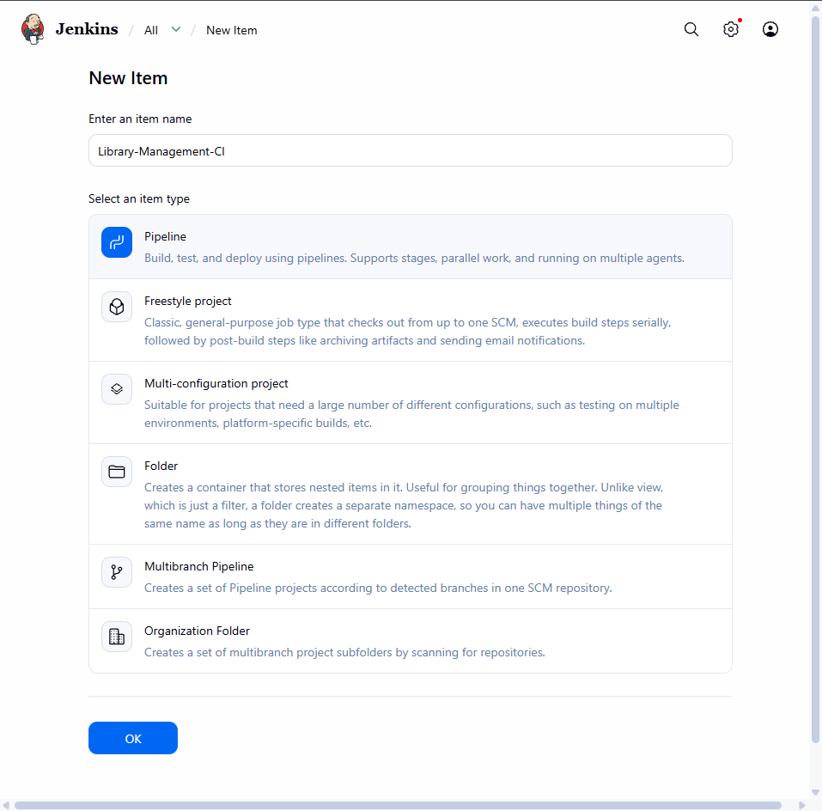
A new job named Library-Management-CI is created using the Pipeline type. This type lets the CI steps be written as stages in a Jenkinsfile.

Step 73: Connect the pipeline to GitHub
Pipeline > Definition: Pipeline script from SCM > SCM: Git
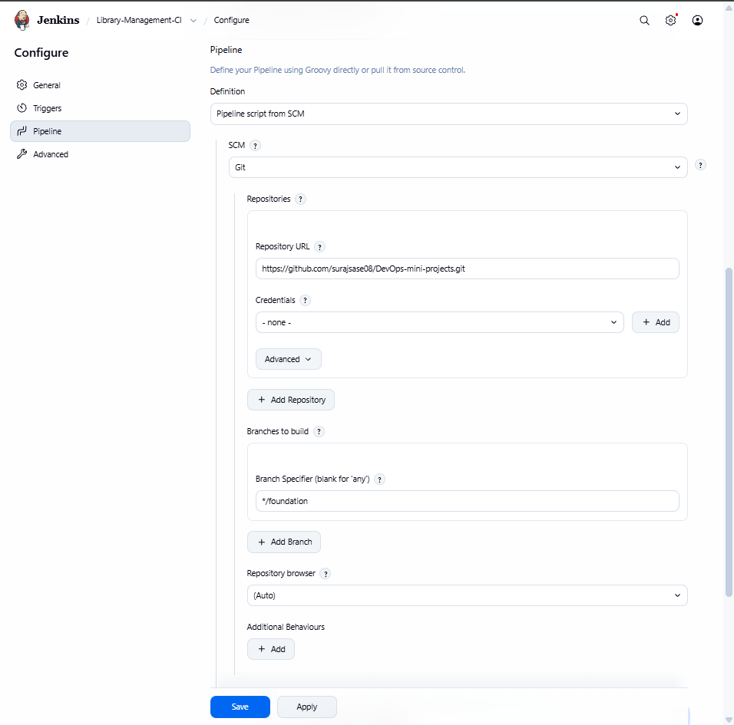
The pipeline reads its script from Git using the repository https://github.com/surajsase08/DevOps-mini-projects.git and the branch */foundation. Jenkins therefore checks out the project and runs the Jenkinsfile from that branch.

Step 74: Job page before the first build
Library-Management-CI > Status
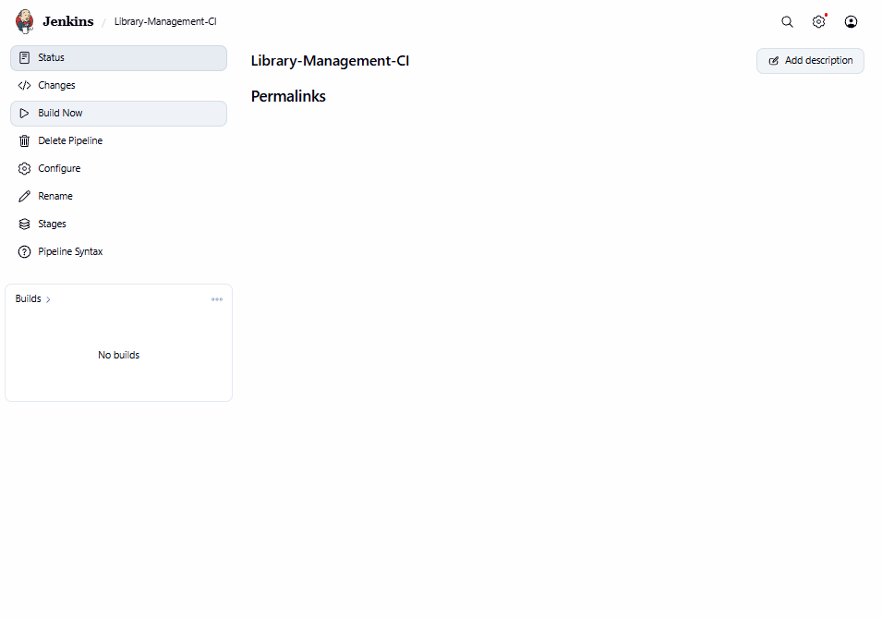
The job's status page shows No builds yet. Clicking Build Now starts the first pipeline run.

Step 75: Build history and test trend
Build Now
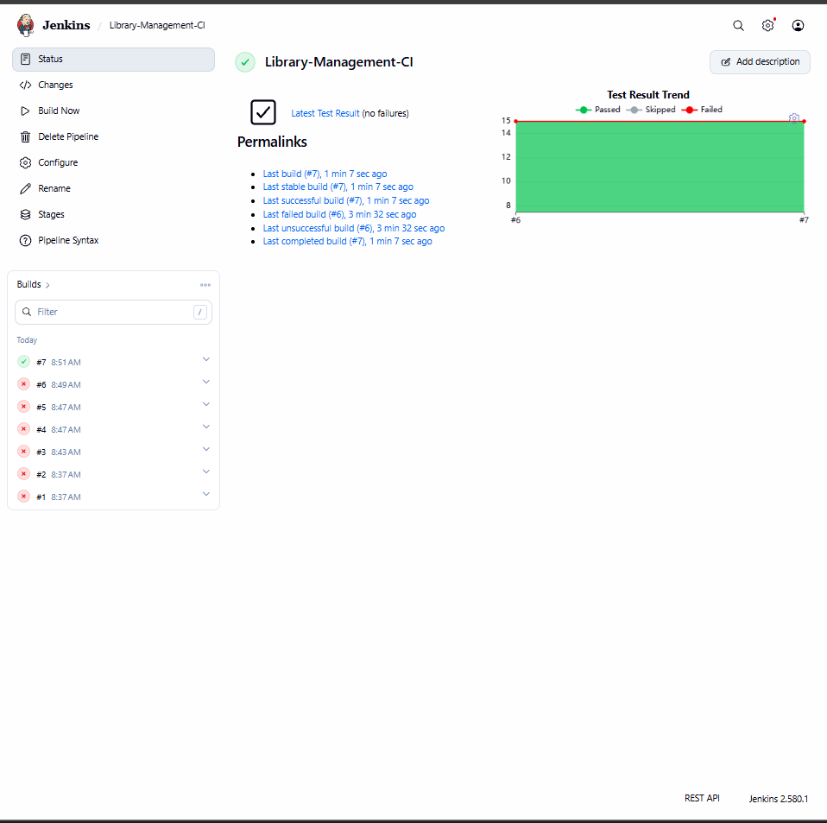
The build history shows builds #1 to #6 failed and build #7 succeeded, with the test trend graph reaching 15 passed tests. The pipeline therefore needed several attempts before it turned green.

Step 76: Pipeline stage view
Library-Management-CI > Stages
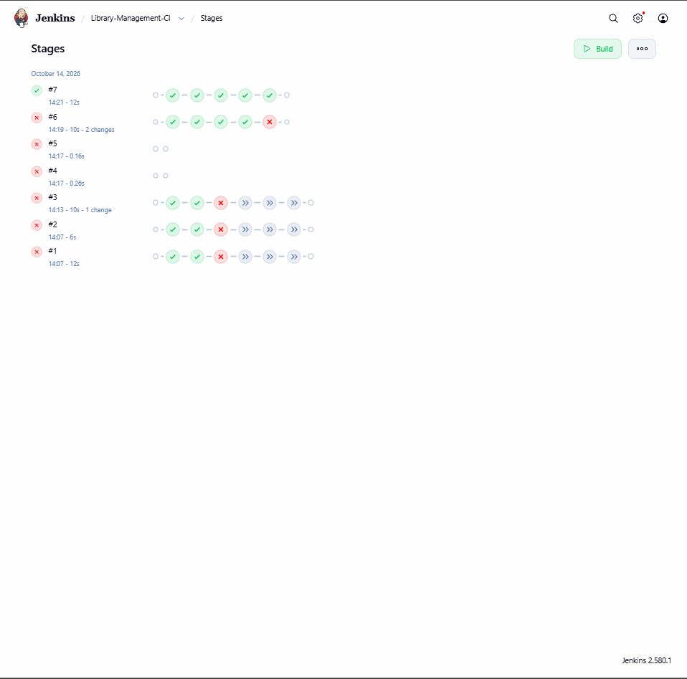
The stage view shows how far each build got, with the earlier builds failing at different stages. Build #7 passed all five stages, and this view makes it easy to see which stage caused a failure.

Step 77: Console output of build #7
Build #7 > Console Output
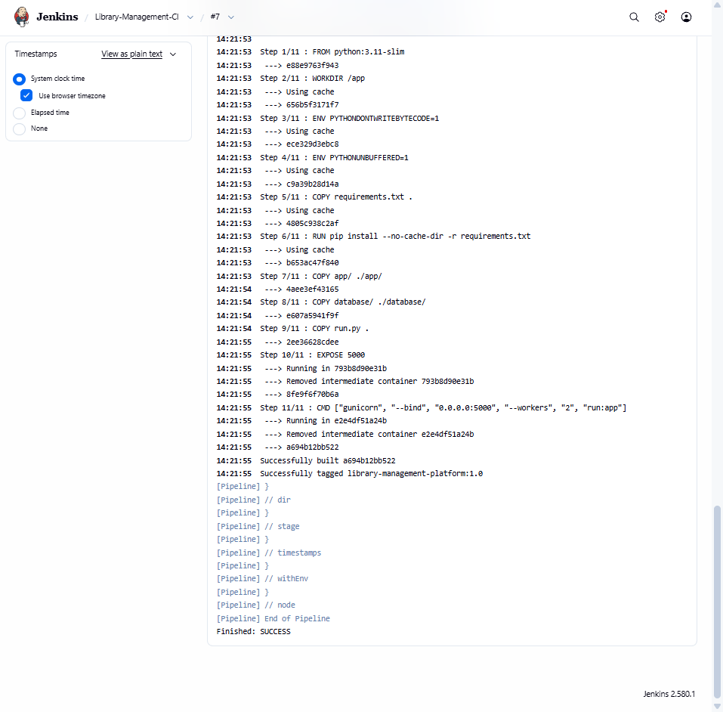
The log shows the Docker build steps (Step 1/11 to 11/11) ending with Successfully tagged library-management-platform:1.0. The last line, Finished: SUCCESS, confirms the whole pipeline passed.

Step 78: Test results of build #7
Build #7 > Tests
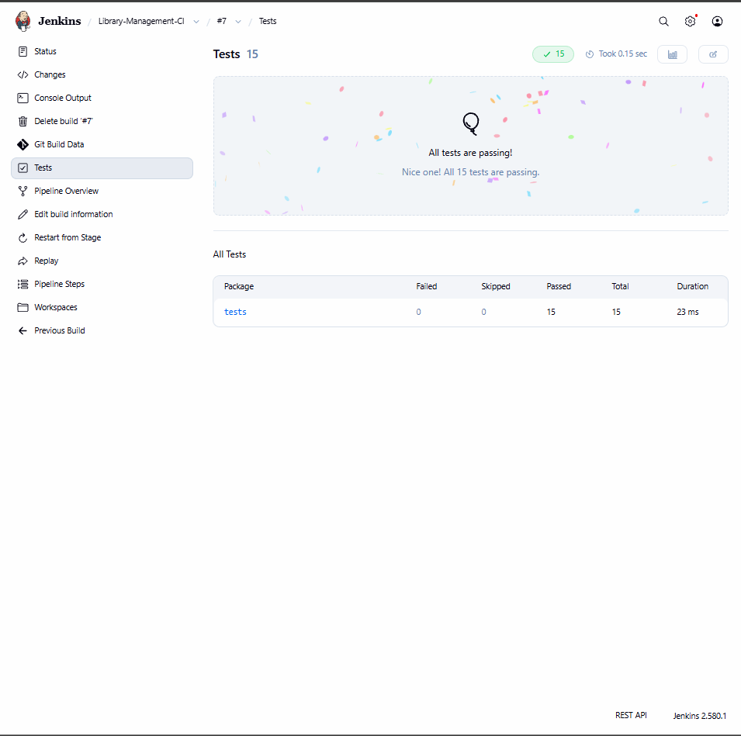
Jenkins reads the pytest JUnit report and shows all 15 tests passing, with 0 failed and 0 skipped. This proves the automated tests run correctly on every build.

Step 79: Jenkins dashboard
Jenkins > Dashboard
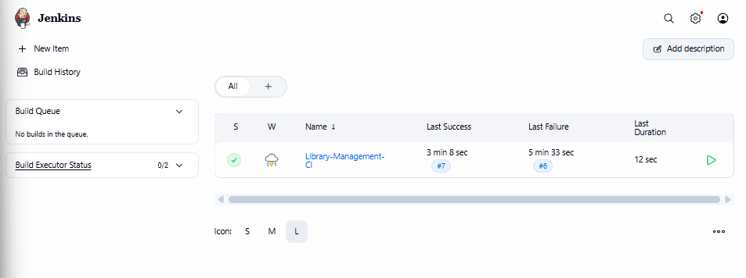
The dashboard lists Library-Management-CI with a green status icon and build #7 as the last success. The last failure was build #6, and the most recent build took 12 seconds.

Step 80: Docker images after the Jenkins build
sudo docker images
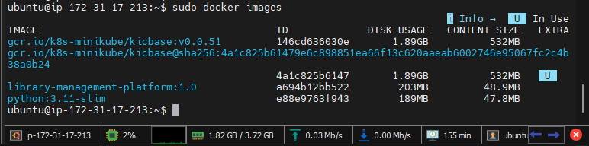
The image list now shows library-management-platform:1.0 with image ID a694b12bb522, the image built by the Jenkins pipeline. The Minikube base image and python:3.11-slim are also listed.

8.7 Final Verification and Pull Request

Step 81: Final check of pods, deployment and services
kubectl get pods
kubectl get deployment
kubectl get services
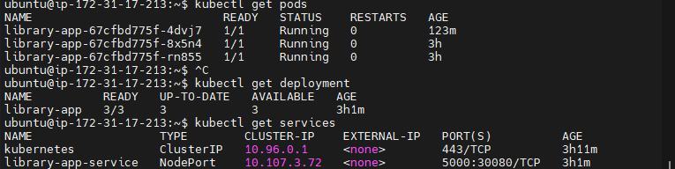
All three library-app pods are 1/1 Running with 0 restarts, and the deployment shows 3/3 ready. The service is still NodePort 5000:30080/TCP, showing the deployment stayed stable for over three hours.

Step 82: Self-healing test: delete a pod
kubectl get pods -w
kubectl delete pod library-app-67cfbd775f-4dvj7
kubectl get pods -w
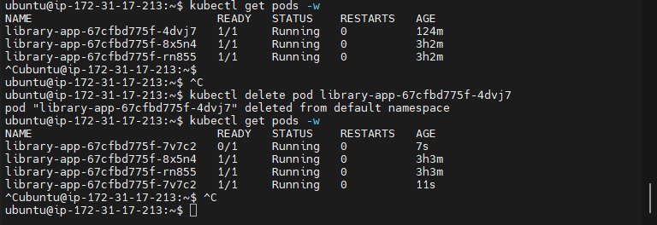
Deleting one pod makes Kubernetes start a replacement, library-app-67cfbd775f-7v7c2, which first shows 0/1 and then 1/1 Running. The other two pods stay healthy throughout, confirming the Deployment's self-healing behaviour.

Step 83: Final check of the container and images
curl http://localhost:5000/health
sudo docker images
sudo docker ps
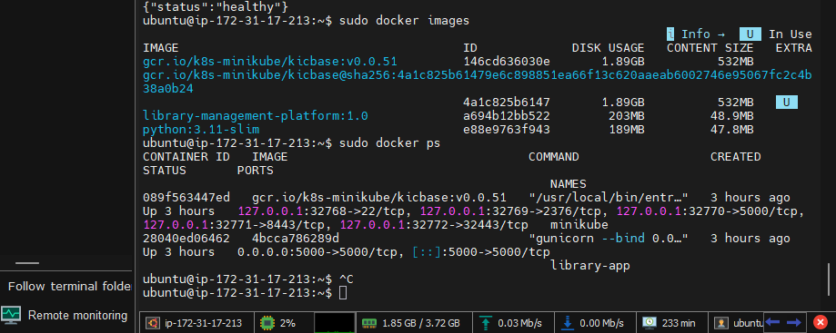
The health endpoint still returns {"status":"healthy"}, and docker ps shows both the minikube container and the library-app container on port 5000. This confirms the Docker container and the Kubernetes deployment are both working on the EC2 server.

Step 84: Open a pull request on GitHub
GitHub > Pull requests > Open a pull request (base: main, compare: foundation)
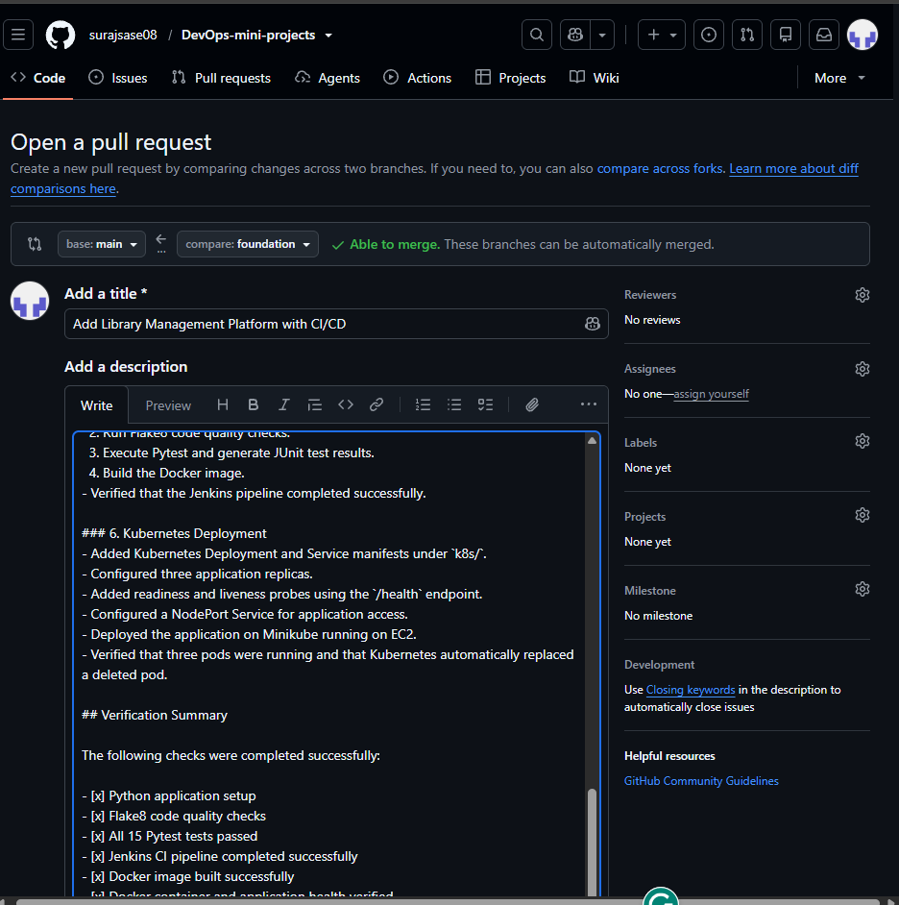
A pull request titled Add Library Management Platform with CI/CD is opened from foundation into main, and GitHub reports Able to merge. The description summarises the work and ends with a verification checklist that includes all 15 Pytest tests passed.

9. Results and Verification Summary
Component | Evidence / Result | Status
AWS EC2 / SSH | Ubuntu instance accessed through MobaXterm terminal | Completed
Jenkins service | Jenkins installed and service active | Completed
Jenkins pipeline | Latest build on staged/foundation ended with Finished: SUCCESS | Passed
Automated tests | All tests passed; JUnit results available in Jenkins | Passed
Docker image | library-management-platform:1.0 exists locally | Verified
Docker container | library-app running on host port 5000 | Verified
Health endpoint | Returns {"status":"healthy"} | Healthy
Kubernetes deployment | 3 desired / 3 available replicas | Healthy
Kubernetes service | NodePort service maps 5000:30080/TCP | Verified
Self-healing | Deleted pod replaced automatically and became 1/1 Ready | Passed

10. What I Learned
- How to launch and administer a Linux cloud server through SSH using MobaXterm.
- How to install and verify server packages with apt and systemctl.
- How Jenkins automates repeatable quality checks, unit tests, and image builds.
- How Docker images and containers package and run an application.
- How Kubernetes Deployments maintain the desired number of replicas and Services expose an application.
- How to validate service health and demonstrate pod self-healing by deleting a pod and observing its replacement.

11. Submission Checklist
- Add the AWS EC2 launch screenshot at the beginning (included in this report).
- Include screenshots showing the instance connection/terminal, Jenkins success, test results, Docker image and container, health endpoint, Kubernetes pods/deployment/service, and pod replacement.
- Keep all screenshots readable; crop unnecessary desktop space only if it does not remove command context or results.
- Do not submit private keys, passwords, initial admin secrets, or other credentials.
- Make sure the final report reflects the actual AWS/MobaXterm work; VS Code is not presented as the deployment environment.

End of Report

