DATA CLEANING AND PRELIMINARY ANALYSIS WITH R
Week 1 Internship Report
Prepared By: _ Suraj sen

1. Introduction
This report presents data cleaning and preliminary exploratory analysis of the Titanic passenger dataset using R. The workflow covers missing values, duplicates, outlier detection, normalization, categorical encoding, descriptive analysis, visualizations and correlation analysis.

2. Objectives
- Inspect the dataset.
- Handle missing values.
- Check duplicates.
- Detect potential outliers using IQR.
- Normalize Fare to 0–1.
- Encode categorical variables.
- Perform EDA and correlation analysis.

3. Dataset Description
Dataset: Titanic passenger dataset containing numerical and categorical passenger information such as Age, Fare, Sex, Pclass, SibSp, Parch, Embarked and Survived.
Source: https://raw.githubusercontent.com/datasciencedojo/datasets/master/titanic.csv

4. Data Loading
data <- read.csv(file.choose())
head(data)
dim(data)
str(data)
summary(data)

5. Data Cleaning

5.1 Missing Values
colSums(is.na(data))
Age missing values were handled using the median. Embarked missing/unknown values were retained as a separate category. Cabin was removed because of its high missingness. The final check shows zero missing values in retained columns.
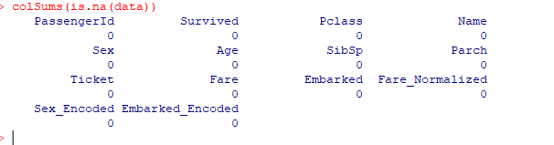
Figure 1. Missing-value check after cleaning.

5.2 Duplicate Records
sum(duplicated(data))
The duplicate check returned 0.
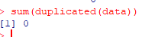
Figure 2. Duplicate-record check.

5.3 Outlier Detection
Q1_Fare <- quantile(data$Fare, 0.25, na.rm = TRUE)
Q3_Fare <- quantile(data$Fare, 0.75, na.rm = TRUE)
IQR_Fare <- Q3_Fare - Q1_Fare
Lower_Fare <- Q1_Fare - 1.5 * IQR_Fare
Upper_Fare <- Q3_Fare + 1.5 * IQR_Fare
Fare_Outliers <- data[data$Fare < Lower_Fare | data$Fare > Upper_Fare, ]
nrow(Fare_Outliers)
The IQR method identified 116 potential Fare outliers. They were identified for analysis and not automatically deleted.
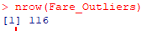
Figure 3. Fare outlier count: 116.

5.4 Normalization
data$Fare_Normalized <- (data$Fare - min(data$Fare, na.rm = TRUE)) /
(max(data$Fare, na.rm = TRUE) - min(data$Fare, na.rm = TRUE))
summary(data$Fare_Normalized)
Fare was successfully normalized to the 0–1 range.
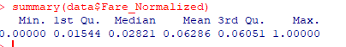
Figure 4. Fare normalization summary.

5.5 Categorical Encoding
data$Sex_Encoded <- ifelse(data$Sex == "male", 1, 0)
table(data$Sex_Encoded)
Sex was encoded numerically; the output shows 314 coded 0 and 577 coded 1.
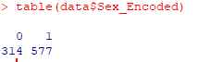
Figure 5. Sex encoding.
data$Embarked_Encoded <- as.numeric(as.factor(data$Embarked))
table(data$Embarked_Encoded)
Embarked was converted to numerical categories. Counts were 2, 168, 77 and 644 for codes 1–4.
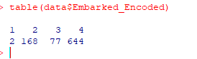
Figure 6. Embarked encoding.

6. Exploratory Data Analysis

6.1 Age Distribution
Most observations are concentrated in younger and middle-age ranges.
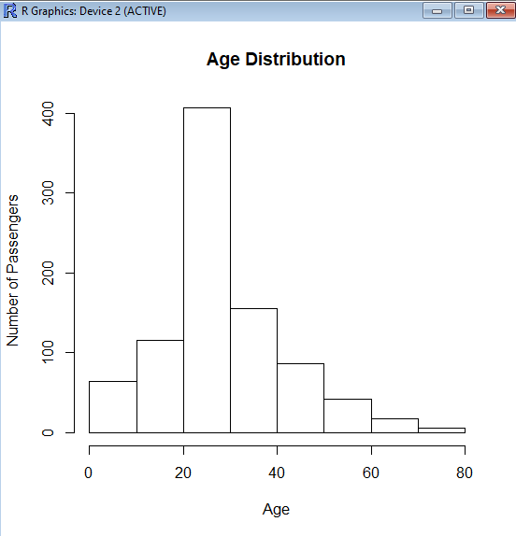
Figure 7. Age Distribution.

6.2 Survival Count
The chart shows more non-survivors than survivors.
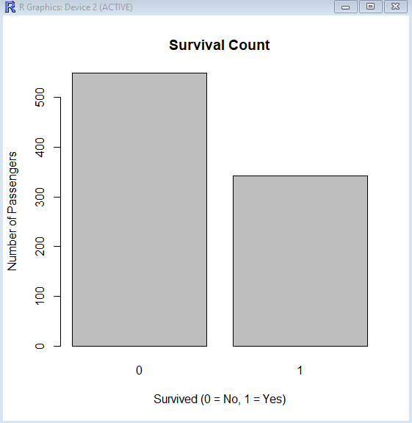
Figure 8. Survival Count.

6.3 Fare Distribution
Fare is strongly right-skewed, with most fares low and a small number very high.
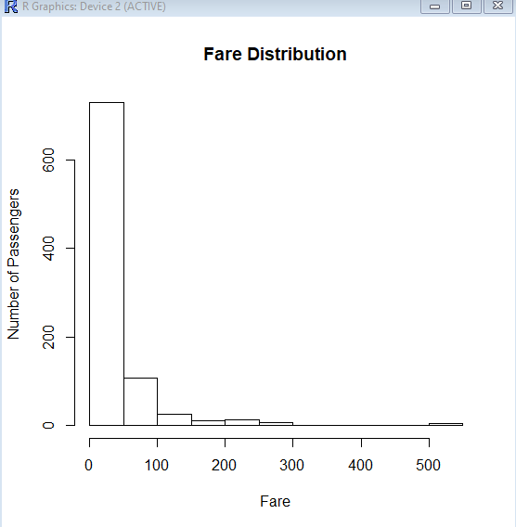
Figure 9. Fare Distribution.

6.4 Gender-wise Survival
Female passengers have a much larger survivor count, while male passengers have a much larger non-survivor count.
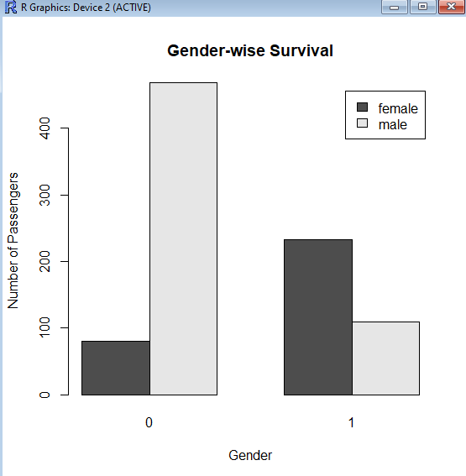
Figure 10. Gender-wise Survival.

7. Descriptive Statistics
mean(data$Age, na.rm = TRUE)
median(data$Age, na.rm = TRUE)
sd(data$Age, na.rm = TRUE)
mean(data$Fare, na.rm = TRUE)
median(data$Fare, na.rm = TRUE)
sd(data$Fare, na.rm = TRUE)
Mean, median and standard deviation were calculated for Age and Fare.

8. Correlation Analysis
numeric_data <- data[, c("Age", "Fare", "SibSp", "Parch", "Survived")]
cor(numeric_data, use = "complete.obs")
- Fare–Survived = 0.257: weak positive relationship.
- SibSp–Parch = 0.415: moderate positive relationship.
- Age–Survived = -0.065: very weak negative relationship.
- SibSp–Survived = -0.035: almost no linear relationship.
- Parch–Survived = 0.082: very weak positive relationship.
Correlation indicates association and does not establish causation.

9. Initial Findings
- No missing values remained in retained columns.
- No duplicate records were identified.
- 116 potential Fare outliers were detected.
- Fare was normalized to 0–1.
- Sex and Embarked were encoded numerically.
- Fare is strongly right-skewed.
- There are more non-survivors than survivors.
- Female survivors substantially outnumber male survivors in the displayed chart.
- Fare has a weak positive association with survival.

10. Conclusion
The Titanic dataset was successfully cleaned and preliminarily analyzed using R. The required data-cleaning operations, visual exploration, descriptive statistics and correlation analysis were completed.

11. R Code Appendix
# Load
data <- read.csv(file.choose())
# Inspect
head(data); dim(data); str(data); summary(data)
# Missing values
colSums(is.na(data))
data$Age[is.na(data$Age)] <- median(data$Age, na.rm=TRUE)
data$Cabin <- NULL
# Duplicates
sum(duplicated(data))
# Outliers
Q1_Fare <- quantile(data$Fare, .25, na.rm=TRUE)
Q3_Fare <- quantile(data$Fare, .75, na.rm=TRUE)
IQR_Fare <- Q3_Fare-Q1_Fare
Lower_Fare <- Q1_Fare-1.5*IQR_Fare
Upper_Fare <- Q3_Fare+1.5*IQR_Fare
Fare_Outliers <- data[data$Fare<Lower_Fare | data$Fare>Upper_Fare,]
nrow(Fare_Outliers)
# Normalization
data$Fare_Normalized <- (data$Fare-min(data$Fare,na.rm=TRUE))/
(max(data$Fare,na.rm=TRUE)-min(data$Fare,na.rm=TRUE))
# Encoding
data$Sex_Encoded <- ifelse(data$Sex=="male",1,0)
data$Embarked_Encoded <- as.numeric(as.factor(data$Embarked))
# Correlation
numeric_data <- data[,c("Age","Fare","SibSp","Parch","Survived")]
cor(numeric_data,use="complete.obs")

