WEEK 2 INTERNSHIP REPORT
Data Visualization and Insight Communication using R
Dataset: Titanic Passenger Dataset
Tool: R Base Graphics
Name:- Suraj sen

1. Introduction
This Week 2 project focuses on data visualization and insight communication using R. The Titanic passenger dataset from Week 1 was continued because the assignment allows reuse of the previous dataset. Multiple chart types were created to communicate distributions, comparisons, relationships, and survival patterns.

2. Objectives
- Create informative visualizations using R.
- Use bar charts, histograms, a scatter plot, a box plot, and a line chart.
- Explain the purpose and significance of each visualization.
- Identify patterns, differences, and anomalies.
- Communicate findings for a non-technical audience.

3. Dataset Overview
The Titanic dataset contains passenger information including passenger class (Pclass), sex, age, fare, family-related variables, and survival status. Survived uses 0 for not survived and 1 for survived. The dataset was cleaned in Week 1 and is reused here for visualization.

4. Data Loading Code
data <- read.csv(file.choose())
head(data)
str(data)

5. Visualizations and Insights

5.1 Titanic Survival Count
R Code:
barplot(table(data$Survived),
main="Titanic Survival Count",
xlab="Survival Status (0 = No, 1 = Yes)",
ylab="Number of Passengers")
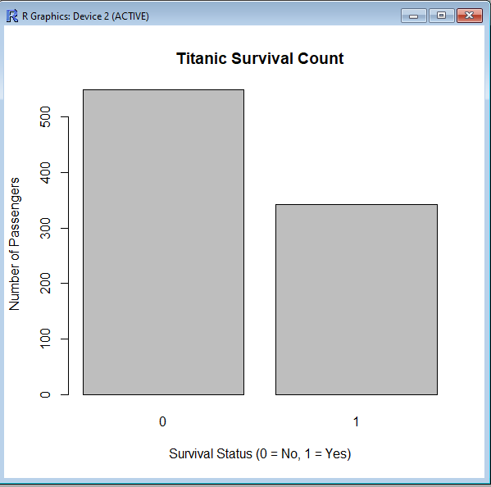
Interpretation: The bar chart clearly compares passengers who survived and did not survive. The graph shows that non-survivors were considerably more numerous than survivors.

5.2 Gender-wise Survival
R Code:
barplot(table(data$Sex, data$Survived),
beside=TRUE,
main="Gender-wise Survival",
xlab="Survival Status (0 = No, 1 = Yes)",
ylab="Number of Passengers",
legend.text=TRUE)
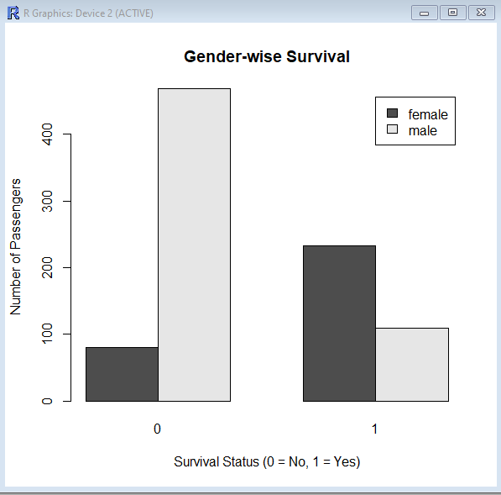
Interpretation: The grouped bar chart shows a strong difference by gender. Male non-survivors greatly outnumber male survivors, while the female survival count is much higher than female non-survival. This indicates a strong association between gender and survival in this dataset.

5.3 Age Distribution
R Code:
hist(data$Age,
main="Age Distribution of Titanic Passengers",
xlab="Age",
ylab="Number of Passengers")
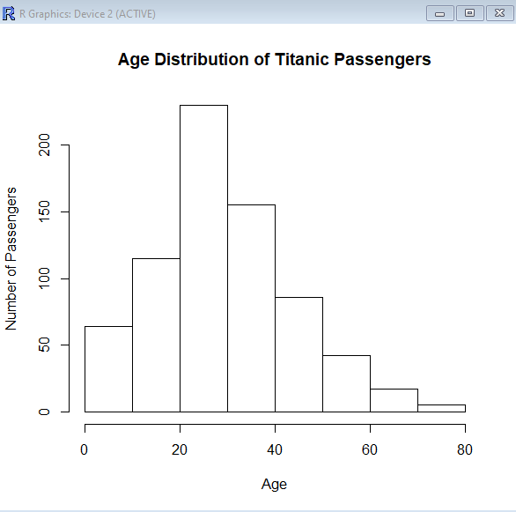
Interpretation: The histogram shows that passengers were concentrated mainly in young and middle adulthood. There were fewer passengers at older ages, while both children and elderly passengers were present.

5.4 Fare Distribution
R Code:
hist(data$Fare,
main="Fare Distribution of Titanic Passengers",
xlab="Fare",
ylab="Number of Passengers")
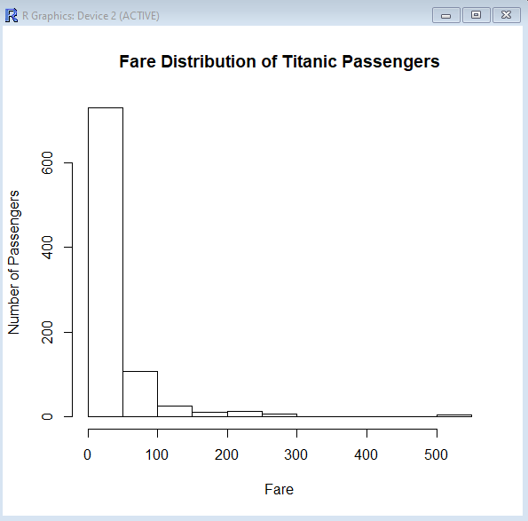
Interpretation: Most passengers paid relatively low fares. A small number paid very high fares, producing a long right tail and showing a strongly right-skewed fare distribution.

5.5 Age vs Fare
R Code:
plot(data$Age, data$Fare,
main="Age vs Fare",
xlab="Age",
ylab="Fare",
pch=19)
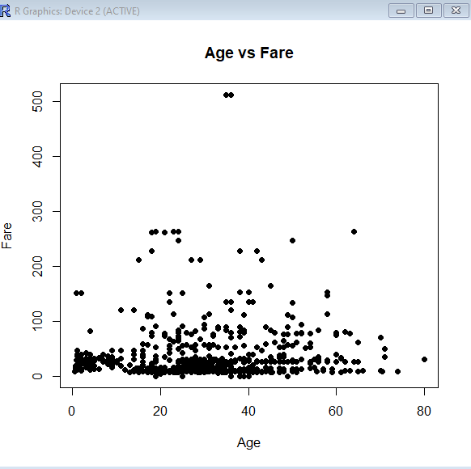
Interpretation: The scatter plot shows a wide spread of fares across ages. Most observations are concentrated at lower fares, with several high-fare outliers. There is no strong simple linear relationship visible between age and fare.

5.6 Passenger Class vs Survival
R Code:
barplot(table(data$Pclass, data$Survived),
beside=TRUE,
main="Passenger Class vs Survival",
xlab="Passenger Class",
ylab="Number of Passengers",
legend.text=TRUE)
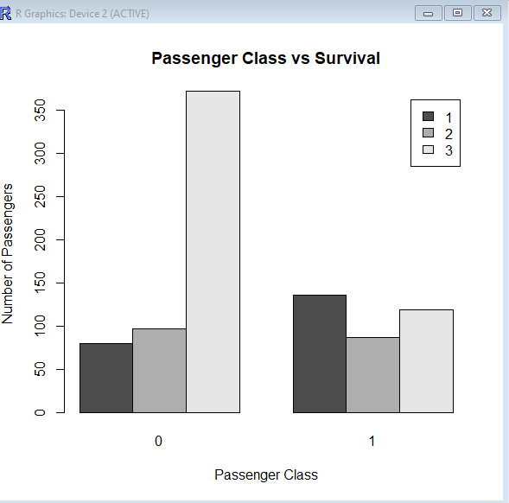
Interpretation: The grouped bar chart shows a clear survival difference across passenger classes. Third class has a particularly high number of non-survivors, while first class has a comparatively larger number of survivors.

5.7 Fare by Survival Status
R Code:
boxplot(Fare ~ Survived,
data=data,
main="Fare by Survival Status",
xlab="Survival Status (0 = No, 1 = Yes)",
ylab="Fare")

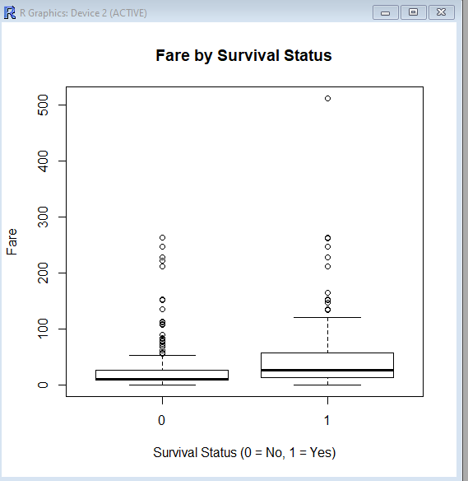
Interpretation: A box plot compares the fare distribution between survivors and non-survivors and is useful for showing median, spread, and outliers. It provides a compact view of how fare values differ between the two survival groups.

5.8 Survival Rate by Age Group
R Code:
data$Age_Group <- cut(data$Age,
breaks=c(0,12,18,35,60,Inf),
labels=c("Child","Teenager","Young Adult","Adult","Senior"),
include.lowest=TRUE)
survival_rate <- aggregate(Survived ~ Age_Group, data=data, FUN=mean)
plot(survival_rate$Age_Group, survival_rate$Survived,
type="o",
main="Survival Rate by Age Group",
xlab="Age Group",
ylab="Survival Rate")

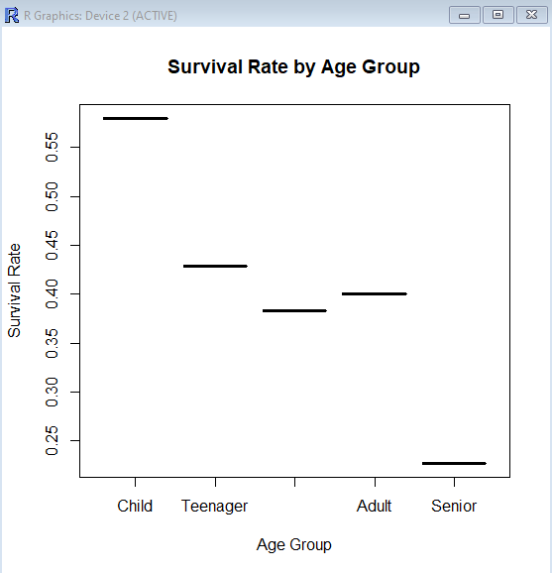
Interpretation: The line chart compares survival rates across ordered age groups. Connecting the points makes changes between age groups easy to see and communicates the overall age-related survival pattern.

6. Overall Key Findings
- Non-survivors were more numerous than survivors.
- Gender-wise survival shows a substantially higher survival count among female passengers.
- Passenger ages are concentrated mainly in young and middle adulthood.
- Fare is strongly right-skewed, with a small number of very high fares.
- Age and fare show a widely scattered relationship rather than a strong simple linear pattern.
- Passenger class is visibly associated with survival, especially the high number of third-class non-survivors.
- Fare distributions can be compared between survival groups using a box plot, including potential outliers.
- Age-group survival rates provide an additional view of how survival varied across age categories.

7. Visualization Design Rationale
Bar charts were used for categorical comparisons, histograms for numerical distributions, a scatter plot for two numerical variables, a box plot for group-wise numerical distributions, and a line chart for ordered age-group comparisons. Selecting the chart type according to the analytical question improves clarity for non-technical readers.

8. Conclusion
The Week 2 analysis demonstrates how R visualizations can convert passenger-level data into clear insights. The graphs highlight differences in survival by gender and passenger class, show age and fare distributions, reveal high-fare observations, and provide additional views of survival patterns.

9. Appendix – Week 2 R Code
# Load data
data <- read.csv(file.choose())
# 1 Survival Count
barplot(table(data$Survived), main="Titanic Survival Count",
xlab="Survival Status (0 = No, 1 = Yes)", ylab="Number of Passengers")
# 2 Gender-wise Survival
barplot(table(data$Sex, data$Survived), beside=TRUE,
main="Gender-wise Survival", xlab="Survival Status (0 = No, 1 = Yes)",
ylab="Number of Passengers", legend.text=TRUE)
# 3 Age Distribution
hist(data$Age, main="Age Distribution of Titanic Passengers",
xlab="Age", ylab="Number of Passengers")
# 4 Fare Distribution
hist(data$Fare, main="Fare Distribution of Titanic Passengers",
xlab="Fare", ylab="Number of Passengers")
# 5 Age vs Fare
plot(data$Age, data$Fare, main="Age vs Fare",
xlab="Age", ylab="Fare", pch=19)
# 6 Passenger Class vs Survival
barplot(table(data$Pclass, data$Survived), beside=TRUE,
main="Passenger Class vs Survival", xlab="Passenger Class",
ylab="Number of Passengers", legend.text=TRUE)
# 7 Fare by Survival Status
boxplot(Fare ~ Survived, data=data, main="Fare by Survival Status",
xlab="Survival Status (0 = No, 1 = Yes)", ylab="Fare")
# 8 Survival Rate by Age Group
data$Age_Group <- cut(data$Age, breaks=c(0,12,18,35,60,Inf),
labels=c("Child","Teenager","Young Adult","Adult","Senior"), include.lowest=TRUE)
survival_rate <- aggregate(Survived ~ Age_Group, data=data, FUN=mean)
plot(survival_rate$Age_Group, survival_rate$Survived, type="o",
main="Survival Rate by Age Group", xlab="Age Group", ylab="Survival Rate")
# Survival percentage
survival_percentage <- prop.table(table(data$Survived)) * 100
print(survival_percentage)

