WEEK 4 – COMPREHENSIVE DATA ANALYSIS
Titanic Dataset: Final Report
R Data Analyst Internship
Data Cleaning • Visualization • Statistical Analysis • Predictive Modeling

1. Introduction
This final Week 4 report consolidates the four-week R Data Analyst internship project using the Titanic passenger dataset. The project follows a complete analytics workflow: understanding the data, cleaning and transforming it, exploratory analysis, visualization, statistical testing, predictive modeling, model evaluation, and communication of insights.

2. Project Objectives
- Understand dataset structure and quality.
- Handle missing values and duplicate records.
- Detect potential outliers using IQR.
- Normalize numerical data and encode categorical variables.
- Create visualizations and identify patterns.
- Apply Chi-Square, correlation and normality analysis.
- Build a logistic regression survival model.
- Evaluate accuracy, sensitivity, specificity and cross-validation.
- Communicate findings, limitations and future scope.

3. Dataset Overview
The Titanic dataset contains passenger characteristics including passenger class, sex, age, fare, family-related variables, embarkation information and survival status. The target variable Survived is binary: 0 indicates non-survival and 1 indicates survival.
data <- read.csv(file.choose())
head(data)
dim(data)
str(data)
summary(data)

4. Methodology
The project used a sequential workflow. The raw data was first inspected, followed by missing-value treatment, removal of the highly incomplete Cabin field, duplicate checking, outlier detection, normalization and encoding. Exploratory graphs were then created. Statistical tests examined relationships and distributional assumptions. Finally, logistic regression was trained using an 80/20 split and evaluated with a confusion matrix, performance metrics, ROC analysis, diagnostics and 5-fold cross-validation.

5. Data Cleaning & Preparation

5.1 Missing Values and Duplicates
colSums(is.na(data))
data$Age[is.na(data$Age)] <- median(data$Age, na.rm=TRUE)
data$Cabin <- NULL
sum(duplicated(data))
colSums(is.na(data))
Missing Age values were replaced with the median. Cabin was removed because of substantial missingness. Duplicate records were checked and a final missing-value check was performed.
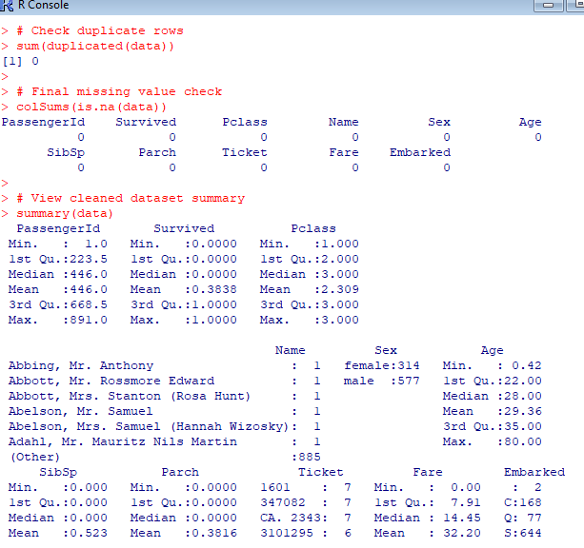

5.2 Outlier Detection
Q1_Fare <- quantile(data$Fare, .25, na.rm=TRUE)
Q3_Fare <- quantile(data$Fare, .75, na.rm=TRUE)
IQR_Fare <- Q3_Fare-Q1_Fare
Lower_Fare <- Q1_Fare-1.5*IQR_Fare
Upper_Fare <- Q3_Fare+1.5*IQR_Fare
Fare_Outliers <- data[data$Fare<Lower_Fare | data$Fare>Upper_Fare,]
nrow(Fare_Outliers)
The IQR method was used to identify unusually high or low Fare observations. Potential outliers were identified rather than automatically deleted because extreme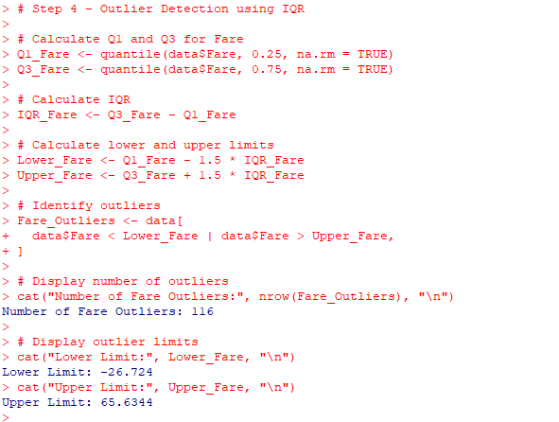

5.3 Normalization and Encoding
data$Fare_Normalized <- (data$Fare-min(data$Fare,na.rm=TRUE))/(max(data$Fare,na.rm=TRUE)-min(data$Fare,na.rm=TRUE))
data$Sex_Encoded <- ifelse(data$Sex=="male",1,0)
data$Age_Group <- cut(data$Age, breaks=c(0,12,18,35,60,Inf), labels=c("Child","Teenager","Young Adult","Adult","Senior"), include.lowest=TRUE)

Fare was Min-Max normalized, Sex was encoded numerically, and Age was grouped into five categories for age-based survival analysis.
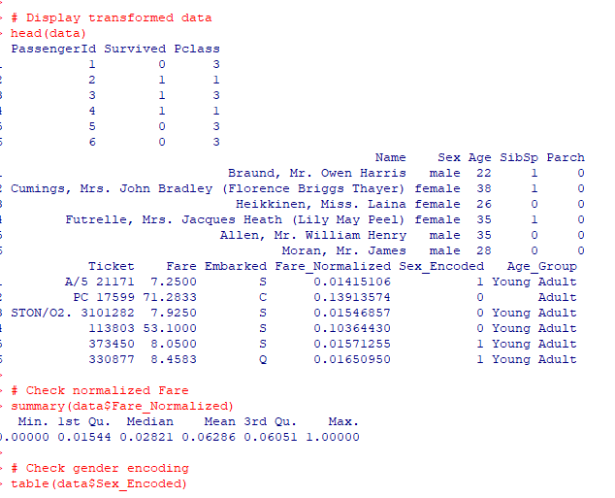

6. Exploratory Data Analysis
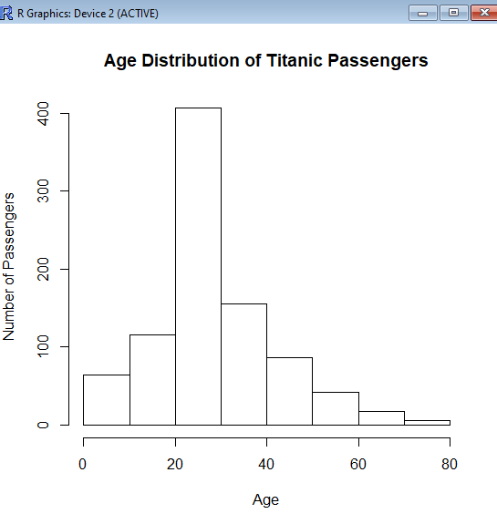
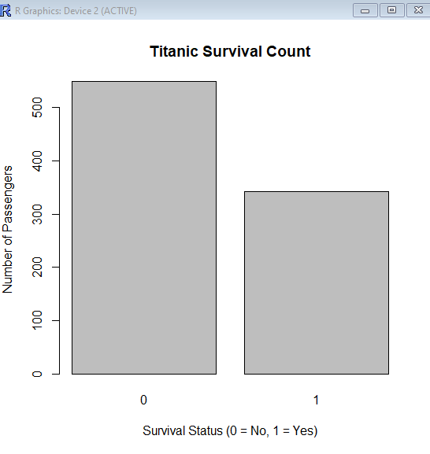
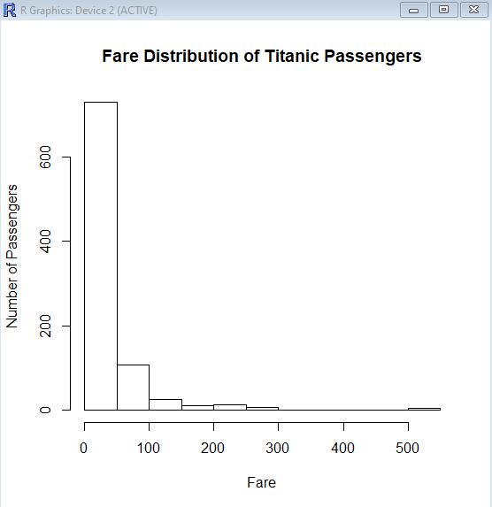
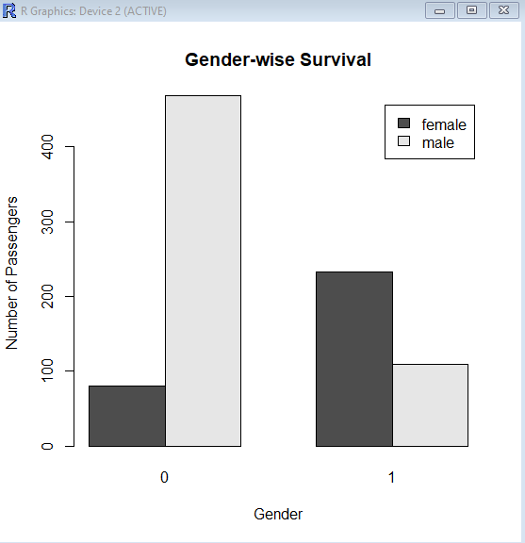
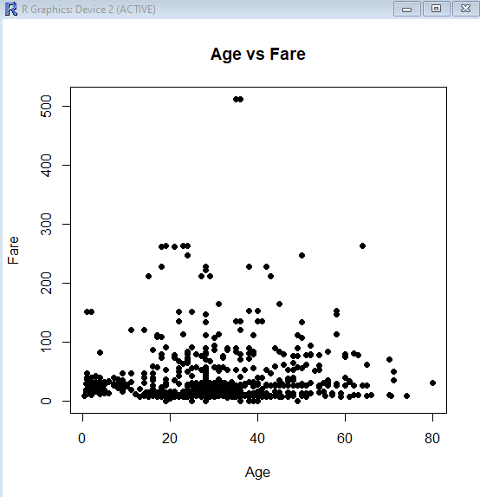
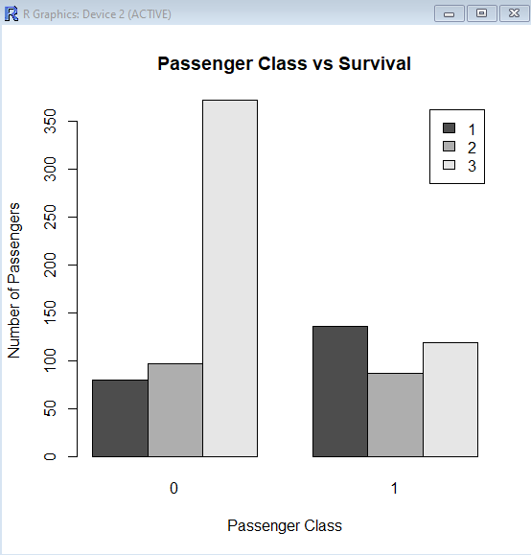
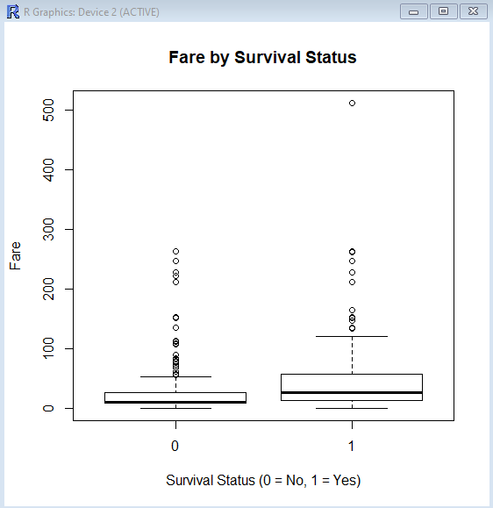
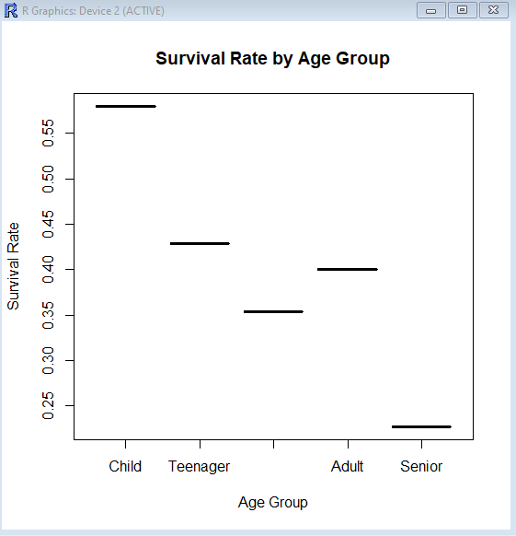

7. Statistical Analysis

7.1 Chi-Square Test
survival_gender <- table(data$Sex,data$Survived)
chi_test <- chisq.test(survival_gender)
print(chi_test)
The Chi-Square test examined whether gender and survival were statistically associated. The null hypothesis stated independence; the alternative stated that an association existed.
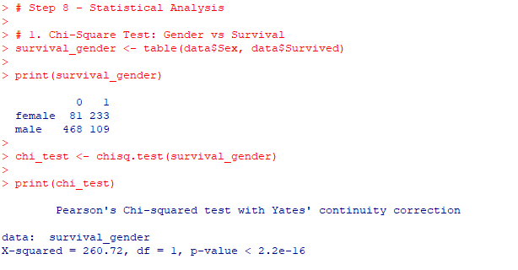

7.2 Correlation Analysis
numeric_data <- data[,c("Age","Fare","SibSp","Parch","Survived")]
correlation_matrix <- cor(numeric_data,use="complete.obs")
print(correlation_matrix)
Correlation was used to describe linear relationships among numerical variables. Correlation does not establish causation.
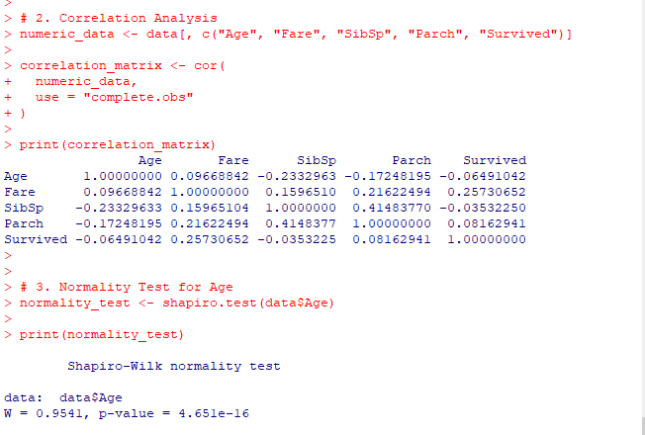

7.3 Normality Test
normality_test <- shapiro.test(data$Age)
print(normality_test)
The Shapiro-Wilk test was applied to Age. The p-value in the R output should be used when interpreting the normality assumption.

8. Predictive Modeling

8.1 Train/Test Split
set.seed(123)
train_index <- sample(1:nrow(data),size=.80*nrow(data))
train_data <- data[train_index,]
test_data <- data[-train_index,]
An 80/20 train-test split was used with a fixed seed for reproducibility.

8.2 Logistic Regression
model <- glm(Survived ~ Age + Fare + Sex_Encoded + Pclass + SibSp + Parch,
data=train_data,family=binomial)
summary(model)
Logistic regression was selected because survival is a binary outcome. Predictors included Age, Fare, encoded Sex, passenger class, SibSp and Parch.
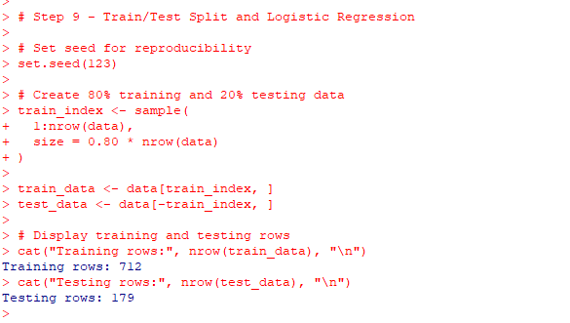
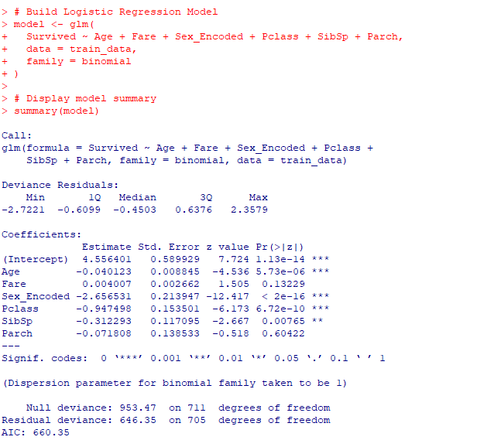

8.3 Prediction and Confusion Matrix
predicted_probability <- predict(model,newdata=test_data,type="response")
predicted_class <- ifelse(predicted_probability>=.5,1,0)
confusion_matrix <- table(Actual=test_data$Survived,Predicted=predicted_class)
print(confusion_matrix)
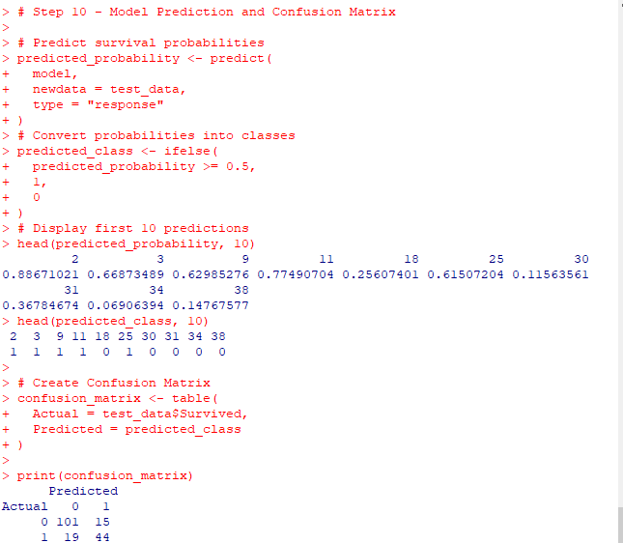

9. Model Performance
accuracy <- (TP+TN)/sum(confusion_matrix)
sensitivity <- TP/(TP+FN)
specificity <- TN/(TN+FP)
Accuracy measures overall correct classification. Sensitivity measures identification of survivors, while specificity measures identification of non-survivors.
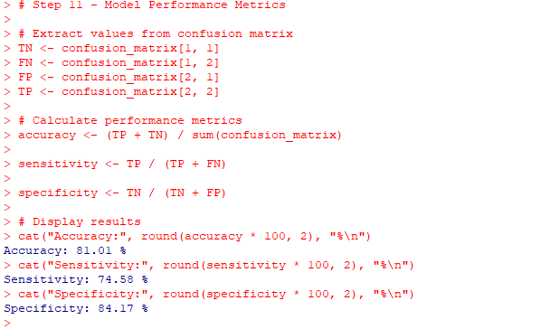

10. ROC Curve and Diagnostics
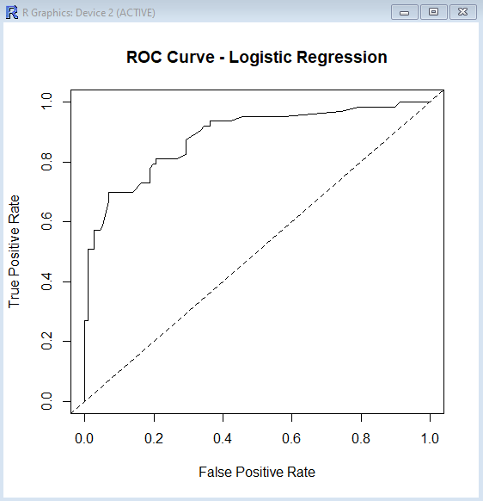
The ROC curve compares true-positive and false-positive rates across classification thresholds.
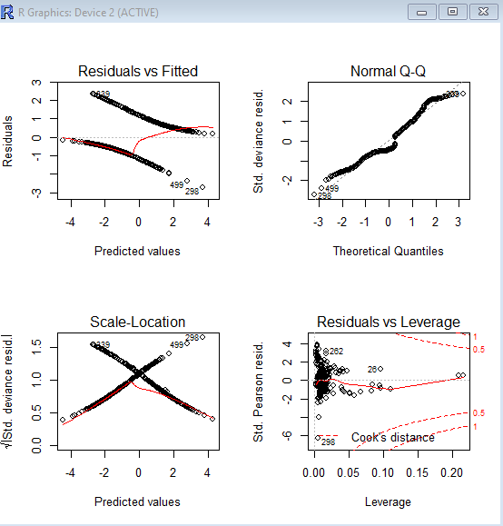
Diagnostic plots were reviewed for residual patterns, unusual observations and potential model issues.

11. Five-Fold Cross-Validation
set.seed(123)
folds <- sample(rep(1:5,length.out=nrow(data)))
# Each fold is used once as validation data.
Five-fold cross-validation was used to assess whether predictive performance was reasonably stable across different subsets.
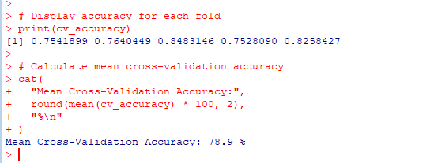

12. Coefficients and Odds Ratios
coefficients <- summary(model)$coefficients
print(coefficients)
odds_ratios <- exp(coef(model))
print(odds_ratios)
Coefficients describe effects on the log-odds scale. Exponentiated coefficients provide odds ratios, which are easier to interpret.
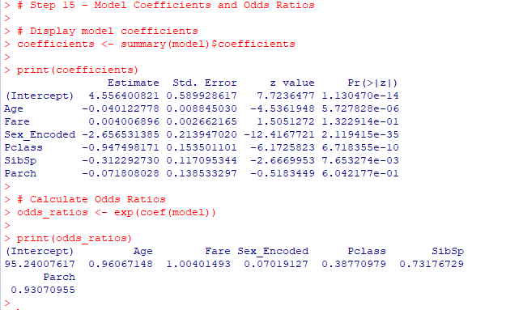

13. Final Model Performance
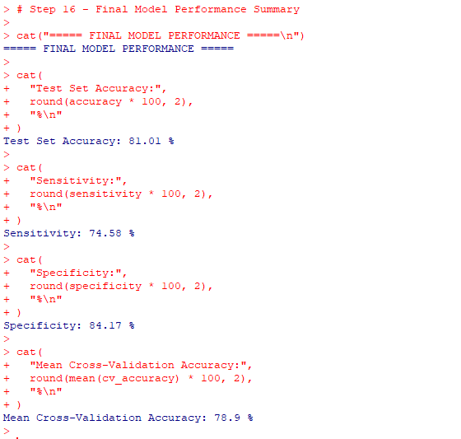
Actual performance values should be taken directly from the R Console. No values have been invented in this report.

14. Key Findings
- Passenger characteristics such as gender, passenger class and fare showed meaningful survival patterns.
- Fare was right-skewed and contained potential high-value outliers.
- Visualizations made survival differences across passenger groups easier to communicate.
- Correlation results describe association and should not be interpreted as causation.
- Logistic regression provided a structured method for estimating survival probability.
- Cross-validation was included to assess performance stability.

15. Business / Practical Implications
Although Titanic is a historical dataset, the workflow demonstrates a reusable approach for customer segmentation, risk prediction, churn analysis and other classification tasks. A professional analyst should combine visual evidence, statistical evidence and model evaluation rather than relying on one metric.

16. Challenges Faced
- Working with R Console without RStudio.
- Understanding and documenting cleaning, outliers, normalization and encoding.
- Interpreting statistical and logistic regression outputs.
- Organizing screenshots as evidence of analysis.

17. Lessons Learned
- Data cleaning is essential for reliable analysis.
- Visualizations make patterns easier to communicate.
- Statistical tests provide evidence for relationships and assumptions.
- Logistic regression is appropriate for binary classification.
- Multiple evaluation metrics provide a more complete view of model quality.
- Cross-validation helps assess stability.

18. Recommendations & Future Scope
- Compare logistic regression with decision trees, random forests and other classifiers.
- Calculate formal ROC-AUC using a dedicated evaluation package.
- Explore feature engineering and interaction effects.
- Use automated cross-validation frameworks for larger datasets.
- Apply the workflow to a current real-world business dataset.

19. Conclusion
This four-week project covered the complete data analytics lifecycle in R using the Titanic dataset. The work progressed from data cleaning and transformation to visualization, statistical testing and predictive modeling. It demonstrated how raw data can be transformed into structured insights and a reproducible classification workflow, while also emphasizing evidence-based reporting and model evaluation.

20. Appendix – R Code
The complete working script contains the full sequence of loading, cleaning, transformation, visualization, statistical testing, logistic regression, prediction, evaluation, ROC analysis, diagnostics, cross-validation and final reporting.

