WEEK 3 INTERNSHIP PROJECT
Statistical Analysis and Predictive Modeling using R
Dataset: Titanic Passenger Dataset
Name:- Suraj
Tools: R / R Console

1. Introduction
This Week 3 project focuses on statistical analysis and predictive modeling using R. The Titanic passenger dataset was continued from the previous weeks because it contains numerical and categorical variables and a clear binary outcome, Survived. The main objective is to perform statistical testing, examine relationships between variables, build a classification model, and evaluate its predictive performance.

2. Dataset Selection and Rationale
The Titanic dataset was selected because it is publicly available, suitable for statistical analysis, and contains a binary target variable. Survived has two outcomes: 0 for passengers who did not survive and 1 for passengers who survived. Age, Fare, Sex, Pclass, SibSp and Parch can be used as predictors, making the dataset appropriate for logistic regression.

3. Dataset Loading and Initial Inspection
data <- read.csv(file.choose())
head(data)
dim(data)
str(data)
summary(data)

4. Data Preparation
colSums(is.na(data))
data$Age[is.na(data$Age)] <- median(data$Age, na.rm = TRUE)
data$Sex_Encoded <- ifelse(data$Sex == "male", 1, 0)
colSums(is.na(data))
Missing Age values were replaced with the median age. Sex was converted into a binary numeric variable so it could be used by the predictive model.

5. Hypothesis Testing
A Chi-Square test was used to examine whether passenger gender and survival were statistically associated.
H0: Gender and survival are not significantly associated.
H1: Gender and survival are significantly associated.
survival_gender <- table(data$Sex, data$Survived)
print(survival_gender)
chi_test <- chisq.test(survival_gender)
print(chi_test)
Interpretation: Use the reported p-value. If p < 0.05, reject H0 and report evidence of an association between gender and survival.

6. Correlation Analysis
numeric_data <- data[, c("Age", "Fare", "SibSp", "Parch", "Survived")]
correlation_matrix <- cor(numeric_data, use = "complete.obs")
Correlation values describe the direction and strength of linear relationships. Values near +1 or -1 indicate stronger relationships, while values near 0 indicate weak linear relationships. Correlation does not imply causation.

7. Normality Test
normality_test <- shapiro.test(data$Age)
print(normality_test)
Use the p-value to assess the normality assumption. A p-value below 0.05 generally provides evidence against normality.

8. Train-Test Split
set.seed(123)
train_index <- sample(1:nrow(data), size = 0.80 * nrow(data))
train_data <- data[train_index, ]
test_data <- data[-train_index, ]
cat("Training rows:", nrow(train_data), "\n")
cat("Testing rows:", nrow(test_data), "\n")

9. Logistic Regression Model
A logistic regression model was developed because Survived is a binary outcome. The model estimates survival probability using Age, Fare, Sex, Passenger Class, SibSp and Parch.
model <- glm(
Survived ~ Age + Fare + Sex_Encoded + Pclass + SibSp + Parch,
data = train_data,
family = binomial
)
summary(model)
SCREENSHOT PLACEHOLDER
Insert the complete logistic regression model summary screenshot.
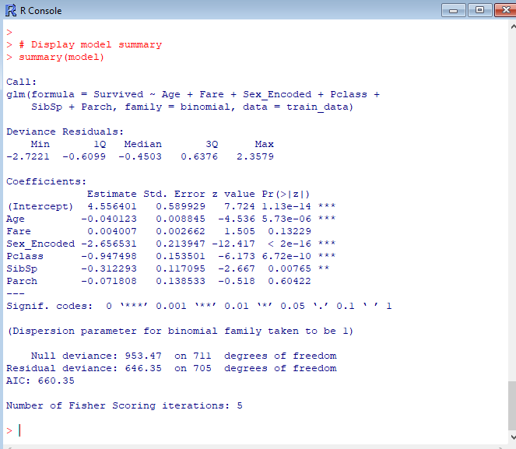

10. Model Predictions
predicted_probability <- predict(model, newdata = test_data, type = "response")
predicted_class <- ifelse(predicted_probability >= 0.5, 1, 0)
head(predicted_probability, 10)
head(predicted_class, 10)
SCREENSHOT PLACEHOLDER
Insert the screenshot showing predicted probabilities and predicted classes.
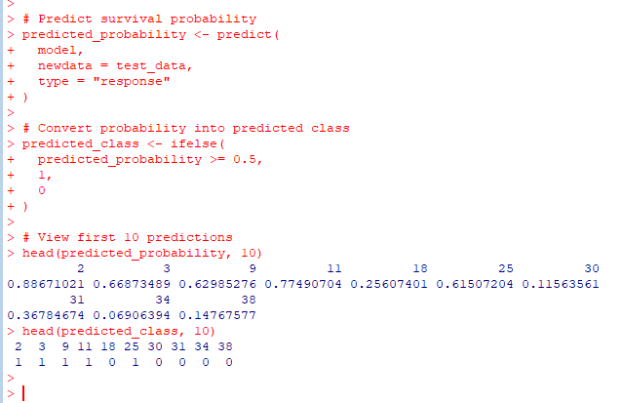

11. Confusion Matrix
confusion_matrix <- table(
Actual = test_data$Survived,
Predicted = predicted_class
)
print(confusion_matrix)
SCREENSHOT PLACEHOLDER
Insert the confusion matrix screens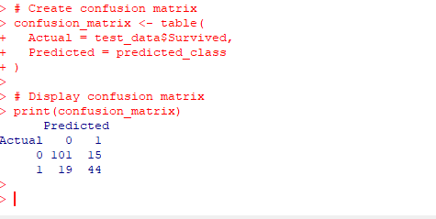
The confusion matrix compares actual and predicted survival outcomes and is used to calculate accuracy, sensitivity and specificity.

12. Model Performance Metrics
TN <- confusion_matrix[1, 1]
FN <- confusion_matrix[1, 2]
FP <- confusion_matrix[2, 1]
TP <- confusion_matrix[2, 2]
accuracy <- (TP + TN) / sum(confusion_matrix)
sensitivity <- TP / (TP + FN)
specificity <- TN / (TN + FP)
cat("Accuracy:", round(accuracy * 100, 2), "%\n")
cat("Sensitivity:", round(sensitivity * 100, 2), "%\n")
cat("Specificity:", round(specificity * 100, 2), "%\n")
SCREENSHOT PLACEHOLDER
Insert the screenshot showing Accuracy, Sensitivity and Specificity.
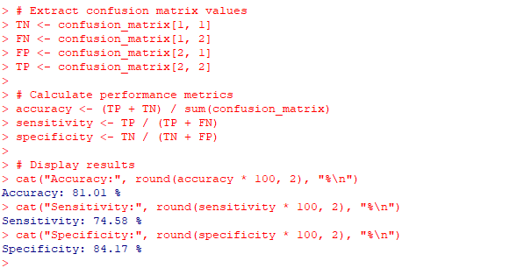

13. ROC Curve
thresholds <- seq(0, 1, by = 0.01)
TPR <- numeric(length(thresholds))
FPR <- numeric(length(thresholds))
for (i in seq_along(thresholds)) {
predicted <- ifelse(predicted_probability >= thresholds[i], 1, 0)
cm <- table(factor(test_data$Survived, levels=c(0,1)),
factor(predicted, levels=c(0,1)))
TN_i <- cm[1,1]; FP_i <- cm[1,2]
FN_i <- cm[2,1]; TP_i <- cm[2,2]
TPR[i] <- TP_i / (TP_i + FN_i)
FPR[i] <- FP_i / (FP_i + TN_i)
}
plot(FPR, TPR, type="l", main="ROC Curve - Logistic Regression",
xlab="False Positive Rate", ylab="True Positive Rate")
abline(0, 1, lty=2)
SCREENSHOT PLACEHOLDER
Insert the ROC curve screenshot.
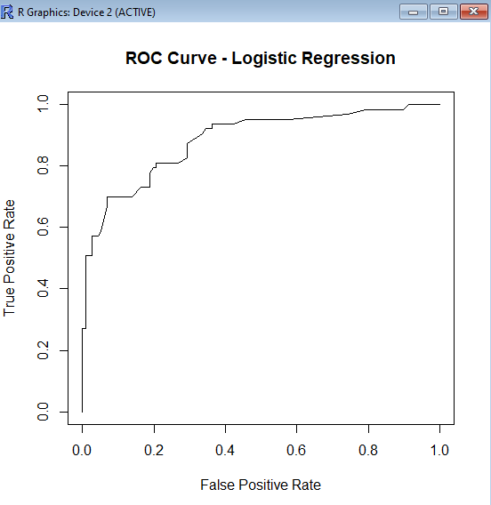
The ROC curve shows the trade-off between true positive rate and false positive rate across classification thresholds.

14. Model Diagnostics
par(mfrow = c(2, 2))
plot(model)
par(mfrow = c(1, 1))
SCREENSHOT PLACEHOLDER
Insert the diagnostic plots screenshot from R.
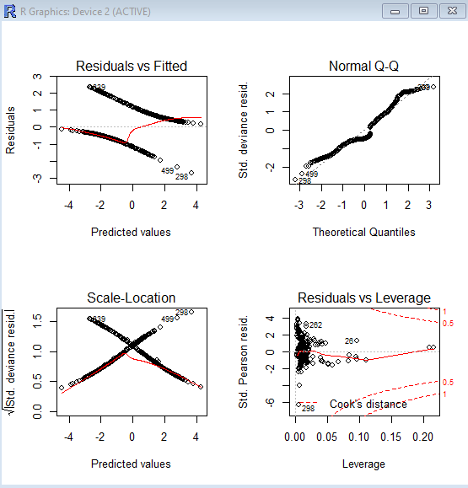
Diagnostic plots help identify unusual observations, influential points and potential issues in model fitting.

15. Five-Fold Cross-Validation
set.seed(123)
folds <- sample(rep(1:5, length.out = nrow(data)))
cv_accuracy <- numeric(5)
for (i in 1:5) {
cv_train <- data[folds != i, ]
cv_test <- data[folds == i, ]
cv_model <- glm(Survived ~ Age + Fare + Sex_Encoded + Pclass + SibSp + Parch,
data=cv_train, family=binomial)
cv_probability <- predict(cv_model, newdata=cv_test, type="response")
cv_prediction <- ifelse(cv_probability >= 0.5, 1, 0)
cv_accuracy[i] <- mean(cv_prediction == cv_test$Survived)
}
print(cv_accuracy)
cat("Mean Cross-Validation Accuracy:",
round(mean(cv_accuracy) * 100, 2), "%\n")
SCREENSHOT PLACEHOLDER
Insert the five-fold cross-validation output screenshot.
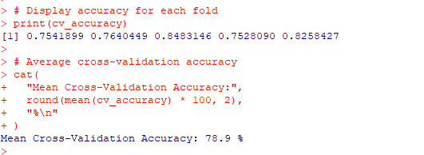

16. Model Coefficients and Odds Ratios
coefficients <- summary(model)$coefficients
print(coefficients)
odds_ratios <- exp(coef(model))
print(odds_ratios)
SCREENSHOT PLACEHOLDER
Insert the coefficients and odds-ratio output screenshot.
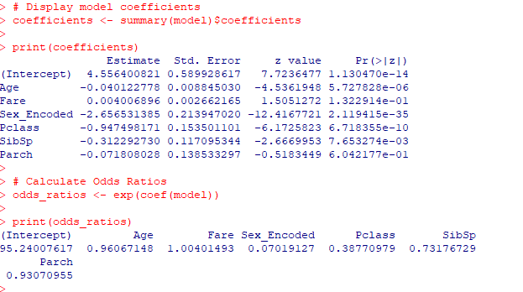
Odds ratios above 1 indicate higher estimated odds of survival for a one-unit increase in the predictor; values below 1 indicate lower estimated odds, holding other variables constant.

17. Final Model Performance Summary
cat("===== FINAL MODEL PERFORMANCE =====\n")
cat("Test Set Accuracy:", round(accuracy * 100, 2), "%\n")
cat("Sensitivity:", round(sensitivity * 100, 2), "%\n")
cat("Specificity:", round(specificity * 100, 2), "%\n")
cat("Mean Cross-Validation Accuracy:",
round(mean(cv_accuracy) * 100, 2), "%\n")
SCREENSHOT PLACEHOLDER
Insert the final performance summary screenshot.

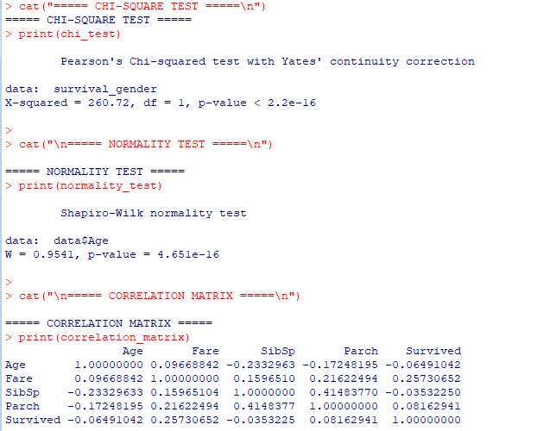

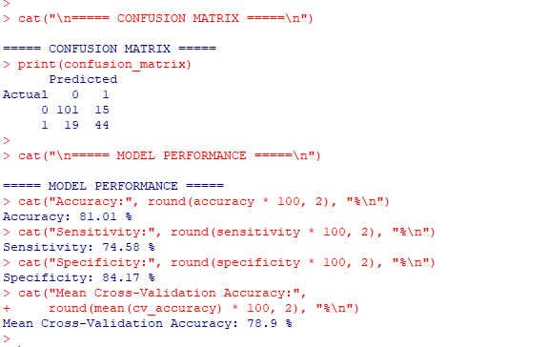

18. Model Strengths
- Logistic regression is appropriate for the binary Survived outcome.
- The model uses several relevant demographic and ticket-related predictors.
- A separate test set provides an independent performance check.
- Five-fold cross-validation provides an additional stability check.
- Confusion matrix, ROC curve and multiple metrics give a broader evaluation.

19. Potential Improvements
- Compare logistic regression with decision trees, random forests or other classifiers.
- Tune model parameters and compare models using the same cross-validation strategy.
- Create additional features such as family size or passenger title.
- Investigate class imbalance and use suitable metrics where needed.
- Use repeated cross-validation and a final untouched test set for stronger validation.

20. Overall Interpretation
The project combines statistical testing, correlation analysis, assumption checking and predictive modeling. The logistic regression model provides an interpretable method for predicting Titanic survival. Final claims about performance should be based on the actual accuracy, sensitivity, specificity and cross-validation values obtained in R.

21. Conclusion
This Week 3 project demonstrated a complete statistical and predictive modeling workflow in R. The Titanic dataset was prepared, statistically examined and used to develop a logistic regression classifier. Hypothesis testing, correlation analysis, normality testing, confusion-matrix evaluation, ROC analysis, diagnostics and five-fold cross-validation were included. Further improvements can be made through feature engineering, model comparison and optimization.

22. Appendix — Main R Workflow
The complete R script is saved separately as the Week 3 project file. The code excerpts throughout this report document the major analysis and modeling stages.

