Web Enggineering

Practical File

suraj singh ( 20210102718 )

2018-2022

**Practical 1:** Using JavaScript demonstrate Nested loop.

**CODE:**

|  |
| --- |
| <!DOCTYPE html>  <html>  <head>  <title>Nested Loop</title>  </head>  <body>  <h1>NESTED LOOP</h1>  <button onclick="nestedLoop()">Click me and see console</button>  </body>  <script type="text/javascript">  function nestedLoop(){  for (var i = 0; i <= 10; i++) {  console.log(`table of ${i}`)  for (var j = 1; j <= 10; j++) {  console.log(`${i} * ${j} = ${i*j}` )  }  }  }  </script>  </html> |

**Output:**

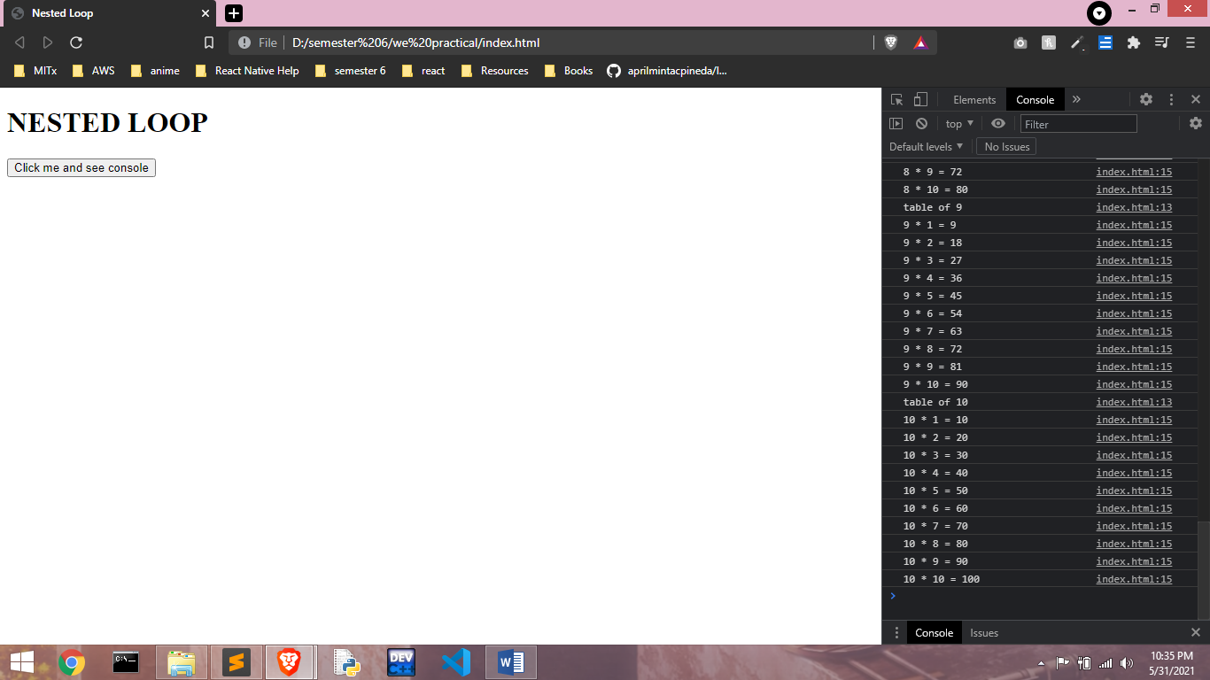

**Practical 2:** Validate the Registration, user login, user profile and payment by credit card pages using JavaScript.

**CODE:**

|  |
| --- |
| <!DOCTYPE html>  <html>  <head>  <title>Validate Form Using Html</title>  </head>  <body>  <form onsubmit="return false" name="register">  <div style="display: flex; ">  <p>  <label>Name</label>  <input type="text" size="30" name="name" placeholder="name">  <br />  <label>Email</label>  <input type="email" size="30" name="email" placeholder="email">  <br />  <label>Password</label>  <input type="password" size="30" name="password" placeholder="password">  <br />  <label>Mobile</label>  <input type="tel" size="30" name="mobile" placeholder="mobile">  <br />  <label>Credit Card</label>  <input type="text" size="30" name="credit" placeholder="Credit Card number">  <br />  <input type="submit" value="Submit" onclick="validateForm()">  <br />  </div>  </form>  </body>  <script type="text/javascript">  const validateForm = () => {  const {name , email , password , mobile , credit} = document.register;  if(name.value==="" || email.value==="" || password.value==="" || mobile.value===""){  alert(`Any Field can't be Empty`);  return false;  }  if (!/^[a-zA-Z0-9.!#$%&'*+/=?^_`{|}~-]+@[a-zA-Z0-9-]+(?:\.[a-zA-Z0-9-]+)*$/.test(email.value))  {  alert("enter valid email")  return false  }  if(!/^(\+\d{1,3}[- ]?)?\d{10}$/.test(mobile.value)){  alert("Invalid Mobile")  return false  }  if(!/^(?:4[0-9]{12}(?:[0-9]{3})?|[25][1-7][0-9]{14}|6(?:011|5[0-9][0-9])[0-9]{12}|3[47][0-9]{13}|3(?:0[0-5]|[68][0-9])[0-9]{11}|(?:2131|1800|35\d{3})\d{11})$/.test(credit.value) ){  alert("wrong Credit Card Number")  return false  }  console.log("all OK")  alert("All Validate")    }  </script>  </html> |

**Output:** 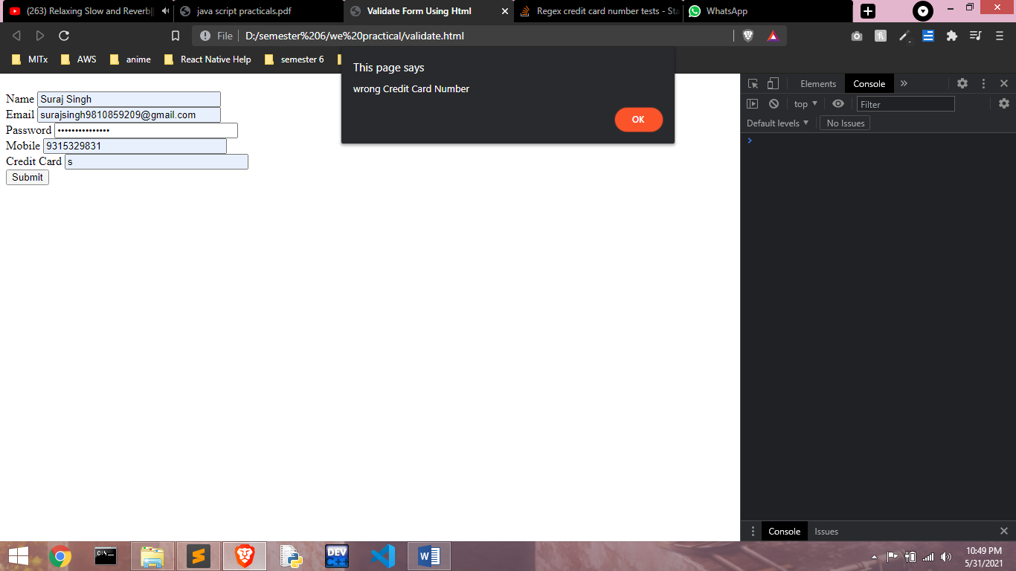

**Practical 3:** Develop and demonstrate a XHTML file that includes JavaScript that uses functions for the following problems:

1. Parameter: A string

Output: The position in the string of the left-most vowel.

b) Parameter: A number

Output: The number with its digits in the reverse order

**CODE:**

|  |
| --- |
| <!DOCTYPE html>  <html>  <head>  <title>JavaScript Function</title>  </head>  <body>  <h1 id="foo">JavaScript Fuctions</h1>  </body>  <script type="text/javascript">  element = document.getElementById("foo")  const Takeinput = () => {  i = prompt("Enter the String or an Integer")  type = isNaN(parseInt(i)) ? "string" : "int"  if(type === "string"){  if(i.search(/[aeiou]/i) === -1){  element.innerHTML = "Not Found"  return  }  element.innerHTML = "The position in the string of the left-most vowel is: " + (i.search(/[aeiou]/i) + 1)  }else if(type === "int") {  element.innerHTML = "The number with its digits in the reverse order is: " + i.split("").reverse().join("")  }  }  Takeinput()  </script>  </html> |

**Output:**

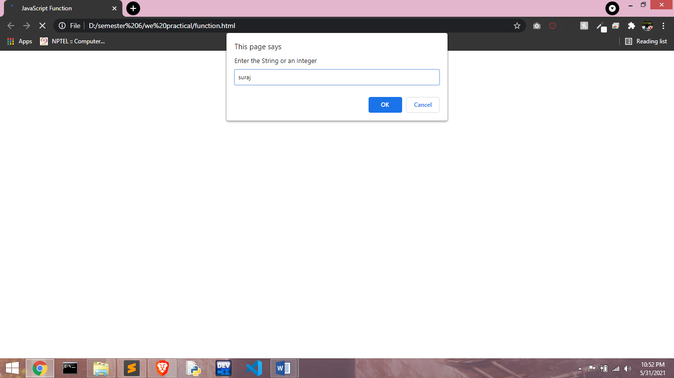 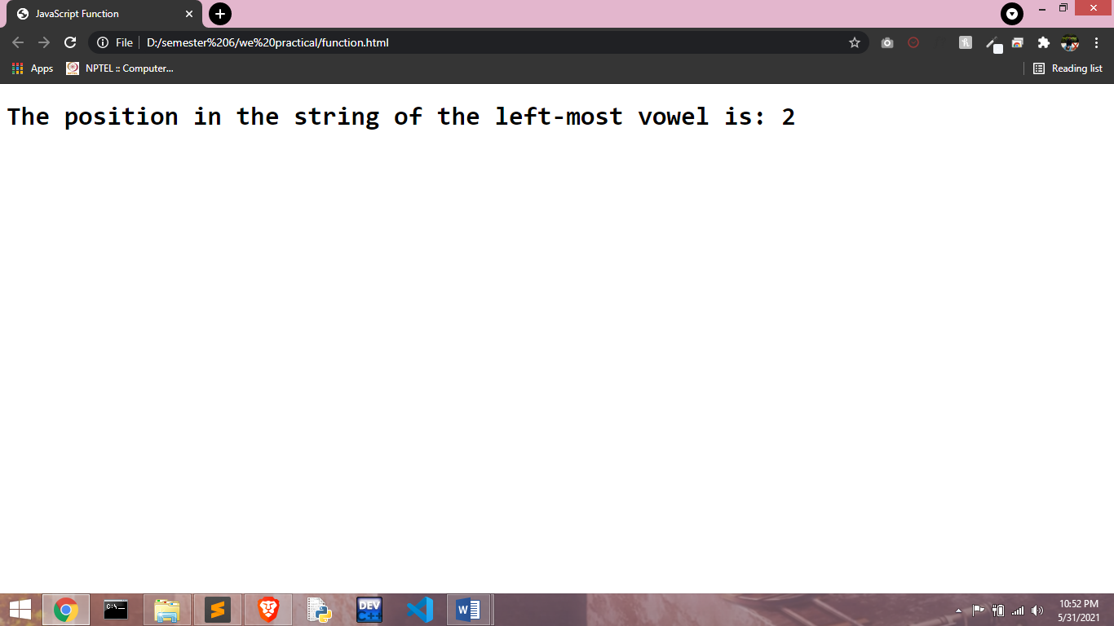

**Practical 4:** Using javascript demonstrate fade from one color to another on load.

**CODE :**

|  |
| --- |
| <!DOCTYPE html>  <html>  <head>  <title>On Load</title>  </head>  <style>  body {  transition: background-color 2s;  }  </style>  <body onload="onloading()">  </body>  <script type="text/javascript">  var colors = [ "yellow", "blue"];  var currentIndex = 0;  const onloading = () => {  console.log("Loading Complete")  setInterval(function () {  document.body.style.cssText = "background-color: " + colors[currentIndex];  currentIndex++;  if (currentIndex == undefined || currentIndex >= colors.length) {  currentIndex = 0;  }  }, 1000);  }  </script>  </html> |

**Output:**

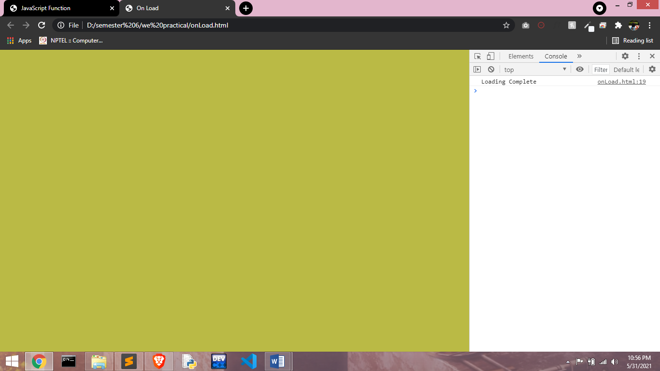

**Practical 5:** Develop and demonstrate a XHTML file that includes Javascript script for the following problems:

1. Input: A number n obtained using prompt.

Output: The first n Fibonacci numbers.

1. Input: A number n obtained using prompt.

Output: A table of numbers from 1 to n and their squares using alert.

**CODE :**

|  |
| --- |
| <!DOCTYPE html>  <html>  <head>  <title>Fibonacci</title>  </head>  <body>  <h1 id="foo"></h1>  <button onclick="Fibonacci()">Find Fibonacci</button>  <p id="pPrint"></p>  <button onclick="printTable()">Print Table</button>  </body>  <script type="text/javascript">  function Fibonacci(){  num = prompt("Enter the Number")  num = parseInt(num)  var num1=0;  var num2=1;  var sum;  var i=0;  for (i = 1; i < num; i++)  {  sum=num1+num2;  num1=num2;  num2=sum;  }  alert(sum)  document.getElementById("foo").innerHTML = `Fibonacci = ${sum}`  }  function printTable(){  var num;  num = prompt("Enter the Number")  num = parseInt(num)  for(var i=1; i<=10; i++){  var pTag= document.getElementById('pPrint');  pTag.innerHTML += `${num} * ${i} = ${(num*i)}` + "<br/>"  }  alert(num*num)  }  </script>  </html> |

**Output:**

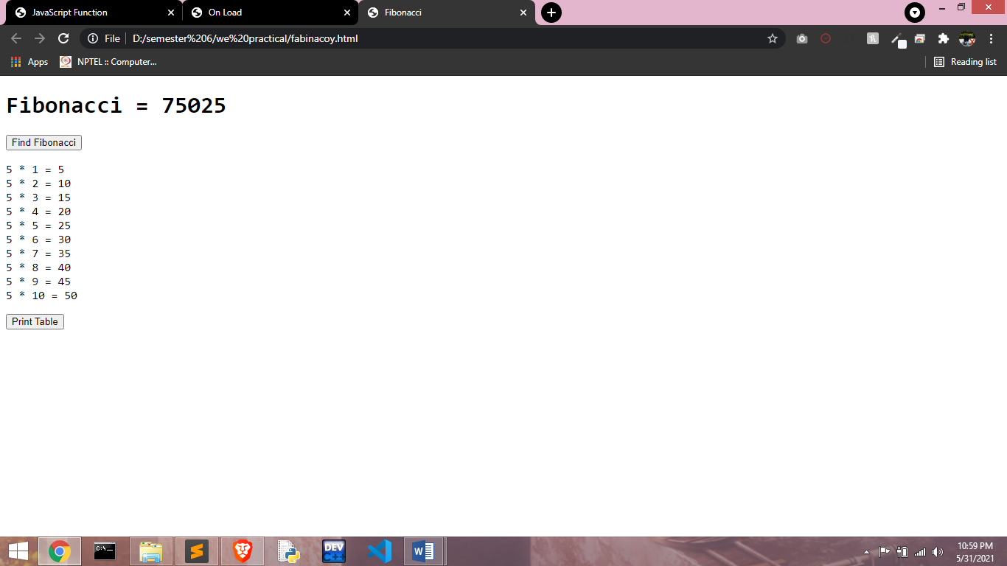

**Practical 6:** Design a registration form and validate its field by using javascript

**CODE :**

|  |
| --- |
| <!DOCTYPE html>  <html>  <head>  <title>Validate Form Using Html</title>  </head>  <body>  <form onsubmit="return false" name="register">  <div style="display: flex; ">  <p>  <label>Name</label>  <input type="text" size="30" name="name" placeholder="name">  <br />  <label>Email</label>  <input type="email" size="30" name="email" placeholder="email">  <br />  <label>Password</label>  <input type="password" size="30" name="password" placeholder="password">  <br />  <label>Mobile</label>  <input type="tel" size="30" name="mobile" placeholder="mobile">  <br />  <input type="submit" value="Submit" onclick="validateForm()">  <br />  </div>  </form>  </body>  <script type="text/javascript">  const validateForm = () => {  const {name , email , password , mobile} = document.register;  if(name.value==="" || email.value==="" || password.value==="" || mobile.value===""){  alert(`Any Field can't be Empty`);  return false;  }  if (!/^[a-zA-Z0-9.!#$%&'*+/=?^_`{|}~-]+@[a-zA-Z0-9-]+(?:\.[a-zA-Z0-9-]+)*$/.test(email.value))  {  alert("enter valid email")  return false  }  if(!/^(\+\d{1,3}[- ]?)?\d{10}$/.test(mobile.value)){  alert("Invalid Mobile")  return false  }  console.log("all OK")  alert("All Validate")    }  </script>  </html> |

**Output:**

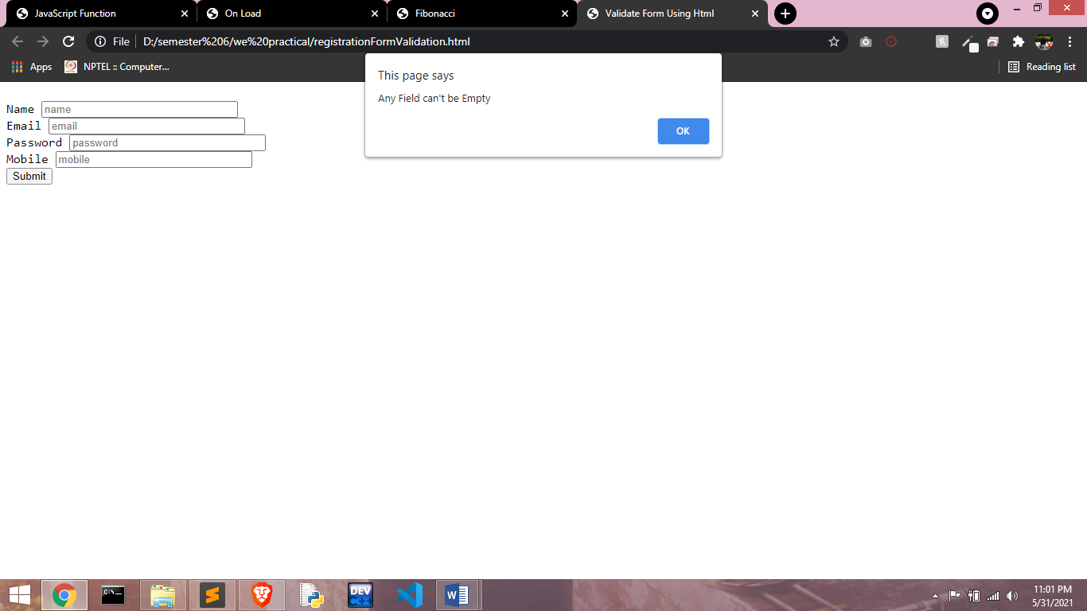

**Practical 7:** To design the scientific calculator and make event for each button using javascript.

**CODE :**

|  |
| --- |
| <!DOCTYPE html>  <html>  <head>  <title>Calculator</title>  </head>  <style type="text/css">  form{  width:440px;  padding:25px;  margin:auto;  }    input{  background:linear-gradient(45deg, red, blue);  color:#fff;  font-size:15px;  padding-top:15px;  padding-bottom:15px;  padding-left:19px;  padding-right:19px;  margin:6px;  }    h2{  text-align:center;  }    .sc{background: #C33764; /* fallback for old browsers */  background: -webkit-linear-gradient(to top, #1D2671, #C33764); /* Chrome 10-25, Safari 5.1-6 */  background: linear-gradient(to top, #1D2671, #C33764); /* W3C, IE 10+/ Edge, Firefox 16+, Chrome 26+, Opera 12+, Safari 7+ */  color:#fff;  }  </style>  <body>  <h2>SCIENTIFIC CALCULATOR</h2>  <br />  <br />  <form name="sci-calc">  <table cellspacing="0" cellpadding="1">  <TR>  <TD COLSPAN="5" ALIGN="center"><input NAME="display" class="sc" VALUE="0" SIZE="44" MAXLENGTH="25"></TD>  </TR>  <TR>  <td align="center"><input type="button" value="Clear" ONCLICK="this.form.display.value = 0 "></TD>  <td align="center" colspan="2"><input type="button" value=" Backspace " ONCLICK="deleteChar(this.form.display)"></TD>  <td align="center" colspan="2"><input type="button" value=" Enter " NAME="Enter" ONCLICK="if (checkNum(this.form.display.value)) { compute(this.form) }"></TD>  </TR>  <TR>  <td align="center"><input type="button" value=" exp " ONCLICK="if (checkNum(this.form.display.value)) { exp(this.form) }"></TD>  <td align="center"><input type="button" value=" 7 " ONCLICK="addChar(this.form.display, '7')"></TD>  <td align="center"><input type="button" value=" 8 " ONCLICK="addChar(this.form.display, '8')"></TD>  <td align="center"><input type="button" value=" 9 " ONCLICK="addChar(this.form.display, '9')"></TD>  <td align="center"><input type="button" value=" / " ONCLICK="addChar(this.form.display, '/')"></TD>  </TR>  <TR>  <td align="center"><input type="button" value=" ln " ONCLICK="if (checkNum(this.form.display.value)) { ln(this.form) }"></TD>  <td align="center"><input type="button" value=" 4 " ONCLICK="addChar(this.form.display, '4')"></TD>  <td align="center"><input type="button" value=" 5 " ONCLICK="addChar(this.form.display, '5')"></TD>  <td align="center"><input type="button" value=" 6 " ONCLICK="addChar(this.form.display, '6')"></TD>  <td align="center"><input type="button" value=" * " ONCLICK="addChar(this.form.display, '*')"></TD>  </TR>  <TR>  <td align="center"><input type="button" value=" sqrt " ONCLICK="if (checkNum(this.form.display.value)) { sqrt(this.form) }"></TD>  <td align="center"><input type="button" value=" 1 " ONCLICK="addChar(this.form.display, '1')"></TD>  <td align="center"><input type="button" value=" 2 " ONCLICK="addChar(this.form.display, '2')"></TD>  <td align="center"><input type="button" value=" 3 " ONCLICK="addChar(this.form.display, '3')"></TD>  <td align="center"><input type="button" value=" - " ONCLICK="addChar(this.form.display, '-')"></TD>  </TR>  <TR>  <td align="center"><input type="button" value=" sq " ONCLICK="if (checkNum(this.form.display.value)) { square(this.form) }"></TD>  <td align="center"><input type="button" value=" 0 " ONCLICK="addChar(this.form.display, '0')"></TD>  <td align="center"><input type="button" value=" . " ONCLICK="addChar(this.form.display, '.')"></TD>  <td align="center"><input type="button" value=" +/- " ONCLICK="changeSign(this.form.display)"></TD>  <td align="center"><input type="button" value=" + " ONCLICK="addChar(this.form.display, '+')"></TD>  </TR>  <TR>  <td align="center"><input type="button" value=" ( " ONCLICK="addChar(this.form.display, '(')"></TD>  <td align="center"><input type="button" value="cos" ONCLICK="if (checkNum(this.form.display.value)) { cos(this.form) }"></TD>  <td align="center"><input type="button" value=" sin " ONCLICK="if (checkNum(this.form.display.value)) { sin(this.form) }"></TD>  <td align="center"><input type="button" value=" tan" ONCLICK="if (checkNum(this.form.display.value)) { tan(this.form) }"></TD>  <td align="center"><input type="button" value=" ) " ONCLICK="addChar(this.form.display, ')')"></TD>  </TR>    </table>  </form>  </body>  <script type="text/javascript">  function addChar(input, character) {  if(input.value == null || input.value == "0")  input.value = character  else  input.value += character  }    function cos(form) {  form.display.value = Math.cos(form.display.value);  }    function sin(form) {  form.display.value = Math.sin(form.display.value);  }    function tan(form) {  form.display.value = Math.tan(form.display.value);  }    function sqrt(form) {  form.display.value = Math.sqrt(form.display.value);  }    function ln(form) {  form.display.value = Math.log(form.display.value);  }    function exp(form) {  form.display.value = Math.exp(form.display.value);  }    function deleteChar(input) {  input.value = input.value.substring(0, input.value.length - 1)  }    function changeSign(input) {  if(input.value.substring(0, 1) == "-")  input.value = input.value.substring(1, input.value.length)  else  input.value = "-" + input.value  }    function compute(form) {  form.display.value = eval(form.display.value)  }    function square(form) {  form.display.value = eval(form.display.value) * eval(form.display.value)  }    function checkNum(str) {  for (var i = 0; i < str.length; i++) {  var ch = str.substring(i, i+1)  if (ch < "0" || ch > "9") {  if (ch != "/" && ch != "*" && ch != "+" && ch != "-" && ch != "."  && ch != "(" && ch!= ")") {  alert("invalid entry!")  return false  }  }  }  return true  }  </script>  </html> |

**Output:**

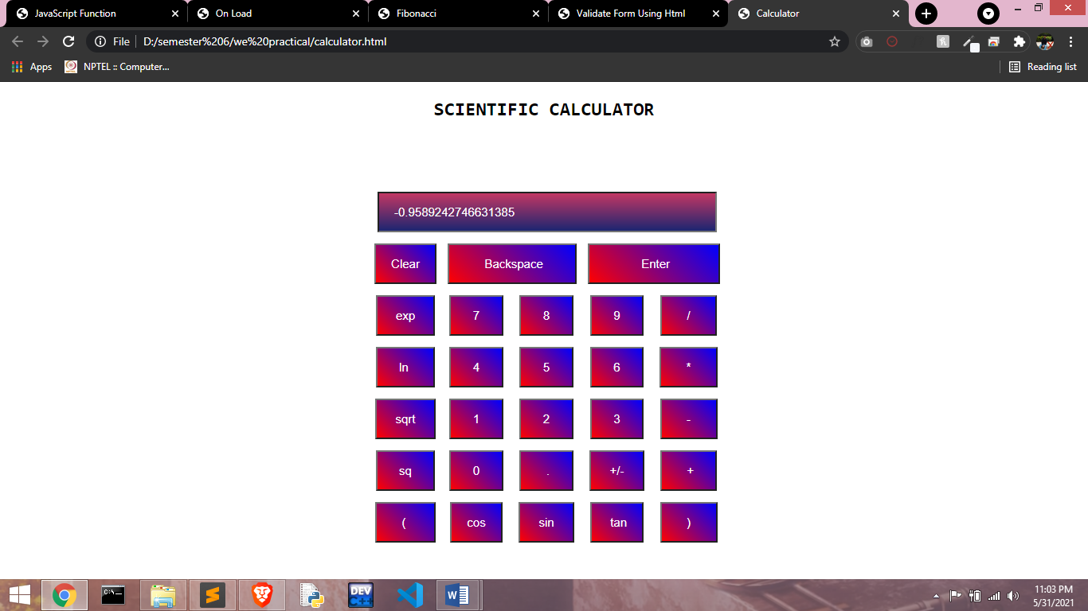

**Practical 8:** WAP to create popup boxes in javascript.

**CODE :**

|  |
| --- |
| **<!DOCTYPE html>**  **<html>**  **<head>**  **<title>Popup</title>**  **</head>**  **<body>**  **<h1>This is to Create to popup</h1>**  **</body>**  **<script type="text/javascript">**  **function pop(){**  **alert("this is Popup")**  **}**  **pop()**  **</script>**  **</html>** |

**Output:**

