**Sample project for Rotary International**

Project Name: Rotary Branch Location

Project Description: The project is use to show all the branch of rotary international within the USA. It will show the contact information of each branch. It does have the facility to add the new branch which will display later on in the frontend in a USA map. Once we click on the map the data will be populated based on the selected state.

Project Duration: 5 Hrs.

Software and Hardware

1. PHP version 5.2 or above
2. MySQL
3. CSS3 and HTML5
4. Bootstrap (CSS framework)
5. Javascript and jQuery
6. jQuery Vector Map
7. JSON
8. ORM for database class
9. Adobe Dreamweaver
10. Apache (Web Server)

Folder Structure:

|- _kernal (Store all the database connection, paging, mail)   
|- css (Store the css files of bootstrap, fontawesome and custom)   
|- fonts (fonts related files)   
|- js (custom javascript, jquery, bootstrap and other)   
|- class.branches.php (Use this file to do the crud operation)   
|- config_db.php (Initial files to load all the database information, log and other)   
|- crud.php (File to handle the crud operation)   
|- footer.php (Footer file)   
|- header.php (header file)   
|- index.php (Main Page)   
|- json.php (Json based data of branch which will retrieve via AJAX)   
|- db.sql (SQL script file)

Some Screen Shot

Home Page:

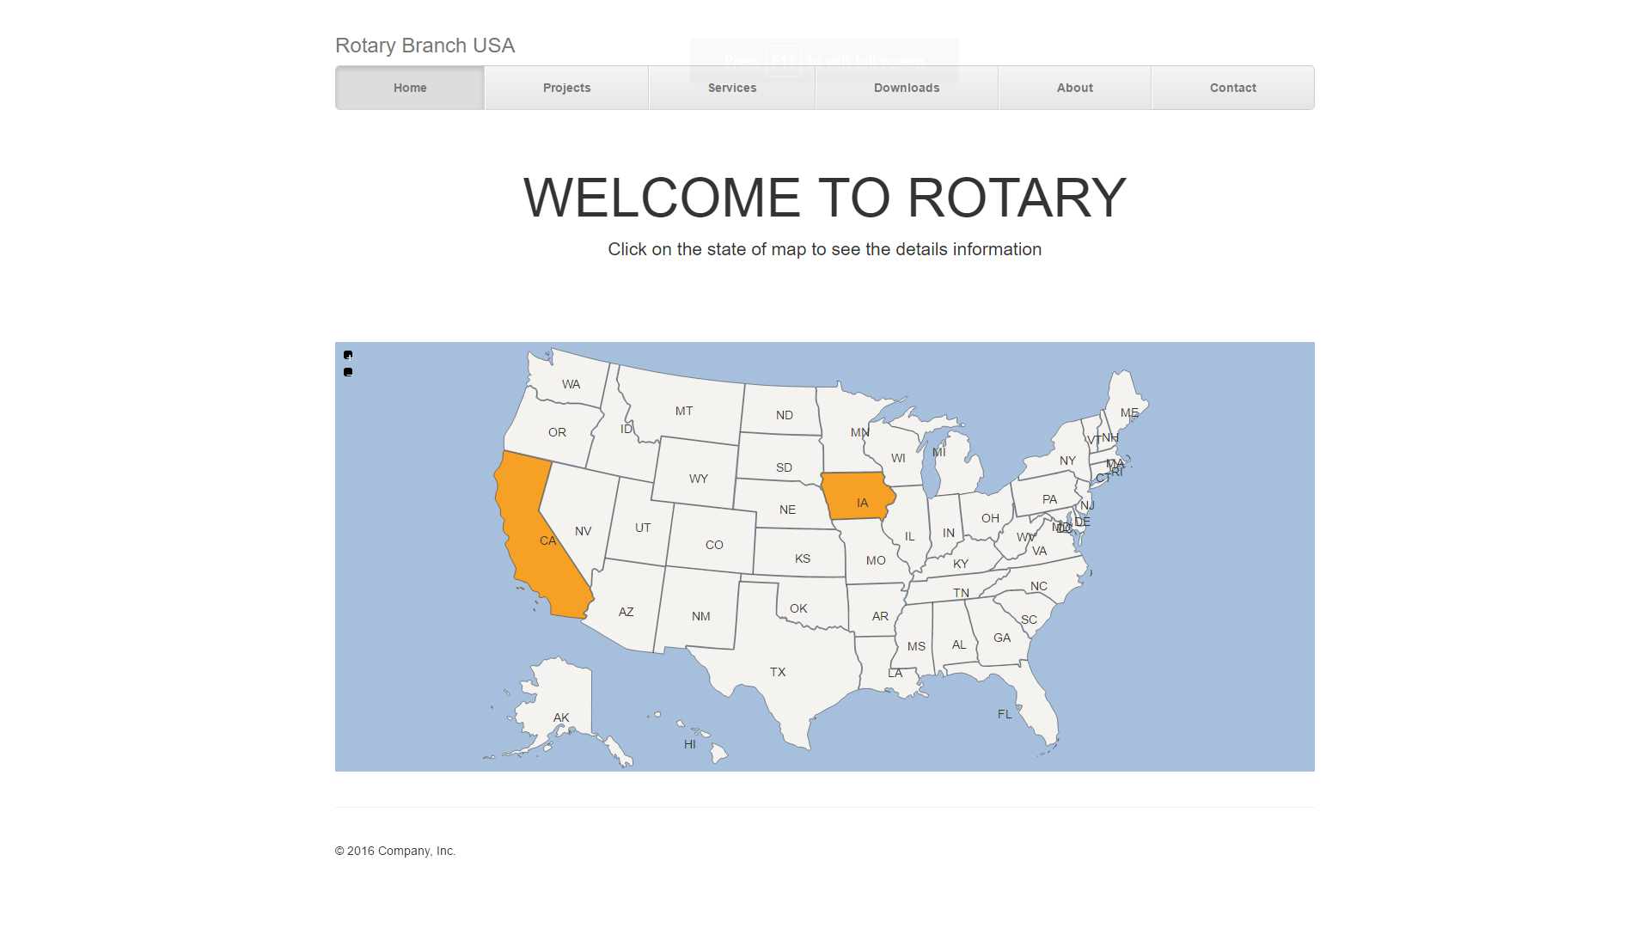

Once click on the state It will show the data which is populated via JSON

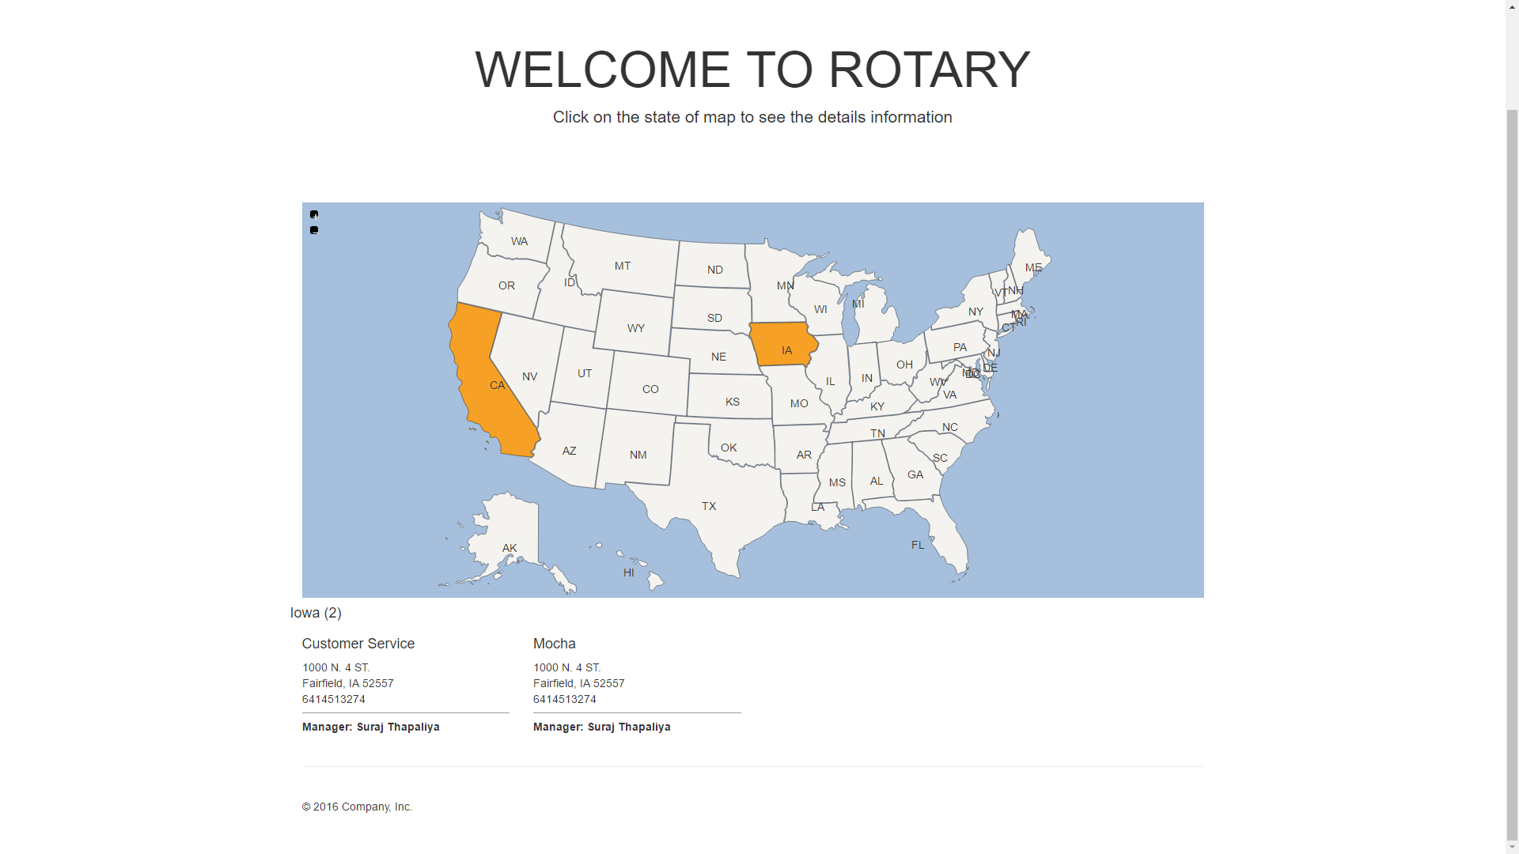

Click on Project will show the CRUD page of branch. The first page will display the data and the side bar with the form will allow inserting new data.

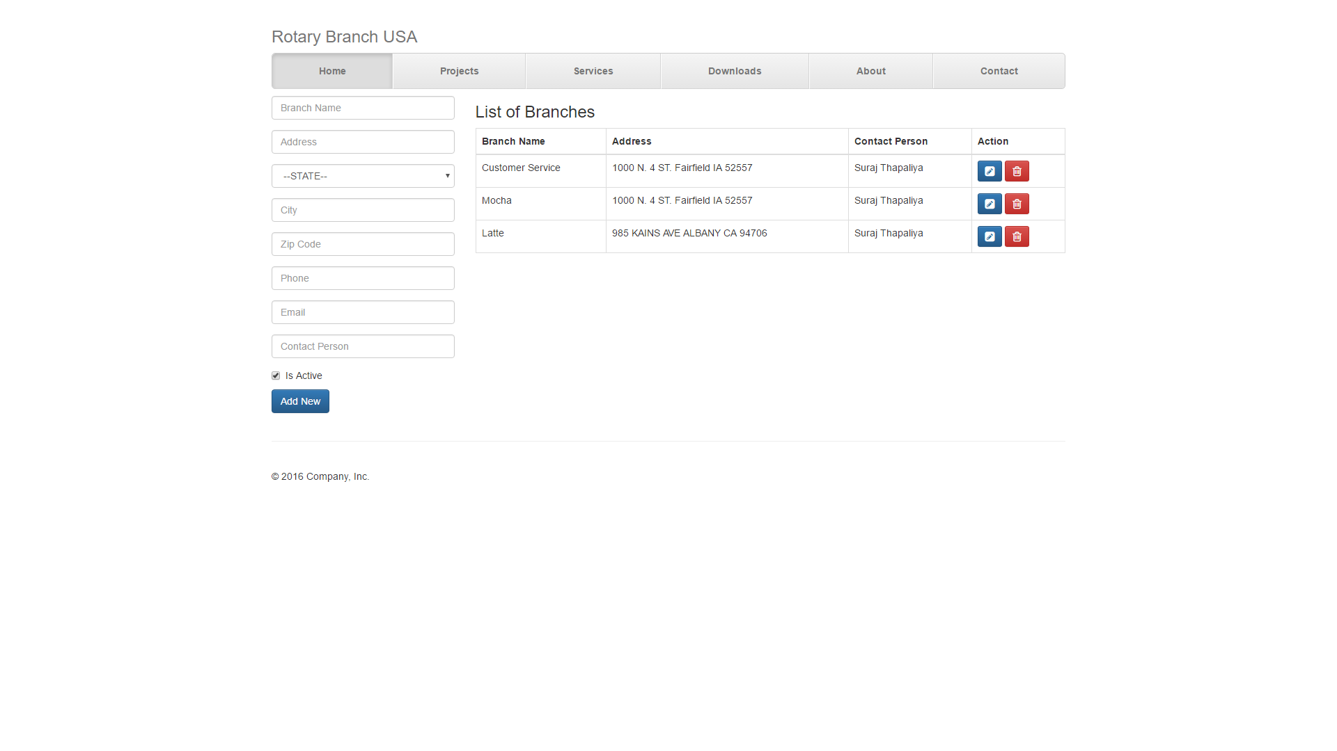

Clicking on delete will show the javascript code and once click on Ok will delete the records other wise stay on the same page.

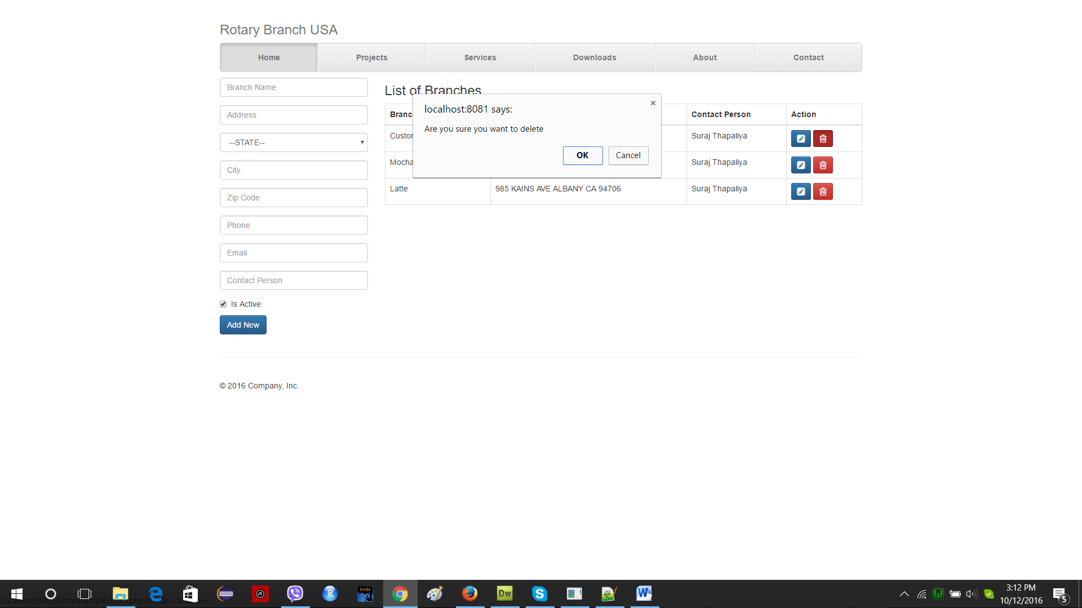

I certify that the whole code is written by me. There are plugins and framework which does have a GNU license.

Suraj Thapaliya   
Email: [opensource.suraj@gmail.com](mailto:opensource.suraj@gmail.com)   
P: 510 750 9398 or 641 451 3274   
Skype: suraj.syber