**Lab 0**

**Concurrent Programming**

*Name : Suraj B Thite*

**Code Organization :**

The below tree describes the brief organization of the code for the Lab0 in SRC directory.

Lab0

|----main.c - Main Application File consisting sequential flow of operations.

* main()
* file_to_array()
* array_to_file()

|----sorts.c - Source File consisting of functions for Merge sort and Quick sort on input data.

* mergesort()
* quicksort()
* partition()
* swap()
* merge ()

|----Makefile - Make file to build the project and application binary mysort.

**Files Description:**

1. **main.c :** The main application source file which consist of sequential flow of instruction to parse input from the user, fetch the data from the file, sort the data depending upon the argument passed and writeback to the output file. In case of –name argument is passed, the Author name i.e. Suraj Thite is printed and the rest of the process is skipped. The getopt_long() function is used to parse the arguments from the user.
2. **sorts.c :** The source application for merge and quick sort algorithms along with associated member functions. The function takes the array as input arguments and sorts it.
3. **Makefile :** The make file to build the source binaries using gnu C compiler running on Linux Platform.

**Compilation Instructions :**

Navigate to the working directory of the project and open a terminal.

Run make to compile the project and generate mysort binary file.

Run make clean to clean the application binary from the project folder.

**Execution Instructions :**

Usage :

./mysort [--name] [sourcefile.txt] [-o outputfile.txt] [--alg=<merge,quick>] as per lab0 requirements.

If -- name is passed as argument, the program is terminated.

Failure to open the input file or write sorted data to the output file or incorrect no of arguments passed will stop the further execution printing appropriate messages on terminal.

**Extant Bugs :**

No bugs in the code as such, the project compiles successfully and passes the test case as mentioned in the assignment requirements.

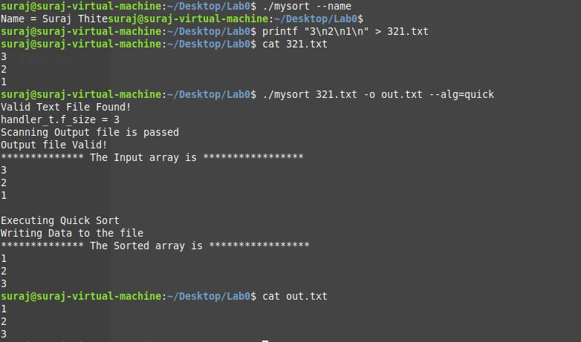



The test cases as mentioned in the lab0 assignment document passes successfully as per the above images.