**HARMAN I2C Driver Block Diagram**

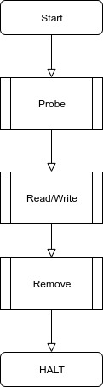

Figure 1: operations implemented by the driver.

The driver code comprises of a set of operations or call backs which are shown in figure 1

Each of these features are further described below

1. Probe: The probe function is called when an entry in the id_table name field matches the device's name.Probe is used for binding a device with its corresponding driver.

The flow graph of probe function is shown below.

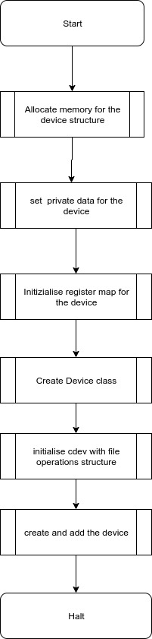

Figure 2: Probe flowgraph

1. Remove: This call back is responsible for destroying the class and device which were created in the probe function and also freeing any unfreed memory

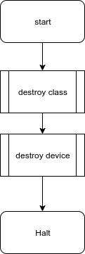

Figure 2: Remove callback

1. Read : The read file operation is responsible for reading 10 bytes(time, daya and month) using regmap_bulk_read() from the rtc device and copying the read data to user space buffer using copy to user api.

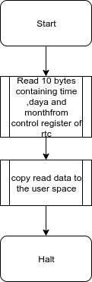

Figure 3: Read Operation:

1. Write Operation: Uses dev_dbg api to receive time, day and month information to be written from user space and write the same to the rtc device using regmap_bulk_write().

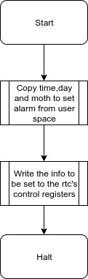

Figure 4: Write Operation