**HARMAN Assigment i2c client device driver**

-------------------------------------------------------------------------------------------------------------------------------

Software used :

Raspbian OS: Kernel version: 4.19.95-v7+

Hardware used:

Raspberry Pi 3-> i2c Master

MCP7940 -> i2c slave

-------------------------------------------------------------------------------------------------------------------------------

Generic Block Diagram

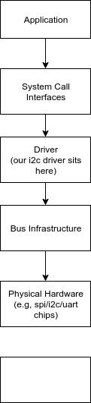

Figure 1: - Abstraction hierarchy between application and Hardware

The application layer communicates with the driver using API calls or System calls and the client driver in turn reads/writes using the services provided by the bus controller drivers managing transmission on physical bus interfaced with the hardware.

**Interfacing pin details:**

|  |  |  |
| --- | --- | --- |
| Function | Raspberry Pi 3 | MCP7940 RTC |
| SCL | Pin 5 | Pin 6 |
| SDA | Pin 3 | Pin 5 |
| VCC | Pin 2 | Pin 8 |
| GND | GND | GND |