DBMS LAB EXPERIMENT 1 (Modified for Classroom Allotment System)

AIM
To Create, Alter, Drop, Rename and Truncate tables for the Classroom Allotment System using Data Definition Language (DDL) statements.

DESCRIPTION
DDL (Data Definition Language) statements are used to define and modify the database structure.
Commands: CREATE, ALTER, DROP, TRUNCATE and RENAME.

QUESTIONS

1) Create a table STUDENT
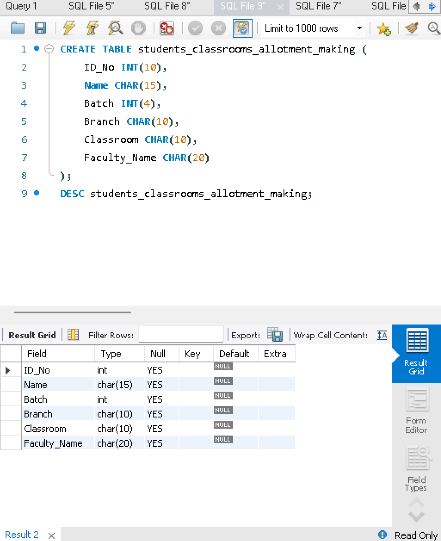
CREATE TABLE student(
ID_No INT,
Name VARCHAR(20),
Batch INT,
Branch VARCHAR(10),
Fee INT,
Grade CHAR(2)
);

2) Create a table FACULTY (Classroom Allotment)
CREATE TABLE faculty(
FacultyID VARCHAR(10),
FacultyName VARCHAR(25),
Subject VARCHAR(25),
Classroom VARCHAR(10),
NoOfStudents INT
);
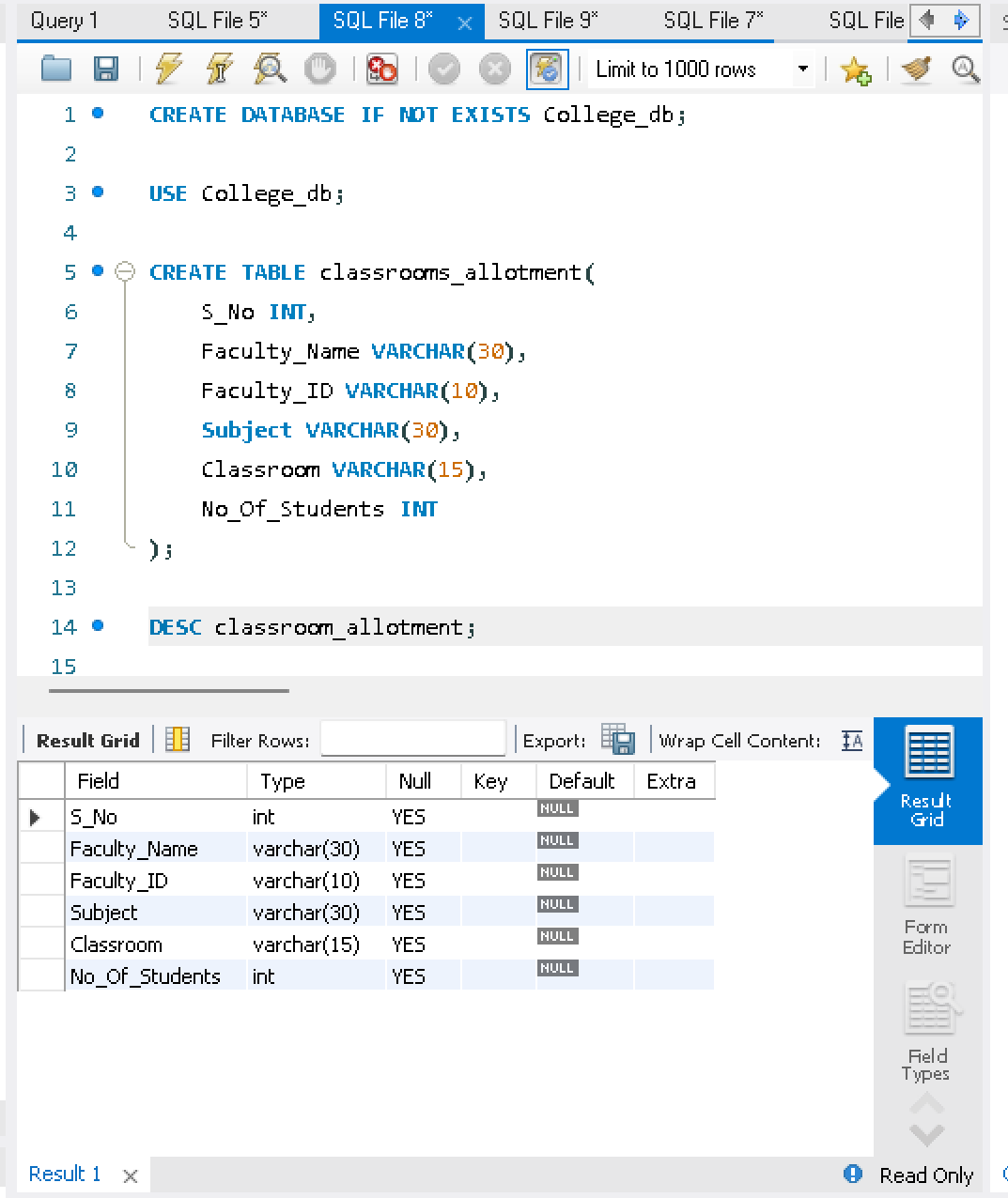

3) Create a table DEPARTMENT
CREATE TABLE department(
DeptNo INT,
DeptName VARCHAR(20),
DeptHead VARCHAR(25)
);
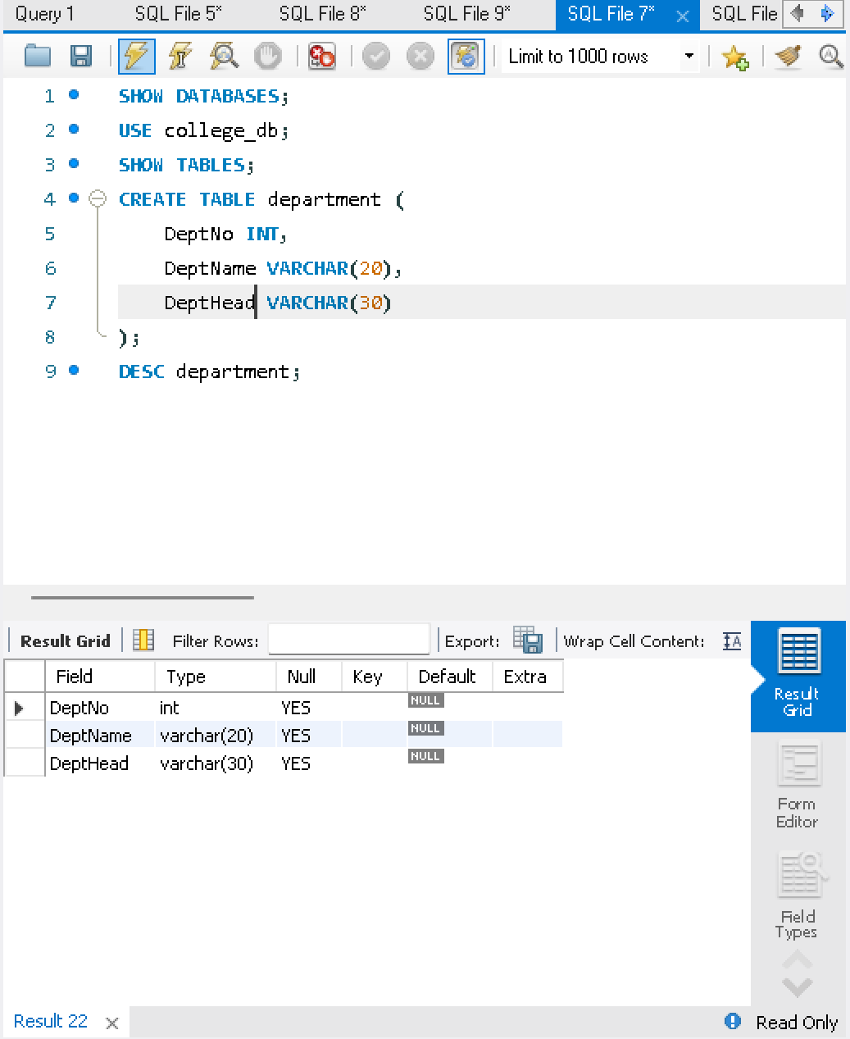

4) Create a table COURSE
CREATE TABLE course(
CourseNo VARCHAR(5),
CourseName VARCHAR(30),
CourseType VARCHAR(20),
SemNo INT,
HallNo VARCHAR(10),
FacNo VARCHAR(10)
);
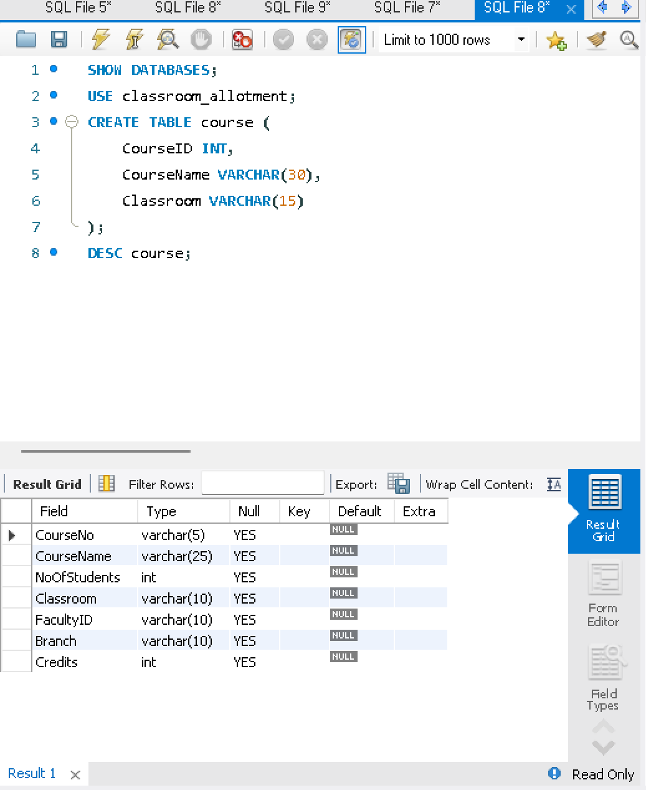

5) Modify the FACULTY table by adding Branch
ALTER TABLE faculty
ADD Branch VARCHAR(10);

OUTPUTS
- DESC student;
2) DESC faculty;
3) DESC department;
4) DESC course;
5) DESC faculty;
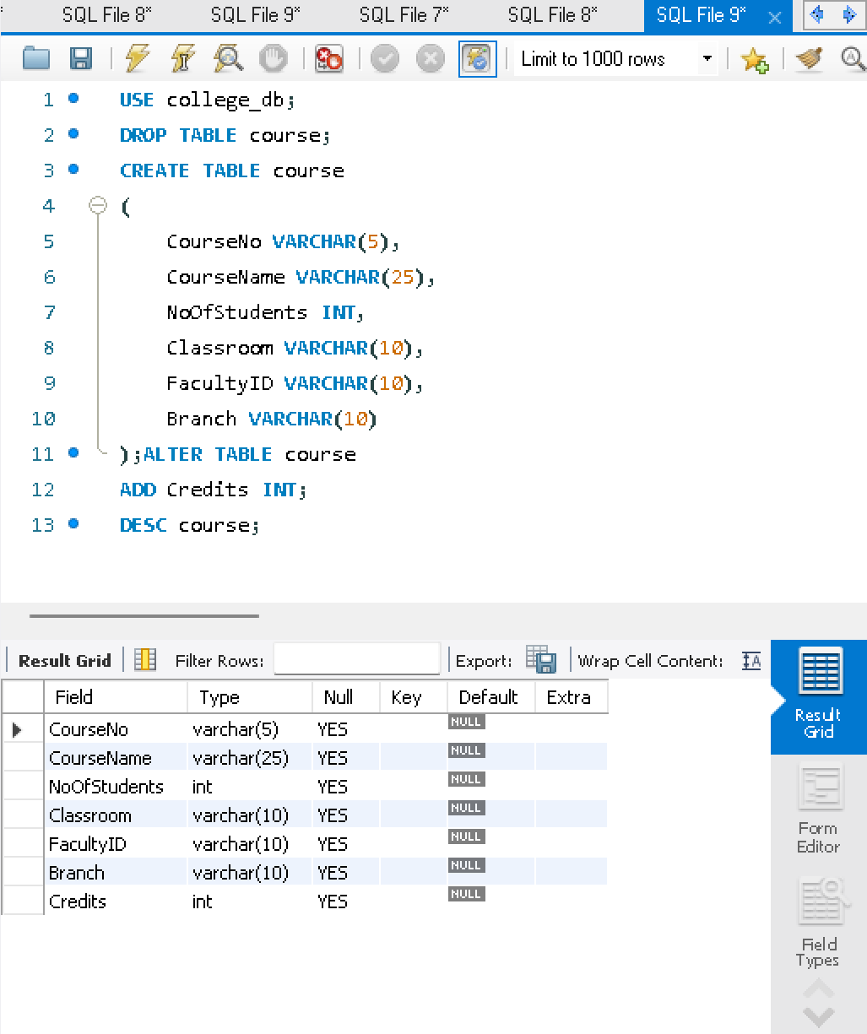

RESULT
The STUDENT, FACULTY, DEPARTMENT and COURSE tables for the Classroom Allotment System were successfully created and modified using DDL commands.

