DBMS Experiment 2 - Classroom Allotment System

Title
DDL Commands with Constraints – PRIMARY KEY, FOREIGN KEY, UNIQUE, CHECK

AIM
To add PRIMARY KEY, FOREIGN KEY, UNIQUE and CHECK constraints to the Classroom Allotment System tables using DDL commands.

Questions with SQL Code

1) Alter STUDENT table - Add PRIMARY KEY
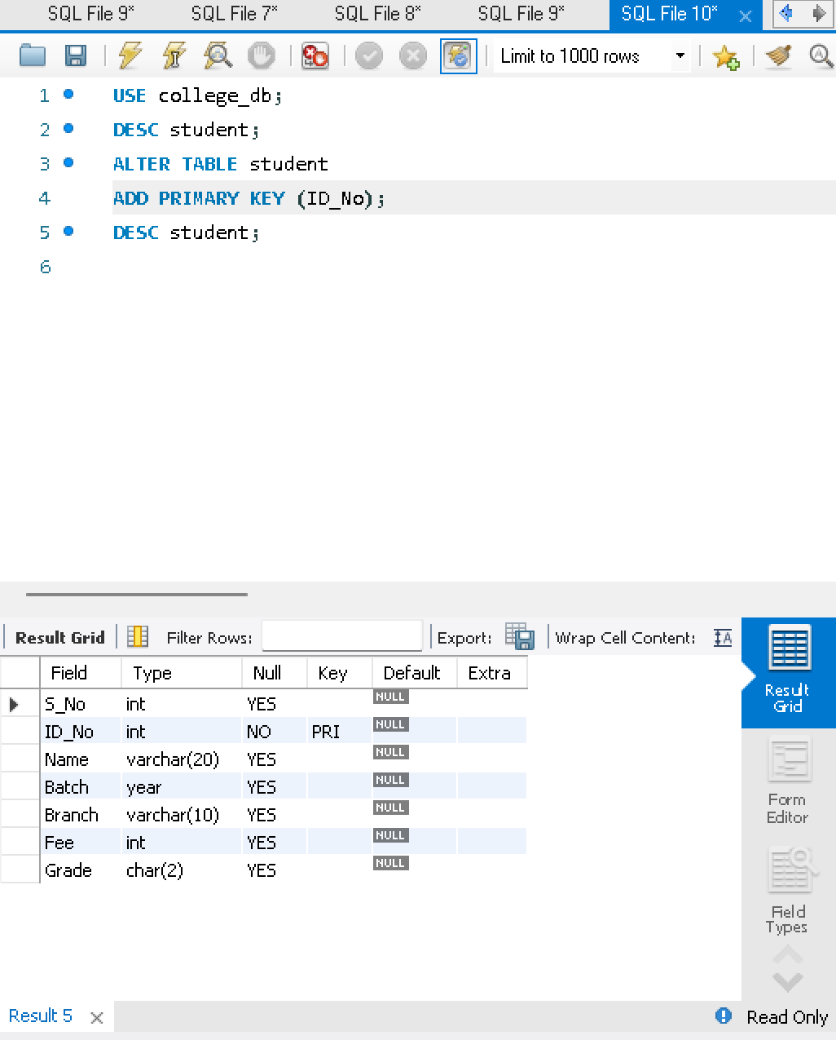
ALTER TABLE student
ADD PRIMARY KEY (ID_No);
DESC student;
2) Alter FACULTY table - Add PRIMARY KEY and CHECK
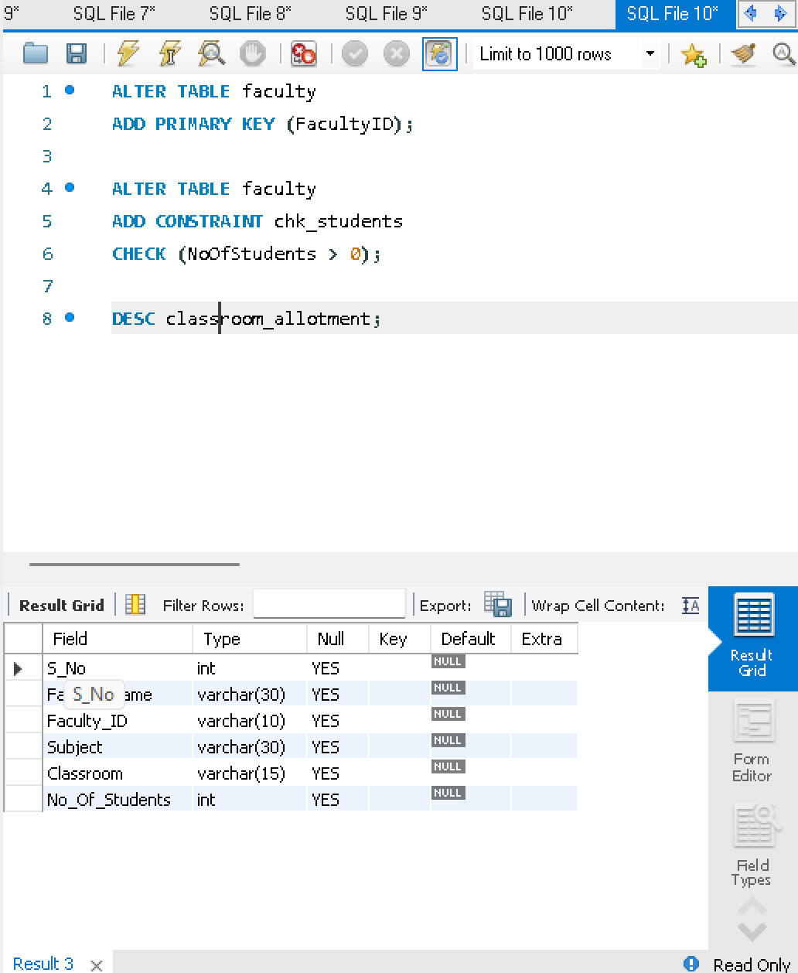
ALTER TABLE faculty
ADD PRIMARY KEY (FacultyID);
ALTER TABLE faculty
ADD CONSTRAINT chk_students
CHECK (NoOfStudents > 0);
DESC faculty;

3) Alter DEPARTMENT table - Add PRIMARY KEY
ALTER TABLE department
ADD PRIMARY KEY (DeptNo);
DESC department;
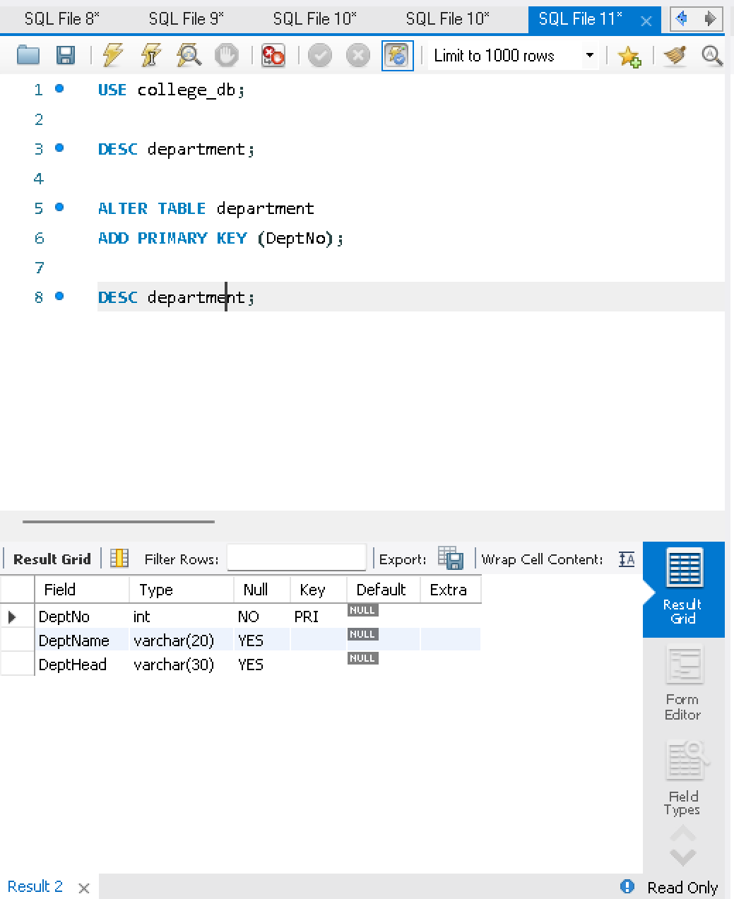

4) Alter COURSE table - Add PRIMARY KEY and CHECK
ALTER TABLE course
ADD PRIMARY KEY (CourseNo);
ALTER TABLE course
ADD CONSTRAINT chk_sem
CHECK (SemNo BETWEEN 1 AND 8);
DESC course;

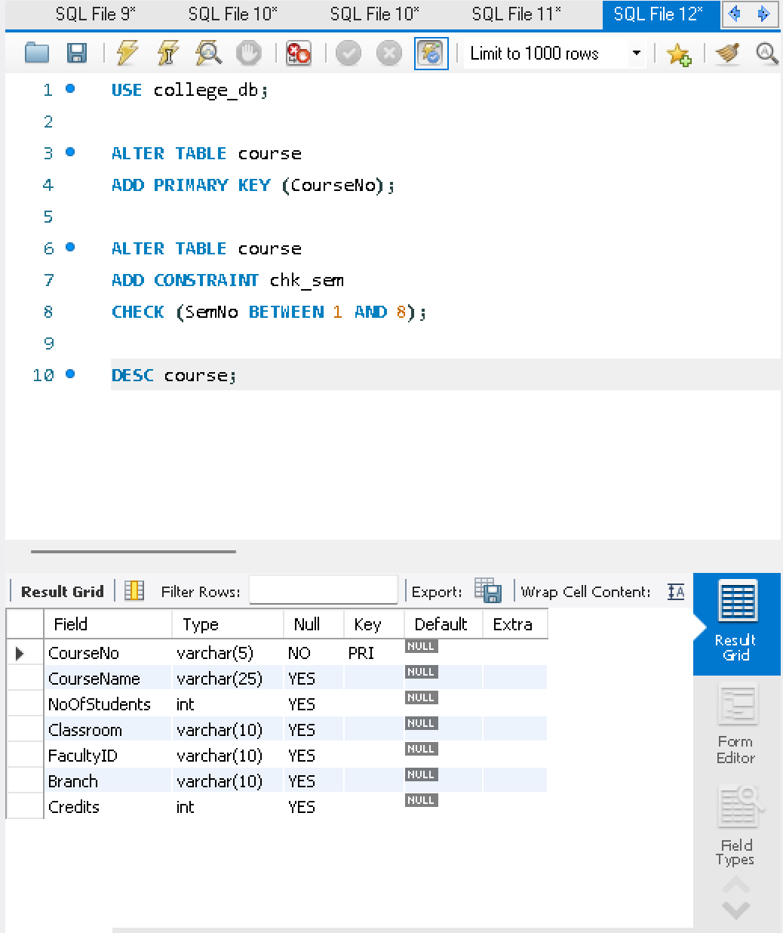

5) Alter STUDENT table - Add UNIQUE KEY
ALTER TABLE student
ADD CONSTRAINT uq_student_name UNIQUE(Name);
DESC student;

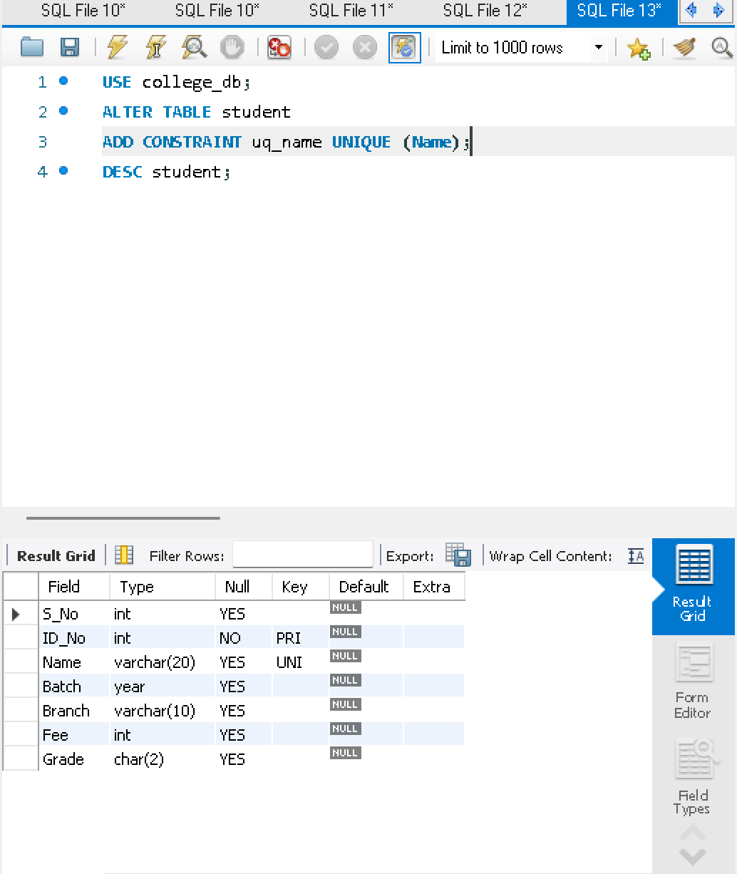
6) Add FOREIGN KEY between COURSE and FACULTY
ALTER TABLE course
ADD CONSTRAINT fk_course_faculty
FOREIGN KEY (FacNo)
REFERENCES faculty(FacultyID);
DESC course;

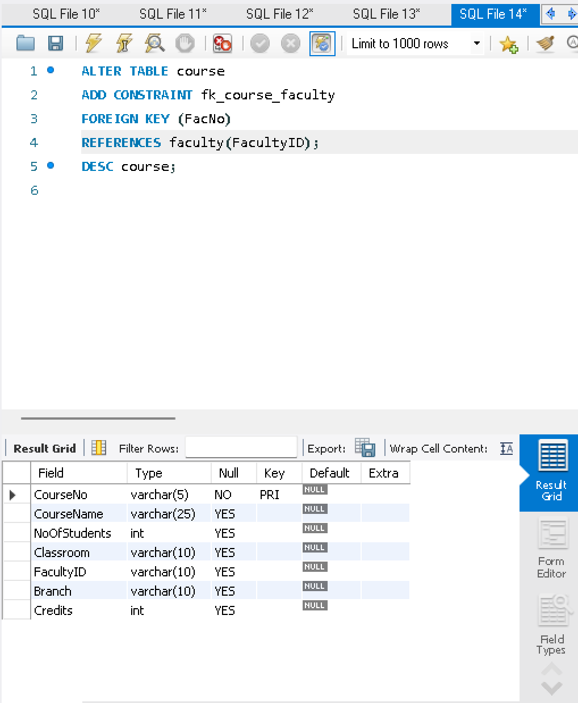

Result
PRIMARY KEY, FOREIGN KEY, UNIQUE and CHECK constraints were successfully added and verified for the Classroom Allotment System database.

