**Course Project – Group 6**

# Introduction

The purpose of the project "City of St. Petersburg Commercial Corridors: Investments and Property Value Analysis" is to examine and release significant data associated with the ongoing investments made in the eight commercial corridors situated in the South St. Petersburg Community Redevelopment Area (CRA) since the CRA's establishment in 2015. The research questions of this project are focused on the analysis of properties by value per acre and per square feet for 2015 and 2022, the comparison of 2015 results to 2022 results, and the determination of the average and median just value per square foot, non-school district assessed value per square foot, non-school district taxable value per square foot, and land value per square foot for properties across all commercial corridors in the CRA. The results of the project could have an impact on the City of St. Petersburg's approach to investing in and improving the areas surrounding the commercial corridors within the South St. Petersburg Community Redevelopment Area (CRA).

# Methodology

**Data Description:**

To analyze the commercial corridors by value per acre and per square feet between 2015 and 2022, we used **Property Appraiser/Department of Review Data** of 2015 and 2022. The data provides information on property just value, land value, non-school district assessed value, non-school district taxable value and all the relevant information pertaining to the commercial corridors within the South St. Petersburg CRA.

**Data Processing:**

For the purpose of our analysis**, R studio** is used for data cleaning, processing, and feature extraction from the dataset. The data is checked across all the relevant columns to see if there are any NULL values within the field and there are no null values. Redundant columns like ignore, PIN, physical city, zipcode columns are dropped as they are not required for this analysis.

**Feature Extraction:** Our research aims to provide information on property values per square feet. The data set has property values (like just value, land value, etc.,) and square feet in separate columns. Therefore, we do feature engineering (divide each property value by its respective land square feet) and produce new property fields. Please find below the extracted property values per sqft for 2015 and 2022 data.

* **Just Value per sqft**
* **Land Value per sqft**
* **Non-school assessed value per sqft**
* **Non-school taxable value per sqft**

We limit our analysis to only eight corridors from the list of commercial corridors within South St. Petersburg. We have the eight corridors listed as separate fields in our dataset. Therefore, we group the property values based on each corridor and find the mean, median for all the above-mentioned property values in our analysis.

**Data Visualization**: All the aggregate property values (mean and median) for the eight corridors is produced in a new excel sheet and extracted to Tableau for visualizing the results. Using **Tableau**, the aggregate values are plotted on bar graphs and compared between 2015 and 2022 data. A new variable called Rank is created for each property value to visualize the trend lines and help understand which corridors are on the top and which are on the bottom. The rank is calculated by taking a difference of (mean of property value in 2022) and (mean of property value in 2015). The corridor with the highest difference is ranked as 1 and the same is plotted as a trend line across all the property values.

# Results

1. **Average and Median Just Value per sqft:**

The just value per square foot represents the fair market value of a property. According to our analysis, the Central Avenue corridor has experienced the highest increase in just value per square foot from $19 to $62 (which is $43) in 2022, followed by 5th Ave St where we can see an increase of 20$. On the other hand, the 16th Street corridor has seen the lowest increase in just value per square foot of $7 between 2015 and 2022.

1. **Average and Median Non-school assessed value per sqft:**

A notable observation from the analysis is that the Central Avenue corridor has experienced the highest growth in non-school assessed value per square foot. Specifically, the increase in value is approximately $30 per square foot, which is significant in comparison to other corridors analyzed. 16th Street corridor has been the lowest among all corridors, with an increase of only $4 between 2015 and 2022.

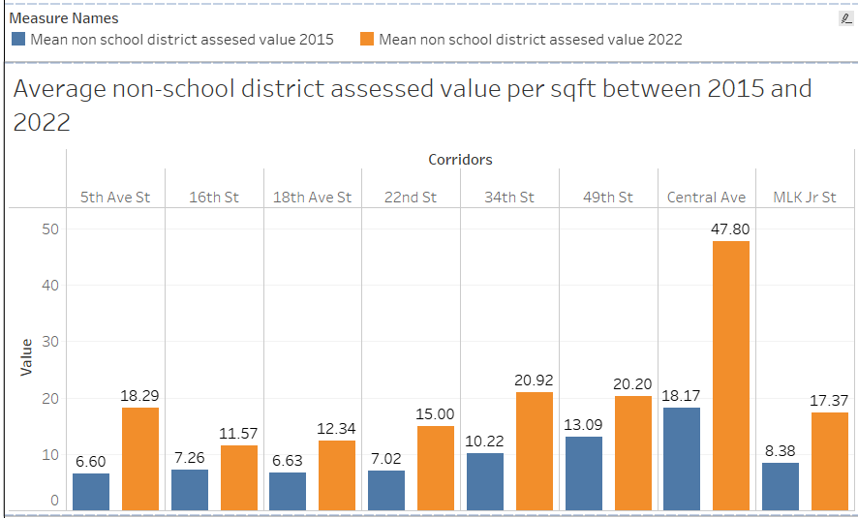

1. **Average and Median Non-school taxable value per sqft:**

The non-school district taxable value has shown the highest growth in the Central Avenue corridor with an increment of $29 per square foot, while the 5th Ave St follows with an increase of nearly $11. The 16th Street corridor has shown the least growth compared to all other corridors, with a mere increase of $2.3 per square foot from 2015 to 2022.

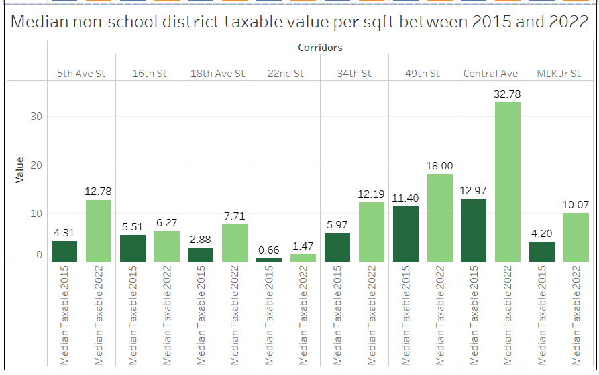

1. **Average and Median Land value per sqft:**

The Central Avenue corridor has witnessed a significant boost in land value per square foot, rising from $7 to $33, which is an increase of $25 per square foot. In contrast, the 16th Street corridor has exhibited the lowest growth rate among all corridors, with an increase of just $5 per square foot between 2015 and 2022.

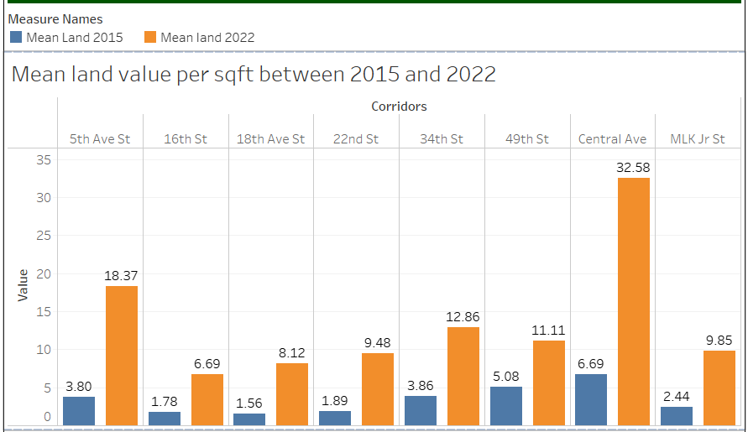

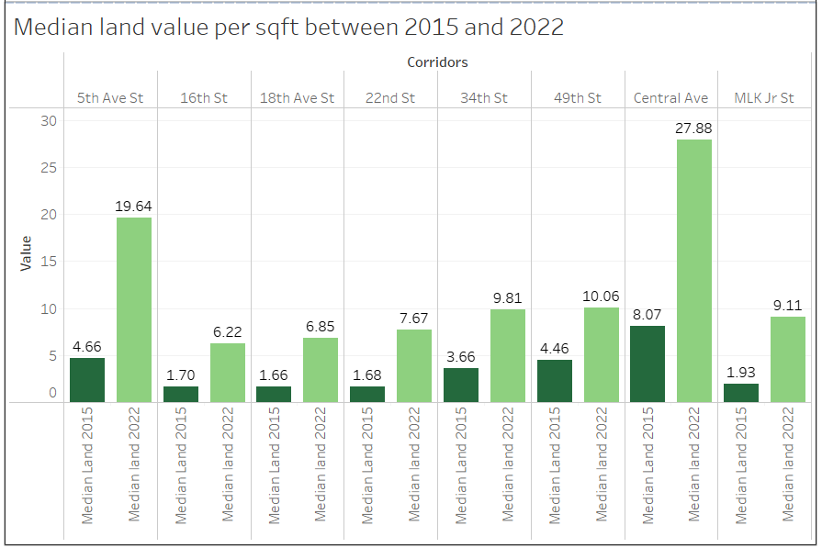

1. **Rank of property value across all the corridors:**

Central Avenue boasts the highest ranking in various categories including just value per square foot, non-school assessed value per square foot, non-school district taxable value per square foot, and land value per square foot. On the other hand, 16th street is the least performer in these categories.

# Conclusions

The analysis shows that the Central Avenue corridor has exhibited the highest growth in just value per square foot, non-school assessed value per square foot, non-school district taxable value per square foot, and land value per square foot. The increase in value per square foot in the Central Avenue corridor ranges from $25 to $43, depending on the metric. 5th Ave St also experienced growth in just value per square foot and non-school district taxable value per square foot. In contrast, the 16th Street corridor had the lowest growth rate in all categories, with an increase ranging from $2.3 to $7 per square foot. These findings suggest that investment in the Central Avenue corridor may yield higher returns than other corridors in the area.

# Link to Visualizations

**Datasets**:

Data_2015.xlsx

Data_2022.xlsx

**Tableau Links:**

Just value per sqft and ranking of property values:

<https://public.tableau.com/app/profile/saranya.chintalapati6092>

Non-assessed school district assessed, taxable and land value per sqft:

<https://public.tableau.com/app/profile/keerthi.bai.reddy1713>

**R code:**

[R script file](R%20script%20file)

# Appendix

**SARANYA CHINTALAPATI**

**SAI AKHILESH POTHARAJU**

**SURAJ VARMA DANTULURI**

**PRASANNA EDDALA**

**KEERTHI BAI REDDY**