Some observations of Hardware Support page

Search Results:

1. User searches for “Camera” in the search box, clicks search icon and results are displayed

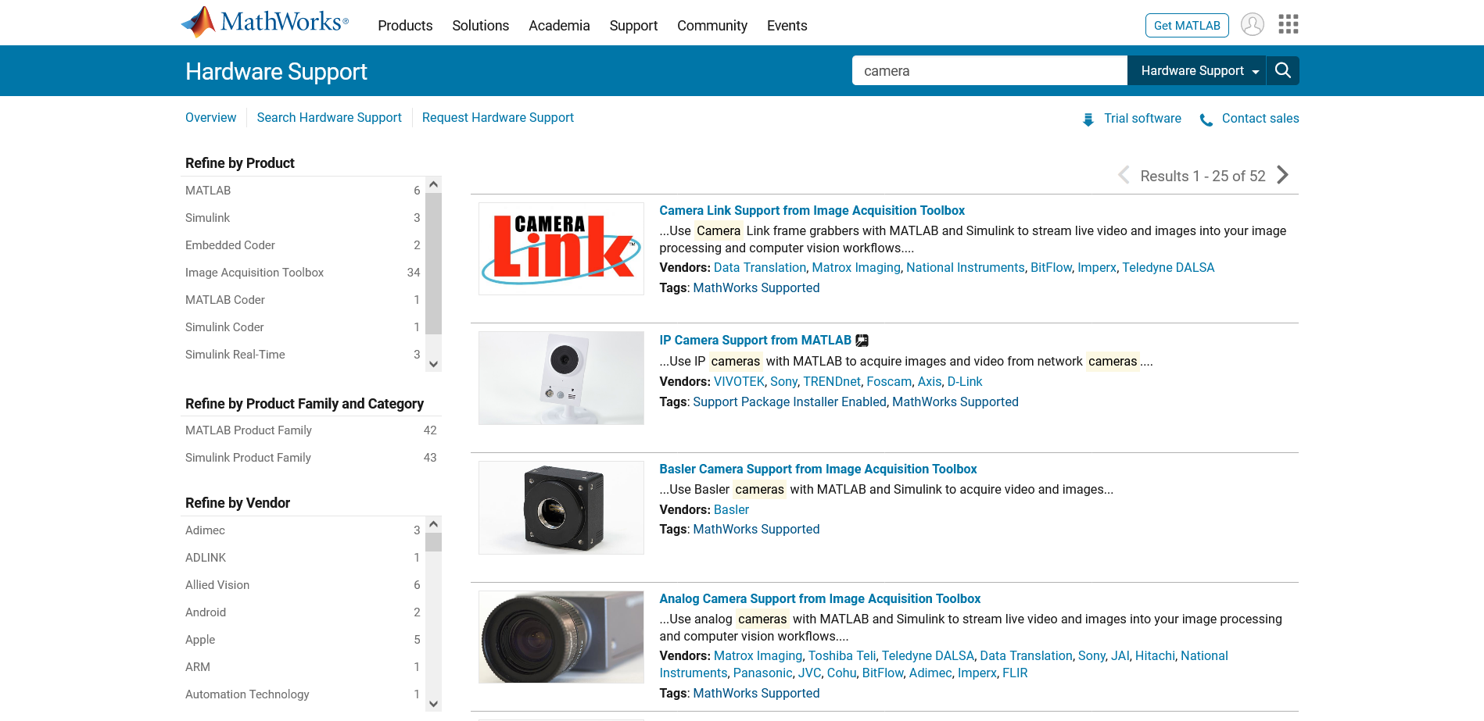

1. User decides to filter search results by selecting a vendor. Suppose user wants to see Camera products only from Apple and Sony. First user clicks on “Apple”

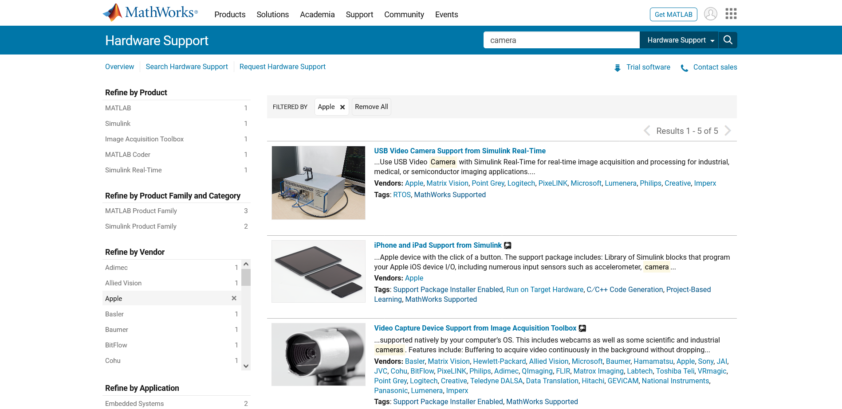

Now the results are filtered out wherein the Vendor tag/field contains Apple. It is perfectly fine but now these products are manufactured by Apple and by other companies as well as mentioned in their respective Vendors tag/field. So now the “Refine by Vendor” filter contains these manufacturers name and not the original all vendors list of “Camera search” which were displayed earlier. So now if the user selects “Sony” then result displayed is of the Camera product which is supplied by both Vendors (Apple + Sony) and not the result of all camera products whose vendors are “Apple” or “Sony”.

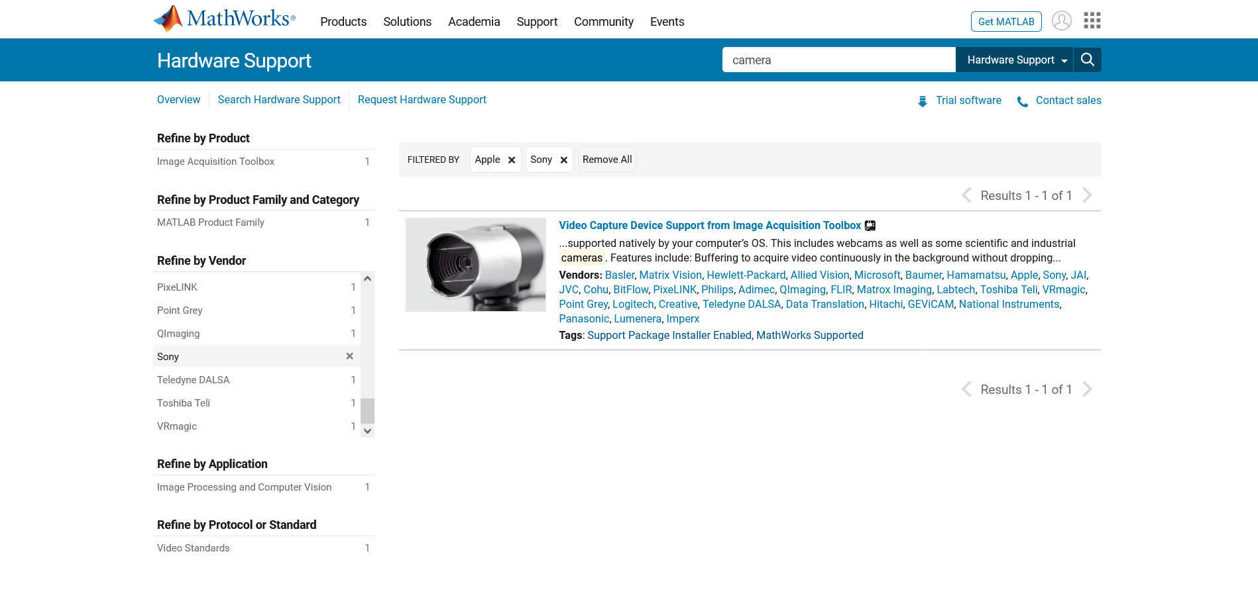

If we refine the Camera results only by Selecting “Sony” then there are more results as shown below

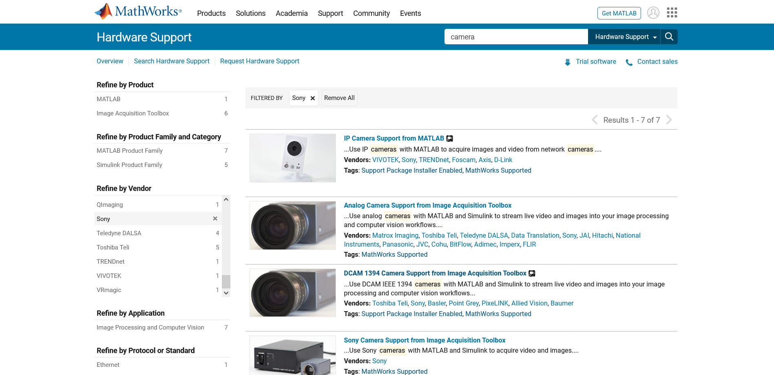

I thought maybe the “Refine by Vendor” filter should remain the same containing all vendors for a product so user can easily add/remove them and accordingly then results are displayed as per selected vendors i.e. it should filter the results as per the vendor field contains using OR ( Apple or Sony) rather than AND ( Apple and Sony ). I am unaware of the exact expectation of user from Hardware support point of view so sorry if I misunderstood it.

3) Results link – For less results user can navigate back and forth easily using the current view. But if there are many results then to come back to first page it is tedious. So usually we have a small icon link using which user can easily navigate to either first or last page.

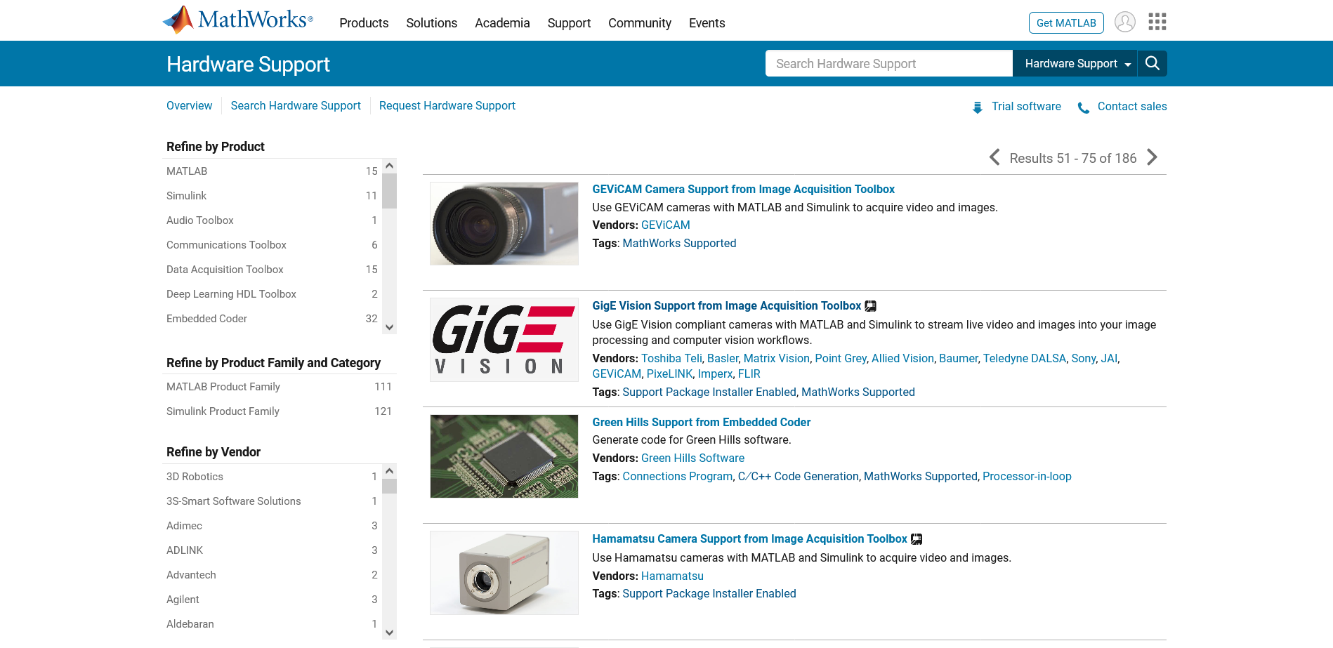

4) Tags – Just an observation maybe this is an expected functionality for tags.

User searches for ‘Camera’ and results are displayed.

User clicks on “MathWorks Supported” tag.

Results are displayed and it consists of all products having “MathWorks Supported” tag and not just of Camera Products having MathWorks Supported tag

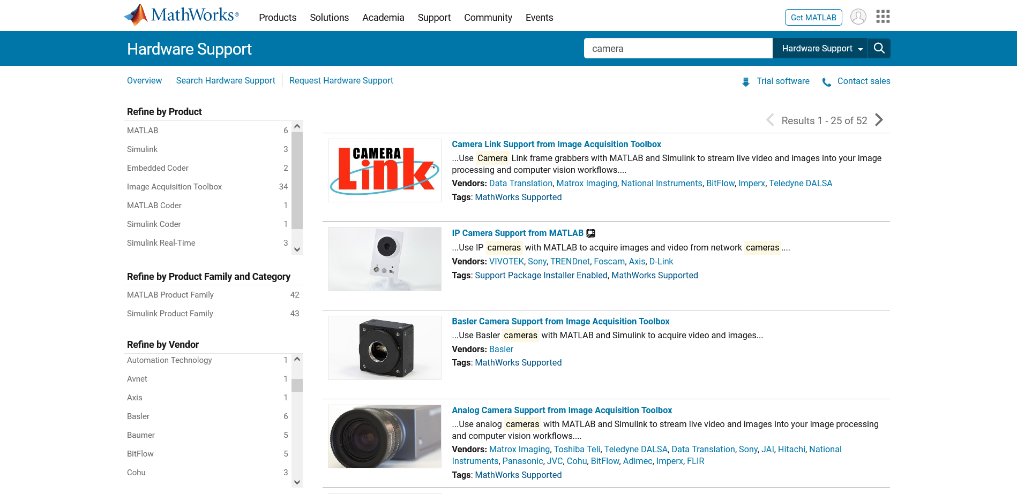

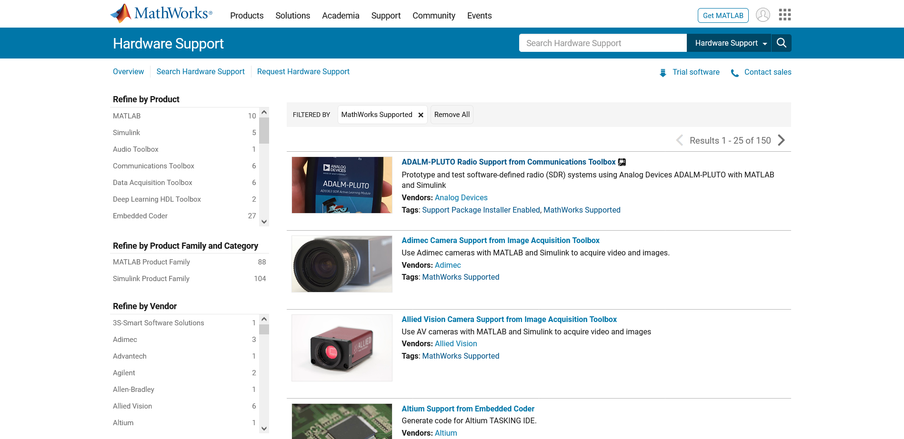

5) Search – While searching new products existing search filters applied are also taken into consideration for search results.

User searches for Camera and applies Vendor filter for “Apple”.



User searches for another keyword “Deep Learning”

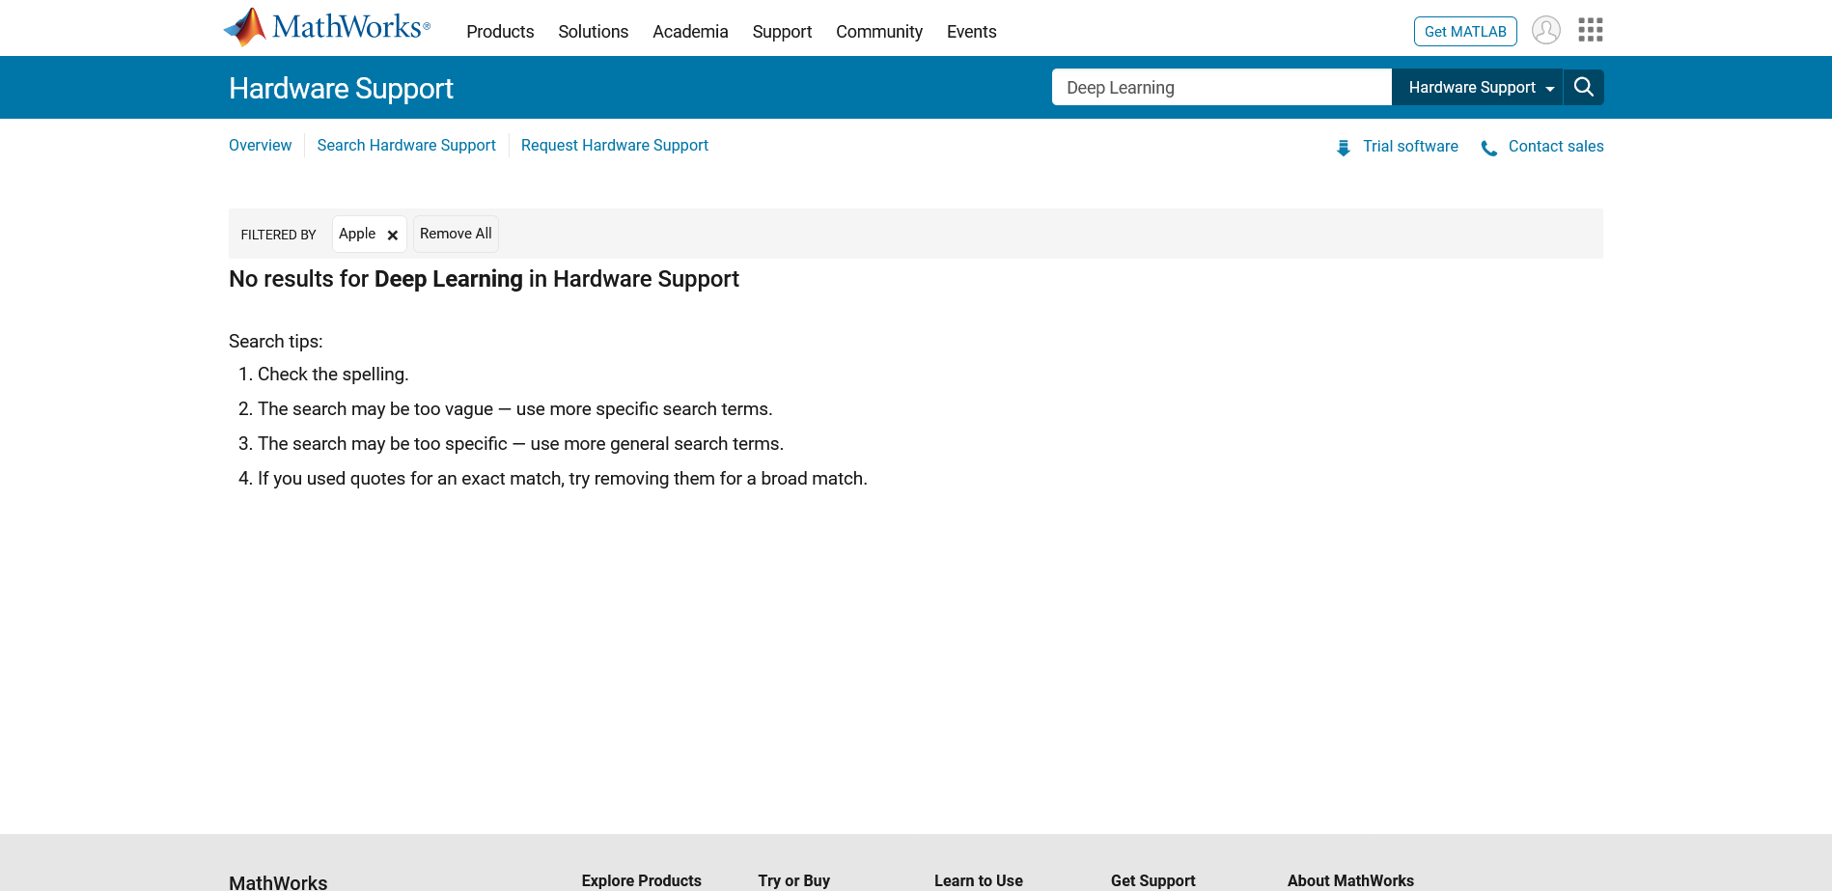

The results are present for “Deep Learning” but due to existing filter of “Apple” taken into consideration they are not displayed.

If “Apple” filter is removed from the “no results displayed” page, then results for “Deep Learning” are displayed.

But the Page Template used here is different than initial page used to display results.

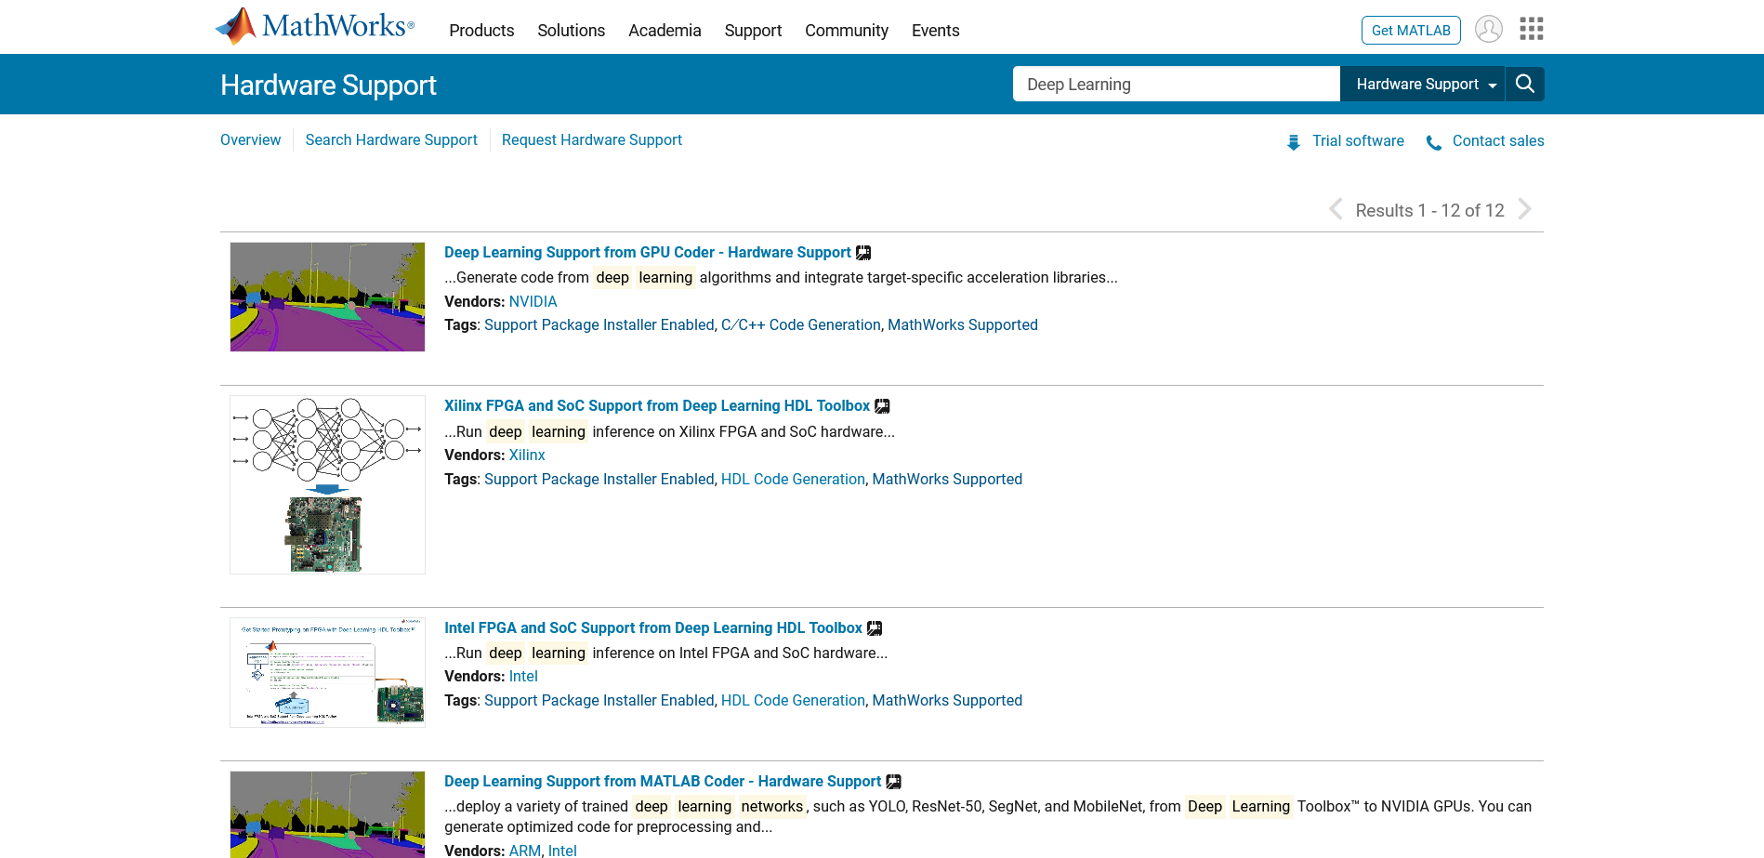

I think this is the same reason for the bug which was discovered during call.

User searches some product. Applies any filter. Now user again searches something which do not have any results



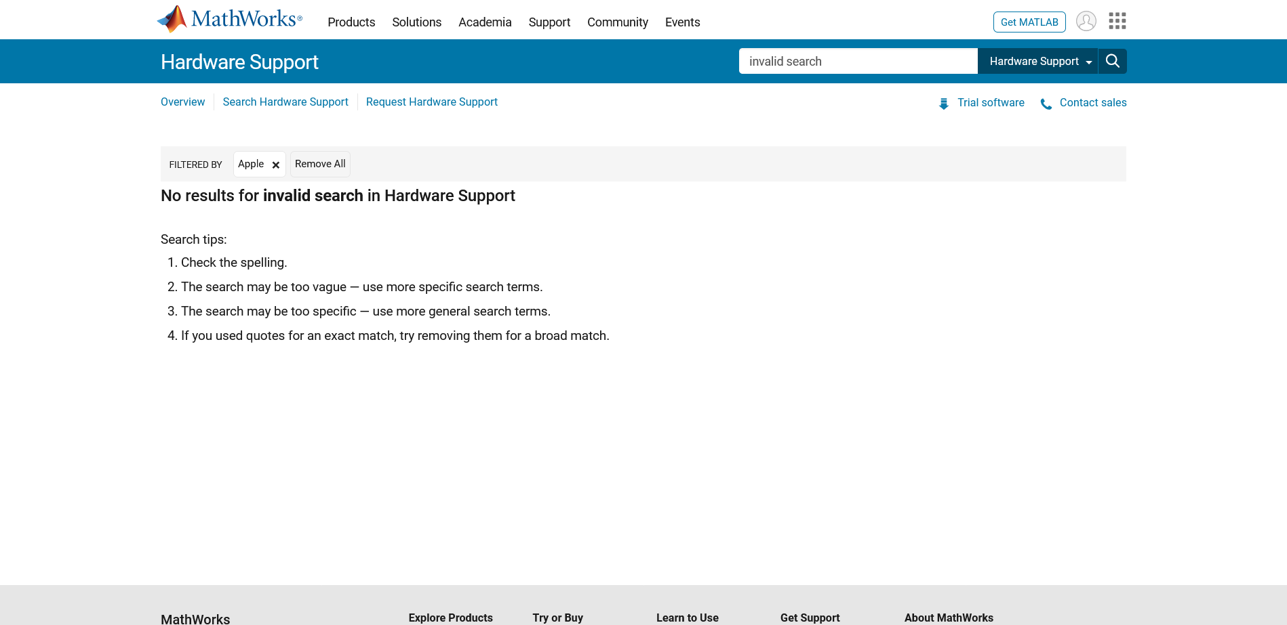

6) Just a small observation regarding the API response body.

For some fields dash ( - ) is used in case field name has multiple words instead of underscore ( _ ). Due to which dot (.) cannot be used to fetch data and gives an error instead we have to use square brackets [‘field-Name’] to navigate to required json field as shown below.

It might be due to some frontend naming requirement as well but other all fields had underscore, so I was able to spot it.

expect(vendorFilteredResults.response.body.response.docs[0]['hardware-support-vendor']).to.include('adlink')

